An Internship Report
Of
CodSoft Artificial Intelligence Virtual Internship

Submitted
To

School of Computer Science and Engineering
IILM University, Greater Noida, U.P.

In partial fulfilment of the requirement of degree of
B.Tech (Computer Science and Engineering)

By

Roll Number of Student: 2410030905
Name of Student: AKSHAT SHIVHARE
Batch: 2024-2028 (3rd Year, 5th Semester)

CANDIDATE'S DECLARATION

I, Akshat Shivhare, do hereby declare that the internship report titled “CodSoft Artificial Intelligence Virtual Internship” has been completed by me to fulfil the requirement for the award of the degree of Bachelor of Technology in Computer Science and Engineering. All the references have been quoted and I have not taken as such any material from any other source. I affirm that this report is my own and has not been submitted to any other institute for any degree/diploma requirement, and further I shall be solely responsible for any kind of copyright violation in this regard.
Signature:-
Student Name: AKSHAT SHIVHARE
Roll No.: 2410030905

ACKNOWLEDGEMENT

I am using this opportunity to express my gratitude to everyone who supported me throughout the internship program. I am thankful for their aspiring guidance, invaluably constructive criticism and friendly advice during this work. I am sincerely grateful to them for sharing their truthful and illuminating views on a number of issues related to this work.
I would like to thank the CodSoft team for providing me the opportunity and the structured platform to learn and gain hands-on exposure in the domain of Artificial Intelligence. I am also thankful to my institute, IILM University, Greater Noida, and the faculty of the School of Computer Science and Engineering for their continuous support and encouragement.
I express my gratitude to my parents for their blessings.
Signature:-
Student Name: AKSHAT SHIVHARE
Roll No.: 2410030905

TABLE OF CONTENTS

1. Candidate's Declaration i
2. Acknowledgement ii
3. Internship Completion Certificate -
4. Project Description 1
4.1 Introduction 1
4.2 Organization Profile 1
4.3 Problem Statement 2
4.4 Project Objectives 2
4.5 Scope of the Project 3
4.6 Technologies and Tools Used 3
4.7 System Architecture 4
4.8 Methodology / Tasks Undertaken 4
4.9 Expected Outcomes 6
4.10 Certificates of Completion and Communication Proof 7
5. Bibliography/References 8

3. INTERNSHIP COMPLETION CERTIFICATE
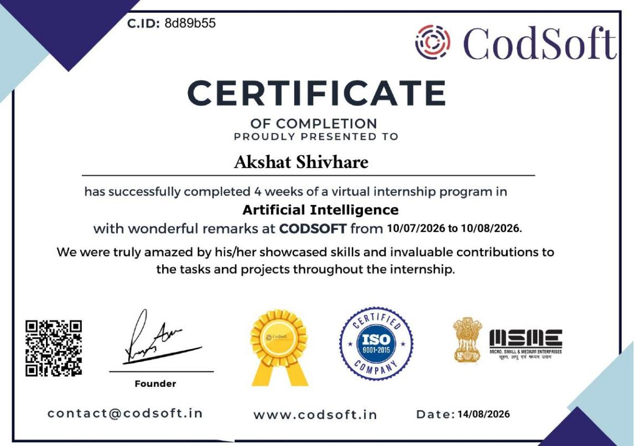

4. PROJECT DESCRIPTION

4.1 Introduction
This report presents a detailed account of the 4-week Virtual Internship undertaken with CodSoft, an ed-tech and software development platform, in the domain of “Artificial Intelligence”. The internship was carried out from 10 July 2026 to 10 August 2026. The primary aim of this internship was to build a practical foundation in core Artificial Intelligence concepts — covering rule-based natural language processing, adversarial search/game-playing algorithms, and recommender systems — by independently designing, coding, and deploying small end-to-end AI projects.
As per the internship guidelines, a minimum of three tasks out of the five offered (Rule-Based Chatbot, Tic-Tac-Toe AI, Image Captioning, Recommendation System, and Face Detection & Recognition) needed to be completed for successful certification. Three tasks were undertaken and completed as part of this internship: a Rule-Based Chatbot, a Tic-Tac-Toe AI agent, and a Movie Recommendation System. Each task was implemented independently, documented, and pushed to a public GitHub repository as required by the program.

4.2 Organization Profile
CodSoft is a technology education and software development platform that aims to empower aspiring developers by transforming theoretical knowledge into practical, hands-on expertise. Through virtual internships, project-based learning curriculums, and AI-driven career tools such as a resume builder, ATS score checker, and AI interview coach, CodSoft provides a holistic ecosystem for skill development. CodSoft is an ISO 9001:2015 certified and MSME-registered organization that runs structured virtual internship programs across domains such as Web Development, Android Development, Java Development, Python Programming, and Artificial Intelligence.

4.3 Problem Statement
While the theoretical foundations of Artificial Intelligence — such as search algorithms, natural language processing, and recommendation techniques — are widely taught in academic coursework, students often lack structured, self-driven opportunities to design and build small but complete AI applications from scratch. The problem addressed by this internship was to independently identify appropriate algorithms and techniques for three distinct AI problem categories (conversational agents, adversarial game-playing, and recommender systems), implement them in Python, and deliver working, demonstrable projects within a fixed timeline.

4.4 Project Objectives
- To understand and implement pattern-matching and rule-based techniques for building a conversational chatbot.
- To understand game theory and adversarial search, and implement the Minimax algorithm to build an unbeatable Tic-Tac-Toe AI agent.
- To understand recommendation techniques such as content-based and collaborative filtering, and build a movie recommendation system.
- To gain practical, hands-on experience translating AI concepts into working Python code.
- To maintain proper version control and public documentation of each project via GitHub.
- To successfully complete a minimum of three tasks for internship certification.

4.5 Scope of the Project
The scope of this internship covered three independent but conceptually distinct areas of Artificial Intelligence: rule-based conversational systems, adversarial search in game-playing agents, and recommender systems. Each project was scoped as a self-contained, console/script-based Python application intended for learning and demonstration purposes rather than production deployment. The internship was conducted in a virtual, self-paced format, with tasks selected from a list of five options provided by CodSoft, guided tutorials and online resources used for reference, and each completed project documented and submitted through GitHub.

4.6 Technologies and Tools Used
- Programming Language: Python
- Concepts Applied: Rule-based pattern matching, Minimax algorithm with game-tree search, Content-based and collaborative filtering
- Libraries/Tools (as applicable per task): Python standard libraries for string/pattern matching, NumPy/Pandas for data handling in the recommendation system
- Version Control & Hosting: Git and GitHub, with a dedicated repository maintained for each task
- Development Environment: Python IDE / Jupyter Notebook / VS Code
- Learning Resources: Online tutorials, documentation, and guided reference material as permitted by the internship guidelines

4.7 System Architecture
The general architecture followed across the three tasks completed during this internship can be summarized as follows:
- Input Layer: User input is captured via the console/interface — free-text queries for the chatbot, player moves for Tic-Tac-Toe, and user/movie preferences for the recommendation system.
- Processing Layer: Task-specific logic is applied — pattern/rule matching for the chatbot, Minimax game-tree search for Tic-Tac-Toe, and similarity-based filtering for the recommendation engine.
- Decision Layer: The system determines the appropriate response, optimal move, or ranked list of recommendations based on the processing layer's output.
- Output Layer: Results are returned to the user — a chatbot reply, the AI's next move on the board, or a list of recommended movies.
- Version Control Layer: Each project's source code, along with documentation, is maintained in its own GitHub repository as required by the submission guidelines.

4.8 Methodology / Tasks Undertaken
The internship followed a self-paced, task-based methodology. Three tasks were selected from the five options provided by CodSoft and completed independently, with each project designed, coded, tested, and documented before being pushed to a dedicated public GitHub repository, in line with the program's submission guidelines. The table below summarizes the three tasks completed:

Task | Title | Description
Task 1 | Rule-Based Chatbot | A simple chatbot that responds to user inputs using predefined rules and pattern-matching (if-else logic) to identify intents in user queries and provide appropriate responses. Built to establish a basic understanding of natural language processing and conversational flow.
Task 2 | Tic-Tac-Toe AI | An AI agent that plays Tic-Tac-Toe against a human player using the Minimax algorithm, making the AI unbeatable by exhaustively evaluating possible game states. Built to develop an understanding of game theory and basic adversarial search algorithms.
Task 3 | Movie Recommendation System | A recommendation system that suggests movies to users based on their preferences, using content-based and/or collaborative filtering techniques to identify similarity between movies or users and generate relevant suggestions.

Note: There was no stipend associated with this internship. As per the internship guidelines, each completed task was maintained in a separate GitHub repository and documented with a project demonstration.

4.9 Expected Outcomes
- Ability to design and implement rule-based/pattern-matching logic for a conversational chatbot.
- Practical understanding of adversarial search, game theory, and the Minimax algorithm through the Tic-Tac-Toe AI project.
- Hands-on exposure to building a recommendation system using content-based/collaborative filtering techniques.
- Improved proficiency in Python programming and translating AI concepts into working applications.
- Experience maintaining version-controlled, publicly documented project repositories on GitHub.
- Successful completion of the minimum three required tasks, resulting in the award of the CodSoft Artificial Intelligence Internship Completion Certificate.

4.10 Certificates of Completion and Communication Proof
The Internship Offer Letter and the Internship Completion Certificate issued by CodSoft, confirming successful completion of the 4-week virtual internship in Artificial Intelligence (10 July 2026 to 10 August 2026, Certificate ID: 8d89b55), are provided below as proof of completion.
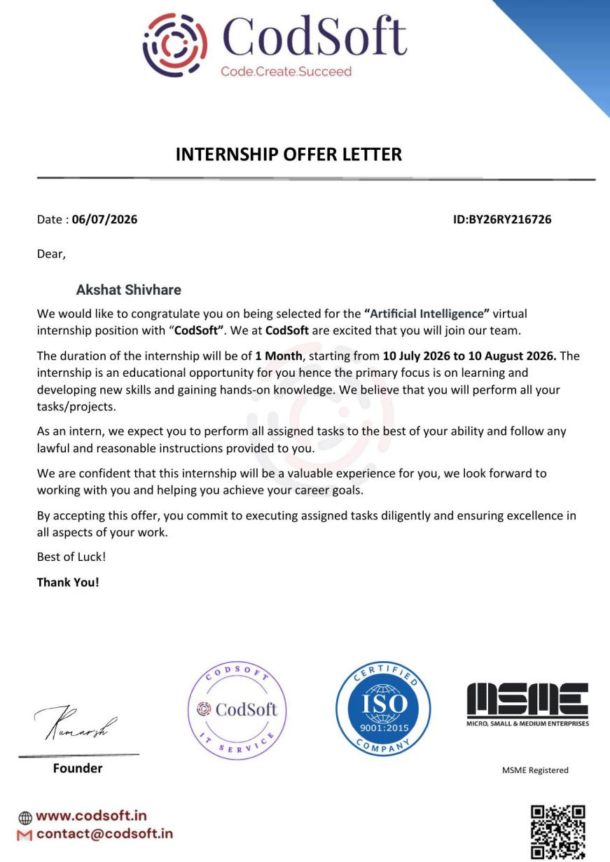
Project Repositories (GitHub links for the three completed tasks):
1. Rule-Based Chatbot — https://github.com/akshattshivhare/Rule-Based-Chatbot.
2. Tic-Tac-Toe AI — https://github.com/akshattshivhare/Tic-Tac-Toe-main
3. Movie Recommendation System — https://github.com/akshattshivhare/Movie-Recommendation-System

5. BIBLIOGRAPHY/REFERENCES
- CodSoft, “Artificial Intelligence Virtual Internship,” Internship Offer Letter, ID: BY26RY216726, 2026.
- CodSoft, “Certificate of Completion — Artificial Intelligence Internship,” Certificate ID: 8d89b55, 2026.
- Project Repository — Rule-Based Chatbot: https://github.com/anshkr12/Rule-Based-Chatbot
- Project Repository — Tic-Tac-Toe AI: https://github.com/anshkr12/Tic-Tac-Toe
- Project Repository — Movie Recommendation System: https://github.com/anshkr12/Movie-Recommendation-System
- Python Documentation, https://docs.python.org/
- CodSoft, https://www.codsoft.in

