ASSIGNMENT 2
NSW Train Crowding Classification
Group 208
SID and UniKey | Main responsibility and contribution | Agreed percentage
[Add member 1 SID and UniKey] | [Add agreed analytical work and quality review] | [Agree]
[Add member 2 SID and UniKey] | [Add agreed analytical work and quality review] | [Agree]
Both members must review and agree on the contribution statement before submission. Names are omitted in accordance with the assignment instructions.

Executive summary
We compare a majority-class baseline, Logistic Regression and Random Forest to flag crowded station-stop observations for operational review. Crowding accounts for 1,994 of 49,927 cleaned observations. On the stratified random holdout, Logistic Regression achieves 88.97% recall and 37.69% precision; Random Forest achieves 21.30% recall and 88.54% precision. The random benchmark favours Logistic Regression when missed crowding is the greater concern, but the grouped check below changes the operational recommendation.
The grouped holdout reduces recall to 20.00% for Logistic Regression and 3.08% for Random Forest. Neither model is ready for operational deployment on unseen services. Logistic Regression is only the stronger research candidate under a recall priority; more independent validation is necessary before any pilot.

1. Scope and evaluation contract

1.1 Stage 1 Handover and Feedback
Assignment 1 received 14/15 marks and established NSW Train Occupancy as the selected dataset for investigating passenger crowding. The dataset choice is retained because it supports a practical transport operations problem and provides relevant service, station and occupancy information. The existing data dictionary, cleaning pipeline and exploratory findings provide the foundation for the modelling stage.
The Stage 1 analysis identified important limitations, including the short observation period and the risk of target leakage from occupancy-related variables. These limitations will be considered throughout the modelling and evaluation process.

1.2 Stakeholder Decision and Research Objective
The primary stakeholder is a public transport operations team responsible for service planning and capacity management. The intended decision is to identify train observations associated with passenger crowding so that potentially problematic services and locations can be prioritised for further operational investigation.
The research question for Stage 2 is:
Can supervised classification identify crowded train observations more effectively than a simple baseline using information available at the intended decision time?
The models are intended to support operational investigation rather than automatically determine service changes or establish the causes of crowding.

1.3 Target and Unit of Prediction
The proposed target is a binary variable, Crowded, derived from Occupancy Status:
Crowded (1): FEW_SEATS_AVAILABLE or STANDING_ROOM_ONLY.
Not crowded (0): MANY_SEATS_AVAILABLE.
The unit of prediction is one recorded train observation at a station stop. Each prediction classifies whether that particular observation is crowded. Records with missing occupancy status are excluded because the outcome cannot be reliably inferred from the available occupancy information.
The Stage 1 feedback led us to strengthen the cleaning audit trail and make the modelling notebook load the exact output recreated by the pipeline. The reported Stage 1 mark of 14/15 is carried forward from the team draft.

Decision time and feature availability
The intended decision is made before the station stop. Occupancy Status and Occupancy Range are excluded because they reveal the outcome; actual timestamps and the departure-time band are excluded because their availability at that decision time is unconfirmed. Remaining service and station fields are candidate pre-stop information, but the source must confirm their availability, including Leading.Set.Type and Actual.Stop.Station. This is an offline benchmark pending that confirmation.

2. Evaluation contract and experimental design

Consequences and metrics
A false negative leaves a crowded observation unflagged and may delay investigation. A false positive creates unnecessary staff review. Crowded-class recall is the primary metric in the notebook contract; precision and F1 describe the workload trade-off, while accuracy is contextual because the majority class dominates. We have not established numerical stakeholder costs or a maximum review budget.

Data preparation and predictors
The deterministic pipeline starts with 50,250 records, removes 73 missing outcomes and 250 redundant exact duplicates, and retains 49,927 records. It trims text, maps three known occupancy-label variants, and repairs time-only timestamps only where a paired complete timestamp supplies a date. Timestamp repair assumes the same calendar date and may not handle overnight stops correctly; those fields are excluded from prediction. Crowded equals 1 for FEW_SEATS_AVAILABLE or STANDING_ROOM_ONLY and 0 for MANY_SEATS_AVAILABLE.
The nine retained predictors are day, Actual.Stop.Station, Segment.Direction, Trip.Name, Service.Line, Orig..Station, Dest..Station, Leading.Set.Type, Node.Seq.Order. No automatic feature search was performed. These fields represent recorded service, location, train type and sequence information; their operational availability remains an assumption.

Fair comparison and leakage controls
The original holdout uses an 80/20 stratified split with seed 42: 39,941 training and 9,986 test observations, including 399 crowded test observations. Training-only pipelines impute categorical values with the mode and one-hot encode them, and impute numeric values with the median and scale them. Each candidate has a separate cloned preprocessor. Outcome fields are excluded, and transformations are never fitted on test data.
The random split shares 2,919 Trip.Name values across sets. It describes held-out observations from partly shared services, not later observations in chronological order. We added a grouped sensitivity check after observing this overlap: the first fold of five-fold StratifiedGroupKFold, shuffled with seed 42, gives 9,672 test observations, 390 crowded cases and zero shared identifiers. This is one grouped holdout, not a five-fold average, and it was not part of the original scope lock.

3. Exploratory analysis supporting the models
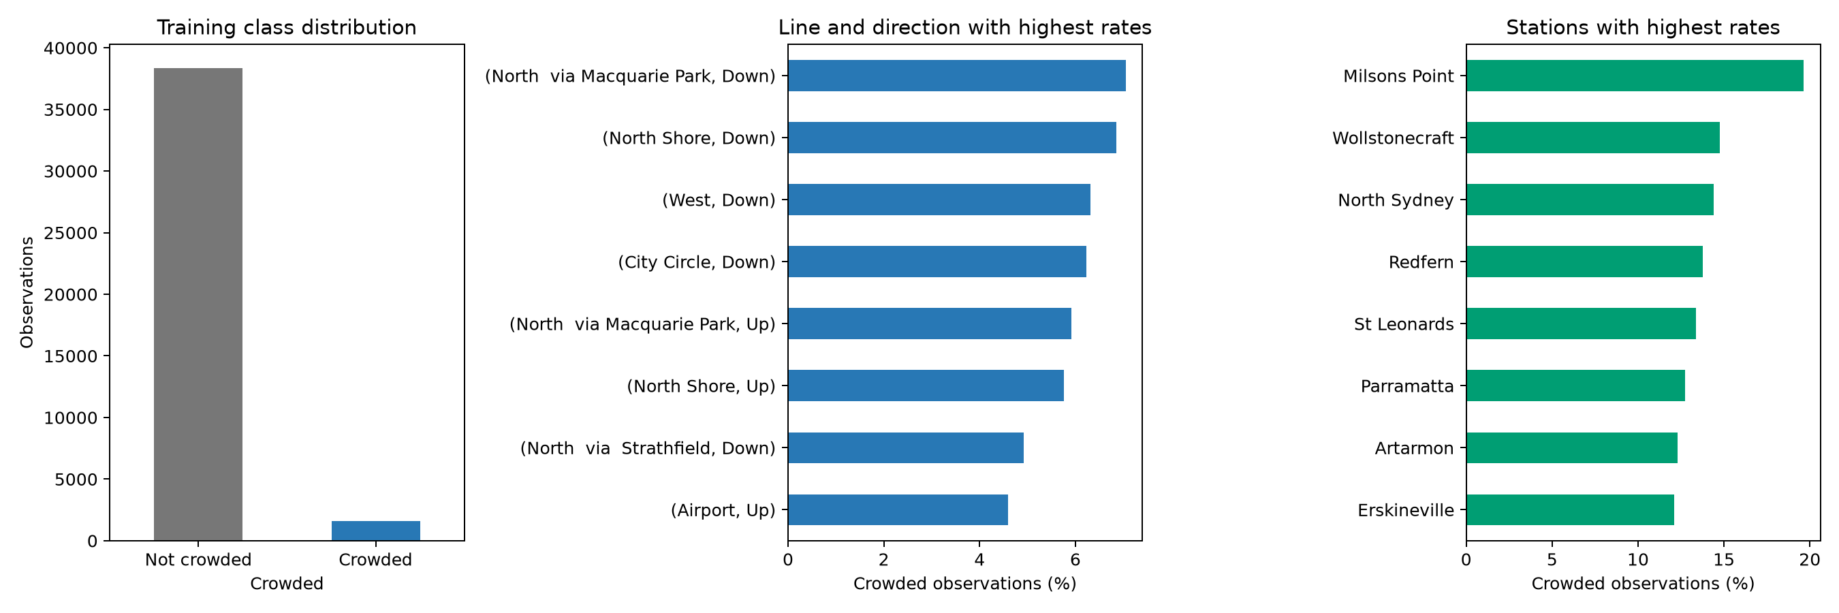
Figure 1. Descriptive EDA on the original training subset. Group rankings require at least 100 observations.
The first panel explains the baseline: predicting the majority class produces high accuracy while overlooking every crowded observation. This supports balanced class weights and recall as the primary measure. The other panels compare the share of recorded observations labelled crowded, not physical train capacity utilisation.
The highest displayed line-direction group is North via Macquarie Park / Down, with 7.05% crowded among 1192 training observations. The highest displayed station is Milsons Point, at 19.64% among 336 observations. These are sensible places to examine review demand, but group size, repeated services and the short observation window prevent causal or network-wide claims.
A minimum of 100 records is an inclusion rule rather than a significance test. The rankings are descriptive and were not used to select features or optimise either model. Time-band EDA is omitted from this model comparison because actual departure bands are unavailable at the intended decision time.

4. Candidate models and explainability
Logistic Regression is a regularised linear classifier: predictor contributions combine additively on the log-odds scale. It is suitable as a relatively simple starting point with sparse one-hot features. It does not assume normally distributed predictors, but an additive relationship may miss interactions between line, direction and station. We use balanced class weights, default L2 regularisation with C=1, max_iter=1000 and seed 42. Its weighted probabilities are not established as calibrated crowding risks.
Random Forest averages predictions from 200 decision trees and can capture nonlinear relationships and feature interactions without hand-coding them. We use balanced class weights, seed 42 and the implementation defaults for depth and feature sampling. Scaling is unnecessary for trees but shared numeric preprocessing keeps input preparation consistent. The forest can be slower and less transparent, and rare categories or repeated identifiers can encourage patterns that do not generalise. Neither model proves causes of crowding.
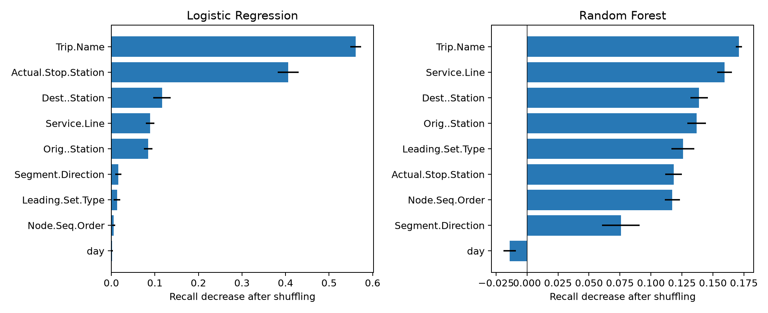
Figure 2. Held-out recall decrease after independently shuffling each original predictor. Error bars show the standard deviation across five repeats.
Logistic Regression relies most strongly on Trip.Name by this diagnostic: mean recall decrease 0.561. This measures dependence of the fitted model on a feature, not its causal importance.
Random Forest relies most strongly on Trip.Name by this diagnostic: mean recall decrease 0.171. This measures dependence of the fitted model on a feature, not its causal importance.
Correlated predictors can substitute for each other, so a small importance does not establish irrelevance. Shuffling can create implausible service combinations. These test-set explanations are descriptive and were not used to tune models or choose features; five shuffle repeats are not a confidence interval for model performance.

5. Results and operational trade offs
Model | Accuracy | Precision | Recall | F1
Baseline | 96.00% | 0.00% | 0.00% | 0.0000
Logistic Regression | 93.68% | 37.69% | 88.97% | 0.5295
Random Forest | 96.75% | 88.54% | 21.30% | 0.3434
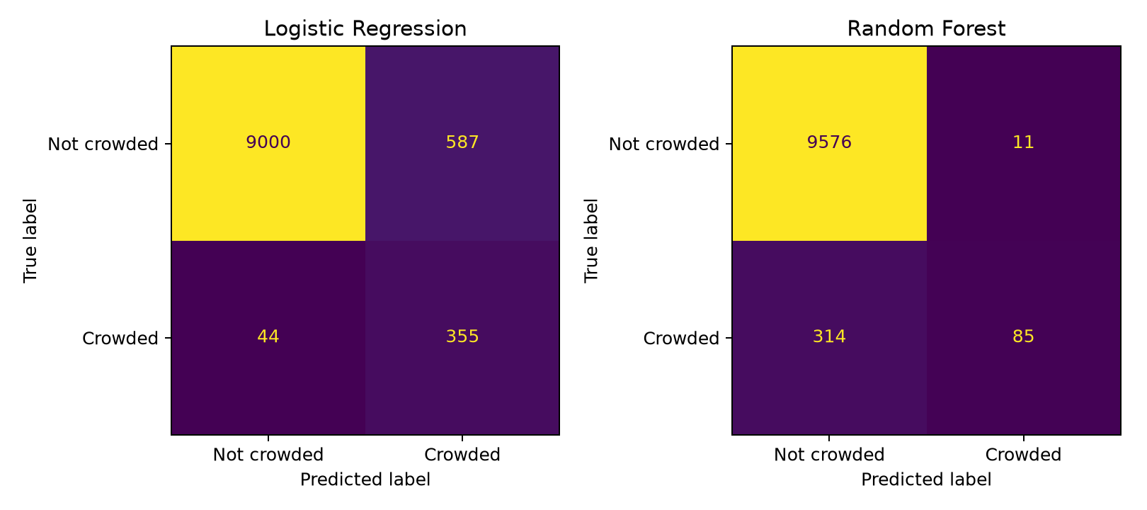
Figure 3. Actual classes are rows and predicted classes are columns. Both models use the same original test set.
Logistic Regression detects 355 of 399 crowded observations and misses 44. It generates 587 false alarms, so 942 observations would be flagged for review. Its precision is 37.69%. These counts describe station-stop observations; they are not distinct services requiring intervention.
Random Forest detects 85 of 399 crowded observations and misses 314. It generates 11 false alarms, so 96 observations would be flagged for review. Its precision is 88.54%. These counts describe station-stop observations; they are not distinct services requiring intervention.
The majority baseline detects no crowding. Logistic Regression is the preferred research candidate under the declared recall priority, but the grouped check below rules out a deployment recommendation at this stage. Differences in precision or accuracy do not override the recall priority. We do not claim statistical significance or stability from a single split.

Grouped sensitivity results
Model | Precision | Recall | F1 | Missed
Baseline | 0.00% | 0.00% | 0.0000 | 390
Logistic Regression | 20.05% | 20.00% | 0.2003 | 312
Random Forest | 85.71% | 3.08% | 0.0594 | 378
Logistic Regression recall falls from 88.97% to 20.00% and Random Forest recall from 21.30% to 3.08%. Logistic Regression misses 312 of 390 crowded cases in the grouped test set; Random Forest misses 378. The random benchmark substantially overstates their demonstrated ability to detect crowding on unseen trip identifiers. Since the test population also changes, the entire drop cannot be attributed to identifier leakage alone. Repeated grouped splits and later-time validation are needed to assess stability.

6. Thresholds errors and recommendation
Threshold | Precision | Recall | False alarms | Missed
0.25 | 20.93% | 93.48% | 1409 | 26
0.5 | 37.69% | 88.97% | 587 | 44
0.75 | 53.29% | 75.19% | 263 | 99
A lower threshold expands review workload to catch more crowding; a higher threshold reduces that workload while missing more cases. These thresholds were inspected on the original test set, so they are descriptive trade-offs rather than a validated optimisation. Retain 0.50 as the benchmark threshold. Select any operational replacement on a separate validation set with an agreed review capacity, then evaluate it once on untouched data.
Line | Test rows | Crowded | Missed | Miss rate
City Circle | 665 | 41 | 11 | 26.83%
North | 517 | 17 | 6 | 35.29%
North Shore | 981 | 62 | 6 | 9.68%
This table shows the three lines with the largest numbers of missed crowded observations for Logistic Regression. Counts indicate review volume; miss rates divide missed cases by actual crowded cases. Small denominators make rates unstable. Investigate uneven performance before allocating attention by model score, and retain routine reviews of unflagged services.
Do not deploy either model yet: the grouped recall is too weak to support reliable unseen-service detection. Retain Logistic Regression as the stronger research candidate under the recall priority, then verify service identifiers, confirm pre-stop features and validate on later data. If performance subsequently meets agreed criteria, a supervised pilot could consolidate repeated flags into services for analyst review. Record false alarms, missed cases and review workload. No acceptable minimum recall or review capacity has yet been agreed.

Limitations and responsible use
The short January 2017 observation period may not represent current schedules, demand, disruptions or seasonal conditions. Few seats available is a broad proxy for crowding, not a verified safety limit. Label errors and exclusion of missing outcomes may bias the analysis. Shared trips and correlated station stops weaken independence assumptions. Feature availability and the meaning of Trip.Name need confirmation. No demographic fairness conclusion is possible from these fields; differences across lines may still cause uneven allocation of attention.
No passenger-level identifiers are used as predictors. Service identifiers are operational information and should still be shared only as permitted by the dataset conditions. The model should not be used for individual passenger profiling, automatic capacity allocation or causal claims.

7. Model card

Intended use and outcome
Research candidate only; not ready for deployment. Model: balanced Logistic Regression. Intended eventual use: flag station-stop observations for human crowding review. Crowded includes few seats available as well as standing room only. The intended prediction point is before the stop, conditional on confirming predictor availability and meeting agreed validation criteria.

Data and implementation
49,927 cleaned observations, 1,994 crowded labels. Nine service and station predictors, with outcome fields and actual timestamps excluded. Training-only imputation, one-hot encoding and scaling; L2 Logistic Regression, C=1, balanced weights, max_iter=1000, seed 42. Both notebooks reproduce tables and figures from the raw dataset.

Performance and evaluation boundary
Original random holdout: accuracy 93.68%, precision 37.69%, recall 88.97%, F1 0.5295. Grouped holdout: precision 20.05%, recall 20.00%, F1 0.2003. No future-period, external-population or calibrated-probability validation has been performed.

Failure modes and inappropriate uses
False alarms consume review capacity; missed crowding leaves relevant observations unflagged. Rare or new service categories, changed schedules and the short data window may cause poorer performance. Do not treat the model as evidence of causes, individual passenger risk, verified physical overcrowding or a basis for automatic service changes.

Monitoring and conditions for a pilot
Confirm that predictors exist before the stop, validate on later data, agree acceptable review workload and error costs, and assess errors by service line with denominators. Monitor prevalence, missingness, unseen categories, recall, precision, workload and staff outcomes. Reassess the threshold on validation data and investigate material deterioration before continued use.

Accountability
The operations team retains responsibility for decisions. The group must confirm the contribution statement and review all claims, metrics and code before submission. Model outputs should prompt an investigation supported by current operational evidence.

8. Reproducibility references and declarations
Run notebooks/01_data_pipeline.ipynb first and notebooks/02_modelling_evaluation.ipynb second, from the notebooks directory. The pipeline recreates data/processed/train_occupancy_model_ready.csv. The modelling notebook generates figures and CSV result tables in figures and results. Random seeds are 42; original model settings remain fixed. The experiment sequence is the baseline and two candidates on the random split, followed by descriptive diagnostics and an additional grouped check. Runtime depends on hardware, especially the forest and repeated permutation predictions.
Verified software versions: python 3.11.9, pandas 2.3.3, numpy 2.4.6, scikit-learn 1.7.2, matplotlib 3.11.2.

References
COMP5310 teaching team. Assignment 2 Project Stage 2 brief, supplied via the unit learning materials. The brief specifies the evaluation contract, reproducible package and maximum 12-page report.
COMP5310 teaching team. Train Occupancy dataset supplied for the assignment. [Add the exact Canvas dataset citation and original provenance used in Assignment 1.]
Group 208. Assignment 1 dataset readiness and EDA; Assignment 2 executable notebooks and generated results. Internal project materials.

Generative AI acknowledgement
OpenAI ChatGPT and Codex assisted with code development and debugging, drafting explanations, preparing report text and formatting, and checking consistency between results and the report. The notebooks were executed to generate the reported outputs. [Both members must review this declaration, confirm the checks they personally performed and ensure this use meets the unit conditions before submission.]

Items to complete before submission
Add both SIDs and UniKeys and the agreed contribution statement on the cover. Confirm the dataset reference, Stage 1 mark and scope-lock history. Review the final narrative and all generated results together. Remove these completion notes and any remaining bracketed fields, then export a self-contained PDF of no more than 12 pages.

