ASSIGNMENT-1
  - Dataset Selection and Preparation
  - Group-208

Group Member | Main Responsibility and contribution | Agreed Contribution (%)
560441347-spad0736 | Dataset audition and selection, Data readiness, Cleaning Audit | 50
560299645-atya0928 | Report Review, EDA, Stakeholder Problem and success criteria | 50

Datasets Comparison Table
Dataset | Size and variables | Opportunity and stakeholder decision | Quality risk and ethical or feasibility concern
NSW Train Occupancy | 50,250 rows; 14 columns; 2 numeric and 12 categorical/text | Identify crowding patterns and later predict crowding risk. NSW train operations can prioritise capacity or timetable review by time, station, and corridor. | Risk: mixed timestamp formats, minor missingness, and 0.5% duplicates. Concern: the short January observation period may not represent all demand conditions.
Air Travel Delay | 101,000 rows; 29 columns; 14 numeric and 15 categorical/text | Identify delay patterns and later predict delay risk. Airline or airport operations can prioritise disruption-prevention and delay-management actions. | Risk: several delay-related fields have substantial missingness. Concern: historical operations may not generalise to future disruptions or weather events.
Hotel Booking | 119,987 rows; 32 columns; 20 numeric and 12 categorical/text | Analyse cancellations and booking demand. Hotel managers can adjust staffing, bookings, and revenue-management decisions. | Risk: 26.1% exact duplicates. Concern: booking records may reflect historical customer behaviour and require care around customer-data privacy.

The NSW Train Occupancy Dataset was chosen due to its feasibility and relevance for Assignment 2. It includes 50,250 observations and 14 features, low number of missing values, and 0.5% of exact duplicates. On the other hand, the Airline Delay Dataset contains missing values in its variables that define causes of delays. Moreover, the Hotel Booking Dataset contains 26.1% of duplicates. The Train Occupancy Dataset addresses the needs of the assignment in advising an NSW transport operations team about the situation with crowds.

Stakeholder Problem and success criteria
The identified primary stakeholders will be the NSW trains operation team. They are responsible for ensuring timetables and services are catered to provide the most efficient and robust schedule while minimizing crowding and delays.
The team will need to decide which times, station and routes should receive priority for capacity or timetable review
Research Question: Which departure times, station stops and service line-direction/route combinations show the highest crowding risks?
Success criteria: A successful and useful answer would be able to identify the number of high priority times and locations using concrete evidence through exploratory analysis, rather than having to treat every service with equal priority.
Cost of Misleading Conclusion: A misleading conclusion will affect the real decisions made by the team. Data driven decision need to be made with evidence that is proper and correct. A false finding, in this case providing a station, time or route that doesn’t need priority will lead to waste of resources that instead of solving a problem will lead to more loss. If we identify the wrong crowded routes passengers will still keep dealing with packed trains, fewer seats and more time loss. This makes travel less comfortable and reliable and can cause lack of trust or public shame to the NSW trains department. Hence, we must provide correct information and use this data as a guide to an investigation rather than final proof.

Cleaning Evidence
The following cleaning log provides the steps taken to reach the final dataset.
Issue | Evidence | Action | Justification | Impact
Missing occupancy status | 73 records | Dropped rows with missing Occupancy Status | The target could not be reliably inferred from Occupancy Range | 50,250 to 50,177 rows before duplicate removal
Exact duplicates | 250 duplicate rows | Removed exact duplicates | Repeated records add no information and would distort frequencies | 50,177 to 49,927 rows
Whitespace inconsistencies | Up , Down, Hunter Valley | Applied .str.strip() | Standardises equivalent labels | Categories combined
Inconsistent occupancy labels | 165 MANY_SEATSAVAILABLE, 8 lowercase few-seats labels, 2 typo standing-room labels | Replaced with standard labels | Prevents equivalent categories from being counted separately | Three valid occupancy categories
Mixed timestamp formats | Full datetimes, 1421, 09.08PM, unknown, ?? | Parsed valid formats; paired valid timestamp supplies date for time-only values | Avoids interpreting compact times as years | 202 time-only values repaired
Unusable timestamps | 19 arrival and 28 departure values remain unavailable | Retained in master file; excluded only from timestamp-complete subset | These records remain useful for non-timestamp EDA | 49,880 timestamp-complete records

- The initial raw data set ‘train_occupancy.csv’ comprised of 50,250 records with 14 variables (evidence provided in ‘data_readiness. ipynb’ ).
- We found 250 duplicate rows that match exactly to each other and hence provide no actionable data, these were dropped from the dataset.
- On further analysis we found 73 records with missing ‘occupancy status’ and removed since they can’t be inferred from just occupancy range.
- IMPORTANT TARGET LEAKAGE: occupancy range was excluded since it is closely related to occupancy status and occupancy status provides a much clearer image for predictive analysis
- String cleaning was performed to remove whitespace from categorial variable (categories: UP, Down and Hunter Valley) also combining the categories.
- Next, we standardize the occupancy labels: MANY_SEATS_AVAILABLE, FEW_SEATS_AVAILABLE and STANDING_ROOM_ONLY.
- Numerical fields were checked and found that ‘day’ ranges from 9-16 and ‘Node.seq.order’ ranges from 1-38 without invalid values
- Arrival and departure times had invalid or inconsistent format for example: 9.08 pm and 1421.
- Timestamps were cleaned by and repaired using the date from the paired timestamp.
- The final dataset contains 49,927 rows and 16 columns including the cleaned timestamps (Arrival_Clean and Departure_Clean)

Exploratory Data Analysis
There were 3 questions posed, and their corresponding figures and explanations are as follows:
- Crowding Rate Per Hour:
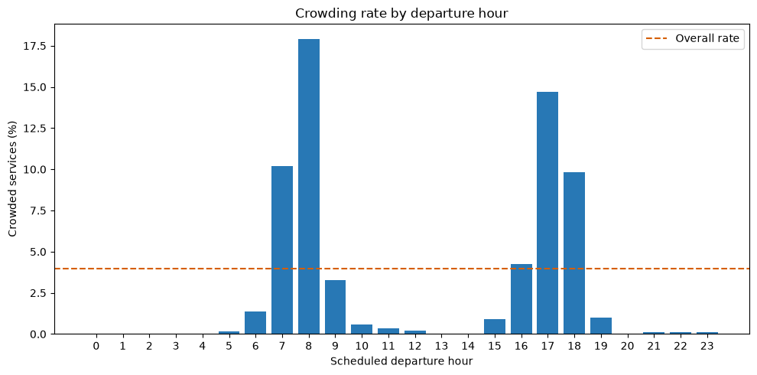
At which departure hour is the crowding rate the highest?
Departure_Hour | Records | Crowding_Rate
8 | 3270 | 0.179205
17 | 3169 | 0.147050
7 | 2956 | 0.102165
18 | 3048 | 0.098425
16 | 2869 | 0.042524

We grouped the records by the departure hour and defined the crowded service as the ‘FEW_SEATS_AVAILABLE’ or ‘STANDING_ROOM_ONLY’. The chart displayed each hour’s crowded rate.
We found that the Crowding is highest during the commuter peak. I.e during start of day and end of day for average work shift. The identified departure hours are shown below with their corresponding crowding rate. The time range of morning( 7am-8am) and afternoon(4pm-6pm) show the highest crowding.
- Top 15 stations by crowding rate:
Which stops have the highest crowding risk?
To avoid unstable percentages from very small samples, we included only stations with at least 100 records. The top 15 stations are shown below:

Stop Station | Records | Crowding rate
Milsons Point | 409 | 0.183374
North Sydney | 420 | 0.142857
Wollstonecraft | 384 | 0.140625
Redfern | 1518 | 0.137022
Parramatta | 390 | 0.128205
Waverton | 353 | 0.124646
Tempe | 168 | 0.119048
Green Square | 301 | 0.116279
Erskineville | 165 | 0.115152
Mascot | 306 | 0.114379
Artarmon | 387 | 0.113695
St Leonards | 407 | 0.113022
Wolli Creek | 761 | 0.103811
Sydenham | 488 | 0.102459
Central | 1973 | 0.099848

Milsons point has the highest crowding rate (18.3%), followed by North Sydney (14.3%), Wollstonecraft(14.06%), Redfern(13.7%) and Parramatta(12.8%)

These station should be kept as the priority for investigating crowding issues. This analysis identified which station have the highest crowding rate, this does not mean that the stations themselves are the cause and hence a targeted investigation will be required to find the root cause. However this does show that these stations should be investigated first.

- Top Service line-direction Combinations
Which line-direction combinations show the highest crowding rate?

We grouped records by service line and direction (Up or Down). We included only service line-direction combinations with at least 100 records, because smaller groups can produce unstable crowding percentages.

The findings are as follows:

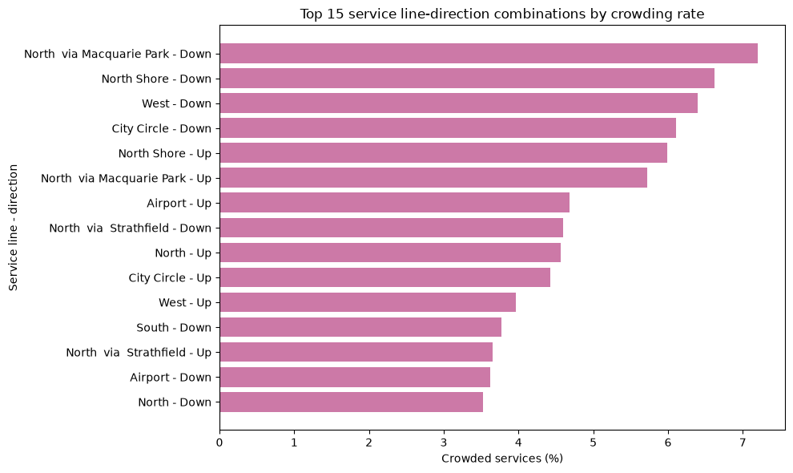

Service.Line | Segment.Direction | Records | Crowding_Rate | Line_Direction
North | Down | 1420 | 0.035211267605633804 | North - Down
Airport | Down | 2267 | 0.03617115130127922 | Airport - Down
North via Strathfield | Up | 793 | 0.03656998738965952 | North via Strathfield - Up
South | Down | 1804 | 0.037694013303769404 | South - Down
West | Up | 3002 | 0.039640239840106596 | West - Up
City Circle | Up | 1855 | 0.044204851752021566 | City Circle - Up
North | Up | 1336 | 0.04565868263473054 | North - Up
North via Strathfield | Down | 913 | 0.04600219058050383 | North via Strathfield - Down
Airport | Up | 2287 | 0.04678618277219064 | Airport - Up
North via Macquarie Park | Up | 1572 | 0.05725190839694656 | North via Macquarie Park - Up
North Shore | Up | 2304 | 0.059895833333333336 | North Shore - Up
City Circle | Down | 1311 | 0.06102212051868802 | City Circle - Down
West | Down | 3207 | 0.06392266916120985 | West - Down
North Shore | Down | 2477 | 0.0662091239402503 | North Shore - Down
North via Macquarie Park | Down | 1513 | 0.07204230006609386 | North via Macquarie Park - Down

We found that the North via Macquarie Park–Down has the highest crowding rate (7.2%), followed by North Shore–Down (6.6%), West–Down (6.4%), and City Circle–Down (6.1%)

These lines should be the first candidates for the detailed service capacity reviews as they show the most crowding rates of all line-direction combinations. These are crucial for analysis since they represent the most crowding rates depending on the specific direction of the train lines. The NSW team can use this finding to further investigate the root causes and hence come up with targeted approaches such as checking if this is true throughout the day, weekends or is concentrated to a certain time.
Final Findings:
- Crowding is more prevalent in morning and afternoon peaks
- Crowding differs by station and service direction
- High-risk line-direction results might be due to small number of station time combinations

Assignment 2 recommendations
Assignment 2 could predict the `Crowded` outcome using stop station, service line, direction, origin, destination, train-set type, and station-sequence order. Departure-time variables may be used only if they are available at the intended prediction time. `Occupancy Range` should be excluded because it is closely related to the outcome and could cause target leakage. The cleaned dataset provides the starting point for this later modelling work.
Limitations:
- Data only covers a short period of time from 9-16 January
- Findings are not covering other seasons, holidays, disruptions etc
- Some categorical fields have missing values
- EDA shows only the association of data and does not give a root cause
- Crowded records are less with respect to the entire data set
- Station and line combinations do not reflect peak time completely and hence a different combination might be required

GENAI disclosure
Generative AI (OpenAI Codex/ChatGPT) was used to support code explanation, reproducibility documentation, data-cleaning troubleshooting, and AI-assisted proofreading. All dataset checks, cleaning decisions, code outputs, visualisations, and interpretations were reviewed by the group against the raw data, cleaned data, unit materials, and assignment requirements. The group remains responsible for the final submitted work.
All dataset checks, cleaning decisions, code outputs, visualisations, and interpretations were made and reviewed by the group against the raw data, cleaned data, unit materials, and assignment requirements.

