Footfall Data Cleaning & Preparation — What We Did, Why, and How
Below is a step-by-step walkthrough of the entire process.
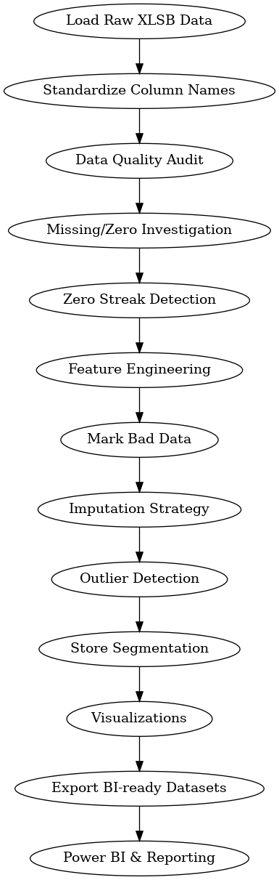

1. Loaded the Raw Dataset
What
We loaded the footfall data from a .xlsb Excel-binary file into Python using pandas.
Why
.xlsb files are not readable by normal engines; they are optimized for large datasets.
How
df = pd.read_excel("Data.xlsb", engine="pyxlsb")

2. Standardized Column Names
What
Cleaned messy column names (lowercase, no spaces).
Why
- Avoid future errors
- Easier to reference in code
- Better compatibility with BI tools
How
df.columns = df.columns.str.strip().str.lower().str.replace(" ", "_")

3. Explored Data Quality
What? Checked for:
- missing values
- zeros
- duplicates
- date ranges
Why
To identify all reliability issues before cleaning.
How
df.isna().sum()
df.duplicated().sum()
(df['cy_footfall'] == 0).sum()

4. Investigated Missing & Zero Patterns
What
Found:
- which stores had missing/zero values
- on which dates
Why
A missing day or long zero sequence usually means:
- sensor failures
- data loading failures
How
df[df['cy_footfall']==0].groupby('invoice_associate_name').size()

5. Detected Zero Streaks
What
Calculated consecutive zero-day streaks per store.
Why
If a store reports 0 for 100+ days, it’s NOT real customer behavior.
How
Cumulative grouping on zero flags.
Result: Himayat Nagar = 0% reliability.

6. Added Weekday & Month Columns (Feature Engineering)
What
Derived:
- weekday names
- month numbers
- weekend flags
Why
Footfall depends on:
- weekend rush
- seasonal shopping
- weekday behavior
How
df['weekday'] = df['invoice_date'].dt.day_name()
df['month'] = df['invoice_date'].dt.month
df['is_weekend'] = df['weekday'].isin(['Saturday','Sunday']).astype(int)

7. Marked Bad Data
What
Flagged rows where:
- footfall was missing
- footfall was zero
Why
To replace artificially low values.
How
df['is_bad_data'] = (df['cy_footfall']==0) | (df['cy_footfall'].isna())

8. Imputed Missing Values (Responsibly)
What
Replaced missing values using:
- Previous-year footfall + 5% uplift
- Store × weekday median
- Global median fallback
Why
- Footfall is seasonal
- Weekends behave differently
- Averages are too generic
How
df['cy_imputed'] = df['py_footfall'] * 1.05
Then:
store_weekday_median = df.groupby(['store','weekday'])['cy_imputed'].median()

9. Avoided Bad Alternatives
We did NOT use:
- dropping missing rows (loses data)
- random noise generation (unrealistic)
- linear interpolation (kills weekend spikes)
Choosing simple, business-aligned imputation increases trustworthiness.

10. Generated Insightful Visualizations
What
We plotted:
- Daily trends
- Store ranking
- Weekday patterns
- Store volatility
Why
Helps understand:
- peak periods
- risk exposure
- stable vs unstable stores
How
Using matplotlib.

11. Classified Stores into Performance Segments
What
Three tiers:
- HIGH (top 20%)
- MEDIUM (middle)
- LOW (bottom 40%)
Why
Leads to:
- targeted promotions
- staffing optimization
- benchmarking
How
Percentile thresholds.

12. Built Seasonality Matrix (Store × Month)
What
Heatmap shows demand cycles per store.
Why
Used for:
- staffing
- inventory
- marketing campaigns

13. Audited Anomalies
What
- Outliers
- Missing dates
- Data continuity
- Zero streak length
- Reliability %
Why
Prevents wrong business decisions.
Result:
- 381 valid event spikes
- Himayat Nagar unreliable

14. Exported BI-Ready Datasets
We produced 3 files:
- footfall_clean.csv — daily clean data
- store_summary.csv — store performance
- daily_summary.csv — portfolio level
Why
These are ready to load into:
- Power BI
- Tableau
- Excel
- ML models

Final Summary

We:
Phase | What We Did | Why
Load & Inspect | Understood structure | Avoid surprises
Clean Column Names | Standardized | Prevent code errors
Audit Missing/Zero | Find sensor failures | Improve reliability
Detect Streaks | Identify outages | Flag suspicious stores
Impute Smartly | Fill gaps realistically | Protect trends
Feature Engineer | Add weekday, weekend, month | Improve analysis power
Visualize | Spot patterns | Communicate insights
Segment Stores | Rank performance | Enable business actions
Export Clean Data | BI-ready output | Dashboards & reporting

Technical Value Delivered
- Preserved real seasonal patterns
- Avoided over-engineering
- Transparent logic, easy to explain
- Reusable pipeline
- Ready for automation

Business Value Delivered
Decision-makers can now:
- Staff correctly on weekends
- Plan festivals strategically
- Improve low-performing stores
- Repair bad sensors early

