Assignment 4: Section- Theory GR NO-21920090

Lab Assignment No 4 :Write a function template and class template selection Sort. Write a program that inputs, sorts and outputs an integer array and a float array.

Aim: Use template class and template function to perform selection sort on integer and float array.

Description: Template class and template functions are used in the program. Using function template I sorted array using selection sort algorithm. Function class is used to create array of given type and other variables.

Oop Concepts Used:

1)Templates in C++:

Function Template
- Generic functions use the concept of a function template. Generic functions define a set of operations that can be applied to the various types of data.
- The type of the data that the function will operate on depends on the type of the data passed as a parameter.
- For example, Quick sorting algorithm is implemented using a generic function, it can be implemented to an array of integers or array of floats.
- A Generic function is created by using the keyword template. The template defines what function will do.

Syntax of Function Template
- template <class Ttype> ret_type func_name(parameter_list)
- {
- //body of function.
- }

Function Templates with Multiple Parameters
We can use more than one generic type in the template function by using the comma to separate the list.
Syntax:
- template<class T1, class T2,.....>
- return_type function_name (arguments of type T1, T2....)
- {
- // body of function.
- }

CLASS TEMPLATE
Class Template can also be defined similarly to the Function Template. When a class uses the concept of Template, then the class is known as generic class.

Syntax
- template<class Ttype>
- class class_name
- {
- .
- .
- }

Ttype is a placeholder name which will be determined when the class is instantiated. We can define more than one generic data type using a comma-separated list. The Ttype can be used inside the class body.
Now, we create an instance of a class
- class_name<type>ob;
where class_name: It is the name of the class.
type: It is the type of the data that the class is operating on.
ob: It is the name of the object.

CLASS TEMPLATE WITH MULTIPLE PARAMETERS
We can use more than one generic data type in a class template, and each generic data type is separated by the comma.

Syntax
- template<class T1, class T2, ......>
- class class_name
- {
- // Body of the class.
- }

Output:

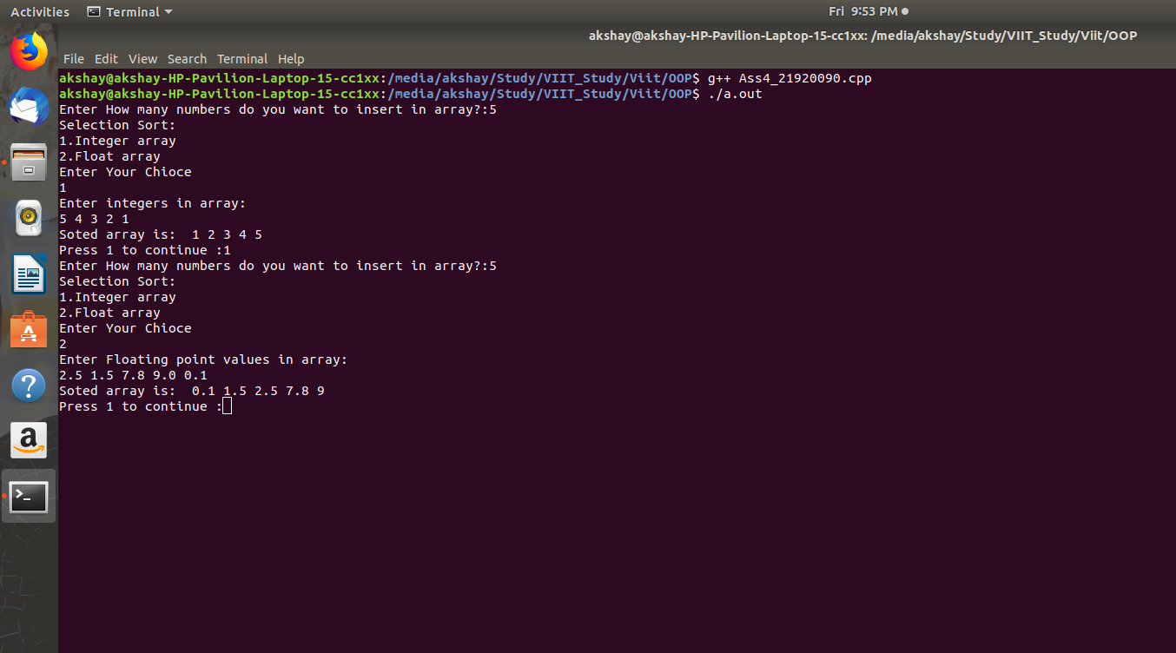

Conclusion:
Thus we have successfully implemented template class and template functions.

