EXERCISE 2
IMPLEMENTATION OF FORK(), EXEC() AND WAIT() SYSTEM CALLS
PROGRAM:
#include <stdio.h>
#include <stdlib.h>
#include <unistd.h>
#include <sys/wait.h>
int main()
{
pid_t pid;
int status;
printf("Parent process: PID = %d\n", getpid());
pid = fork();
if (pid < 0)
{
perror("fork failed");
exit(1);
}
else if (pid == 0)
{
printf("Child process: PID = %d, Parent PID = %d\n",
getpid(), getppid());
printf("Child is about to execute 'ls -l' using execlp()\n");
execlp("ls", "ls", "-l", NULL);
perror("execlp failed");
exit(1);
}
else
{
printf("Parent waiting for child (PID = %d) to finish...\n", pid);
wait(&status);
if (WIFEXITED(status))
printf("Child terminated normally with exit code %d\n",WEXITSTATUS(status));
else
printf("Child terminated abnormally\n");
printf("Parent process finished execution.\n");
}
return 0;
}

OUTPUT:
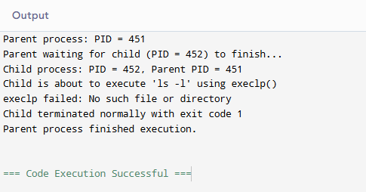

EXERCISE 3

FILE COPY USING OPEN(), READ() AND WRITE() SYSTEM CALLS

PROGRAM:

#include <stdio.h>

#include <stdlib.h>

#include <unistd.h>

#include <fcntl.h>

#include <sys/stat.h>

#define BUF_SIZE 1024

int main(int argc, char *argv[])

{

int src_fd, dest_fd;

ssize_t n_read;

char buffer[BUF_SIZE];

char src_name[100], dest_name[100];

if (argc == 3)

{

snprintf(src_name, sizeof(src_name), "%s", argv[1]);

snprintf(dest_name, sizeof(dest_name), "%s", argv[2]);

}

else

{

printf("Enter source file name: ");

scanf("%99s", src_name);

printf("Enter destination file name: ");

scanf("%99s", dest_name);

}

src_fd = open(src_name, O_RDONLY);

if (src_fd < 0) {

perror("Error opening source file");

exit(1);

}

dest_fd = open(dest_name, O_WRONLY | O_CREAT | O_TRUNC, 0644);

if (dest_fd < 0)

{

perror("Error opening destination file");

close(src_fd);

exit(1);

}

while ((n_read = read(src_fd, buffer, BUF_SIZE)) > 0)

{

if (write(dest_fd, buffer, n_read) != n_read)

{

perror("Error writing to destination file");

close(src_fd);

close(dest_fd);File Copy using open(), read() and write() System Calls

exit(1);

}

}

if (n_read < 0)

perror("Error reading source file");

else

printf("File '%s' copied to '%s' successfully.\n", src_name, dest_name);

close(src_fd);

close(dest_fd);

return 0;

}

OUTPUT:

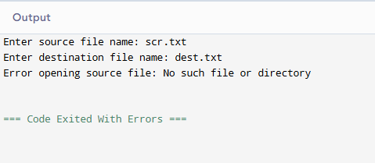

EXERCISE 4
CPU SCHEDULING - FIRST COME FIRST SERVE (FCFS)
PROGRAM:
#include <stdio.h>
int main()
{
int n, i;
int bt[20], at[20], wt[20], tat[20];
float total_wt = 0, total_tat = 0;
printf("Enter number of processes: ");
scanf("%d", &n);
printf("Enter Arrival Time and Burst Time for each process:\n");
for (i = 0; i < n; i++) {
printf("P%d - Arrival Time: ", i + 1);
scanf("%d", &at[i]);
printf("P%d - Burst Time: ", i + 1);
scanf("%d", &bt[i]);
}
int completion_time = 0;
printf("\nProcess\tAT\tBT\tWT\tTAT\n");
for (i = 0; i < n; i++) {
if (completion_time < at[i])
completion_time = at[i];
wt[i] = completion_time - at[i];
completion_time += bt[i];
tat[i] = completion_time - at[i];
total_wt += wt[i];
total_tat += tat[i];
printf("P%d\t%d\t%d\t%d\t%d\n", i + 1, at[i], bt[i], wt[i], tat[i]);
}
printf("\nAverage Waiting Time = %.2f\n", total_wt / n);
printf("Average Turnaround Time = %.2f\n", total_tat / n);
return 0;
}
OUTPUT:
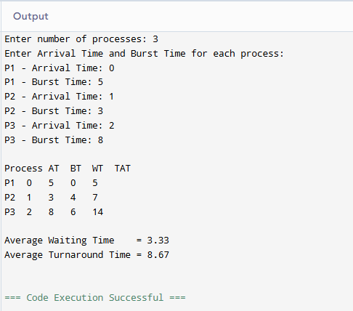

EXERCISE 5

CPU SCHEDULING - SHORTEST JOB FIRST (SJF), NON-PREEMPTIVE

PROGRAM:

#include <stdio.h>

int main()

{

int n, i;

int bt[20], at[20], wt[20], tat[20], done[20];

float total_wt = 0, total_tat = 0;

int completed = 0, current_time = 0;

printf("Enter number of processes: ");

scanf("%d", &n);

printf("Enter Arrival Time and Burst Time for each process:\n");

for (i = 0; i < n; i++) {

printf("P%d - Arrival Time: ", i + 1);

scanf("%d", &at[i]);

printf("P%d - Burst Time: ", i + 1);

scanf("%d", &bt[i]);

done[i] = 0;

}

while (completed != n) {

int idx = -1;

int min_bt = 1000000;

for (i = 0; i < n; i++) {

if (!done[i] && at[i] <= current_time) {

if (bt[i] < min_bt) {

min_bt = bt[i];

idx = i;

}

}

}

if (idx == -1)

{

current_time++;

continue;

}

wt[idx] = current_time - at[idx];

current_time += bt[idx];

tat[idx] = current_time - at[idx];

done[idx] = 1;

completed++;

}

printf("\nProcess\tAT\tBT\tWT\tTAT\n");

for (i = 0; i < n; i++) {

total_wt += wt[i];

total_tat += tat[i];

printf("P%d\t%d\t%d\t%d\t%d\n", i + 1, at[i], bt[i], wt[i], tat[i]);

}

printf("\nAverage Waiting Time = %.2f\n", total_wt / n);

printf("Average Turnaround Time = %.2f\n", total_tat / n);

return 0;

}

OUTPUT:



EXERCISE 6

CPU Scheduling - Round Robin

PROGRAM:

/* Program 5: Round Robin CPU Scheduling

Aim: Simulate Round Robin scheduling with a given time quantum and

compute waiting time & turnaround time. */

#include <stdio.h>

int main()

{

int n, i, tq;

int bt[20], at[20], rem_bt[20], wt[20], tat[20];

float total_wt = 0, total_tat = 0;

printf("Enter number of processes: ");

scanf("%d", &n);

printf("Enter Arrival Time and Burst Time for each process:\n");

for (i = 0; i < n; i++) {

printf("P%d - Arrival Time: ", i + 1);

scanf("%d", &at[i]);

printf("P%d - Burst Time: ", i + 1);

scanf("%d", &bt[i]);

rem_bt[i] = bt[i];

}

printf("Enter Time Quantum: ");

scanf("%d", &tq);

int current_time = 0, completed = 0;

int queue[1000], front = 0, rear = 0;

int in_queue[20] = {0};

/* Enqueue all processes that arrive at time 0 */

for (i = 0; i < n; i++) {

if (at[i] <= current_time && !in_queue[i]) {

queue[rear++] = i;

in_queue[i] = 1;

}

}

while (completed != n) {

if (front == rear) {

/* Queue empty - advance time to next arrival */

current_time++;

for (i = 0; i < n; i++)

if (at[i] <= current_time && !in_queue[i] && rem_bt[i] > 0) {

queue[rear++] = i;

in_queue[i] = 1;

}

continue;

}

int idx = queue[front++];

if (rem_bt[idx] > tq) {

current_time += tq;

rem_bt[idx] -= tq;

} else {

current_time += rem_bt[idx];

wt[idx] = current_time - at[idx] - bt[idx];

tat[idx] = current_time - at[idx];

rem_bt[idx] = 0;

completed++;

}

/* Enqueue any new arrivals during this time slice (before re-adding idx) */

for (i = 0; i < n; i++)

if (at[i] <= current_time && !in_queue[i] && rem_bt[i] > 0) {

queue[rear++] = i;

in_queue[i] = 1;

}

/* Re-add current process at the back of the queue if not finished */

if (rem_bt[idx] > 0)

queue[rear++] = idx;

}

printf("\nProcess\tAT\tBT\tWT\tTAT\n");

for (i = 0; i < n; i++) {

total_wt += wt[i];

total_tat += tat[i];

printf("P%d\t%d\t%d\t%d\t%d\n", i + 1, at[i], bt[i], wt[i], tat[i]);

}

printf("\nAverage Waiting Time = %.2f\n", total_wt / n);

printf("Average Turnaround Time = %.2f\n", total_tat / n);

return 0;

}

OUTPUT:

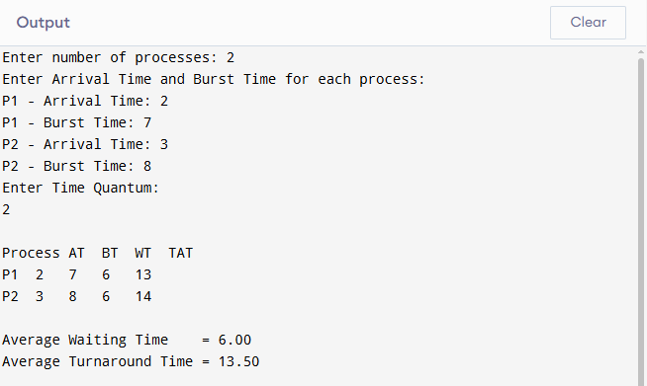

EXERCISE 7

CPU Scheduling - Priority Scheduling (Non-Preemptive)

PROGRAM:

/* Program 6: Priority Scheduling - Non-Preemptive

Aim: Simulate priority scheduling (lower number = higher priority) and

compute waiting time & turnaround time. */

#include <stdio.h>

int main()

{

int n, i;

int bt[20], at[20], pr[20], wt[20], tat[20], done[20];

float total_wt = 0, total_tat = 0;

int completed = 0, current_time = 0;

printf("Enter number of processes: ");

scanf("%d", &n);

printf("Enter Arrival Time, Burst Time and Priority (lower value = higher priority):\n");

for (i = 0; i < n; i++) {

printf("P%d - Arrival Time: ", i + 1);

scanf("%d", &at[i]);

printf("P%d - Burst Time: ", i + 1);

scanf("%d", &bt[i]);

printf("P%d - Priority: ", i + 1);

scanf("%d", &pr[i]);

done[i] = 0;

}

while (completed != n) {

int idx = -1;

int best_pr = 1000000;

/* Among arrived, unfinished processes, pick the one with the

highest priority (smallest priority number); break ties by

arrival time */

for (i = 0; i < n; i++) {

if (!done[i] && at[i] <= current_time) {

if (pr[i] < best_pr ||

(pr[i] == best_pr && idx != -1 && at[i] < at[idx])) {

best_pr = pr[i];

idx = i;

}

}

}

if (idx == -1) {

current_time++;

continue;

}

wt[idx] = current_time - at[idx];

current_time += bt[idx];

tat[idx] = current_time - at[idx];

done[idx] = 1;

completed++;

}

printf("\nProcess\tAT\tBT\tPriority\tWT\tTAT\n");

for (i = 0; i < n; i++) {

total_wt += wt[i];

total_tat += tat[i];

printf("P%d\t%d\t%d\t%d\t\t%d\t%d\n", i + 1, at[i], bt[i], pr[i], wt[i], tat[i]);

}

printf("\nAverage Waiting Time = %.2f\n", total_wt / n);

printf("Average Turnaround Time = %.2f\n", total_tat / n);

return 0;

}

OUTPUT:

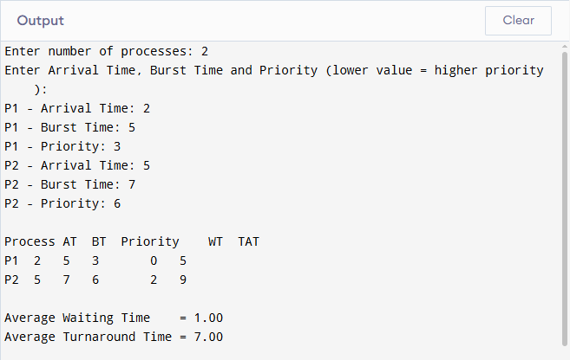

EXERCISE 8

Process Synchronization - Producer-Consumer Problem using Semaphores

PROGRAM:

/* Program 7: Producer-Consumer Problem using Semaphores and POSIX Threads

Aim: Solve the bounded-buffer producer-consumer problem using

pthreads and POSIX semaphores (sem_t) to ensure mutual exclusion

and correct synchronization. */

#include <stdio.h>

#include <stdlib.h>

#include <unistd.h>

#include <pthread.h>

#include <semaphore.h>

#define BUFFER_SIZE 5

#define ITEMS_TO_PRODUCE 10

int buffer[BUFFER_SIZE];

int in = 0, out = 0;

sem_t empty; /* counts empty slots */

sem_t full; /* counts filled slots */

pthread_mutex_t mutex; /* protects buffer access */

void *producer(void *arg)

{

int item;

for (item = 1; item <= ITEMS_TO_PRODUCE; item++) {

sem_wait(&empty); /* wait for an empty slot */

pthread_mutex_lock(&mutex); /* enter critical section */

buffer[in] = item;

printf("Producer produced item %d at slot %d\n", item, in);

in = (in + 1) % BUFFER_SIZE;

pthread_mutex_unlock(&mutex); /* leave critical section */

sem_post(&full); /* signal a new filled slot */

usleep(100000); /* simulate production time */

}

return NULL;

}

void *consumer(void *arg)

{

int item;

for (int count = 1; count <= ITEMS_TO_PRODUCE; count++) {

sem_wait(&full); /* wait for a filled slot */

pthread_mutex_lock(&mutex); /* enter critical section */

item = buffer[out];

printf("\tConsumer consumed item %d from slot %d\n", item, out);

out = (out + 1) % BUFFER_SIZE;

pthread_mutex_unlock(&mutex); /* leave critical section */

sem_post(&empty); /* signal a new empty slot */

usleep(150000); /* simulate consumption time */

}

return NULL;

}

int main()

{

pthread_t prod_thread, cons_thread;

sem_init(&empty, 0, BUFFER_SIZE); /* initially all slots empty */

sem_init(&full, 0, 0); /* initially no slots filled */

pthread_mutex_init(&mutex, NULL);

pthread_create(&prod_thread, NULL, producer, NULL);

pthread_create(&cons_thread, NULL, consumer, NULL);

pthread_join(prod_thread, NULL);

pthread_join(cons_thread, NULL);

sem_destroy(&empty);

sem_destroy(&full);

pthread_mutex_destroy(&mutex);

printf("\nAll items produced and consumed successfully.\n");

return 0;

}

OUTPUT:

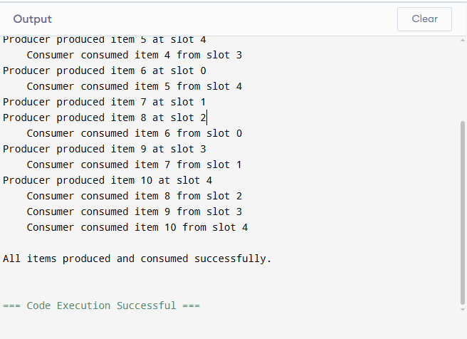

EXERCISE 9

PROCESS SYNCHRONIZATION - DINING PHILOSOPHERS PROBLEM USING SEMAPHORES

PROGRAM:

/* Program 8: Dining Philosophers Problem using Semaphores and POSIX Threads

Aim: Solve the Dining Philosophers problem avoiding deadlock by

allowing at most (N-1) philosophers to try to pick up forks at

the same time, using a counting semaphore. */

#include <stdio.h>

#include <stdlib.h>

#include <unistd.h>

#include <pthread.h>

#include <semaphore.h>

#define N 5 /* number of philosophers / forks */

#define MEALS 3 /* number of times each philosopher eats */

sem_t forks[N]; /* one semaphore (binary) per fork */

sem_t room; /* allows at most N-1 philosophers to sit,

preventing circular-wait deadlock */

void think(int id)

{

printf("Philosopher %d is thinking.\n", id);

usleep(100000);

}

void eat(int id)

{

printf("Philosopher %d is eating.\n", id);

usleep(100000);

}

void *philosopher(void *arg)

{

int id = *(int *)arg;

int left = id;

int right = (id + 1) % N;

for (int m = 0; m < MEALS; m++) {

think(id);

sem_wait(&room); /* enter the "room" (max N-1 at a time) */

sem_wait(&forks[left]); /* pick up left fork */

printf("Philosopher %d picked up left fork %d\n", id, left);

sem_wait(&forks[right]); /* pick up right fork */

printf("Philosopher %d picked up right fork %d\n", id, right);

eat(id);

sem_post(&forks[right]); /* put down right fork */

sem_post(&forks[left]); /* put down left fork */

printf("Philosopher %d put down both forks.\n", id);

sem_post(&room); /* leave the room */

}

return NULL;

}

int main()

{

pthread_t phil[N];

int ids[N];

for (int i = 0; i < N; i++)

sem_init(&forks[i], 0, 1); /* each fork starts available */

sem_init(&room, 0, N - 1); /* only N-1 philosophers allowed in */

for (int i = 0; i < N; i++) {

ids[i] = i;

pthread_create(&phil[i], NULL, philosopher, &ids[i]);

}

for (int i = 0; i < N; i++)

pthread_join(phil[i], NULL);

for (int i = 0; i < N; i++)

sem_destroy(&forks[i]);

sem_destroy(&room);

printf("\nAll philosophers have finished eating. No deadlock occurred.\n");

return 0;

}

OUTPUT:

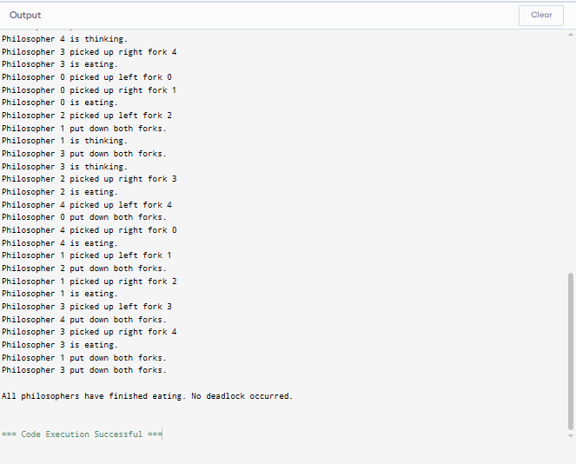

PROGRAM 10

DEADLOCK AVOIDANCE - BANKER'S ALGORITHM

PROGRAM:

/* program 9: banker's algorithm for deadlock avoidance

aim: implement the banker's algorithm to (a) check if the system is

in a safe state and print a safe sequence, and (b) process a

resource request from a process using the safety algorithm. */

#include <stdio.h>

#define p 5 /* number of processes */

#define r 3 /* number of resource types */

int allocation[p][r];

int max[p][r];

int need[p][r];

int available[r];

void calculate_need()

{

int i, j;

for (i = 0; i < p; i++)

for (j = 0; j < r; j++)

need[i][j] = max[i][j] - allocation[i][j];

}

/* returns 1 and fills safe_seq[] if the system is in a safe state */

int is_safe(int safe_seq[])

{

int work[r];

int finish[p] = {0};

int i, j, count = 0;

for (i = 0; i < r; i++)

work[i] = available[i];

while (count < p) {

int found = 0;

for (i = 0; i < p; i++) {

if (!finish[i]) {

int can_allocate = 1;

for (j = 0; j < r; j++) {

if (need[i][j] > work[j]) {

can_allocate = 0;

break;

}

}

if (can_allocate) {

for (j = 0; j < r; j++)

work[j] += allocation[i][j];

safe_seq[count++] = i;

finish[i] = 1;

found = 1;

}

}

}

if (!found)

return 0; /* no process could proceed -> unsafe */

}

return 1;

}

/* attempts to grant a resource request from process p_id.

returns 1 if granted, 0 if the request must be denied. */

int request_resources(int p_id, int request[r])

{

int i;

int safe_seq[p];

/* step 1: request must not exceed the process's declared need */

for (i = 0; i < r; i++) {

if (request[i] > need[p_id][i]) {

printf("error: process p%d has exceeded its maximum claim.\n", p_id);

return 0;

}

}

/* step 2: request must not exceed currently available resources */

for (i = 0; i < r; i++) {

if (request[i] > available[i]) {

printf("process p%d must wait; resources are not available.\n", p_id);

return 0;

}

}

/* step 3: tentatively allocate and check if the resulting state is safe */

for (i = 0; i < r; i++) {

available[i] -= request[i];

allocation[p_id][i] += request[i];

need[p_id][i] -= request[i];

}

if (is_safe(safe_seq)) {

printf("request can be granted safely.\nnew safe sequence: ");

for (i = 0; i < p; i++)

printf("p%d ", safe_seq[i]);

printf("\n");

return 1;

} else {

/* roll back — the request would leave the system unsafe */

for (i = 0; i < r; i++) {

available[i] += request[i];

allocation[p_id][i] -= request[i];

need[p_id][i] += request[i];

}

printf("request denied: granting it would leave the system in an unsafe state.\n");

return 0;

}

}

int main()

{

int i, j;

printf("enter allocation matrix (%d processes x %d resources):\n", p, r);

for (i = 0; i < p; i++) {

printf("p%d: ", i);

for (j = 0; j < r; j++)

scanf("%d", &allocation[i][j]);

}

printf("enter maximum matrix (%d processes x %d resources):\n", p, r);

for (i = 0; i < p; i++) {

printf("p%d: ", i);

for (j = 0; j < r; j++)

scanf("%d", &max[i][j]);

}

printf("enter available resources vector (%d resources):\n", r);

for (j = 0; j < r; j++)

scanf("%d", &available[j]);

calculate_need();

printf("\nneed matrix:\n");

for (i = 0; i < p; i++) {

printf("p%d: ", i);

for (j = 0; j < r; j++)

printf("%d ", need[i][j]);

printf("\n");

}

int safe_seq[p];

if (is_safe(safe_seq)) {

printf("\nsystem is in a safe state.\nsafe sequence: ");

for (i = 0; i < p; i++)

printf("p%d ", safe_seq[i]);

printf("\n");

} else {

printf("\nsystem is in an unsafe state (deadlock may occur).\n");

return 0;

}

/* Demonstrate a resource request */

int p_id;

int request[R];

printf("\nEnter process number requesting resources: ");

scanf("%d", &p_id);

printf("Enter request vector (%d resources): ", R);

for (j = 0; j < R; j++)

scanf("%d", &request[j]);

request_resources(p_id, request);

return 0;

}

OUTPUT:

