PayNotify Project Architecture / System Design

1. Project Goal
The purpose of this system is to detect successful UPI payments in near real time by using a mobile app that listens to payment notifications and sends them to the backend, which then validates the payment and updates the web application instantly.
This is useful for cases where:
- QR is generated on web
- customer pays from any UPI app
- merchant mobile receives payment notification
- backend verifies payment
- web screen updates automatically

2. High-Level Architecture
There are 3 main components:

A. Web Frontend
Used by merchant/operator to:
- generate QR
- display QR to customer
- listen for live payment status updates by WebSocket
- show success/failure instantly

B. Spring Boot Backend
Acts as the central system to:
- generate QR and payment records
- store transaction state in database
- receive notification data from Flutter app
- validate incoming payment notification
- publish real-time updates using WebSocket

C. Flutter Mobile App
Installed on merchant mobile device to:
- listen to payment notifications from GPay/PhonePe/Paytm/bank apps
- receive active payment ID from backend
- send notification content to backend for validation

3. Core Architecture Diagram
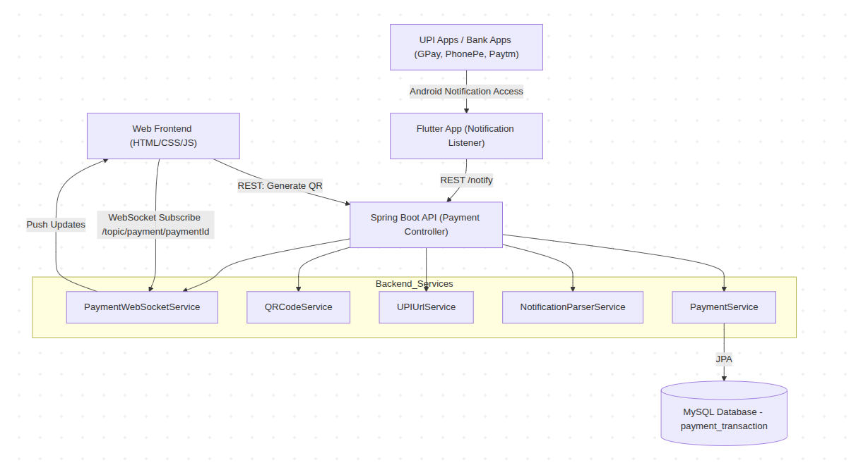

4. Main Functional Flow

Phase 1: QR Generation
- User opens web frontend
- User enters merchant name, UPI ID, amount
- Web calls backend API:
POST /api/payment/qr/generate

4.Backend:
- creates paymentId
- creates transactionRef
- creates note / validation token
- builds UPI URL
- generates QR image
- saves transaction with PENDING

5.Backend returns:
- paymentId
- transactionRef
- qrImageBase64
6.Web shows QR
7. Web subscribes to:
/topic/payment/{paymentId}
8.Backend also broadcasts active payment to Flutter:
/topic/payment/active

Phase 2: Flutter Receives Active Payment
- Flutter app connects to backend WebSocket
- Flutter subscribes to:
/topic/payment/active
3.When QR is created, backend sends latest active payment
- Flutter stores:
  - currentPaymentId
Fallback:
- if no paymentId is received through WebSocket, Flutter fetches:
GET /api/payment/latest-pending

Phase 3: Payment Notification Capture
- Customer makes payment using UPI app
- Merchant mobile receives payment notification
- Flutter app reads notification text using Android Notification Access
- Flutter filters notifications:
  - package name
  - strong payment keywords
  - weak payment keywords
- If likely payment:
  - builds notify request
  - sends to backend:
POST /api/payment/notify

Payload example:
{
"paymentId": "PAY1776492638449",
"packageName": "com.google.android.apps.nbu.paisa.user",
"title": "Vighnesh Vinod Bagal paid you ₹1.00",
"message": "PADMPAY-TXN123412+ORD123 PADMPAY-TXN123412+ORD123"
}

Phase 4: Backend Validation
Backend PaymentService.processNotification():
- receives payment notification
- finds payment by paymentId
- parses text using NotificationParserService
- extracts:
  - amount
  - UTR
  - payer name
  - transaction token/reference
- compares with DB record
Validation logic:
- primary: validation token / note / transactionRef match
- secondary: amount match
- optional: UTR / payer support

If matched:
- update payment status to SUCCESS
- save raw message
- save payer name
- save UTR
- update timestamp

Phase 5: Real-Time UI Update
- After successful DB update, backend publishes:
/topic/payment/{paymentId}
2.Web frontend receives event instantly
3.UI updates to:
  - SUCCESS
  - show success message
  - stop waiting for payment

