Supplier Packing List Pre Fill Walkthrough
Illustrated local proof of concept | Example document pdf-3.pdf | 2 October 2026
This guide shows how a supplier uploads a packing-list PDF, checks the proposed shipment details, reviews uncertain fields, and downloads a reviewed draft. The current application runs locally. Finishing a review does not submit a shipment or post anything to an ERP.

The example document
The sample packing list prints a DATE of 04/11/2025, a ship-via value of DPL/LOGIFISH, lot 9399 and a quantity of 150. It does not clearly label the date as a ship date or print a unit for the quantity. The application therefore asks the supplier to confirm those details instead of treating the document as fully verified.
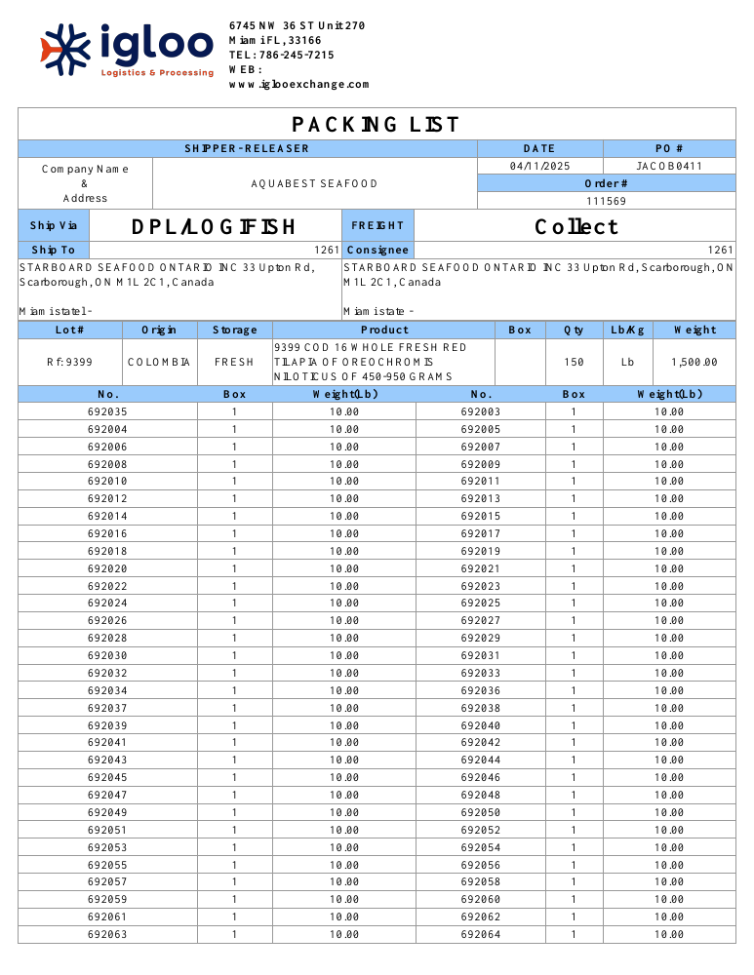
Figure 1. Page 1 of the two-page sample packing list.

1 Upload the document
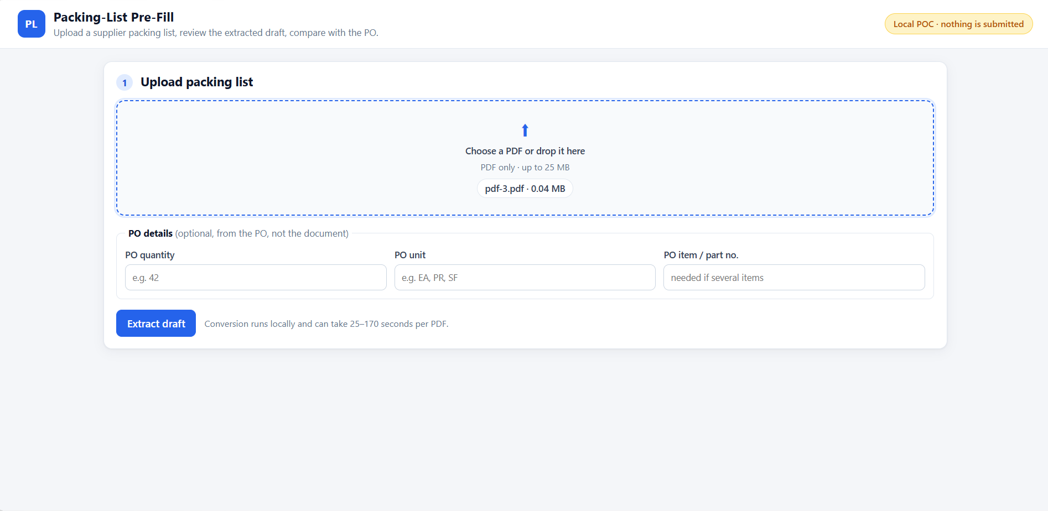
Figure 2. The supplier selects pdf-3.pdf. Purchase-order details are optional.
The page accepts a PDF up to 25 MB. PO quantity, unit and item number may be entered if available; they are comparison inputs from the purchase order, not values extracted from the packing list. The supplier presses Extract draft to start local processing.

2 Wait for extraction
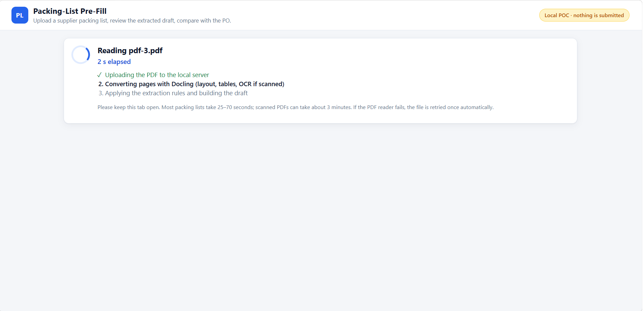
Figure 3. The browser shows the elapsed time and conversion stage.
Docling reads the PDF layout and tables. OCR is used for scanned PDFs. Python rules then find labels, quantities, carriers and identifiers and build a draft with source evidence. The model runs locally after its files have been downloaded; a conversion may take tens of seconds or several minutes. A native PDF-reader failure is retried once in a fresh child process.

3 Review the extracted draft
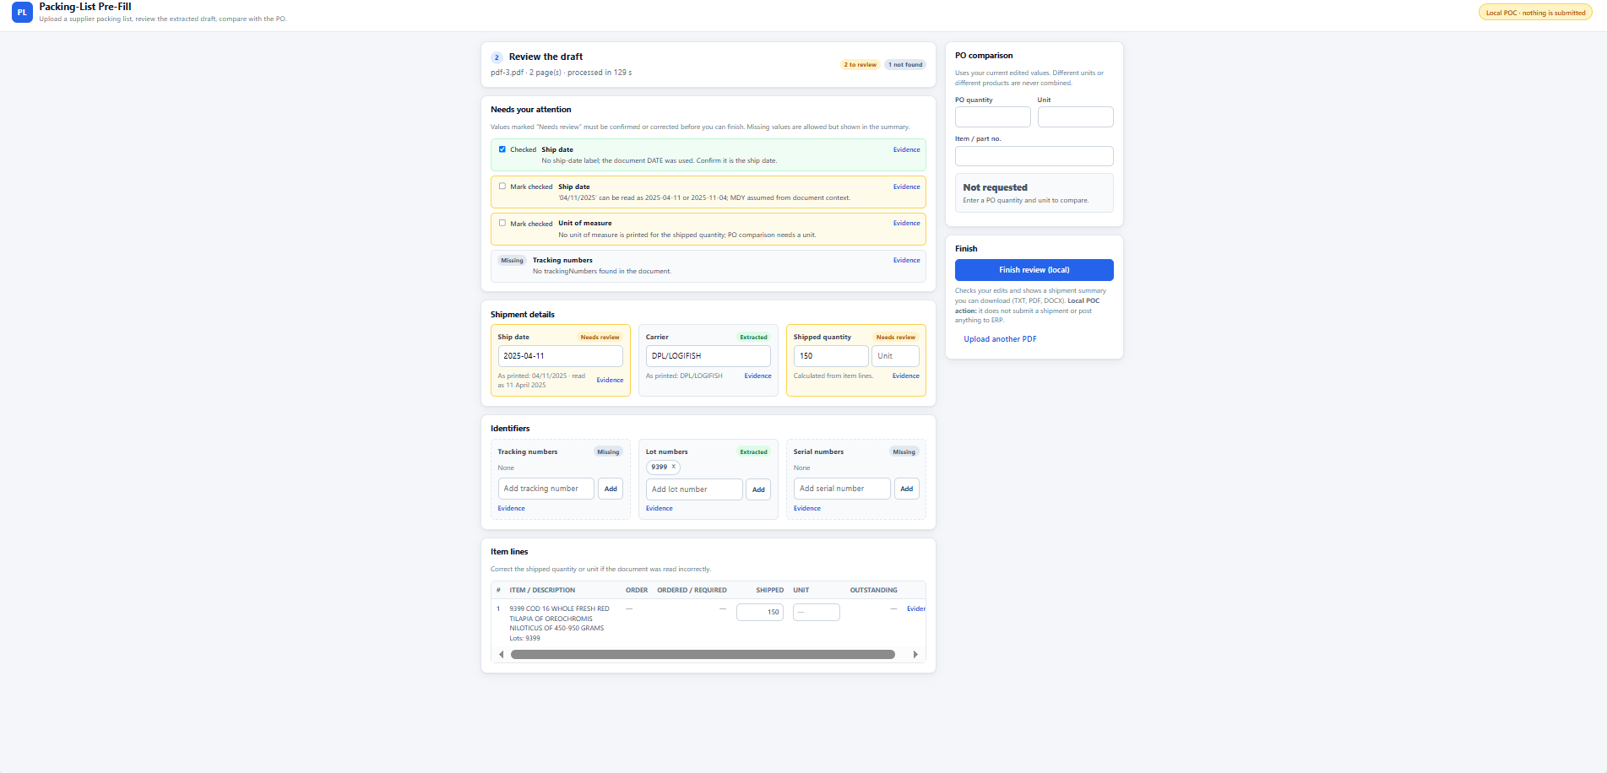
Figure 4. Extracted shipment fields, review flags, identifier lists, item line and optional PO panel.
The application proposes carrier DPL/LOGIFISH, shipped quantity 150 and lot 9399. It leaves tracking and serial numbers empty because they were not found. The ship date is shown as a candidate, while two warnings explain that the document only says DATE and that 04/11/2025 may mean 11 April or 4 November. The missing unit also needs attention. The supplier can edit the fields, add identifiers and mark flagged values checked.
Field | Draft value | Why the supplier checks it
Ship date | 2025-04-11 | Inferred from DATE, not a Ship Date label; numeric order is ambiguous.
Carrier | DPL/LOGIFISH | Read from Ship Via; supplier may correct the carrier.
Quantity and unit | 150, unit missing | 150 was read; the unit must be supplied if known.
Lot number | 9399 | Read from the Lot column, separate from tracking and order numbers.

4 Inspect source evidence
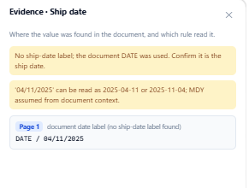
Figure 5. Evidence for the date shows the source label and both possible readings.
The Evidence link shows the source page, text and rule behind a proposed value. Here it shows DATE / 04/11/2025 on page 1 and explains why a human needs to confirm whether this is a ship date. Evidence helps the reviewer correct the draft without treating a plausible guess as a confirmed fact.

5 Finish review and download
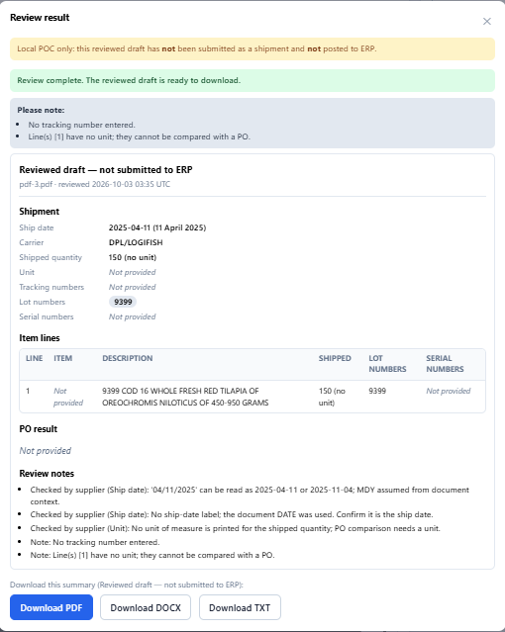
Figure 6. The final screen presents a readable reviewed draft with PDF, DOCX and TXT exports.
After required flags are checked, Finish review creates a local summary from the supplier’s current edits. It lists shipment details, item lines, missing values, PO result if supplied, and review notes. The PDF, Word and text downloads carry the same “Reviewed draft - not submitted to ERP” meaning. The structured JSON remains available inside the application for later backend integration, but is not shown in this supplier-facing result.

What the current application contains
Part | Role
Docling and Python extraction | Read PDF pages, layout, tables and OCR when needed; apply field rules.
Isolated conversion | Run each PDF in a child process, retry once on failure and return a clear error.
Browser review | Show evidence and warnings; let the supplier correct shipment fields.
PO check | Compare quantity only when usable PO context and matching units/items are present.
Exports | Build a readable summary and PDF, DOCX and TXT reviewed drafts.

Scope and next integration step
This is a local PDF proof of concept. It does not yet upload images, authenticate suppliers, keep reviews after a server restart, submit a shipment, or connect to SAP, Infor LN or another ERP. The production supplier portal would supply the purchase-order context, store the supplier’s corrections and handle submission through its own backend. Samhit’s image work is a separate planned integration.

Validation and limits
The PDF pipeline converted seven development documents in the final recorded run. At the later UI checkpoint, 66 automated tests passed, and browser checks covered real PDF uploads, editing and exports. These documents were used during rule development, so the result is not an accuracy guarantee for new suppliers’ documents. Scans may take longer, ambiguous fields need human review, and the native PDF-parser fault is contained by a retry rather than fixed.

How the work is organized
app.py extracts one PDF from the command line. layout.py configures Docling and keeps page positions; extractor.py and fields.py apply rules to identify dates, carriers, quantities, lots, serials and tracking numbers. isolation.py gives each conversion a separate child process with a 600-second default timeout and one retry. evaluate.py converts the five labelled samples and scores them. The browser workflow uses ui_server.py, review.py and summary_export.py for upload, edits and local exports. The web folder contains plain HTML, CSS and JavaScript.

Technical overview from the project README

Models and where they run
Docling 2.132.0 runs on the local CPU. The layout and table models are used on every PDF. When the preliminary text-layer check finds fewer than 20 characters on any page, OCR is enabled for the document. The models are cached on this Windows machine; first-time downloads and possible revision checks may contact Hugging Face. There is no LLM call, external inference API or ERP API in this POC. Fully offline operation has not been verified.
Stage | Model | Stored on this machine | Size
Layout | Docling Layout Heron | Hugging Face cache | 163.71 MB
Tables | TableFormer accurate | Hugging Face cache | 202.90 MB
OCR | RapidOCR detection, recognition and angle models | .venv site-packages | 30.67 MB

The README reports 366.61 MB of checkpoints used for a text PDF and about 397.35 MB for a scanned PDF. The complete model folders occupy 566.47 MB on this machine, including unused checkpoint copies. These are disk sizes, not memory requirements.

Measured processing time
The final validation used a four-core Intel i5 Windows laptop with 7.8 GB RAM and cached models. Each PDF loaded models in its own process. The rule extraction step took only about 0.02–0.04 seconds per PDF; model loading and Docling conversion account for nearly all of the time.
PDF | Pages | OCR | Wall time
pdf-1 | 5 | No | 39.6 s
pdf-2 | 1 | No | 24.7 s
pdf-3 | 2 | No | 72.6 s
pdf-4 | 2 | No | 33.2 s
pdf-5 | 3 | No | 45.2 s
unseen-1 | 6 | No | 67.7 s
unseen-2 | 6 | Yes | 168.9 s

Validation and handoff
The final recorded run converted all seven PDFs on the first attempt, with no Windows crash events. The five labelled PDFs had 20 checks verified from the project brief: 19 correct and one correctly flagged for review. Another 41 labels were proposed by reading those PDFs: 36 correct against those proposed labels and five correctly flagged. None were scored incorrect or missing. These results do not establish accuracy on new supplier documents: the rules were developed on the original five, and the two later PDFs were used to repair missed fields.

What has been tested
At the latest UI checkpoint, 66 automated tests passed, covering rules, process isolation, edited-value review, exports and the local HTTP API. Browser checks covered real PDF uploads, editing and export contents. The retry and error path was simulated in isolation tests; the final seven-PDF run needed no retry. The source PDF shown in this guide is pdf-3.pdf, whose ambiguous date and missing unit demonstrate why supplier review remains necessary.

Current limits and next step
The local browser accepts PDFs up to 25 MB and processes one upload at a time. It does not accept images, provide supplier login, persist jobs after server restart, or submit to SAP, Infor LN or another ERP. A native Docling PDF-parser access violation was observed in earlier runs; isolation contains a crash through one retry but does not remove its cause. A PDF that fails both attempts returns a conversion error. The next integration step is to let the portal backend supply PO context, store reviewed values and perform the actual shipment submission.

Run and inspect the POC
On the working Windows setup, activate the Python 3.11 virtual environment and run .\.venv\Scripts\python.exe ui_server.py from C:\packing-list-poc. Open http://127.0.0.1:8765/. The project README.md contains the pinned dependency list, full command-line options and JSON contract. The code also saves Docling Markdown during evaluation for inspection; extraction rules use page and text positions, not the Markdown as their input.
Source material: supplied project README, five browser screenshots and the supplied pdf-3.pdf sample. Facts and timings reflect the recorded 2 October 2026 validation on the project machine.

