|  |
| --- |
| R AKSHAY CHELLIAH |

# CONTACT

## **📱 PHONE 📧 EMAIL**

+919384657590 akshaychelliah@gmail.com

# PROFILE

Third year Smart Manufacturing student at IIITDM Kancheepuram with a passion for integrating machine learning and Al into materials science. Proficient in atomistic modeling, deep neural networks, and hybrid simulations, specializing in grain boundaries. Actively seeking opportunities in the material science field to contribute ML and Al expertise, advancing material understanding and driving innovation.

***SKILLS***

*GRAIN BOUNDARY SIMULATION*

*DEEP NEURAL NETWORK*

*HYBRID MONTE CARLO AND MOLECULAR DYNAMICS(MC/MD) SIMULATIONS*

*DFT CALCULATION*

*PROBLEM SOLVING*

# education

## ***BACHELOR OF TECHNOLOGY IIITDM Kancheepuram |2025***

|  |  |  |  |  |  |
| --- | --- | --- | --- | --- | --- |
| Semester | I | II | III | IV | V |
| GPA | 8.48 | 8.12 | 8.53 | 8.64 | 8.56 |

## CGPA (TILL DATE) **8.47, Ranked 5th in the Department**

## ***DAV BOYS MOGAPPAIR, Chennai |2020***

## 12th Board Score **90%**

# PROJECTS

## ***GRAIN BOUNDARY PROPERTY PREDICTION USING DEEP LEARNING (GENETIC ALGORITHM GUIDED)***

## ***(JAN 2024-PRESENT)***

Utilizing hybrid MC/MD simulations, genetic algorithms, and deep neural networks, we achieve rapid prediction of grain boundary (GB) properties in a 7D space, enabling the construction of complexion diagrams. This approach significantly accelerates predictions compared to atomistic simulations, providing insights into millions of distinct GBs, including asymmetric-tilt and mixed tilt-twist GBs crucial in understanding real polycrystals' performance limitations.

## ***GRAIN BOUNDARY STRUCTURES AND ENERGITICS PREDICTION***

## ***(JUL 2023- JAN 2024)***

The research aims to accurately predict grain boundary (GB) structures and energetics using an artificial-neural-network (ANN) interatomic potential. Large amounts of density-functional-theory (DFT) data, including pointdefects, surfaces, and GBs, to be used to train the ANN potential. This approach could significantly reduce computational costs and improve the prediction accuracy of GB structures

*** 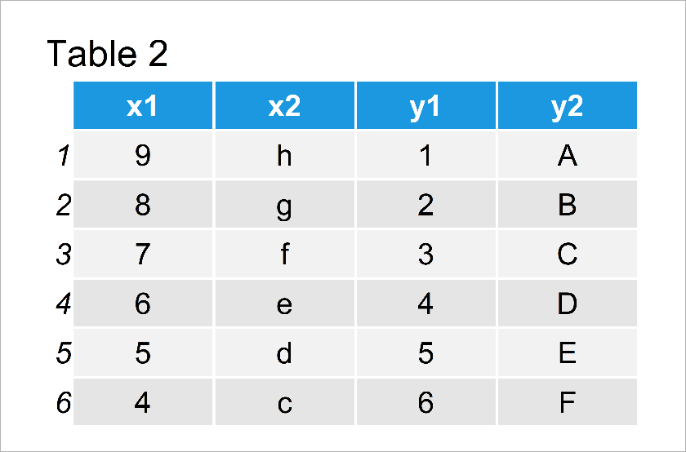COURSES***

***ATOMISTIC MODELING OF MATERIALS***

***(JAN 2024 – PRESENT)***

*It explores the theoretical underpinnings and practical applications of density functional theory (DFT), including DFT calculations and functionals. Finally, it covers the use of DFT in predicting electronic structures and designing materials for device applications.*

***DESIGN WITH ADVANCED ENGINEERING MATERIALS***

***(JAN 2024 – PRESENT)***

*Covers the engineering design process, focusing on material selection and mechanical behaviors. It includes computer-aided selection, design with polymers and composites, addressing their deformation, fatigue, and fracture. Additionally, it explores designing with superalloys and advanced ceramics, emphasizing high-temperature performance and reliability.*

***ARTIFICIAL INTELLIGENCE (JAN 2024-PRESENT)***

*The AI course covers foundational concepts, search algorithms, game theory, logic, uncertainty, and their applications in real-world AI challenges, complemented by practical programming exercises.*

***OPTIMIZATION TECHNIQUES FOR MACHINE LEARNING***

***(JUL 2023-DEC 2023)***

*Encompasses categorization of optimization problems, techniques for both unconstrained and constrained optimization, gradient-based methods, stochastic optimization, and combinatorial strategies.*

***MATERIALS FOR ENGINEERS***

***(DEC 2021-JAN 2024)***

Delves into the classification and properties of engineering materials, processing of polymers, ceramics, composites, and their microstructure-property relationships. It also touches on the properties of electrical and magnetic materials, and introduces advanced materials and their application in design across various industries.

# LANGUAGES

## ***ENGLISH***

***HINDI***

***TAMIL***