Answers:

#1) create deployment file- deployment.yaml

apiVersion: apps/v1

kind: Deployment

metadata:

name: app-deployment

labels:

app: app

spec:

replicas: 2

selector:

matchLabels:

app: app

template:

metadata:

labels:

app: app

spec:

containers:

- name: app

image: sirfragalot/docker-demo:dcus

ports:

- containerPort: 80

Create service file: service.yaml

apiVersion: v1

kind: Service

metadata:

name: app-service

spec:

selector:

app: app

type: NodePort

ports:

- port: 8080

nodePort: 30080

#2) Create namespace test and deploy k8s cluster in it

deployment.yaml

apiVersion: apps/v1

kind: Deployment

metadata:

name: app-deployment

namespace: test

labels:

app: app

spec:

replicas: 2

selector:

matchLabels:

app: app

template:

metadata:

labels:

app: app

spec:

containers:

- name: app

image: sirfragalot/docker-demo:dcus

ports:

- containerPort: 80

Service.yaml

apiVersion: v1

kind: Service

metadata:

name: app-service

namespace: test

spec:

selector:

app: app

type: NodePort

ports:

- port: 8080

nodePort: 30080

#3) Expose deployment on local machine

Minikube is running on docker image and using docker driver so it is making tunnel to application port no to random port number as you can see in below screenshot.

We can access application on localhost:54304 url.

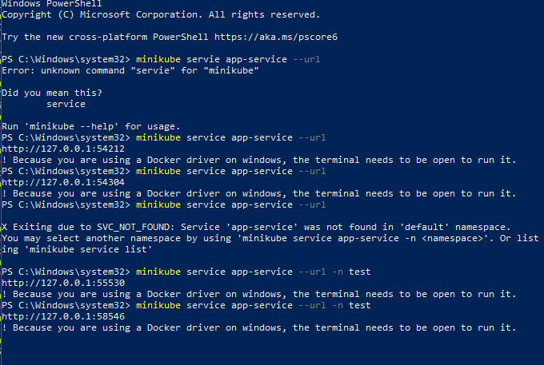

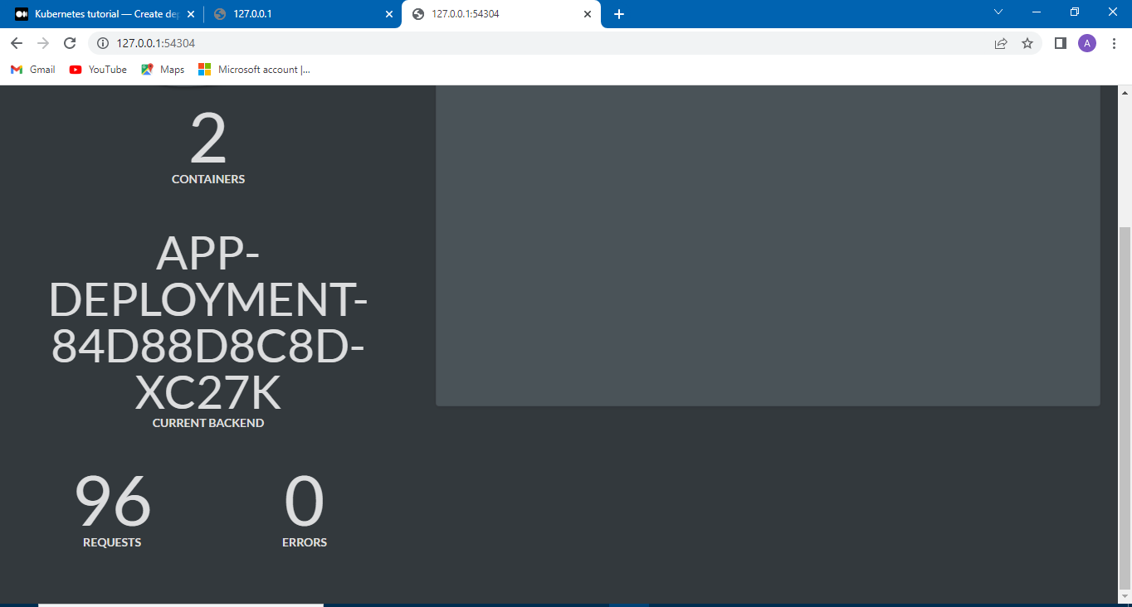

#4)Scale replicas upto 5.

Deployment.yaml

apiVersion: apps/v1

kind: Deployment

metadata:

name: app-deployment

namespace: test

labels:

app: app

spec:

replicas: 5

selector:

matchLabels:

app: app

template:

metadata:

labels:

app: app

spec:

containers:

- name: app

image: sirfragalot/docker-demo:dcus

ports:

- containerPort: 80

Service.yaml

apiVersion: v1

kind: Service

metadata:

name: app-service

namespace: test

spec:

selector:

app: app

type: NodePort

ports:

- port: 8080

nodePort: 30080

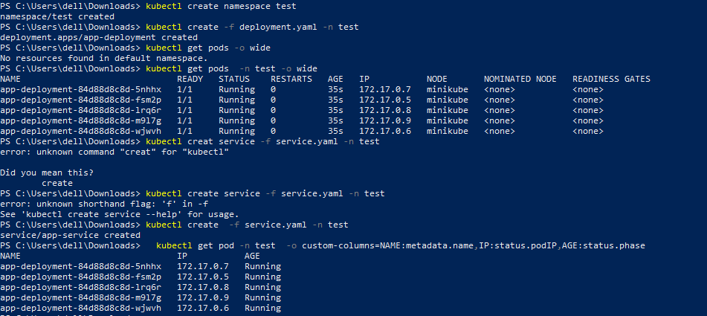

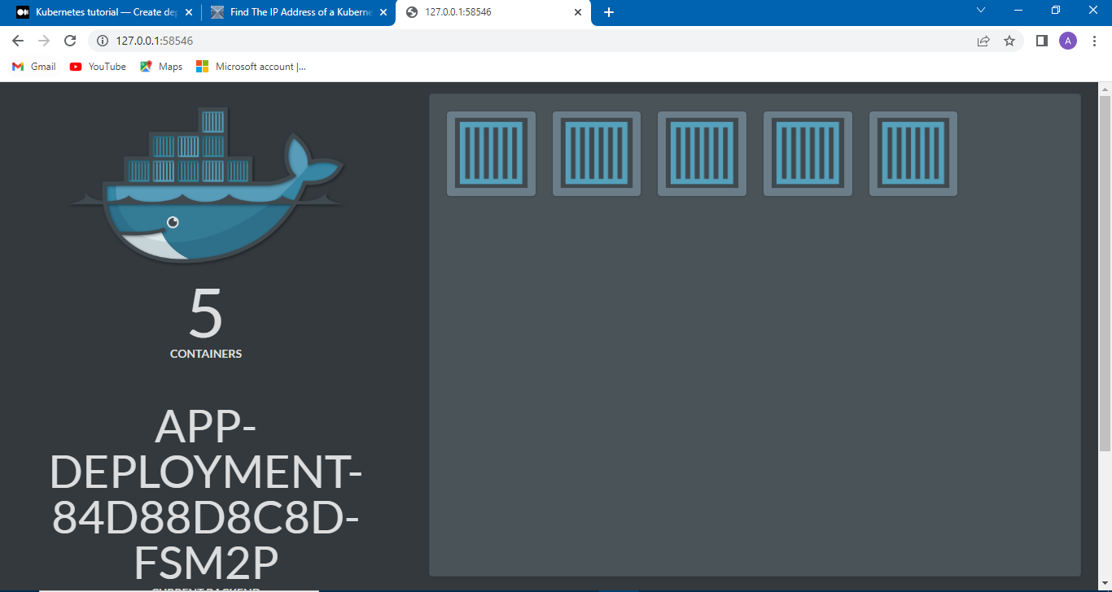

#5) show only pods Ips and health under the headers IP and Health.

kubectl get pod -n test -o custom-columns=NAME:metadata.name,IP:status.podIP,AGE:status.phase

