### HRIS/Data Extract Report

#### **Task:** Create an ADP connection on your Hire2Retire workflow. Connect to the SFTP using the key generated for the above connection. Drop a file in the folder specific to your flow.

**Common HR Systems**

An HR (Human Resources) system, also known as an HRIS (Human Resources Information System) or HRM (Human Resource Management) system, is a software application or suite of tools designed to streamline and automate various HR processes and tasks within an organization. It serves as a central repository of employee data, providing functionalities to manage employee information, track employee performance, and handle HR-related administrative tasks. Some Common HR systems that are supported in Hire2retire are ADP (Data Extract and API Integration), UltiPro, Oracle HCM, BambooHR, Paymaster, Zoho, Workday®,SAP SuccessFactors, Ceridian, Paycom, Deltek Costpoint, Paylocity, Infor HCM and iCIMS.

**Fetching data from the HR system**

Secure File Transfer Protocol (SFTP) is a file protocol for transferring large files over the web. Hire2Retire uses SFTP protocol to get files from the user. In API-based HR systems, Hire2retire fetch employee fields and their values from the API provided by the HR system.

Hire2Retire can fetch data from HR system using CSV file or API Integration:

* CSV File (Data Extract): Using CSV file Hire2Retire can fetch the data of Employees. While configuring the flow you will be asked to put the name and headers of the .csv file.
* For the HR systems that are based on API (BambooHR, ADP (API Integration)), we have 3 methods to fetch the data:
  + Initial one-time full load: You can select the Initial one-time full load checkbox if you want to receive an initial pull of the full report as soon as the flow is deployed.
  + Full Extract: If you have selected “Full Extract” then a full report for all the selected attributes from the employee attributes will be generated. This report will be generated on the basis of the type of polling interval selected.
  + Delta Extract:  If you have selected “Delta Extract” then whenever there is any update or change in any of the attributes, it will automatically pull the updated report within the selected intervals of time.

**Pushing a file to the RoboMQ SFTP server for further processing by your workflow**

FileZilla Client is a free and open-source FTP (File Transfer Protocol) software application. It provides an easy-to-use graphical user interface (GUI) for transferring files between a local computer and a remote server.

To push .csv files into the RoboMQ SFTP server, we need to set up FileZilla Client:

* Install FileZilla Client from your browser.
* Refer To set up new account on FileZilla to establish a new connection to connect with hire2retire. Here, a username, host and port will be provided on your connection's page.

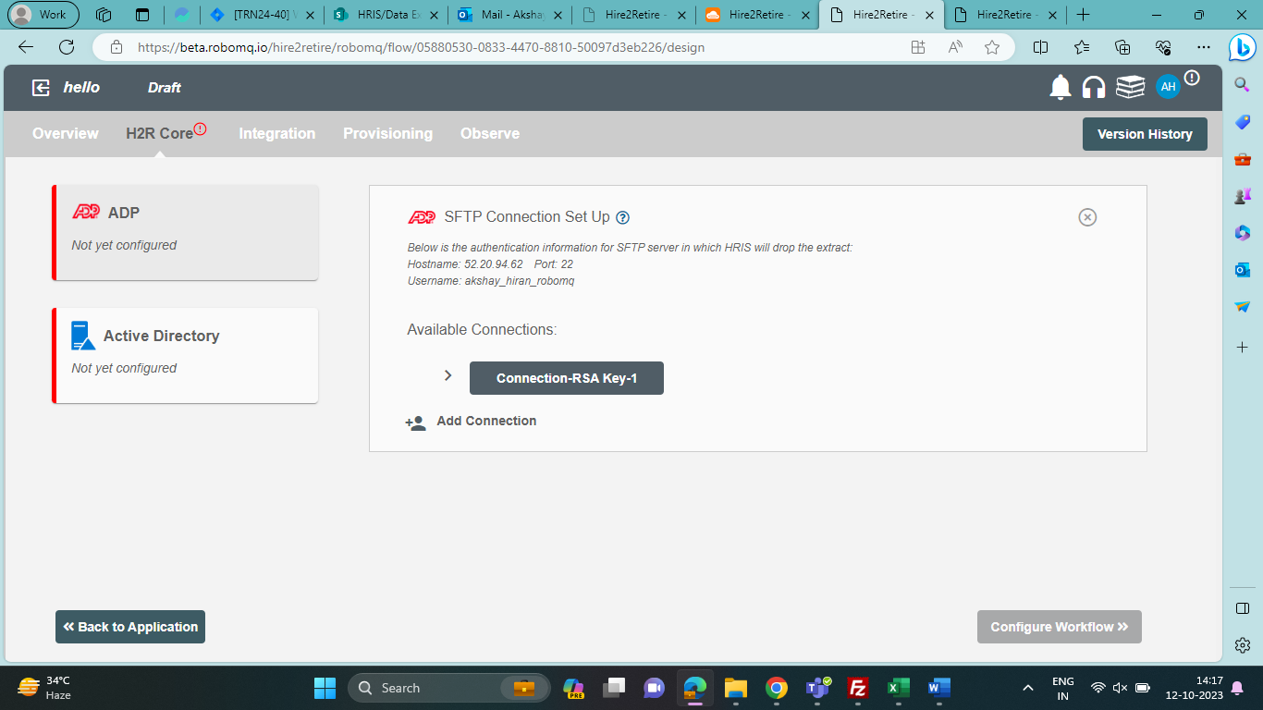

* After establishing the connection, you will be able to see the folder name in Filezilla, that you have filled on your connection page in Hire2retire.
* Go to the respective folder → Input → Drop your .csv file.

### Build a Workflow

Hire to Retire is a pre-packaged integration solution for managing employee lifecycle and provisioning their identity. Hire2Retire automates business processes that were once performed manually. Using Hire2Retire the onboarding and offboarding employee processes an be achieved automatically. With Hire2Retire HR and IT Teams will be freed up and will have have more time to focus on other core areas of their business.

## **1.Benefits of using Hire to Retire**

1. Enhance employee experience with a faster onboarding process
2. Save operational costs by automating manual system admin work
3. Avoid costly terminations by quickly removing employee access during offboarding
4. Enable single sign on to manage employee access effectively

***Note***: Please keep in mind the following points.

1. Never deploys flow on pod3, only use beta.
2. If the flow is unused, Make sure those flows are paused or delete them, because they cost us.

**Features :**

**2 Clone Flow**

It is the feature in which we can make a new flow from another existing flow, which is exactly similar to the existing flow but in draft state.

steps to be followed

1. Go to manage page.
2. Click on the more vert icon present on any flow card whichever’s clone you want to take.
3. Click on “Clone Flow”.
4. Write the name of the new flow.
5. Click on the “Create Workflow”.
6. Clone has been successfully made.

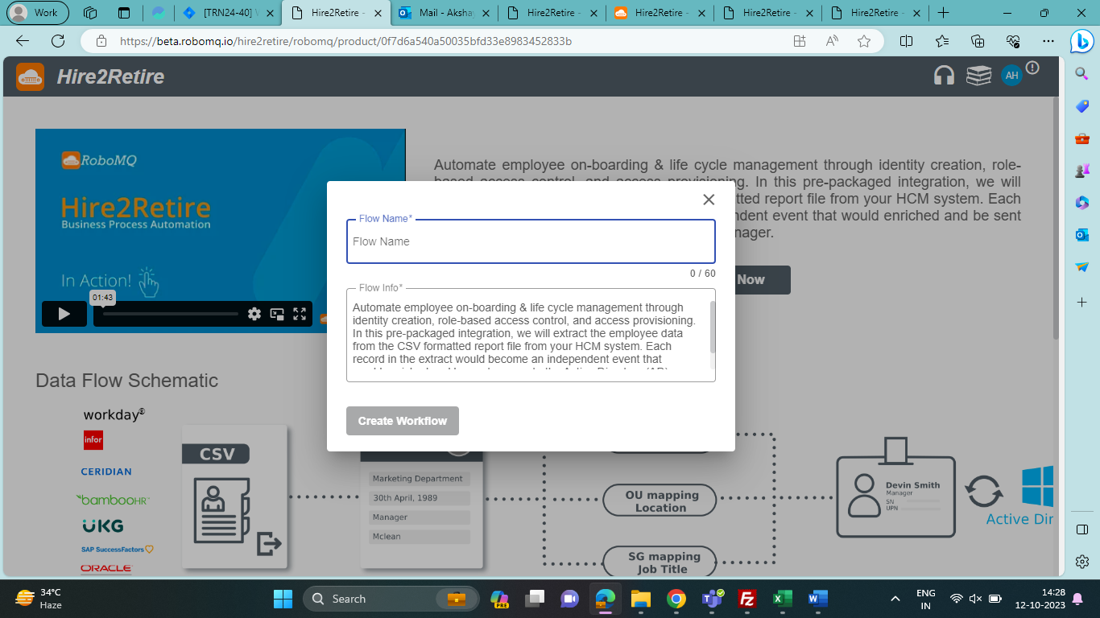

1. **Applications and Connections**

* **Applications**: When you start designing your Hire2Retire workflow, you can select your HRIS and Identity Management System from the Application Page.
* **HR System**: Hire2Retire supports the following HR Systems. By configuring the connection, you will enable RoboMQ to fetch your HR data using either SFTP or REST API.

1. [ADP](https://docs.robomq.io/hire2retire/Application/ADP/)
2. [UltiPro](https://docs.robomq.io/hire2retire/Application/UltiPro/)
3. [Oracle HCM](https://docs.robomq.io/hire2retire/Application/Oracle_HCM/)
4. [Bamboo HR](https://docs.robomq.io/hire2retire/Application/Bamboo_HR/)
5. [Workday®](https://docs.robomq.io/hire2retire/Application/Workday/)
6. [SAP Successfactors](https://docs.robomq.io/hire2retire/Application/SAP_Successfactors/)
7. [Ceridian](https://docs.robomq.io/hire2retire/Application/Ceridian/)
8. [iCIMS](https://docs.robomq.io/hire2retire/Application/iCIMS/)
9. [Infor HCM](https://docs.robomq.io/hire2retire/Application/Infor_HCM/)
10. [Paylocity](https://docs.robomq.io/hire2retire/Application/Paylocity/)
11. [Paycom (RSA Key Auth)](https://docs.robomq.io/hire2retire/Application/Paycom/)
12. [Paycom (Password)](https://docs.robomq.io/hire2retire/Application/Paycom-password/)
13. [Other HR Systems with Extract capability](https://docs.robomq.io/hire2retire/Get_Started/.Application/MFT.md)
14. [Deltek Costpoint Connection](https://docs.robomq.io/hire2retire/Application/Deltek_Costpoint/)
15. [Zoho](https://docs.robomq.io/hire2retire/Application/Zoho/)
16. [Paymaster](https://docs.robomq.io/hire2retire/Application/Paymaster/)

**Identity Management**: Hire2Retire supports the following options for Identity Management. Based on the HR data, Hire2Retire will make changes to the target Identity management system to provide a seamless sync between HR System and the AD system.

1. [On-prem (Active Directory)](https://docs.robomq.io/hire2retire/Scenario/Active_Directory/)
2. [Cloud-Only (Azure AD)](https://docs.robomq.io/hire2retire/Scenario/Azure_Active_Directory/)
3. [Hybrid](https://docs.robomq.io/hire2retire/Scenario/Hybrid/)

**Connections**: To allow Hire2Retire to get data from your HR System and to perform sync operations to your on-premises or Azure Active Directory, you will need to grant permissions to Hire2Retire for access to each system.

There are two connection tabs, one for the HR system and other for the Identity Manager system.

1. **How to upload sample CSV file**

Entering all the headers manually can be a tedious task. You can upload a sample CSV file from your device and all the header name in the CSV file will automatically added. The uploaded file should use the same delimiter which is selected in above menu item.

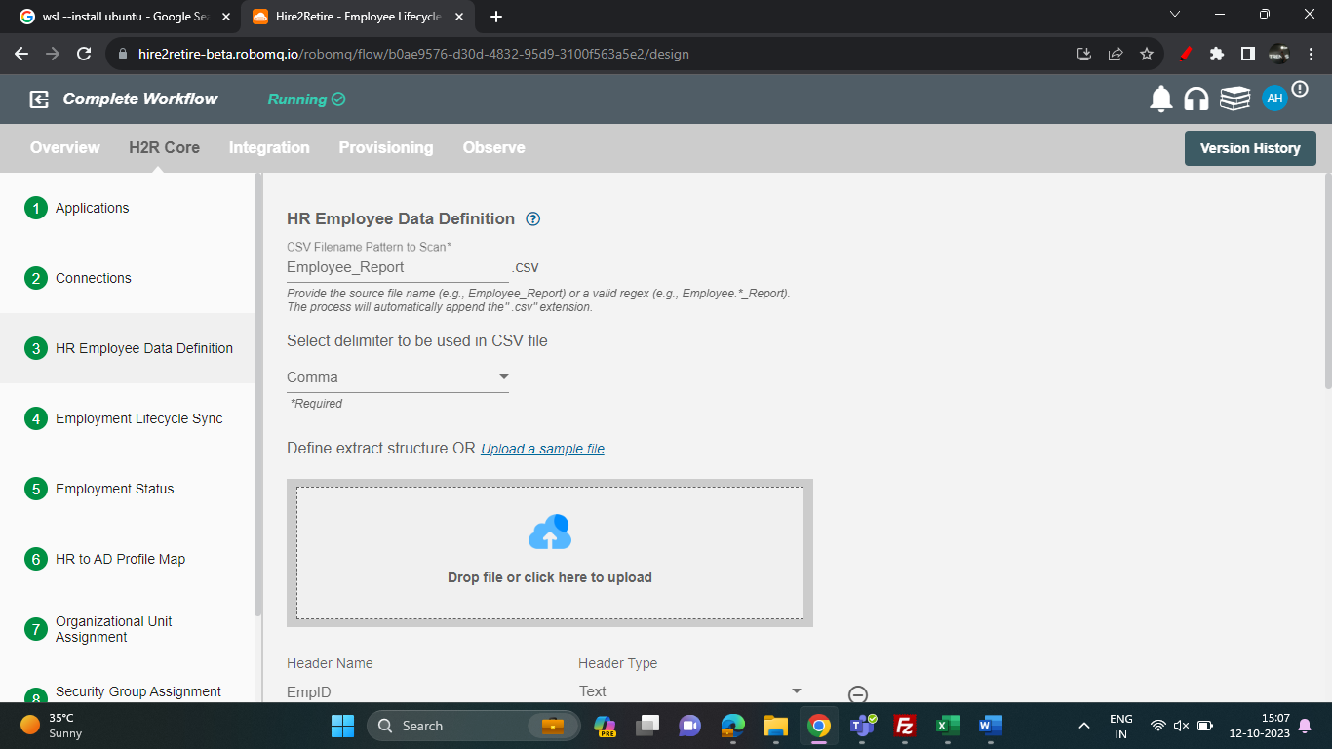

1. **How to define the structure of extract.**

1. Set up all the values of the column header which you will find at the top row in your CSV file. At runtime, the workflow will validate the file first and break each record into independent events.

2. You can add column headers along with column header type by clicking the plus button and delete the incorrect column header value by clicking the minus button.

3. Please make sure the column headers you put match the header column in the CSV file. It will reject the file if the headers in the actual file do not match the column headers defined in workflow.

**5. Apply filter**

Hire2Retire enables you to process specific events and filter out the rest by defining filter criteria. On clicking the "Apply Filter" button, you will be able to set up conditions using employee attributes. Only employees who match the conditions will be processed.

**6. Lifecycle Events**

Employee Lifecycle is an HR model that defines the various stages in which a worker progresses within an organization. Employment Lifecycle Sync provides 4 stages：

1. **Create/Reactivate user in AD when employee is created in HR system** : Using this operation, you can create or reactivate an employee profile in the active directory when an employee is created or reactivated in the HR system. If the employee is not present with that employee id in AD, then it will be created and if an employee already exists with that employee id then it will be reactivated
2. **Update user in AD when employee is updated in HR system**: Using this operation, you can update an Employee profile in the Active Directory when employee is updated in HR system.
3. **Terminate user in AD when employee is terminated in HR system** : Using this operation, you can terminate an Employee account in the Active Directory when an employee is terminated in HR system. The manager of that particular user will get removed permanently on termination.
4. **Process Leave or Long-Term Leave in HR System to AD**: If an employee is on leave and you want to configure the employee access then select this operation.

You can pick the Employee Lifecycle required for your business use cases. At the runtime, the workflow will only process employee which match the selected stages.

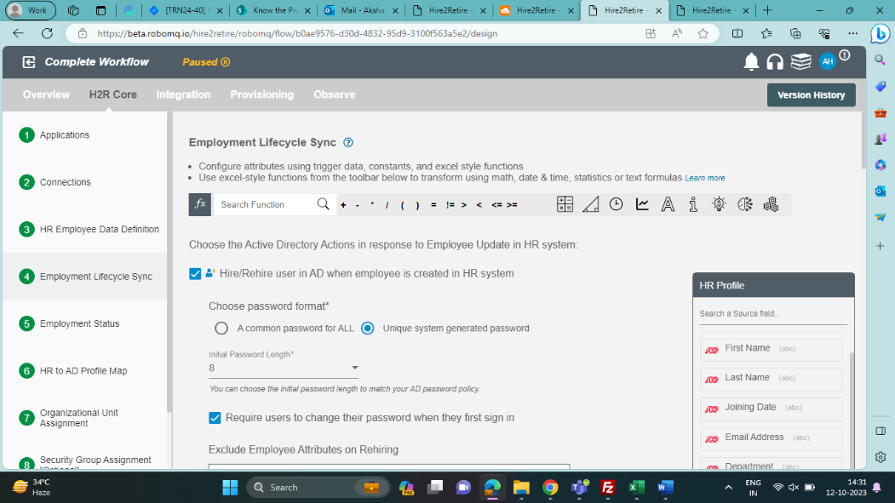

**7. Custom Password**: Hire2Retire provided two ways by which user can generate password.

1. **A common password for ALL :** By selecting the "A common password for ALL" radio button, user will be provided with a textarea in which user can map from trigger data or put user input value for password. User can also put some conditions using excel function.
2. **Unique system generated password :** A random unique password will be generated by the system. Initial password length - Choose the initial password length to match your AD password policy. Password is randomly generated according to the provided length.

**8. Require user to change their password when they first sign in** : Selecting the "Require users to change their password when they first sign in" checkbox, user will be asked to change password when they first sign in.

**9. Write back work email to HR system during new hire process:** By selecting the "Write back work email to HR system during new hire process" checkbox, work email will be written back to the HR system.

**10. Disable user in leave**: It is a checkbox, when selected, restricts user access to all security groups, distribution lists, Microsoft 365 groups, and other confidential company data.

**11. Do not change OU in leave/ terminate**

1. All **terminated** users will be moved to the selected user group. You can choose "Do not change OU" from the dropdown if you do not want to change an OU.
2. Choose OU, which you want to configure for an employee which is on **leave**. You can choose "Do not change OU" from the dropdown if you do not want to change an OU.

**12. Whitelist Option in Update/ leave/terminate**

**Update** –

1. the security groups and distribution lists which are manually added i.e, not added using hire2retire, will be retained.
2. All the security groups and distribution lists which are already added will be retained.
3. None of the existing security groups and distribution lists will be retained.
4. All the selected security groups and distribution lists will be retained.

**Terminate** – The selected security groups and distribution lists will not be touched when terminating an employee profile.

**Leave** -

1. All the security group and distribution list will get retained.
2. All the security group and distribution list will be removed.
3. The selected security groups and distribution lists will not be touched when an employee is on leave.

**13. How to give the Employee status?**

HR data will provide position status and you can map its value to different Employee Lifecycle. At the run time, the workflow will check the status mapping and decide which Lifecycle to perform for the employee record.

**Employment Status**

Pick the attribute which represent position status in your HR system. The attribute needs to be defined in the "HR Employee Data Definition" step.

**Map Employee Lifecycle Status**

Based on the Employee Status you chose in the "Employee Status" step, you will see one or multiple options of status groups:

* Hire, Rehire, or Profile Update
* Leave
* Terminate

You need to map the value of "Position Status" to those groups. As shown in the image below:

1. When position status from HR data is Active, the workflow will perform Hire, Rehire or Profile Update operation.
2. When position status from HR data is Leave, the workflow will perform leave operation.
3. When position status from HR data is Terminated, the workflow will perform Termination operation.

If you have multiple values in HR system, you can also map multiple values to status group using comma. For example, "Active, A, Hire" for Hire, Rehire or Profile Update; "Leave, L" for Leave, and "Terminated, T" for "Terminate".

**14. Exclude list**

**Exclude Employee Attributes on Reactivating** - This multi-select consists of all the AD attributes. You needs to select the attributes to exclude them from updating while performing ‘Create/Reactivate’. For your convenience, Hire2Retire pre-selects important attributes. Pre-selected attributes can be removed by you if you want them to be updated.

**15. How to use excel function in HR to AD profile Map**

Hire2Retire provides a powerful set of features to apply complex formulas on data for transformation. Here are the set of functions that are available event notification and audit trail.

1. **Math Functions (ABS, EXP, INT etc.)** : The Excel Math Functions perform many of the common mathematical calculations, including basic arithmetic, conditional sums & products, exponents & logarithms. For example - RAND () function returns a random number between 0 and 1.
2. **Trigonometry Functions (SIN, TAN, COS etc.):**Excel uses several built-in trigonometry functions. Those that are most often used including SIN, COS, TAN, RADIANS etc are provided.
3. **Date Time Functions (Today, Now() etc.):** Excel Date and Time functions can be used to extract information from, and perform operations on Dates and Times. Some Date & Time functions provided by us are DATE(), NOW(), SECOND(), TODAY().

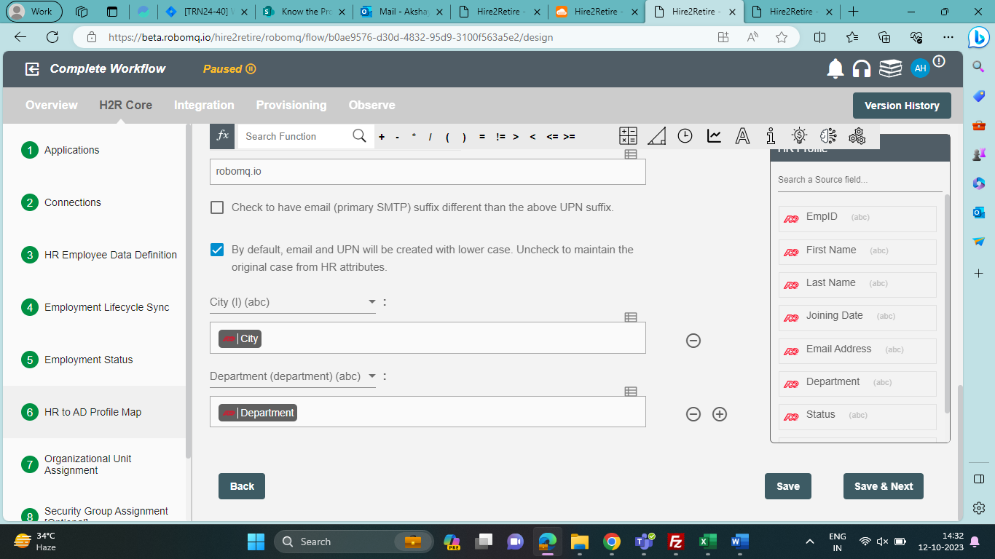

1. **Deploy your flow and generate events.**

### 

### 