PROJECT LISTS
Project-1
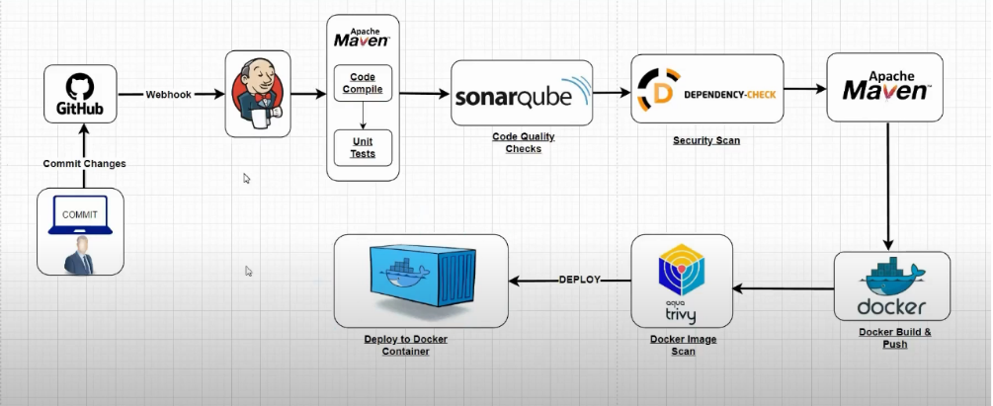

Project-2
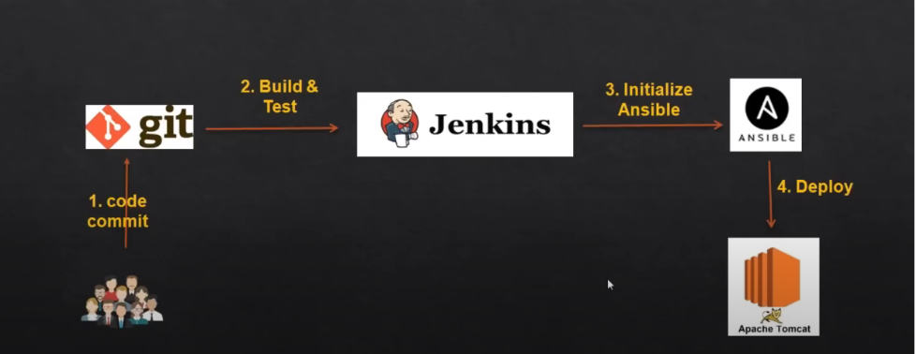
Project-3
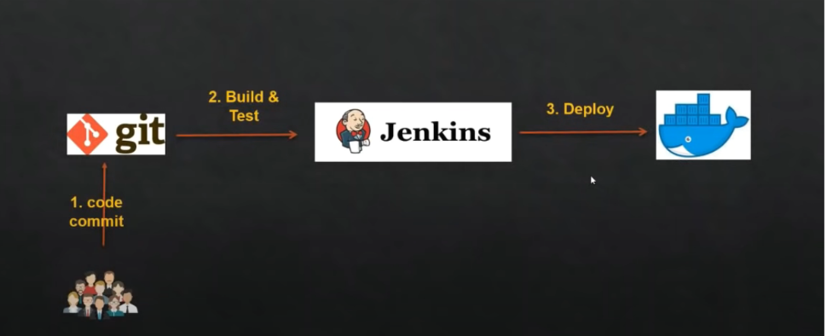
Project-4
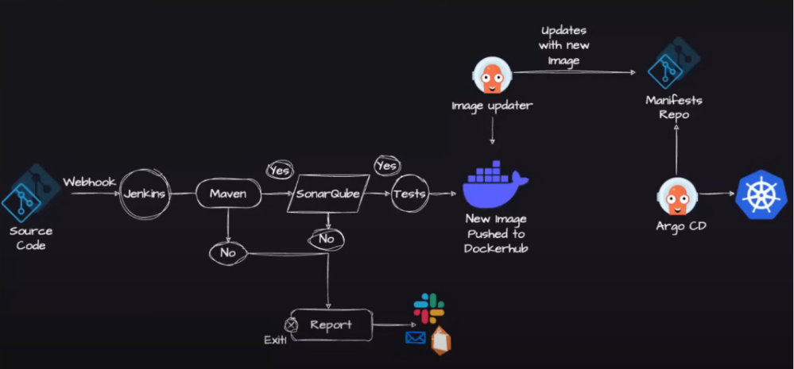
Project-5
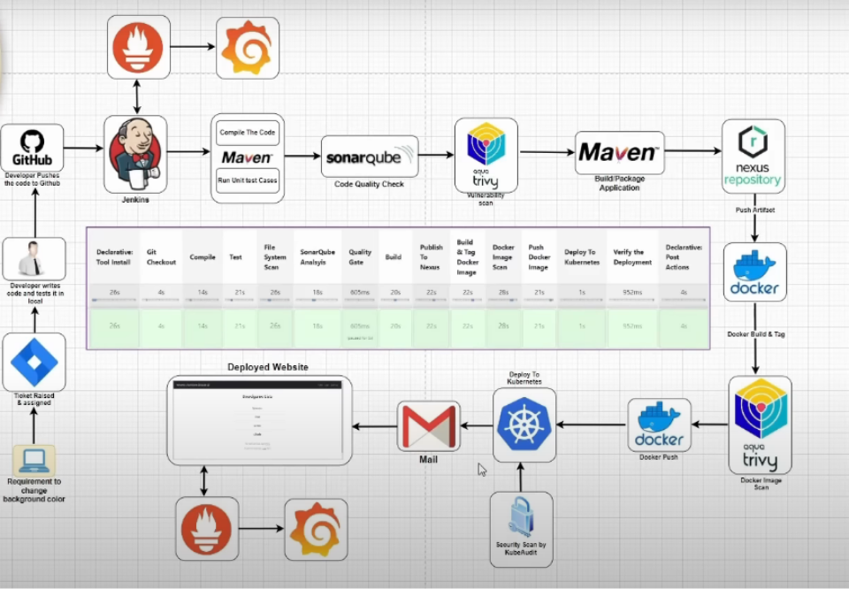

Project-6

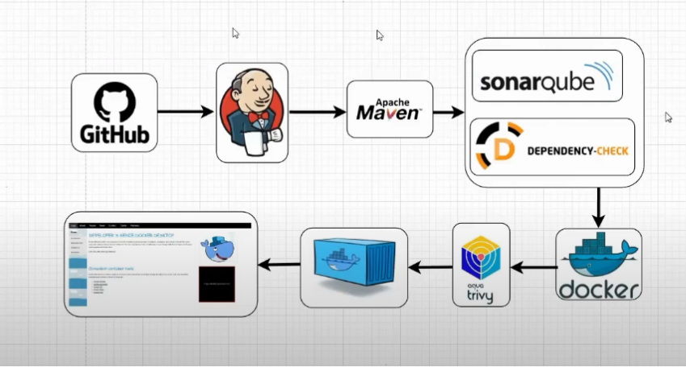

Project-7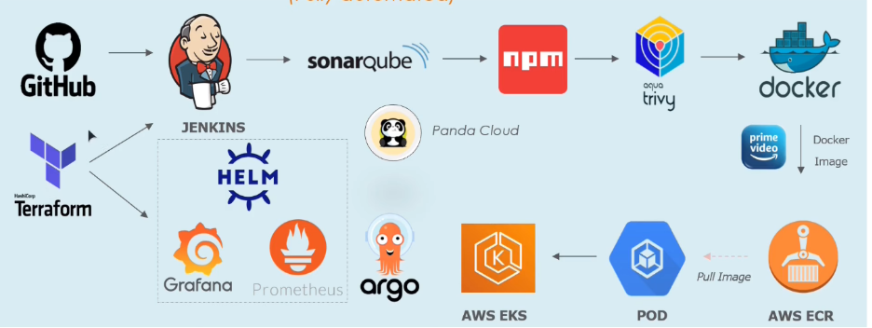

Project-9
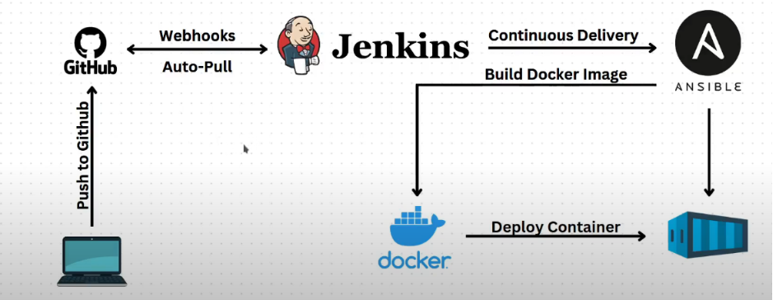

Project-10

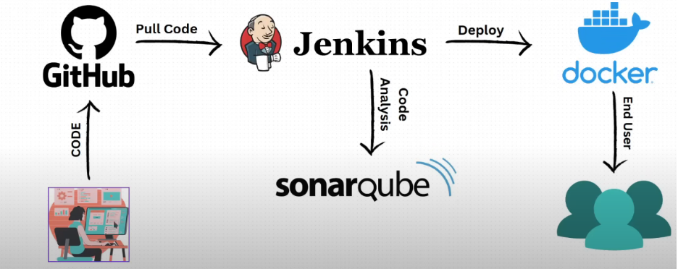

Project-11

Project on Azure:
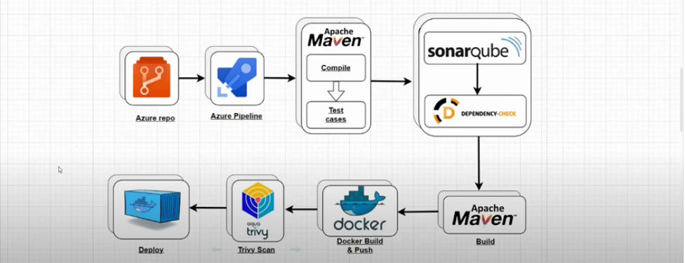

Project-12
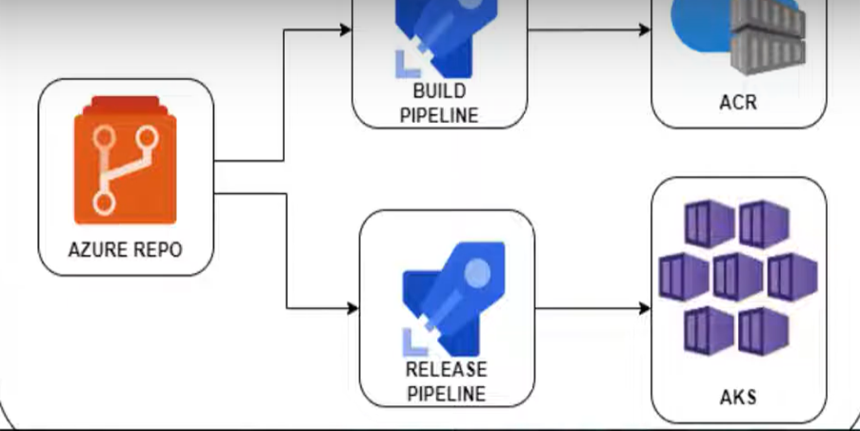

Project-13
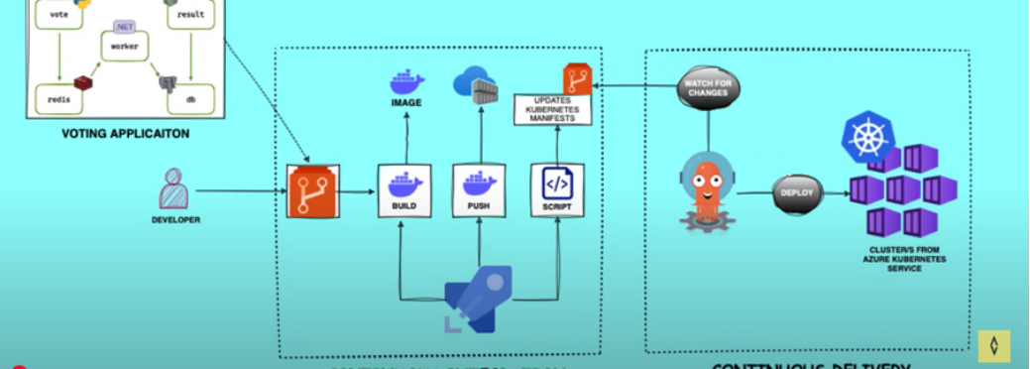

Project-14

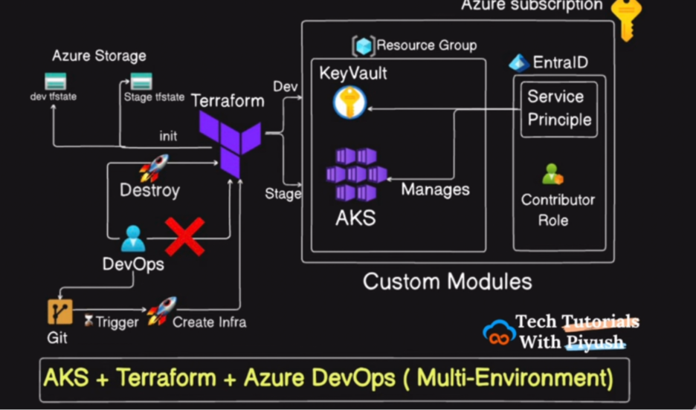

Project -15

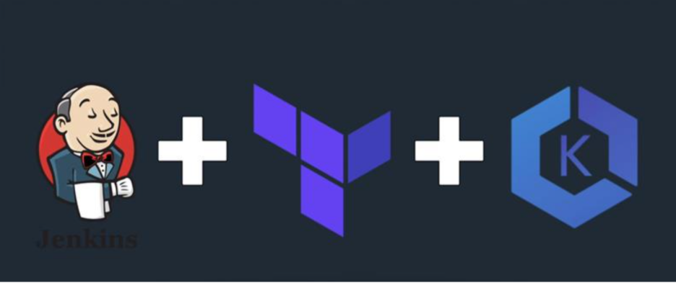

Project 16

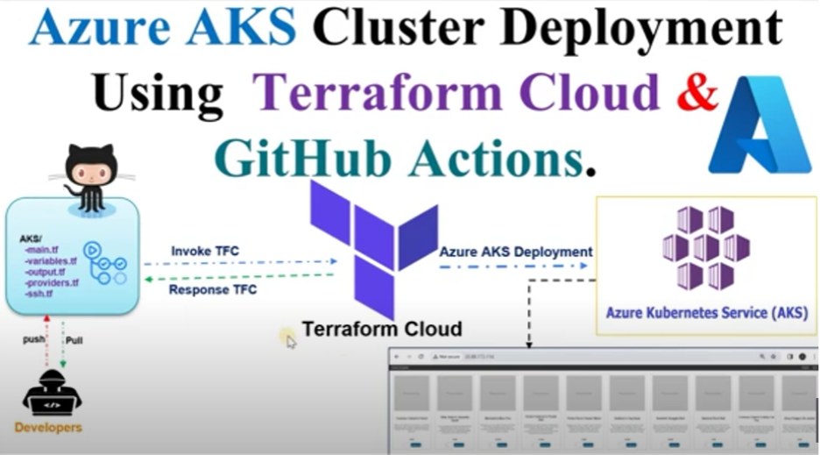

Project 17
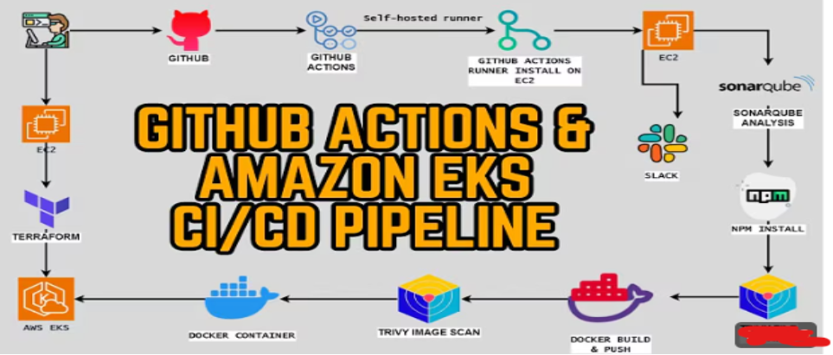

Project-18: AWS DevOps CI-CD Project - 2 [Amazon Prime Clone (Fully automated)]
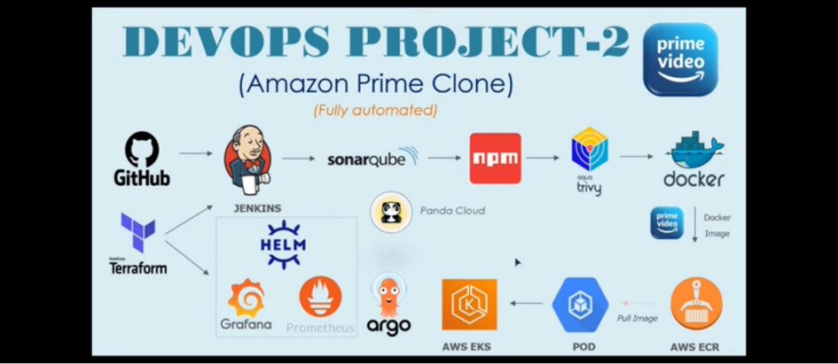

Project-19
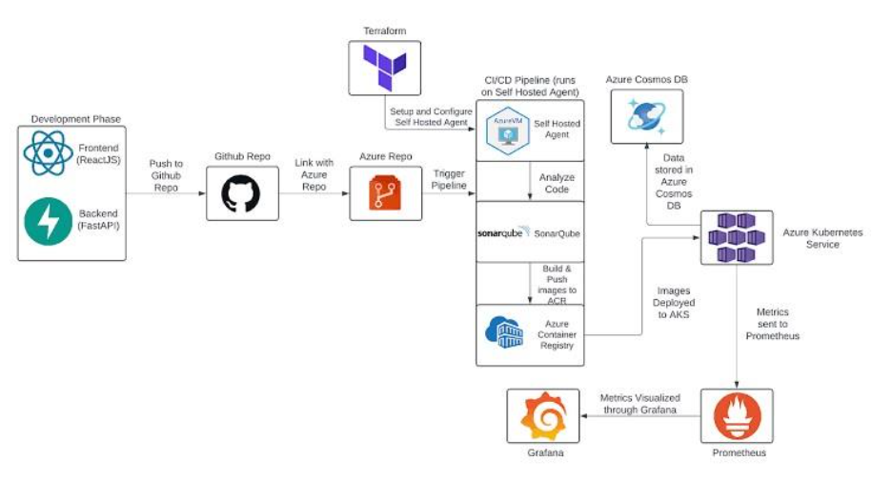
8,10,13,19,20,21,22,23,24,25
Project – 20

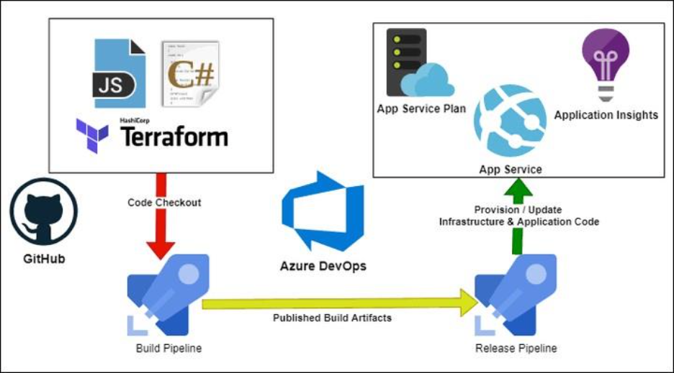
Project-21 (New)
Deploying amazon EKS cluster using Terraform and github.

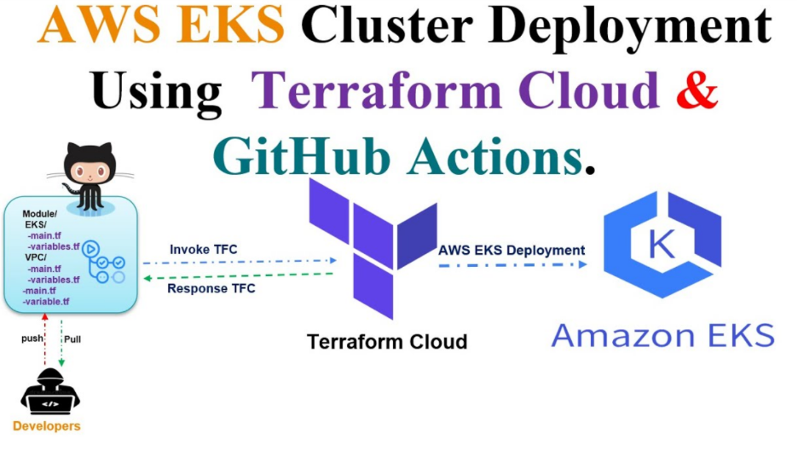

Project-22 (New)
7Deploying a website on aws ecs with AuroraDb .
Requirements:
- For a IAC use Terraform for further creation of deploying AWS resources.
- Deploy the Website in ECS using Fargate launch type.
- Deploy and AuroraDb Cluster using by website to ensure the multi-agent availability zones deployment.
- Ensure that dev and staging Environment separation.
- Setup Route53 for respective Ecs services for both dev and staging.
- Integrate Cloud watch for logging and monitoring for both ECS service and Aurora Db.
- Ensure all resources are securely configured, proper vpc and subnet configuration with secure access to the DB.

Project-23 (New)
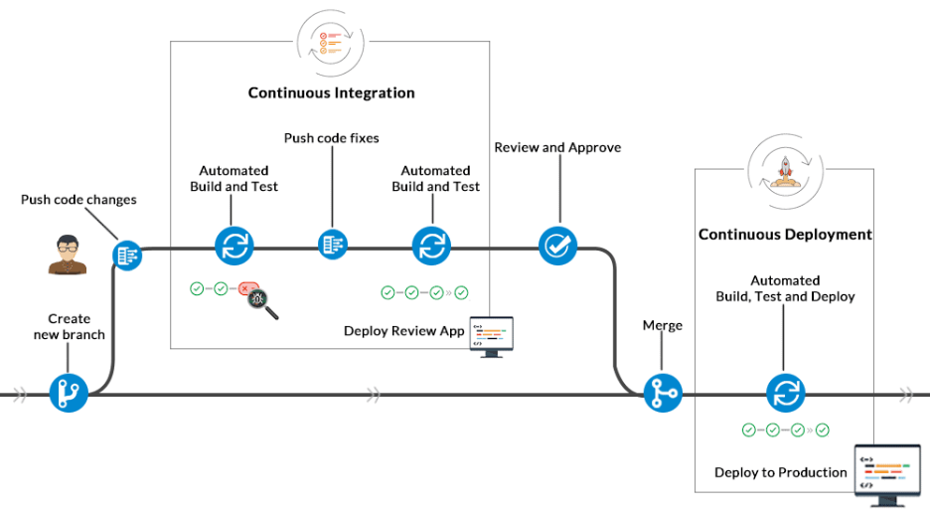

Project-24 (New)

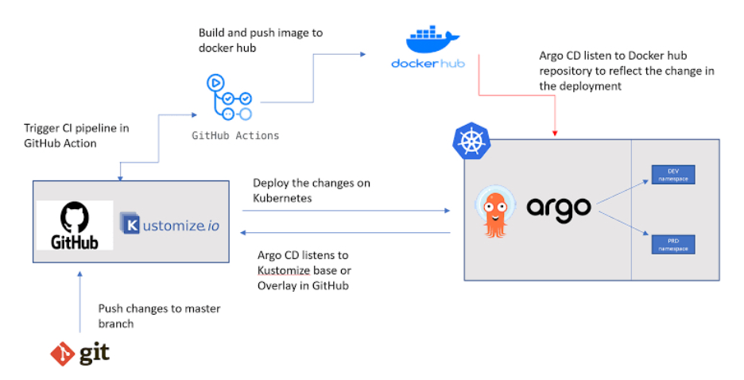

Project-25 (New)

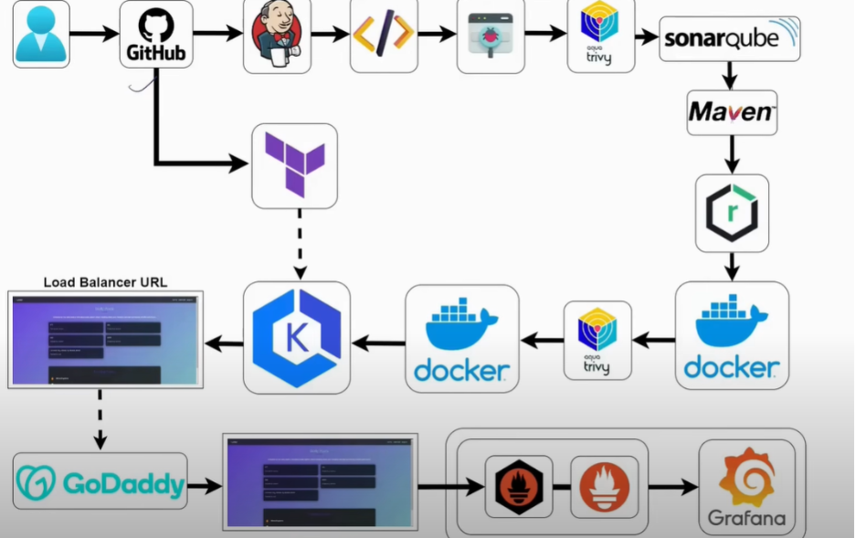

Project-26 (New)
CI/CD Pipeline for a Node.js Web App on EC2
Background: Automating application deployment on EC2 using AWS native tools is a great
entry point into AWS DevOps practices.
Objective: Build and deploy a Node.js application to EC2 using CodeCommit, CodeBuild,
and CodeDeploy through CodePipeline.
Tools & Services:
• AWS CodeCommit, CodeBuild, CodeDeploy, CodePipeline
• EC2, IAM, S3
Implementation Steps:
1. Push sample Node.js app to CodeCommit.
2. Set up EC2 with CodeDeploy agent installed.
3. Create CodeBuild to install dependencies and run tests.
4. Use CodeDeploy to push the artifact to EC2.
5. Set up CodePipeline to automate the entire flow.
Hints:
• Use AppSpec.yml for deployment instructions.
• Use EC2 user-data script to install CodeDeploy agent.
Expected Outcome:
• Successful end-to-end deployment on EC2 after every commit.

Project-27
Host Static Website with S3 and CloudFront
Background: Static site hosting is one of the easiest and cheapest ways to deploy a
frontend using AWS.
Objective: Deploy a static HTML/CSS or React site to S3, serve it via CloudFront.
Tools & Services:
• S3, CloudFront, Route53 (optional), CodePipeline
Implementation Steps:
1. Create S3 bucket with static website hosting.
2. Upload React build or static files.
3. Set up CloudFront for global CDN delivery.
4. Optionally configure Route53 for custom domain.
5. Automate updates with CodePipeline.
Hints:
• Don’t forget to set public read access for S3.
• Use invalidation to refresh CloudFront cache.
Expected Outcome:
• Website accessible via CloudFront or custom domain.

Project-28

Deploy Docker App on ECS Fargate with CI/CD
Background: ECS Fargate offers serverless container deployment without needing to
manage EC2 infrastructure.
Objective: Build and deploy a containerized app on ECS Fargate via CodePipeline.
Tools & Services:
• Docker, Amazon ECR, ECS Fargate, ALB, CodePipeline
Implementation Steps:
1. Dockerize app and push to ECR.
2. Create ECS Cluster and Task Definition.
3. Set up ALB with target groups.
4. Deploy via CodePipeline.
5. Enable auto-scaling and health checks.
Hints:
• Ensure IAM roles allow ECR pull.
• Set up environment variables through Task Definition.
Expected Outcome:
• Containerized service running and exposed via ALB.

Project 29:
Infrastructure as Code with Terraform for EC2 and S3
Background: IaC standardizes provisioning. Terraform allows managing AWS resources
using HCL.
Objective: Provision VPC, EC2 instance, and S3 bucket using Terraform.
Tools & Services:
• Terraform, EC2, S3, IAM
Implementation Steps:
1. Install Terraform and initialize AWS provider.
2. Write modules for EC2, VPC, S3.
3. Use variables and outputs.
4. Apply configuration and verify in AWS console.
5. Automate via CodeBuild.
Hints:
• Use S3 and DynamoDB backend for state management.
Expected Outcome:
• Infrastructure reproducibly deployed with a single command.

Project 30:
Event-Driven Automation with S3 and Lambda
Background: Serverless functions are powerful for processing storage events.
Objective: Trigger a Lambda when a file is uploaded to S3.
Tools & Services:
• Lambda, S3, CloudWatch, IAM
Implementation Steps:
1. Create a Lambda to process or log file metadata.
2. Configure S3 to trigger on PUT event.
3. Upload file to S3 and observe logs.
4. Use IAM roles for permissioning.
Hints:
• Log full event structure to understand payload.
Expected Outcome:
• Lambda executes automatically after file upload.

Project 31:
Blue-Green Deployment using CodeDeploy and EC2
Background: Blue-Green is a proven strategy for safe deployments.
Objective: Deploy a web app using two EC2 environments with CodeDeploy Blue-Green
strategy.
Tools & Services:
• CodeDeploy, EC2, ELB, CodePipeline
Implementation Steps:
1. Set up two EC2 environments (Blue/Green).
2. Register with ELB target groups.
3. Use CodeDeploy with AppSpec.yml to deploy new version.
4. Shift traffic gradually or swap manually.
Hints:
• Use tags to distinguish Blue and Green environments.
Expected Outcome:
• Deployment rolls out without downtime.

Project 32:
Secure Secret Injection with AWS Secrets Manager
Background: Avoid storing secrets in code or pipelines. Use secure vaults instead.
Objective: Manage secrets securely and inject into ECS containers or Lambda.
Tools & Services:
• Secrets Manager, ECS, Lambda, IAM
Implementation Steps:
1. Store a DB string or API key in Secrets Manager.
2. Configure IAM role for access.
3. Inject into ECS Task or Lambda env.
4. Test access and log result.
Hints:
• Rotate secrets using built-in rotation Lambda.
Expected Outcome:
• Secure runtime access to secret, not exposed in logs or console.

Project 33g:
Monitoring and Alerting with CloudWatch and SNS
Background: Cloud-native monitoring ensures issues are detected and resolved quickly.
Objective: Set CloudWatch alarms for CPU, error rate, and integrate with SNS.
Tools & Services:
• CloudWatch, EC2, Lambda, SNS
Implementation Steps:
1. Enable detailed monitoring on EC2 or Lambda.
2. Create alarm thresholds.
3. Subscribe to SNS topic.
4. Simulate failure or resource spike.
Hints:
• Use scripts to simulate high CPU.
Expected 4:
• Alert notification received via email.

Project 34:
GitOps Deployment with EKS and ArgoCD
Background: GitOps automates Kubernetes management by syncing from a Git repo.
Objective: Set up EKS cluster and use ArgoCD to sync application manifests.
Tools & Services:
• EKS, ArgoCD, GitHub, IAM, Helm (optional)
Implementation Steps:
1. Provision EKS cluster.
2. Install ArgoCD in a namespace.
3. Connect ArgoCD to GitHub repo with K8s manifests.
4. Apply changes and observe automated sync.
Hints:
• Use ArgoCD UI or CLI to manage sync.
Expected Outcome:
• EKS apps auto-deployed on git commit.

Project 35:
Cost Optimization and Budget Alerting
Background: Cost visibility is key in cloud. AWS Budgets allows proactive monitoring.
Objective: Set budget alerts for sandbox environments.
Tools & Services:
• AWS Budgets, Billing Console, SNS
Implementation Steps:
1. Define a cost threshold.
2. Link SNS to budget.
3. Simulate resource creation.
4. Receive notification when usage exceeds budget.
Hints:
• Tag resources to filter by environment.
Expected Outcome:
• Email alerts when budget limit crossed.

Azure Project

Project 36:
CI/CD Pipeline for a Node.js Web App
Background: CI/CD automation is a foundational DevOps skill. Azure DevOps provides
robust tools to create pipelines that automate building, testing, and deploying applications
to cloud services like Azure App Service.
Objective: Develop and automate a CI/CD pipeline to build, test, and deploy a Node.js
application to Azure App Service using Azure Pipelines.
Tools & Services:
• Azure DevOps (Repos + Pipelines)
• Azure App Service (Linux)
• Azure Key Vault
• Node.js runtime environment
• Application Insights
Implementation Steps:
1. Create an Azure DevOps project and push sample Node.js code to Azure Repos.
2. Set up an Azure App Service for Linux and link Application Insights.
3. Create a CI pipeline to install dependencies, run unit tests, and publish artifacts.
4. Create a CD pipeline to deploy artifacts to App Service.
5. Secure secrets using Azure Key Vault and integrate with the pipeline.
6. Validate pipeline triggers and deployment.
Hints:
• Use template YAMLs for pipelines.
• Ensure build artifacts include web.config or correct startup commands.
Expected Outcome:
• Successful CI/CD setup, with app visible via App Service URL.
• Logs available in Application Insights.

Project 37:
Static Website Deployment Using Azure Storage and Pipeline
Background: Hosting frontend projects (React/HTML) can be done via Azure Blob Static
Websites. Integrating this with Azure Pipelines allows full automation.
Objective: Deploy a React or HTML website to Azure Blob Storage via CI/CD pipeline.
Tools & Services:
• Azure DevOps (Repos + Pipelines)
• Azure Storage Account
• Azure CLI
Implementation Steps:
1. Create a React app or use a static HTML/CSS template.
2. Enable static website hosting in Azure Blob Storage.
3. Push code to Azure Repos and set up a pipeline to build the React app.
4. Use Azure CLI in pipeline to upload output files to $web container.
5. Test website via static endpoint URL.
Hints:
• Use az storage blob upload-batch for efficient file upload.
Expected Outcome:
• Website is deployed and accessible publicly via Azure static website endpoint.

Project 38:
Deploy Dockerized App to Azure Web App for Containers
Background: Docker allows consistent deployment across environments. Azure App
Service for Containers enables simple Docker deployments.
Objective: Containerize an app and deploy it to Azure Web App using CI/CD pipelines.
Tools & Services:
• Docker, Azure Container Registry (ACR)
• Azure App Service for Containers
• Azure Pipelines
Implementation Steps:
1. Dockerize a Node.js or Python app.
2. Create ACR and push the image.
3. Create a pipeline to build and push Docker image to ACR.
4. Set up Azure Web App for Containers linked to ACR.
5. Test deployment and application functionality.
Hints:
• Use docker build and docker push in Azure Pipelines.
Expected Outcome:
• Container deployed to App Service and app is accessible via URL.

Project 39:
Infrastructure as Code with Bicep and Azure Pipelines
Background: Bicep is a domain-specific language for deploying Azure infrastructure. It
simplifies IaC management over ARM templates.
Objective: Provision a web app and storage account using Bicep and deploy using
pipelines.
Tools & Services:
• Azure DevOps, Azure CLI, Bicep
Implementation Steps:
1. Write Bicep files for App Service and Storage.
2. Validate Bicep files locally.
3. Create Azure pipeline with CLI task to deploy the Bicep templates.
4. Monitor resources in the portal.
5. Destroy resources using the same pipeline if needed.
Hints:
• Use modules for reusable Bicep patterns.
Expected Outcome:
• Resources deployed via pipeline and visible in Azure portal.

Project 40:
Deploy and Monitor Azure Function from DevOps Pipeline
Background: Azure Functions provide serverless compute. Automating deployment
enables scalable microservices.
Objective: Create an HTTP-triggered Azure Function and deploy it using Azure Pipelines.
Tools & Services:
• Azure Functions, Azure DevOps, Application Insights
Implementation Steps:
1. Develop a sample HTTP-triggered Function in VS Code.
2. Push code to Azure Repos.
3. Create a CI pipeline to install tools and build function.
4. Deploy via Azure Function App.
5. Monitor logs using Application Insights.
Hints:
• Use func azure functionapp publish CLI command.
Expected Outcome:
• Deployed function triggers successfully and logs data in Insights.

Project 41:
Implement Blue-Green Deployment on Azure App Service
Background: Blue-green deployment reduces downtime by swapping production slots.
Objective: Deploy an updated version of a web app to a staging slot and swap on success.
Tools & Services:
• Azure App Service Deployment Slots, Azure Pipelines
Implementation Steps:
1. Set up staging slot in Azure App Service.
2. Modify pipeline to deploy to staging slot.
3. Add post-deployment validation step.
4. Swap to production slot upon validation success.
Hints:
• Use AzureWebApp task to target specific slots.
Expected Outcome:
• Zero-downtime release with automated slot swap.

Project 42:
Use Azure Key Vault for Secure Configuration
Background: Secrets management is essential in secure DevOps pipelines. Azure Key
Vault helps manage this securely.
Objective: Store secrets in Key Vault and use them during build and deployment.
Tools & Services:
• Azure Key Vault, Azure Pipelines
Implementation Steps:
1. Create a Key Vault and add secrets (e.g., connection strings).
2. Configure service connection with Key Vault access.
3. Use AzureKeyVault@2 task to fetch secrets.
4. Inject secrets into runtime config files (env vars or appsettings).
Hints:
• Use variable substitution for JSON or YAML files.
Expected Outcome:
• Secrets not exposed in pipelines, application receives them securely.

Project 43:
Configure Azure Monitor Alerts for AKS
Background: Monitoring containerized workloads ensures cluster reliability and visibility.
Objective: Configure CPU and memory alerts for workloads running in AKS.
Tools & Services:
• AKS, Azure Monitor, Log Analytics
Implementation Steps:
1. Create or reuse an AKS cluster.
2. Enable monitoring with Azure Monitor.
3. Deploy a sample app and simulate CPU load.
4. Create alerts using metrics or KQL queries.
Hints:
• Use kubectl run with a stress image to generate load.
Expected Outcome:
• Alerts trigger on thresholds and notify via email or webhook.

Project 44:
Cost Management and Budget Alerts for Azure Dev/Test
Background: DevOps engineers should track cloud costs and stay within budgets.
Objective: Set up budgets and receive alerts based on Azure usage.
Tools & Services:
• Azure Cost Management, Budgets, Action Groups
Implementation Steps:
1. Create a budget in Azure Cost Management.
2. Set threshold limits (e.g., 80%).
3. Configure Action Groups for email notification.
4. Simulate usage by deploying test resources.
Hints:
• Use free-tier resources to avoid cost while testing.
Expected Outcome:
• Alert triggers once budget threshold crossed.

Project 45:
Unified Dashboard for DevOps Metrics
Background: A centralized dashboard helps visualize application health and DevOps
pipeline status.
Objective: Create a custom dashboard to display pipeline status, app metrics, and cost
insights.
Tools & Services:
• Azure Dashboards, Application Insights, Azure DevOps Analytics
Implementation Steps:
1. Enable analytics views in Azure DevOps.
2. Collect app logs in App Insights.
3. Create tiles for build success rate, error rate, uptime, and cost.
4. Share dashboard with stakeholders.
Hints:
• Use KQL queries in Log Analytics for advanced charts.
Expected Outcome:
• Functional, shared dashboard with updated visualizations.

Project-46
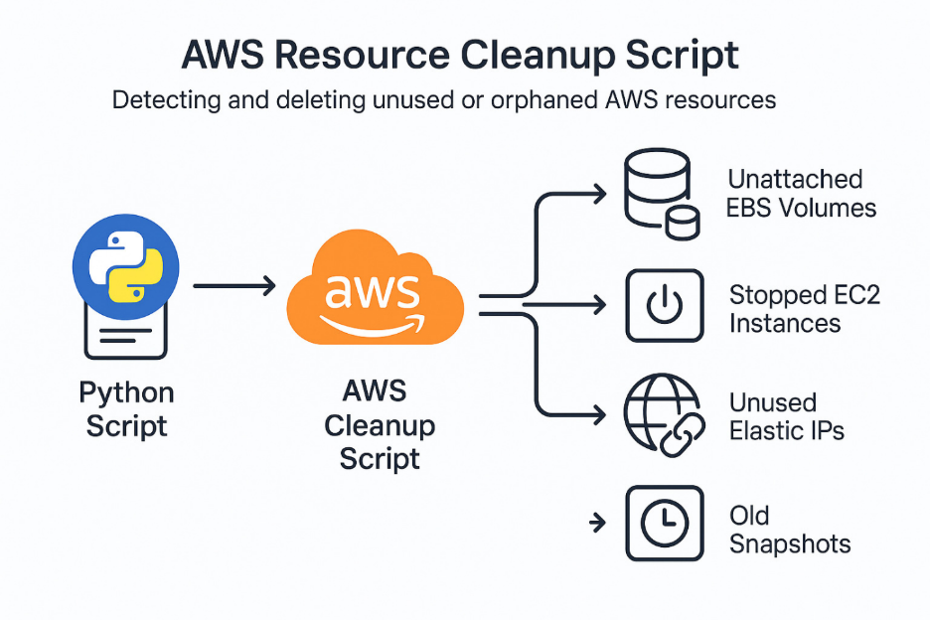

Project 47
Project: Automating S3 Access Using STS and Boto3
Background
AWS S3 is a highly durable object storage service, and controlling access securely is critical. AWS STS (Security Token Service) enables temporary, limited-privilege credentials to access AWS resources. Python’s Boto3 library allows programmatic access to AWS services, enabling automation of S3 operations.
Objective
Automate secure access to S3 using temporary credentials, upload/download files, and monitor basic S3 operations.
Tools & Services
- AWS S3
- AWS STS
- Boto3 (Python SDK)
- Python 3.x
Implementation Steps
S3 Access Automation Using STS and Boto3
- Create an IAM user/role with limited S3 access (read/write permissions to a specific bucket).
- Use Boto3 in Python to assume the role via STS, generating temporary credentials.
- Use the temporary credentials to interact with S3:
- List buckets and objects
- Upload sample files
- Download files
- Delete test files (optional)
- Log all operations (success/failure) locally using Python logging.
- Monitor basic metrics such as object count and last modified timestamps for S3 objects.

Project 48
Linux Firewall Hardening Project with UFW
Background
Linux servers often run web applications that are exposed to the internet. Without proper firewall rules, attackers can exploit unused open ports. UFW (Uncomplicated Firewall) provides a simple yet powerful way to control network traffic on Ubuntu by allowing only the necessary services.
Objective
- Host a sample web service using Nginx
- Secure the server by applying UFW firewall rules
- Allow only HTTP and HTTPS traffic
- Block all other incoming traffic
- Enable logging for monitoring and validation
- Change the default ssh port to 2222
Tools & Services
- Ubuntu Linux
- Nginx Web Server
- UFW (Uncomplicated Firewall)

Project 49
Project Problem Statement: Static Website Hosting & Monitoring with AWS Amplify (India Access Only)
Background
Static websites built with HTML, CSS/SCSS, and JavaScript need fast, scalable, and secure hosting with minimal infrastructure management. AWS Amplify provides serverless hosting with built-in CI/CD, making deployments easy and reliable. Additionally, some applications require regional access restrictions for compliance or security.

Objectives
- Host a static SCSS-based web service using AWS Amplify.
- Enable Git-based CI/CD for automated deployments.
- Configure branch-based environments (dev, staging, main).
- Monitor request volume and errors with AWS CloudWatch and SNS notifications.
- Implement geo-restriction using AWS WAF to allow access only from India.

Tools & Services
- AWS Amplify: Static website hosting with CI/CD.
- GitHub: Source code repository and version control.
- AWS CloudWatch: Logs, metrics, and alarms.
- Amazon SNS: Email/SMS alerts for monitoring.
- AWS WAF: Geo-restriction firewall to allow only India traffic.

Project 50
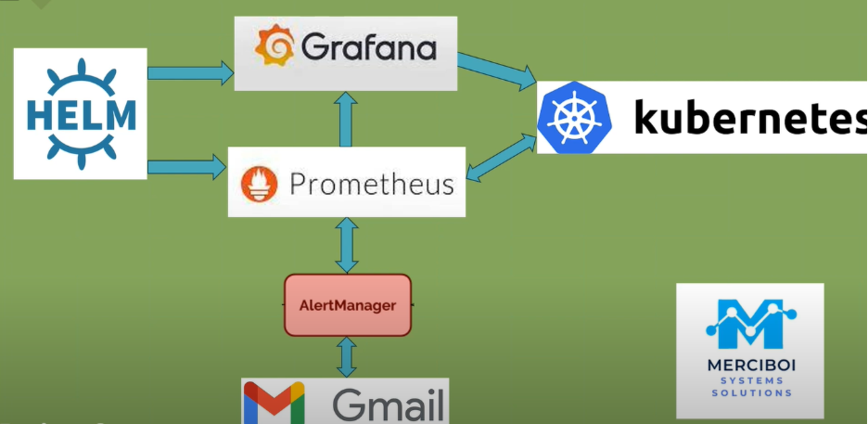

Project 51
