WEEK-1:

1. Demonstrate usage of branching and looping statements
2. Demonstrate Recursive functions

3. Demonstrate Lists

- Demonstrate usage of branching and looping statements

Branching (if, elif and else)
Very often in life, and in computer programs, the next action depends on the outcome of a question starting with “if”. This gives the possibility of branching into different types of action depending on some criterion.
As an introduction to branching, let us “build up” a little program that evaluates a water temperature provided by the program user.

One if test:
T = float(input(’What is the water temperature? ’))
if T > 24:
print(’Great, jump in!’)
# First line after if part

Two if-tests
Immediately, we realize that this is not satisfactory, so (as a “first fix”) we extend our code with a second if test, as
T = float(input(’What is the water temperature? ’))
if T > 24: # testing condition 1
print(’Great, jump in!’)
if T <= 24: # testing condition 2
print(’Do not swim. Too cold!’)
# First line after if-if construction

If-else test
T = float(input(’What is the water temperature? ’))
if T > 24: # testing condition 1
print(’Great, jump in!’)
else:
print(’Do not swim. Too cold!’)
# First line after if-else construction

A more general form of an if-elif-else construction reads
if condition_1: # testing condition 1
<code line 1>
<code line 2>
...
elif condition_2: # testing condition 2
<code line 1>
<code line 2>
...
elif condition_3: # testing condition 3
<code line 1>
<code line 2>
...
else:
<code line 1>
<code line 2>
...
# First line after if-elif-else construction

The for Loop
Many computations are repetitive by nature and programming languages have certain loop structures to deal with this. One such loop structure is the for loop.

1.1.1 Example: Printing the 5 Times Table
Assume the task is to print out the 5 times table. Before having learned about loop structures in programming, most of us would first think of coding this like:
# Naively printing the 5 times table
print(’{:d}*5 = {:d}’.format(1, 1*5))
print(’{:d}*5 = {:d}’.format(2, 2*5))
print(’{:d}*5 = {:d}’.format(3, 3*5))
print(’{:d}*5 = {:d}’.format(4, 4*5))
print(’{:d}*5 = {:d}’.format(5, 5*5))
print(’{:d}*5 = {:d}’.format(6, 6*5))
print(’{:d}*5 = {:d}’.format(7, 7*5))
print(’{:d}*5 = {:d}’.format(8, 8*5))
print(’{:d}*5 = {:d}’.format(9, 9*5))

print(’{:d}*5 = {:d}’.format(10, 10*5))
When executed, the 10 results are printed quite nicely as
1*5 = 5
2*5 = 10
...
...
With a for loop, however, the very same printout may be produced by just two (!) lines of code:
for i in [1, 2, 3, 4, 5, 6, 7, 8, 9, 10]: # Note... for, in and colon
print(’{:d}*5 = {:d}’.format(i, i*5)) # Note indent
With this construction, the loop variable i takes on each of the values 1 to 10, and for each value, the print function is called.

The while Loop
The other basic loop construction in Python is the while loop, which runs as long as a condition is True. Let us move directly to an example, and explain what happens there, before we consider the loop more generally.

The Program In a program named ball_time.py, we may find the time of flight as the time when heights switch from positive to negative. The program could look like this
import numpy as np
v0 = 4.5 # Initial velocity
g = 9.81 # Acceleration of gravity
t = np.linspace(0, 1, 1000) # 1000 points in time interval
y = v0*t - 0.5*g*t**2 # Generate all heights
# Find index where ball approximately has reached y=0
i = 0
while y[i] >= 0:
i = i + 1
# Since y[i] is the height at time t[i], we do know the
# time as well when we have the index i...
print(’Time of flight (in seconds): {:g}’.format(t[i]))
# We plot the path again just for comparison
import matplotlib.pyplot as plt
plt.plot(t, y)
plt.plot(t, 0*t, ’g--’)
plt.xlabel(’Time (s)’)
plt.ylabel(’Height (m)’)

plt.show()

- Demonstrate Recursive Functions

Definition of a recursive function: “A recursive function is a function defined in terms of itself via self-referential expressions.”
This means that the function will continue to call itself and repeat its behavior until some condition is met to return a result.

All recursive functions share a common structure made up of two parts: base case and recursive case.
To demonstrate this, let’s write a recursive function to calculate Factorial of n (n!):
Decompose the original problem into simpler instances of the same problem. This is the recursive case:
n! = n x (n−1) x (n−2) x (n−3) ⋅⋅⋅⋅ x 3 x 2 x 1
n! = n x (n−1)!
As the large problem is broken down into successively less complex ones, those sub problems must eventually become so simple that they can be solved without further subdivision. This is the base case:
n! = n x (n−1)!
n! = n x (n−1) x (n−2)!
n! = n x (n−1) x (n−2) x (n−3)!
⋅
⋅
n! = n x (n−1) x (n−2) x (n−3) ⋅⋅⋅⋅ x 3!
n! = n x (n−1) x (n−2) x (n−3) ⋅⋅⋅⋅ x 3 x 2!
n! = n x (n−1) x (n−2) x (n−3) ⋅⋅⋅⋅ x 3 x 2 x 1!

Here, 1! is our base case, and it equals 1.

Recursive function for calculating n! Implemented in Python:

def factorial_recursive(n):
# Base case: 1! = 1
if n == 1:
return 1
# Recursive case: n! = n * (n-1)!
else:
return n * factorial_recursive(n-1)
>>> factorial_recursive(5)
120
3. Demonstrate Lists

How to create a list?
In Python programming, a list is created by placing all the items (elements) inside square brackets [], separated by commas.
It can have any number of items and they may be of different types (integer, float, string etc.).
# empty list
my_list = []

# list of integers
my_list = [1, 2, 3]

# list with mixed data types
my_list = [1, "Hello", 3.4]
A list can also have another list as an item. This is called a nested list.
# nested list
my_list = ["mouse", [8, 4, 6], ['a']]
Nested lists are accessed using nested indexing.
# List indexing
my_list = ['p', 'r', 'o', 'b', 'e']

# Output: p
print(my_list[0])
# Output: o
print(my_list[2])
# Output: e
print(my_list[4])
# Nested List
n_list = ["Happy", [2, 0, 1, 5]]
# Nested indexing
print(n_list[0][1])
print(n_list[1][3])
# Error! Only integer can be used for indexing
print(my_list[4.0])

Output
p
o
e
a
5
Traceback (most recent call last):
File "<string>", line 21, in <module>
TypeError: list indices must be integers or slices, not float

Introduction to python Libraries

- Numpy
- Pandas
- Matplotlib
- Scikit

Essential Python Libraries For those who are less familiar with the scientific Python ecosystem and the libraries used throughout the Manual, introduction of each library given blow.

WEEK- 2:
SEQUENCE DATATYPES AND OBJECT-ORIENTED PROGRAMMING
Sequences, Mapping and Sets- Dictionaries- -Classes: Classes and Instances-Inheritance-
Exceptional Handling-Introduction to Regular Expressions using “re” module.
Lab Exercises
1. Demonstrate Tuples and Sets
2. Demonstrate Dictionaries
3. Demonstrate inheritance and exceptional handling
4. Demonstrate use of “re”.

1.Write a program to Demonstrate Tuples and Sets

tuple1 = tuple(input("Enter the tuple elements ..."))
print(tuple1)
count = 0
for i in tuple1:
print("tuple1[%d] = %s"%(count, i));
Output:
Enter the tuple elements ...12345
('1', '2', '3', '4', '5')
tuple1[0] = 1
tuple1[0] = 2
tuple1[0] = 3
tuple1[0] = 4
tuple1[0] = 5

OR

# empty tuple
my_tuple = ()
print(my_tuple)

# tuple having integers
my_tuple = (1, 2, 3)
print(my_tuple)

# tuple with mixed datatypes
my_tuple = (1, "Hello", 3.4)
print(my_tuple)

# nested tuple
my_tuple = ("mouse", [8, 4, 6], (1, 2, 3))
print(my_tuple)

# tuple can be created without parentheses
my_tuple = 3, 4.6, "dog"
print(my_tuple)

a, b, c = my_tuple
print(a)
print(b)
print(c)
Output:
()
(1, 2, 3)
(1, 'Hello', 3.4)
('mouse', [8, 4, 6], (1, 2, 3))
(3, 4.6, 'dog')
3
4.6
Dog

2. Demonstrate Dictionaries
Employee = {"Name": "John", "Age": 29, "salary":25000,"Company":"GOOGLE"}
print(type(Employee))
print("printing Employee data .... ")
for x in Employee.items():
print(x)

print("Enter the details of the new employee....");
Employee["Name"] = input("Name: ");
Employee["Age"] = int(input("Age: "));
Employee["salary"] = int(input("Salary: "));
Employee["Company"] = input("Company:");
print("printing the new data");
for x,y in Employee.items():
print(x,y)
output:
<class 'dict'>
printing Employee data ....
('Name', 'John')
('Age', 29)
('salary', 25000)
('Company', 'GOOGLE')
Enter the details of the new employee....
Name: David
Age: 19
Salary: 8900
Company:Wipro
printing the new data
Name David
Age 19
Salary 8900
Company Wipro

Demonstrate inheritance and exceptional handling
Write a program to implement Inheritance
class Polygon:
def __init__(self, no_of_sides):
self.n = no_of_sides
self.sides = [0 for i in range(no_of_sides)]

def inputSides(self):
self.sides = [float(input("Enter side "+str(i+1)+" : ")) for i in range(self.n)]

def dispSides(self):
for i in range(self.n):
print("Side",i+1,"is",self.sides[i])

class Triangle(Polygon):
def __init__(self):
Polygon.__init__(self,3)

def findArea(self):
a, b, c = self.sides
# calculate the semi-perimeter
s = (a + b + c) / 2
area = (s*(s-a)*(s-b)*(s-c)) ** 0.5
print('The area of the triangle is %0.2f' %area)

t = Triangle()

t.inputSides()
t.dispSides()
t.findArea()

output:
Enter side 1 : 3
Enter side 2 : 5
Enter side 3 : 4

Side 1 is 3.0
Side 2 is 5.0
Side 3 is 4.0
The area of the triangle is 6.00
Write a program to Exception Handling.

try:
a = int(input("Enter a:"))
b = int(input("Enter b:"))
c = a/b;
print("a/b = %d"%c)
except:
print("can't divide by zero")
else:
print("Hi I am else block")

output:
Enter a:10
Enter b:2
a/b = 5
Hi I am else block

Enter a:10
Enter b:0
can't divide by zero

Demonstrate use of “re”.
# Program to remove all whitespaces
import re
# multiline string
string = 'abc 12\
de 23 \n f45 6'
# matches all whitespace characters
pattern = '\s+'
# empty string
replace = ''
new_string = re.subn(pattern, replace, string)
print(new_string)
Output:
('abc12de23f456', 4)

WEEK-3

Lab Exercises
1. Demonstrate Aggregation
2. Demonstrate Indexing and Sorting

NumPy :
NumPy, short for Numerical Python, is the foundational package for scientific computing in Python. The majority of this book will be based on NumPy and libraries built on top of NumPy. It provides, among other things:
• A fast and efficient multidimensional array object ndarray
• Functions for performing element-wise computations with arrays or mathematical operations between arrays • Tools for reading and writing array-based data sets to disk
• Linear algebra operations, Fourier transform, and random number generation
• Tools for integrating connecting C, C++, and Fortran code to Python
Beyond the fast array-processing capabilities that NumPy adds to Python, one of its primary purposes with regards to data analysis is as the primary container for data to be passed between algorithms. For numerical data, NumPy arrays are a much more efficient way of storing and manipulating data than the other built-in Python data structures. Also, libraries written in a lower-level language, such as C or Fortran, can operate on the data stored in a NumPy array without copying any data.

1.Demonstrate Aggregation
Aggregation
- np.sum() - faster than .sum(), make demo, np is really fast
- np.mean()
- np.std()
- np.var()
- np.min()
- np.max()
- np.argmin() - find index of minimum value
- np.argmax() - find index of maximum value
sum(a1)
6
np.sum(a1)
6
Use NumPy's np.sum() on NumPy arrays and Python's sum() on Python lists.
massive_array = np.random.random(100000)
massive_array.size
100000
%timeit sum(massive_array) # Python sum()
%timeit np.sum(massive_array) # NumPy np.sum()
33 ms ± 2.08 ms per loop (mean ± std. dev. of 7 runs, 10 loops each)
97.3 µs ± 2.12 µs per loop (mean ± std. dev. of 7 runs, 10000 loops each)
import random
massive_list = [random.randint(0, 10) for i in range(100000)]
len(massive_list)
100000
massive_list[:10]
[6, 3, 9, 1, 6, 0, 1, 1, 7, 3]
%timeit sum(massive_list)
%timeit np.sum(massive_list)
1.59 ms ± 70.4 µs per loop (mean ± std. dev. of 7 runs, 1000 loops each)
11.3 ms ± 49.6 µs per loop (mean ± std. dev. of 7 runs, 100 loops each)
a2
array([[1. , 2. , 3.3],
[4. , 5. , 6.5]])
# Find the mean
np.mean(a2)
3.6333333333333333
# Find the max
np.max(a2)
6.5
# Find the min
np.min(a2)
1.0
# Find the standard deviation
np.std(a2)
1.8226964152656422
# Find the variance
np.var(a2)
3.3222222222222224
# The standard deviation is the square root of the variance
np.sqrt(np.var(a2))
1.8226964152656422

2. Demonstrate Indexing and Sorting

import numpy as np
# 1-dimensonal array, also referred to as a vector
a1 = np.array([1, 2, 3])
# 2-dimensional array, also referred to as matrix
a2 = np.array([[1, 2.0, 3.3], [4, 5, 6.5]])
# 3-dimensional array, also referred to as a matrix
a3 = np.array([[[1, 2, 3], [4, 5, 6], [7, 8, 9]], [[10, 11, 12], [13, 14, 15], [16, 17, 18]]])
a1
array([1, 2, 3])
a2
array([[1. , 2. , 3.3],
[4. , 5. , 6.5]])
a3
array([[[ 1, 2, 3],
[ 4, 5, 6],
[ 7, 8, 9]],
[[10, 11, 12],
[13, 14, 15],
[16, 17, 18]]])
a1[0]
1
a2[0]
array([1. , 2. , 3.3])

a3[0]
array([[1, 2, 3],
[4, 5, 6],
[7, 8, 9]])
# Get 2nd row (index 1) of a2
a2[1]
array([4. , 5. , 6.5])
# Get the first 2 values of the first 2 rows of both arrays
a3[:2, :2, :2]
array([[[ 1, 2],
[ 4, 5]],
[[10, 11],
[13, 14]]])

Sorting arrays
- np.sort()
- np.argsort()
- np.argmax()
- np.argmin()
random_array
array([[0, 0, 7],
[3, 3, 2],
[9, 4, 9],
[4, 7, 2],
[1, 9, 9]])
np.sort(random_array)
array([[0, 0, 7],
[2, 3, 3],
[4, 9, 9],
[2, 4, 7],
[1, 9, 9]])
np.argsort(random_array)
array([[0, 1, 2],
[2, 0, 1],
[1, 0, 2],
[2, 0, 1],
[0, 1, 2]], dtype=int64)
a1
array([1, 2, 3])
# Return the indices that would sort an array
np.argsort(a1)
array([0, 1, 2], dtype=int64)
# No axis
np.argmin(a1)
0
random_array
array([[0, 0, 7],
[3, 3, 2],
[9, 4, 9],
[4, 7, 2],
[1, 9, 9]])
# Down the vertical
np.argmax(random_array, axis=1)
array([2, 0, 0, 1, 1], dtype=int64)
# Across the horizontal
np.argmin(random_array, axis=0)
array([0, 0, 1], dtype=int64)

WEEK-4

Lab Exercises
1. Demonstrate handling of missing data
2. Demonstrate hierarchical indexing

Pandas:
pandas provides rich data structures and functions designed to make working with structured data fast, easy, and expressive. It is, as you will see, one of the critical ingredients enabling Python to be a powerful and productive data analysis environment. The primary object in pandas that will be used in this manual is the DataFrame, a two dimensional tabular, column-oriented data structure with both row and column labels:
>>> frame
total_bill tip sex smoker day time size
1 16.99 1.01 Female No Sun Dinner 2
2 10.34 1.66 Male No Sun Dinner 3
3 21.01 3.5 Male No Sun Dinner 3
4 23.68 3.31 Male No Sun Dinner 2
5 24.59 3.61 Female No Sun Dinner 4
6 25.29 4.71 Male No Sun Dinner 4
7 8.77 2 Male No Sun Dinner 2
8 26.88 3.12 Male No Sun Dinner 4
9 15.04 1.96 Male No Sun Dinner 2
10 14.78 3.23 Male No Sun Dinner 2

pandas combines the high performance array-computing features of NumPy with the flexible data manipulation capabilities of spreadsheets and relational databases (such as SQL). It provides sophisticated indexing functionality to make it easy to reshape, slice and dice, perform aggregations, and select subsets of data. pandas is the primary tool that we will use in this manual

For financial users, pandas feature rich, high-performance time series functionality and tools well-suited for working with financial data. In fact, I initially designed pandas as an ideal tool for financial data analysis applications.
For users of the R language for statistical computing, the DataFrame name will be familiar, as the object was named after the similar R data.frame object. They are not the same, however; the functionality provided by data.frame in R is essentially a strict subset of that provided by the pandas DataFrame. While this is a manual about Python, I will occasionally draw comparisons with R as it is one of the most widely-used open source data analysis environments and will be familiar to many readers.
The pandas name itself is derived from panel data, an econometrics term for multidimensional structured data sets, and Python data analysis itself.
1. Demonstrate handling of missing data
- Reassigning the column changes it in the original DataFrame. This trend occurs throughout all kinds of data manipulation with pandas.
- Some functions have a parameter called inplace which means a DataFrame is updated in place without having to reassign it.
- Let's see what it looks like in combination with .fillna(), a function which fills missing data. But the thing is, our table isn't missing any data.
- In practice, it's likely you'll work with datasets which aren't complete. What this means is you'll have to decide whether how to fill the missing data or remove the rows which have data missing.
- Let's check out what a version of our car_sales DataFrame might look like with missing values.
1. Demonstrate handling of missing data
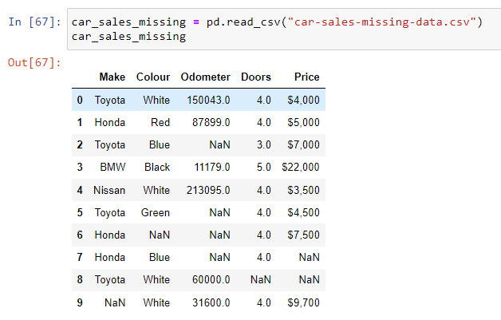

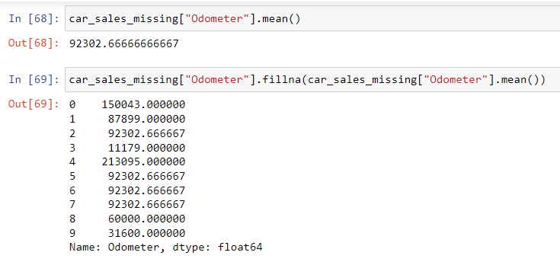

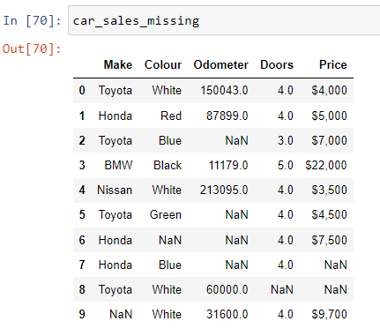
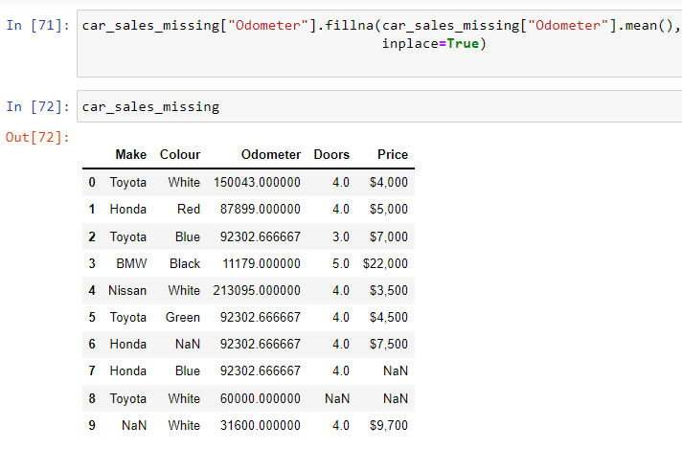

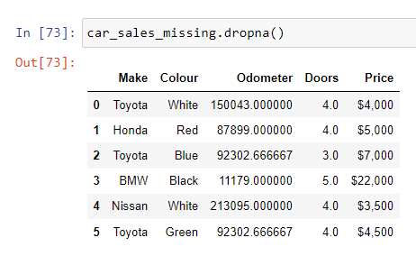

WEEK-5

1. Demonstrate usage of Pivot table
2. Demonstrate use of and query ()

import pandas as pd
# 2 main datatypes
series = pd.Series(["BMW", "Toyota", "Honda","BMW"])
series
OUT:
0 BMW
1 Toyota
2 Honda
3 BMW
dtype: object

colours = pd.Series(["Red", "Blue", "White","Green"])
colours
0 Red
1 Blue
2 White
3 Green
dtype: object
# DataFrame = 2-dimensional
car_data = pd.DataFrame({"Carmake": series, "Colour": colours})
car_data
car_data.query("(Carmake=='BMW') or (Colour=='Green')")
out:
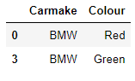

2. Demonstrate use of and query ()
car_data.query("(Carmake=='BMW') and (Colour=='Green')")
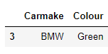
df = pd.DataFrame({
'name':['john','david','anna'],
'country':['USA','UK', 'USA'],
'age':[23,45,45]
})

df.query("(country=='USA') and (age==23)")
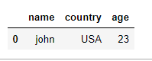

1. Demonstrate usage of Pivot table
#PIVOT TABLE
# Import data
car_sales = pd.read_csv("car-sales.csv")
car_sales
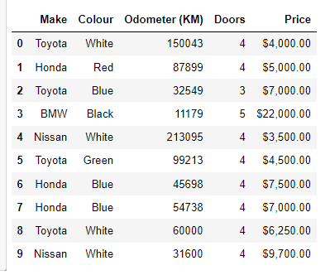

table = pd.pivot_table(car_sales,index=['Make','Price'])
table
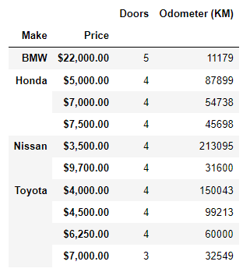

WEEK-6

1. Demonstrate Scatter Plot
2. Demonstrate 3D plotting

matplotlib
matplotlib is the most popular Python library for producing plots and other 2D data visualizations. It was originally created by John D. Hunter (JDH) and is now maintained by a large team of developers. It is well-suited for creating plots suitable for publication. It integrates well with IPython (see below), thus providing a comfortable interactive environment for plotting and exploring data. The plots are also interactive; you can zoom in on a section of the plot and pan around the plot using the toolbar in the plot window.

Import Conventions
The Python community has adopted a number of naming conventions for commonly used modules:
import numpy as np
import pandas as pd
import matplotlib.pyplot as plt
This means that when you see np.arange, this is a reference to the arange function in NumPy. This is done as it’s considered bad practice in Python software development to import everything (from numpy import *) from a large package like NumPy.

2. Demonstrate 3D plotting
from mpl_toolkits import mplot3d
import numpy as np
import matplotlib.pyplot as plt

fig = plt.figure()

# syntax for 3-D projection
ax = plt.axes(projection ='3d')

# defining axes
z = np.linspace(0, 1, 100)
x = z * np.sin(25 * z)
y = z * np.cos(25 * z)
c = x + y
ax.scatter(x, y, z, c = c)

# syntax for plotting
ax.set_title('3d ')
plt.show()

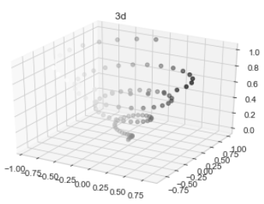

WEEK-7

Week 7: Perform Data exploration and pre-processing in Python

Perform Data exploration and pre-processing in Python
