XSV

|  |  |
| --- | --- |
| **Summary** | XSV installation and Working |
| **URL** | <https://github.com/BurntSushi/xsv>  <https://drive.google.com/file/d/1NbWYAdTabsWzwNWXXZOULKxDmir8ZRN8/view?usp=sharing> |
| **Tools** | XSV |

Installation

Command Run on it

3 Lesson Learned

# **XSV Installation**

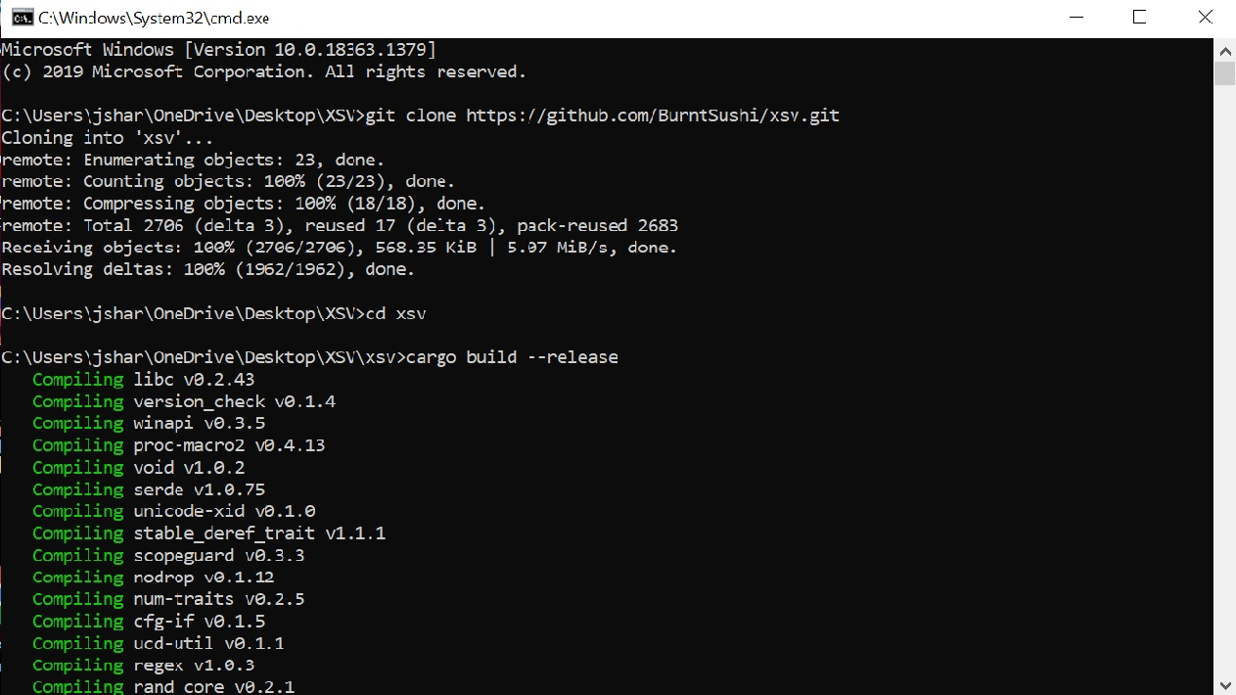

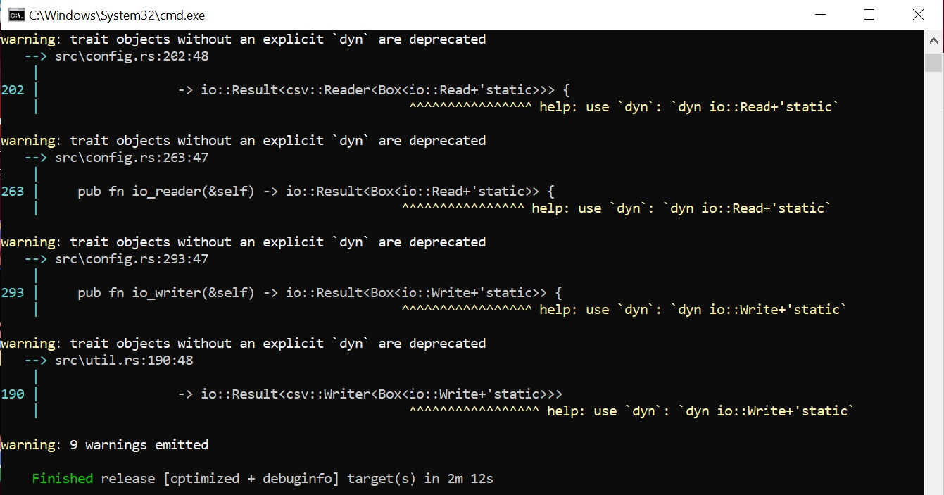

# 

# **Commands Run on it**

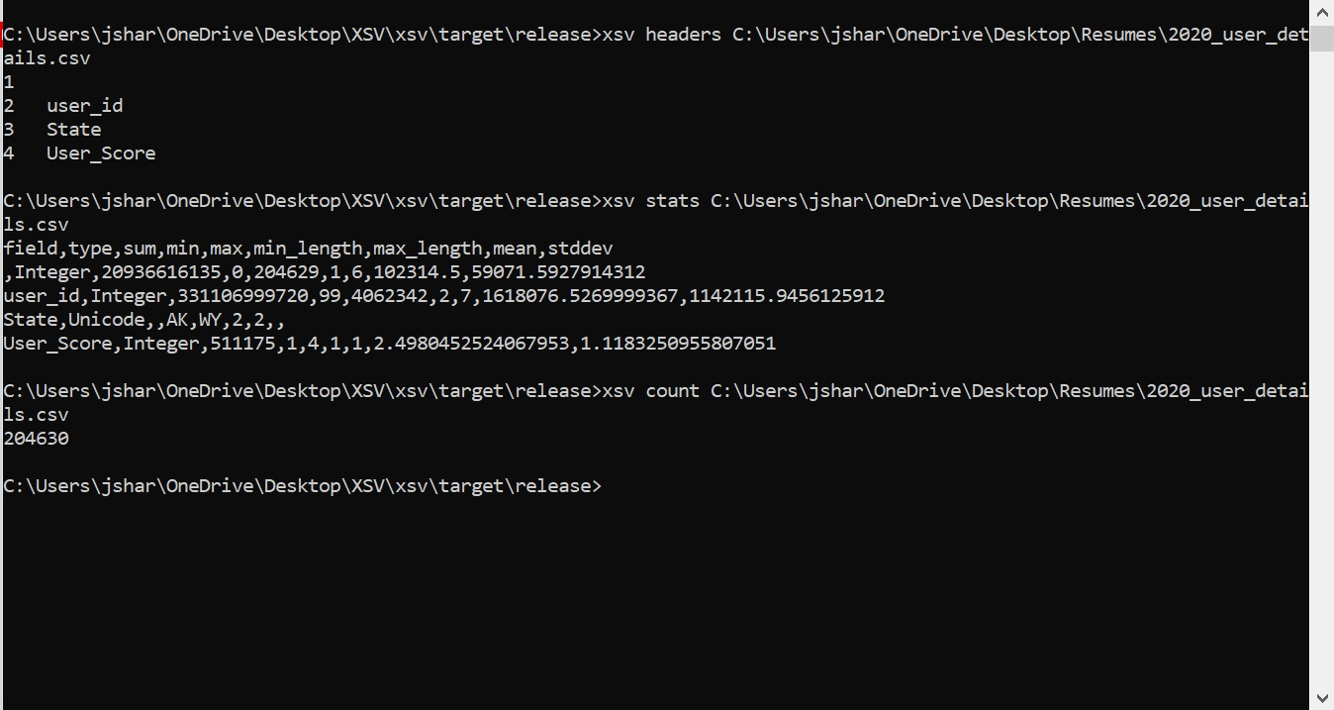

# **3 Lesson Learned**

1. XSV is a command-line program for indexing, slicing, analyzing, splitting, and joining CSV files.
2. I like xsv because it makes it extremely quick and easy to work with CSV files.
3. We can use XSV stats to view the stats such as sum, min, max, mean, and standard deviation. Thus it is very simple and fast to do calculations and generate results.