------- Book Store Application -----

Objectivities:

Provide users with well-informed details about the wide range of books, users experience with the books and their ratings, recommendations to others etc.

Tools and Technologies:

Java-11, Spring Tool Suite/Eclipse, Maven, JDBC with MySQL-8.

Application Description:

This application is developed into two interfaces with admin and user interfaces, based on the roles and requirements of each.

Admin is welcomed with the interface which provides regulation of application as a whole and is able to add new book or remove the existing one from application, if required. He can see all the users who have registered and also all the books and able to find which books performing better based on ratings. He also has blocking and unblocking rights, if any misconceptions occur because of any user.

Users have explorative options to dive into bookish-world. But before that they have account with the application. If don’t have one, they can register as a new user. Being a user, he can see all the books and their details. He can rate a book based on his experience and also can recommend to others.

Functions:

Admin specific functionalities:

1. Show / Add / Update / Remove a book
2. Able to find Top Rated / Recommended books
3. Block or Unblock a user

User specific functionalities:

1. Able to see all books and their details
2. Can rate and recommend a book
3. Can see books, he rated or recommended.
4. Can see cumulative ratings of all the books

Welcome screen interfaces: User Screen:

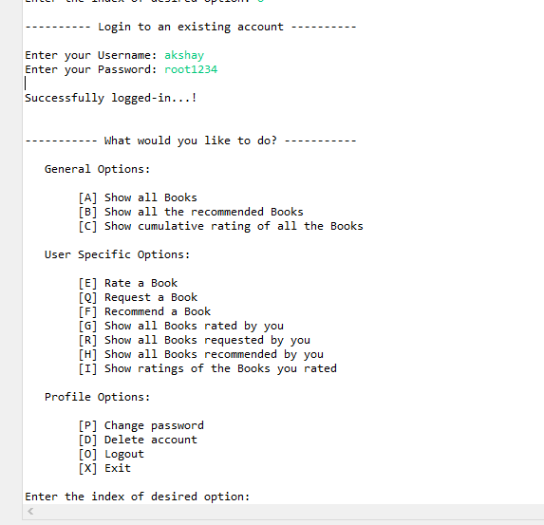

Admin screen interface:

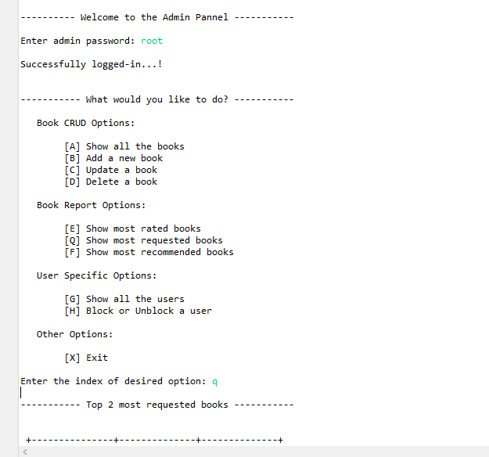

Database tables used:

This application has four tables named as Users, Books, Ratings, Recommendations, Blocklists and Requests table for books requested by users. Their properties are described below.

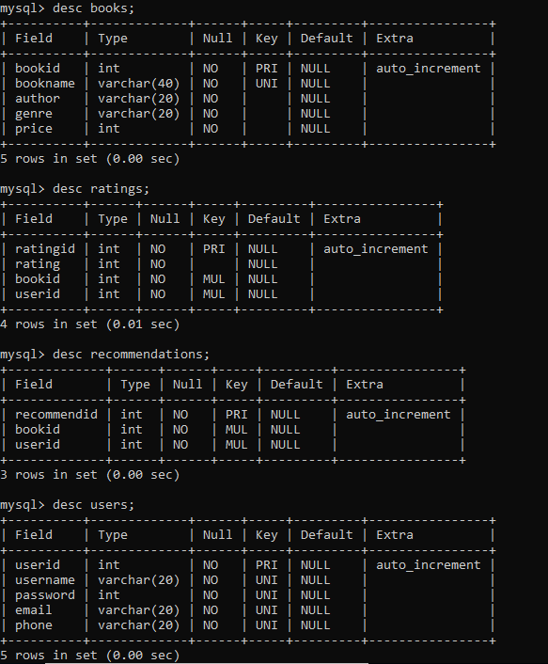

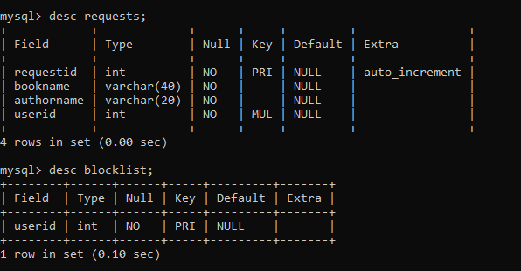

**Developed by Akshay Nile and Thirupathi Reddy.**

**Under the guidance of our mentor @Payal.**