**ABSTRACT**

With the changing of time world has become faster & smarter. In todays date it very necessary to compete with world to survive. The thesis explains the construction of “VIRTUALAB” BELIEVE THAT web site. The practical experience is very essential component in education especially in the UG’s & PG’s education. The student develops the practical skill such as real world problem solving.

The aim of the “VirtuaLab” project is to provide student access via the internet to various labs conducted in different ways in different colleges. In the “VirtuaLab” they are able to gain some unique problem solving technics. The objective is to develop a user – friendly educational site where any student can accesses the Lab and gain value added services from the colleges and staff.

**ACKNOWLEDGEMENT**

I consider it is privilege to express my sincere gratitude and respect to all those who guided and inspired throughout this project.

I express my sincere regards and thanks to our guide **Prof. Sneha Palankar** lecture of BCA Department, Jagadguru Tontadarya College, Gadag. For her valuable guidance and suggestions during the courses of this project. The successful of this project owes to her co-ordination and streamlining of the project progress.

I would like to express my immense gratitude of **Prof. S. S. Gurubasavangouder** Principle/ Co-ordinator, Jagadguru Tontadarya College, for his timely help and inspiration during the tenure of this course.

I express deep sense of gratitude to our academic coordinator **Prof. Sneha Palankar** of BCA Department, Jagadguru Tontadarya College, Gadag.

I also thankfully acknowledge the help we received form **Prof. S. S. Gurubasangoudar, Miss Shridevi Rachayyanavar, Prof Gowra Yalamail** of BCA Department, Jagadguru Tontadarya College, Gadag, for their kind supporting completing the project.

**Project Associates:**

Akshay D Vyas (13U11608 )

**CONTENTS**

**CHAPTER 1 INTRODUCTION 1**

1.1 INTRODUCTION TO THE PROJECT 1

1.2 PURPOSE OF THE PROJECT 2

1.3 PROBLEM ON EXISTING SYSTEM 2

1.4 SOLUTION OF THESE PROBLEMS 2

**CHAPTER 2 SYSTEM ANALYSIS 3**

2.1 STUDY OF THE SYSTEM 3

2.2 PROPOSED SYSTEM 6

2.3 INPUT AND OUTPUT 7

2.4 PROCESS MODEL USED WITH JUSTIFICATION 8

**CHAPTER 3 FEASIBILITY STUDY 9**

3.1 TECHNICAL FEASIBILITY 9

3.2 OPERATIONAL FEASIBILITY 10

3.3 ECNOMICAL FEASIBILITY 10

**CHAPTER 4 SOFTWARE REQUIREMENT SPECIFICATION 11**

4.1 FUNCTIONAL REQUIRMENT 12

4.2 PREFORMANCE REQUIRMENT 17

4.3 SOFTWARE REQUIRMENTS 19

4.4 HARDWARE REQURIMENTS 19

**CHAPTER 5 TESTING 20**

5.1 METHODOLOGY USED FOR TESTING 20

5.2 WHITE BOX TESTING 21

5.3 BLACK BOX TESTING 21

**CHAPTER 6 SYSTEM DESIGN 22** 6.1 INTRODUCTION 22

6.2 NORMALIZATION 22

6.3 E – R DIAGRAM 24

6.4 DATA FLOW DIAGRAM 27

6.5 UML DIAGRAM 36

6.6 DATA DICTIONARY 37

**CHAPTER 7 SYSTEM DEVELOPMENT AND IMPLIMENTATION 41**

7.1 IMPLEMENTATION 41

**CHAPTER 8 OUTPUT SCREEN 51**

**CHAPTER 9 SYSTEM SECURITY 54**

9.1 INTRODUCTION 54

9.2 SECURITY IN SOFTWARE 55

**CHAPTER 10 ADVANTAGES 57**

**CHAPTER 10 CONCLUSION 58**

**CHAPTER 11 FUTURE SCOPE 59**

**BIBILIOGRAPHY**

CHAPTER 1

INTRODUCTION

1.1 INTRODUCTION TO PROJECT

Physical distances and the lack of resources make us unable to perform experiments, especially when they involve sophisticated technique. Also, good teachers are always a scarce resource. Web-based courses address the issue of teaching to some extent. Conducting joint experiments by two participating institutions and also sharing costly resources has always been a challenge. With the present day internet and computer technologies the above limitations can no more hamper students and researchers in enhancing their skills and knowledge. Web enabled experiments can be designed for remote viewing so as to enthuse the curiosity and innovation into students. This would help in learning basic and advanced concepts through remote experimentation. Internet-based experimentation further permits use of resources – knowledge, software, and data available on the web, apart from encouraging skilful experiments being simultaneously performed at points separated in space (and possibly, time).

For instance, we go for Lab Practical’s and we are guided how to do each and every Practical’s, after when we meet our friends and try to explain the practical what we have thought will be different for both. Were either what we have learnt will be unique or what they have learnt will be unique. It will be very disappointing movement for anyone at that time because they missed something which was unique, simple and very helpful. We all know that practical life is more useful than anything else. As if now it’s not possible to go for each college to see how and in which way the Practical’s are thought as we don’t have time to travel all over the college and to collect the notes as the distance will be more.

Where the distance is reduced to get the skill we go the “VIRTUALAB” Believe That. This provides the interface for various colleges to get connected with students to enhance their skill.

**1.2 PURPOSE OF THE PROJECT**

The purpose of this project is taking an example of Student Life and how to avoid those problems related to Lab Practical’s.

**1.3 PROBLEM ON EXISTING SYSTEM**

In the present way there is no such media through which student can access Lab Activities in various colleges.

**1.4 SOLUTION OF THESE PROBLEMS**

“VIRTUALAB” allows various colleges to get registered, and colleges are then allowed to add those departments of Lab activates. Student can than access all the Lab Activities of college those are registered.

CHAPTER 2

SYSTEM ANALYSIS

**2.1 STUDY OF THE SYSTEM**

In flexibility of the uses the interface has been developed a graphics concept in mind, associated through a browser interface. The GUI’s at the top level have been categorised as

1. Administrative user interface

2. The operational or generic user interface

The administrative user interface concentrates on the consistent information that is practically, part of the organizational activities and needs proper authentication for the data collection. The interface helps the administrations with the transactional states like data insertion, data deletion, and data updating along with extensive data search capabilities.

The operational or generic user interface helps the user upon the system in transaction through the existing data and required services. The operational user interface also helps the ordinary user in managing their own information helps the ordinary users in managing their own information in a customized manner as per the assisted flexibilities.

Modules:

This application consists following modules

1. Admin module

2. College module

3. Staff module

4. Student module

**Admin module**

* Can register a new college details into system.
* Admin can view all the college details.
* Admin can view the files staff details.
* Admin can view student details.

**College module**

* College should get register to the site with admin rights.
* College can add its department.
* College can register its staff.

**Staff module**

* Staff can add their own Lab Activities in .png, .jpg, .pdf format.
* Staff can edit their profile.
* Staff can view student query and respond to it.

**Student module**

* Student can register to the site with personal details.
* Student should mention the course they are studying and in which college.
* Student can view any college Lab Activities.
* Student can download the file.
* Student can ask query to particular staff of any college.

**Registration**

The system has a process of registration. Every Student needs to give his complete details in the form of registration. Whenever student registration is completed they are cross verified by the college they have selected. College needs to verify they student and make them active.

**Authentication:**

Authentication is nothing but providing security to the system. Hence everyone should get enter into the system throw the login page. The login page will restrict the unauthorised user. A user must provide his credential like User ID and password for login to the system.

Whenever User enters his User ID and Password, it checks in the details in the database for user existence. If the user exists they can be treated as valid user. Otherwise the request will throw back.

**SOFTWARE REQUIREMENTS**

* + - Windows XP – SP2 / 7 / 8.1 above
    - SOFTWARE: Dreamweaver
    - BROWSERS: INTERNET EXPLORE, GOOGLE CHROME

**HARDWARE REQUIREMENTS**

* + - Processor: Dual core (2.0) GHz or Core to Duo or above
    - RAM: 1 GB
    - HDD: 120GB

**2.2 PROPOSED SYSTEM**

To debug the existing system, remove procedure those cause data redundancy, make navigational sequence proper. To provide information about users on different level and also to reflect the current work status depending on organization. To build strong password mechanism.

**Need For Computerization**

We all know the important of computerization. The world is moving ahead at lightning speed and everyone is running short of time. One always wants to get the information and perform a task they desire within a short period time and too with amount of efficiency and accuracy. The application areas for the computerization have been selected on the basis of the following:

* Minimizing the manual records kept at different location.
* There will be more data integrity.
* Facilitating desired information displays, very quick, by retrieving information from user.
* Facilitating various statistical information which helps in decision making?
* To reduce manual efforts in activates that involved repetitive work.

**Functional Feature of the model**

As far as the project is developed the functionality is simple, the objective of the proposal is to strengthen the functioning of Audit status monitoring and make them effective and better. The entire scope has been classified into five streams known as Coordinator level, Management Level. Auditor Level and State Web Coordinate Level. The proposed software will cover information needs with respect to each request of the user group viz. accepting the request, providing vulnerability document report and current status of the audit.

**2.3 INPUT AND OUTPUT**

The major inputs and outputs and major function of the system are follows:

**INPUTS:**

* Admin entries his user id and password to get login.
* Admin adds the college.
* Admin can view college details
* Admin can view staff details
* Admin can view student details.

**OUTPUT:**

* Admin can get staff and student information.
* Admin can get all the files information.
* Admin can get their queries information.
* Can generate college reports.

**2.4 PROCESS MODEL USED WITH JUSTIFICATION**

Access control for data which requires user authentication:

The following commands specify access control identifiers and they are typically used to authorised and authenticate the user.

**USER NAME:**

The user identification is that which is required by the server for access to its files system. This command will normally be the first command transmitted by the user after the control connections are made.

**PASSWORD:**

This command must be immediately preceded by the user name command and for some sites, completes the user’s identification for access control. Since password information is quite sensitive, it is desirable in general to make “mask” it suppress type of it.

CHAPTER 3

**FEASIBILITY STUDY**

**FEASIBILITY REPORT**

Preliminary investigation examines project feasibility. The likelihood system will be useful to the organisation. The main objective of the feasibility study is to test the technical, Operational & Economical feasibility for adding new modules and debugging old running system. All the system is feasible if they are given unlimited resources and infinite time. There are aspects in the feasibility study portion of the preliminary investigation.

* Technical Feasibility
* Operational Feasibility
* Economic Feasibility

**3.1 TECHNICAL FEASIBILITY**

The technical issue usually raised during the feasibility stage of the investigation includes:

* Does the necessary technology exits to do what is suggested?
* Do the proposed equipment’s have the technical capacity to hold the data required to use the new system?
* Will the proposed system provide adequate response to inquiries, regardless of the number or location of user?
* Can the system be upgraded if developed?
* Are there technical guarantees of accuracy, reliability, ease of access and Data security?

**3.2 OPERATONAL FEASIBILITY**

Proposed project are beneficial only if they can be turned out into information system, which will meet the organisation’s operating requirement. Operational Feasibility aspects of the project are to be taken as an important part of the project implementation. Some of the important issues raised are to test operational feasibility of a project includes the following:

* Is there sufficient support for the management from the user?
* Will the system be used and work properly if it is being developed and implemented?
* Will there be any resistances from the user that will undermine application benefits?

This system targeted to be in accordance with the above mentioned issue. Beforehand, the management issues and user requirement have been taken into consideration. So there is no question of resistance from the user that can undermine the possible application benefits. The well planned design would ensure optimal utilisation of the computer resources and would help in the improvement of performance state.

**3.3 ECONOMICAL FEASIBILITY**

A system can be developed technically and that will be used if installed must still be a good investment for the organisation. In the economically feasibility, the development cost in creating the system is evaluated against the ultimate benefit derived from the new system. Financial benefits equal or exceed the cost. The system is economically feasible. It does not require additional hardware or software.

CHAPTER 4

SOFTWARE REQUIREMENT SPECIFICATION

**INTRODUCTION**

The software, sites explore is designed for the management of the web site from a remote location.

**Purpose:**

The main purpose for preparing this doucument is to give a general insight into the analysis and requirement of the existing system or situation and for determining the operating characteristics of the system.

**Scope:**

This document plays a vital role in the development life cycle and described the complete requirement of the system. It meant for the system. It is meant for the use by the developers and will be the basic during testing phase. Any changes made to the requirement in the future will have to go through formal change approval process.

**Developers Responsibilities Overview:**

The developer is responsible for:

* Developing the system, which meets the SRS and solving all the requirements of the system?
* Demonstrating the system and installing the system at client’s location after the acceptance testing is successful.
* Submitting the required user manual describing the system interface to work on it and also the documents of the system.
* Conducting any user training that might be needed for using the system.
* Maintaining the system for period of one year after installation.

**4.1 FUNCTIONAL REQUIRMENTS**

**OUTPUT DESIGN**

Outputs from computer system are required primarily to communicate the results of processing to users. They are also used to provide a permanent copy of the results of for later consultation. The various types of outputs in general are:

* External Outputs whose destination is outside the organization.
* Internal Outputs whose destination is within organization.
* User’s main interface with computer.
* Interface outputs whose use is purely within the computer department.

**OUTPUT DEFINATION**

The output should be defined in terms of the following points:

* Type of the output.
* Content of the output.
* Format of the output.
* Location of the output.
* Frequency of the output.
* Volume of the output.
* Sequence of the output.

It is not always desirable to print or display data as it is held on computer. It should be decided as which form of the output is the most suitable.

For Example

* Will decimal points need to be inserted?
* Should leading zeros be suppressed.

**OUTPUT MEIDA:**

In the next stage it is to be decided that which medium is the most appropriate for the output. The main consideration when deciding about the output media are:

* The suitability for the device to particular application:
* The need for hard copy.
* The response time required.
* The location of the user.
* The software and hardware available.

Keeping in view the above description the project is to have outputs mainly coming under the category of internal outputs. The main outputs desired according to the requirement specification are:

The outputs were needed to be generated as a hot copy and as well as queries to be viewed on the screen. Keeping in views these outputs, the format for the output is taken from the outputs, which are currently being obtained after a manual processing. The standard printer is to be used as output media for hard copies.

**INPUT DESIGN**

Input design is a part of overall system design. The main objective during the input design is as given below:

* To produce a cost effective method of input.
* To achieve the highest possible level of accuracy.
* To ensure that the input is acceptable and understood by the user.

**INPUT STAGES:**

The main input stags are:

* Data recording.
* Data transcription.
* Data conversion.
* Data verification.
* Data control.
* Data transmission.
* Data validation.
* Data correction.

**INPUT TYPES:**

It is necessary to determine the various types of inputs. Inputs can be categorized follows:

* External inputs which are prime inputs for the system.
* Internal inputs which user communications with system.
* Operational which are computer department’s communications to the system?
* Interactive which are inputs entered during a dialogue.

**INPUT MEDIA:**

At this stage choice has to be made about the input media. To conclude about the input media consideration is to given:

* Type of input.
* Flexibility of format.
* Speed
* Accuracy
* Verification methods.
* Rejection rates.
* Ease of correction.
* Storage and handling requirements.
* Security.

Keeping in view the above description of the input and type and input media, it can be said that most of the inputs are of the form of internal and interactive. As input data is to be directly keyed in by the user, the keyboard can be considered to be the most suitable input device.

**ERROR AVOIDANCE**

At this stage care is to be taken to ensure that input data remains accurate from the stage at which it is recorded up to the stage in which the data is accepted by the system. This can be achieved only by means of carful control each time the data is handled.

**ERROR DETECTION**

Even though every effort is make to avoid the occurrence of errors, still a small proportion of errors are always likely to occur, these types of errors can be discovered by using validations to check the input data.

**DATA VALIDATION**

Procedures are designed to detect errors in data at lower level of detail. Data validations have been included in the system in almost every area where there is a possibility for the user to commit errors. The system will not accept invalid data. Whenever an invalid data is keyed in, the system immediately prompts the user and the user has to again key in the data and system will accept the data only if the data is correct. Validation have been included where necessary.

The system is designed to be a user friendly one. In other word the system has been designed to communicate effectively with the user. The system has been designed with popup menus.

**USER INTERFACE DESIGN**

It is essential to consult the system users and discuss their needs while designing the user interface:

**USER INTERFACE SYSTEMS CAN BE BROADLY CLASIFIED AS:**

* User Initiated Interface

The user is in charge, controlling the progress of the user/computer dialogue. In the computer initiated interface, the computer selects the next stage in the interaction.

* Computer initiated Interface:

In the computer initiated interface the computer guides the progress of the user/computer dialogue. Information is displayed and the user response of the computer takes action or displays further information.

**USER INITIATED INTERGFACES**

User initiated interface fall into two approximate classes:

* Command driven interface: in this type of interface the user commands or queries which are interpreted by the computer.
* Forms oriented interface: The user calls up an image of the form to the screen and fills in the form. The forms oriented interface is chosen because it is the best choice.

**COMPUTER INITIATED INTERFACES**

The following computer initiated interfaces were used:

* The menu system for the user is represented with list of alternatives and the user chosen one of alternative.
* Question – answer type dialog system where the computer asks question and takes action based on the basis of the user reply.

Right from the start the system is going to menu driven, the opening menu displays the available options. Choosing one option gives another popup menu displays the more options. In this way every option leads the user to data entry from where the user can key in the data.

**ERROR MESSAGE DESIGN:**

The design of error message is an important part of the user interface design. As user is bound to commit some errors or other while designing a system the system should be designed to be helpful by providing the user with the information regarding the error they have committed.

The application must be able to produce output at different modules for different inputs.

**4.2 PERFORMANCE REQUIRMENTS**

Performance is measured in terms of the output provided by the application. Requirements specification plays an important role in the analysis of system. Only when the requirement specifications are properly given, it is possible to design a system, which will fill into required environment. It rests largely in the part of users of existing system to give the requirement specification because they are the people who finally use the system. This is because the requirement have to be known during the initial stages so that the system can be designed according to those requirements. It is very difficult to change the system once it has been designed and on the other hand designing a system, which does not cater to the requirement of the user, if of no use.

The requirement specification for any system can be broadly stated as given below:

* The system should be able to interface with the existing system.
* The system should be accurate.
* The system should be better than existing system.

The existing system is completely dependent on the user to perform all the duties.

**APPLICATION DEVELOPMENT**

**N – Tire Application:**

N – Tire application can easily implement the concepts of Distributed Application Design and Architecture. The N – Tire application provides strategic benefits to Enterprise Solutions. While 2 – Tire, client-server can help us create quick and easy solutions and may be used for Rapid Prototyping they can easily become a maintenance and security night mare.

The N – Tire Application provide specific advantages that are vital to the business continuity of the enterprise. Typical features of a real life N – Tire may include :

* Security
* Availability and scalability
* Manageability
* Easy maintenance
* Data abstraction

The above mentioned points are some of the key design goals of successful N – Tire Application that intend to provide a good business solution.

**Definition:**

Simply stated, an N – Tire Application helps us distribute the overall functionality into various tires or layer.

* Presentation Layer
* Business Rules Layer
* Data Access Layer
* Database / Data Store

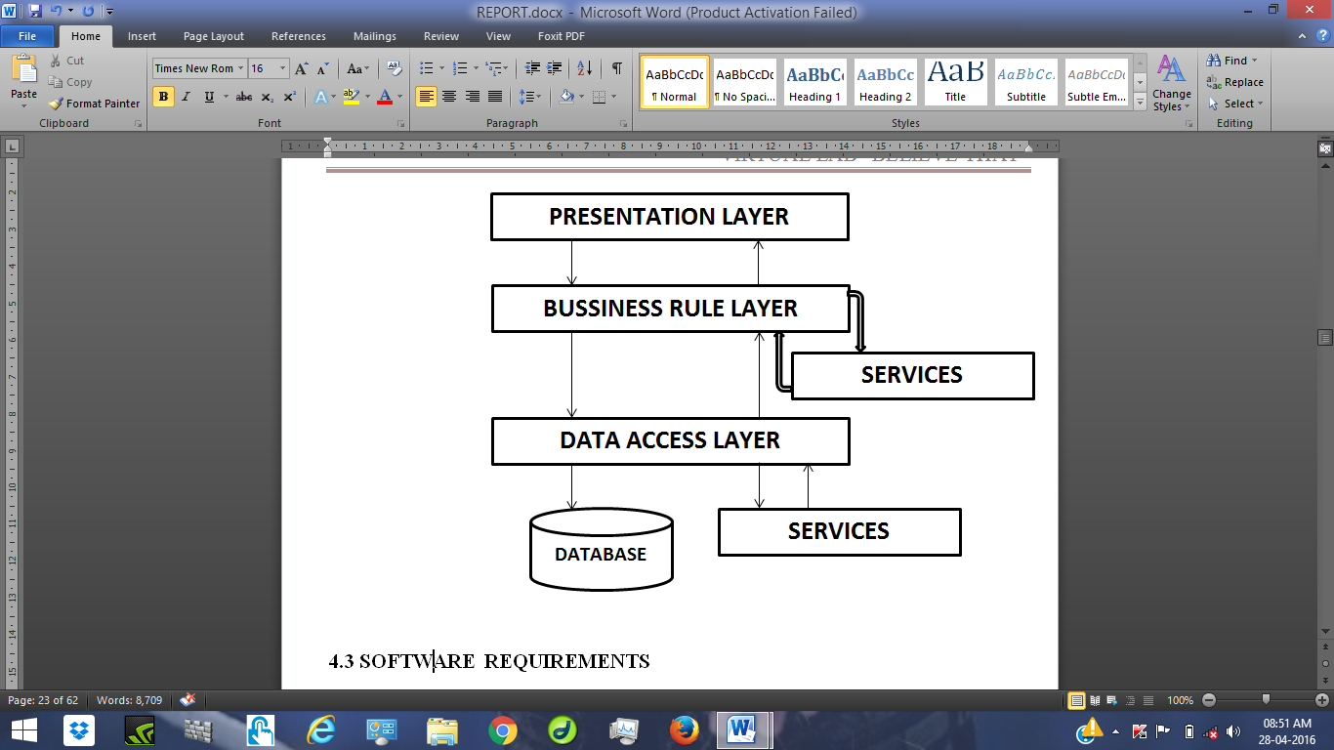

**4.3 SOFTWARE REQUIREMENTS**

Operating System : Windows XP – SP2 / 7 / 8.1 above

SOFTWARE : Dreamweaver

BROWSERS : INTERNET EXPLORE, GOOGLE CHROME

**4.4 HARDWARE REQUIREMENTS**

Processor : Dual core (2.0) GHz or Core to Duo or Above

RAM : 1 GB Above

HDD : 120GB Above

**CHAPTER 5**

**TESTING**

**5.1 METHADOLOGY USED FOR TESTING**

Testing is the process of detecting errors. Testing performs a very critical role for quality assurance and for ensuring the reliability of software. The results of testing are used later on during maintenance also.

**LEVEL OF TESTING**

In order to uncover the errors present in different phases we have the concept of levels of testing. The basic levels of testing are follows:-

**System Testing**

The philosophy behind testing is to find errors. Test cases are devised with this in mind. A strategy employed for system testing is code testing.

**Code Testing**

This strategy examines the logic of the program. To follow this method we developed some test data that resulted in executing every instruction in the program and module i.e. every path is tested. System is not designed as entire nor are they tested as single systems. To ensure that the coding is perfect two types of testing is performed or for that matter is performed on all system.

**Types of Testing**

* Unit Testing
* Link Testing

**Unit Testing**

Unit testing focuses verification effort on the smallest unit of software i.e. the module. Using the detailed design and the process specification testing is done to uncover errors within the boundary of the modules must be successful in the unit test before the start of the integration testing begins.

In this project each service can be thought of a module. Giving different set of inputs has tested each module. When developing the module as well as finishing the development so that each module works without any error. The inputs are validated when accepting from the user.

**System Testing**

Here the entire software system is tested. The reference document for this process is the requirement document, and the goal OS to see if software meets its requirements.

Here entire ‘ATM’ has been tested against requirements of project and it is checked whether all requirements of project have been satisfied or not.

**Acceptance Testing**

Acceptance Test is performed with realistic data of the client to demonstrate that the software is working satisfactorily. Testing here is focused on external behavior of the system: the internal logic of program is not emphasized.

In this project ‘Network Management of Database System’ I have collected some data and tested whether project is working correctly or not.

It is the process of finding errors and missing operations and also a complete verification to determine whether the objectives are met and the user requirements are satisfied.

**5.2 White Box Testing**

This is a unit testing method where a unit will be taken at a time and tested thoroughly at a statement level to find the maximum possible errors. I tested step wise every piece of code, taking care that every statement in the Code is executed at least once. The white box testing is also called Glass Box Testing.

I have generated a list of test cases, sample data. This is used to check all possible combinations of execution paths though the code at every module level.

**5.3 Black Box Testing**

This testing method considers a module as a single unit and checks the unit at interface and communication with other module rather getting into details at statement level. Here the module will be treated as a block box that will take some input and generate output. Output for a given set of input combination is forwarded to other modules.

CHAPTER 6

SYSTEM DESIGN

**6.1 INRODUCTION**

Software design sits at that technical kernel of the software engineering process and is applied regardless of the development paradigm and area of application. Design is the first step in the development phase for any engineered product or system. The designer’s goal is to produce a model or requirement have been specified and analysed, system design is the first of three technical activities design, code and test that is required to build and verify software.

The importance can be stated with a single word “quality”. Design is the place where quality is fostered in software development. Design provides us with representation of software that can assess for quality. Design is the only way that we can accurately translate a customer’s view into finished software product or system. Software design serves as a foundation for all the software engineering steps that follow. Without a strong design we risk building an unstable system – one that will be difficult to test, one whose quality cannot be assessed until the last stage.

During design, progressive refinement of data structure, program structure, and procedural details are developed reviewed and documented. System design can be viewed from either technical or project management perspective. From technical point of view, design is comprised of four activities – architectural design, data structure design, interface design and procedural design.

**6.2 NORMALIZATION**

It is a process of converting a relation to standard form. The process is used to handle the problems that can arise due to data redundancy i.e., repetition of data in the database, maintain data integrity as well as handling problems that can arise due to insertion, updating, deletion anomalies. A relational database consists of collection of variables, each of which is assigned a unique name. A row in table represents the relational ship among a set value. Since a table is a set of such relationships, there is a close correspondence between the concept of the table and the mathematical concept of relation model comes into picture.

The global aim of relational aim is to generate an asset of relations, which allows storing information without redundancy and also allowing us to store and retrieve information with ease. One approaches to design scheme that is in appropriate level of redundancy.

The table are organized so as to:

* Reduce duplication of the data
* Minimize addition, deletion and updating anomalies
* Simplify querying data from the database

The method of organizing or structuring data into table by eliminating anomalies is known as normalization. Decomposing is the process f slitting relations into multiple relations to eliminate anomalies and maintan anomalies and maintain data integrity. To do this we use normal forms or rules for structuring relation.

**Insertion anomaly:**

Inability to add data to the database due to absence of other data.

**Deletion anomaly:**

Unintended loss of data due to deletion of other data.

**Update anomaly:**

Data inconsistency resulting from data redundancy and partial update.

**Normal Forms:**

These are the rules for structuring relations that eliminate anomalies.

**First Normal Form:**

A relation is said to be in first normal form if the values in the relation are atomic for every attribute in the relation. By this we mean simply that no attribute value can be set of values or, as it is sometimes expressed, a repeating group.

**Second Normal Form:**

A Relation is said to be in second normal form is it is in first normal form and it should satisfy anyone of the following rules:

* Primary key is not a composite primary key.
* No non key attributes are present.
* Every non key attribute is fully functionally dependent on full set of primary key.

**Third normal form:**

A relation is said to be in third normal form if their exits no transitive dependencies.

Transitive Dependency: If two non – key attributes depend on each other as well as on the primary key then they are said to be transitively dependent.

The above normalization principles were applied to decompose the data in multiple table thereby making the data to be maintained in a consistent state.

**6.3 E – R DIAGRAM**

**DATA FLOW DESIGN USING PROCESS MODULE (E R – MODULE)**

The basic object that the ER model represents is an entity, which is a “thing” in the real world with an independent existence; an entity may be an object with an independent existence. An entity may be and object with physical conceptual existence-accompany a job or university course. Each entity has particular properties called attributes that describe it.

For example the entity may be described by the user’s, email, password etc., particular entity will have value for its each of its attributes. The attributes value that described types of attributes occur in the ER model such as simple verse composite, single-valued verse multi valued and stored verse derived.

THE COMPONENT USED TO DRAW ER – DIAGRAM A ARE AS FOLLOWS

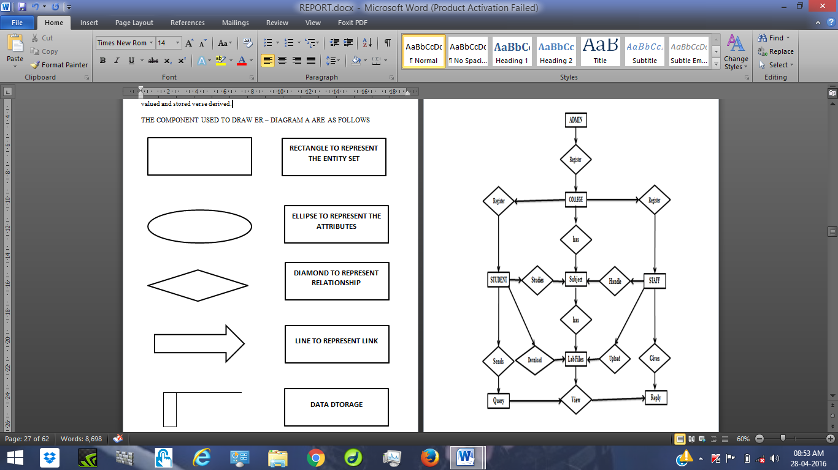

**ER diagram**

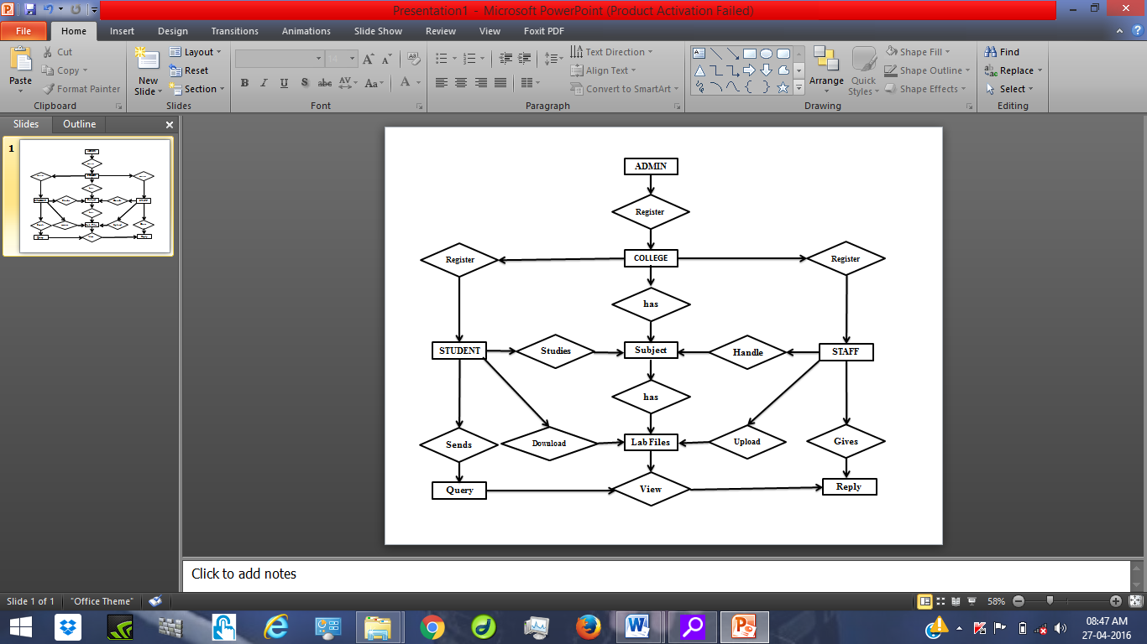

**6.4 DATA FLOW DIAGRAMS**

A data flow diagram is graphical tool used to describe and analyse movement of data through a system. These are the central tool and the basis from which the other components are developed. The transformation of data from input to output, through processed, may be described logically and independently of physical components associated with the system. These are known as the logical data flow diagrams. The between people, department and workstations. A full description of a system actually consists of set of data flow diagrams.

Using two familiar notations Yourdon, Gane and sarson notation develops the data flow diagrams. Each component in a DFD is labelled with a descriptive name.

Process is further identified with a number that will be used for identification purpose. The development of DFD’s is done in several levels. Each process in lower level diagrams can be broken down into a more detailed DFD in the next level. The top level diagram is often called context diagram. It consist a single process bit, which plays vital role in studying the current system. The process in the context level diagram is exploded into other process at the first level DFD.

The idea behind the explosion of a process into more process is that understanding at one level of details is exploded into greater details at the next level. This is done until further explosion is necessary and an adequate amount of detail is described for analyst to understand the process.

Larry Constantine first developed the DFD as a way expressing system requirement in a graphical from, this lead to the modular design.

A DFD is also known as a “Bubble Chart” has the purpose of clarifying system requirement and identifying major transformation that will become programs in system design. So it is starting point of the design to lowest level of details. A DFD consists of series of bubbles joined by data flows in the system,

**DFD SYMBOLS:**

In the DFD, there are four symbols

* A SQUARE: Defines a source (originator) or destination of system data.
* An ARROW: Identifies data flow.
* A CIRCLE: Represent a process that transforms incoming data flow into outgoing data flow.
* OPEN RECTANGLE: It is a data store, data at rest or temporary repository of data.

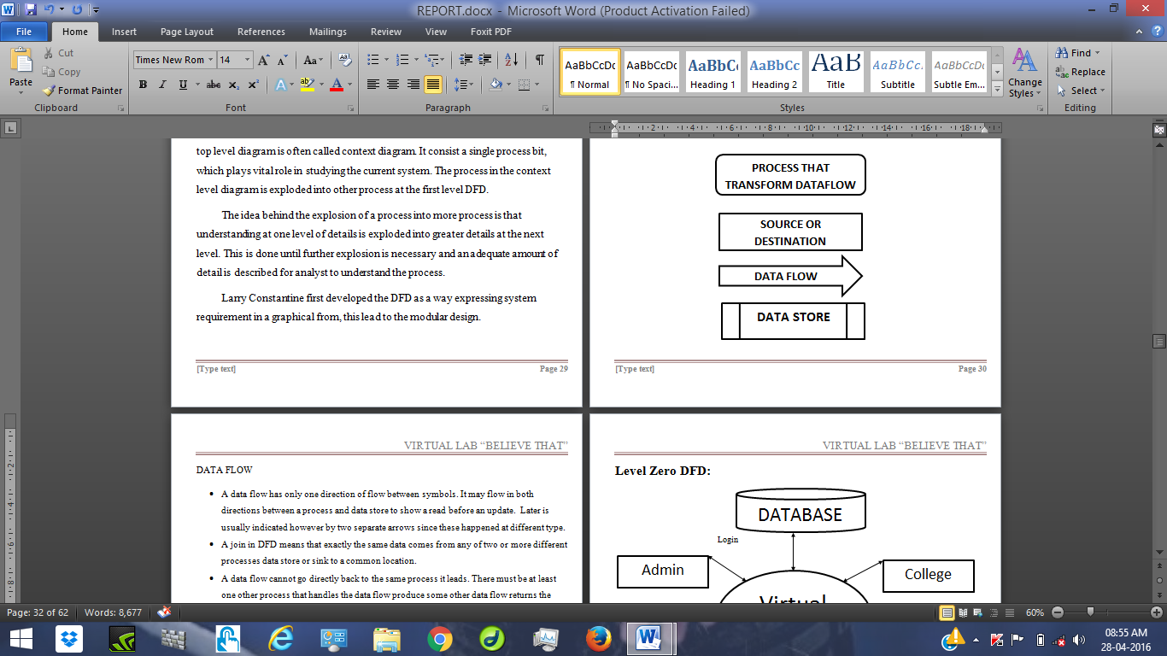

**DATA FLOW**

* A data flow has only one direction of flow between symbols. It may flow in both directions between a process and data store to show a read before an update. Later is usually indicated however by two separate arrows since these happened at different type.
* A join in DFD means that exactly the same data comes from any of two or more different processes data store or sink to a common location.
* A data flow cannot go directly back to the same process it leads. There must be at least one other process that handles the data flow produce some other data flow returns the original data into the beginning process.
* A Data flow to a data store means update (delete or change).
* A Data flow from a data store means retrieve or use.

A data flow has a noun phrase label more than one data flow noun phrase can appear on a single arrow as long as all the same arrow move together as one package.

**Level Zero DFD:**

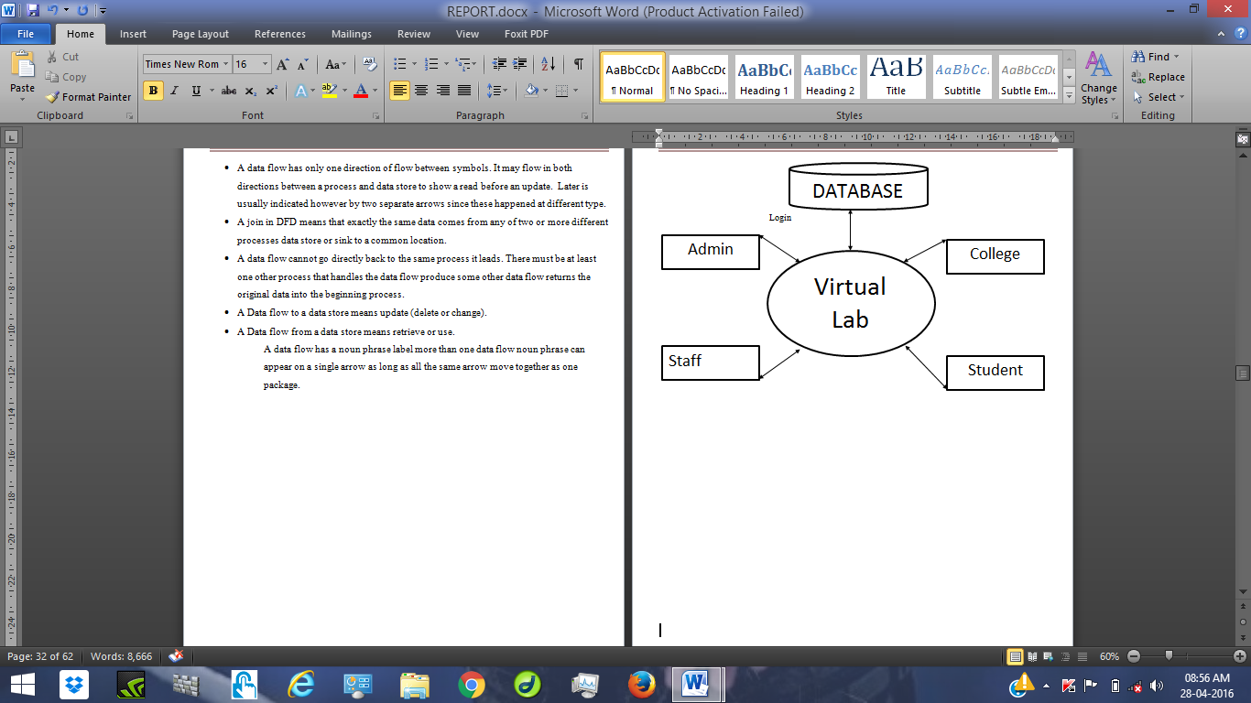

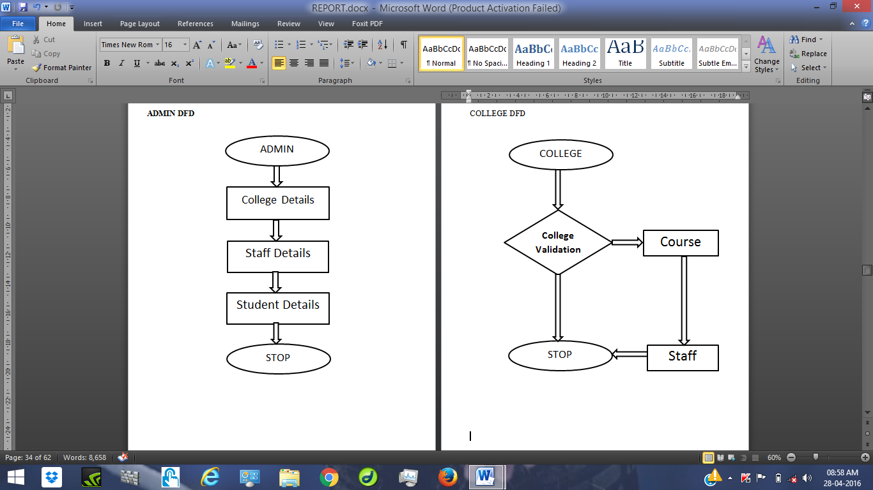



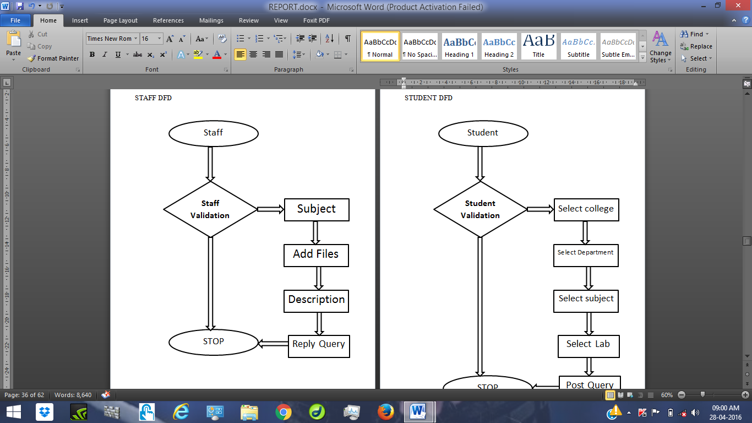

STUDENT DFD

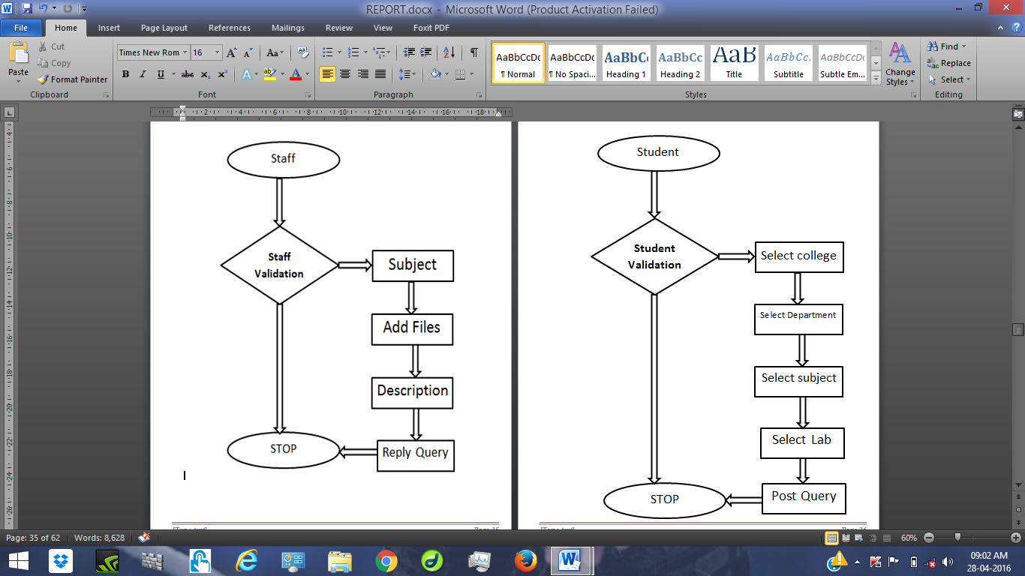

**6.5 UML DIAGRAMS**

**Use Case Diagrams**

A use case diagram is a diagram that shows a set of use cases and actors and their relationships enclosed by a system boundary.

Use case diagram represents the functionality of the system from a user’s point of view. Use cases are used during requirements elicitation and analysis to represent the functionality of the system. Use cases focus on the behaviour of the system from externals point of view.

Actors are external entities that interact with system. Examples of actors include users like administrator, bank, customer etc. or another system like central database.

**USE CASE MODEL**

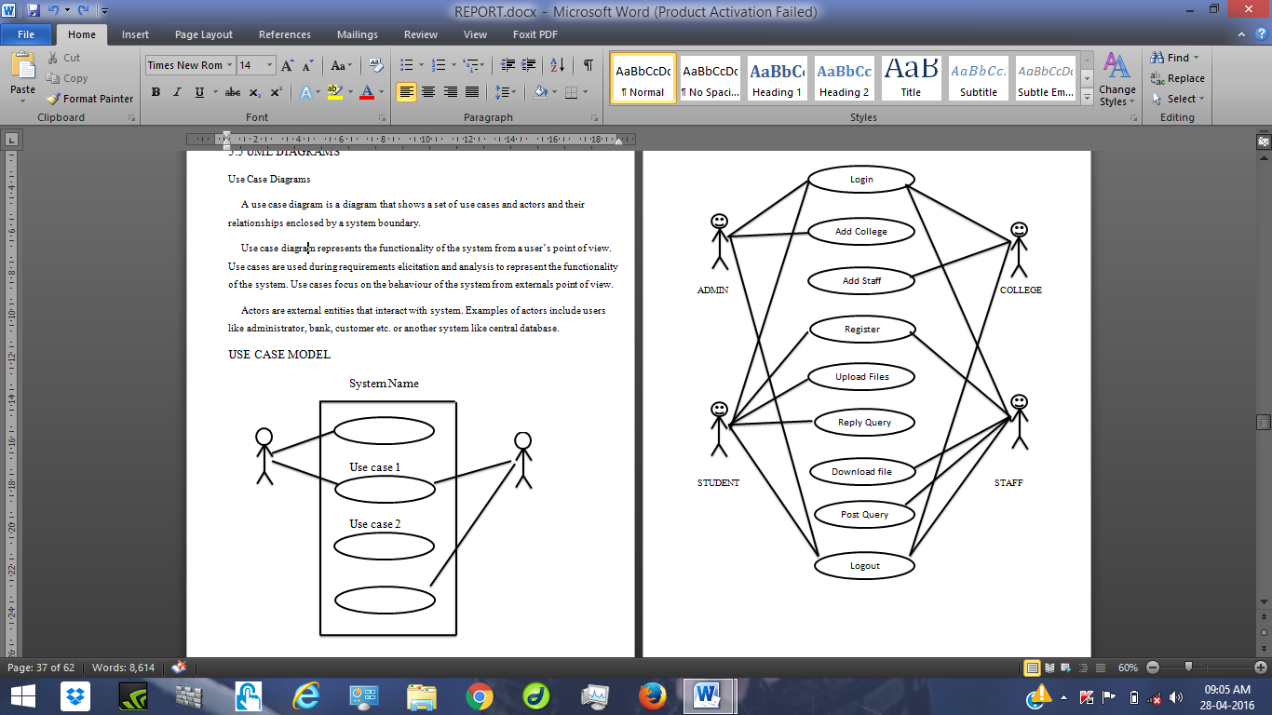



**6.6 DATA DICTIONARY**

After carefully understanding the requirement of the client the entire data storage requirement are divided into table. The below table are normalized to avoid any anomalies during the course of data entry.

**Tables Design**

**Table: attached_files**

|  |  |
| --- | --- |
| **Field Name** | **Data Type** |
| attached_id | int(100) |
| attached_by | varchar(100) |
| attached_date | varchar(100) |
| Title | varchar(100) |
| attached_file | varchar(100) |
| subject_id | int(50) |

**Table: category**

|  |  |
| --- | --- |
| **Field Name** | **Data Type** |
| Id | int(50) |
| category_name | varchar(100) |
| Description | Varchar(200) |

**Table: clg**

|  |  |
| --- | --- |
| **Filed Name** | **Data Type** |
| clg_id | int(20) |
| clg_name | varchar(100) |
| clg_city | varchar(100) |
| clg_address | varchar(100) |

**Table: course**

|  |  |
| --- | --- |
| **Filed Name** | **Data Type** |
| course_id | int(100) |
| clg_id | int(30) |
| Duration | varchar(100) |
| course_name | varchar(100) |
| sem_id | int(100) |

**Table: dept**

|  |  |
| --- | --- |
| **Filed Name** | **Data Type** |
| dept_id | int(100) |
| dept_name | varchar(100) |
| Description | varchar(100) |

**Table: login**

|  |  |
| --- | --- |
| **Filed Name** | **Data Type** |
| Username | varchar(100) |
| Password | varchar(100) |
| Type | varchar(100) |
| hint_qst | varchar(100) |
| hint_ans | varchar(100) |
| Status | varchar(100) |

**Table: queries**

|  |  |
| --- | --- |
| **Filed Name** | **Data Type** |
| q_id | int(50) |
| q_from | varchar(100) |
| q_to | varchar(100) |
| query_desc | varchar(100) |
| Reply | varchar(100) |

**Table: sem**

|  |  |
| --- | --- |
| **Filed Name** | **Data Type** |
| sem_id | int(100) |
| sem_name | varchar(100) |
| s_course_id | varchar(100) |

**Table: subject**

|  |  |
| --- | --- |
| **Filed Name** | **Data Type** |
| subject_id | int(100) |
| sub_name | varchar(100) |
| course_id | varchar(100) |
| Sem | varchar(100) |

CHAPTER 7

SYSTEM DEVELOPMENT AND IMPLEMENTATION

7.1 **Implementation**

Implementation is the realization of an application, or execution of a plan, idea, model, design, specification, standard, algorithm, or policy and it is a process of having the systems personnel check out and put new equipment’s into use, train users, install new application a and construct any files of data needed to use it.

Another factor to be considered in the implementation phase in the acquisition of the hardware and software. Once the software is developed for the system and testing is carried out, it is the process of making the newly designed system fully operational and consistent in performance. To implement ‘*Student Relationship Staff*’, we have made use PHP language with Mysql.

Implementation is the process of converting a new revised system design into operation. The objective is to put the new revised system, which has been tested into operation while holding costs, risks and personal irritation to the minimum. A critical aspect of the implementation process is to ensure that there will be no description in the function of the organization. The best methods for gaining control while implementation any new system would be to use well-planned test files testing all new programs.

Another factor to be considered in the implementation phase is the acquisition of the hardware and software. Once the software is developed for the system and testing is carried out, it is process of making the newly designed system fully operational and consistent in performance

**PHP:**

PHP is a scripting language originally designed for producing dynamic web pages. It has evolved to include a command line interface capability and can be used in standalone graphical applications. While PHPwas originally created by Rasmus Lerdorf in 1995, the main implementation of PHP is now produced by The PHP Group and serves as the de facto standard for PHP as there is no formal specification.

PHP is free software released under the PHP License; however it is incompatible with the GNU General Public License (GPL), due to restrictions on the usage of the term PHP. It is a widely-used general-purpose scripting language that is especially suited for web development and can be embedded into HTML. It generally runs on a web server, taking PHP code as its input and creating web pages as output. It can be deployed on most web servers and on almost every operating system and platform free of charge. PHP is installed on more than 20 million websites and 1 million web servers.PHP originally stood for Personal Home Page

**Usage**

PHP is a general-purpose scripting language that is especially suited for web development. PHP generally runs on a web server, taking PHP code as its input and creating web pages as output. It can also be used for command-line scripting and client-side GUI applications. PHP can be deployed on most web servers, many operating systems and platforms, and can be used with many relational database management systems. It is available free of charge, and the PHP Group provides the complete source code for users to build, customize and extend for their own use.

PHP primarily acts as a filter, taking input from a file or stream containing text and/or PHP instructions and outputs another stream of data; most commonly the output will be HTML. It can automatically detect the language of the user. From PHP 4, the PHP parser compiles input to produce byte code for processing by the Zend Engine, giving improved performance over its interpreter predecessor. Originally designed to create dynamic web pages, PHP’s principal focus is server-side scripting, and it is similar to other server-side scripting languages that provide dynamic content from a web server to a client, such as Microsoft’s Active Server Pages, Sun Microsystems’ Java Server Pages, and mod_perl. PHP has also attracted the development of many frameworks that provide building blocks and a design structure to promote rapid application development (RAD). Some of these include CakePHP, Symfony, CodeIgniter, and Zend Framework, offering features similar to other web application frameworks.

The WAMP architecture has become popular in the web industry as a way of deploying web applications. PHP is commonly used as the PHP in this bundle alongside Linux, Apache and MySQL, although the P may also refer to Python or Perl.As of April 2007, over 20 million Internet domains were hosted on servers with PHP installed, and PHP was recorded as the most popular Apache module. Significant websites are written in PHP including the user-facing portion of Face book, Wikipedia (MediaWiki), Yahoo!, My Yearbook, , Digg, Wordpress and Tagged.

**Speed Optimization:**

As with many scripting languages, PHP scripts are normally kept as human-readable source code, even on production web servers. In this case, PHP scripts will be compiled at runtime by the PHP engine, which increases their execution time. PHP scripts are able to be compiled before runtime using PHP compilers as with other programming languages such as C (the language PHP and its extensions are written in). Code optimizers aim to reduce the computational complexity of the compiled code by reducing its size and making other changes that can reduce the execution time with the overall goal of improving performance. The nature of the PHP compiler is such that there are often opportunities for code optimization, and an example of a code optimizer is the Zend Optimizer PHP extension.

Another approach for reducing overhead for high load PHP servers is using PHP accelerators. These can offer significant performance gains by caching the compiled form of a PHP script in shared memory to avoid the overhead of parsing and compiling the code every time the script runs.

Macromedia Dreamweaver MX 2004 is an easy, powerful, and open authoring tool that every member of the development team can use to quickly build robust websites and Internet applications. It provides rich, powerful CSS support and lets you work within one environment to easily create and manage any professional website, whether it's built using HTML, XHTML, XML, web services, ColdFusion, ASP.NET, ASP, JSP, or PHP.

In your work at Rutgers, you may want at some point to publish your own web page or site, either for a class or personal use. One of the most widely-used and versatile programs for creating web pages today is Macromedia's Dreamweaver MX 2004. This is a WYSIWYG (What You See Is What You Get) program, so you don't need any previous knowledge of HTML hand-coding for creating a web page. Dreamweaver MX 2004 allows you to create and edit web pages and sites in a graphical user interface, so you are able to see changes to your work as you make them.

**WAMP SERVER**

The acronym WAMP refers to a set of free ([open source](http://www.webopedia.com/TERM/O/open_source.html)) [applications](http://www.webopedia.com/TERM/A/application.html), combined with Microsoft Windows, which are commonly used in [Web server](http://www.webopedia.com/TERM/W/Web_server.htm) environments. The WAMP stack provides developers with the four key elements of a Web server:  an [operating system](http://www.webopedia.com/TERM/O/operating_system.htm), [database](http://www.webopedia.com/TERM/D/database.html), Web server and Web scripting software. The combined usage of these programs is called a server stack. In this stack, [Microsoft Windows](http://www.webopedia.com/TERM/M/Microsoft_Windows.html) is the operating system (OS), [Apache](http://www.webopedia.com/TERM/A/Apache_Web_server.html) is the Web server, [MySQL](http://www.webopedia.com/TERM/M/MySQL.html) handles the database components, while [PHP](http://www.webopedia.com/TERM/P/PHP.html), [Python](http://www.webopedia.com/TERM/P/Python.htm), or [PERL](http://www.webopedia.com/TERM/P/Perl.html) represents the dynamic scripting languages.

The WAMP architecture has become popular in the web industry as a way of deploying web applications. PHP is commonly used as the PHP in this bundle alongside Linux, Apache and MySQL, although the P may also refer to Python or Perl .As of April 2007, over 20 million Internet domains were hosted on servers with PHP installed, and PHP was recorded as the most popular Apache module. Significant websites are written in PHP including the user-facing portion of Face book, Wikipedia (MediaWiki), Yahoo!, My Yearbook, , Digg, Word press and Tagged.

Definitions and Acronyms:

|  |  |
| --- | --- |
| **Definitions** | **Acronyms** |
| PHP | Personal Home Page |
| XML | Extended Markup Language |
| My SQL | MY SQL is tool of database which is the acronym of Structured Query Language. where i can store the data. |
| CSS | Casescade sheet system |
| GUI | Graphical User Interface |
| Open source | This software will be an open source. Open source describes practices in production and development that promote access to the end product's source materials—typically, their source code |

**HTML**

HTML means Hypertext Markup Language. HTML is a method of describing the format of documents which allows them to be viewed on computer screens. HTML documents are displayed by web browsers, programs which can navigate across networks and display a wide variety of types of information. HTML pages can be developed to be simple text or to be complex multimedia extravaganzas containing sound, moving images, virtual reality, and Java applets.

The global publishing format of the Internet is HTML. It allows authors to use not only text but also format that text with headings, lists, and tables, and to include still images, video, and sound within text. Readers can access pages of information from anywhere in the world at the click of a mouse-button. Information can be downloaded to the reader’s own PC or workstation. HTML pages can also be used for entering data and as the front-end for commercial transactions.

**Features of HTML:**

* It is not a programming language.
* It is not a data description language.
* It is simple to understand and implement.
* HTML constructs a very easy to comprehend, and can be used effectively by anybody.
* The methodology used by HTML to mark up information is independent of its representation on a particular hardware or software architecture.
* HTML syntax is a worldwide standard.

JAVA SCRIPT:

JavaScript is a fairly simple language, which is only suitable for fairly simple task. The language is best suited to task which runs for a short time and most commonly used to manipulate the pieces of the document object model. The idea behind finding JavaScript is to find a language which could be used to provide a client side in browser application but which was not as complicated as java.

**Benefits of JavaScript:**

* JavaScript has number of benefit to anyone who wants to make their ib site dynamic.
* It is widely supported in ib browsers.
* It gives easy access to document object and can manipulate most of them.
* Java Script can give interesting animation without long download time associated with many multimedia data objects.
* Web surfers don’t need a special plug in to use script.
* JavaScript relatively secure- JavaScript can neither read from out hard drive not write it, and i cannot get a virus infection from JavaScript**.**

**DREAMWEAVER**

Macromedia Dream weaver MX 2004 is an easy, powerful, and open authoring tool that every member of the development team can use to quickly build robust websites and Internet applications. It provides rich, powerful CSS support and lets you work within one environment to easily create and manage any professional website, whether it's built using HTML, XHTML, XML, web services, Cold Fusion, ASP.NET, ASP, JSP, or PHP.

In your work at Rutgers, you may want at some point to publish your own web page or site, either for a class or personal use. One of the most widely-used and versatile programs for creating web pages today is Macromedia's Dream weaver MX 2004. This is a WYSIWYG (What You See Is What You Get) program, so you don't need any previous knowledge of HTML hand-coding for creating a web page. Dream weaver MX 2004 allows you to create and edit web pages and sites in a graphical user interface, so you are able to see changes to your work as you make them. This tutorial will walk you through many aspects of Dream weaver MX 2004, from creating a new document, to publishing it on your RCI space.

**MySQL:**

What is a database? Quite simply, it’s an organized collection of data. A database management system (DBMS) such as Access, FileMaker Pro, Oracle or SQL Server provides you with the software tools you need to organize that data in a flexible manner. It includes facilities to add, modify or delete data from the database, ask questions (or queries) about the data stored in the database and produce reports summarizing selected contents.

MySQL is a multithreaded, multi-user SQL database management system (DBMS). The basic program runs as a server providing multi-user access to a number of databases. Originally financed in a similar fashion to the JBoss model, MySQL was owned and sponsored by a single for-profit firm, the Sidish company MySQL now a subsidiary of Sun Micro system , which holds the copyright to most of the code base.

The project’s source code is available under terms of the GNU (General Public License), as will as under a variety of proprietary agreements. MySQL is a database. The data in MySQL is stored in database objects called tables. A table is a collection of related data entries and it consists of columns and rows. Databases are useful when storing information categorically.

**Queries**

A query is a question or a request. With MySql, we can query a database for specific information and have a record set returned.

**Create a connection to a database**

Before you can access data in a database, you must create a connection to the database. In PHP, this is done with the mysql_connect() function.

**Syntax: Mysql connect (server name, username, password);**

Server name: Optional Specifies the Server to connect .Default values is localhost: 3306

CHAPTER 8

OUTPUT SCREEN

LOGIN PAGE

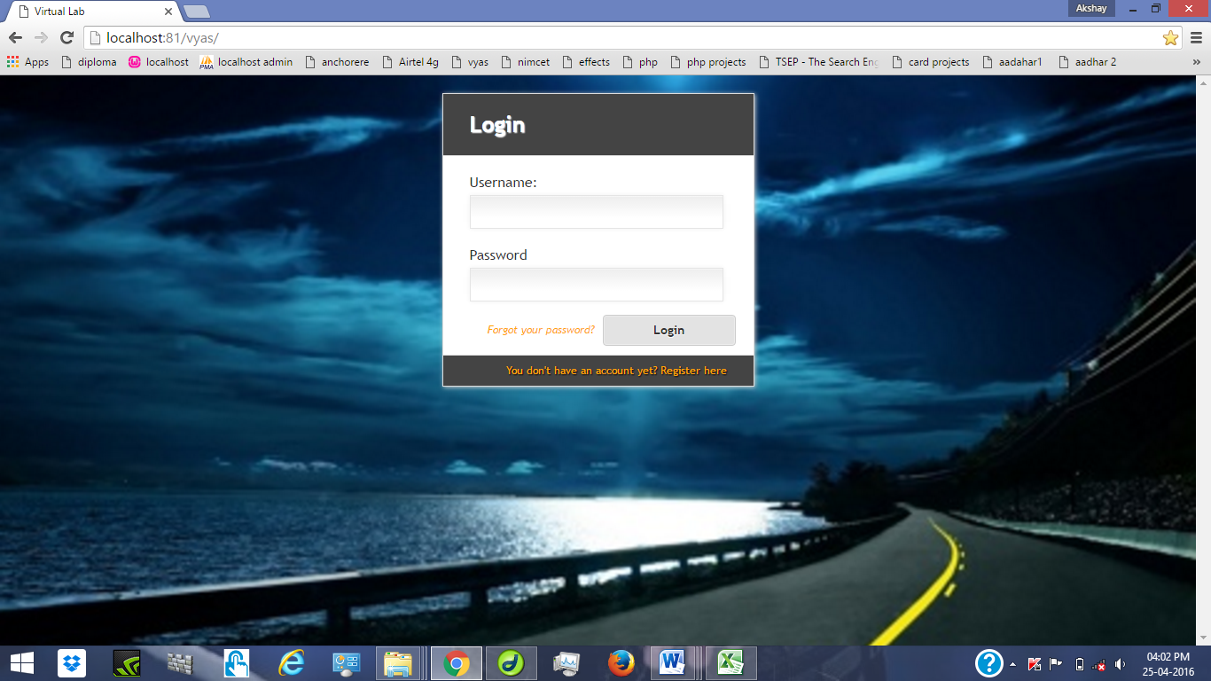

**Admin home page**

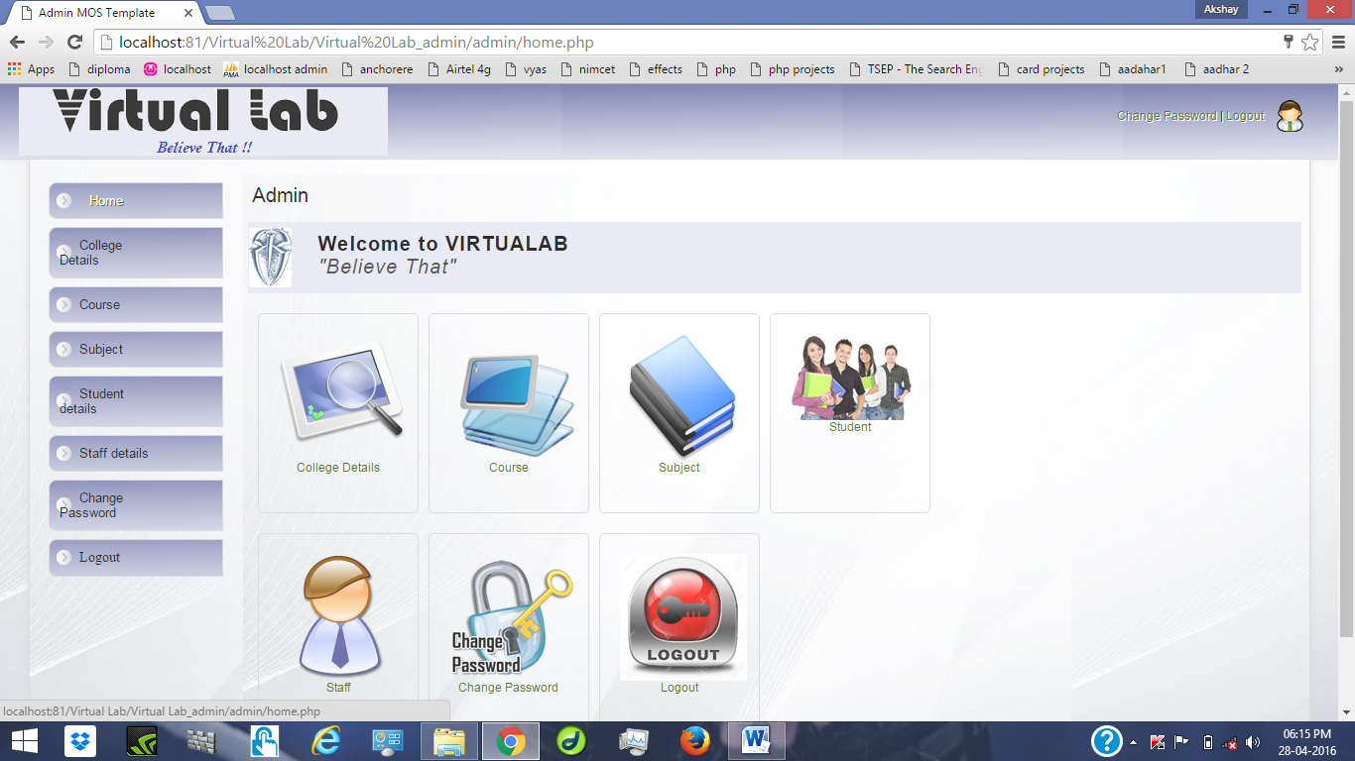

**College home page**

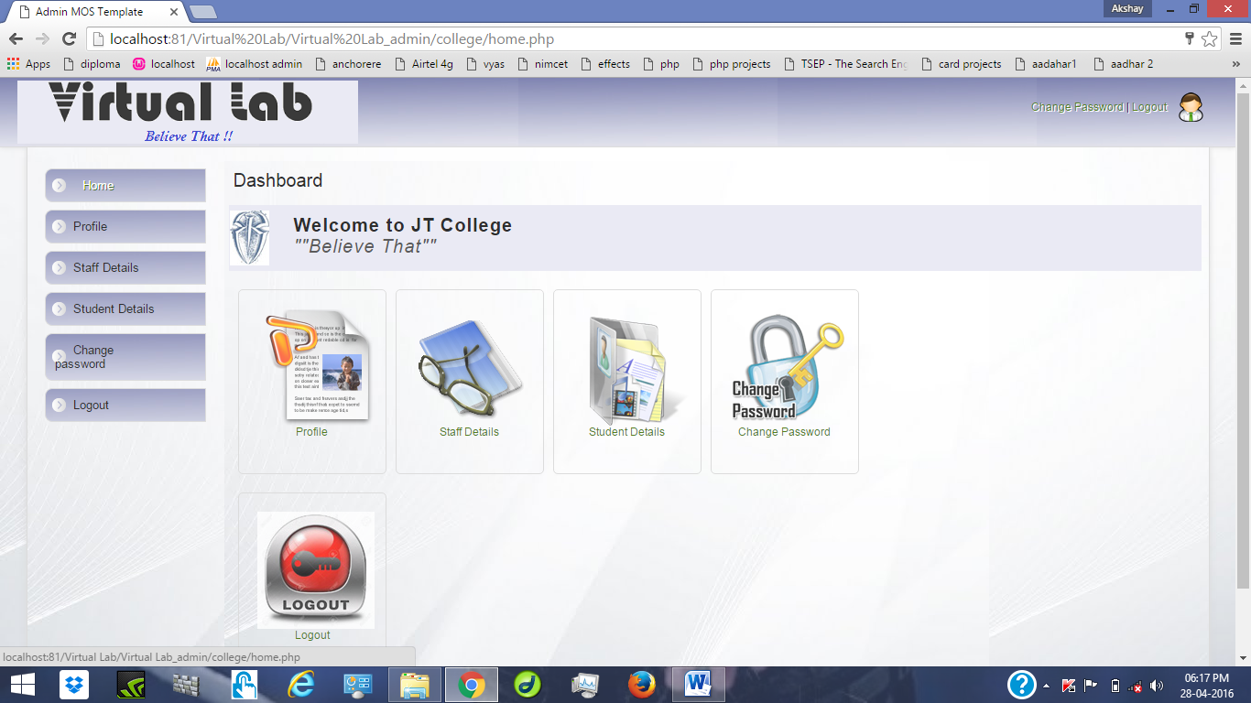

**Staff home page**

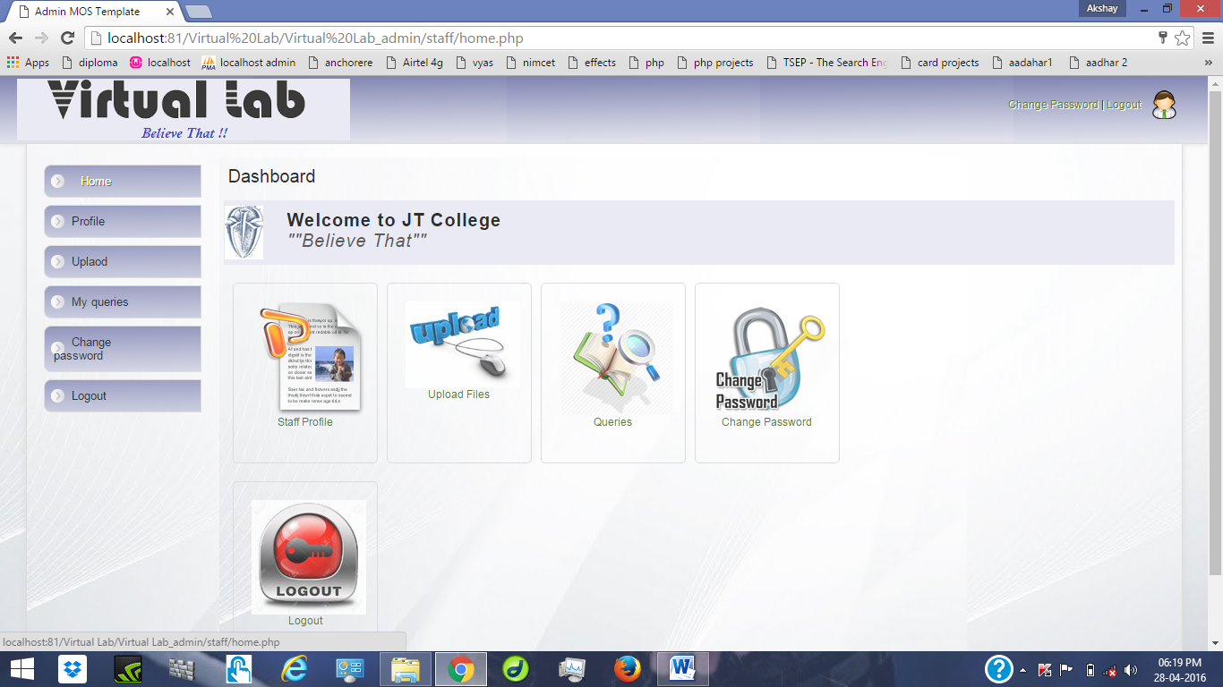

**Student home page**

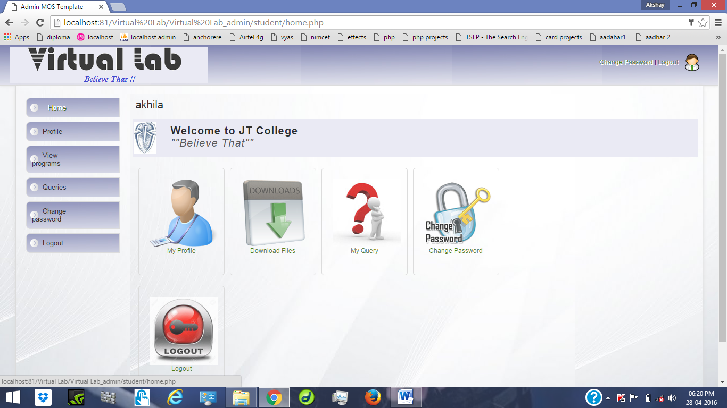

CHAPTER 9

SYSTEM SECURITY

**9.1 INTRODUCTION**

The protection of computer based resources that includes hardware, software, data, procedures and people against unauthorised use or natural disaster is known as System Security.

System Security can be divided into four related issue:

* Security
* Integrity
* Privacy
* Confidentiality

**System Security** refers to the technical innovations and procedures applied to the hardware and operation systems to protect against deliberate or accidental damage from a defined threat.

**Data security** is the protection of data from loss, disclosure, modification and destruction.

**System integrity** refers to the power functioning of hardware and programs, appropriate physical security and safety against external threats such as eavesdropping and wiretapping.

**Privacy** defines the rights to user or organization to determine what information they are willing to share with accept from others and how the organization can be protected against unwelcome, unfair or excessive dissemination of information about it.

**Confidentiality** is a special status given to sensitive information in a database to minimize the possible invasion of privacy. It is attribute information that characterizes its need for protection.

**9.2 SECURITY IN SOFTWARE**

System security refers to various validations on data in form of checks and control to avoid the system from failing. It is always important to ensure that only valid data is entered and only valid operations are performed on the system. The system employee two types of check and controls:

**CLIENT SIDE VALIDATION**

Various client side validations are used to ensure on the client side that only valid data is entered. Client side validation saves server time and load to handle invalid data. Some checks imposed are:

* Java script is used to ensure those required fields are filled with suitable data only. Maximum lengths of the fields of the forms are appropriately defined.
* Forms cannot be submitted without filling up the mandatory data so that manual mistakes of submitting empty fields that are mandatory can be sorted out at the client side.
* Tab-index are set according to the need and taking into account the ease of user while working with the system.

**SERVER SIDE VALIDATION**

Some checks cannot be applied at the client side. Server side checks are necessary to save the system from failing and intimating the user that some invalid operation has been performed or the performed operation is restricted. Some of the server side checks imposed is:

* A server side constraint has been imposed to check for the validity of primary key and foreign key. A primary key value cannot be duplicated. Any attempt to duplicate the primary values results into a message intimating the user about those values through the forms using foreign key can be updated only of the existing foreign key values.
* User is intimating through appropriate messages about the successful operations or exceptions occurring at server side.
* Various access control mechanisms have been built so that one user may not agitate upon another. Access permission to various types of user are controlled according to the organizational structure. Only permitted user can name, passwords and permissions are controlled to the server side.
* Using server side validation, constraints on several restricted operations are imposed.

CHAPTER 10

**ADVANTAGES**

The project is identified by the merits of the system offered to user. The merits of this project are as follows:

* It’s web – enabled project.
* This project offers user to enter the data through simple and interactive forms. This is very helpful for staff to enter the desired information through so much simplicity.
* The user is mainly more concerned about the validity of the data, whatever they enter. There is a check on every stage of any new creation, data entry or updating so that the user cannot enter the invalid data, which can create problems at later date.
* Sometimes the user finds in the later stage of using project that they need to update some information that they have entered earlier. There are options for them by which they can update the records. Moreover there is restriction for them that they cannot change the primary data fields. This keeps the validity of the data to longer extent.
* User is provided an option of monitoring the records they have entered earlier. He can see the desired records with the variety of options provided to them.
* From every part of the project the user is provided with links through framing so that he can jump from one option of project to other as per requirement. This bound to be simple and very friendly which is one of the primary concerns of any good project.
* Allocating of sample results become much faster because at a time the user can see the records of last years.
* Easier and faster data transfer through latest technology associated with the computer and communication.
* Through these features it will increase the efficiency, accuracy and transparency,

CHAPTER 11

**CONCLUSION**

It has been a great pleasure for me to work on this exciting project and challenging project. This project proved good for me as it provided practical knowledge of not only programming in PHP web based application and on some extent windows application and SQL server, but also about all handling procedure related with “VIRTUALAB” Believe That. It also provides knowledge about the latest technology used in web enabled application and client server technology that will be great demand in future. This will provide better opportunities and guidance in future in developing project independently.

CHAPTER 12

**FUTURE SCOPE**

More over some part of my project have remained uncompleted due to some reasons, though that was not part of objective of this project but it would have great to implement that, provided I’d enough time.

Some of them are listed down:

1. **“VIRTUALAB” Believe That**, will be made more effective and realistic by providing students a live video streaming of Lab Practical’s.

2. A module from where entities can communicate.

3. And faster process for subjective flash news, regular events, satff notifications.

BIBILOGRALHY

1. [www.vwingsgroup.com](http://www.vwingsgroup.com)
2. IEEE SRS Format.
3. Database Management Systems, by Navathe