# Introduction

The SAES Submission file process is a Data Transformation procedure created in Pentaho. This process will take information from the atrieveHR system and create the CSV file. The layout of this file is based as outllined in the document ‘School Authority Employment Submission Batch Upload Guide.doc’.

Table of Contents

Introduction 1

Setup 2

Position Cross Reference file 2

Content Area Cross Reference file 2

Transformation Properties file 3

Transformation Start Batch File 4

Process Job 4

Process Transformation 6

# Setup

## Position Cross Reference file

The Positions cross-reference file (**SAES_Positions.xlsx**) is used to map the positions used inside atrieveERP with the positions that Alberta Education want to report. This file is distributed without any local codes setup, and needs to be in a location where the client can fill in the local codes. The spreadsheet is setup as follows.

|  |  |  |
| --- | --- | --- |
| **Local Code** | **SAES Position Code** | **SAES Position Description** |
|  | SUP | Superintendent |
|  | ASU | Assistant Superintendent |
|  | OAM | Other Central Office Mgmt |
|  | PRI | Principal / School Leader |
|  | VPL | Assistant/Vice Principal |
|  | TCR | Teacher |
|  | TCR | Teacher |
|  | LIB | Librarian |
|  | GCO | Counselor |
|  | PSY | Psychologist |
|  | SNS | Education Specialist |
|  | AST | Education Assistant |
|  | CON | Consultant |
|  | COA | Coach/Teaching Support |
|  | LST | Student Learning Support |
|  | OLS | Other Learning Support |
|  | SUB | Substitute Teacher |
|  | OTH | Other Learning Support |
|  | ABS | FNMI Specialist |
|  | CUR | Curriculum/Learning Leader |

The SAES Position Code and Description columns are set by Alberta Education and should not be changed. The Local Code column is where the client will fill in the position that they use for the matching SAES Position. If there are multiple atrieveERP positions for a SAES Position Code, then additional lines can be added in with those atrieveERP positions and the appropriate SAES position code.

## Content Area Cross Reference file

The Content Area cross-reference file (**SAES_ContentAreas.xlsx**) is used to map the Subjects used inside atrieveERP with the Content Areas that Alberta Education want to report. This file is distributed without any local codes setup, and needs to be in a location where the client can fill in the local codes. The spreadsheet is setup as follows.

|  |  |  |
| --- | --- | --- |
| **Local Code** | **SAES Content Code** | **SAES Content Description** |
|  | 01 | Elementary Generalist |
|  | 02 | Math |
|  | 03 | English LA |
|  | 04 | French LA |
|  | 05 | Social Studies |
|  | 06 | Science |
|  | 07 | CTS |
|  | 08 | Wellness/Phys-ed |
|  | 09 | Special Needs |
|  | 10 | Religion |
|  | 11 | ECE Education |
|  | 12 | Arts |
|  | 12 | Arts |
|  | 13 | Music |
|  | 14 | Second Language |
|  | 15 | Other |
|  | 16 | Not Applicable |

The SAES Content Area Code and Description columns are set by Alberta Education and should not be changed. The Local Code column is where the client will fill in the subject codes that they use for the matching SAES Content Area. If there are multiple atrieveERP subjects for a SAES Content Area Code, then additional lines can be added in with those atrieveERP positions and the appropriate SAES Content Area code.

## Transformation Properties file

The Properties file (**SAES.properties**) is used to setup variables that are different for each client and are used in the transformation.

Variables:

|  |  |
| --- | --- |
| **Variable** | **Description** |
| SOURCE_DRIVER | The SOURCE_DRIVER variable indicates what driver to use to access the VMS atrieve database. This will be vortex.sql.vortexDriver |
| SOURCE_CONNECTION_URL | This variable defines how to connect to the VMS atrieve database. |
| POSITION_FILE | This points to where the Excel spreadsheet used for cross-referencing the client’s positions with the positions that Alberta Education wants reported. Requires the full path and the file name. |
| CONTENT_FILE | This points to where the Excel spreadsheet used for cross-referencing the client’s subject areas with the content areas that Alberta Education wants reported. Requires the full path and the file name. |
| OUTPUT_PATH | This variable sets the folder where the output file will be created. Note that this needs to have the trailing slash included. |
| DIST_DOMAIN | This is the default district domain (i.e. sd41.ab.ca) and will be added on to any email addresses that do not have a domain. |
| EMAIL_LOG | This is either TRUE or FALSE, to indicate on whether or not the results log from the transformation is to be emailed. |
| EMAIL_TO_ADDRESS | Email address of person to receive the log report |
| EMAIL_FROM_ADDRESS | Spoof Email address of person who is sending the log report |
| EMAIL_FROM_NAME | Name of the person sending the log report |
| EMAIL_SERVER | SMTP Server |
| EMAIL_PORT | Port used on SMTP Server |

Sample **SAES.properties**

JOB_TYPE=DW

SOURCE_DRIVER=vortex.sql.vortexDriver

SOURCE_CONNECTION_URL=jdbc:vortex://tsc/tscssi0101/RMS:qatesting_prm_1965.INI@1965:192.168.130.1!VTX4

POSITION_FILE=C:\\SAES\\SAES_Positions.xlsx

CONTENT_FILE=C:\\SAES\\SAES_ContentAreas.xlsx

OUTPUT_PATH=C:\\TMP\\

DIST_DOMAIN=sd41.ab.ca

EMAIL_LOG=FALSE

EMAIL_TO_ADDRESS=degoudreau@shaw.ca

EMAIL_FROM_ADDRESS=don.goudreau@srb-es.com

EMAIL_FROM_NAME=Don Goudreau

EMAIL_SERVER=smtp2.srb-es.com

EMAIL_PORT=587

## Transformation Start Batch File

The start batch file (**startSAES.bat**) is used to run the transformation on a client’s system.

## Process Job

The job process (**SAES.kjb**) performs a number of steps in pulling information from atrieveHR into the SQL staging area.

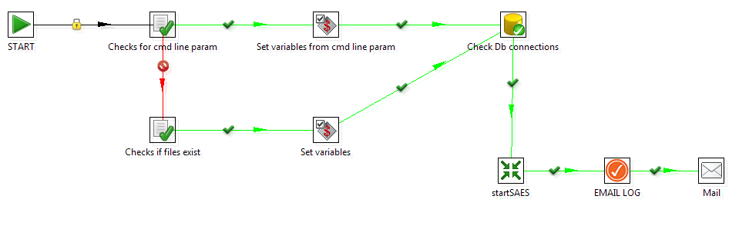

1. **Check for cmd line param**. This step will return a TRUE if the process is called from the START batch process (which will then move to step 2 below) or FALSE (which would indicate that the process is started from within the Pentaho environment), which moves to Step 3.
2. **Set variables from cmd line param.** If the process gets to this step, it will assign variables based on the properties file assigned in the start batch process. After completion of this step, the process moves to Step 5 (Check DB Connections)
3. **Check if files exist.** If the process gets to this step, it will return a True or False based if a specified file (the properties file) is found. If FALSE, then the process stops. If TRUE, process continues to step 4.
4. **Set variables.** If the process gets to this step, it will assign variables based on the properties file assigned in the start batch process
5. **Check Db connections.** This step will attempt to connect to the SOURCE and STAGING databases (using the variables assigned in the properties file). If unsuccessful, the process will stop.
6. **StartSAES.** This transformation (see below) will run the process of creating the submission file.
7. **EMAIL LOG.** If the *EMAIL_LOG* variable is set to TRUE, then the process will continue to the next step. Otherwise, this is the end of the job.
8. **Mail.** Email of the LOG report will be sent to the person designated in the variable *EMAIL_TO_ADDRESS*

## Process Transformation

The transformation ( **startSAES.ktr** ) takes information from the atrieveHR tables in VMS and creates the submission file.

