# Introduction

The Staging to SchoolLogic process is a Data Transformation procedure created in Pentaho. This process will pull staff that are in the Staging database and insert / update them into the SchoolLogic database..

Table of Contents

Introduction 1

Setup 2

SQL-Server 2

Transformation Properties file 2

Transformation Start Batch File 2

Process Job 2

Process Transformation 3

# Setup

## SQL-Server

The Staging to Schoollogic process utilizes only SQL Server databases. It reads data from the **staff** table in the **SRB_StageDB** database and updates the Schoollogic **staff** and **staffcommunications** tables in the **SchoolLogic** database.

## Transformation Properties file

The Properties file (**SL_Integration_to_SchoolLogic.properties**) is used to setup variables that are different for each client and are used in the transformation.

Variables:

|  |  |
| --- | --- |
| **Variable** | **Description** |
| STAGE_DRIVER | The STAGE_DRIVER indicates how to connect to the Staging SQL-Server database. We use a generic driver for this |
| STAGE_CONNECTION_URL | The STAGE_CONNECTION_URL variable has the SQL connection string to the staging database, including the database name, user and password. |
| SCHOOLLOGIC_DRIVER | The SCHOOLLOGIC_DRIVER indicates how to connect to the Schoollogic SQL-Server database. We use a generic driver for this |
| SCHOOLLOGIC_CONNECTION_URL | The SCHOOLLOGIC_CONNECTION_URL variable has the SQL connection string to the Schoollogic database, including the database name, user and password. |
| EMAIL_LOG | This is either TRUE or FALSE, to indicate on whether or not the results log from the transformation is to be emailed. |
| EMAIL_TO_ADDRESS | Email address of person to receive the log report |
| EMAIL_FROM_ADDRESS | Spoof Email address of person who is sending the log report |
| EMAIL_FROM_NAME | Name of the person sending the log report |
| EMAIL_SERVER | SMTP Server |
| EMAIL_PORT | Port used on SMTP Server |
| INSERT_STAFF | This is either TRUE or FALSE, to indicate on whether or not you want to have the process automatically add staff that are not found in the Schoollogic database. |

Sample **SL_Integration_to_SchoolLogic.properties**

STAGE_DRIVER=net.sourceforge.jtds.jdbc.Driver

STAGE_CONNECTION_URL=jdbc:jtds:sqlserver://localhost:1433/srb_**stageDB**;user=tsc;password=tsc;useLOBs=false;

SCHOOLLOGIC_DRIVER=net.sourceforge.jtds.jdbc.Driver

SCHOOLLOGIC_CONNECTION_URL=jdbc:jtds:sqlserver://localhost:1433/schoollogic_sample;user=tsc;password=tsc;useLOBs=false;

EMAIL_LOG=TRUE

EMAIL_TO_ADDRESS=degoudreau@shaw.ca

EMAIL_FROM_ADDRESS=don.goudreau@srb-es.com

EMAIL_FROM_NAME=Don Goudreau

EMAIL_SERVER=smtp2.srb-es.com

EMAIL_PORT=587

**INSERT_STAFF=TRUE**

## Transformation Start Batch File

The start batch file (**startStaging_toSchoollogic.bat**) is used to run the transformation on a client’s system.

## Process Job

The job process (**startStagingToSchoollogic.kjb**) performs a number of steps in pulling information from the Staging area into the SchoolLogic database.

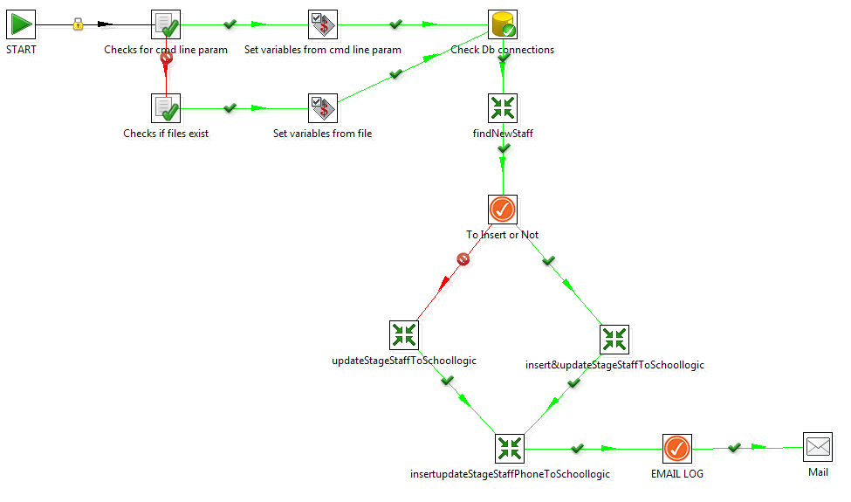

1. **Check for cmd line param**. This step will return a TRUE if the process is called from the START batch process (which will then move to step 2 below) or FALSE (which would indicate that the process is started from within the Pentaho environment), which moves to Step 3.
2. **Set variables from cmd line param.** If the process gets to this step, it will assign variables based on the properties file assigned in the start batch process. After completion of this step, the process moves to Step 5 (Check DB Connections)
3. **Check if files exist.** If the process gets to this step, it will return a True or False based if a specified file (the properties file) is found. If FALSE, then the process stops. If TRUE, process continues to step 4.
4. **Set variables.** If the process gets to this step, it will assign variables based on the properties file assigned in the start batch process
5. **Check Db connections.** This step will attempt to connect to the SCHOOLLOGIC and STAGING databases (using the variables assigned in the properties file). If unsuccessful, the process will stop.
6. **Find New Staff.** This transformation compares staff from the staged area and staff in Schoollogic. Staff that are not found (based on a last name and first name match) are considered new staff and are placed in the srblog table for future queries.
7. **To Insert or Not.** This is a decision point, where the process looks at the variable INSERT_STAFF to determine what to do with New Staff (found in step 6).

* If TRUE, then the process goes to Step 9, which will insert and update staff.
* If FALSE, then the process goes to Step 8, which only updates found staff.

1. **Update Stage Staff to SchoolLogic.** This transformation will update staff that match based on last name and firstname. Information that is updated includes address and email.
2. **Insert & Update Stage Staff to Schoollogic.** This transformation will update staff that match based on last name and firstname. Information that is updated includes address and email. Any staff that is new will be added to the Schoollogic database. The staff member will be assigned to a school where the location code that is used in atrieveERP matches with the school’s location alternate code in Schoollogic.
3. **Insert/Update Stage Staff Phone to Schoollogic.** This transformation will update the staff primary phone number from the Staged table into the StaffCommunication table in SchoolLogic.
4. **EMAIL.LOG.** If the *EMAIL_LOG* variable is set to TRUE, then the process will continue to the next step. Otherwise, this is the end of the job.
5. **Mail.** Email of the LOG report will be sent to the person designated in the variable *EMAIL_TO_ADDRESS*

## Process Transformation (Find New Staff)

The transformation ( **findNewStaff.ktr** ) takes information from Schoollogic tables and information from the Staged staff table, and compares the staff found in those tables. It then filters out records where there was a match, leaving only the records which were in the **srb_Staged:staff** table, but not in the **Schoollogic** table. That information is combined into a message which is then placed into the **srb_staged:srblog** table.

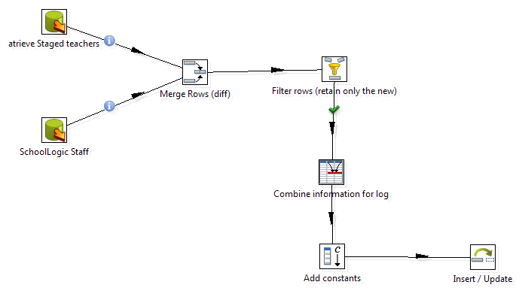

## Process Transformation (Update Stage Staff to SchoolLogic)

The transformation ( **updateStageStaffToSchoollogic.ktr** ) takes information from srb_Staged:Staff table and updates the found staff in the Schoollogic tables. Staff names are converted to proper case, the address fields are combined into a single element and the correct keys are located for the title and school.

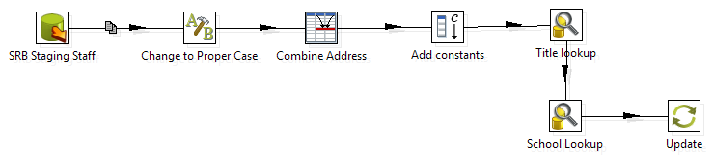

## Process Transformation (Insert & Update Stage Staff to SchoolLogic)

The transformation ( **insertupddateStageStaffToSchoollogic.ktr** ) takes information from srb_Staged:Staff table and updates the found staff in the Schoollogic tables. Staff names are converted to proper case, the address fields are combined into a single element and the correct keys are located for the title and school. Any staff that are new are inserted into the staff table. The school assigned to new staff is based on a match of the location code from atrieveERP with the school’s alternate school code. If there is no match, then the staff is not assigned to a school. Within Schoollogic, the staff can be assigned to a school.

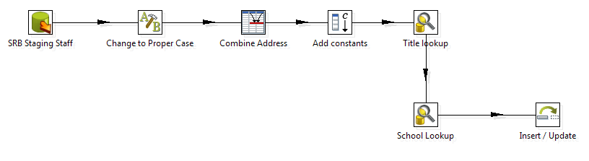

The process counts the following and creates entries in the **srblog** table with the counts.

## Process Transformation (Insert & Update Stage Staff Phone to SchoolLogic)

The transformation ( **insertupddateStageStaffPhoneToSchoollogic.ktr** ) takes the primary phone number from the srb_Staged:staff table and either inserts or updates the staffcommunication table with the primary phone.

