# Introduction

The atrieveERP to Staging process is a Data Transformation procedure created in Pentaho. This process will take staff information from the atrieveHR system and post it into a staging table (which resides in SQL-Server). This table will subsequently be used in the SchoolLogic transformation (updating staff, retrieving stats).

Table of Contents

Introduction 1

Setup 2

SQL-Server 2

Transformation Properties file 2

Transformation Start Batch File 2

Process Job 3

Process Transformation 3

# Setup

## SQL-Server

2 tables need to exist in SQL-Server for the staging process. These tables are staff and srblog. These 2 tables can be in their own database, or can be part of a database in the SRB data warehouse.

The SQL scripts **SRB_Staged_DBCreation.sql** and **SRB_Staged_TableCreation.sql** will create the database and tables respectively.

## Transformation Properties file

The Properties file (**SL_Integration_to_Staging.properties**) is used to setup variables that are different for each client and are used in the transformation.

Variables:

|  |  |
| --- | --- |
| **Variable** | **Description** |
| SOURCE_DRIVER | The SOURCE_DRIVER variable indicates what driver to use to access the VMS atrieve database. This will be vortex.sql.vortexDriver |
| SOURCE_CONNECTION_URL | This variable defines how to connect to the VMS atrieve database. |
| SOURCE_USER | Variable to set the username to the SOURCE connection |
| STAGE_DRIVER | The STAGE_DRIVER indicates how to connect to the Staged SQL-Server database. We use a generic driver for this |
| STAGE_CONNECTION_URL | The STAGE_CONNECTION_URL variable has the SQL connection string to the database, including the database name, user and password. |
| EMAIL_LOG | This is either TRUE or FALSE, to indicate on whether or not the results log from the transformation is to be emailed. |
| EMAIL_TO_ADDRESS | Email address of person to receive the log report |
| EMAIL_FROM_ADDRESS | Spoof Email address of person who is sending the log report |
| EMAIL_FROM_NAME | Name of the person sending the log report |
| EMAIL_SERVER | SMTP Server |
| EMAIL_PORT | Port used on SMTP Server |

Sample **SL_Integration_to_Staging.properties**

SOURCE_DRIVER=vortex.sql.vortexDriver

SOURCE_CONNECTION_URL=jdbc:vortex://tsc/tscssi0101/RMS:dev_prm.INI@1965:192.168.130.1!VTX4

SOURCE_USER=tsc

STAGE_DRIVER=net.sourceforge.jtds.jdbc.Driver

STAGE_CONNECTION_URL=jdbc:jtds:sqlserver://localhost:1433/srb_**stageDB**;user=tsc;password=tsc;useLOBs=false;

EMAIL_LOG=FALSE

EMAIL_TO_ADDRESS=degoudreau@shaw.ca

EMAIL_FROM_ADDRESS=don.goudreau@srb-es.com

EMAIL_FROM_NAME=Don Goudreau

EMAIL_SERVER=smtp2.srb-es.com

EMAIL_PORT=587

## Transformation Start Batch File

The start batch file (**startStaging.bat**) is used to run the transformation on a client’s system.

## Process Job

The job process (**startAtrieveToStaging.kjb**) performs a number of steps in pulling information from atrieveHR into the SQL staging area.

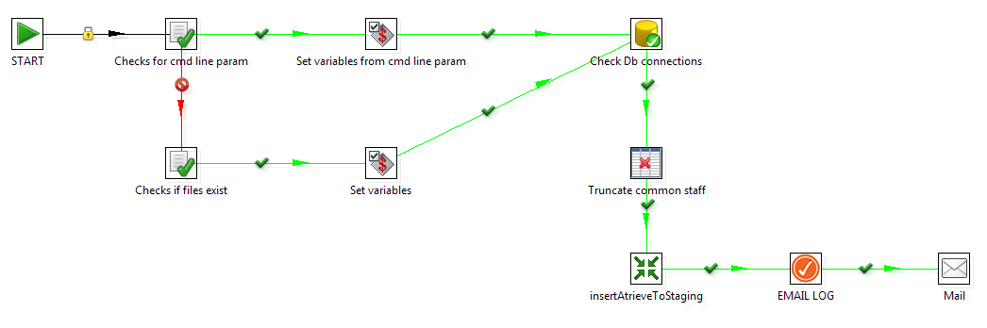

1. **Check for cmd line param**. This step will return a TRUE if the process is called from the START batch process (which will then move to step 2 below) or FALSE (which would indicate that the process is started from within the Pentaho environment), which moves to Step 3.
2. **Set variables from cmd line param.** If the process gets to this step, it will assign variables based on the properties file assigned in the start batch process. After completion of this step, the process moves to Step 5 (Check DB Connections)
3. **Check if files exist.** If the process gets to this step, it will return a True or False based if a specified file (the properties file) is found. If FALSE, then the process stops. If TRUE, process continues to step 4.
4. **Set variables.** If the process gets to this step, it will assign variables based on the properties file assigned in the start batch process
5. **Check Db connections.** This step will attempt to connect to the SOURCE and STAGING databases (using the variables assigned in the properties file). If unsuccessful, the process will stop.
6. **Truncate common staff.** This process will remove all records from the staff table in the srb_StageDB:Staff table.
7. **InsertAtrieveToStaging.** This transformation (see below) will bring in active teachers into the srb_StageDB:Staff table.
8. **EMAIL.LOG.** If the *EMAIL_LOG* variable is set to TRUE, then the process will continue to the next step. Otherwise, this is the end of the job.
9. **Mail.** Email of the LOG report will be sent to the person designated in the variable *EMAIL_TO_ADDRESS*

## Process Transformation

The transformation ( **insertAtrieveToStaging.ktr** ) takes information from the atrieveHR tables in VMS and fills in the srb_Staged:staff table.

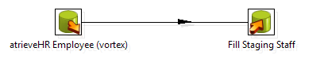

This is done thru a SQL statement, which retrieves only active teaching staff (payroll = TEAC and Status = A). The results are then inserted into the srb_stageDB:Staff table.

Select distinct HR_EMPLOYEE_INTERLINK.employee_no,

salutation,

last_name,

first_name,

hr_employee_demographics.phone_no,

unlisted_phone_no,

phone_no_2,

unlisted_phone_no_2,

HR_EMAIL_ADDRESS.employee_email,

address_1,

address_2,

city,

hr_employee_demographics.postal_code,

province,

country,

HR_ASSIGNMENT_LOCATIONS.LOCATION,

location_name,

HR_EMPLOYEE_INTERLINK.status

from HR_EMPLOYEE_INTERLINK

left join HR_EMPLOYEE_DEMOGRAPHICS on HR_EMPLOYEE_DEMOGRAPHICS.employee_no = HR_EMPLOYEE_INTERLINK.employee_no

left join HR_EMAIL_ADDRESS on HR_EMAIL_ADDRESS.EMPLOYEE_NO = HR_EMPLOYEE_INTERLINK.employee_no

left join HR_ASSIGNMENTS on hr_assignments.EMPLOYEE_NO = HR_EMPLOYEE_INTERLINK.EMPLOYEE_NO

left join HR_ASSIGNMENT_LOCATIONS on HR_ASSIGNMENT_LOCATIONS.THE_KEY = HR_ASSIGNMENTS.THE_KEY

inner join HR_LOCATION on HR_LOCATION.LOCATION_NO = HR_ASSIGNMENT_LOCATIONS.LOCATION

where HR_EMPLOYEE_INTERLINK.status = 'A'

and HR_ASSIGNMENTS.PAYROLL_ID = 'TEAC'

and (HR_ASSIGNMENTS.STATUS = 'A' OR HR_ASSIGNMENTS.END_DATE = '99999999')

order by last_name, first_name