
Project Report on :

Online Food Ordering

Submitted for the partial fulfillment of Project in

Bachelor Of Computer Application
( Semester – VI )

-: Submitted To :-
Department Of IT Harivandana College, Rajkot.

-: Affiliated To :-
Saurashtra University, Rajkot

-: Submitted By :-
Student Name : Kher Akshaykumar Makabhai
Enroll no : 003203192060

-: Under the Guidance of :-
Prof. Ashwin Rathod (Professor & Head)
Prof. Dharmendra Ambani (Lecturer & Project in charge)

ACKNOWLEGEMENT

- We are very thankful to the project coordinator of Prof. Harshad
Fefar of Harivandana College, who has provided us a lot of support & guidance from the beginning to the end of the project development.

- A work of this nature would not have been possible without the encouragement and meticulous attention received from them. The faculties has also played a vital role in building up my project website, under their guidance and training it became much easier to develop a project.

- A work of this nature would not have been possible without encouragement and meticulous .
MealMonkey FoodOrdering

1
INTRODUCTION

Project Summery

- My Project is basically Online Food Ordering App regarging like Many Food Website Type Zomato,Swiggy,Dunzo,etc..
- In This Application are Helpful for Small Kitchen. Like Many Indian Start-up zomato,swiggy are connected and typed up Big Restorant and big hotels. But in my System are uselly in This type.
- My Android Application Through Small Kitchen best Items Sellout. I developed Bridge(Website) and Connect User and Food Items Seller.
- The Android Application is developed in Android(Java), XML, Web Api’s(PHP) and MySQL for the Database.
- After all the entries administrator can view orders of all customers which Type Dish ordered users .
- Administrator are checked which dish Currently most popular and Insert MenuItems and Perticular Category.
- Admin are check How many Dish available currently and in which dish are currently most popular.
- This Android Application maintains the data of the user and it’s searching results for the order online products.

SCOPE
- Language Scope :
  - Language – XML , ANDROID(JAVA) , PHP, MYSQL
- Project Scope :
  - The scope of the project is defining what will and will not be supported by the application. This application will enable servers to manage accounts: products, fill out and submit order
  - After order complete user can check when they ordered product.admin can add products, category and manage it. Users also search his choices product in FoodOrdering Website. we currently provides only in Rajkot city.

PROJECT BOUNDRY :
  - Require Xammp web server
  - Require Android Studio

DURATION :
In 14 weeks my website will be completed.
Analysis : 2 weeks
Design : 2 weeks
Coding : 7 weeks
Testing : 3 weeks

2
LITERATURE
SURVEY

XML Overview :

- XML stands for eXtensible Markup Language.
- XML is a markup language much like HTML used to describe data. It is derived from Standard Generalized Markup Language(SMGL). Basically, the XML tags are not predefined in XML.
- We need to implement and define the tags in XML. XML tags define the data and used to store and organize data. It’s easily scalable and simple to develop.
- In Android, the XML is used to implement UI-related data, and it’s a lightweight markup language that doesn’t make layout heavy. XML only contains tags, while implementing they need to be just invoked.
- Basically in Android XML is used to implement the UI-related data. So understanding the core part of the UI interface with respect to XML is important
- The User Interface for an Android App is built as the hierarchy of main layouts, widgets. The layouts are ViewGroup objects or containers that control how the child view should be positioned on the screen
- Widgets here are view objects, such as Buttons and text boxes

JAVA Overview :

- Java is one of the most popular and widely used programming languages.
- Java has been one of the most popular programming languages for many years
- Java is Object Oriented. However, it is not considered as pure object-oriented as it provides support for primitive data types (like int, char, etc)
- Java is used in all kinds of applications like Mobile Applications (Android is Java-based), desktop applications, web applications, client-server applications, enterprise applications, and many more

MYSQL Overview :

- MYSQL DATABASE MANAGEMENT SYSTEM :

  - MySQL, the most popular Open Source SQL database management system, is developed, distributed, and supported by MySQL.
  - MySQL is a commercial company, founded by the MySQL developers. It is a second generation Open Source Company that unites Open Source values and methodology with a successful business model.
  - The MySQL Web site (http://www.mysql.com/) provides the latest information about MySQL software and MySQL.
  - The official way to pronounce “MySQL” is “My Ess Que Ell” (not “my sequel”), but we don't mind if you pronounce it as “my sequel” or in some other localized way.

- MYSQL FEATURES :
  - MySQL, the most popular Open Source SQL database management system, is developed, distributed, and supported by MySQL.
  - MySQL is a commercial company, founded by the MySQL developers. It is a second generation Open Source Company that unites Open Source values and methodology with a successful business model.
  - The MySQL Web site (http://www.mysql.com/) provides the latest information about MySQL software and MySQL.
  - The official way to pronounce “MySQL” is “My Ess Que Ell” (not “my sequel”), but we don't mind if you pronounce it as “my sequel” or in some other localized way.

ANDROID Overview :

- Android is the best-selling Operating System among various mobile platforms across the globe. Hundreds of millions of mobile devices are powered by Android in more than 190 countries of the world.
- It conquered around 75% of the global market share by the end of 2020, and this trend is growing bigger every other day.
- Android is an open source and Linux-based operating system for mobile devices such as smartphones and tablet computers. Android was developed by the Open Handset Alliance, led by Google, and other companies.
- Android offers a unified approach to application development for mobile devices which means developers need only develop for Android, and their applications should be able to run on different devices powered by Android.
- The first beta version of the Android Software Development Kit (SDK) was released by Google in 2007 where as the first commercial version, Android 1.0, was released in September 2008.

Why Android Development?

Cost-Effective Platform:
- Easy access to tools and systems to Android developers.
- The end devices and hardware are relatively less expensive.
- Rare compatibility issues with every updated OS version.

* Quick and Easy to Develop:
- The availability of the easy working model makes it so quick to develop apps.

Benefits of Android App Development

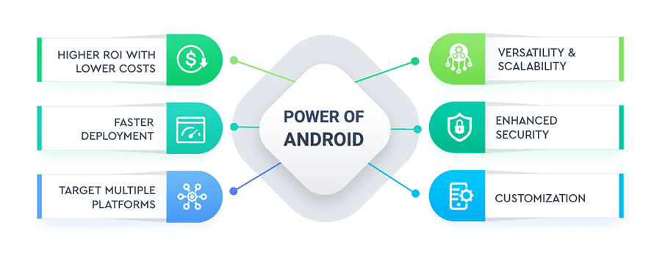
Android Ecosystem
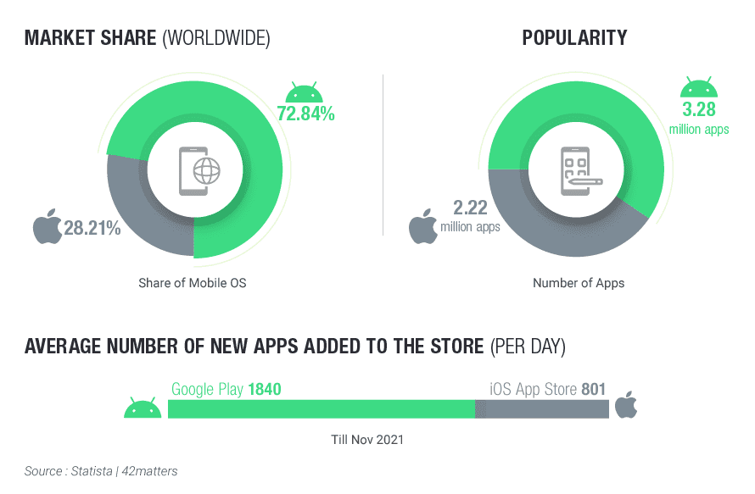
Analysis :
- When I started My Project First of all I had seen Food Ordering Application Like Zomato, Swiggy, Dunzo ,etc.. . And seen their Facility which they provide.
.
- Then I collected the Information about How Actual food ordering Application Order system work and hardware product Application then I collect information which i want for my Application
I have given following facilities in My Application.
❖ Application Side :

- Listed Food dish Horizontal & Vertical
- My Cart
- Sorting Categories
- Search Dish
- Shop, About & Contact Us
- Food Rating
- Buy Now

❖ Admin Side :

- Dashboard
- Add Categories
- Add MenuItem
- All Tables
- Categoty Table With Edit and Delete Record Functionality
- MenuItem Table With Edit and Delete Functionality
- User Cart Details Table with Delete Record Functionality
- Admin Details Table With Delete Record Functionality

` 3
PROJECT
MANAGEMENT

Project Planning and Scheduling Project Planning and Scheduling
- 3.1.1) Project Development Approach
• Software Development Process : Waterfall Model

In the waterfall model, a project progresses through an orderly sequence of steps from the initial software concept through system testing. The project holds a review at the end of each phase to determine whether it is ready to advance to the next phase - from requirements analysis to architectural design. If the review determines that the project isn't ready to move to the next phase, it stays in the current phase until it is ready.
The waterfall model is document driven, which means that the main work products that are carried from phase to phase are documents. In the pure waterfall model, the phases are also discontinuous - they do not overlap. The following shows how the pure waterfall lifecycle model progresses.
The pure waterfall model performs well for product cycles in which you have a stable product definition and when you're working with well- understood technical methodologies. In such cases, the waterfall model helps you to find errors in the early, low-cost stages of a project. It provides the requirement stability that developers crave. If you're building a well-defined maintenance release of an existing product or porting an existing product to a new plat. Form, a waterfall lifecycle might be the right choice for rapid development.
The pure waterfall model helps to minimize planning overhead because you can do all the planning up front. It doesn't provide tangible results in the form of software until the end of the lifecycle, but, to someone who is familiar with it, the documentation it generates provides meaningful progress throughout the lifecycle.

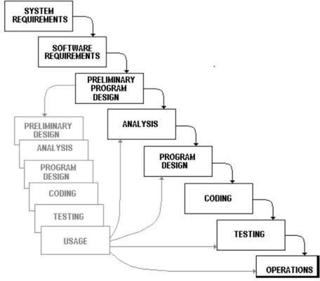

3.1.2) Project Plan :

System Analysis | Duration | Resource Requirement
System Design and Documentation | 2 WEEKS | All
Actual Development | 2 WEEKS | All
Unit Testing | 1 WEEKS | All
Integrated of System | 1 WEEKS | All
Test case preparation | 2 WEEKS | All
System Testing | 2 WEEKS | All
Bug Fixing | 1 WEEKS | All

Schedule Representation :

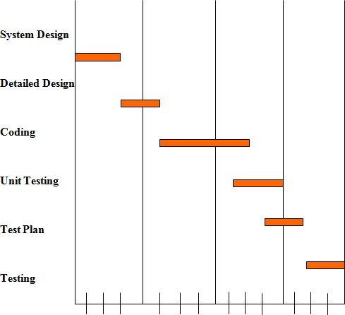

4
Requirements
Specification

HARDWARE REQUIREMENTS :
- Intel i3 7th generation And Above
- Minimum 1 TB Hard disk
- Minimum 8 GB RAM
- Mouse, Keyboard ➢ 4x CR-ROM drive OR USB port

SOFTWARE REQUIREMENTS :

- Ubuntu 18.04LTS, Window 10 ,7
- Mozilla Fire Fox & Google Chrome latest version
- Xamp web server latest version or wamp server
- Android 7.0.2
- PHP 5.6.3
- MySQL 5.5.32
- Microsoft word

5
SYSTEM
DESIGN

Basic Flow of System

- UML Use Case Diagram

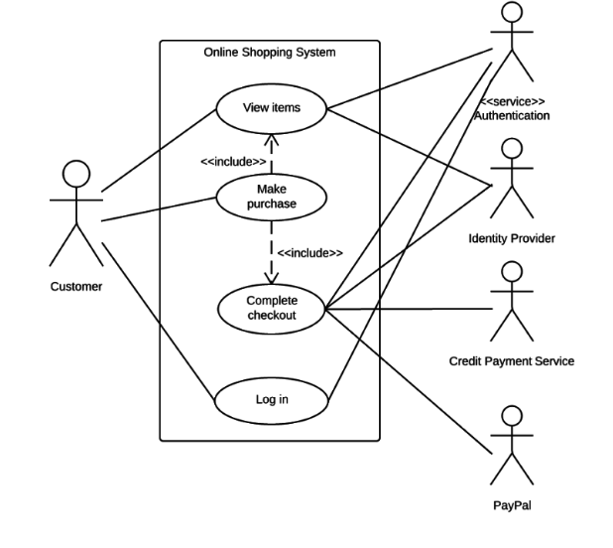

- 5.1.2) Data Flow Diagram

• What is a Data Flow Diagrams(DFD)?
✓ Data flow diagrams are commonly used for understanding the system and can be effectively used for analysis. When you are designing an application system, you must first consider the flow of the data into the out of it. A DFD shows the flow of the data through a system. DFD does not show decision or timing of events.
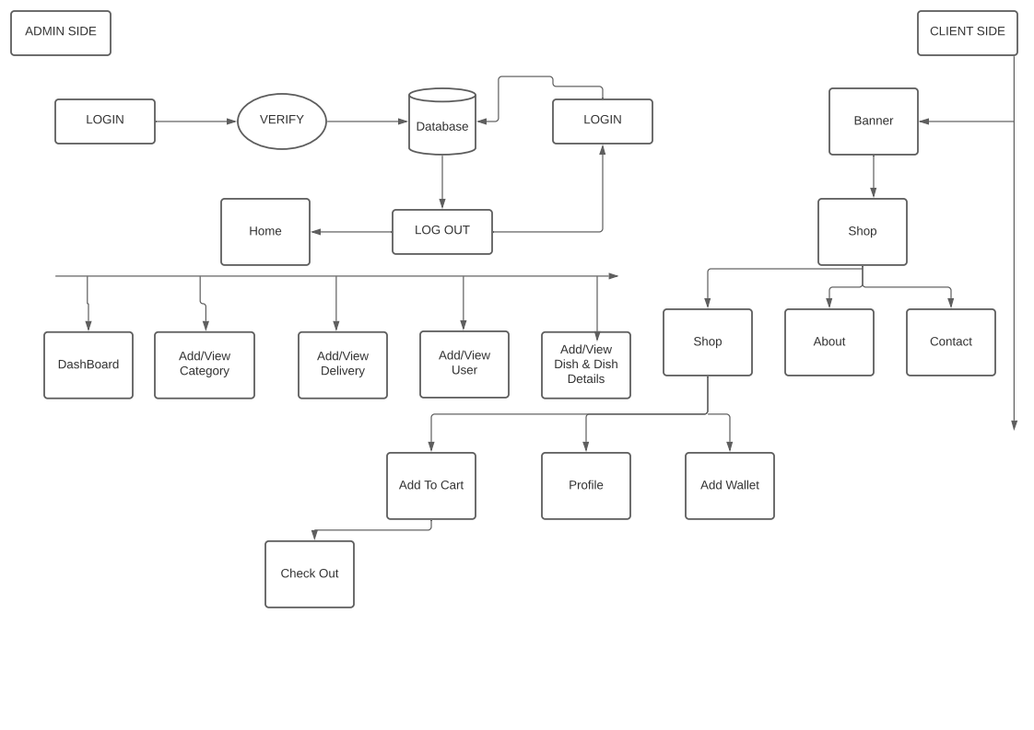

System Procedural Design

- 5.2.1) Context Level Diagram :



REQUEST

RESPONSE

ADMIN

Food Ordering

6

IMPLEMENTATION

- Add To Cart

Table Name |  |  | addcart
Description |  |  | Cart details
Primary Key |  |  | ID
Field Name | Type | Size | Constraints
ID | Integer | 11 | Not Null
user_id | integer | 255 | Not Null
quantity | integer | 255 | Not Null
total_price | integer | 255 | Not Null
food_name | text | - | Not Null
food_img | text | - | Not Null
date | timestamp | - | -

- Admin

Table Name |  | admin
Description |  | This table is used to stored data show dynamically in front page
Primary Key |  | id
Key | Field Name | Type | Size | Constraints
* | id | Integer | 11 | Not Null
 | name | Varchar | 255 | Not Null
 | email | Varchar | 255 | Not Null
 | password | Varchar | 255 | Not Null
 | time | Varchar | 255 | Not Null
 | status | Varchar | 255 | Not Null

- Category

Table Name |  | Cat
Description |  | This table is used to maintain and store the information related tto your Category
Primary Key |  | id
Key | Field Name | Type | Size | Constraints
* | id | Integer | 11 | Not Null
 | name | text | - | Not Null
 | img | text | - | Not Null
 | date | timestamp | - | -
 | status | int | 255 | Not Null

- ItemDetails

Table Name |  | itemmenu
Description |  | This table is used to maintain and store the information related itemmenu
Primary Key |  | id
Key | Field Name | Type | Size | Constraints
* | id | Integer | 255 | Not Null
 | name | text | - | Not Null
 | img | text | - | Not Null
 | description | text | - | Not Null
 | price | integer | 255 | Not Null
 | rating | varchar | 255 | Not Null
 | delivery | text | - | Not Null
 | type | text | - | Not Null
 | date | timestamp | - | Not Null
 | status | integer | 255 | Not Null

User_Details

Table Name |  | user_detail
Description |  | This table is used to maintain and store the information related to user_detail
Primary Key |  | id
Key | Field Name | Type | Size | Constraints
* | id | Integer | 11 | Not Null
 | name | Varchar | 255 | Not Null
 | email | varchar | 255 | Not Null
 | phone | varchar | 255 | Not Null
 | address | varchar | 255 | Not Null
 | date | varchar | 255 | Not Null
 | status | Integer | 255 | Not Null

Application Layout

- Splash Activity
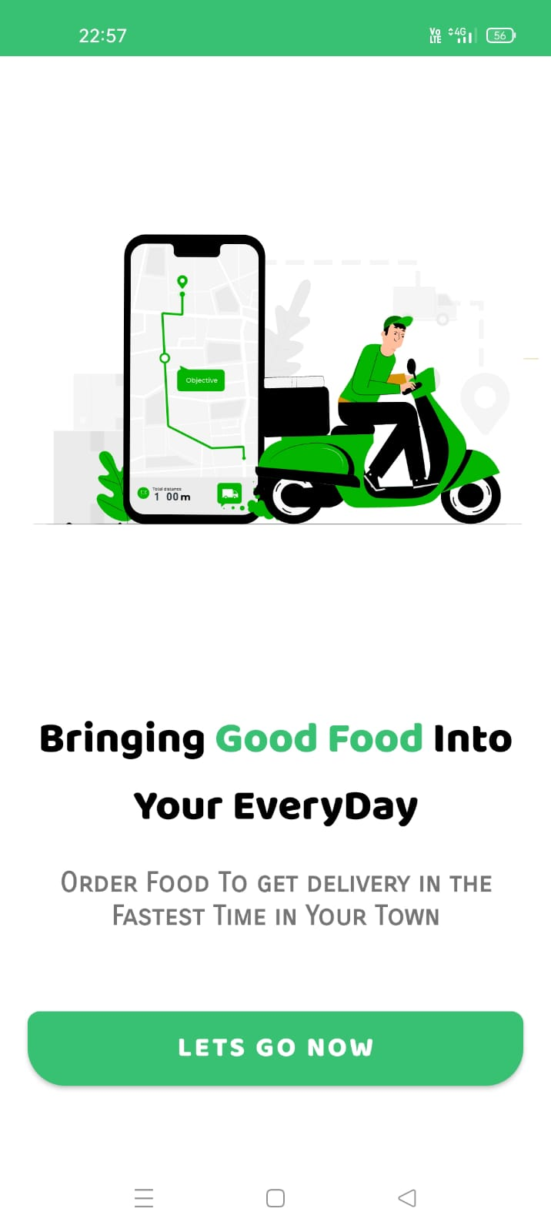

- Home Activity 1
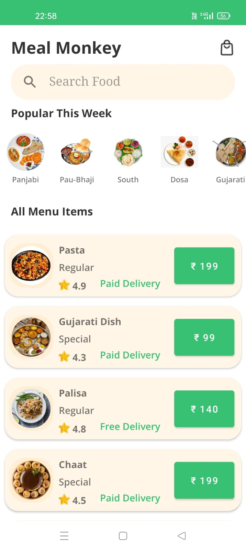

- Home Activity 2

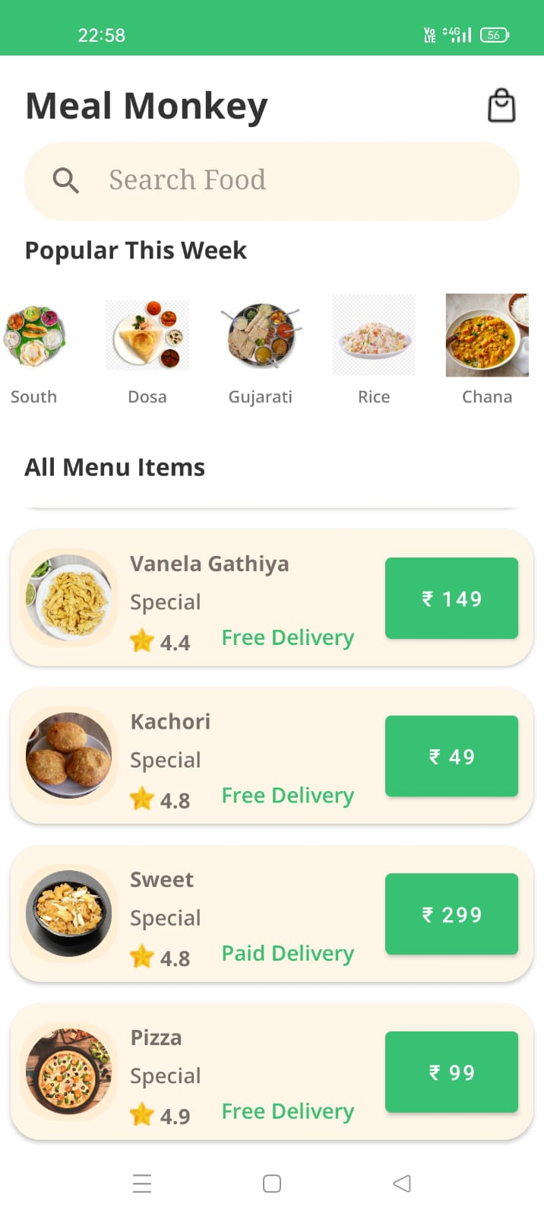

Add To Cart Activity
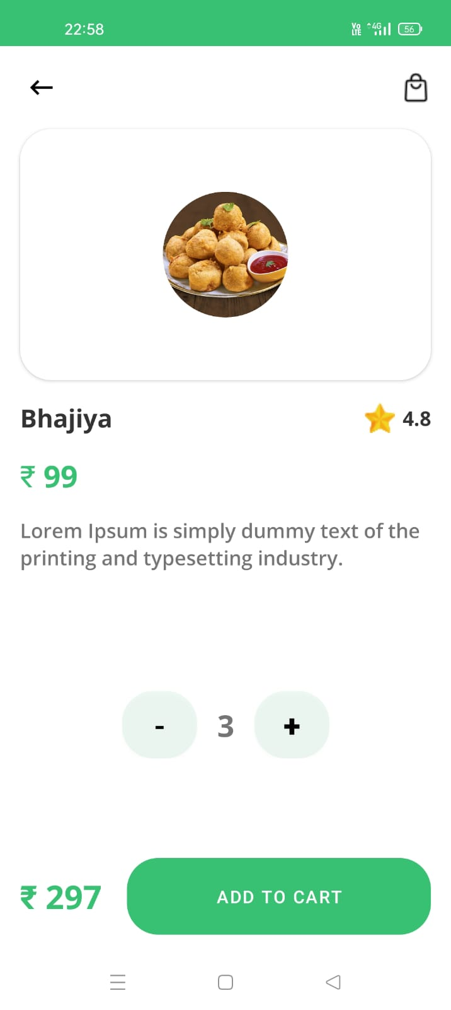

User Empty Form Activity

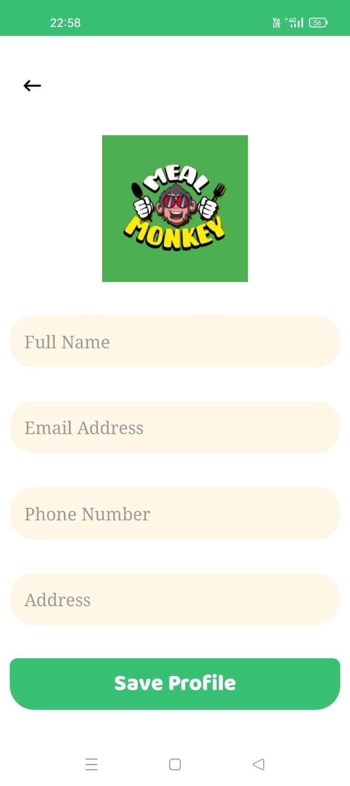

User Fillup Form Activity

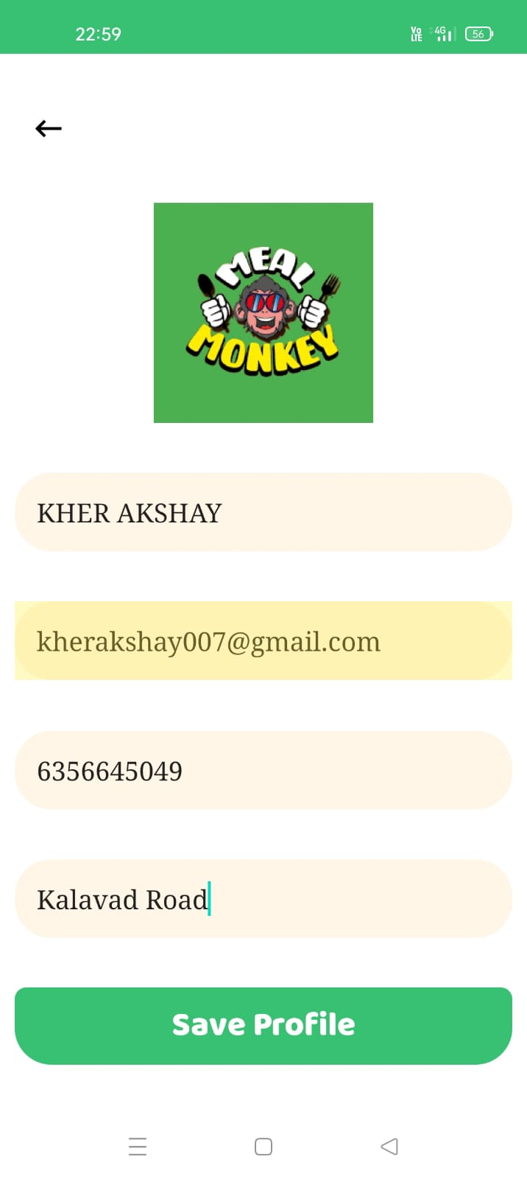

Total Bill Payment Activity

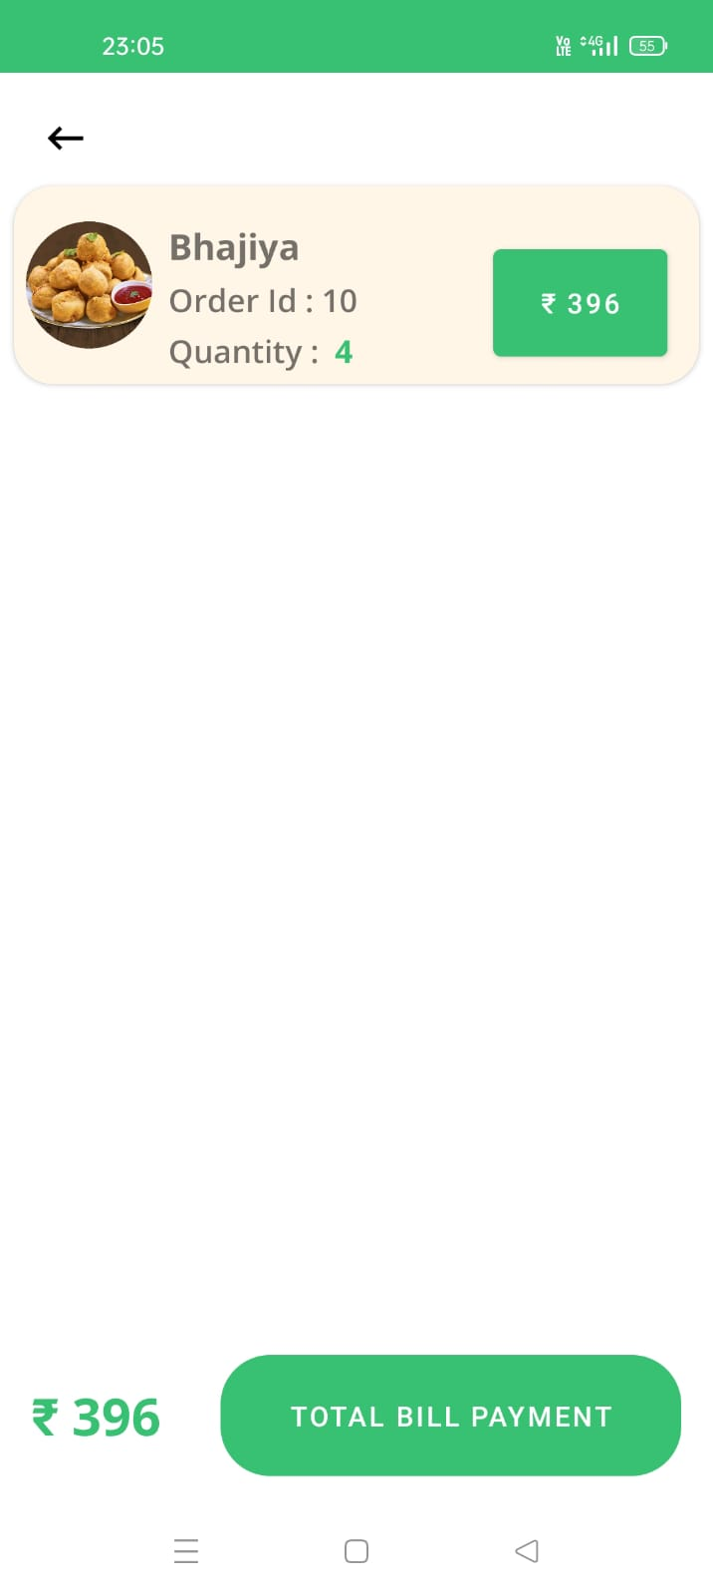

Update Activity

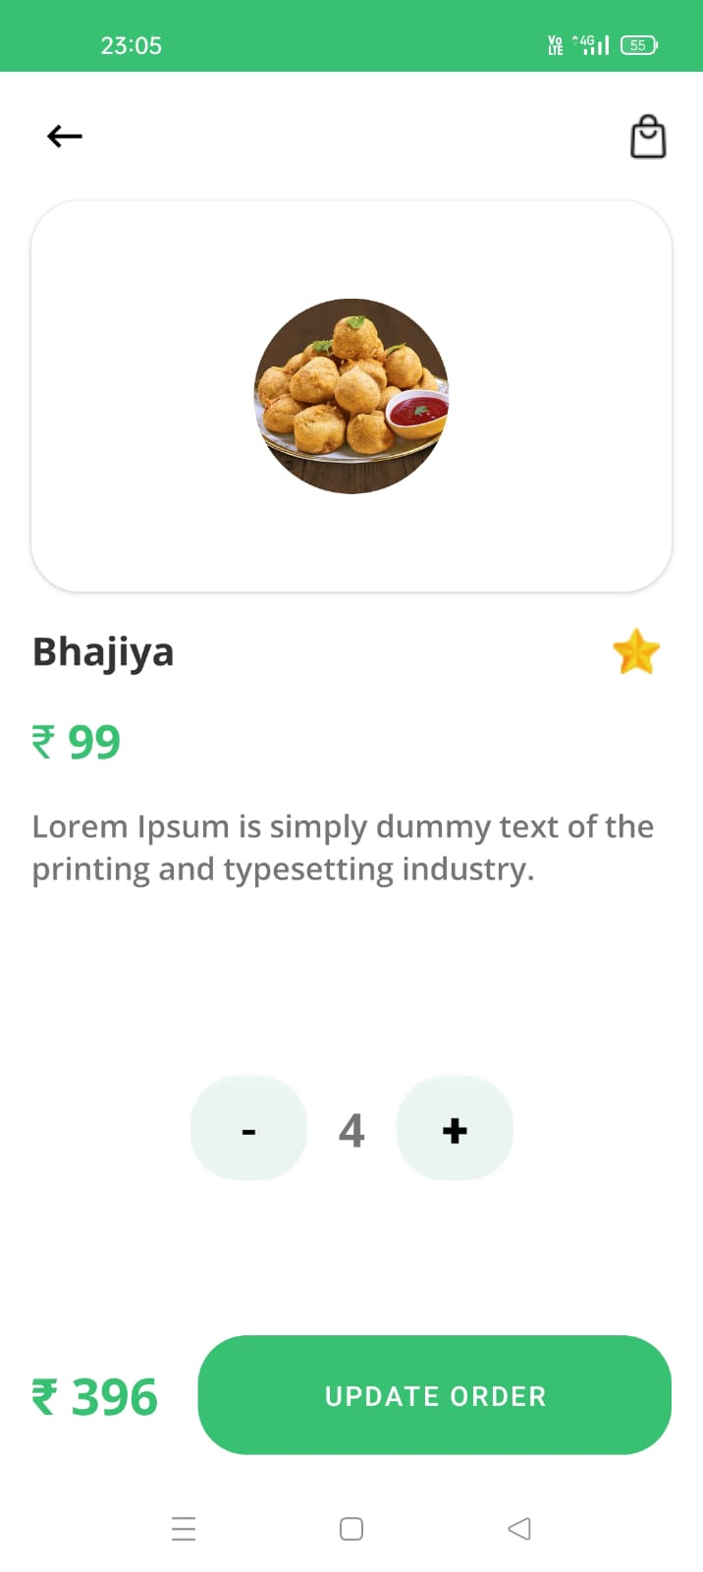

Order Success Activity
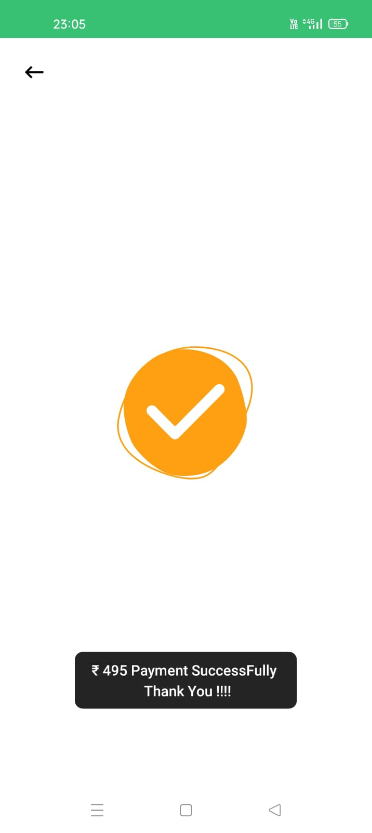

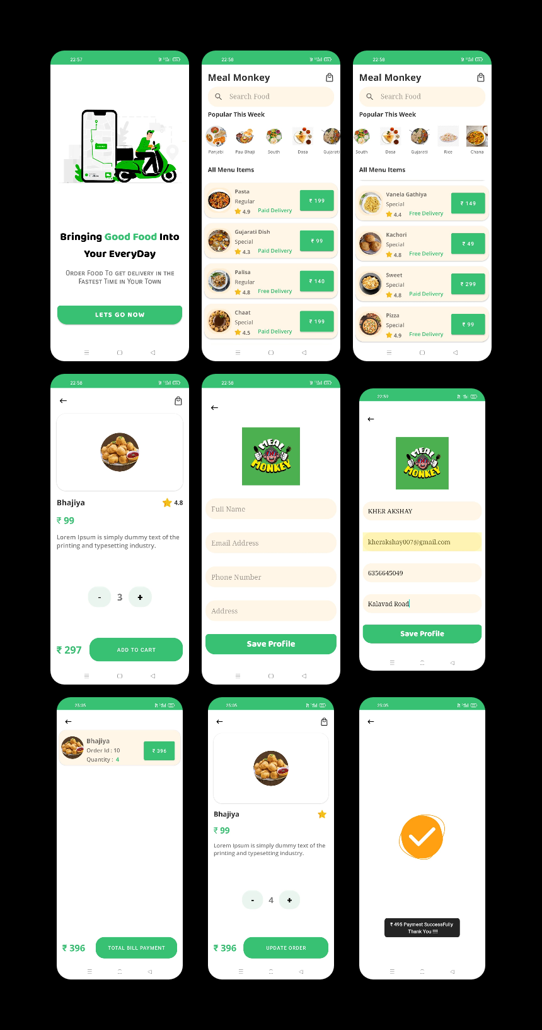

Admin Panel
Login Page
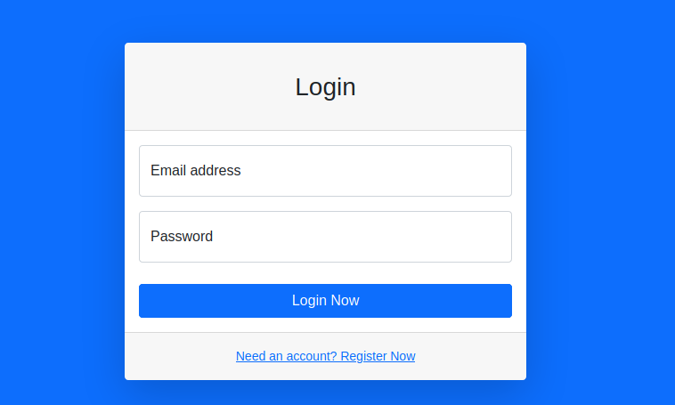

DashBoard
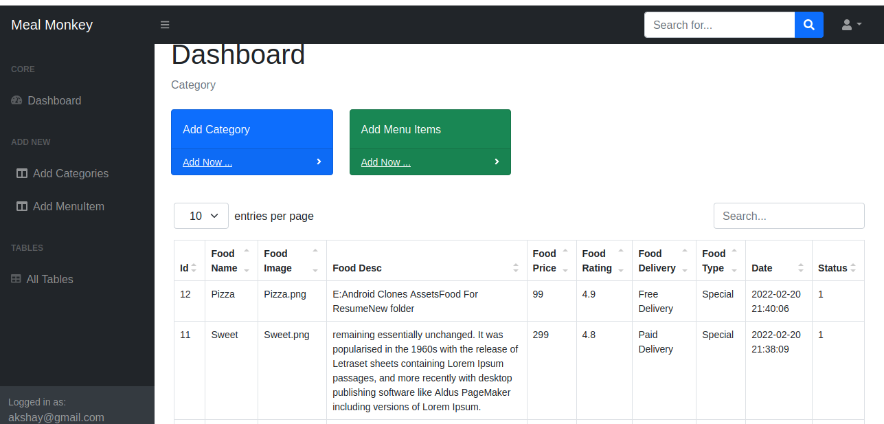
Add Categories

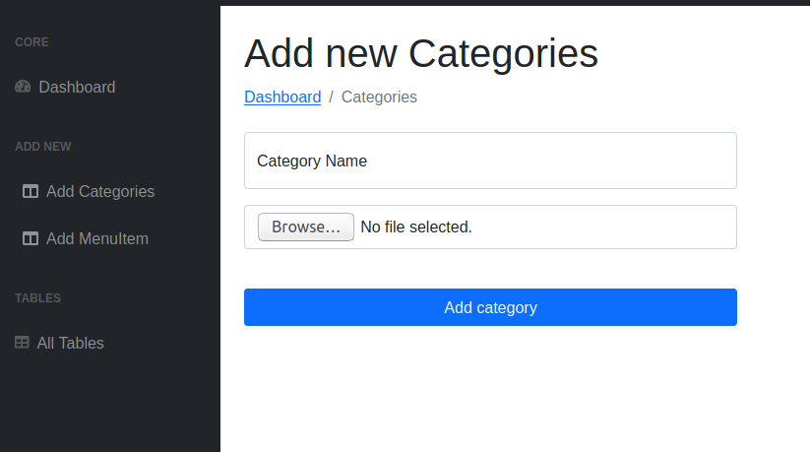

Add menuItem

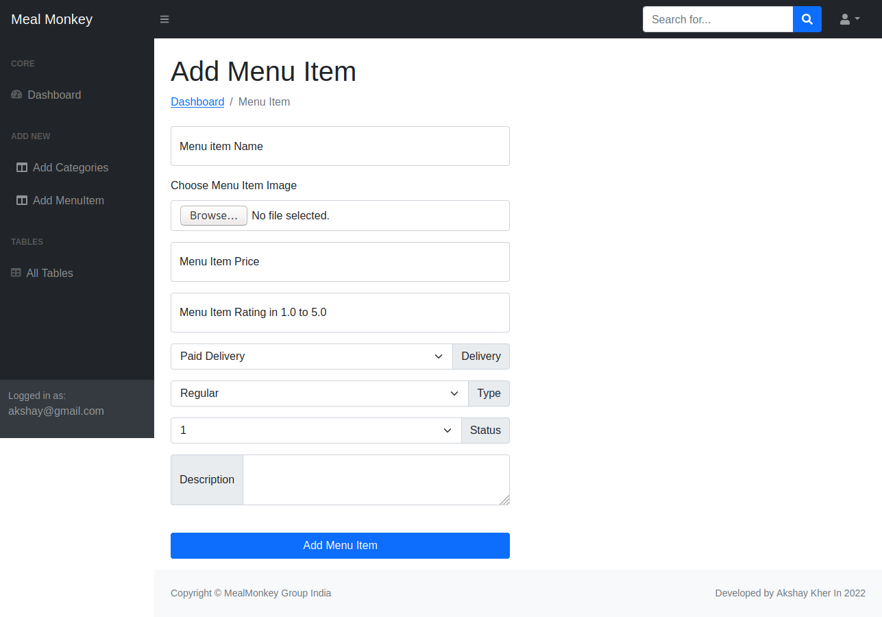

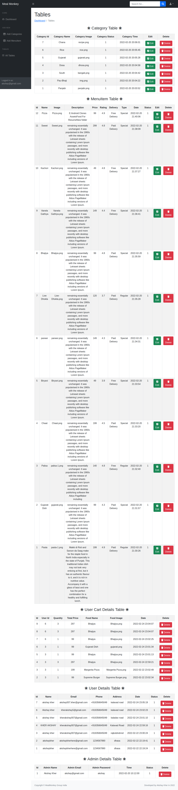

7
TESTING

TESTING

    - Testing is one of the important steps in system development. Software Testing also provides an objective, independent view of the software to allow the business to appreciate and understand the risks at implementation of the software. Test techniques include, but are not limited to, the process of executing a program or application with the intent of finding software bugs.
    - Software Testing can also be stated as the process of validating and verifying that a software program/application/product:
    - Meets the business and technical requirements that guided its design and development.
    - Works as expected; and
    - Can be implemented with the same characteristics.

- Software Testing, depending on the testing method employed can be implemented at any time in the development process. However, most of the test effort occurs after the requirements have been defined and the coding process has been completed. As such, the methodology of the test is governed by the Software Development methodology adopted.

TESTING LEVELS :

- Tests are frequently grouped by where they are added in the software development process, or by the level of specificity of the test.
Unit Testing :

      - Unit Testing refers to tests that verify the functionality of a specific section of code, usually at the function level. In an object-oriented environment, this is usually at the class level, and the minimal unit tests include the constructors and destructors.

      - These types of tests are usually written by developers as they work on code (white-box style), to ensure that the specific function is working as expected. One function might have multiple tests, to catch corner cases or other branches in the code. Unit testing alone cannot verify the functionality of a piece of software, but rather is used to assure that the building blocks the software uses work independently of each other.Unit testing is also called Component Testing.

Integration Testing :

      - Integration Testing is any type of software testing that seeks to verify the interfaces between components against a software design. Software components may be integrated in an iterative way or all together ("big bang"). Normally the former is considered a better practice since it allows interface issues to be localized more quickly and fixed.
      - Integration Testing works to expose defects in the interfaces and interaction between integrated components (modules). Progressively larger groups of tested software components corresponding to elements of the architectural design are integrated and tested until the software works as a system.

System Testing :
      - System Testing tests a completely integrated system to verify that it meets its requirements.

TYPES OF TESTING :

Functional Testing :

      - It is an approach to testing where the tests are derived from the program or component specification. The system is a black box whose behavior can only be determined by studying its inputs and the related outputs.

Structural Testing :

      - Structural testing is an approach to testing where the tests are derived from knowledge of the software„s structure and implementation. This approach is sometimes called ‗white-box testing„ to distinguish from black –box testing.

8
FUTURE
WORK

- We have done analysis of this entire system till now, and in future we will develop this system as per our analysis.

- In future this application will became very user-friendly..

- In This App are daily basis use And future i will change some Design part and more.

- We will covert this App into Cross-plateform app management so that any user can access our app anywhere through their mobiles
- Currently Payment System not available but we will add this in future
- Add Google Map for Tracking User his Order And Delivery Boy Track User Location And Safely Delivery.

9
CONCLUSION

- I have developed “Online Food Odering ” App in order to overcome the difficulties in managing the existing manual system. The Application has been designed effectively keeping in mind, the possible future enhancement and additional functionality; it has been designed to run in an efficient way.
- The Application is designed to be very user-friendly and interactive manner so that the user cannot find any difficulty while browsing the website. Thereby the proposed website, which is an economically, technically and operationally feasible system has overcome the deficiency that was present in the manual system.

10
REFERENCES

- This project was impossible to be a success without the support and help from the experience guide; the books and mainly the internet really prove it for us the
- “Information Highway”. Everything was really easy to find out on the internet. Spacaliy Thanks for StackOverFlow .
WEBSITE :
www.w3school.com
www.zomato.com/
www.swiggy.com/
www.dunzo.com/
https://stackoverflow.com/

Last But Not List
1. Github ( Source Code) Link : shorturl.at/csuJS

