**ACKNOWLEDGEMENT**

The satisfaction that accompanies that the successful completion of any task would be incomplete without the mention of people whose ceaseless cooperation made it possible, whose constant guidance and encouragement crown all efforts with success.

We are grateful to our project guide Mr. Harshad fefar for the guidance, inspiration and constructive suggestions that helpful us in the preparation of this project.

We also thank our colleagues who have helped in successful completion of the project.

**DATE:**

**PLACE:HARIVANDANA COLLEGE**

**RAJKOT**

**Project Title: Online Voting System.**

**Student Information:**

**Enrollment No.:**

**Name : Vasoya Mit**

**At: Rajkot,**

**Tal: Rajkot,**

**Dist: Rajkot**

**Phone no.:**

**E-mail : ­**

**INDEX**

|  |  |  |
| --- | --- | --- |
| **NO** | **Index** | **No** |
|  | Acknowledgement | 1 |
| 1 | Introduction  1.1.purpose  1.2.scope  1.3.overview  1.4.overalldescription  1.4.1.Goals of proposed system  1.4.2.Backgroud  1.4.3.Commnication Interface | 5 -8 |
| 2 | Literature survey  2.1.php overview  2.2.mysqli overview | 9 -11 |
| 3 | Project management  3.1.Project development Model  3.2.Project Plan | 12-15 |
| 4 | Requirement Specification  4.1.Technology to be used  4.2.Hardware Requirement  4.3.Software Requirement | 16-17 |
| 5 | System Design | 18-26 |
| 6 | Implementation | 27-40 |
| 7 | Feasibilty Study  7.1.Technical Feasibilty  7.2.schedule Feasibility | 41-44 |
| 8 | Conclution | 45-46 |
| 9 | Biologigraphy | 47-48 |

**TABLE INDEX:**

|  |  |  |
| --- | --- | --- |
| **No** | **Table Index** | **No** |
| 1 | ER Diagram | 19 |
| 2 | UseCase Diagram | 20-22 |
| 3 | DFD Diagram | 23-26 |
| 4 | Table  4.1.student detail  4.2.committee  4.3.candiadte  4.4.Admin  4.5.vote | 28-32 |

**1. INTRODUCTION:**

**1.1.Purpose:**

In “ONLINE VOTING SYSTEM” a voter can use his\her voting right online without any difficulty. He\She has to fill a registration form to register himself\herself. All the entries is checked by the DATABASE which has already all information about the voter. If all the entries are correct then a USER ID and PASSWORD is given to the voter, by using that ID and PASSWORD he\she can use his\her vote. If conditions are wrong then that entry will be discarded.

**1.2Scope:**

The scope of the project that is hosted on the server. There is a DATABASE which is maintained by the ADMIN in which all the names of voter with complete information is stored.

**1.3 Overview:**

* Project is related to Online Voting System.
* The project maintains two levels of users:-
  + - Administrator Level
    - Voter Level
* Main facilities available in this project are:-
  + - Maintaining voter’s Identification.
    - Providing online voting management.
    - Providing Updation of voter’s information.
    - Provide voter information to ADMIN.
  + ADMIN maintains the complete information of voter.

**1.4 OVERALL DESCRIPTION:**

**1.4.1Goals of proposed system**

1. **Planned approach towards working: -** The working in the organization will be well planned and organized. The data will be stored properly in data stores, which will help in retrieval of information as well as its storage.

2. **Accuracy: -** The level of accuracy in the proposed system will be higher. All operation would be done correctly and it ensures that whatever information is coming from the center is accurate.

3. **Reliability:** - The reliability of the proposed system will be high due to the above stated reasons. The reason for the increased reliability of the system is that now there would be proper storage of information.

4. **No Redundancy: -** In the proposed system utmost care would be that no information is repeated anywhere, in storage or otherwise. This would assure economic use of storage space and consistency in the data stored.

5. **Easy to Operate: -** The system should be easy to operate and should be such that it can be developed within a short period of time and fit in the limited budget of the user.

**1.4.2 Background**

ONLINE VOTING SYSTEM is a voting system by which any Voter can use his\her voting rights from any where in India. ONLINE VOTING SYSTEM contains-:

* Voter’s information in database.
* Voter’s Names with ID.
* Voter’s vote in a database.
* Calculation of total number of votes.

**Advantages:**

* Fast and easy service
* The online voting system provides a less time consuming .
* It is a better way for voting.

**1.4.3Communication interface:**

* **Client side Application server Database**
* The above diagram shows the connectivity between the client side, application server and database server. The client or customer can access the HTML server or client software. These are connected to the Xamp Server (XAMP) by a TCP/IP which is a communication protocol used to connect the teachers or parents to the internet. This XAMP Server now directly communicates with the database made in MYSQLi. All the enquires or data will be retrieved from the database.

**2.LITERATURE SURVEY**

**2.1.php overview:**

**DEFINITION:**

PHP is a server-side scripting language designed for web development but also used as a general-purpose programming language. PHP is now installed on more than 244 million websites and 2.1 million web servers.Originally created by Rasmus Lerdorf in 1995, the reference implementation of PHP is now produced by The PHP Group.While PHP originally stood for Personal Home Page, it is now said to stand for PHP: Hypertext Preprocessor, a recursive acronym.

PHP code is interpreted by a web server with a PHP processor module which generates the resulting web page: PHP commands can be embedded directly into an HTML source document rather than calling an external file to process data. It has also evolved to include a command-line interface capability and can be used in standalone graphical applications.

**ADVANTAGES OF PHP WEB DEVELOPMENT:**

* **PHP** is Open Source. ...
* **PHP** is extendible.
* large amount of databases are supported.
* **PHP** is platform independent. ...
* Compatible with servers like IIS and APACHE.
* Low development and maintenance cost with very high -performance and reliability.

**2.2 mysqli overview**

**DEFINITION:**

* **The MySQLi Extension (MySQL Improved) is a relational database driver used in the PHP scripting language to provide an interface with MySQL databases.**

**ADVANTAGES OF MYSQLI:**

* Object-oriented interface.
* Support for Prepared Statements.
* Support for Multiple Statements.
* Support for Transactions.
* Enhanced debugging capabilities.
* Embedded server support.

**3.PROJECT MANAGEMENT:**

**3.1.Project development Model**:

* **Software Development Process: Waterfall Model**

In the waterfall model, a project progresses through an orderly sequence of steps from the initial software concept through system testing. The project holds a review at the end of each phase to determine whether it is ready to advance to the next phase - from requirements analysis to architectural design. If the review determines that the project isn't ready to move to the next phase, it stays in the current phase until it is ready.

The waterfall model is document driven, which means that the main work products that are carried from phase to phase are documents. In the pure waterfall model, the phases are also discontinuous - they do not overlap. The following shows how the pure waterfall lifecycle model progresses.

The pure waterfall model performs well for product cycles in which you have a stable product definition and when you're working with well-understood technical methodologies. In such cases, the waterfall model helps you to find errors in the early, low-cost stages of a project. It provides the requirement stability that developers crave. If you're building a welldefined maintenance release of an existing product or porting an existing product to a new plat. Form, a waterfall lifecycle might be the right choice for rapid development.

The pure waterfall model helps to minimize planning overhead because you can do all the planning up front. It doesn't provide tangible results in the form of software until the end of the lifecycle, but, to someone who is familiar with it, the documentation it generates provides meaningful progress throughout the lifecycle.

Software

Requirement

Preliminary Program

Design

Analysis

Priliminary Design

Analysis

Program design

Program

Design

Coding

Coding

Usage

Operations

Testing

The waterfall model works well for projects that are well understood hut complex, because you can benefit from tackling complexity in an orderly way. It works well when quality requirements dominate cost and schedule requirements. Elimination of midstream changes eliminates a huge and common source of potential errors

**3.2.Project Plan:**

|  |  |  |
| --- | --- | --- |
| **System Analysis** | **Duration** | **Resource**  **Requirement** |
| System Design and Documentation | 2 week | All |
| Actual Development | 3 week | All |
| Unit Testing | 2 week | All |
| Integrated of System | 2 week | All |
| Test case preparation | 2 week | All |
| System Testing | 3 week | All |
| Bug Fixing | 1 week | All |

**4. REQUIREMENT SPECIFICATION**

**4.1. Technologies to be used:-**

This project will be a Web application to be developed in PHP having

* Database Design (My SQLI)
* Form Design (HTML 4.0)
* Coding (PHP)
* Testing (XAMP SERVER)
* Reporting Tool (Data Report)

**4.2. Hardware Requirements (Processor *RAM Disk Space):***

* Pentium II,
* Pentium III
* Pentium IV
* Higher 128 Mb or Higher 130 Mb

**4.3.Software Requirements (Operating *System Database)*:**

* Win-98
* Win-XP
* Linux
* My SQL

**5.System design**

**5.1.ER diagram:**

Student

Login

Login fail

Committee detail

Candidate information

Register student

Give vote

**5.2.Use case:Profile:**

**Diagram:**

Register

Login

Index

User

**5.2.1:Client sideUsecase Diagram:**

Login

User Admin

Register

zsza

Database

**5.2.2.Adminside use case:**

**Login**

**Login**

**Database**

**Add Committee**

**Add Committee**

Admin

**View Committee**

**View Committee**

**Add Candiadte**

**Add Candiadte**

**View Candidate**

**View Candidate**

**5.3.Elements of a DFD**

There are 4 key elements in a Data Flow diagram, Processes, Data Flows, Data stores, and external entities.

|  |  |
| --- | --- |
| **SYMBOLS** | **DESCRIPTION** |
|  | EXTERNAL ENTITIES  (INPUT/OUTPUT) |
|  | PROCESSES |
|  | DATAFLOWS |
|  | DATA STORES |

**5.3.1.DFD:**

Committee

Student

Register

Admin/

Student Detail

Candidate

Home

LogIn

**Wrong username**

**and password**

Vote store

The above shown diagram is 5.3.1.alevel Data Flow Diagram for the Online voting system. According to this DFD. The student can register the student information and show committee, candidate, after login in student and give vote for candidate . Admin can allow or denies the voter. A voter can give vote if all the information filled by him\her are correct.

**Admin:**

**5.3.2.DFD:**

Admin

login

The above shown diagram is a 5.3.2-level Data Flow Diagram for the Online voting system. According to this DFD is admin add password and username then after show other pages.

**5.3.3.DFD:**

**5**

Add Committee

Add Candidate

Admin

Edit or Delete Candidate

Edit or Delete

Committee

Result

The above shown diagram is a 5.3.3-level Data Flow Diagram for the Online voting system. According to this DFD various process are done after login process. The Admin can AddCommitte, AddCandidate, editordelete Candiadte, editordelete Committee. The admin can view the final result after giving vote..

**6.Implementation:**

**Table:**

**6.1.1.StudentDeatil**

|  |  |  |  |  |  |
| --- | --- | --- | --- | --- | --- |
| Table name | | Studentdetail | | | |
| Description | | This table is used to maintain and store the student all information | | | |
| Primary Key | | s_id | | | |
| No | Field name | | Type | Size | Constraints |
| 1 | **s_id** | | Int | 4 | Not null |
| 2 | **s_no** | | Int | 5 | Not null |
| 3 | **s_fnm** | | Varchar | 200 | Not null |
| 4 | **s_unm** | | Varchar | 50 | Not null |
| 5 | **s_gender** | | Varchar | 20 | Not null |
| 6 | **s_mno** | | Int | 12 | Not null |
| 7 | **s_pwd** | | Varchar | 20 | Not null |
| 8 | **s_cpwd** | | Varchar | 20 | Not null |
| 9 | **s_email** | | Varchar | 50 | Not null |
| 10 | **s_cources** | | Varchar | 20 | Not null |
| 11 | **s_time** | | Bigint | 20 | Not null |
| 12 | **s_status** | | Int | 1 | Not null |

**6.1.2.committee**

|  |  |  |  |  |  |
| --- | --- | --- | --- | --- | --- |
| Table name | | Committee | | | |
| Description | | This table is used to display committee information. | | | |
| Primary Key | | com_id | | | |
| No | Field name | | Type | Size | Constraints |
| 1 | **com_id** | | Int | 3 | Not null |
| 2 | **com_no** | | Int | 2 | Not null |
| 3 | **com_cnm** | | Varchar | 200 | Not null |
| 4 | **com_img** | | Longtext | - | Not null |
| 5 | **com_desc** | | Longtext | - | Not null |
| 6 | **com_time** | | Bigint | 20 | Not null |
| 7 | **com_status** | | Int | 1 | Not null |

**6.1.3.candidate:**

|  |  |  |  |  |  |
| --- | --- | --- | --- | --- | --- |
| Table name | | Candidate | | | |
| Description | | This table is used to display candidate all information. | | | |
| Primary Key | | c_id | | | |
| No | Field name | | Type | Size | Constraints |
| 1 | **c_id** | | Int | 3 | Not null |
| 2 | **c_fnm** | | Varchar | 200 | Not null |
| 3 | **c_gender** | | Varchar | 20 | Not null |
| 4 | **c_bd** | | Varchar | 20 | Not null |
| 5 | **c_mno** | | Int | 12 | Not null |
| 6 | **c_email** | | Varchar | 40 | Not null |
| 7 | **c_cources** | | Varchar | 16 | Not null |
| 8 | **c_committee** | | Varchar | 30 | Not null |
| 9 | **c_time** | | Bigint | 20 | Not null |
| 10 | **c_status** | | Int | 1 | Not null |

**6.1.4.Admin1:**

|  |  |  |  |  |  |
| --- | --- | --- | --- | --- | --- |
| Table name | | Admin1 | | | |
| Description | | This table is used to display admin information. | | | |
| Primary Key | | a_id | | | |
| No | Field name | | Type | Size | Constraints |
| 1 | **a_id** | | Int | 30 | Not null |
| 2 | **a_fnm** | | Varchar | 180 | Not null |
| 3 | **a_pwd** | | Int | 15 | Not null |
| 4 | **a_gender** | | Varchar | 20 | Not null |
| 5 | **a_bd** | | Int | 20 | Not null |
| 6 | **a_mno** | | Int | 12 | Not null |
| 7 | **a_email** | | Varchar | 40 | Not null |
| 8 | **c_time** | | Int | 255 | Not null |
| 9 | **c_status** | | Int | 2 | Not null |

**6.1.5. vote:**

|  |  |  |  |  |  |
| --- | --- | --- | --- | --- | --- |
| Table name | | Vote | | | |
| Description | | This table is display the login student id and select candidate id | | | |
| Primary Key | | a_id | | | |
| No | Field name | | Type | Size | Constraints |
| 1 | **vote_id** | | Int | 3 | Not null |
| 2 | s_id | | Int | 3 | Not null |
| 3 | **c_id** | | int | 3 | Not null |
| 4 | **vote_time** | | bigint | 20 | Not null |
| 5 | **vote_status** | | Int | 1 | Not null |

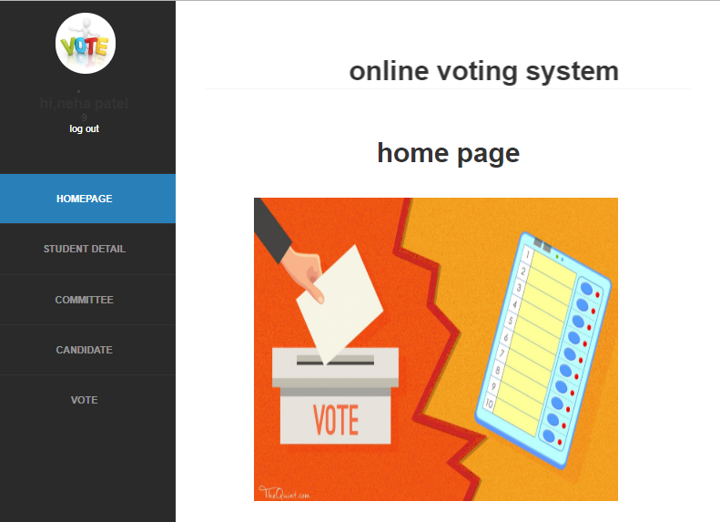

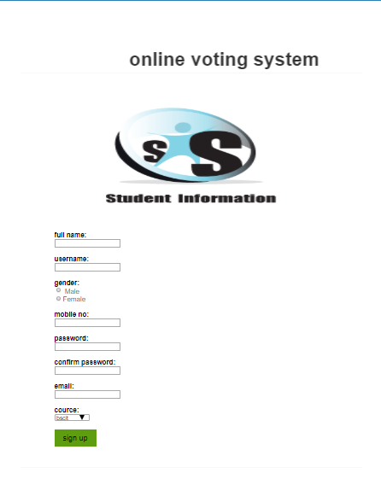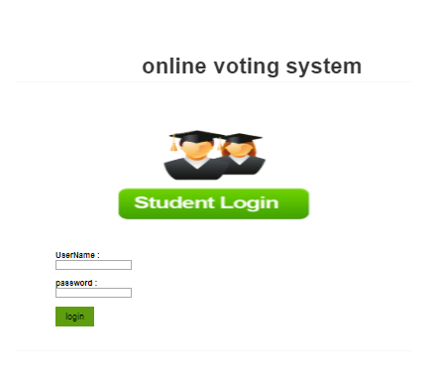

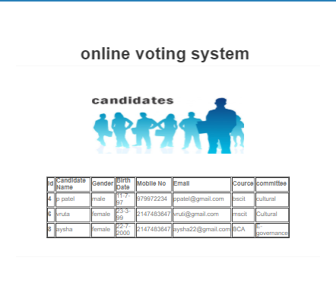

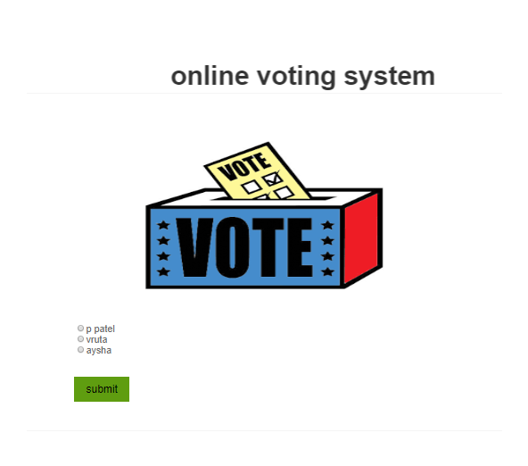

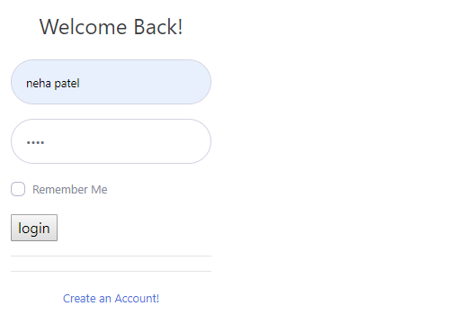

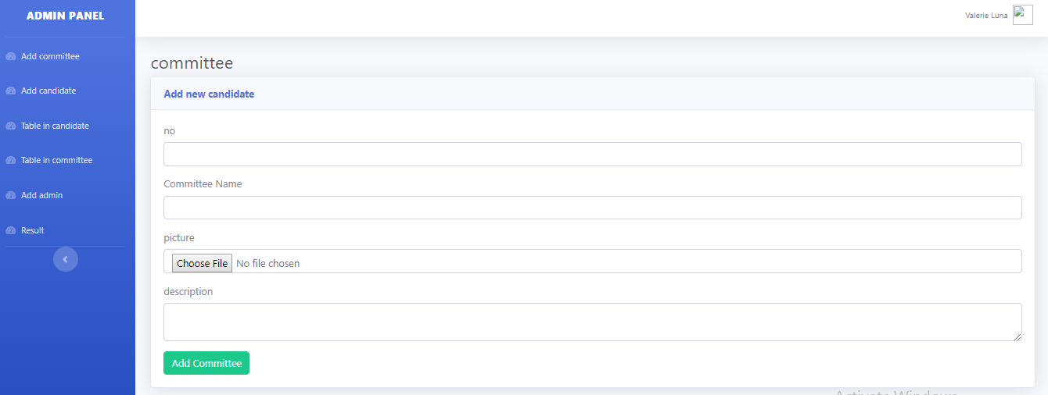

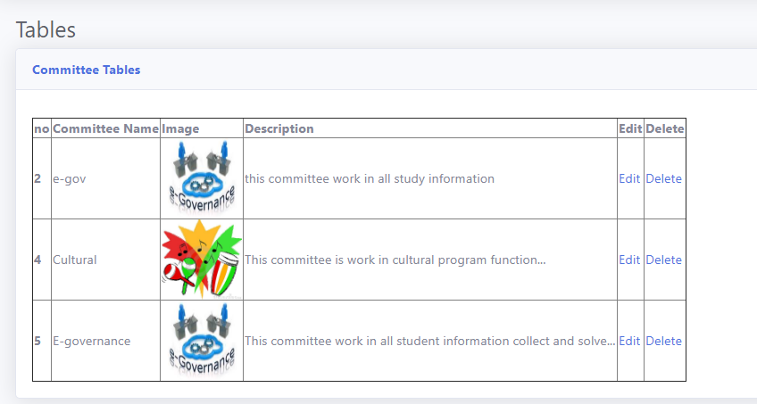

**7.FEASIBILITY STUDY:**

Depending on the results of the initial investigation the survey is now expanded to a more detailed feasibility study. “***FEASIBILITY STUDY***” is a test of system proposal according to its workability, impact of the organization, ability to meet needs and effective use of the resources. It focuses on these major questions:

1. What are the user’s demonstrable needs and how does a candidate system meet them?

2. What resources are available for given candidate system?

3. What are the likely impacts of the candidate system on the organization?

4. Whether it is worth to solve the problem?

During feasibility analysis for this project, following primary areas of interest are to be considered. Investigation and generating ideas about a new system does this.

Steps in feasibility analysis

Eight steps involved in the feasibility analysis are:

* Form a project team and appoint a project leader.
* Prepare system flowcharts.
* Enumerate potential proposed system.
* Define and identify characteristics of proposed system.
* Determine and evaluate performance and cost effective of each proposed system.
* Weight system performance and cost data.
* Select the best-proposed system.
* Prepare and report final project directive to management.

**7.1 Technical feasibility:**

A study of resource availability that may affect the ability to achieve an acceptable system. This evaluation determines whether the technology needed for the proposed system is available or not.

* Can the work for the project be done with current equipment existing software technology & available personal?
* Can the system be upgraded if developed?
* If new technology is needed then what can be developed?
* This is concerned with specifying equipment and software that will successfully satisfy the user requirement. The technical needs of the system may include:

**Front-end and back-end selection**

An important issue for the development of a project is the selection of suitable front-end and back-end. When we decided to develop the project we went through an extensive study to determine the most suitable platform that suits the needs of the organization as well as helps in development of the project.

The aspects of our study included the following factors.

**Front-end selection:**

1. It must have a GUI that assists employees that are not from IT background.

2. Scalability and extensibility.

3. Flexibility.

4. Robustness.

5. According to the organization requirement and the culture.

6. Must provide excellent reporting features with good printing support.

7. Platform independent.

8. Easy to debug and maintain.

9. Event driven programming facility.

10. Front end must support some popular back end like Ms Access.

According to the above stated features we selected PHP as the front-end for

developing our project.

**Back-end Selection:**

1. Multiple user support.

2. Efficient data handling.

3. Provide inherent features for security.

4. Efficient data retrieval and maintenance.

5. Stored procedures.

6. Popularity.

7. Operating System compatible.

8. Easy to install.

9. Various drivers must be available.

10. Easy to implant with the Front-end.

According to above stated features we selected MY SQL as the backend.

The technical feasibility is frequently the most difficult area encountered at this stage. It is essential that the process of analysis and definition be conducted in parallel with an assessment to technical feasibility. It centers on the existing computer system and to what extent it can support the proposed system.

**7.2Schedule feasibility:**

Time evaluation is the most important consideration in the development of project. The time schedule required for the developed of this project is very important since more development time effect machine time, cost and cause delay in the development of other systems.

A reliable **Online voting system** can be developed in the considerable amount of time

**8.CONCLUSION:**

This Online Voting system will manage the Voter’s information by which voter can login and use his voting rights. The system will incorporate all features of Voting system. Its provide the tools for maintaining voter’s vote to every candidate and it count total no. of votes of every candiadte. There is a DATABASE which is maintained by the ADMIN in which all the names of voter with complete information is stored.

The user(student) register his/her information on the database and when he/she want to vote he/she has to login by his username and password and can vote to any party only single time. Voting detail store in database and the result is displayed by calculation. By online voting system percentage of voting is increases. It decreases the cost and time of voting process. It is very easy to use and It is vary less time consuming. It is very easy to debug.

**9.Biologigraphy:**

I have studying about PHP, MySQLI etc.Dream weaver 8 was the main source in working of PHP.I have also used MySQLI to store the data in database.

In the making of report it got a lot of help from websites

The sources are:-

* [*www.php.net*](http://www.php.net/)
* [*www.w3schools.com*](http://www.w3schools.com/)
* [*www.google.com*](http://www.google.com/)