Day 1 : 14/05/18 : About BLE
- BLE (Bluetoooth Low Energy) : It is a classical bluetooth but with low power consumption and similar communication range.
- BLE is not Backward compatable with Bluetooth Basic Rate / Enhanced Data Rate (BR/EDR).
- Bluetooth 4.0 supports both LE and (or) BR/EDR.
- BLE uses 2.4 GHz radio frequency channel with simpler modulation system.
- Bluetooth 5 has quadruple range which is achieved by increased transimission power or coded physical layer. Double Speed is achieved by using optional half of the symbol time and 8x increase in the data broadcasting capacity of BLE.
- Specifications : Range 2.4GHz - 2.4835 GHz , 40 2MHz channels instead of 79 1MHz channel , Bit Rate : 1Mbit/sec and Max Power : 10mWatt.
- uses Counter Mode CBC-MAC encryption which has both authentication and encryption mechanisms.
- BLE devices uses GATT (Generic Attribute Profile).
- API offered by a BLE will be based around GATT Concepts.
- Client(PC or Mobile) | Server(Sensor) | Characteristics | Service | Description | Identifiers
- GATT offers notifications and indications.
Building Blocks of BLE :
                - 3 Major building blocks of BLE Application, Host, Controller.
                - Host covers the upper layers of Bluetooth Protocol Stack.
                - Controller covers the lower layers of the protocol stack.
                - Host communicates with BLE module with the help of a Host-Controller Interface (HCI).
                - BLE devices sends two types of data packets : Advertising Packets and Scan Response Packet.
                - Application Packets are necessary and constantly transmitted from peripheral devices(Sensors).
                - Scan Response Data is also sent by Peripheral devices as a response of the request of additional data from other devices.
                - There are 2 network topologies: Broadcast and Connections.
                - In Broadcast topology multiple observer devices are connected to single BLE Broadcaster at a given time. The connection is temporary an done way.
                - In Connections topology a central entity establishes a permanent two way connection with the peripheral devices.
Day 2 : 15/05/18 : BLE Layers and Beacons
- BLE Layers:
- Application Layer (Topmost).
- Controller Side Layers : Physical Layer(Modulation and Demodulation), Link Layer and HCI(Controller Side).
- Host Side Layers : Logical Link Control & Adaptation Protocol(L2CAP), ATT , GATT , SMP , Generic Access Profile (GAP).
- Beacons: Small Bluetooth radio transmitter which repeatedly transmits a single signal that other devices can see. It broadcasts a radio signal that is made up of a combination of letters and numbers transmitted on a regular interval of approximately 1/10th of a second.
- It transmitts a unique ID number that tells the listining device which beacon it is next to.
- Communication : The beacon sends out its ID numbers. A nearby bluetooth devicepicks up the signal. Whwn a dedicated app recognizes it, it links it to an action or piece of content stored in the cloud and display it to the user.
- Packets : Beacon's packet is the data that a beacon transmitts. iBeacons have one packet and Eddystone has three seperate packets.
- iBeacons and Eddystone :
- iBeacons : It is a beacon profile. It is not a physical hardware but a language that is used to power physical beacon technology. Although it works on other mobile OS , it works best with iOS.
- Working and Information transferred.
- Eddystone : Open communication protocol designed by Google mainly for android users. Key Qualities include interoperability and longterm strength.
- Working and Frames.
- 4 different types of frames UID , URL , TLM , EID.
- Difference between Eddystone and iBeacon :
- minor differences that endusers will not notice unless building a physical web.
- iBeacon is relatively easy to implement.
- Eddystone Protocol Specifications : https://github.com/google/eddystone/blob/master/protocol-specification.md
- Eddystone Data Packet Format :https://support.kontakt.io/hc/en-gb/articles/206853889-Beacon-profile-Eddystone
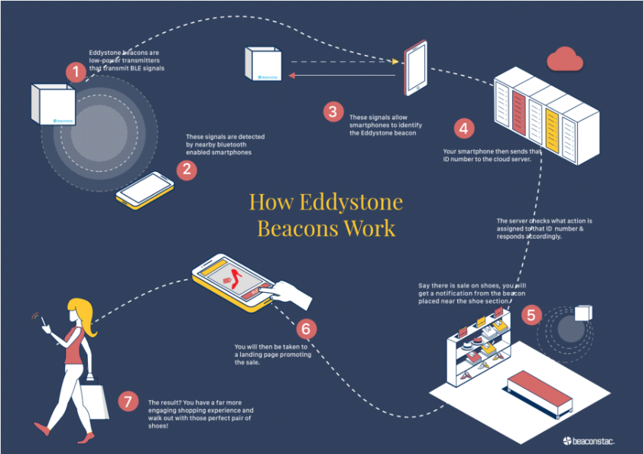
- iBeacon Data Packet Format : https://os.mbed.com/blog/entry/BLE-Beacons-URIBeacon-AltBeacons-iBeacon/

Day 3 : 16/05/18 : Beacons Overview and Configuration
Eddystone Format
Edystone UID
Edystone URL
Edystone TLM
Edystone EID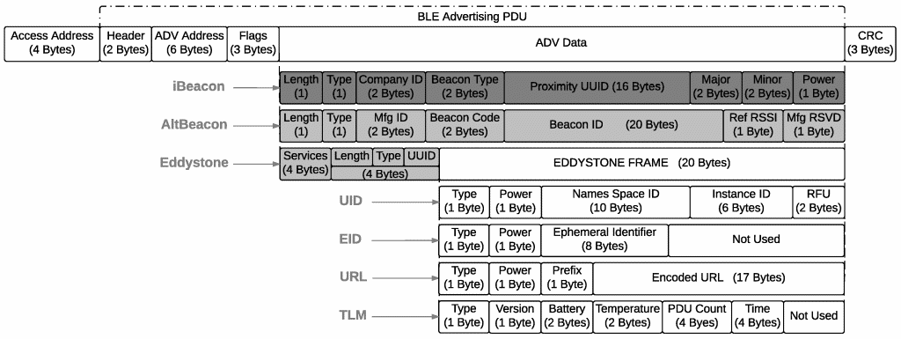
Retrieve Beacon attachment using Nearby
Proximity Beacon API Overview
Nearby API Overview
Physical Web
https://developers.google.com/beacons/proximity/guides
Day 4 : 17/05/18 : Setting up App Intent and Power Optimization
Refer PDF Wirless Communication on desktop Pg 9 and 13
Clearer Understanding of the Google Beacon Platform and Beacon Setup
Nearby Notifications Observation : By using Google Beacone Platform to setup Nearby notifications we could only set a Beacon to one state i.e. a beacon can only be set to either WEB URL or APP INTENT. If the beacon is set to multiple notifications then we get the last modified notification which can be either a WEB URL or an APP INTENT.

Day 5 : 18/05/18 : Eddystone - EID and Encrypted TLM
Eddystone EID: https://github.com/akshay0297/eddystone/tree/master/eddystone-eid
Eddystone ETLM : https://github.com/akshay0297/eddystone/blob/master/eddystone-tlm/tlm-encrypted.md
Help on ETLM : https://github.com/google/eddystone/issues/180
Day 6 : 21/05/18 : Power Optimization
Using the formula on page 13 in the PDF Wireless Communication and by testing on various devices with different bluetooth configurations we were able to calculate the threshold power to limit the range of the beacon to a particular value.
We considered 30 cm (0.3 m) as our reference point we observed that the minimum power obtained by considering various devices is -64dBm and by using the breakpoint formula with these references we can calculate the power obtained for various distances and accordingly set the range of beacon's detection in our app using that power.
Day 7 : 22/05/18 : Power Optimization Implementation
Calculating the optimal RSSI using the breakpoint formula and compairing it with the observed practical value to set a threshold RSSI to limit the distance to 1 mt.
Day 8 : 23/05/18 : Knowing the appropriate RSSI
Considering all the losses in the wireless transmission an re-computing the RSSI for setting an accurate threshold.
Taking into consideration the AVG-RSSI and RSSI obtained using the API and checking the correctness by setting either RSSI or AVG-RSSI as threshold.
Day 9 : 24/05/18 : Testing various devices for Optimal RSSI Range
Testing via a dummy application installed on various devices and multiple Beacons setup at some distances from the mobile finding the range of RSSI values to limit the beacon's signal (hypothetically) at 1 mt.
Day 10 : 25/05/18 : AWS
Familiarization of the some of the basic services of AWS like Lambda, IoT, SNS etc..
Day 11 : 28/05/18 : Basic Cryptography
Learned about 'what is cryptography' and JAVA implementation of AES algorithm.
Day 12 : 29/05/18 : Google Beacon Platform
Proximity Beacon's API
Day 13 : 30/05/18 : Google Beacon Platform
Nearby Message API
Day 14 : 31/05/18 : Testing all the Possibilities
Testing the application for bugs from a customer's point of view and finding out a better solution to overcome a different kind of near-far problem occured at the user end when more than one beacon is in the vicinity of the application.
Day 15 : 01/06/18 : Testing all the Possibilities
Testing the application for bugs from a customer's point of view and finding out a better solution to overcome a different kind of near-far problem occured at the user end when more than one beacon is in the vicinity of the application.
Day 16 : 04/06/18 : Exploring Nearby Message API
Reading about the implementation part of the Nearby Messages API on the android side.
Day 17 : 05/06/18 : Exploring Nearby Message API (cont..)
Reading about the implementation part of the Nearby Messages API on the android side. Started reading implementation part of AltBeacon API.
Day 18 : 06/06/18 : Implementing Nearby Messages API
Implementing functions of Nearby message API in an application and reteriving the attachments stored on Google Beacon Platform.
Day 19 : 07/06/18 : Exploring New Beacons
Exploring the applications that can be used to configure new beacons which was assigned as a project.
Day 20: 08/06/18 : Testing and Configuring new Beacons
Using the applications nrfConnect and LightBlue|Explorer to configure the characteristics like Tx Power, Broadcasting Frame Type etc. of the beacons. Calculating the range of the beacons via several onfield experiments. Finally calculating the transmission power to achieve the minimum range possible.

Day 21 : 11/06/18 : Configuring Various modes in new Beacons
Configuring beacons to broadcast various frame types like UID, URL, EID, TLM individually or simultaneously. (All the frames are sent individually even though multiple frames are configured to broadcast at same time.)
Day 22 : 12/06/18 : R&D about the methods to configure beacons on Eddystone EID
Exploring various methods to configure beacons on Eddystone EID and also noting various queries related to beacons.
Day 23 : 13/06/18 : Working on Nearby App
Started working on the Nearby API implementation in an application and trying to get the distance of the messages received from beacons.
Day 24 : 14/06/18 : Working on Nearby App (cont.)
Trying to get the distance of the messages received from beacons. Changing the subscription from background to foreground.
Day 25 : 18/06/18 : Working on Nearby App (cont.)
Getting the distance and Ble Signal of the messages found and on change of the position of the beacon.
Day 26 : 19/06/18 : Working on Nearby App (cont.)
Background subscribe and foreground subscribe are working separately but not together.
Day 27 : 20/06/18 : Working on Nearby App (cont.) and Starting Proximity Beacon API
Background subscribe and foreground subscribe are working separately but not together. Message Filter is working fine. Integrating Proximity Beacon API.
Day 28: 21/06/18 : Working on Proximity App
Working on an application using Proximity Beacon API.
Day 29 : 22/06/18 : Working on Proximity App (cont.) and New Beacon Testing
Working on an application using Proximity Beacon API. R&D about the new beacon(with sensors).

Day 30 : 25/06/18 : Working on how to register Eddystone Eid Frame
R&D about the frame filter that is used to scan EID frame in Proximity Beacon API using the Proximity Beacon App and the Beacon Configuration App with GATT services.
Day 31 : 26/06/18 : Diagnostics of Beacons
Retrieving the diagnostics of the beacon for fleet maintenance and also R&D about why beacon tools app is unable to scan EID frame
Day 32 : 27/06/18 : Getting EID Params from the cloud
Using getEidparams to get the Parameters from the Cloud and tally it with the beacon for its registration.
Day 33 : 28/06/18 : Debugging the Nearby App and Proximity App
Debugging the Nearby App and Proximity App to see the possibilities of their integration and also looking for the possibilities to integrate Nearby App and Proximity App.
Day 34 : 29/06/18 : Integrating Distance feature in Proximity API
Trying to scan continuously for beacons to get a stable RSSI value to get the distance of the beacons.
Day 35 : 02/07/18 : Filterting based on type in Nearby Messages API
Applying filter on the received messages based on the type of messages we want to display in the application
Day 36 : 03/07/18 : Integrating Nearby Messages API in WIO
Integrating Nearby Messages API in WIO application so as to retrieve the attachments from the google cloud.
Day 37 : 05/07/18 : Figuring out Background Scan in Nearby Messages API
Trying to apply Background scan in Nearby Messages API for continuous subscribing of the beacons’ messages.

