**Run the code as follows:**

testDemo.py clothing.csv accessories.csv household_cleaners.csv > result.csv

**Outputs for the Unit Tests written are as follows:**

Unit Test-1: When we run the code with no csv files passed as argument it results as follows:

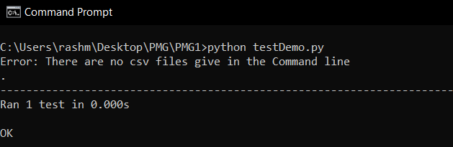

Unit Test-2: When we run the code with only 1 csv files passed as argument it results as follows:

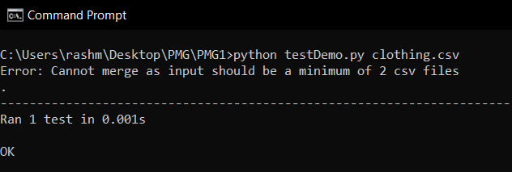

Unit Test-3: When we run the code with an invalid Input and only 1 file (arguments passed is not CSV)

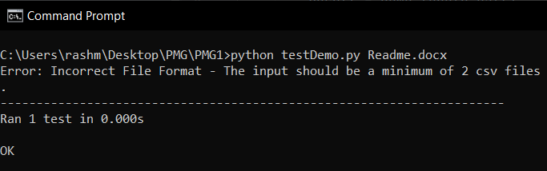

Unit Test-4: When we run the code with an invalid set of Inputs

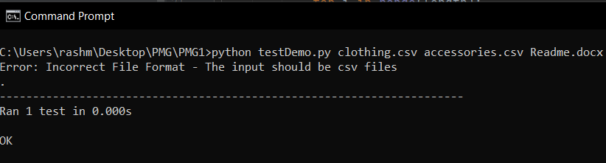

Unit Test-5: When we run the code with 3 csv it merges and the result is stored in the result.csv (success case)

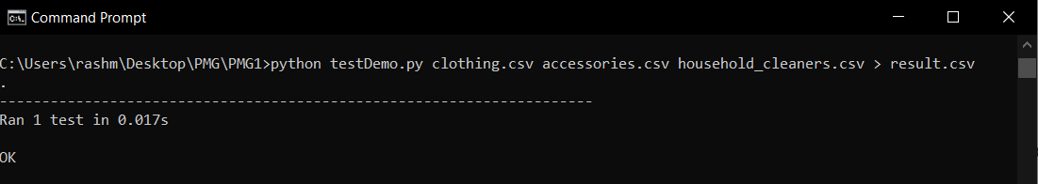

**Tested by a CI/CD process: Used Jenkins and the build was successful. Used Jenkins freestyle job and Jenkins CI/CD pipeline job by writing a pipeline script and integrating it with GitHub.**

**Jenkins Freestyle job:**

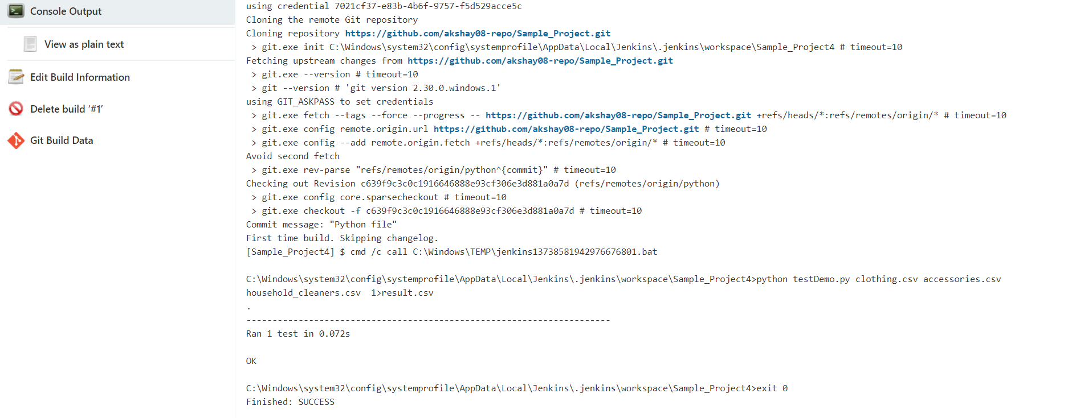

**Jenkins CI/CD Pipeline Job:**

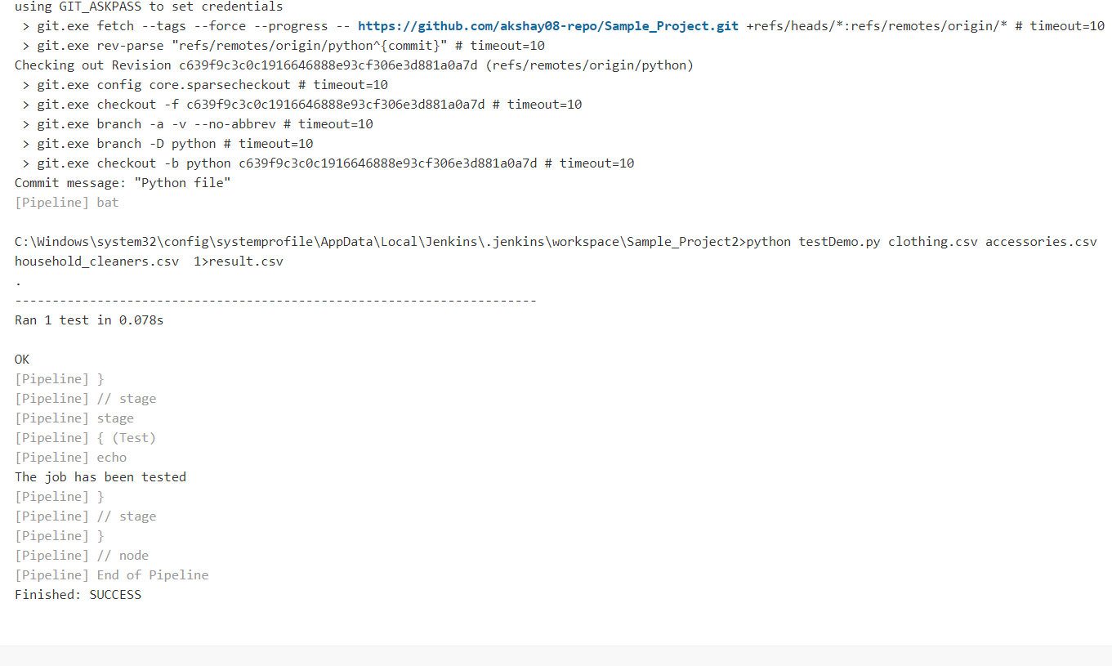

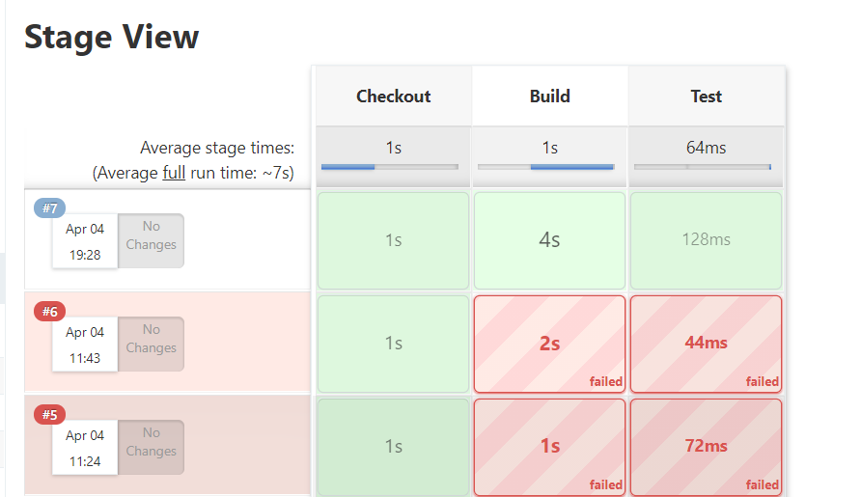

The Pipeline Scripts:

pipeline {

agent any

stages {

stage('Checkout') {

steps {

checkout([$class: 'GitSCM', branches: [[name: '*/python']], extensions: [], userRemoteConfigs: [[credentialsId: '7021cf37-e83b-4b6f-9757-f5d529acce5c', url: 'https://github.com/akshay08-repo/Sample_Project.git']]])

}

}

stage('Build') {

steps {

git branch: 'python', credentialsId: '7021cf37-e83b-4b6f-9757-f5d529acce5c', url: 'https://github.com/akshay08-repo/Sample_Project.git'

bat 'python testDemo.py clothing.csv accessories.csv household_cleaners.csv > result.csv'

}

}

stage('Test') {

steps {

echo 'The job has been tested'

}

}

}

}

Snippet of the output:

