1. Find the Total Number of Students in Each Department

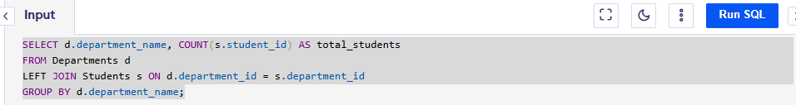

1. List All Courses Taught by a Specific Professor

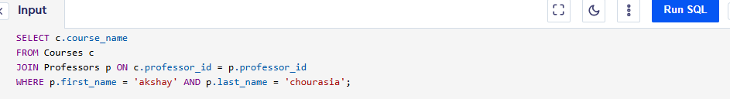

1. Find the Average Grade of Students in Each Course

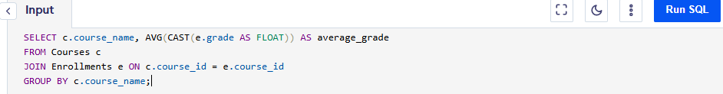

1. List All Students Who Have Not Enrolled in Any Courses

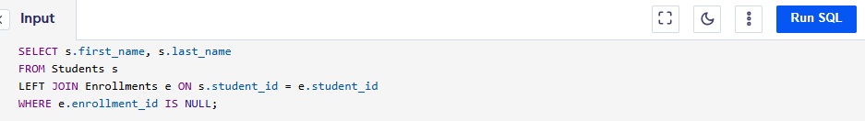

1. Find the Number of Courses Offered by Each Department

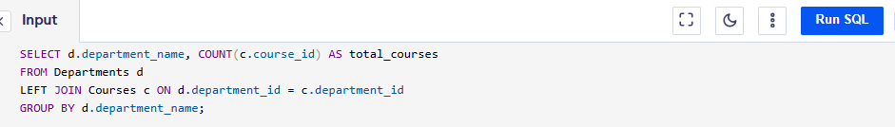

1. List All Students Who Have Taken a Specific Course (e.g., 'Database Systems')

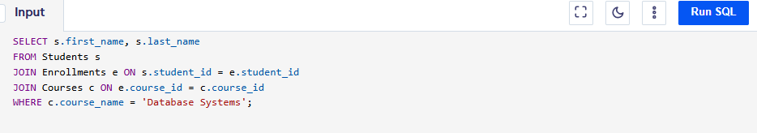

1. Find the Most Popular Course Based on Enrollment Numbers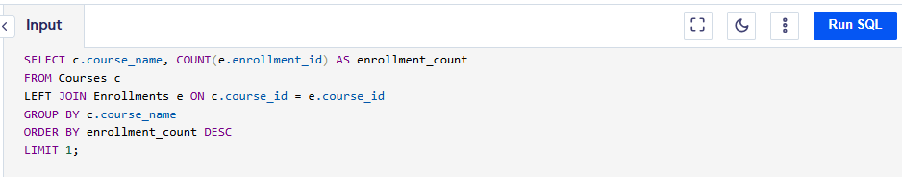
2. Find the Average Number of Credits Per Student in a Department

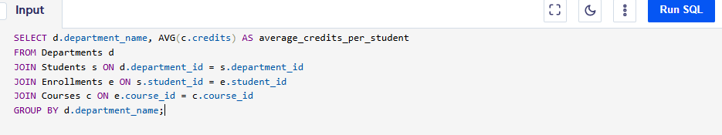

1. List All Professors Who Teach in More Than One Department

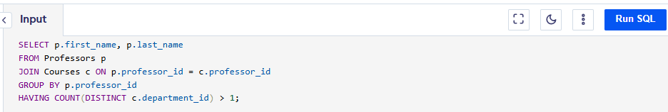

1. Get the Highest and Lowest Grade in a Specific Course (e.g., 'Operating Systems'

