1. Retrieve the names and contact details of all drivers with a rating of 4.5 or higher 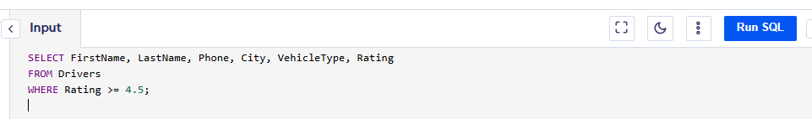

2. Find the total number of rides completed by each driver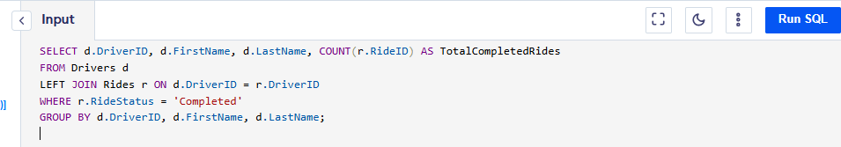

3. List all riders who have never booked a ride.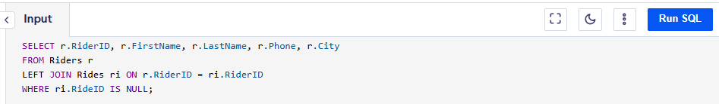

4. Calculate the total earnings of each driver from completed rides.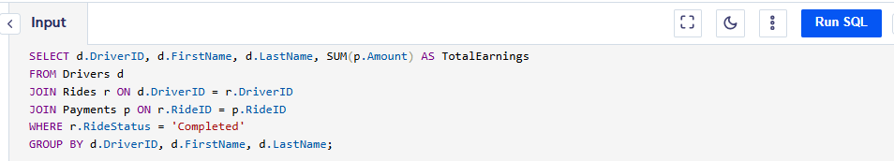

5. Retrieve the most recent ride for each rider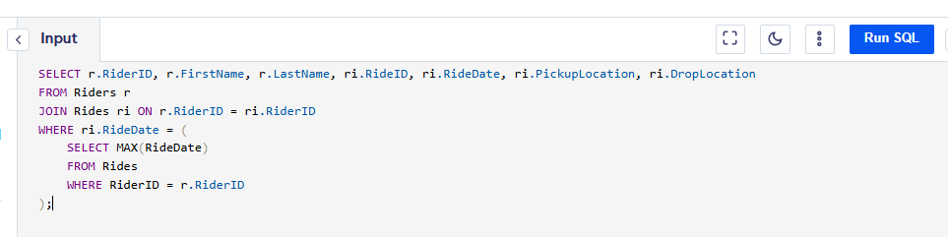

6. Count the number of rides taken in each city. 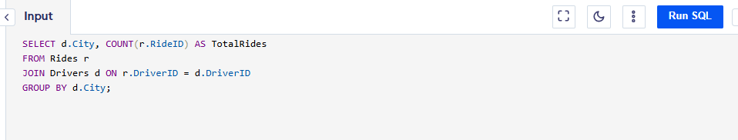7. List all rides where the distance was greater than 20 km. 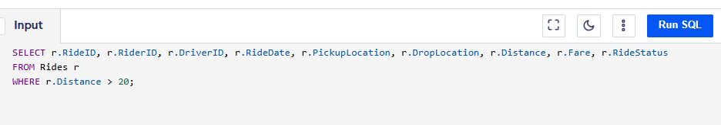

8. Identify the most preferred payment method.

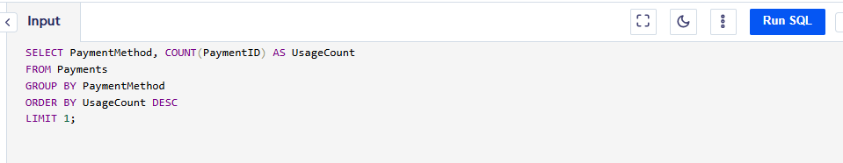

9. Find the top 3 highest-earning drivers.

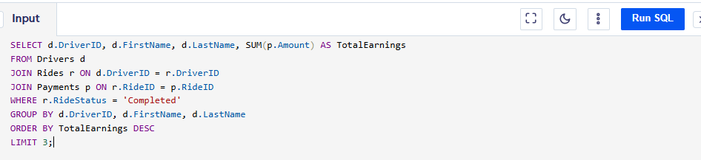

10. Retrieve details of all cancelled rides along with the rider's and driver's names

