1. **Find the Total Number of Orders for Each Customer**

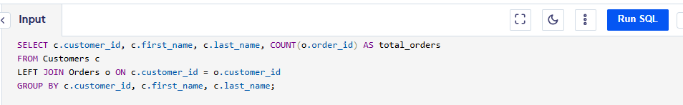

2. **Find the Total Sales Amount for Each Product (Revenue per Product)**  
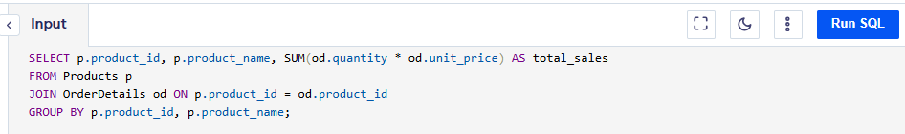

3. **Find the Most Expensive Product Sold**  
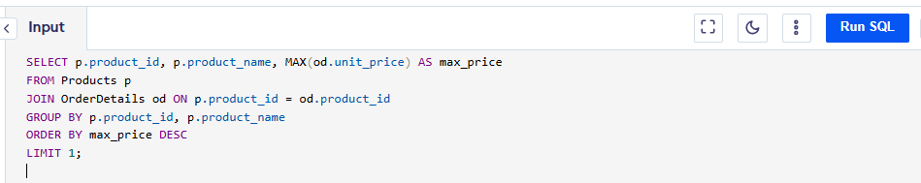

4. **Get the List of Customers Who Have Placed Orders in the Last 30 Days**

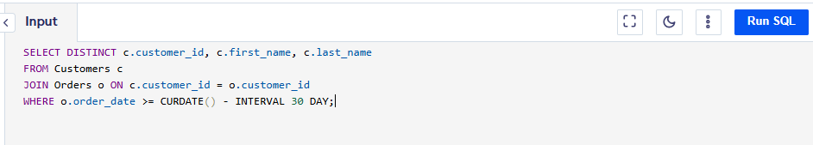

5. **Calculate the Total Amount Paid by Each Customer**

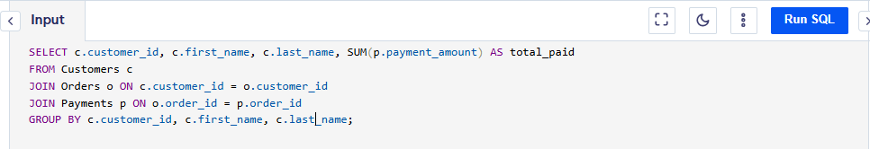

6. **Get the Number of Products Sold by Category**

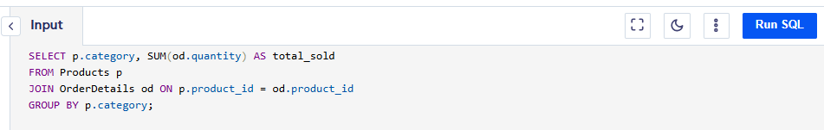

7. **List All Orders That Are Pending (i.e., Orders that haven't been shipped yet)**

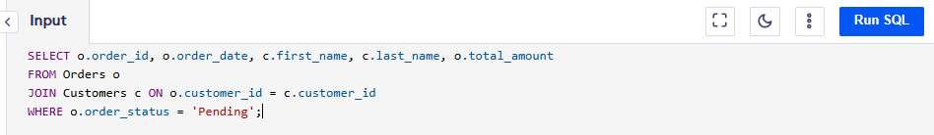  
**)**

8. **Find the Average Order Value (Total Order Amount / Number of Orders)**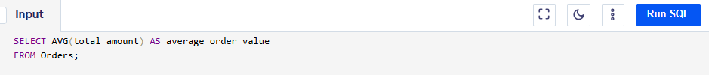

9. **List the Top 5 Customers Who Have Spent the Most Money**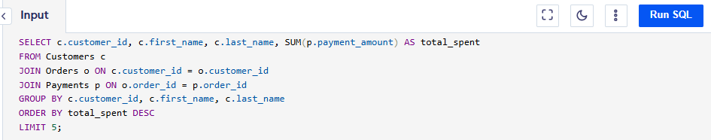

10. **Find the Products That Have Never Been Sold**