UNIT-III
1. Discuss In Detail About The Normalization Using Functional And Join Independencies (May 2012) (Apr 2011) (Nov 2009) (May 2009) (Nov 2015) (Apr 2016)
NORMALIZATION
- Db designed based on E-R model may have some amount of inconsistency (variation), uncertainty (in security) and redundancy (duplication).
- To eliminate these drawbacks some refinement has to be done on the db.
- Refinement process is called normalization.
- Normalization is defined as a step by step process of decomposing a complex relation into simple and stable relations.
  - A DB schema design tool
  - A process of replacing associations among attributes in a relation schema
  - An approximation of the relation schemas that should be created
  - Objectives: accomplish the goals of relational DB design
  - 2 approaches: decomposition and synthesis
Purpose of Normalization
Minimize redundancy in data
Remove insert, delete and update anomaly (irregularity) during db activities.
Reduce the need to recognize the data when it is modified or enhanced.
Because of duplicate data elimination, we will be able to reduce the overall size of the db.
The different stages of normalization are called as normal forms. They are,
1NF
2NF
3NF
FIRST NORMAL FORM (1NF)
- A relation is said to be in first normal form if all of its attributes have domains that are indivisible or atomic
- Also called as Flat File.
- No Repeating Elements or Groups of Elements.
- Each attribute must be atomic.
- No repeating columns within a row.
- No multi-valued columns.
Each attribute must be atomic
- No repeating columns within a row.
- No multi-valued columns.
- Each row of data must have a unique identifier (or Primary Key)
Employee (unnormalized)
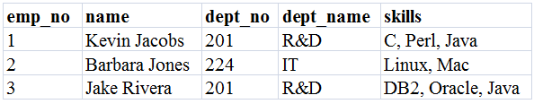
Employee (normalized – 1 NF)
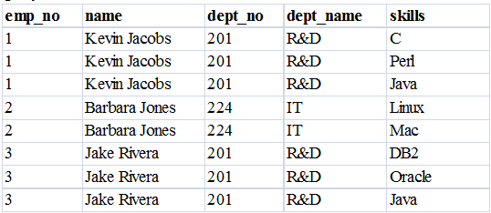
Second Normal Form (2NF)
- A relation is said to be in second normal form if it meets both the followings
  - The relation is in first normal form
  - All non-key attributes are functionally dependent on the entire primary key
  - Each attribute must be functionally dependent on the primary key.
- 2NF improves data integrity.
- Prevents update, insert, and delete anomalies.
- Functional dependence
- The property of one or more attributes that uniquely determines the value of other attributes.
- Any non-dependent attributes are moved into a smaller (subset) table.
Employee (normalized – 1 NF)
- Name, dept_no, and dept_name are functionally dependent on emp_no.
(emp_no -> name, dept_no, dept_name)
- Skills is not functionally dependent on emp_no since it is not unique to each emp_no.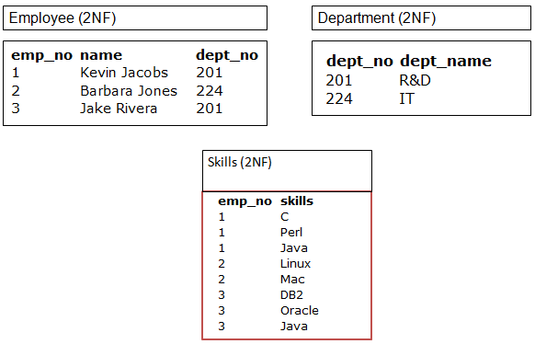
THIRD NORMAL FORM (3NF)
- A relation is said to be in third normal form if it meets both the followings
- The relation is in second normal form.
- There is no transitive dependence
- that is, all the non-key attributes depend only on the primary key.
- Remove transitive dependencies.
- Any transitive dependencies are moved into a smaller (subset) table.
- 3NF further improves data integrity.
- Prevents update, insert, and delete anomalies.
- Meet all the requirements of the second normal form.
- Remove columns that are not dependent upon the primary key.
- Remove columns that are not fully dependent upon the primary key.
- All columns must relate directly to the primary key
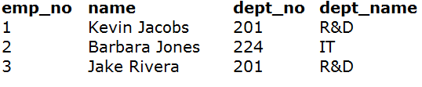
- Dept_no and dept_name are functionally dependent on emp_no
- department can be considered a separate entity.
Note:
- dept_name is functionally dependent on dept_no.
- Dept_no is functionally dependent on emp_no,
- So, dept_no, dept_name is functionally dependent on emp_no.
- (emp_no -> dept_no , dept_no -> dept_name, thus emp_no -> dept_name)
- Discuss the security and authorization mechanism adopted on database in detail
or
What is meant by authorization? Explain the different forms of authorization
SECURITY AND AUTHORIZATION
- Security of data is an important concept in DBMS because it is essential to safeguard the data against any unwanted users.
- 5 different levels of security
- DB System Level
- Operating System Level
- Network Level
- Physical Level
- Human Level
DB system level
Authentication (verification) and authorization mechanism to allow specific users access only to required data.
Operating System Level:
- Protection from invalid logins
- File-level access protection
- Protection from improper use of “superuser” authority,
- Protection from improper use of privileged machine instructions.
Network level:
- Each site must ensure that it communicates with treated sites.
- Links must be protected from theft or modification of messages.
Mechanisms Used:
- Identification protocol (password based).
- Cryptography.
Physical Level:
- Protection of equipment from floods, power failure etc..
- Protection of disks from theft etc…
- Protection of network and terminal cables from wire tapes etc…
Solution:
- Physical security by locks etc…
- Software techniques to detect physical security breaches.
Human Level:
- Protection from stolen passwords etc…
Solution:
- Frequent change of passwords.
- Data audits
- The data stored in the database need protection from unauthorized access and malicious destruction or alteration, in addition to the protection against accidental introduction of inconsistency that integrity constraints provide.
Security Violations
Among the forms of malicious access are:
- Unauthorized reading of data (theft of information)
- Unauthorized modification of data
- Unauthorized destruction of data
- Database security refers to protection from malicious access. Absolute protection of the database from malicious abuse is not possible, but the cost to the perpetrator can be made high enough to deter most if not all attempts to access the database without proper authority.
To protect the database, we must take security measures at several levels:
- Database system .Some database-system users may be authorized to access only a limited portion of the database. Other users may be allowed to issue queries, but may be forbidden to modify the data. It is the responsibility of the database system to ensure that these authorization restrictions are not violated.
- Operating system .No matter how secure the database system is, weakness in operating-system security may serve as a means of unauthorized access to the database.
- Network .Since almost all database systems allow remote access through terminals or networks, software-level security within the network software is as important as physical security, both on the Internet and in private networks.
- Physical .Sites with computer systems must be physically secured against armed or surreptitious entry by intruders.
- Human .Users must be authorized carefully to reduce the chance of any user giving access to an intruder in exchange for a bribe or other favors.
AUTHORIZATION:
We may assign a user several forms of authorization on parts of the database. For
example,
- Read authorization allows reading, but not modification, of data.
- Insert authorization allows insertion of new data, but not modification of existing data.
- Update authorization allows modification, but not deletion, of data.
- Delete authorization allows deletion of data.
- We may assign the user all, none, or a combination of these types of authorization. In addition to these forms of authorization for access to data, we may grant a user authorization to modify the database schema:
- Index authorization allows the creation and deletion of indices.
- Resource authorization allows the creation of new relations.
- Alteration authorization allows the addition or deletion of attributes in a relation.
- Drop authorization allows the deletion of relations.
Authorization in SQL
The SQL language offers a fairly powerful mechanism for defining authorizations.
- Privileges in SQL:
- The SQL standard includes the privileges delete , insert ,select ,and update .
- The select privilege corresponds to the read privilege.
- SQL also includes a references privilege that permits a user/role to declare foreign keys when creating relations.
- If the relation to be created includes a foreign key that references attributes of another relation, the user/role must have been granted references privilege on those attributes.
The SQL data-definition language includes commands to grant and revoke privileges. The grant statement is used to confer authorization. The basic form of this statement is:
grant <privilege list >on <relation name or view name >to <user/role list >

- The privilege list allows the granting of several privileges in one command.
- The following grant statement grants users U 1 ,U 2 ,and U 3 select authorization on
the account relation:
grant select on account to U 1 ,U 2 ,U 3
- In the below example, the grant statement gives users U 1 ,U 2 ,and U 3 update authorization on the amount attribute of the loan relation:
grant update (amount )on loan to U 1 ,U 2 ,U 3
3. Write short notes on the following
(a)referential integrity (may 2009)
(b) functional dependencies (nov 2009) (may 2009)
3a. Functional dependencies:
- Functional dependencies play a key role in differentiating good database designs from bad database designs.
- A functional dependency is a type of constraint that is a generalization of the notion of key.
- Functional dependencies are constraints on the set of legal relations.
- They allow us to express facts about the enterprise that we are modeling with our database.
- There is no fool-proof algorithmic method of identifying dependency. We have to use our commonsense and judgment to specify dependencies.
- t requires that the value for a certain set of attributes determines uniquely the value for another set of attributes.
- In a given relation R, X and Y are attributes. Attributes Y is functionally dependent on attribute X if each value of X determines exactly one value of Y, which is represented as i.e… “ X determines Y” or “Y is functionally dependent on X”
E.G… Marks Grade
TYPES
Full Dependencies
- In relation R, X and Y are attributes. X is functionally determines Y. Subset of X should not be functionally determine Y.
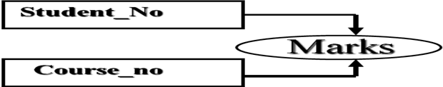
- In the above eg. Marks is fully functionally dependent on student_no and course_no together and not on subset of {student_no,course_no}
Partial Dependencies
- Attribute Y is partial dependent on the attribute X only if it is dependent on a subset of attribute X.
- For eg.. Course_name, Instructor_name are partially dependent on composite attributes { student no, course_no} because course_no alone defines course_name, Instructor_name.
Transitive Dependencies:
X,Y and Z are 3 attributes in the relation R
X Y
Y Z
X Z
- For e.g.. Grade depends on marks and in turn make depends on {student_no course_no}, hence Grade depends fully transitively on {student_no course_no}
single attribute
- Let X and Y be two attributes of a relation. Given the value of X, if there is only one value of Y corresponding to it, then Y is said to be functionally dependentent on X. this is indicated by the notation:
X → Y
- For example, given the value of item code, there is only one value of item name for it. Thus item name is functionally dependent on item code. This is shows as:
Item code → Item name
- Similarly in table 1, given an order number, the date of the order is known.
composite attribute
- Functional dependency may also be based on a composite attribute. For example, if we write
X, Z →Y
- It means that there is only one value of Y corresponding to given values of X, Z. In other words, Y is functionally dependent on the composite X, Z. in table1 mentioned below, for example, Order no and Item code together determine Qty and Price. Thus:
Order no, Item code → Qty, Price
Order no | Order date | Item code | Quantity | Price/unit
1456  1456  1456  1886  1886  1788 | 260289  260289  260289  040389  040389  040489 | 3687  4627  3214  4629  4627  4627 | 52  38  20  45  30  40 | 50.40  60.20  17.50  20.25  60.80  60.20
Table 1: Normalized form of relation
- As another example, consider the relation,
Student (Roll no, Name, Address, Dept, Year of study)
- In this relation, Name is functionally dependent on Roll no.
- In fact, given the value of roll no, the values of all the other attributes can be uniquely determined.
- Name and Department are not functionally dependent because given the name of a student, one cannot find this department uniquely. This is due to the fact that there may be more than one student with the same name.
- Name in this case is not a key.
- Department and Year of study are not functionally dependent as year of Study pertains to a student whereas Department is an independent attribute.
The functional dependency of this relation is shown in figure
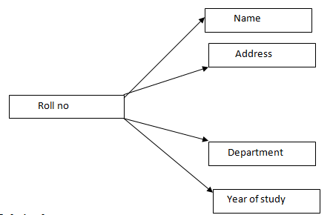
3B. REFERENTIAL INTEGRITY

- It is used to ensure that a value that appears in one relation for a given set of attributes also appears for a certain set of attributes in another relation.
- Suppose there is a Tuple t1 in the account relation with t1[branch-name] = “Lunartown,” but there is no tuple in the branch relation for the Lunartown branch. This situation would be undesirable. We expect the branch relation to list all bank branches. Therefore, tuple t1 would refer to an account at a branch that does not exist. Clearly, we would like to have an integrity constraint that prohibits dangling tuples of this sort.
- Not all instances of dangling tuples are undesirable, however. Assume that there is a tuple t2 in the branch relation with t2[branch-name] =“Mokan,” but there is no tuple in the account relation for the Mokan branch. In this case, a branch exists that has no accounts. Although this situation is not common, it may arise when a branch is opened or is about to close. Thus, we do not want to prohibit this situation.
The distinction between these two examples arises from two facts:
- The attribute branch-name in Account-schema is a foreign key referencing the
Primary key of Branch-schema.
- The attribute branch-name in Branch-schema is not a foreign key.
- In the Lunartown example, tuple t1 in account has a value on the foreign key branch-name that does not appear in branch. In the Mokan-branch example, tuple t2 in branch has a value on branch-name that does not appear in account, but branch-name is not a foreign key.
- Thus, the distinction between our two examples of dangling tuples is the presence of a foreign key.
- Let r1(R1) and r2(R2) be relations with primary keys K1 and K2, respectively.We say that a subset α of R2 is a foreign key referencing K1 in relation r1 if it is required that, for every t2 in r2, there must be a tuple t1 in r1 such that t1[K1] = t2[α]. Requirements of this form are called referential integrity constraints, or subset dependencies.
- The latter term arises because the preceding referential-integrity constraint can be written as Πα (r2) ⊆ ΠK1 (r1). Note that, for a referential-integrity constraint to make sense, either α must be equal to K1, or α and K1 must be compatible sets of attributes.

Example:
create table department
(
dept_no number(5) primary key,
dept_name varchar2(10),
location varchar2(10)
);
create table employee
(
employee_name varchar2(10),
salary number(5),
dob date,
dept_no number references department(dept_no)
);

- An employee database stores the department in which each employee works.
- The field "Dept_no" in the employee table is declared a foreign key, and it refers to the field "Dept_no" in the Department table which is declared a primary key.
- Referential integrity would be broken by deleting a department from the Department table if employees listed in the Employee table are listed as working for that the department.
Referential Integrity in E-R Model:
- Referential-integrity constraints arise frequently. If we derive our relational-database schema by constructing tables from E-R diagrams,

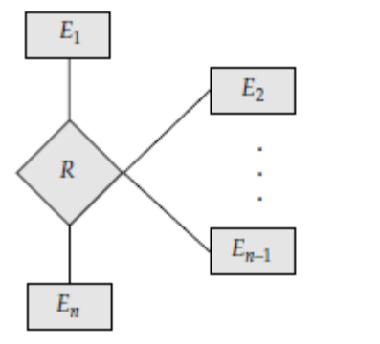
- Every relation arising from a relationship set has referential-integrity constraints. Figure shows an n-ary relationship set R, relating entity sets E1, E2, . . .,En.
- Let Ki denote the primary key of Ei. The attributes of the relation schema for relationship set R include K1 ∪ K2 ∪ · · · ∪ Kn.
- The following referential integrity constraints are then present: For each i, Ki in the schema for R is a foreign key referencing Ki in the relation schema generated from entity set Ei
- Another source of referential-integrity constraints is weak entity sets. That the relation schema for a weak entity set must include the primary key of the entity set on which the weak entity set depends.
- Thus, the relation schema for each weak entity set includes a foreign key that leads to a referential-integrity constraint.
4 .WRITE NOTE ON
- ASSERTIONS (b) TRIGGERS ( MAY 2012)
4A. ASSERTIONS
- An assertion is a predicate expressing a condition that we wish the database always to satisfy.
- Domain constraints and referential-integrity constraints are special forms of assertions.
- Assertions can be easily tested and can apply to a wide range of database applications.
Examples are:
- The sum of all loan amounts for each branch must be less than the sum of all account balances at the branch.
- Every loan has at least one customer who maintains an account with a minimum balance of $1000.00.
- An assertion in SQL takes the form (Syntax)
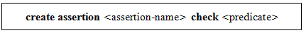
- Since SQL does not provide a “for all X, P(X)” construct (where P is a predicate), we are forced to implement the construct by the equivalent “not exists X such that not P(X)” construct, which can be written in SQL.
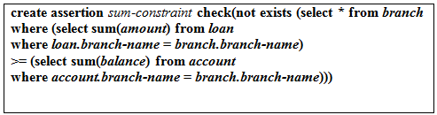
- When an assertion is created, the system tests it for validity. If the assertion is valid, then any future modification to the database is allowed only if it does not cause that assertion to be violated.
- The high overhead of testing and maintaining assertions has led some system developers to omit support for general assertions, or to provide specialized forms of assertions that are easier to test.
4.B TRIGGERS
- A trigger is a statement that the system executes automatically as a side effect of a modification to the database.
- To design a trigger mechanism, we must meet two requirements:
  - Specify when a trigger is to be executed. This is broken up into an event that causes the trigger to be checked and a condition that must be satisfied for trigger execution to proceed.
  - Specify the actions to be taken when the trigger executes. The above model of triggers is referred to as the event-condition-action model for triggers.
- The database stores triggers just as if they were regular data, so that they are persistent and are accessible to all database operations.
- Once we enter a trigger into the database, the database system takes on the responsibility of executing it whenever the specified event occurs and the corresponding condition is satisfied.
The triggering event and actions can take many forms:
- The triggering event can be insert or delete, instead of update. For example, the action on delete of an account could be to check if the holders of the account have any remaining accounts, and if they do not, to delete them from the depositor relation. You can define this trigger as an exercise.
- As another example, if a new depositor is inserted, the triggered action could be to send a welcome letter to the depositor. Obviously a trigger cannot directly cause such an action outside the database, but could instead add a tuple to a relation storing addresses to which welcome letters need to be sent. A separate process would go over this table, and print out letters to be sent.
- For updates, the trigger can specify columns whose update causes the trigger to execute. For instance if the first line of the overdraft trigger were replaced by
create trigger overdraft-trigger after update of balance on account
then the trigger would be executed only on updates to balance; updates to other attributes would not cause it to be executed.
- The referencing old row as clause can be used to create a variable storing the old value of an updated or deleted row. The referencing new row as clause can be used with inserts in addition to updates.
- Triggers can be activated before the event (insert/delete/update) instead of after the event.
- Such triggers can serve as extra constraints that can prevent invalid updates. For instance, if we wish not to permit overdrafts, we can create a before trigger that rolls back the transaction if the new balance is negative.
- As another example, suppose the value in a phone number field of an inserted tuple is blank, which indicates absence of a phone number. We can define a trigger that replaces the value by the null value. The set statement can be used to carry out such modifications.
create trigger setnull-trigger before update on r
referencing new row as nrow
for each row
when nrow.phone-number = ’ ’
set nrow.phone-number = null
- Instead of carrying out an action for each affected row, we can carry out a single action for the entire SQL statement that caused the insert/delete/update. To do so, we use the for each statement clause instead of the for each row clause.
- The clauses referencing old table as or referencing new table as can then be used to refer to temporary tables (called transition tables) containing all the affected rows. Transition tables cannot be used with before triggers, but can be used with after triggers, regardless of whether they are statement triggers or row triggers.
- A single SQL statement can then be used to carry out multiple actions on the basis of the transition tables.
Example of trigger for reordering an item,
create trigger reorder-trigger after update of amount on inventory
referencing old row as orow ,new row as nrow
for each row
when nrow.level <=(select level
from minlevel
where minlevel.item =orow.item )
and orow.level >(select level
from minlevel
where minlevel.item =orow.item )
begin
insert into orders
(select item,amount
from reorder
where reorder.item =orow.item )
end
- minlevel(item,level),which notes the minimum amount of the item to be maintained.
- reorder(item,amount),which notes the amount of the item to be ordered when its level falls below the minimum.
- orders(item,amount),which notes the amount of the item to be ordered.

5. Discuss about database security and authorization with grant graph
  - Security of data is an important concept in DBMS because it is essential to safeguard the data against any unwanted users.

  - 5 different levels of security

    - DB System Level
    - Operating System Level
    - Network Level
    - Physical Level
    - Human Level
- DB system level

  - Authentication (verification) and authorization mechanism to allow specific users access only to required data.
- Operating System Level:

    - Protection from invalid logins
    - File-level access protection
    - Protection from improper use of ―super user‖ authority,
    - Protection from improper use of privileged machine instructions.

- Network level:

  - Each site must ensure that it communicates with treated sites.
  - Links must be protected from theft or modification of messages.

Mechanisms Used:
    - Identification protocol (password based).
    - Cryptography.

- Physical Level:

Protection of equipment from floods, power failure etc..
Protection of disks from theft etc…
Protection of network and terminal cables from wire tapes etc…

Solution:
Physical security by locks etc…
Software techniques to detect physical security breaches.
- Human Level:
Protection from stolen passwords etc…
Solution:
- Frequent change of passwords.
- Data audits

- The data stored in the database need protection from unauthorized access and malicious destruction or alteration, in addition to the protection against accidental introduction of inconsistency that integrity constraints provide.
Security Violations
Among the forms of malicious access are:
Unauthorized reading of data (theft of information) Unauthorized modi .cation of data
Unauthorized destruction of data

Database security refers to protection from malicious access. Absolute protection of the database from malicious abuse is not possible, but the cost to the perpetrator can be made high enough to deter most if not all attempts to access the database without proper authority.
To protect the database, we must take security measures at several levels:
Database system .Some database-system users may be authorized to access only a limited portion of the database.Other users may be allowed to issue queries,but may be forbidden to modify the data.It is the responsibility of the database system to ensure that these authorization restrictions are not violated.
Operating system .No matter how secure the database system is,weakness in operating-system security may serve as a means of unauthorized access to the database.
Network .Since almost all database systems allow remote access through terminals or networks,software-level security within the network software is as important as physical security,both on the Internet and in private networks.
Physical .Sites with computer systems must be physically secured against armed or surreptitious entry by intruders.
Human .Users must be authorized carefully to reduce the chance of any user giving access to an intruder in exchange for a bribe or other favors.
Authorization:
We may assign a user several forms of authorization on parts of the database. For example,
o Read authorization allows reading,but not modi .cation,of data.
- Insert authorization allows insertion of new data,but not modi .cation of existing data.
- Update authorization allows modi .cation,but not deletion,of data.
o Delete authorization allows deletion of data.
We may assign the user all,none,or a combination of these types of authorization.In addition to these forms of authorization for access to data,we may grant a user authorization to modify the database schema:
o Index authorization allows the creation and deletion of indices. o Resource authorization allows the creation of new relations.
o Alteration authorization allows the addition or deletion of attributes in a relation.
o Drop authorization allows the deletion of relations.
Authorization in SQL
The SQL language offers a fairly powerful mechanism for defining authorizations.
Privileges in SQL:
The SQL standard includes the privileges delete ,insert ,select ,and update . The select privilege corresponds to the read privilege.
SQL also includes a references privilege that permits a user/role to declare foreign keys when creating relations.
If the relation to be created includes a foreign key that references attributes of another relation, the user/role must have been granted references privilege on those attributes.
The SQL data-definition language includes commands to grant and revoke privileges. The grant statement is used to confer authorization. The basic form of this statement is:

The privilege list allows the granting of several privileges in one command.
The following grant statement grants users U 1 ,U 2 ,and U 3 select authorization on the account relation:
grant select on account to U 1 ,U 2 ,U 3
In the below example, the grant statement gives users U 1 ,U 2 ,and U 3 update authorization on the amount attribute of the loan relation:
grant update (amount )on loan to U 1 ,U 2 ,U 3
Encryption and Authentication:
The various provisions that a database system may make for authorization may still not provide sufficient protection for highly sensitive data. In such cases, data may be stored in encrypted form. It is not possible for encrypted data to be read unless the reader knows how to decipher (decrypt ) them. Encryption also forms the basis of good schemes for authenticating users to a database.
Encryption Techniques:
There are a vast number of techniques for the encryption of data.Simple encryption techniques may not provide adequate security, since it may be easy for an unauthorized user to break the code.As an example of a weak encryption technique, consider the substitution of each character with the next character in the alphabet. Thus, Perryridge becomes Qfsszsjehf
A good encryption technique has the following properties:
- It is relatively simple for authorized users to encrypt and decrypt data.
- It depends not on the secrecy of the algorithm, but rather on a parameter of the algorithm called the encryption key .
- Its encryption key is extremely difficult for an intruder to determine.
Data Encryption Standard (DES):
The Data Encryption Standard (DES), does both a substitution of characters and a rearrangement of their order on the basis of an encryption key. For this scheme to work, the authorized users must be provided with the encryption key via a secure mechanism. This requirement is a major weakness, since the scheme is no more secure than the security of the mechanism by which the encryption key is transmitted.
Public-key encryption:
Public-key encryption is an alternative scheme that avoids some of the problems that we face with the DES. It is based on two keys; a public key and a private key. Each user U i has a public key E i and a private key D i .All public keys are published: They can be seen by anyone. Each private key is known to only the one user to whom the key belongs. If user U 1 wants to store encrypted data, U 1 encrypts them using public key E 1 .Decryption requires the private key D 1.
For public-key encryption to work there must be a scheme for encryption that can be made public without making it easy for people to figure out the scheme for decryption. In other words, it must be hard to deduce the private key, given the public key. Such a scheme does exist and is based on these conditions:
There is an efficient algorithm for testing whether or not a number is prime. No efficient algorithm is known for finding the prime factors of a number.
- Explain the Third and BCNF normal form in detail. ( DEC 2014)(NOV 2015)
BOYCE-CODD NORMAL FORM (BCNF):
Assumptions:
- Assume that a relation has more than one possible key.
- Assume further that the composite keys have a common attribute in that relation.
If an attribute of a composite key is dependent on an attribute of the other composite key, a normalization called BCNF is needed. Consider, as an example, the relation Professor:
Example:
Professor (Professor code, Dept, Head of Dept, Percent time);
Constraints in that relation:
It is assumed that
1. A professor can work in more than one department
2. The percentage of the time he spends in each department is given.
3. Each department has only one Head of Department.
Keys:
- Professor Code
- Department
Composite keys: (Possible cases)
Case 1: Professor code +Department
By combining these two keys we can find out in each department how many percentage of hours each professor have spent
Case 2: Professor code +Head of Dept
Using Professor and Head of Dept we can find out in particular dept. how many percent of hours he has spent.
Case 3: Professor code +Percent of time
In each dept how many percent of time he spent we cannot find out.
Case 4: Department + Head of Dept →cannot be composite key
Case 5: Department +Percent of time → cannot be composite key
The relationship diagram for the above relation is given in fig. Table gives the relation attributes. The two possible composite keys are professor code and Head of Dept. observe that department as well as Head of Dept are not non-key attributes. They are a part of a composite
key Dependency diagram of Professor relation
Professor code
Department
Percent time
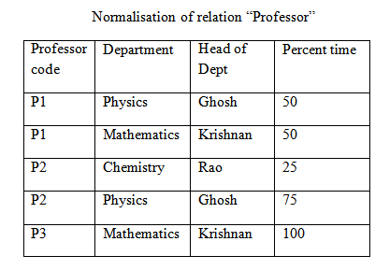
The relation given in table is in 3NF. observe, however, that the names of Dept and Head of Dept are duplicated. further if professor P2 resigns, row 3 and 4 are deleted. We lose the information that Rao is the Head of Dept of chemistry.
The normalization of the relation is done by creating a new relation for Dept and Head of Dept and deleting Head of Dept from professor relation. The normalized relations are shown in the following table.
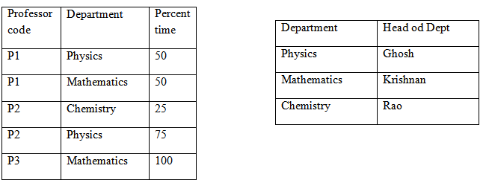
The dependency diagrams for these new relations are shown in fig. the dependency diagram gives the important clue to this normalization step as is clear from figures .
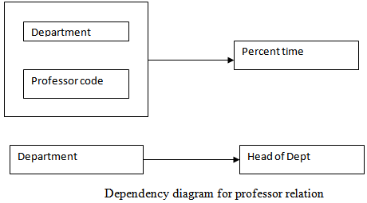

Comparison of BCNF and 3NF
- We have seen BCNF and 3NF.
  - It is always possible to obtain a 3NF design without sacrificing lossless-join or dependency-preservation.
  - If we do not eliminate all transitive dependencies, we may need to use null values to represent some of the meaningful relationships.
  - Repetition of information occurs.
- These problems can be illustrated with Banker-schema.
  - As banker-name bname , we may want to express relationships between a banker and his or her branch.

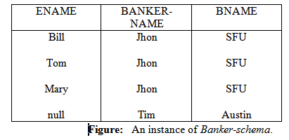
  - Figure shows how we must either have a corresponding value for customer name, or include a null.
  - Repetition of information also occurs.
  - Every occurrence of the banker's name must be accompanied by the branch name.
- If we must choose between BCNF and dependency preservation, it is generally better to opt for 3NF.
  - If we cannot check for dependency preservation efficiently, we either pay a high price in system performance or risk the integrity of the data.
  - The limited amount of redundancy in 3NF is then a lesser evil.
- To summarize, our goal for a relational database design is
  - BCNF.
  - Lossless-join.
  - Dependency-preservation.
- If we cannot achieve this, we accept
  - 3NF
  - Lossless-join.
  - Dependency-preservation.
- A final point: there is a price to pay for decomposition. When we decompose a relation, we have to use natural joins or Cartesian products to put the pieces back together. This takes computational time.
Overall database design process
Database design is the process of producing a detailed data model of a database. This model contains all the needed logical and physical design choices and physical storage parameters needed to generate a design in a Data Definition Language, which can then be used to create a database. A fully attributed data model contains detailed attributes for each entity.
This process tells who normalization fits into overall database design. Let us assume that a relation schema R is given, proceeded to normalize it. There are several ways in which we could have come up with the schema R:
1. R could have been generated when converting a E-R diagram to a set of tables.
2. R could have been a single relation containing all attributes that are of interest. The normalization process then breaks up R into smaller relations.
3. R could have been the result of some ad hoc design of relations, which we then test to verify that it satisfies a desired normal form.

- Difference between 1nf and 2nf and 3nf
First Normal Form (1NF)
First Normal Form (1NF) sets the very basic rules for an organized database as follows:
- Eliminate duplicate columns from the same table.
- Create separate tables for each group of related data and identify each row by using a unique column or set of columns (i.e., primary key).
Second Normal Form (2NF)
Second Normal Form (2NF) further addresses the concept of removing duplicate data as follows:
- Meet all the requirements of the First Normal Form.
- Remove subsets of data that apply to multiple rows of a table and place them in separate tables.
- Create relationships between these new tables and their predecessors through the use of foreign keys
Third Normal Form (3NF)
Third normal form (3NF) goes one step further as follows:
- Meet all the requirements of the Second Normal Form.
- Remove columns that are not dependent upon the primary key.

