UNIT – I
- Explain briefly Reduction of ER schema to tables. (APR 2016)

  - Primary keys allow entity sets and relationship sets to be expressed uniformly as tables which represent the contents of the database.

  - A database which conforms to an E-R diagram can be represented by a collection of tables.

  - For each entity set and relationship set there is a unique table which is assigned the name of the corresponding entity set or relationship set.

  - Each table has a number of columns (generally corresponding to attributes), which have unique names.

  - Converting an E-R diagram to a table format is the basis for deriving a relational database design from an E-R diagram.

Representing Entity Sets as Tables
A strong entity set reduces to a table with the same attributes.
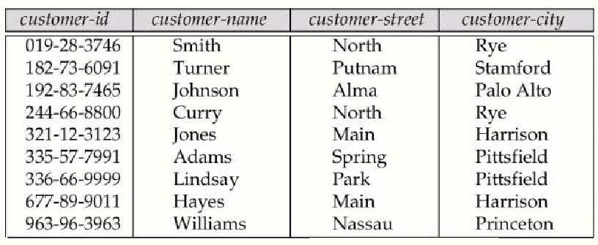

Composite and Multivalued Attributes

  - Composite attributes are flattened out by creating a separate attribute for each component attribute

  - e.g. given entity set customer with composite attribute name with component attributes first-name and last-name the table corresponding to the entity set has two attributes name.first-name and name.last-name
  - A multivalued attribute M of an entity E is represented by a separate table EM

  - Table EM has attributes corresponding to the primary key of E and an attribute corresponding to multivalued attribute M

  - e.g. Multivalued attribute dependent-names of employee is represented by a table employee-dependent-names( employee-id, dname)
  - Each value of the multivalued attribute maps to a separate row of the table EM

  - e.g., an employee entity with primary key John and dependents Johnson and Johndotir maps to two rows:
(John, Johnson) and (John, Johndotir)
Representing Weak Entity Sets

- A weak entity set becomes a table that includes a column for the primary key of the identifying strong entity set.
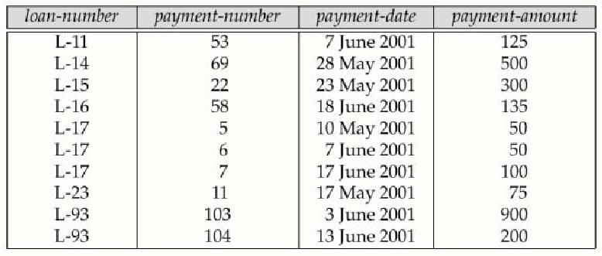

Representing Relationship Sets as Tables

- A many-to-many relationship set is represented as a table with columns for the primary keys of the two participating entity sets, and any descriptive attributes of the relationship set.

- E.g.: table for relationship set borrower
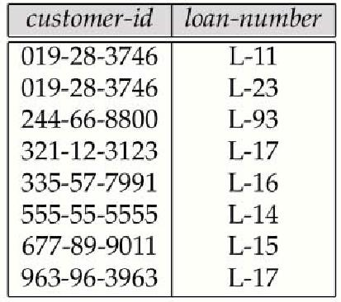

Redundancy of Tables

- Many-to-one and one-to-many relationship sets that are total on the many-side can be represented by adding an extra attribute to the many side, containing the primary key of the one side .

  - e.g.: Instead of creating a table for relationship account-branch, add an attribute branch to the entity set account
- For one-to-one relationship sets, either side can be chosen to act as the ―many‖ side i.e., extra attribute can be added to either of the tables corresponding to the two entity sets.

- If participation is partial on the many side, replacing a table by an extra attribute in the relation corresponding to the ―many‖ side could result in null values.

- The table corresponding to a relationship set linking a weak entity set to its identifying strong entity set is redundant.

e.g. The payment table already contains the information that would appear in the loan-payment table (i.e., the columns loan-number and payment-number).

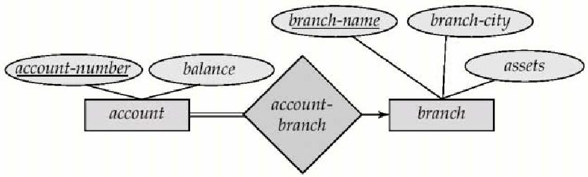

Representing Specialization as Tables
Method 1:
o Form a table for the higher level entity
- Form a table for each lower level entity set, include primary key of higher level entity set and local attributes
Table table attributes
Person name, street, city
Customer name, credit-rating
employee name, salary
Drawback: getting information about, e.g., employee requires accessing two tables
Method 2:
Form a table for each entity set with all local and inherited attributes
Table table attributes
Person name, street, city
customer name, street, city, credit-rating
    - employee name, street, city, salary
- If specialization is total, no need to create table for generalized entity (person)

- Drawback: street and city may be stored redundantly for persons who are both customers and employees

Relations Corresponding to Aggregation

- To represent aggregation, create a table containing primary key of the aggregated relationship, the primary key of the associated entity set

- Any descriptive attributes
  - E.g. to represent aggregation manages between relationship works-on and entity set manager,
- create a table manages(employee-id, branch-name, title, manager-name)

- Table works-on is redundant provided we are willing to store null values for attribute manager-name in table manages

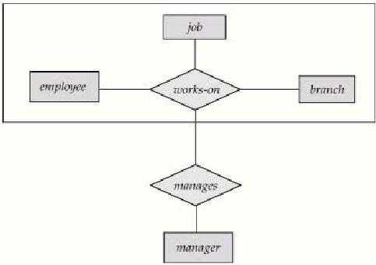

2.Discuss in detail the extended E-R features. ( may 2012)
The basic E-R concepts can model most database features, some aspects of a database may be more aptly expressed by certain extensions of the basic E-R model they are:
- Specialization
- Generalization
- Attribute Inheritance
- Constraints on Generalizations
- Aggregation
Specialization:
- Top-down design process; we designate sub groupings within an entity set that are distinctive from other entities in the set.
- These sub groupings become lower-level entity sets that have attributes or participate in relationships that do not apply to the higher-level entity set.
- The process of designating sub groupings Within an entity is called specialization.
Example: A person may be classified as,
  - Customer
  - Employee
It depicted by a triangle component labeled ISA (E.g. customer “is a” person).
- We can apply specialization repeatedly to refine a design scheme. Employees may be further classified as,
  - Officer
  - Teller
  - Secretary
- The ISA relationship may also be referred to as a super class-subclass relationship. Higher and lower level entity sets are depicted as regular entity sets- i.e. as rectangles containing the name of the entity sets.
Generalization:
- A bottom-up design process – combine a number of entity sets that share the same features into a higher-level entity set.
- Specialization and generalization are simple inversions of each other; they are represented in an E-R diagram in the same way.
- The terms specialization and generalization are used interchangeably.
- Can have multiple specializations of an entity set based on different features.
- E.g. permanent-employee vs. temporary-employee, in addition to officer vs. secretary vs. teller Each particular employee would be a member of one of permanent-employee or temporary-employee, and also a member of one of officer, secretary, or teller.
- The ISA relationship also referred to as super class – subclass relationship
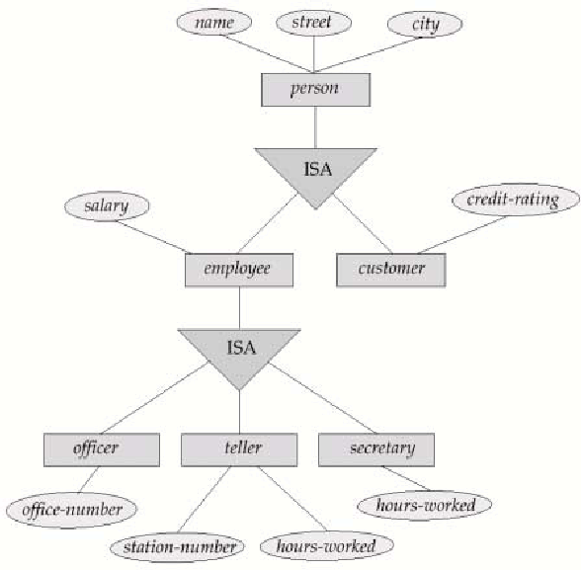
Specialization and Generalization
Attribute inheritance:
- The crucial property of the higher and lower level entities created by specialization and generalization is attribute inheritance.
- A lower-level entity set inherits all the attributes and relationship participation of the higher-level entity set to which it is linked.
Example: The officer, teller, and secretary entity sets can participate in the works_for relationship set, since the super class employee participates in the works_for relationship.
- The attributes of the higher-level entity sets are said to be inherited by the lower-level entity sets.
Example: customer and employee entity inherit the attributes of person.
- If an entity set is a lower-level entity set in one ISA relationship, then it is called as single inheritance.
- If an entity set is a lower-level entity set in more than one ISA relationship, then the entity set has multiple inheritance and the resulting structure is said to be a lattice.

Constraints on Generalizations:
Constraint on which entities can be members of a given lower-level entity set. Such membership may be one of the following:

Condition-defined:
- In condition-defined lower level entity sets, membership is evaluated on the basis of whether or not an entity satisfies an explicit condition or predicate.
E.g. all customers over 65 years are members of seniorcitizen entity set; senior-citizen ISA person.
User-defined:
- User defined lower level entity sets are not constrained by a membership condition; rather, the database user assigns entities to a given entity set.
- Constraint on whether or not entities may belong to more than one lower-level entity set within a single generalization.
- The lower-level entity set may be one of the following:

Disjoint
  - An entity can belong to only one lower-level entity set
  - Noted in E-R diagram by writing disjoint next to the ISA triangle.
Eg: an account entity can satisfy only one condition for the account_type attribute; an entity can be either a savings account or a checking account, but cannot be both.

Overlapping
  - An entity can belong to more than one lower-level entity set within a single generalization.
Eg: suppose generalization is applied to entity set customer and employee leads to a higher level entity set person. The generalization is overlapping if an employee can also be a customer.

Completeness constraints
  - It specifies whether or not an entity in the higher-level entity set must belong to at least one of the lower-level entity sets within a generalization/ specialization.

Total generalization or specialization: an entity must belong to one of the lower-level entity sets.
Partial generalization or specialization: an entity need not belong to one of the lower-level entity sets.

Aggregation
- Aggregation is an abstraction through which relationship are treated as higher level entities.
- Consider the ternary relationship works-on, which we saw earlier
- Suppose we want to record managers for tasks performed by an employee at a branch.
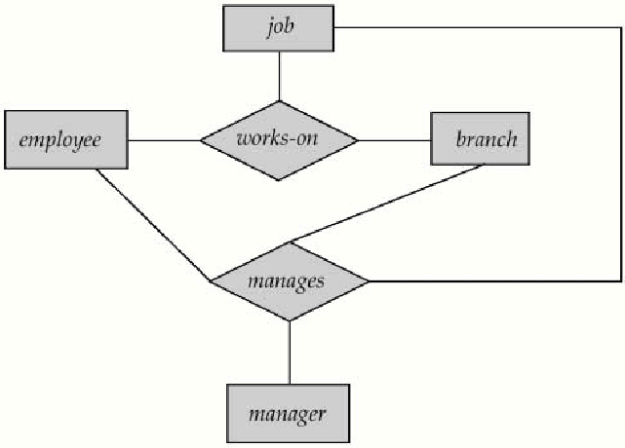
E-R diagram with aggregation
- Relationship sets works-on and manages represent overlapping information
    - Every manages relationship corresponds to a works-on relationship
    - However, some works-on relationships may not correspond to any manages relationships
- So we can’t discard the works-on relationship
- Eliminate this redundancy via aggregation
    - Treat relationship as an abstract entity
    - Allows relationships between relationships
    - Abstraction of relationship into new entity
- Without introducing redundancy, the following diagram represents:
    - An employee works on a particular job at a particular branch
    - An employee, branch, job combination may have an associated manager

3. Discuss the design issues of ER model in detail (APR 2011)
- It is a high level conceptual data model that describes the structure of db in terms of entities, relationship among entities & constraints on them.
- Basic Concepts of E-R Model:
- Entity
- Entity Set
- Attributes
- Relationship
- Relationship set
- Identifying Relationship
Entity
- It is an object that exists in the real world.
Example: Person, Employee, Car, Home etc..
- Object with conceptual Existence
Account, loan, job etc…
Entity Set
  - A set of entities of the same type.
Attributes
- A set of properties that describe an entity.
Types of Attributes
Simple (or) atomic vs. Composite
  - An attribute which can’t be sub divided. (Eg.Age)
  - An attribute which can be divided into sub parts is called as composite attribute.
e.g. Address- Apartment no.
- Street
- Place
- City
- District
Single Valued vs. Multivalued
- An attribute having only one value (e.g.. Age,eid,sno)
- An attribute having multiple values (e.g.. Deptlocat- A dept can be located in several places)
Stored Vs Derived
- Stored attribute is one that has some value
- where as derived attribute is a one where its value is derived from stored attribute.
E.g. SA-DOB
DA- Age derived from DOB.

Key Attribute
- An attribute which is used to uniquely identify records.
E.g.. eid, sno, dno
Relationship
- It is an association among several entities. It specifies what type of relationship exists between entities.
Relationship set:
- It is a set of relationships of the same type.

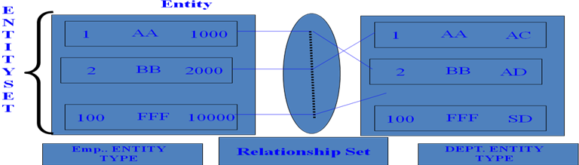
Constraints
Two of the most important constraints are
- a. Mapping Constraints
- b. Participation constraints
a. Mapping Cardinalities:
Express the no. of entities to which another entity can be associated via a relationship set
Types
- One-to-One
An entity in set A is associated with at most one entity in set B and vice versa.
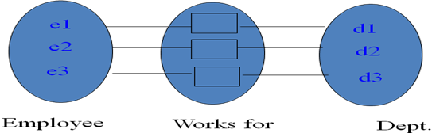
- One-to-many
An entity in set A is associated with zero or more no. of entities in set B and an entity in B is associated with at most one entity in A.

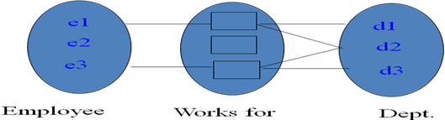

- Many-to-One

One or more no. of entities in set A is associated with at most one entity in B. An entity in B can be associated with any no. of entities in A.

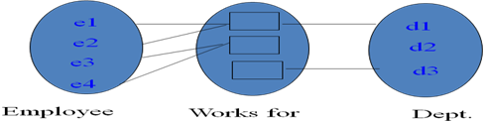
- Many-to-Many
One or more no. of entities in set A is associated with one or more no. of entities in set B.
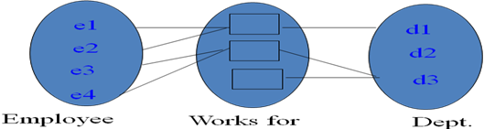
Participation Constraints:
Total Participation
- The participation of an entity set E in a relationship set R is said to be total if every entity in E participates in atleast one relationship in R.

Partial Participation:
- The participation of an entity set E in a relationship set R is said to be partial if only a few of the entities in E participated in relationship in R.

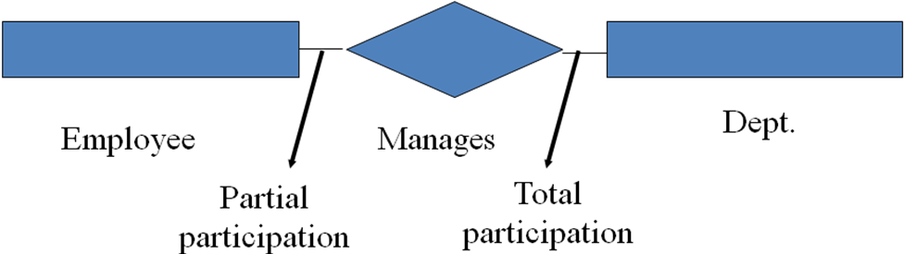
NOTATION USED IN E R MODEL
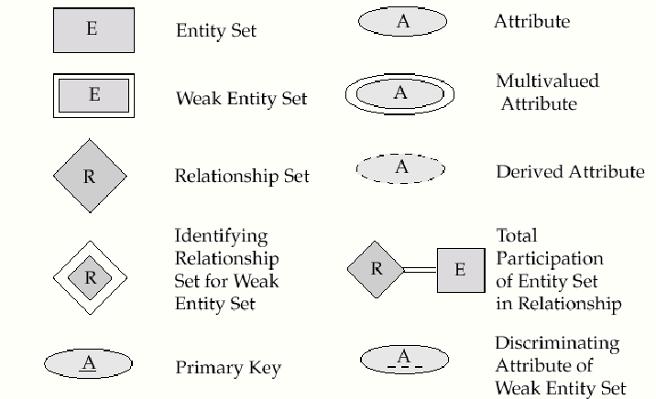
EXAMPLE E R DIAGRAM

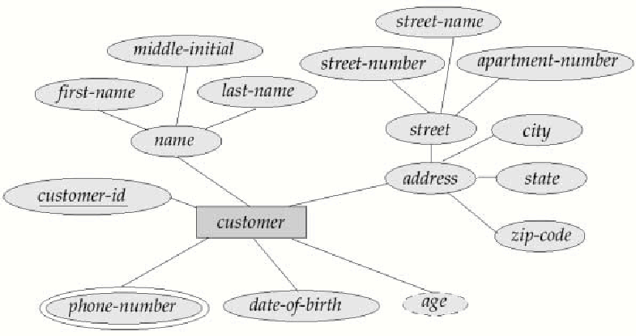

4. Discuss the different data models in detail (MAY 2009)
- A data model is a collection of concepts for describing data.
- A schema is a description of a particular collection of data, using the given data model.
- The relational model of data is the most widely used model today.
- Main concept: relation, basically a table with rows and columns.
- Every relation has a schema, which describes the columns, or fields.

Underlying the structure of a database is the data model a collection of conceptual tools for describing data, data relationships, data semantics, and consistency constraints. It can be categorized into two models they are
- The entity-relationship model and
- The relational model
Both provide a way to describe the design of a database at the logical level.
Entity-Relationship Model
- The entity-relationship (E-R) data model is based on a perception of a real world that consists of a collection of basic objects, called entities, and of relationships among these objects.
- For eg., each person is an entity; and bank accounts can be considered as entities: Entities are described in a database by a set of attributes.
- For eg., the attributes acc_no and bal may describe one particular account in a bank and they form attributes of the account entity set. Similarly, attributes cust_name, cust_street address and cust_id may describe a customer entity.
- An extra attribute cust_id is used to uniquely identify customers (since it may be possible to have two customers with the same name, street address and city).
- A relationship is an association among several entities. For eg. a depositor relationship associates a customer with each account that she has. The set of all entities of the same type and the set of all relationships of the same type are termed an entity set and relationship set, respectively.
The overall logical structure (schema) of a database can be expressed graphically by an E-R diagram, which is built up from the following components:
- Rectangles - which represent entity sets
- Ellipses - which represent attributes
- Diamonds - which represent relationships among entity sets
- Lines, which link attribute to entity sets and entity sets to relationships.

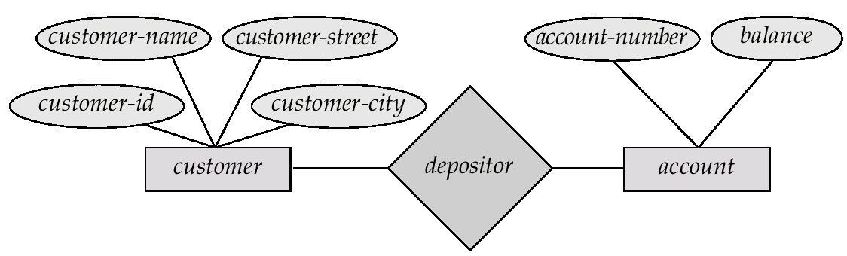Fig 1.2 An example E-R diagram
Relational Model
- The relational model uses a collection if tables to represent both data and the relationships among those data. Each table has multiple columns, and each column has a unique name.
- The relational data model is the most widely used data model, and a vast majority of current database systems are based on the relational model.
- The relational model is at a lower level of abstraction than the E-R model.
- Database designs are often carried out in the E-R model, and then translated to the relational model.
- For eg., it is easy to see customer and account correspond to the entity sets of the same name, while the table depositor corresponds to the relationship set depositor.
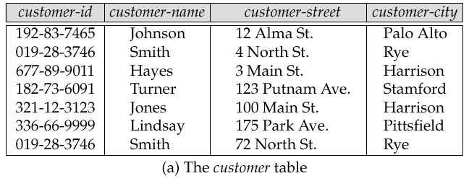
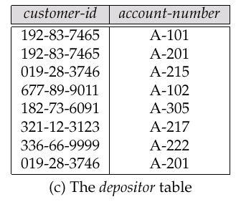
Other Data Models

The object-oriented data model is another data model that has seen increasing attention. The object-oriented model can be seen as extending the E-R model with notions of encapsulation, methods and object identity.
The object-relational data model combines features of the object-oriented data model and relational data model. Semistructured data models permit the specification of data where individual data items of the same type may have different sets of attributes. The extensible markup language (XML) is widely used to represent semistructured data.
Two other data models are
- Network model and
- Hierarchical data model,
5. Differentiate File System Vs Dbms (May 2009)
DBMS contains information about a particular enterprise
- Collection of interrelated data.
- Set of programs to access the data.
- An environment that is both convenient and efficient to use.

In other way
- A very large, integrated collection of data.
- Models real-world enterprise.
    - Entities (e.g., students, courses)
    - Relationships (e.g., Madan is taking Computer)
Goal
- A Database Management System (DBMS) is a software package that is designed to store and manage databases.

Database Applications

- Banking: all transactions
- Airlines: reservations, schedules
- Universities: registration, grades
- Sales: customers, products, purchases
- Online retailers: order tracking, customized recommendations
- Manufacturing: production, inventory, orders, supply chain
- Human resources: employee records, salaries, tax deductions
- Databases touch all aspects of our lives

Purpose of Database Systems

In the early days, database applications were built directly on top of file systems

Why Use a DBMS?
- Data independence and efficient access.
- Reduced application development time.
- Data integrity and security.
- Uniform data administration.
- Concurrent access, recovery from crashes
Files vs DBMS
- Application must store large datasets between main memory and secondary storage
  - (e.g., buffering, page-oriented access, 32-bit addressing, etc.)
- Special code for different queries
- Must protect data from inconsistency due to multiple concurrent users
- Crash recovery
- Security and access control

Drawbacks of using file systems
- Data redundancy and inconsistency
Multiple file formats, duplication of information in different files.
- Difficulty in accessing data
Need to write a new program to carry out each new task
- Data isolation - multiple files and formats
- Integrity problems
- Integrity constraints (e.g. account balance > 0) become “buried” in program code rather than being stated explicitly
- Hard to add new constraints or change existing ones
- Atomicity of updates
- Failures may leave database in an inconsistent state with partial updates carried out
- Example: Transfer of funds from one account to another should either complete or not happen at all
- Program to transfer Rs.200 from A to B acc. System failure occurs then rs. 200 is removed from A but not credited to B
- Concurrent access by multiple users
- Concurrent accessed needed for performance
- Uncontrolled concurrent accesses can lead to inconsistencies
- Example: Two people reading a balance and updating it at the same time
- Security problems
  - Hard to provide user access to some, but not all, data
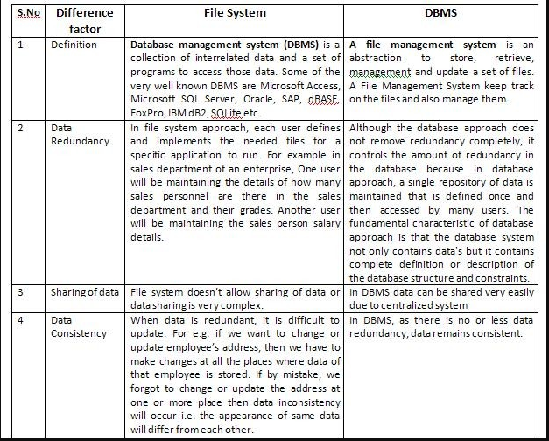

- 6. EXPLAIN THE OVERALL ARCHITECTURE OF DATABASE SYSTEM( MAY 2012) ( APR 2011) (NOV 2009) (Dec 2016)
Application Programmers
- Application programmer is the person who is responsible for implementing the required functionality of database for the end user.
- Application programmer works according to the specification provided by the system analyst.
End Users
End users are those persons who interact with the application directly. They are responsible to insert, delete and update data in the database. They get information from the system as and when required. Different types of end users are as follows:
- Naive Users: Naive users are those users who do not have any technical knowledge about the DBMS. They use the database through application programs by using simple user interface. They perform all operations by using simple commands provided in the user interface.
Example: The data entry operator in an office is responsible for entering records in the database. He performs this task by using menus and buttons etc. He does not know anything about database or DBMS. He interacts with the database through the application program.
- Sophisticated Users: Sophisticated users are the users who are familiar with the structure of database and facilities of DBMS. Such users can use a query language such as SQL to perform the required operations on databases. Some sophisticated users can also write application programs.
Database Administrator
Database administrator is responsible for, managing the whole database system. The one who designs creates and maintains the database. And also manages the users who can access this database, and controls integrity issues. And monitors the performance of the system and makes changes in the system as and when required.

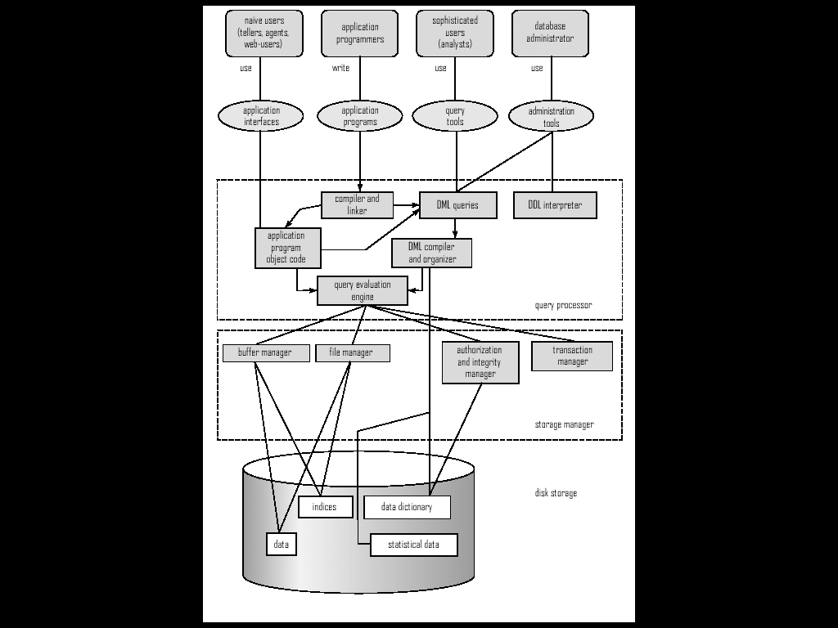

- A database system is partitioned into modules that deal with each of the responsibilities of the overall system.
- The functional components of a database system can be broadly divided into
- The storage manager and
- The query processor components.
- The storage manager is important because databases typically require a large amount of storage space. For eg.,Corporate databases are too large.
- So the main memory of computer cannot store that much of information, the information is stored on disks. Data are moved between disk storage and main memory as needed and also speed of retrieval is slow.
- The database systems structure the data as to minimize the need to move data between disk and main memory.
- The query processor is important because it helps the database system simplify and facilitate access to data. High-level views help to achieve this goal.
- The job of the database system is to translate updates and queries written in a nonprocedural language, at the logical level, into an efficient sequence of operations at the physical level.
Storage Manager
- Storage manager is a program module that provides the interface between the low-level data stored in the database and the application programs and queries submitted to the system.
- The storage manager is responsible to the following tasks:

  - interaction with the file manager
  - efficient storing, retrieving and updating of data

The storage manager components include:
  - Authorization and integrity manager, which tests for the satisfaction of integrity constraints and checks authority to access the data.
  - Transaction manager, which ensures that the database remains in a consistent state despite system failures and that concurrent transaction execution proceed without conflicting.
  - File Manager, which manages the allocation of space on disk storage and the data structures used to represent information stored on disk.
  - Buffer manager, which is responsible for fetching data from disk storage into main memory, and deciding what data to cache in main memory. It is used to handle data sizes that are much larger than the size of main memory.
The storage manager implements several data structures as part of the physical system implementation:
  - Data files, which store the database itself.
  - Data Dictionary, which stores metadata about the structure of the database, in particular the schema of the database.
  - Indices, which provide fast access to data items that hold particular values.
Query Processor : The query processor includes:
  - DDL interpreter, which interprets DDL statements and records the definitions in the data dictionary.
  - DML complier, which translates DML statements in a query language.
- A query can usually be translated into any of a number of alternatives evaluation plans that all give the same result. The DML complier also performs query optimization, that is, it picks the lowest cost evaluation plan from among the alternatives.
- Query evaluation engine, which executes low-level instructions generated by the DML compiler.
7. HOW TO REPRESENT SCHEMA INTO TABLES? EXPLAIN
- An E-R Diagram can express the overall logical structure of a database graphically.
Components of E-R Diagrams and their notations:
Alternative E-R notations
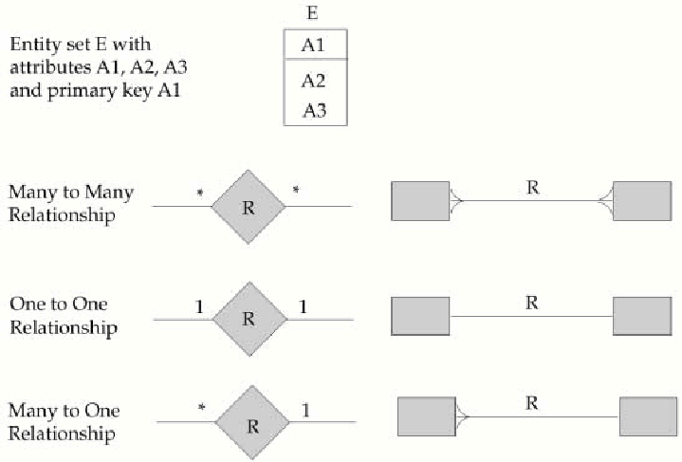
E-R diagrams corresponding to customers and loans
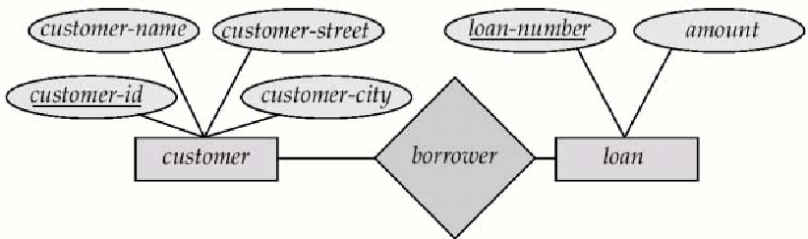
- Consider the above E-R diagram, which consists of two entity sets, customer and loan, related through a binary relationship set borrower.
- The attributes associated with customer are customer_id, customer_name, customer_street, customer_city. The attributes associated with loan are loan_number and amount. In the above figure, attributes of an entity set that are members of the primary key are underlined.
- From the above diagram, we see that the relationship set borrower is many-to-many.
MAPPING CARDINALITIES:
- We express cardinality constraints by drawing either a directed line(→),signifying “one”, or an undirected line(--), signifying “many”, between the relationship set and the entity set.

One-to-one relationship:
- A customer is associated with at most one loan via the relationship borrower.
- A loan is associated with at most one customer via borrower.
- If the relationship set borrower is one-to-one, then both lines from borrower would have arrows: one pointing to the loan entity set and one pointing to the customer entity set.
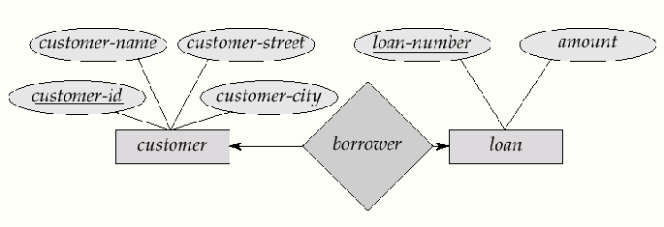
One-to-Many relationship:
- In the one-to-many relationship a loan is associated with at most one customer via borrower, customer is associated with several loan is borrower.
- If the relationship set borrower were one-to-many, from customer to loan, then the line from borrower to customer would be directed, with an arrow pointing to the customer entity set.
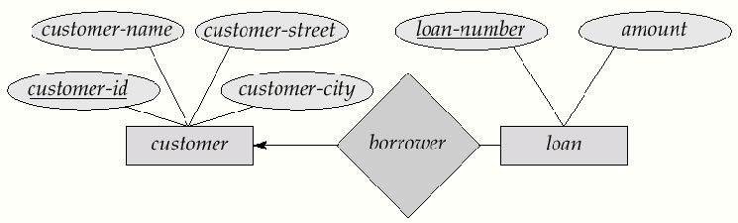
Many-to-One relationships:
- In a many-to-one relationship a loan is associated with several customers via borrower; a customer is associated with at most one loan via borrower.
- If the relationship set borrower were many-to-one from customer to loan, then the line from borrower to loan would have an arrow pointing to the loan entity set.

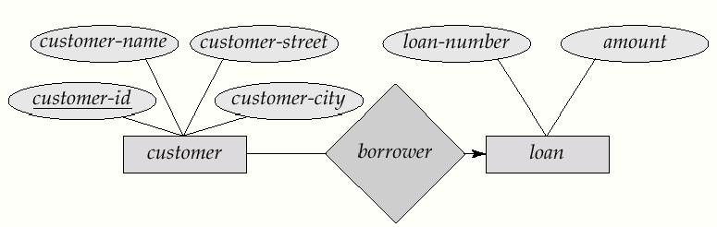
Many-to-many Relationship:
- A customer is associated with several (possibly 0) loans via borrower
- A loan is associated with several (possibly 0) customers.

E-R Diagram with an attribute attached to a relationship set.
- If a relationship set has also some attributes associated with it, then we link these attributes to that relationship set.
- For example, in the below diagram, we have the access_date descriptive attribute attached to the relationship set depositor to specify the most recent date on which a customer accessed that account.
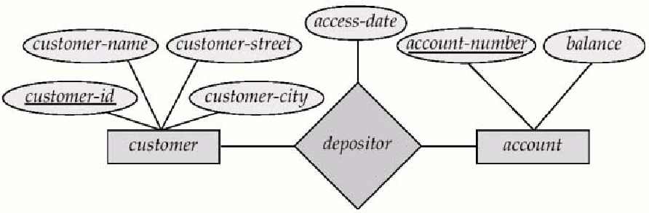
- Draw an E-R diagram for bank has many branches in a country. Each branch is identified with the help of branch name. Each branch of the bank has multiple customers. Customers also include employees of that particular branch. An employee can be a manager or staff of that branch. Branch gives each customer an id in order to identify them. Customers can open two types of accounts i.e. saving account and Checking account. Branches of the bank provide Loan to the customers if required. Re-Payment of loan is done with the help of payment number of that particular loan.
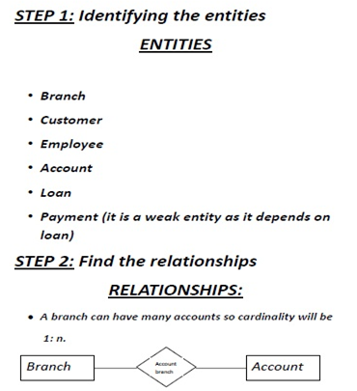

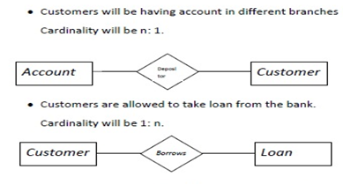
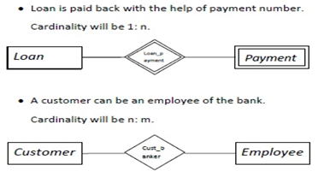
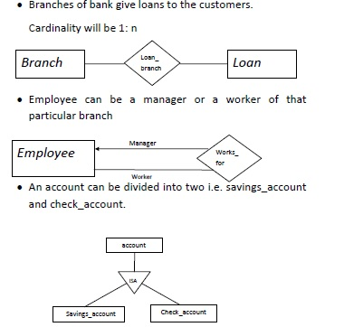

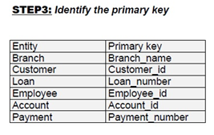
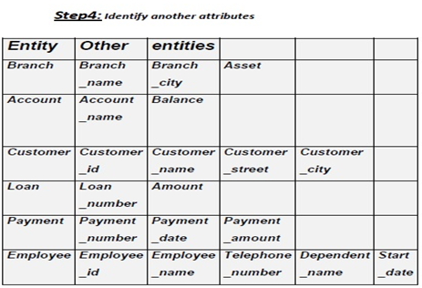
- Discuss the different data models in detail (MAY 2009)

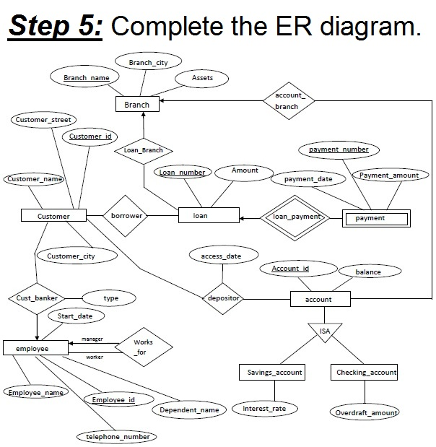
- Discuss the design issues of E-R model in detail ( APR 2011) (DEC 2016)
The design issues in ER relationship:
- Use of entity sets vs. attributes:
Choice mainly depends on the structure of the enterprise being modeled, and on the semantics associated with the attribute in question.
- Use of entity sets vs. relationship sets:
Possible guideline is to designate a relationship set to describe an action that occurs between entities
- Binary versus n-ary relationship sets:
- Although it is possible to replace any non binary (n-ary, for n>2) relationship set by a number of distinct binary relationship sets,
a n-ary relationship set shows more clearly that several entities participate in a single relationship.
- Some relationships that appear to be non-binary may be better represented using binary relationships
- E.g. A ternary relationship parents, relating a child to his/her father and mother, is best replaced by two binary relationships, father and mother .
Using two binary relationships allows partial information (e.g. only mother being know)
- But there are some relationships that are naturally non-binary
E.g. works-on
- In general, any non-binary relationship can be represented using binary relationships by creating an artificial entity set.
- Replace R between entity sets A, B and C by an entity set E, and three relationship sets:
- R_{A}, relating E and A
- R_{B}, relating E and B
- R_{C}, relating E and C
- Create a special identifying attribute for E
- Add any attributes of R to E
- For each relationship (ai , bi , ci) in R, create
- a new entity ei in the entity set E
- add (ei , ai ) to RA
- add (ei , bi ) to RB
- add (ei , ci ) to RC

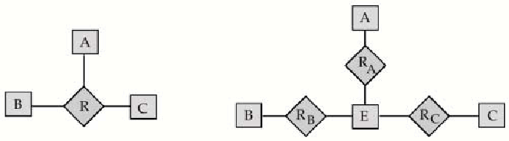
Ternary relationship vs. three binary relationships.
- Also need to translate constraints
  - Translating all constraints may not be possible
  - There may be instances in the translated schema that cannot correspond to any instance of R
  - Exercise: add constraints to the relationships R_{A}, R_{B} and R_{C} to ensure that a newly created entity corresponds to exactly one entity in each of entity sets A, B and C
  - We can avoid creating an identifying attribute by making E a weak entity set (described shortly) identified by the three relationship sets

- Placement of relationship attributes:
- The cardinality ratio of a relationship can affect the placement of relationship attributes. Thus, attributes of one-to-one or one-to-many relationship set can be associated with one of the participating entity sets, rather than with the relationship set.

- Example: Can make access-date an attribute of account, instead of a relationship attribute, if each account can have only one customer i.e., the relationship from account to customer is many to one, or equivalently, customer to account is one to many
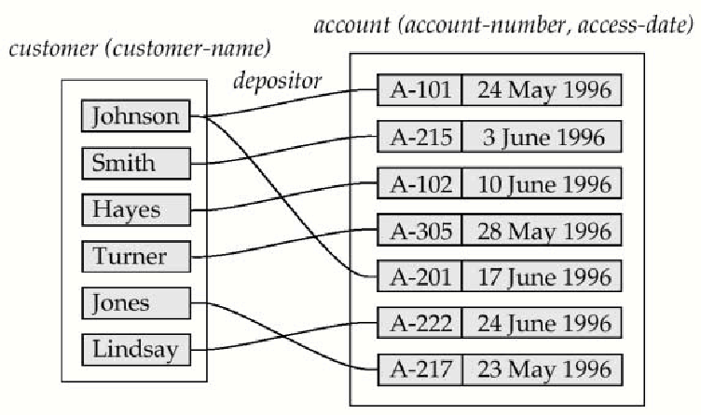
Access-date as attribute of the account entity set.

