**How to add the code into GitHub and git repository.?**

**Warning:** Never git add, commit, or push sensitive information to a remote repository. Sensitive information can include, but is not limited to:

* Passwords
* SSH keys
* [AWS access keys](http://docs.aws.amazon.com/AWSSimpleQueueService/latest/SQSGettingStartedGuide/AWSCredentials.html)
* API keys
* Credit card numbers
* PIN numbers

1. [Create a new repository](https://docs.github.com/en/articles/creating-a-new-repository) on GitHub. To avoid errors, do not initialize the new repository with README, license, or gitignore files. You can add these files after your project has been pushed to GitHub.

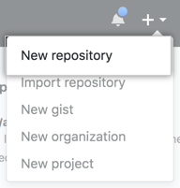

1. Open Git Bash.
2. Change the current working directory to your local project.
3. Initialize the local directory as a Git repository. The project we want push we need to initialize the git. Hence .git file will be create at workspace in our local machine and it is a hidden file we can see this file in cmd prompt

$ git init -b main

1. Add the files in your new local repository. This stages them for the first commit.

$ git add .

# Adds the files in the local repository and stages them for commit. To unstage a file, use 'git reset HEAD YOUR-FILE'.

1. Commit the files that you've staged in your local repository.

$ git commit -m "First commit"

# Commits the tracked changes and prepares them to be pushed to a remote repository. To remove this commit and modify the file, use 'git reset --soft HEAD~1' and commit and add the file again.

1. At the top of your GitHub repository's Quick Setup page, click  to copy the remote repository URL.

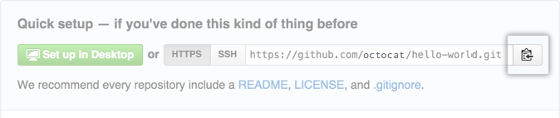

1. In the Command prompt, [add the URL for the remote repository](https://docs.github.com/en/github/getting-started-with-github/managing-remote-repositories) where your local repository will be pushed.

$ git remote add origin <REMOTE_URL>

# Sets the new remote

$ git remote -v

# Verifies the new remote URL

1. $ git push origin main -f

#pushes the changes in your local repository up to the remote repository you specified as the origin

1. [Push the changes](https://docs.github.com/en/github/getting-started-with-github/pushing-commits-to-a-remote-repository) in your local repository to GitHub.

$ git push origin main

# Pushes the changes in your local repository up to the remote repository you specified as the origin

When we want to pull the project from github repository use below command.

1. $ git clone <link of that project from github>

It will clone a folder in our local machine then we can import that project in our eclipse. So this is first time when you need to clone the project from repository after this if you want to pull the updated project then basically use pull command.

1. $git pull origin master

It will pull the updated code from the github repository.