**How to integrate Jenkins with Selenium.?**

**Jenkins** is an open-source Continuous Integration server written in Java for orchestrating a chain of actions to achieve the Continuous Integration process in an automated fashion. Jenkins supports the complete development life cycle of software from building, testing, documenting the software, deploying, and other stages of the software development life cycle. Jenkins is available in the war file. We have to download it. Then get the path of the Jenkins.war file go to that path in command prompt. Run command java -jar **jenkins**.war wait until the process completed. Then you will get password to login to localhost:8080.

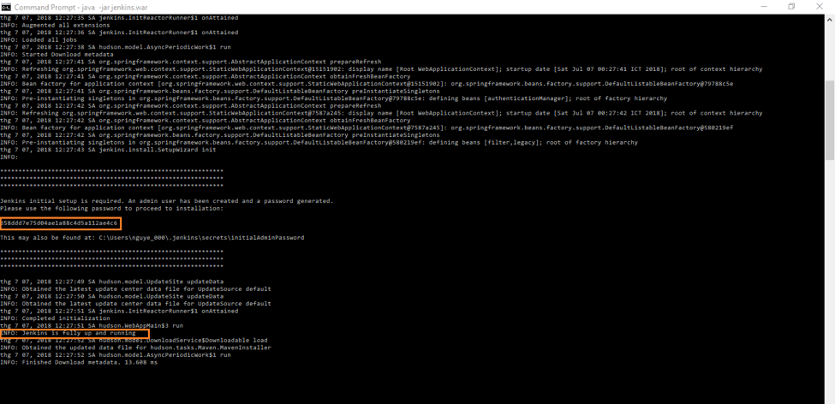

The first box contains password for first time access to localhost:8080