1. Define the Bayesian interpretation of probability.

The Bayesian interpretation is based on one simple idea: A probability reflects our degree of belief in a hypothesis. Probabilities are therefore subjective: Someone with different knowledge will have different probabilities. Thus, by collecting evidence, our degrees of belief change.

2. Define probability of a union of two events with equation.

P(A or B) = P(A) + P(B). The chance of any (one or more) of two or more events occurring is called the union of the events. The probability of the union of disjoint events is the sum of their individual probabilities.

3. What is joint probability? What is its formula?

A joint probability is a possibility of occurring one or more independent events simultaneously, denoted as P (A∩B) or P (A and B). One can calculate it by multiplying the probability of both outcomes = P (A)\*P (B)

4. What is chain rule of probability?

In probability theory, the chain rule (also called the general product rule describes how to calculate the probability of the intersection of, not necessarily independent, events or the joint distribution of random variables respectively, using conditional probabilities. The rule is notably used in the context of discrete stochastic processes and in applications, e.g. the study of Bayesian networks, which describe a probability distribution in terms of conditional probabilities.

5. What is conditional probability means? What is the formula of it?

Conditional probability: p(A|B) is the probability of event A occurring, given that event B occurs. For example, given that you drew a red card, what's the probability that it's a four (p(four|red))=2/26=1/13. So out of the 26 red cards (given a red card), there are two fours so 2/26=1/13.

6. What are continuous random variables?

A random variable X is continuous if possible values comprise either a single interval on the number line or a union of disjoint intervals. Example: If in the study of the ecology of a lake, X, the r.v. may be depth measurements at randomly chosen locations

7. What are Bernoulli distributions? What is the formula of it?

Bernoulli distribution is a discrete probability distribution. It describes the probability of achieving a “success” or “failure” from a Bernoulli trial. A Bernoulli trial is an event that has only two possible outcomes (success or failure). For example, will a coin land on heads (success) or tails (failure)?

8. What is binomial distribution? What is the formula?

The binomial distribution formula helps to check the probability of getting “x” successes in “n” independent trials of a binomial experiment.

The binomial distribution is given by the formula: P(X= x) = nCxpxqn-x, where = 0, 1, 2, 3, … P(X = 6) = 105/512. Hence, the probability of getting exactly 6 heads is 105/512.

9. What is Poisson distribution? What is the formula?

The Poisson distribution is a discrete distribution that measures the probability of a given number of events happening in a specified time period.

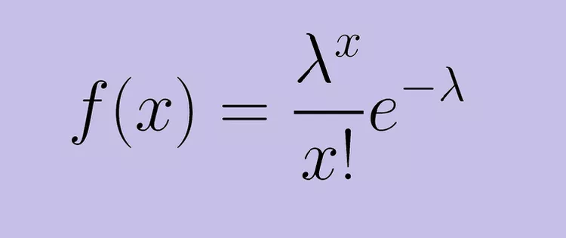

10. Define covariance.

Covariance is a statistical tool used to determine the relationship between the movements of two random variables. When two stocks tend to move together, they are seen as having a positive covariance; when they move inversely, the covariance is negative

11. Define correlation

Correlation is a statistical measure that expresses the extent to which two variables are linearly related (meaning they change together at a constant rate). It's a common tool for describing simple relationships without making a statement about cause and effect.

12. Define sampling with replacement. Give example.

If you sample with replacement, you would choose one person's name, put that person's name back in the hat, and then choose another name. The possibilities for your two-name sample are: John, John. John, Jack.

13. What is sampling without replacement? Give example.

Sampling is called without replacement when a unit is selected at random from the population and it is not returned to the main lot. The first unit is selected out of a population of size N and the second unit is selected out of the remaining population of N–1 units, and so on.

14. What is hypothesis? Give example.

A hypothesis is a tentative statement about the relationship between two or more variable. Professionals typically write hypotheses as if/then statements, such as if someone eats a lot of sugar, then they will develop cavities in their teeth. These statements identify specific variables and propose results. In this example, the variable is the amount of sugar and the result is developing cavities.