1. Using a graph to illustrate slope and intercept, define basic linear regression.

The slope indicates the steepness of a line and the intercept indicates the location where it intersects an axis. The slope and the intercept define the linear relationship between two variables, and can be used to estimate an average rate of change. The greater the magnitude of the slope, the steeper the line and the greater the rate of change.

By examining the equation of a line, you quickly can discern its slope and y-intercept (where the line crosses the y-axis).

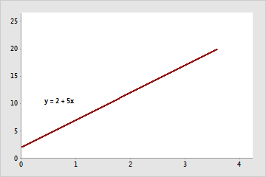

The slope is positive 5. When x increases by 1, y increases by 5. The y-intercept is 2.

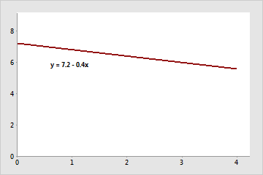

The slope is negative 0.4. When x increases by 1, y decreases by 0.4. The y-intercept is 7.2.

2. In a graph, explain the terms rise, run, and slope.

The vertical change between two points is called the rise, and the horizontal change is called the run. The slope equals the rise divided by the run: Slope =riserun Slope = rise run . You can determine the slope of a line from its graph by looking at the rise and run

3. Use a graph to demonstrate slope, linear positive slope, and linear negative slope, as well as the

different conditions that contribute to the slope.

The mathematical definition of slope is very similar to our everyday one. In math, slope is used to describe the steepness and direction of lines. By just looking at the graph of a line, you can learn some things about its slope, especially relative to other lines graphed on the same coordinate plane.

In order to graph a negative slope, it is important to know that a negative number in the ratio will mean to move down along the y-axis or to the left along the x-axis. A positive number in the ratio will mean to move up along the y-axis or to the right along the x-axis

4. Use a graph to demonstrate curve linear negative slope and curve linear positive slope.

A positive slope moves upward on a graph from left to right. A negative slope moves downward on a graph from left to right.

5. Use a graph to show the maximum and low points of curves.

A useful application of calculus is finding maximum or minimum value(s) of a function.

In this graph of the function y = x^3 - 12x+ 2 there is a local maximum (at x= -2) and local minimum (at x= 2).

The blue horizontal line shows that the gradient at these points is zero i.e. f'(x) = 0

6. Use the formulas for a and b to explain ordinary least squares.

Ordinary least squares (OLS) is a linear regression technique used to find the best-fitting line for a set of data points. It is a popular method because it is easy to use and produces decent results. In this blog post, we will discuss the basics of OLS and provide some examples to help you understand how it works. As data scientists, it is very important to learn the concepts of OLS before using it in the regression model.

7. Provide a step-by-step explanation of the OLS algorithm.

* Set a difference between dependent variable and its estimation:
* Square the difference:
* Take summation for all data.
* To get the parameters that make the sum of square difference become minimum, take partial derivative for each parameter and equate it with zero,

8. What is the regressions standard error? To represent the same, make a graph.

The standard error of the regression (S), also known as the standard error of the estimate, represents the average distance that the observed values fall from the regression line. Conveniently, it tells you how wrong the regression model is on average using the units of the response variable. Smaller values are better because it indicates that the observations are closer to the fitted line.

9. Provide an example of multiple linear regression.

Multiple Linear Regression is one of the important regression algorithms which models the linear relationship between a single dependent continuous variable and more than one independent variable. Example: Prediction of CO2 emission based on engine size and number of cylinders in a car.

10. Describe the regression analysis assumptions and the BLUE principle.

The Gauss-Markov theorem states that if your linear regression model satisfies the first six classical assumptions, then ordinary least squares (OLS) regression produces unbiased estimates that have the smallest variance of all possible linear estimators.

11. Describe two major issues with regression analysis.

1 The regression problem. The regression problem is how to model one or several dependent variables/responses, Y, by means of a set of predictor variables, X. In the PLS method, we divide the variables (columns) into two blocks denoted as X and Y.

12. How can the linear regression model&#39;s accuracy be improved?

Regularization.

Handling Missing & Null Values. Deleting Missing Values. Imputing Missing Values. Imputing by Model-based Prediction.

Categorical Feature Encoding. Label Encoding. One-Hot Encoding.

Feature Engineering.

13. Using an example, describe the polynomial regression model in detail.

Polynomial regression is one of the machine learning algorithms used for making predictions. For example, it is widely applied to predict the spread rate of COVID-19 and other infectious diseases

14. Provide a detailed explanation of logistic regression.

Logistic regression is a data analysis technique that uses mathematics to find the relationships between two data factors. It then uses this relationship to predict the value of one of those factors based on the other. The prediction usually has a finite number of outcomes, like yes or no.

15. What are the logistic regression assumptions?

Basic assumptions that must be met for logistic regression include independence of errors, linearity in the logit for continuous variables, absence of multicollinearity, and lack of strongly influential outliers.

16. Go through the details of maximum likelihood estimation.

Maximum likelihood estimation is a statistical method for estimating the parameters of a model. In maximum likelihood estimation, the parameters are chosen to maximize the likelihood that the assumed model results in the observed data