**Task 1: SQL Database Interaction Scripts**

**Objective**:

Write SQL scripts for storing and retrieving patient data.

**Requirements:**

● Develop INSERT, SELECT, UPDATE, and DELETE operations.

● Test these operations with a mock SQL database with a schema for patient name, age, gender, phone, and Aadhar.

**My Approach:**

Step 1- Create a new database

Step 2- Create a new table named patient_data with columns.

Step 3- Insert mock values into the database

Step 4-Write query to extract data from the database and test it

Step 5-Write query to make updates in the database and test it

Step 6- Write a query to delete records in the database and test it

To accomplish this task, I will be using PostgreSQL software

**Step 1**

Created a new database using the create option in PostgreSQL named patient_data

**Step 2:**

Created a new table in the database using the create table command with schema

* Aadhar with datatype BIGINT as these are 12-digit numbers and a NOT NULL constraint. As it is unique to everyone, I will use it as the primary key
* Patient_name with datatype VARCHAR with 30 characters with NOT NULL constraint.
* Age with integer datatype.
* Gender with datatype VARCHAR with six characters and with CHECK constraint to limit the value within male, female, and other.
* Phone with datatype VARCHAR with 10 characters. Used VARCHAR because a phone number may contain some characters like +, - etc.

The screenshot of this SQL query is below

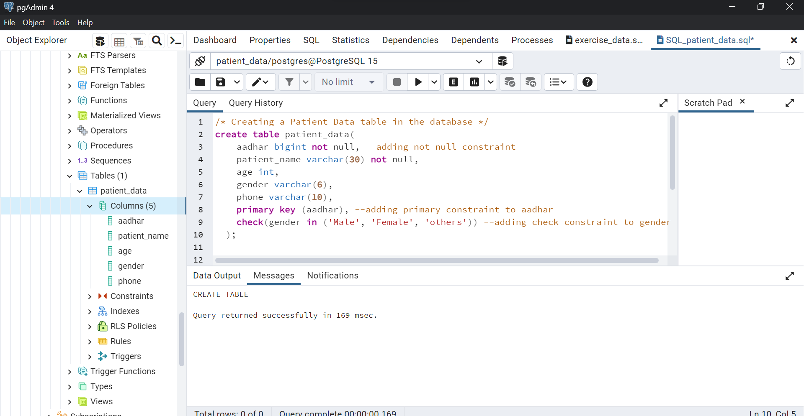

**Step 3:**

Insert mock patient values in the database. Using the INSERT INTO table command and entering multiple mock records into the dataset using the VALUE command in PostgreSQL.

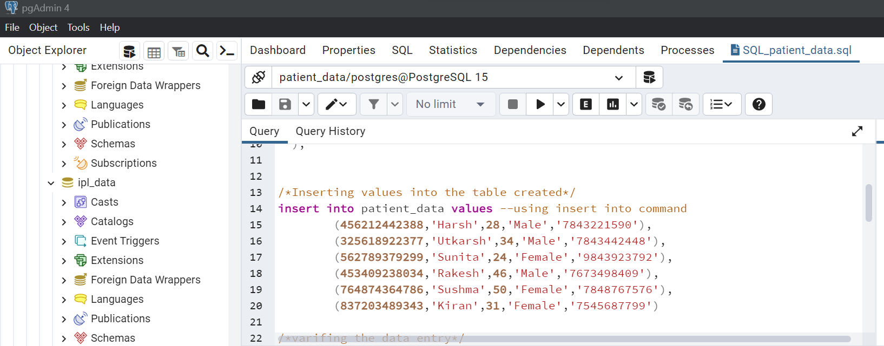

Verifying if all the values are entered in the database using the SELECT command.

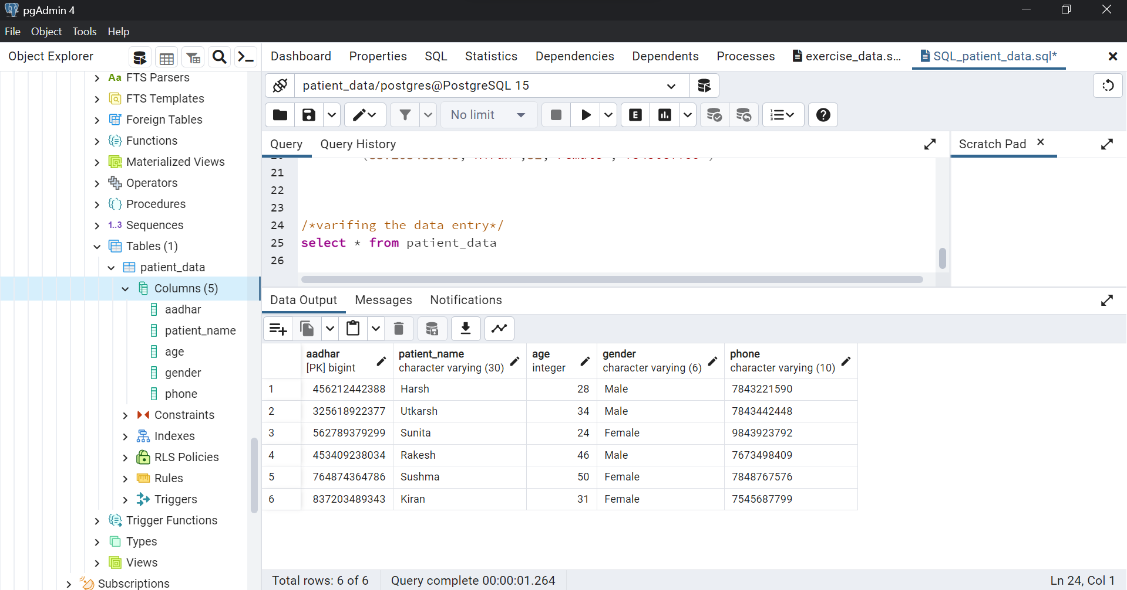

**Step 4:**

Writing a query to extract data from the database. For this task, I will extract patient data from the database who are females and above 30 years of age. Here I have used a SELECT statement with WHERE clause to apply the required condition for extraction. In the WHERE clause, I used the AND command to ensure only those records are extracted where both the conditions are met.

Screenshot for reference

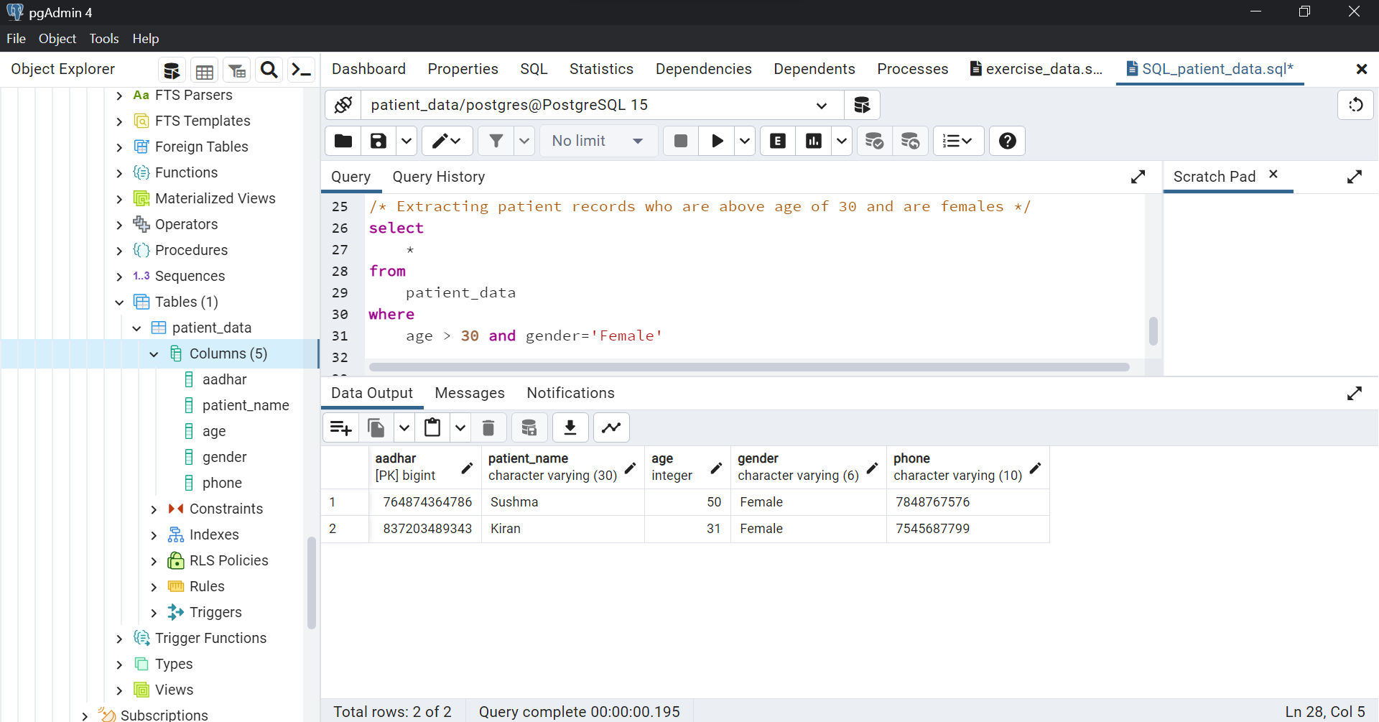

**Step 5:**

Wrote a SQL query to make updates in the database and test it. For this task, I have used the UPDATE TABLE command to make updates with the SET command to specify what particular changes to be made. Finally used primary key Aadhar number in the WHERE clause to specify which records need to be updated.

Check Screenshot for reference

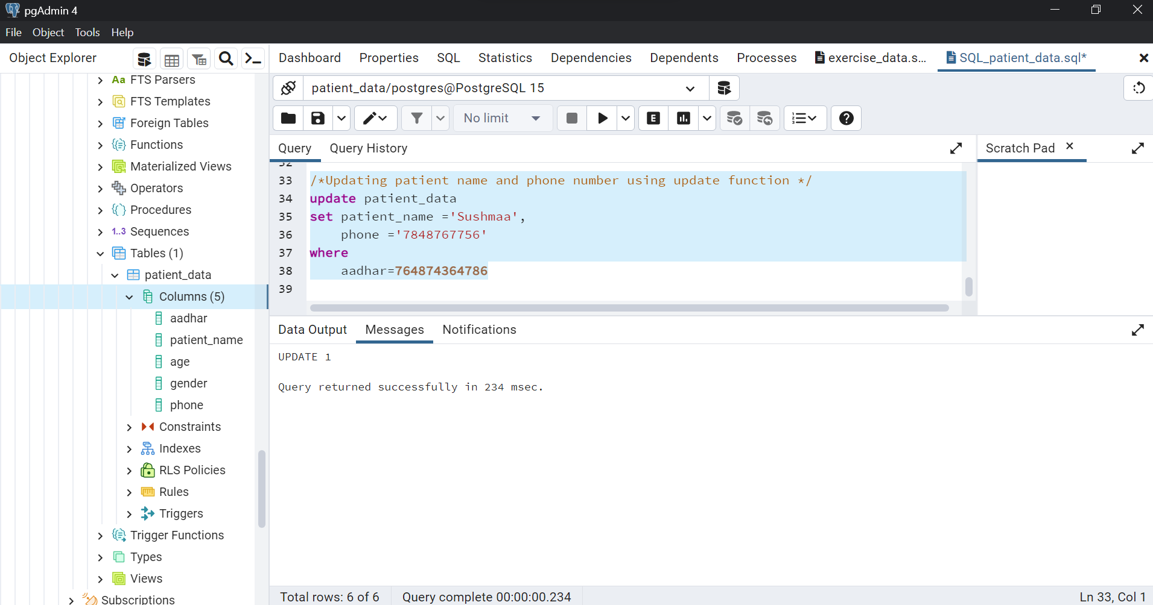Verifying the updates in the database in the below screenshot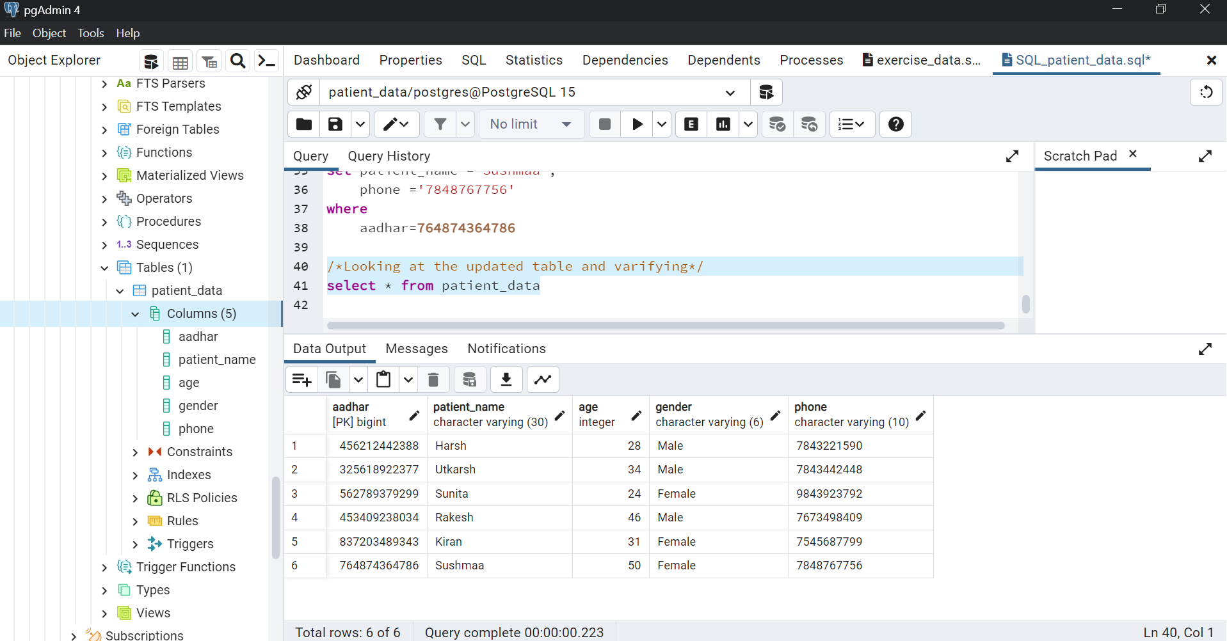

**Step 6:**

Write a query to delete records from the database and test it. For this query, I have used the DELETE FROM table command with the WHERE clause to specify which record needs to be deleted. To test it, I deleted a patient's complete record from the database using the patient_name column in the WHERE clause to specify.

Check the screenshot for reference

