Modules:

|  |
| --- |
|  |
|  |  |
|  | Class: School |
|  | Contains all Admins |
|  | Contains all Students |
|  | Contains all Courses |
|  | Calculates semester information(Ends semester, forces GPA calculations in Student). |
|  | Handles Login |
|  |  |
|  |  |
|  | Class: Admin |
|  | Creates Course and adds to Courses |
|  | Creates Student and adds to Students |
|  | Registers Students to Courses |
|  | Edits Course |
|  | Edits Admin |
|  | Edits Student |
|  | Views Course |
|  | Views Admin |
|  | Views Student |
|  | Views Tests |
|  |  |
|  | Class: Student |
|  | Contains information: Student’s name, student’s ID, registered courses, GPA |
|  | Updates GPA |
|  | Views Course |
|  | Views Tests |
|  |  |
|  | Class: Course |
|  | Contains information: Course ID, Course Time, Semester, Course Description, Exams |
|  | Calculates grade information for course (A,B,ect) |

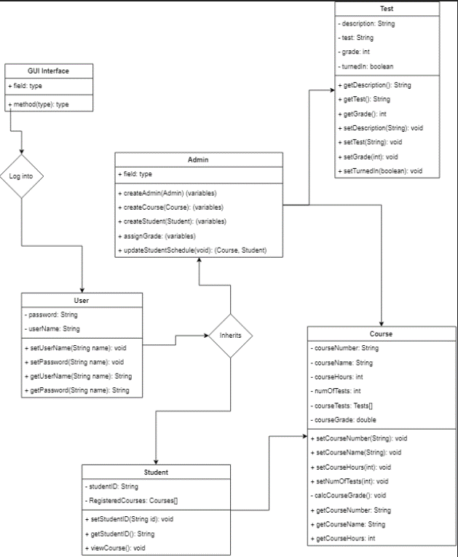

System Requirements:

Minimum Hardware requirements:

* 50 GB free disk space at minimum, 120 GB recommended
* 4 CPU processor with minimum 1.6 GHz
* Network speed minimum of 100 Mbps
* Java RunTime Environment (JRE) or Java Development Kit (JDK) version 1.7

Software Requirements:

* Java
* Java servlets
* Jsp
* mysql