1)CREATE TABLE with NULL CONSTRAINT

use day3;

CREATE TABLE PERSON_1(

P_ID INT DEFAULT NULL,

P_NAME VARCHAR(20) DEFAULT NULL

);

INSERT INTO PERSON_1(P_NAME) VALUE('LOKESH');

INSERT INTO PERSON_1(P_ID) VALUE(101);

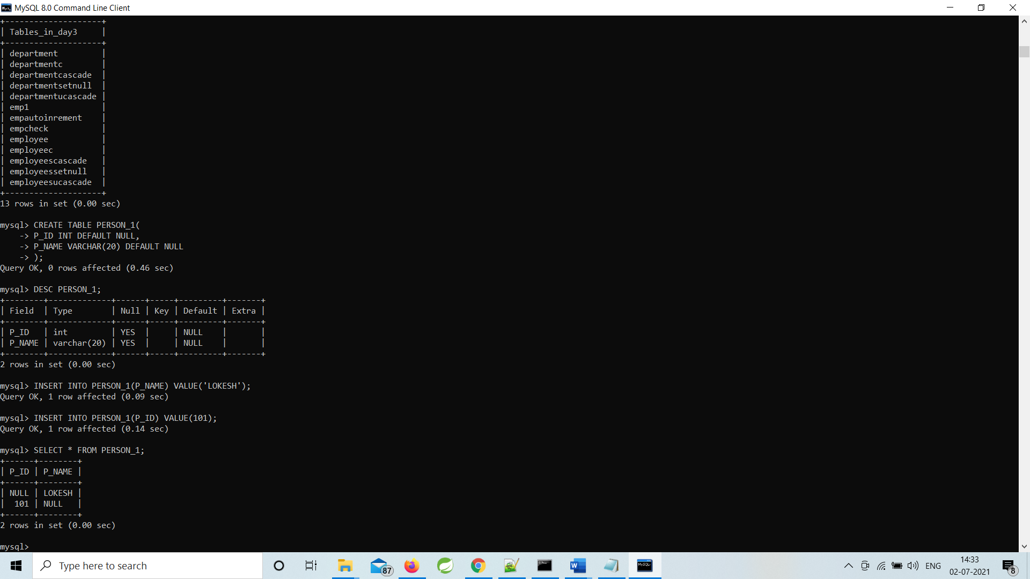

------------------------------------------------------------------------------------------------------------------

2)CREATE TABLE to check values with CHECK CONSTRAINT

CREATE TABLE STUDENTCHECK

(

SID INT CHECK(SID < 100),

SFN VARCHAR(20),

SLN VARCHAR(20)

);

INSERT INTO STUDENTCHECK VALUES(100,'LOKESH','JAWALE');

INSERT INTO STUDENTCHECK VALUES(10,'AJAY','KHARGE');

INSERT INTO STUDENTCHECK VALUES(101,'AKSHAY','KAKADE');

INSERT INTO STUDENTCHECK VALUES(1,'LOKESH','JAWALE');

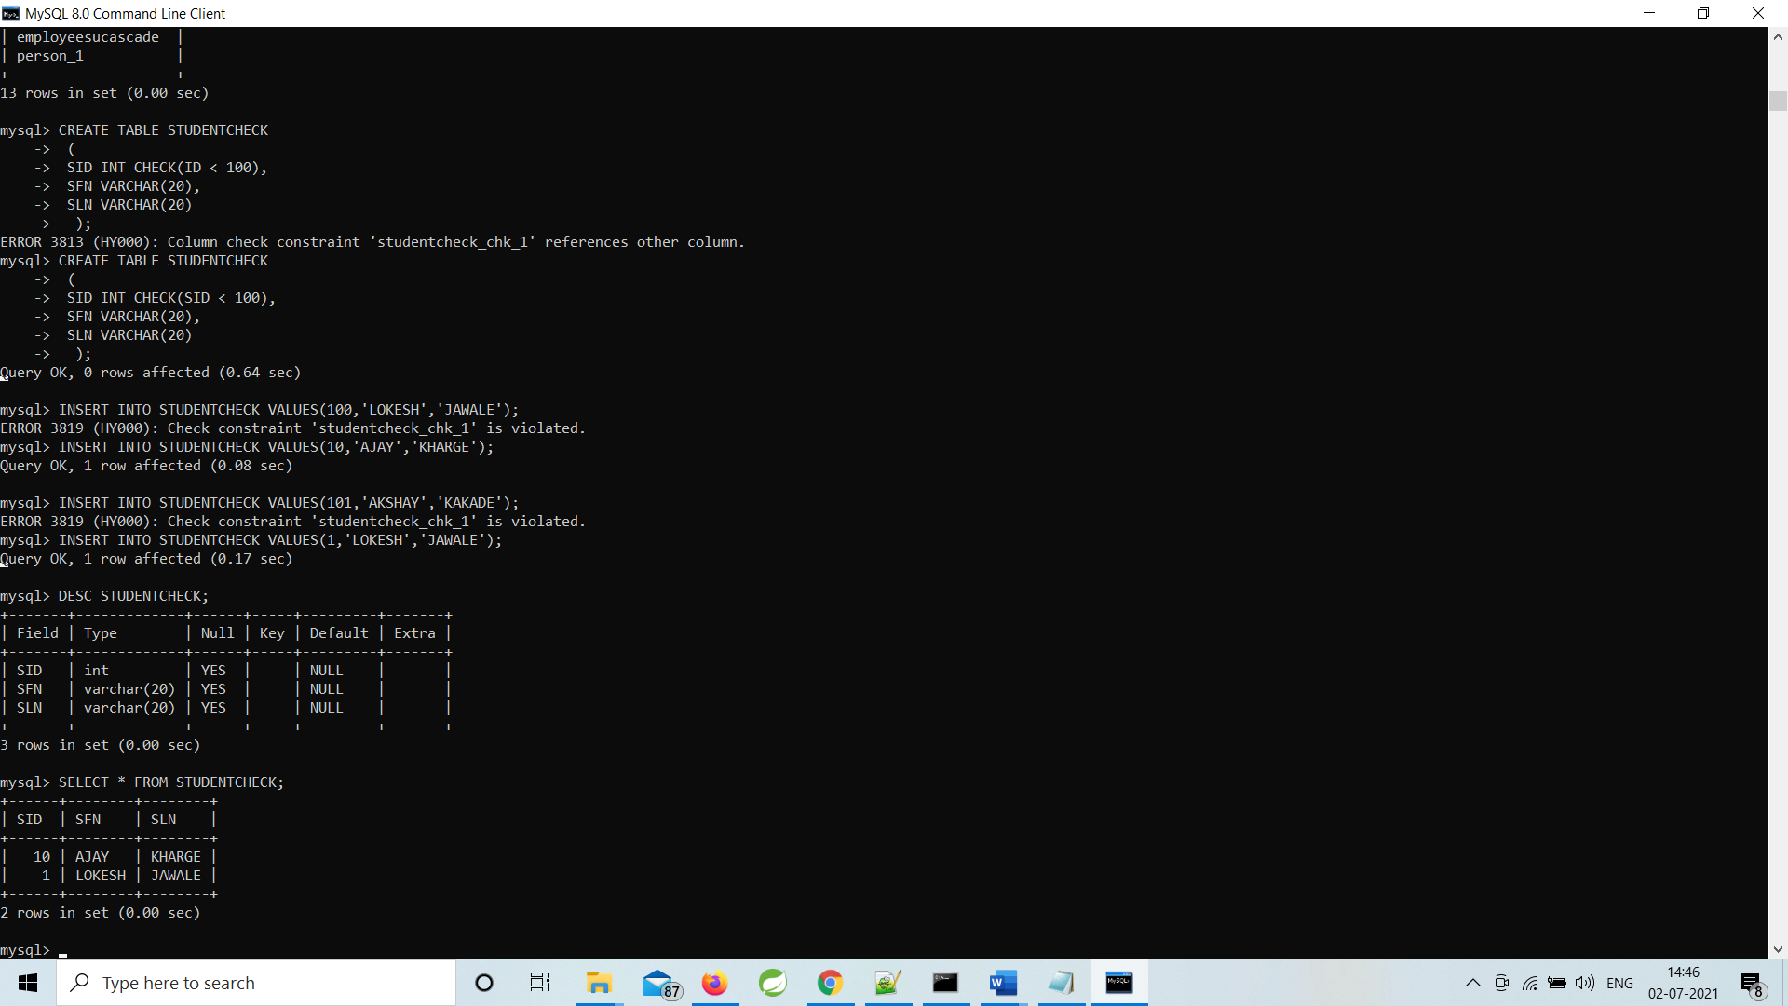

------------------------------------------------------------------------------------------------------------

3)CREATE TABLE with CHECK CONSTRAINT using IN operator

**Continue with previous table**

CREATE TABLE STUDENTCHECK

(

SID INT CHECK(SID < 100),

SFN VARCHAR(20),

SLN VARCHAR(20)

);

INSERT INTO STUDENTCHECK VALUES(10,'AJAY','KHARGE');

INSERT INTO STUDENTCHECK VALUES(1,'LOKESH','JAWALE');

INSERT INTO STUDENTCHECK VALUES(2,'HARRY','POTTER');

INSERT INTO STUDENTCHECK VALUES(1,'HIMANI','DAS');

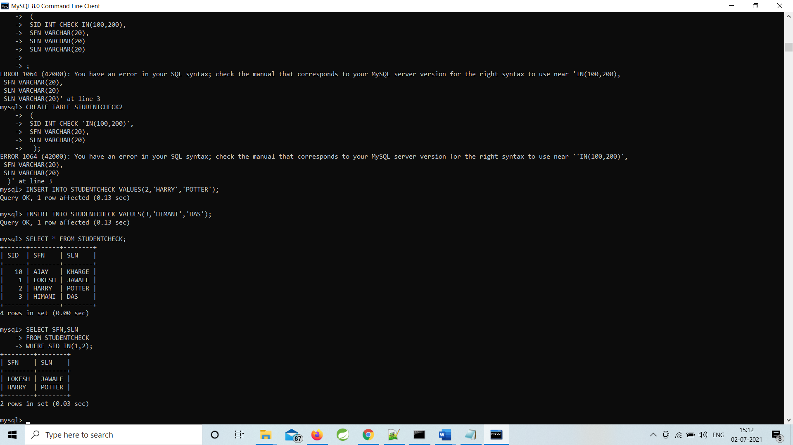

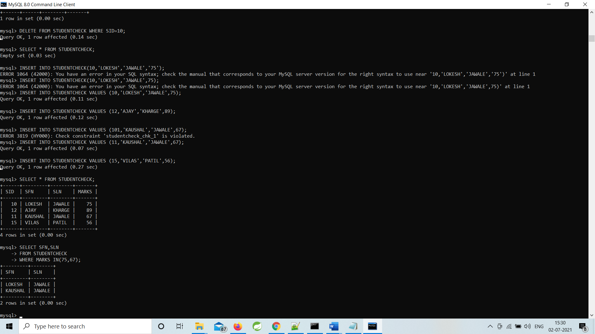

SELECT SFN,SLN

FROM STUDENTCHECK

WHERE SID IN(1,2);

-------------------------------------------------------------------------------------------------------------

4)CREATE TABLE with CHECK CONSTRAINT and LIKE operator

CREATE TABLE STUDENTS(

SID INT PRIMARY KEY,

SFN VARCHAR(20),

SLN VARCHAR(20),

SMARKS INT CHECK(SMARKS < 100)

);

INSERT INTO STUDENTS VALUES(1,'LOKESH','JAWALE',90);

INSERT INTO STUDENTS VALUES(3,'AJAY','KHARGE',88);

INSERT INTO STUDENTS VALUES(5,'LAVISH','SINGH',98);

INSERT INTO STUDENTS VALUES(6,'VIJAY','INGALE',90);

INSERT INTO STUDENTS VALUES(9,'AKSHAY','KAKADE',70);

INSERT INTO STUDENTS VALUES(45,'PINKI','BADGUJAR',80);

---

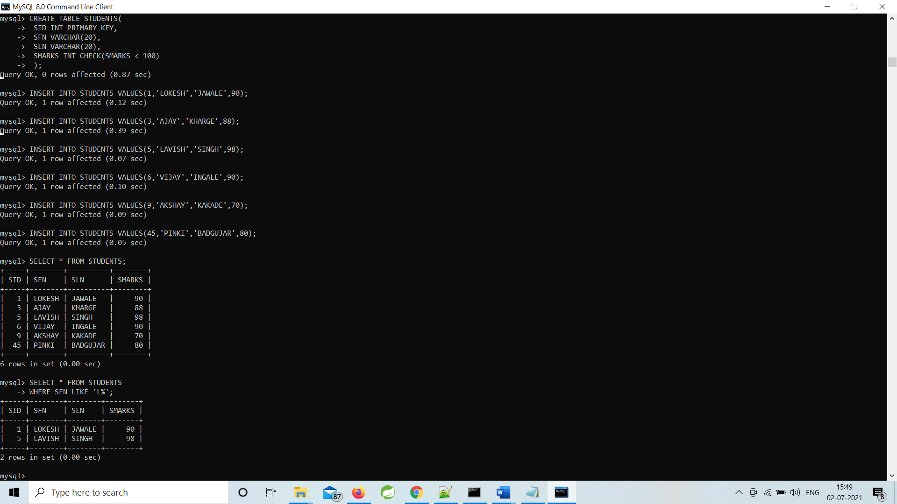

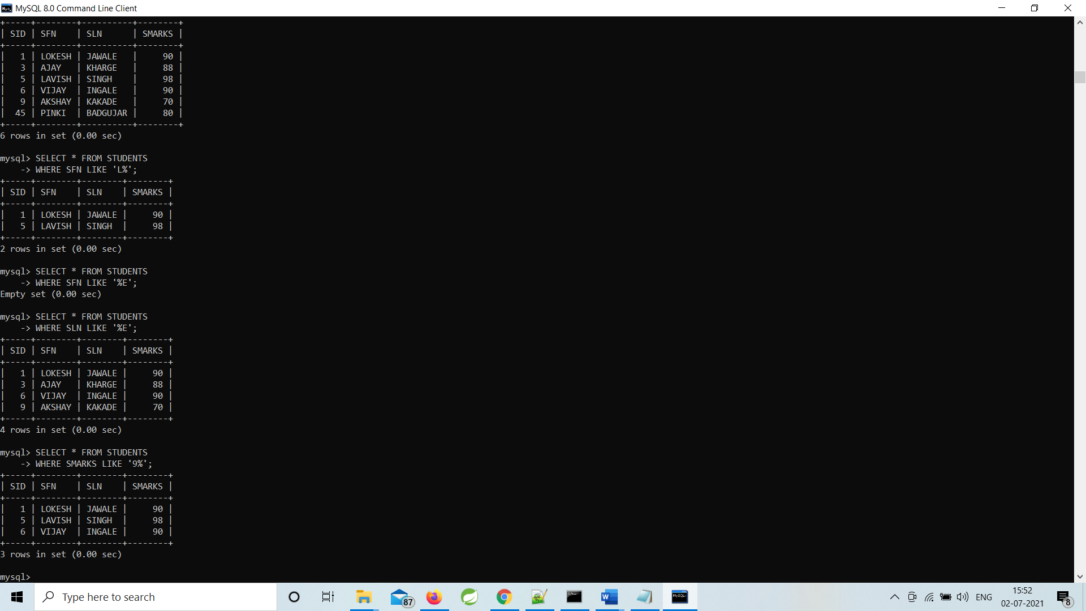

----------------------------------------------------------------------------------------------

5)CREATE TABLE with AND and OR operator and CHECK CONSTRAINT

**Continue with STUDENTS table**

**AND OPERATOR**

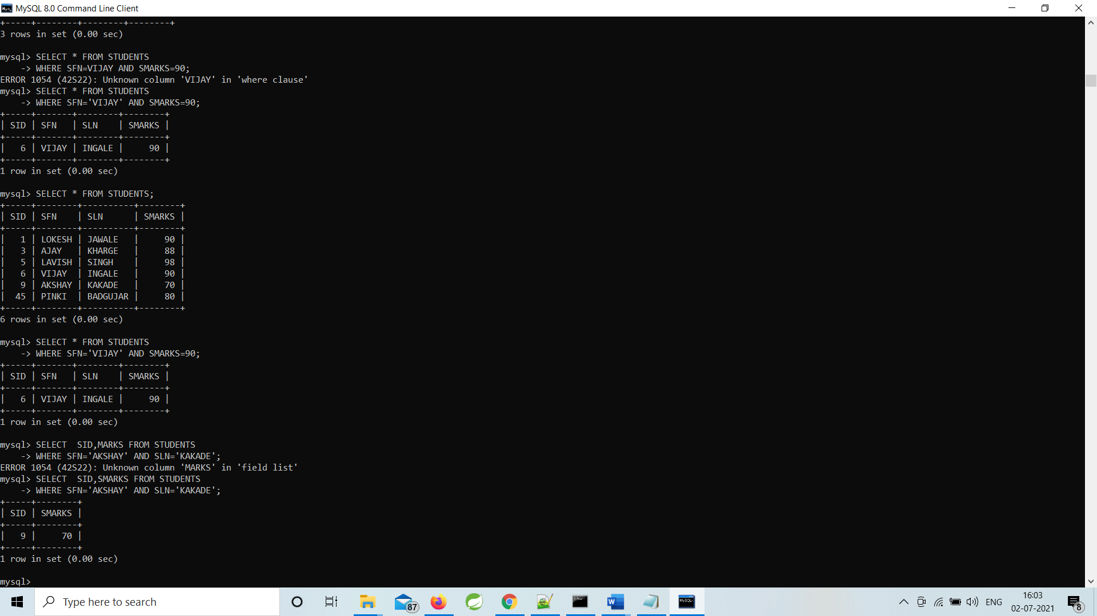

**OR OPERATOR**

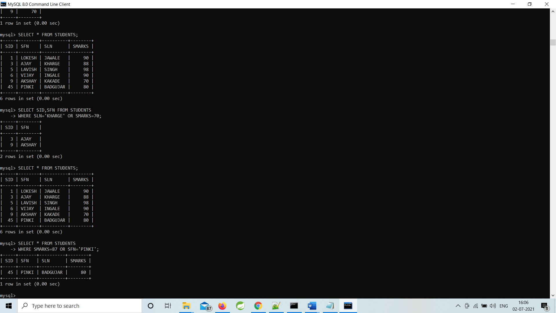

**---------------------------------------------------------------------------------------------**

6)UNIQUE CONSTRAINT

7)UNIQUE CONSTRAINT check unique value

CREATE TABLE PERSON

(

PID INT NOT NULL,

PFN VARCHAR(20),

PLN VARCHAR(20),

PAGE INT NOT NULL,

UNIQUE(PID)

);

INSERT INTO PERSON VALUES(10,'LOKESH','JAWALE',24);

INSERT INTO PERSON VALUES(12,'DIMPAL','GURAV',23);

INSERT INTO PERSON VALUES(10,'AKASH','CHAUDHARI',25);

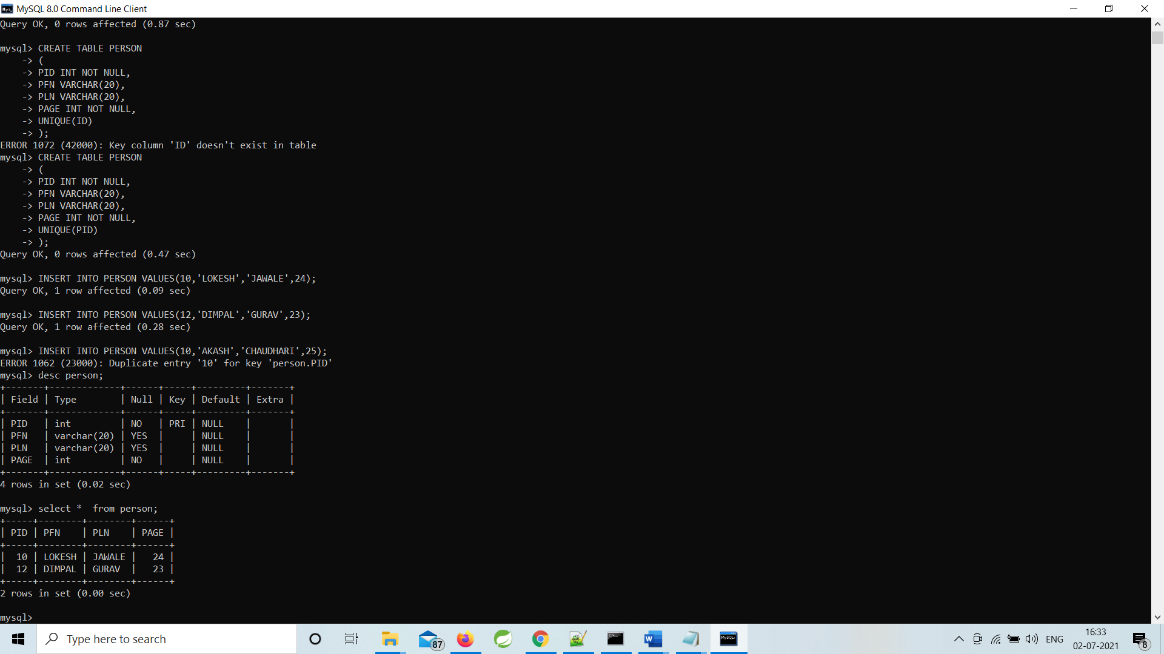

-------------------------------------------------------------------------------------------------------

8)CREATE TABLE with DEFAULT CONSTRAINT

CREATE TABLE CDACSTUDENT

(

PRN LONG NOT NULL,

FIRSTNAME VARCHAR(25),

STATE VARCHAR(40) DEFAULT 'MAHARASHTRA'

);

INSERT INTO CDACSTUDENT(PRN,FIRSTNAME) VALUE(210540181084,'LOKESH');

INSERT INTO CDACSTUDENT(PRN,FIRSTNAME) VALUE(210540181085,'AKSHAY');

INSERT INTO CDACSTUDENT(PRN,FIRSTNAME) VALUE(210540181084,'NAYAN');

INSERT INTO CDACSTUDENT VALUE(210540181077,'NOMESH','HIMACHAL PRADESH');

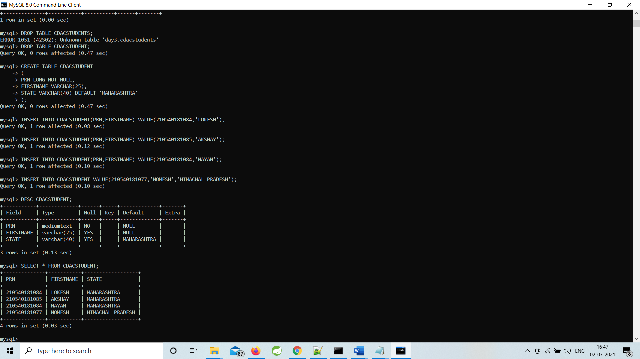

------------------------------------------------------------------------------------------------------------------------

9)CREATE TABLE with AUTO INCREMENT

CREATE TABLE EMP_A_I

(

EID INT PRIMARY KEY AUTO_INCREMENT,

ENAME VARCHAR(20)

);

INSERT INTO EMP_A_I(ENAME) VALUE('LOKESH');

INSERT INTO EMP_A_I(ENAME) VALUE('LOKESH');

INSERT INTO EMP_A_I(ENAME) VALUE('HARSHIT');

INSERT INTO EMP_A_I VALUE(5,'MAYUR');

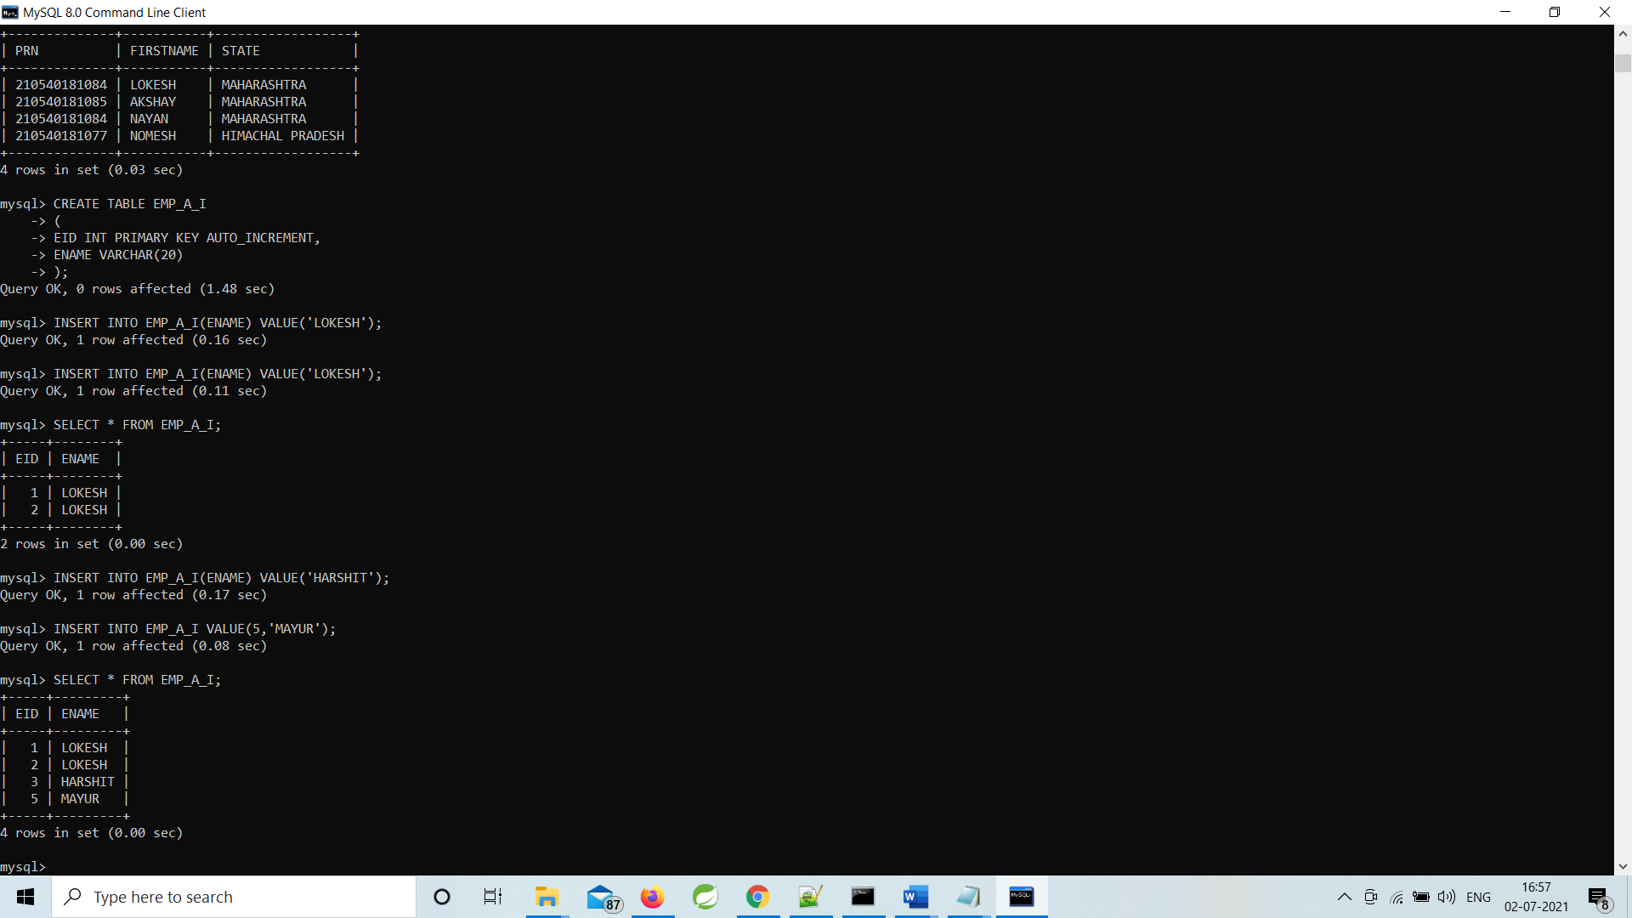

-----------------------------------------------------------------------------------------------------------

10)PRIMARY KEY CONSTRAINT

11)CREATE TABLE PRIMARY KEY CONSTRAINT on single column

12)CREATE TABLE PRIMARY KEY UNIQUE CONSTRAINT

CREATE TABLE PERSON_1

(

PID INT NOT NULL PRIMARY KEY,

PFN VARCHAR(20),

PLN VARCHAR(20),

P_DID INT,

UNIQUE(P_DID)

);

INSERT INTO PERSON_1 VALUES(1,'LOKESH','JAWALE',101);

INSERT INTO PERSON_1 VALUES(2,'NAYAN','DHAKANE',102);

INSERT INTO PERSON_1 VALUES(4,'AKSHAY','KSHIRSAGAR',106);

INSERT INTO PERSON_1 VALUES(1,'OMKAR','KULKARNI',109);

INSERT INTO PERSON_1 VALUES(8,'AKSHAY','KAKADE',102);

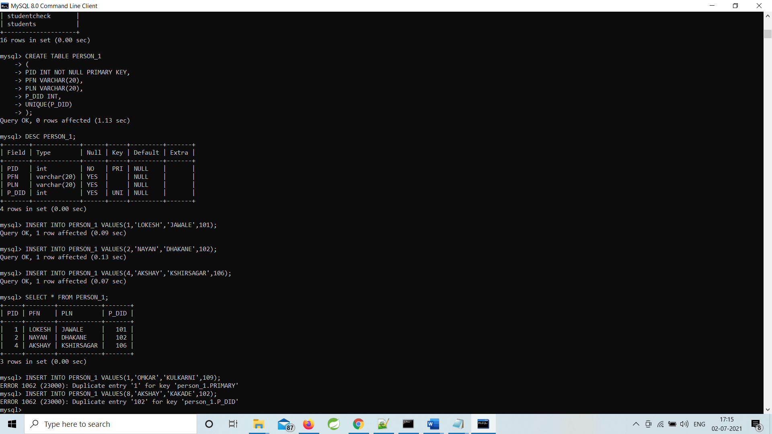

13)CREATE TABLE PRIMARY KEY on multiple columns

CREATE TABLE PERSON_2

(

PID INT NOT NULL,

PN VARCHAR(50),

P_DID INT,

P_AGE INT,

CONSTRAINT PRIMARY KEY(PID,P_DID,P_AGE)

);

INSERT INTO PERSON_2 VALUES(10,'LOKESH JAWALE',101,25);

INSERT INTO PERSON_2 VALUES(16,'MAYUR PATIL',102,23);

INSERT INTO PERSON_2 VALUES(112,'KULDEEP RATNU',188,26);

INSERT INTO PERSON_2 VALUES(10,'NAVAL GAZTA',110,30);

INSERT INTO PERSON_2 VALUES(78,'PALLAV JAIN',188,21);

INSERT INTO PERSON_2 VALUES(30,'SAYALI',201,23);

INSERT INTO PERSON_2 VALUES(10,'VILAS PATIL',110,30);

INSERT INTO PERSON_2 VALUES(78,'MUKESH MAHAJAN',188,21);

INSERT INTO PERSON_2 VALUES(30,'KALPESH MAHAJAN',201,23);

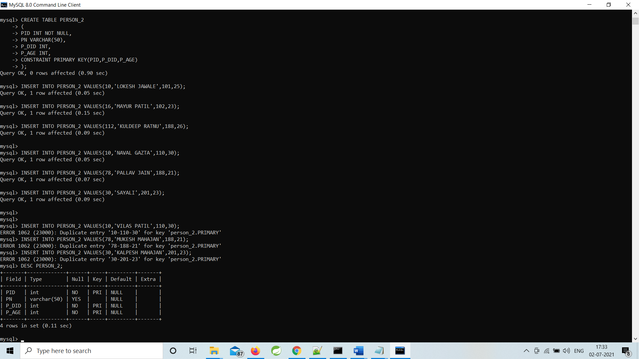

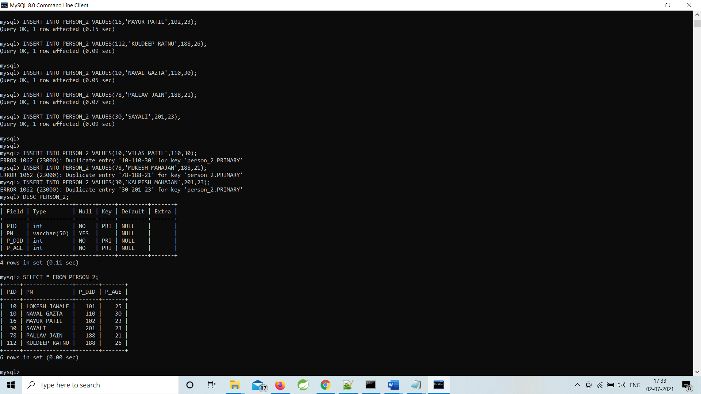

--------------------------------------------------------------------------------------------S

14)creating table with FOREIGN KEY CONSTRAINT

PAREANT TABLE :-

CREATE TABLE DEPT

(

DID INT PRIMARY KEY,

DNAME VARCHAR(20)

);

INSERT INTO DEPT VALUES(100,'HR');

INSERT INTO DEPT VALUES(200,'MARKETING');

INSERT INTO DEPT VALUES(300,'FINANCE');

INSERT INTO DEPT VALUES(400,'PRODUCTION');

CHILD TABLE :-

CREATE TABLE EMP

(

EMPID INT PRIMARY KEY,

EMPNAME VARCHAR(20),

EMPSAL INT,

DID INT,

FOREIGN KEY(DID) REFERENCES DEPT(DID)

);

INSERT INTO EMP VALUES(101,'LOKESH',8979,100);

INSERT INTO EMP VALUES(102,'SUNITA',8979,NULL);

INSERT INTO EMP VALUES(155,'KALPESH',7899,300);

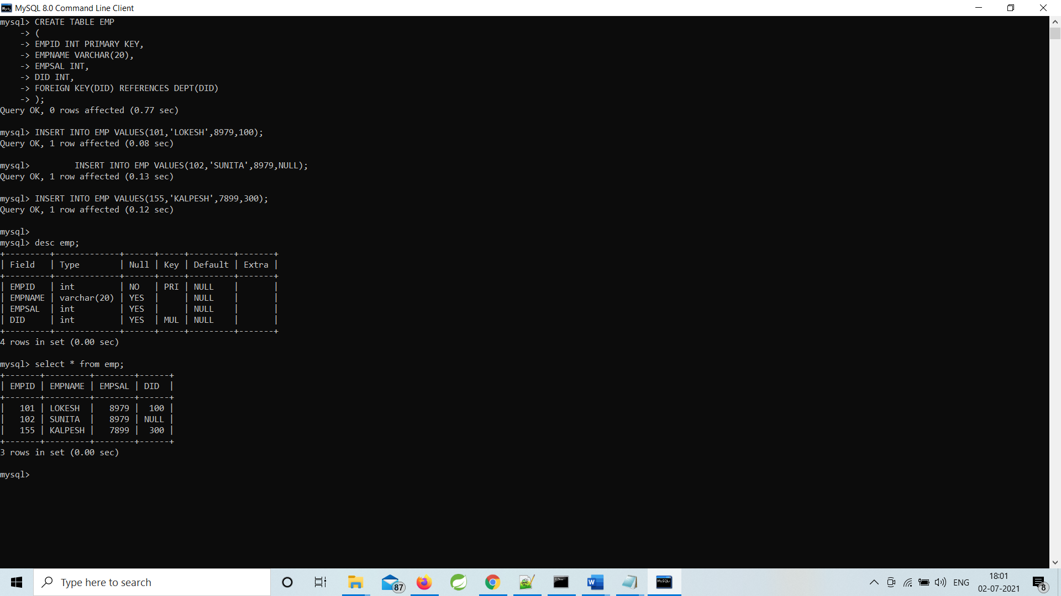

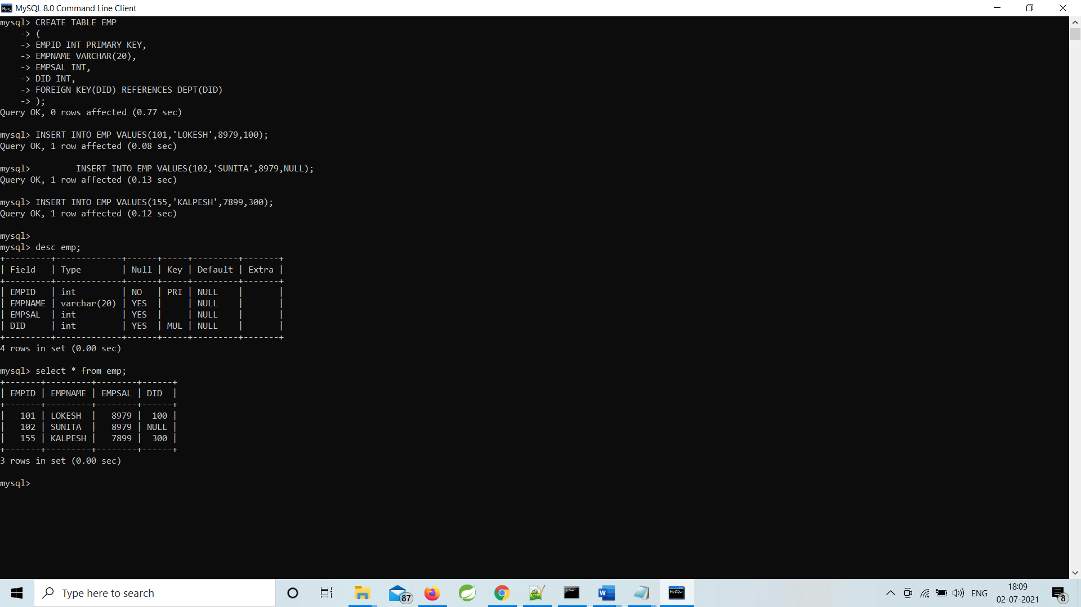

-------------------------------------------------------------------------------------------------------

15)CREATE TABLE with FOREIGN KEY CONSTRAINT on multiple columns

PARENT TABLE:-

CREATE TABLE DEPARTMENTC

(

DEPTNAME VARCHAR(20),

DEPARTMENTL VARCHAR(20),

DEPARTMENTCITY VARCHAR(20),

PRIMARY KEY(DEPTNAME,DEPARTMENTL)

);

INSERT INTO DEPARTMENTC VALUES('HR','VIMANNAGAR','PUNE');

INSERT INTO DEPARTMENTC VALUES('HR','WAKAD','PUNE');

INSERT INTO DEPARTMENTC VALUES('MARKETING','WAKAD','PUNE');

CHILD TABLE:

CREATE TABLE EMPLOYEEC

(

EMPID INT PRIMARY KEY,

EMPNAME VARCHAR(20),

DEPTN VARCHAR(20),

DEPTL VARCHAR(20),

CONSTRAINT EMPLOYEEC_FK FOREIGN KEY(DEPTN,DEPTL)

REFERENCES DEPARTMENTC(DEPTNAME,DEPARTMENTL)

);

INSERT INTO EMPLOYEEC VALUES(101,'LOKESH','HR','WAKAD');

INSERT INTO EMPLOYEEC VALUES(103,'NAYAN','MARKETING','WAKAD');

INSERT INTO EMPLOYEEC VALUES(105,'LOKESH','HR','AKURDI');

INSERT INTO EMPLOYEEC VALUES(106,'NAYAN','HR','VIMANNAGAR');

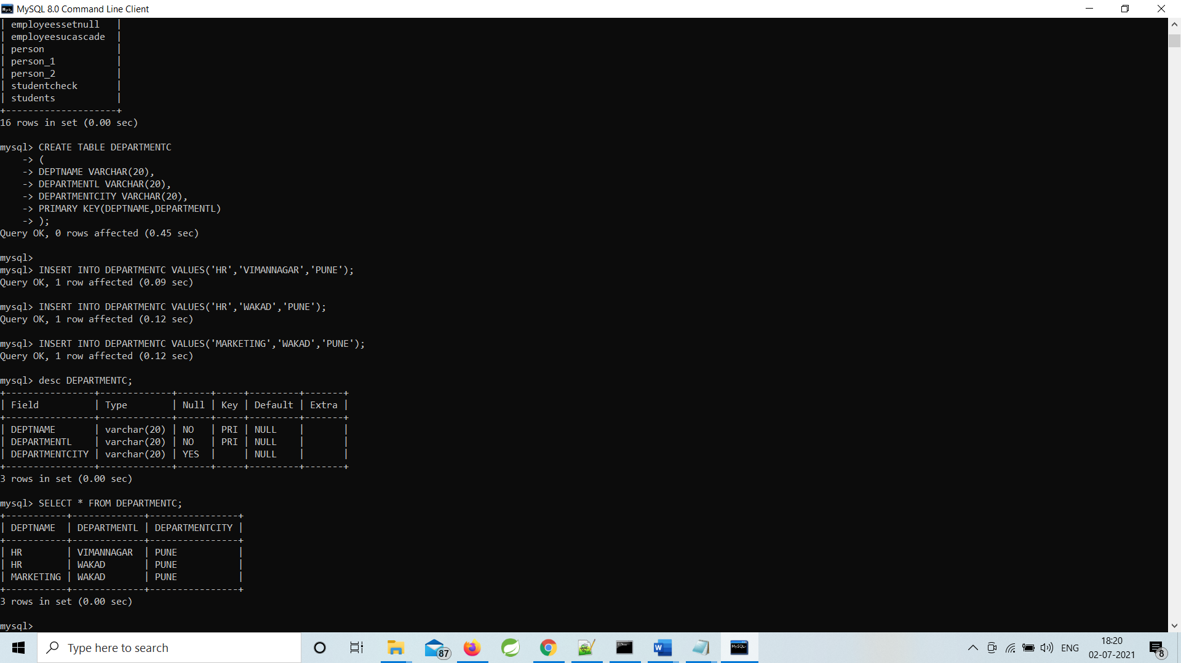

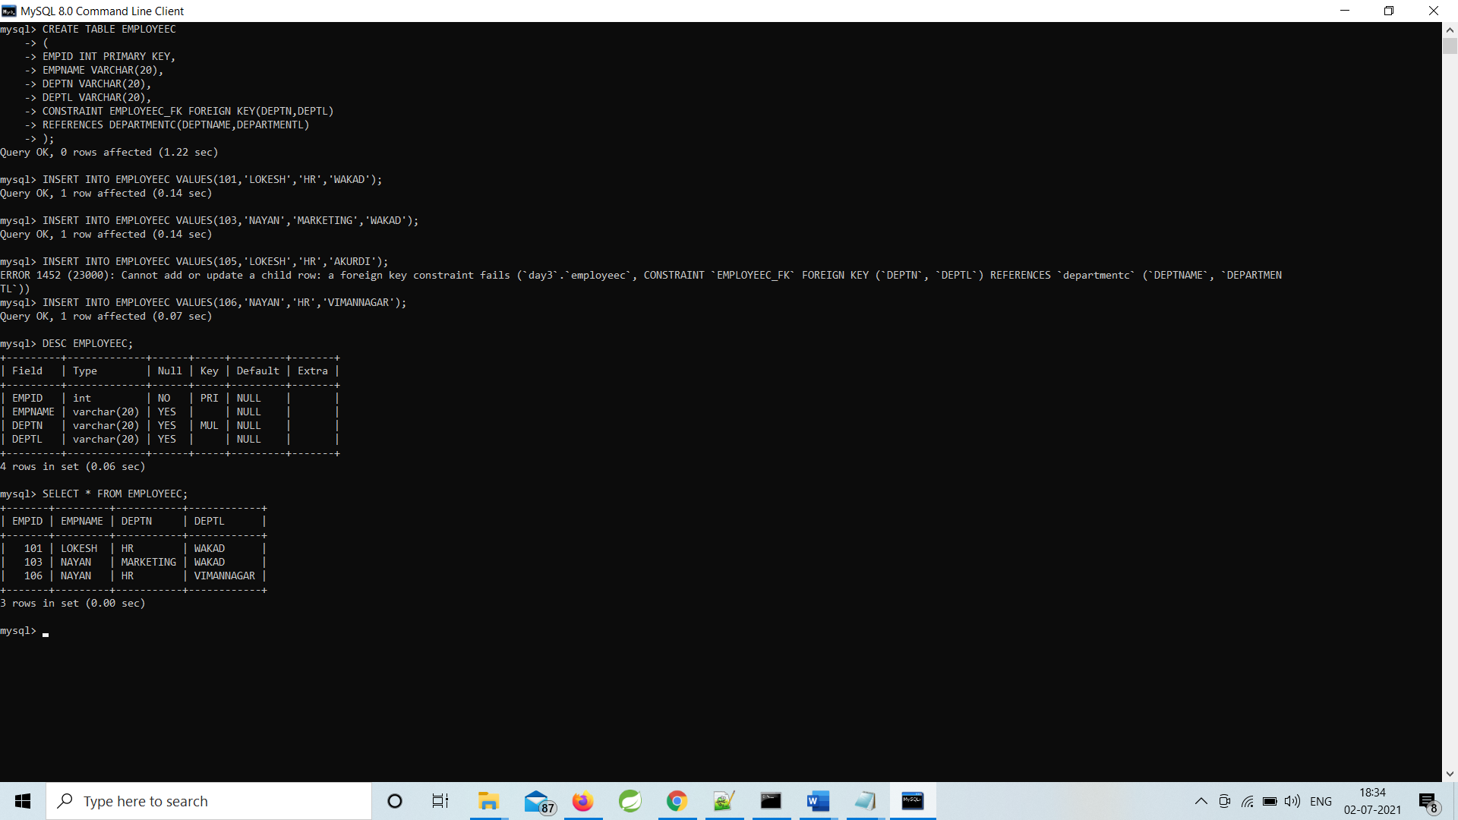

----------------------------------------------------------------------------------------------------------------

16)CREATE TABLE with FOREIGN KEY CONSTRAINT on multiple tables

---------------------------------------------------------------------------------

17)CREATE TABLE with CASCADE

Step 1. Create the buildings table:

CREATE TABLE buildings (

building_no INT PRIMARY KEY AUTO_INCREMENT,

building_name VARCHAR(255) NOT NULL,

address VARCHAR(255) NOT NULL

);

Step 2. Create the rooms table:

CREATE TABLE rooms (

room_no INT PRIMARY KEY AUTO_INCREMENT,

room_name VARCHAR(255) NOT NULL,

building_no INT NOT NULL,

FOREIGN KEY (building_no)

REFERENCES buildings (building_no)

ON DELETE CASCADE

);

Step 3. Insert rows into the buildings table:

INSERT INTO buildings(building_name,address)

VALUES('ACME Headquaters','3950 North 1st Street CA 95134'),

('ACME Sales','5000 North 1st Street CA 95134');

Step 4. Insert rows into the rooms table:

INSERT INTO rooms(room_name,building_no)

VALUES('Amazon',1),

('War Room',1),

('Office of CEO',1),

('Marketing',2),

('Showroom',2);

Step 5. Query data from the buildings table

SELECT * FROM buildings;

Step 6. Query data from the rooms table:

SELECT * FROM rooms;

Step 7. Delete the building with building no. 2:

DELETE FROM buildings

WHERE building_no = 2;

Step 8. Query data from rooms table:

SELECT * FROM rooms;

--------

OUTPUT FOR STEP 5,6,7,8

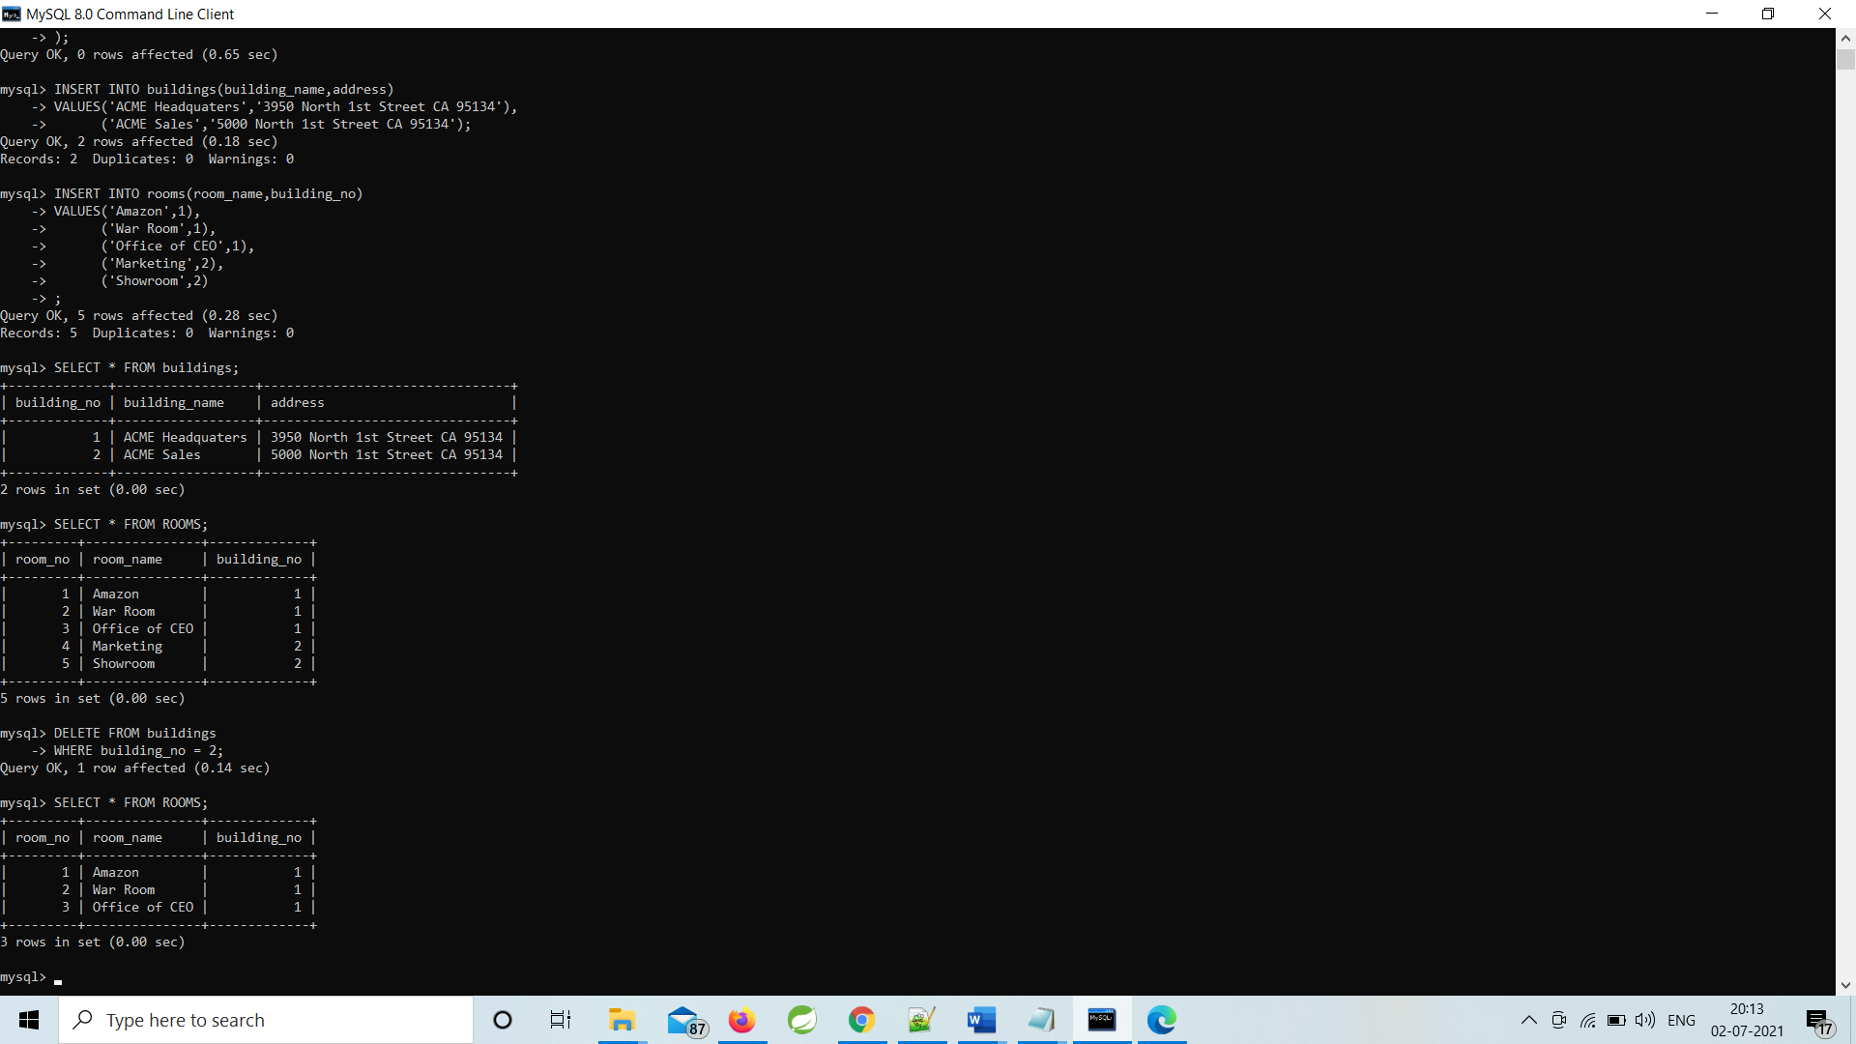--

--------------------------------------------------------------------------------------------------

18)CREATE TABLE with SET NULL

CREATE TABLE DEPARTMENTSETNULL

(

DEPTID INT PRIMARY KEY,

DEPTNAME VARCHAR(20)

);

INSERT INTO DEPARTMENTSETNULL VALUES(10,'HR');

INSERT INTO DEPARTMENTSETNULL VALUES(20,'MARKETING');

INSERT INTO DEPARTMENTSETNULL VALUES(30,'FINANCE');

INSERT INTO DEPARTMENTSETNULL VALUES(40,'PRODUCT');

CREATE TABLE EMPLOYEESSETNULL

(

EMPID INT PRIMARY KEY,

EMPNAME VARCHAR(20),

EMPSAL INT,

DEPTID INT,

FOREIGN KEY(DEPTID) REFERENCES DEPARTMENTSETNULL(DEPTID)

ON DELETE SET NULL

);

INSERT INTO EMPLOYEESSETNULL VALUES(101,'RAHUL',8979,10);

INSERT INTO EMPLOYEESSETNULL VALUES(102,'SUNITA',8979,20);

INSERT INTO EMPLOYEESSETNULL VALUES(103,'NIKITA',890000,10);



