Tennis Game Analytics- Unlocking Tennis Data with SportRadar API- EDA analysis

**Project Name** - Tennis Game Analytics EDA analysis

**Project Type** - EDA

**Contribution** - Team

**Team Member 1 -** - Prachi Mehta

**Team Member 2 -** - Tejashree Narayane **Team Member 3 -** - Akshit Gajanan Hedau **Team Member 4 -** - Akshay Vadnala

**Team Member 5 -** - Keerthana Penta

# Project Summary -

The project "Game Analytics: Unlocking Tennis Data with SportRadar API" seeks to develop a complete solution to

professional tennis data analytics by leveraging real-time data from the SportRadar API. The project seeks to help sports analysts, players, and organizations achieve greater insights into tournament dynamics, player performances, and event distributions. By taking leverage from structured data across categories, competitions, venues, competitors, and player rankings, the project creates a solid foundation for interactive analysis. The core technologies adopted are Python for data scraping, SQL for data management, and Streamlit for building an intuitive and interactive web application. The final outcome allows users to visualize data, filter based on certain parameters, and spot trends across world tennis events by turning raw sports data into operational insights.

# GitHub Link -

Dashboard Report Data Github Link

https://github.com/akshay24032002/Tennis_Data_Analytics.git

API Data Extraction Through Python Github Link

SQL Data Analysis Github Link

https://github.com/akshay24032002/Tennis_Data_Analytics.git

Python EDA Analysis Github Link

https://github.com/akshay24032002/Tennis_Data_Analytics.git

# Problem Statement

Extracted CSV files from API web source need to be analysed through EDA process to provide answers for the business problems ?

Define Your Business Objective?

The following are the business objectives for the project:-

1. To analyze the dataset and find which atheletes are leading.
2. To find which country is promoting Tennis game better and producing great players.
3. Gender analysis, that how much people are actually participating as an athelete in tennis sports on gender basis.
4. To find ways to improve tennis game and encouragement for underperforming countries.

## Know Your Data

Import Libraries

In [6]:

*# Load Dataset*

dataset1 **=** pd**.**read_csv("Categories.csv") dataset2 **=** pd**.**read_csv("Competitions.csv")

dataset3 **=** pd**.**read_csv("Competitor_Rankings.csv") dataset4 **=** pd**.**read_csv("Competitors.csv")

dataset6 **=** pd**.**read_csv("Venue.csv")

dataset5 **=** pd**.**read_csv("Complexes.csv")

*# Import Libraries* **import** pandas **as** pd **import** numpy **as** np

**import** matplotlib.pyplot **as** plt **import** matplotlib.cm **as** cm **import** seaborn **as** sns

**import** missingno **as** ms

**from** sklearn.model_selection **import** train_test_split

**from** sklearn.preprocessing **import** StandardScaler

**from** sklearn.metrics **import** accuracy_score, classification_report, confusion_matrix

**import** plotly.express **as** px

**from** wordcloud **import** WordCloud

**import** ast

**from** PIL **import** Image

**import** IPython.display **as** display

**import** geopandas **as** geo

**import** matplotlib

**from** sklearn.ensemble **import** RandomForestClassifier

**import** random

**import** statsmodels **as** stat

Dataset Loading

In [7]:

In [8]:

In [9]:

In [10]:

Datasets Merging

|  |
| --- |
| data1 **=** pd**.**merge(dataset1,dataset2, on **=** 'category_id', how **=** 'outer') |
| data2 **=** pd**.**merge(dataset3,dataset4, on **=** 'competitor_id', how **=** 'outer') |
| data3 **=** pd**.**merge(dataset5,dataset6, on **=** 'complex_id', how **=** 'outer') |

Dataset First View after Merging into 3 parts

|  |
| --- |
| data1**.**tail(5) |

In [29]:

Out[29]: category_id category_name competition_id competition_name parent_id type gender

WTA 125K San

6105 sr:category:871 WTA 125K sr:competition:47047 Sebastian, Spain sr:competition:47043 doubles women Women Doubles

WTA 125K Caldas da

6106 sr:category:871 WTA 125K sr:competition:47053 Rainha, Portugal Women sr:competition:47051 singles women

Singles

WTA 125K Caldas da

6107 sr:category:871 WTA 125K sr:competition:47055 Rainha, Portugal Women sr:competition:47051 doubles women

Doubles

6108 sr:category:871 WTA 125K sr:competition:47111

WTA 125K Rovereto, Italy Women Doubles

sr:competition:47109 doubles women

6109 sr:category:871 WTA 125K sr:competition:47113

WTA 125K Rovereto, Italy Women Singles

sr:competition:47109 singles women

|  |
| --- |
| data2**.**tail(5) |

In [30]:

Out[30]: rank_id rank movement points competitions_played competitor_id name country country_code abbre

**996** 846 347 -3 224 6 sr:competitor:99405 Australia AUS

Maddison

Inglis,

**998** 469 469 -1 123 12 sr:competitor:99587

Chung, Republic of Yun Seong Korea

KOR

Kestelboim,

**995** 159 159 18 481 21 sr:competitor:99377 Argentina ARG

Mariano

**997** 621 121 0 649 25 sr:competitor:99429 Hule, Petra Australia AUS

Bernet,

999 489 489 1 115 2 sr:competitor:997473 Switzerland CHE

Henry

|  |
| --- |
| data3**.**tail(5) |

In [31]:

Out[31]: complex_id complex_name venue_id venue_name city_name country_name country_code timezone

**3595** sr:complex:9725

Arena Armeets Sofia

sr:venue:17756

Center Court

Sofia Bulgaria BGR Europe/Sofia

**3596** sr:complex:9725

Arena Armeets Sofia

sr:venue:17758 Court 1 Sofia Bulgaria BGR Europe/Sofia

**3597** sr:complex:9725

Arena Armeets

3598 sr:complex:9725 sr:venue:23354 Court 4 Sofia Bulgaria BGR Europe/Sofia Sofia

Arena Armeets Sofia

sr:venue:23352 Court 3 Sofia Bulgaria BGR Europe/Sofia

**3599** sr:complex:9725

Arena Armeets Sofia

sr:venue:23356 Court 2 Sofia Bulgaria BGR Europe/Sofia

Dataset Rows & Columns count

|  |
| --- |
| *# Dataset Rows & Columns count*  data1**.**shape |

In [33]:

Out[33]: (6110, 7)

|  |
| --- |
| data2**.**shape |

In [34]:

Out[34]: (1000, 10)

|  |
| --- |
| data3**.**shape |

In [35]:

Out[35]: (3600, 8)

Dataset Information

|  |
| --- |
| *# Dataset Info*  data1**.**info() |

In [37]:

<class 'pandas.core.frame.DataFrame'> RangeIndex: 6110 entries, 0 to 6109 Data columns (total 7 columns):

# Column Non-Null Count Dtype

--- ------ -------------- -----

0 category_id 6110 non-null object

1 category_name 6110 non-null object

2 competition_id 6110 non-null object

3 competition_name 6110 non-null object

4 parent_id 5846 non-null object

5 type 6110 non-null object

6 gender 6110 non-null object dtypes: object(7)

memory usage: 334.3+ KB

|  |
| --- |
| data2**.**info() |

In [38]:

In [39]:

In [41]:

<class 'pandas.core.frame.DataFrame'> RangeIndex: 1000 entries, 0 to 999 Data columns (total 10 columns):

# Column Non-Null Count Dtype

--- ------ -------------- -----

1. rank_id 1000 non-null int64
2. rank 1000 non-null int64
3. movement 1000 non-null int64
4. points 1000 non-null int64
5. competitions_played 1000 non-null int64
6. competitor_id 1000 non-null object
7. name 1000 non-null object
8. country 1000 non-null object
9. country_code 940 non-null object
10. abbreviation 1000 non-null object dtypes: int64(5), object(5)

memory usage: 78.3+ KB

|  |
| --- |
| data3**.**info() |

<class 'pandas.core.frame.DataFrame'> RangeIndex: 3600 entries, 0 to 3599 Data columns (total 8 columns):

# Column Non-Null Count Dtype

--- ------ -------------- -----

1. complex_id 3600 non-null object
2. complex_name 3600 non-null object
3. venue_id 3455 non-null object
4. venue_name 3455 non-null object
5. city_name 3455 non-null object
6. country_name 3455 non-null object
7. country_code 3455 non-null object
8. timezone 3455 non-null object dtypes: object(8)

memory usage: 225.1+ KB

Duplicate Values

*# Dataset Duplicate Value Count*

duplicates **=** data1**.**duplicated(keep**=False**)

*# Count the duplicate values*

duplicate_count = duplicates.value_counts() print(duplicate_count)

False 6110

Name: count, dtype: int64

In [42]:

*# Dataset Duplicate Value Count*

duplicates **=** data2**.**duplicated(keep**=False**)

*# Count the duplicate values*

duplicate_count = duplicates.value_counts() print(duplicate_count)

False 1000

Name: count, dtype: int64

In [43]:

*# Dataset Duplicate Value Count*

duplicates **=** data3**.**duplicated(keep**=False**)

*# Count the duplicate values*

duplicate_count = duplicates.value_counts() print(duplicate_count)

In [45]:

False 3600

Name: count, dtype: int64

Missing Values/Null Values

|  |
| --- |
| *# Missing Values/Null Values Count*  data1**.**isnull()**.**sum() |

Out[45]: category_id 0

category_name 0

competition_id 0

competition_name 0

parent_id 264

type 0

gender 0

dtype: int64

In [46]:

|  |
| --- |
| data2**.**isnull()**.**sum() |

Out[46]: rank_id 0

rank 0

movement 0

points 0

competitions_played 0

competitor_id 0

name 0

country 0

country_code 60

abbreviation 0

dtype: int64

In [47]:

|  |
| --- |
| data3**.**isnull()**.**sum() |

Out[47]: complex_id 0

complex_name 0

venue_id 145

venue_name 145

city_name 145

country_name 145

country_code 145

timezone 145

dtype: int64

What did you know about your dataset?

The following things are known about the dataset:-

* 1. There are total 6 datasets but we merged them into 3.
  2. There are 8 columns have some missing values in them.
  3. There are no duplicates for all three merged datasets.
  4. Size of the Merged Dataset 1 - 6110 rows , 7 columns.
  5. Size of the Merged Dataset 2 - 1000 rows, 10 columns.
  6. Size of the Merged Dataset 3 - 3600 rows, 8 columns.

## Understanding Your Variables

|  |
| --- |
| *# Dataset Columns*  data1**.**columns |

In [51]:

Out[51]: Index(['category_id', 'category_name', 'competition_id', 'competition_name', 'parent_id', 'type', 'gender'],

dtype='object')

|  |
| --- |
| data2**.**columns |

In [52]:

Out[52]: Index(['rank_id', 'rank', 'movement', 'points', 'competitions_played', 'competitor_id', 'name', 'country', 'country_code', 'abbreviation'],

dtype='object')

|  |
| --- |
| data3**.**columns |

In [53]:

Out[53]: Index(['complex_id', 'complex_name', 'venue_id', 'venue_name', 'city_name', 'country_name', 'country_code', 'timezone'],

dtype='object')

|  |
| --- |
| *# Dataset Describe*  data1**.**describe() |

In [54]:

unique 18 18 6110 6110 2900 4 3

Out[54]: **category_id category_name competition_id competition_name parent_id type gender count** 6110 6110 6110 6110 5846 6110 6110

top sr:category:785 ITF Men sr:competition:12229 IPTL sr:competition:2589 singles men

freq 2198 2198 1 1 5 3163 3493

|  |
| --- |
| data2**.**describe() |

In [55]:

Out[55]: **rank_id rank movement points competitions_played count** 1000.000000 1000.000000 1000.000000 1000.00000 1000.000000

mean 500.500000 250.734000 0.613000 721.74300 18.953000

std 288.819436 144.632153 16.989876 1185.47796 9.090733

min 1.000000 1.000000 -146.000000 110.00000 1.000000

25% 250.750000 125.750000 -2.000000 176.00000 12.000000

50% 500.500000 250.500000 0.000000 299.50000 18.000000

75% 750.250000 376.000000 2.000000 615.25000 26.000000

max 1000.000000 501.000000 167.000000 9095.00000 48.000000

|  |
| --- |
| data3**.**describe() |

In [56]:

**unique** 671 646 3455 828 385 69 69

Out[56]: **complex_id complex_name venue_id venue_name city_name country_name country_code time count** 3600 3600 3455 3455 3455 3455 3455

top sr:complex:33222

National Tennis Center

sr:venue:66889 Court 1 London USA USA America/New_

In [60]:

In [61]:

In [62]:

In [65]:

**freq** 30 63 1 298 45 501 501

Check Unique Values for each variable.

|  |
| --- |
| *# Check Unique Values for each variable.*  **for** x **in** data1**.**columns:  print(f"{x} - {data1[x]**.**nunique()}") |

category_id - 18

category_name - 18

competition_id - 6110

competition_name - 6110

parent_id - 2900

type - 4

gender - 3

|  |
| --- |
| **for** x **in** data2**.**columns:  print(f"{x} - {data2[x]**.**nunique()}") |

rank_id - 1000

rank - 501

movement - 93

points - 552

competitions_played - 42

competitor_id - 1000

name - 1000

country - 77

country_code - 76

abbreviation - 641

|  |
| --- |
| **for** x **in** data3**.**columns:  print(f"{x} - {data3[x]**.**nunique()}") |

complex_id - 671

complex_name - 646

venue_id - 3455

venue_name - 828

city_name - 385

country_name - 69

country_code - 69

timezone - 84

## Data Wrangling

Data Wrangling Code

|  |
| --- |
| *# Write your code to make your dataset analysis ready.*  data1**.**isnull()**.**sum() |

Out[65]: category_id 0

category_name 0

competition_id 0

competition_name 0

parent_id 264

type 0

gender 0

dtype: int64

In [66]:

|  |
| --- |
| data2**.**isnull()**.**sum() |

Out[66]: rank_id 0

rank 0

movement 0

points 0

competitions_played 0

competitor_id 0

name 0

country 0

country_code 60

abbreviation 0

dtype: int64

In [67]:

|  |
| --- |
| data3**.**isnull()**.**sum() |

Out[67]: complex_id 0

complex_name 0

venue_id 145

venue_name 145

city_name 145

country_name 145

country_code 145

timezone 145

dtype: int64

In [68]:

|  |
| --- |
| data1**.**fillna({'parent_id': 0},inplace**=True**) |
| data2**.**fillna({'country_code': 'NA'},inplace**=True**) |
| data3**.**fillna({'venue_id': 0},inplace**=True**) |
| data3**.**fillna({'venue_name': 'NA'},inplace**=True**) |
| data3**.**fillna({'city_name': 'NA'},inplace**=True**) |
| data3**.**fillna({'country_name': 'NA'},inplace**=True**) |
| data3**.**fillna({'country_code': 'NA'},inplace**=True**) |
| data3**.**fillna({'timezone': 'NA'},inplace**=True**) |

In [69]:

In [70]:

In [71]:

In [72]:

In [73]:

In [74]:

In [75]:

Checking Missing Values removed or not

|  |
| --- |
| data1**.**isnull()**.**sum() |

In [77]:

Out[77]: category_id 0

category_name 0

competition_id 0

competition_name 0

parent_id 0

type 0

gender 0

dtype: int64

|  |
| --- |
| data2**.**isnull()**.**sum() |

In [78]:

Out[78]: rank_id 0

rank 0

movement 0

points 0

competitions_played 0

competitor_id 0

name 0

country 0

country_code 0

abbreviation 0

dtype: int64

|  |
| --- |
| data3**.**isnull()**.**sum() |

In [79]:

Out[79]: complex_id 0

complex_name 0

venue_id 0

venue_name 0

city_name 0

country_name 0

country_code 0

timezone 0

dtype: int64

What all manipulations have you done and insights you found?

The Following are the manipulations we have done:-

1. As there were no duplicates in the datasets so no issue of handling duplicates.
2. There were some missing values for the below columns which we replaced by not available or 0 value.

columns

1. parent_id
2. country_code
3. venue_id
4. venue_name
5. city_name
6. country_name
7. country_code
8. timezone

## Data Vizualization, Storytelling & Experimenting with charts : Understand the relationships between variables

Chart - 1

In [199…

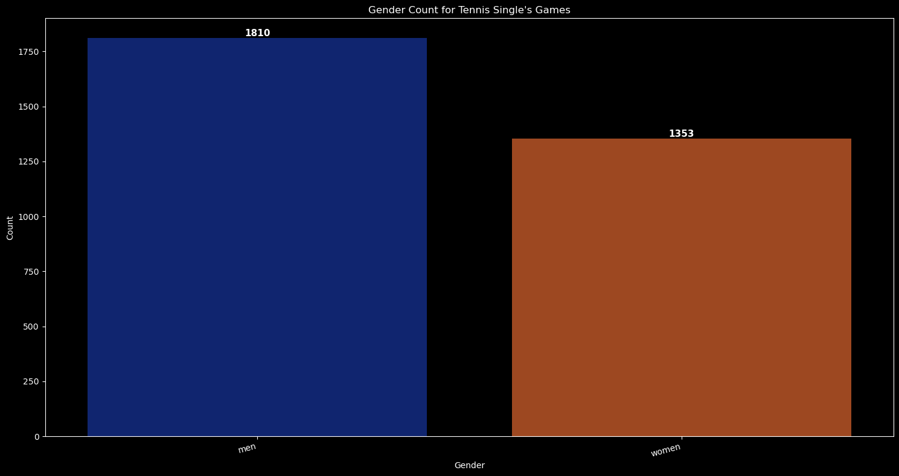

*# Chart - 1 visualization code*

plt**.**style**.**use('dark_background')

gs **=** data1[data1**.**type**==**'singles']**.**groupby('gender')['gender']**.**count() gs_1 **=** pd**.**DataFrame(gs)

*# Rename the count column*

gs_1**.**rename(columns**=**{'gender': 'count'}, inplace**=True**)

*# Create a bar plot*

plt**.**figure(figsize**=**(15, 8)) *# Adjust figure size*

ax **=** sns**.**barplot(data**=**gs_1 , x**=**"gender", y**=**"count", hue**=**"gender", palette**=**"dark", legend**=False**)

*# Rotate x-axis labels for better readability* plt**.**xticks(rotation**=**15, ha**=**"right") plt**.**xlabel("Gender")

plt**.**ylabel("Count")

plt**.**title("Gender Count for Tennis Single's Games")

count **=** int(p**.**get_height())

x **=** p**.**get_x() **+** p**.**get_width() **/** 2 y **=** p**.**get_height()

ax**.**annotate(

(x, y), ha**=**'center', va**=**'bottom', fontsize**=**11,

fontweight**=**'bold'

)

gs_1**.**reset_index(inplace**=True**)

**for** p **in** ax**.**patches:

str(count),

color**=**'white',

plt**.**grid(**False**) plt**.**show()

plt**.**tight_layout()

1. Why did you pick the specific chart?

The above chart gives proper count in the form of bar chart.

1. What is/are the insight(s) found from the chart?

The following are the insights for the above bar chart:-

* 1. Men has highest count for single's tennis games which is 1810.
  2. Women's count for single's tennis games is 1353.
  3. Will the gained insights help creating a positive business impact?

Are there any insights that lead to negative growth? Justify with specific reason.

The above insight shows that the men are participating more in single's tennis games than women and shows that global tennis federation can encourage women to participate in tennis games and contribute in this game as an individual.

Chart - 2

In [209…

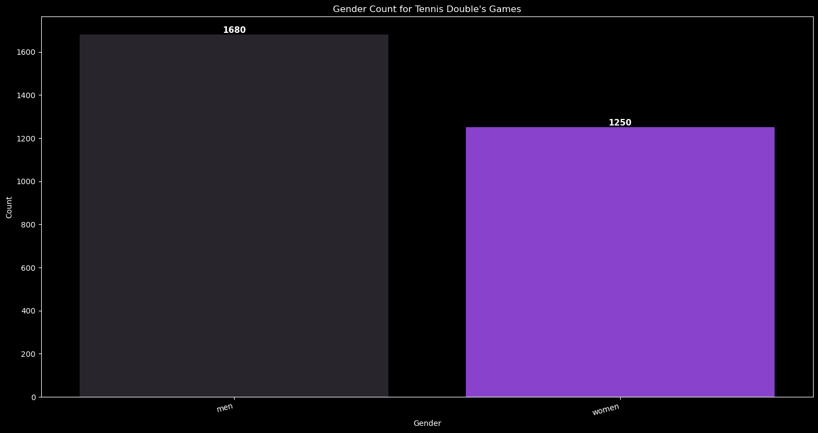

plt**.**style**.**use('dark_background')

*# Filter, group, and count data*

gd **=** data1[data1**.**type **==** 'doubles']**.**groupby('gender')['gender']**.**count() gd_1 **=** pd**.**DataFrame(gd)

gd_1**.**reset_index(inplace**=True**)

*# Plotting*

plt**.**figure(figsize**=**(15, 8))

data**=**gd_1, x**=**"gender", y**=**"count", hue**=**"gender",

legend**=False**

)

gd_1**.**rename(columns**=**{'gender': 'count'}, inplace**=True**)

ax **=** sns**.**barplot(

palette**=**'dark:#8A2BE2',

plt**.**xticks(rotation**=**15, ha**=**"right") plt**.**ylabel("Count")

plt**.**xlabel("Gender")

plt**.**title("Gender Count for Tennis Double's Games")

*# Annotate bars*

**for** p **in** ax**.**patches:

count **=** int(p**.**get_height())

x **=** p**.**get_x() **+** p**.**get_width() **/** 2 y **=** p**.**get_height()

ax**.**annotate(

(x, y), ha**=**'center', va**=**'bottom', fontsize**=**11,

fontweight**=**'bold'

)

str(count),

color**=**'white',

plt**.**grid(**False**) plt**.**show()

plt**.**tight_layout()

1. Why did you pick the specific chart?

The above chart gives proper count in the form of bar chart.

1. What is/are the insight(s) found from the chart?

The following are the insights for the above bar chart:-

* 1. Men has highest count for double's tennis games which is 1680.
  2. Women's count for double's tennis games is 1250.
  3. Will the gained insights help creating a positive business impact?

Are there any insights that lead to negative growth? Justify with specific reason.

The above insight shows that in double's tennis games also the men are dominating so the tennis federation should organize campaigns and seminars to promote women participation in tennis double's game.

Chart - 3

In [221…

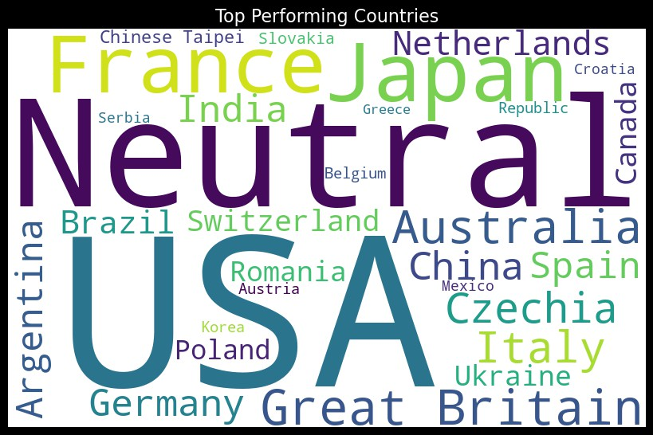

*# Chart - 3 visualization code*

h1 **=** data2["country"]

hl_str **=** " "**.**join(map(str, h1**.**dropna())) wordcloud **=** WordCloud(

width**=**800, height**=**500, background_color**=**'white', min_font_size**=**10, max_words**=**30

)**.**generate(hl_str)

plt**.**figure(figsize**=**(8, 8), facecolor**=None**) plt**.**imshow(wordcloud)

plt**.**axis("off")

plt**.**title("Top Performing Countries", fontsize**=**16) plt**.**show()

plt**.**tight_layout(pad**=**0)

1. Why did you pick the specific chart?

The above word cloud gives a rough estimation of best performing variables of a particular column.

1. What is/are the insight(s) found from the chart?

The following are the insights for the above word cloud:-

* 1. USA has maximum contribution.
  2. Neutral is the second highest contributor to produce tennis players.
  3. Japan is third in producing best tennis players from their country.
  4. France is fourth in producing best tennis players from their country.
  5. Great Britain is fifth in producing best tennis players from their country.

1. Will the gained insights help creating a positive business impact?

Are there any insights that lead to negative growth? Justify with specific reason.

The above insight shows that the USA, France and Japan are great at producing tennis players in maximum nos from their countries.

Chart - 4

In [225…

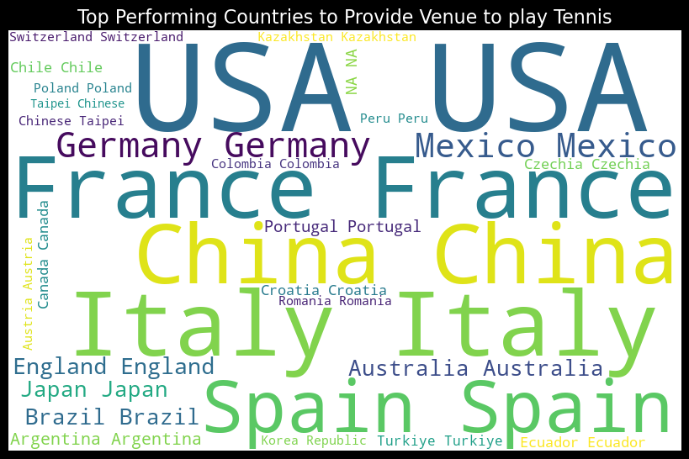

*# Chart - 4 visualization code*

h2 **=** data3["country_name"]

h2_str **=** " "**.**join(map(str, h2**.**dropna())) wordcloud **=** WordCloud(

width**=**800, height**=**500,

min_font_size**=**10, max_words**=**30

)**.**generate(h2_str)

background_color**=**'white',

plt**.**figure(figsize**=**(8, 8), facecolor**=None**) plt**.**axis("off")

plt**.**imshow(wordcloud)

plt**.**title("Top Performing Countries to Provide Venue to play Tennis", fontsize**=**16) plt**.**tight_layout(pad**=**0)

plt**.**show()

1. Why did you pick the specific chart?

The above word cloud gives a rough estimation of best performing variables of a particular column.

1. What is/are the insight(s) found from the chart?

The following are the insights for the above word cloud:-

* 1. The top country to provide venue is USA.
  2. Second highest to provide venue stage is Italy.
  3. Third highest to provide venue stage is France.

1. Will the gained insights help creating a positive business impact?

Are there any insights that lead to negative growth? Justify with specific reason.

The above insight shows that the USA, France and Italy are top countries to provide venue's at their place to play tennis games , this is because the major grand slam's tournament's like US open, French open and Wimbeldon generally happens in these countries making these countries a popular place for tennis enthusiast and tennis players.

Chart - 5

In [227…

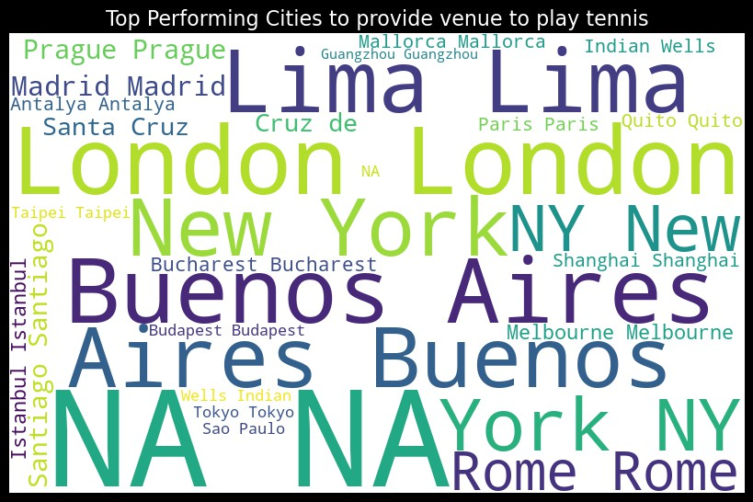

*# Chart - 5 visualization code*

h3 **=** data3["city_name"]

h3_str **=** " "**.**join(map(str, h3**.**dropna()))

wordcloud **=** WordCloud( width**=**800, height**=**500, background_color**=**'white',

)**.**generate(h3_str)

plt**.**figure(figsize**=**(8, 8), facecolor**=None**) plt**.**imshow(wordcloud)

plt**.**axis("off")

plt**.**tight_layout(pad**=**0) plt**.**show()

min_font_size**=**10, max_words**=**30

plt**.**title("Top Performing Cities to provide venue to play tennis", fontsize**=**16)

1. Why did you pick the specific chart?

The above word cloud gives a rough estimation of best performing variables of a particular column.

1. What is/are the insight(s) found from the chart?

The following are the insights for the above word cloud:-

* 1. The top city to provide venue is London.
  2. Second highest city to provide venue stage is Buenos Aires.
  3. Third highest city to provide venue stage is Lima.

1. Will the gained insights help creating a positive business impact?

Are there any insights that lead to negative growth? Justify with specific reason.

The above insight shows that the London, Buenos Aires and Lima are top cities to provide venue's at their place to play tennis games , this is because the major grand slam's tournament's like US open, French open and Wimbeldon mostly happens in these cities making these countries a popular place for tennis enthusiast and tennis players, for example the center court at london is very famous for wimbeldon tournment.

Chart - 6

In [235…

*# Chart - 6 visualization code*

plt**.**style**.**use('dark_background') data2**.**columns **=** data2**.**columns**.**str**.**strip()

d2 **=** data2["country"]**.**value_counts()**.**reset_index() d2**.**columns **=** ["country", "Count"]

*# Create the treemap*

fig **=** px**.**treemap(d2,

values**=**'Count',

title**=**"Count For Countries Producing Top Tennis Players", color**=**'Count',

color_continuous_scale**=**"RdBu")

*# Show the plot*

fig**.**show()

path**=**['country'],

1. Why did you pick the specific chart?

The tree map gives a clear vision of data in one frame.

1. What is/are the insight(s) found from the chart?

The following are the insights for the above tree map:-

* 1. USA has maximum contribution.
  2. Neutral is the second highest contributor to produce tennis players.
  3. Japan is third in producing best tennis players from their country.
  4. France is fourth in producing best tennis players from their country.
  5. Great Britain is fifth in producing best tennis players from their country.

1. Will the gained insights help creating a positive business impact?

Are there any insights that lead to negative growth? Justify with specific reason.

The above insight shows that the USA, France and Japan are great at producing tennis players in maximum nos from their countries.

Chart - 7

In [239…

*# Chart - 7 visualization code*

plt**.**style**.**use('dark_background') data3**.**columns **=** data3**.**columns**.**str**.**strip()

d3 **=** data3["country_name"]**.**value_counts()**.**reset_index()

d3**.**columns **=** ["country_name", "Count"]

*# Create the treemap*

fig **=** px**.**treemap(d3,

path**=**['country_name'],

title**=**"Count For Countries Providing Maximum Venue For Conducting Tennis Games", color**=**'Count',

color_continuous_scale**=**"twilight")

*# Show the plot*

fig**.**show()

values**=**'Count',

1. Why did you pick the specific chart?

The tree map gives a clear vision of data in one frame.

1. What is/are the insight(s) found from the chart?

The following are the insights for the above tree map:-

* 1. The top country to provide venue is USA.
  2. Second highest to provide venue stage is Italy.
  3. Third highest to provide venue stage is France.

1. Will the gained insights help creating a positive business impact?

Are there any insights that lead to negative growth? Justify with specific reason.

The above insight shows that the USA, France and Italy are top countries to provide venue's at their place to play tennis games , this is because the major grand slam's tournament's like US open, French open and Wimbeldon generally happens in these countries making these countries a popular place for tennis enthusiast and tennis players.

Chart - 8

In [241…

*# Chart - 8 visualization code*

plt**.**style**.**use('dark_background') data3**.**columns **=** data3**.**columns**.**str**.**strip()

d33 **=** data3["city_name"]**.**value_counts()**.**reset_index()

d33**.**columns **=** ["city_name", "Count"]

*# Create the treemap*

fig **=** px**.**treemap(d33,

path**=**['city_name'],

title**=**"Count For Cities Providing Maximum Venue For Conducting Tennis Games", color**=**'Count',

color_discrete_map**=**{'(?)':'lightgrey', 'Lunch':'gold', 'Dinner':'darkblue'})

*# Show the plot*

fig**.**show()

values**=**'Count',

1. Why did you pick the specific chart?

The tree map gives a clear vision of data in one frame.

1. What is/are the insight(s) found from the chart?

The following are the insights for the above tree map:-

* 1. The top city to provide venue is London.
  2. Second highest city to provide venue stage is Buenos Aires.
  3. Third highest city to provide venue stage is Lima.

1. Will the gained insights help creating a positive business impact?

Are there any insights that lead to negative growth? Justify with specific reason.

The above insight shows that the London, Buenos Aires and Lima are top cities to provide venue's at their place to play tennis games , this is because the major grand slam's tournament's like US open, French open and Wimbeldon mostly happens in these cities making these countries a popular place for tennis enthusiast and tennis players, for example the center court at london is very famous for wimbeldon tournment.

Chart - 9

In [257…

*# Chart - 9 visualization code*

com_ven = data1.groupby(["competition_name", "gender"]).size().unstack(fill_value=0)

com_ven_1 = com_ven.div(com_ven.sum(axis=1), axis=0) * 100

top_complex = com_ven.sum(axis=1).sort_values(ascending=False).head(20).index data_com_ven = com_ven_1.loc[top_complex]

fig, ax = plt.subplots(figsize=(15, 8))

data_com_ven.plot(kind="barh", stacked=True, colormap="viridis", ax=ax)

plt.xlabel("Distribution for the Gender") plt.ylabel("Competition Name")

plt.title("Distribution of Gender Type vs Competition Name [Top 20]") plt.legend(title="Gender Type", bbox_to_anchor=(1.05, 1), loc="upper left")

plt.tight_layout() plt.show()

1. 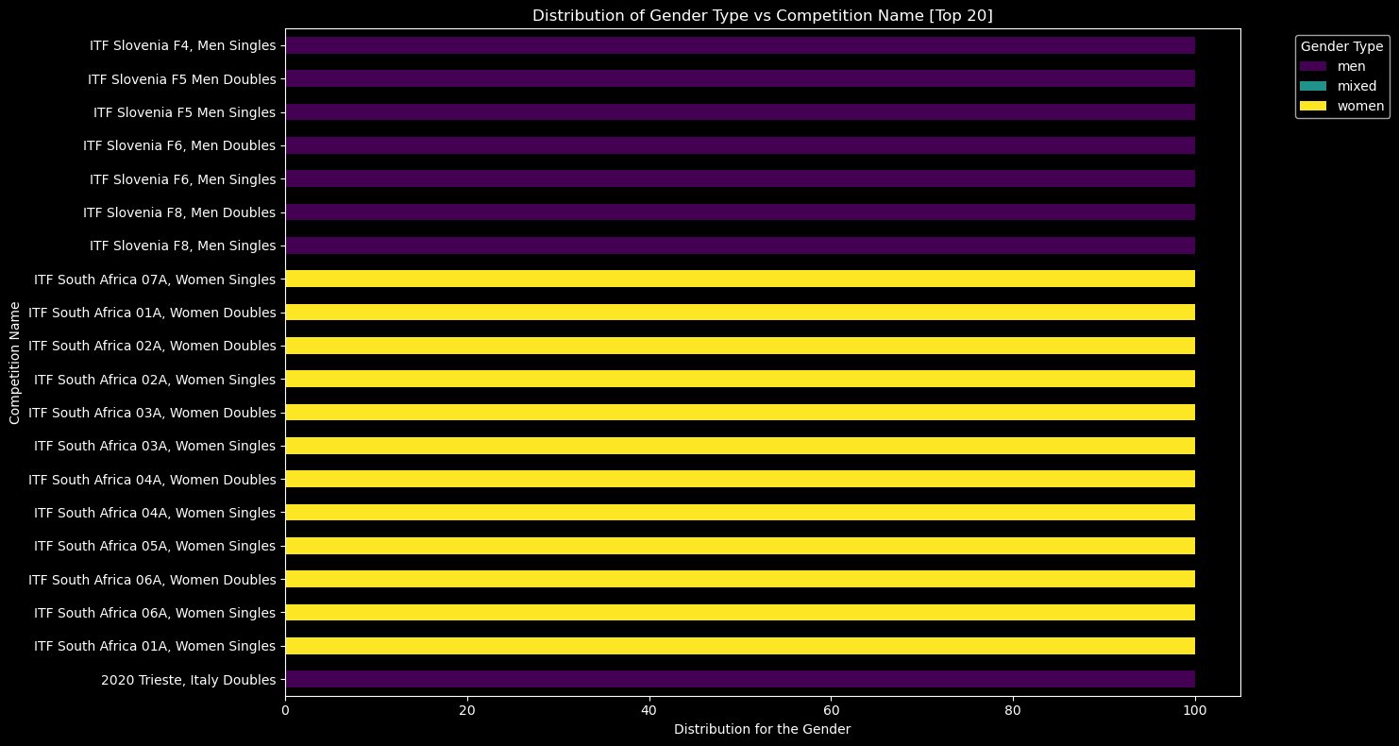Why did you pick the specific chart?

The above multi bar plot chart gives clear distribution for the gender according to the game type.

1. What is/are the insight(s) found from the chart?

The following are the insights for the above multi bar chart:-

* 1. Countries like Italy and Slovenia are dominated by men tennis player's.
  2. South Africa country is mostly dominated by women tennis player's.
  3. Will the gained insights help creating a positive business impact?

Are there any insights that lead to negative growth? Justify with specific reason.

The above insight shows that the Italy and South Africa can produce players from men and women both gender type, this will make an inclusion of gender equality among others and will promote positivity in the tennis games.

Chart - 10

In [20]:

*# Chart - 10 visualization code*

plt.style.use('dark_background')

gen_ty = data1.groupby(["gender", "type"]).size().unstack(fill_value=0)

gen_ty_1 = gen_ty.div(gen_ty.sum(axis=1), axis=0) * 100 fig, ax = plt.subplots(figsize=(15, 8))

gen_ty_1.plot(kind="barh", stacked=True, colormap="plasma", ax=ax)

plt.xlabel("Distribution for the Game type") plt.ylabel("Gender")

plt.title("Distribution of Game Type vs Gender")

plt.legend(title="Game Type", bbox_to_anchor=(1.05, 1), loc="upper left")

plt.tight_layout() plt.show()

1. 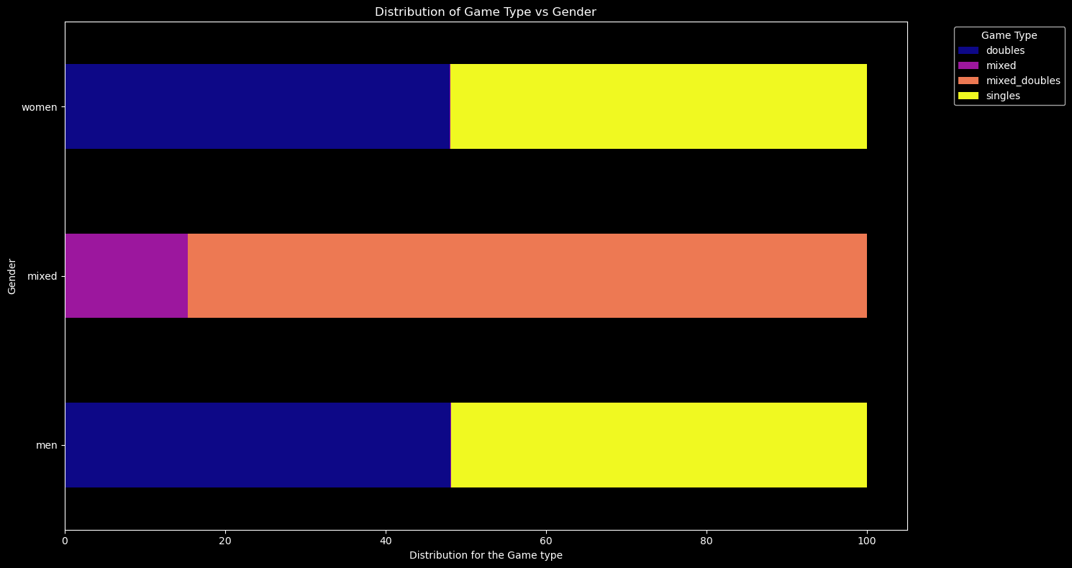Why did you pick the specific chart?

The above multi bar plot chart gives clear distribution for the game type for each gender.

1. What is/are the insight(s) found from the chart?

The following are the insights for the above multi bar chart:-

* 1. For men and women gender the distribution of single's and double's game type is equally distributed.
  2. For mixed gender, less than 20% distribution is for mixed game type and rest is distributed for the mixed_double's game type.
  3. Will the gained insights help creating a positive business impact?

Are there any insights that lead to negative growth? Justify with specific reason.

The above insight shows that the men and women gender are giving equal importance to single's game as well as double's game type while the mixed gender is focusing more on mixed double's game type rather than the mixed single's game type.

Chart - 11

In [265…

*# Chart - 11 visualization code*

plt.style.use('dark_background')

*# Remove any leading or trailing spaces from column names*

data2.columns = data2.columns.str.strip()

*# Sort by date_added and release_year, then select the top 15*

top_d2 = data2[['name', 'country']].sort_values(by='name', ascending=False).head(5)

*# Plot the results*

plt.figure(figsize=(15, 8))

plt.plot(top_d2['name'], top_d2['country'], marker="o", color='tab:blue', linestyle='-', linewidth=2)

plt.xlabel("Name of the Player") plt.ylabel("Country Name") plt.title("(Top 5) Country Vs Player") plt.grid(True)

plt.tight_layout() plt.show()

1. 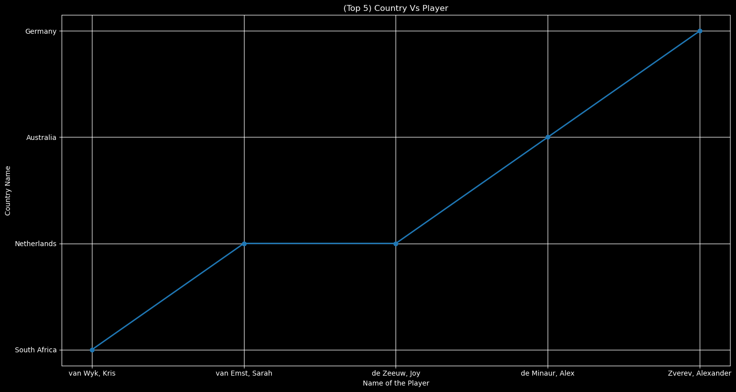Why did you pick the specific chart?

The above line chart gives clear trend analysis over a period of specific time.

1. What is/are the insight(s) found from the chart?

The following are the insights for the above line chart:-

* 1. The top performing player is from germany whose name is zverev, alexander.
  2. The second highest performing player is from australia whose name is de minaur, alex.
  3. The third highest performing player is from netherlands whose name is de zeeuw, joy.

1. Will the gained insights help creating a positive business impact?

Are there any insights that lead to negative growth? Justify with specific reason.

The above insight shows that the top performing tennis players are from germany, australia and netherlands.

Chart - 12

In [279…

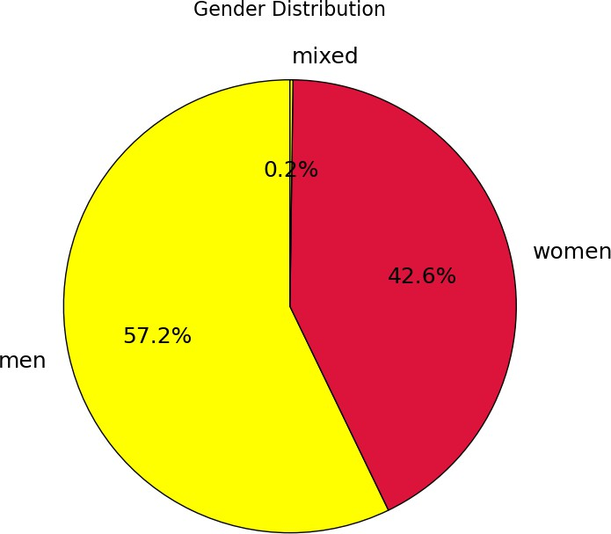

*# Chart - 12 visualization code*

plt**.**style**.**use('default')

data1**.**columns **=** data1**.**columns**.**str**.**strip()

co **=** data1['gender']**.**value_counts()**.**head(10) plt**.**figure(figsize**=**(15, 7))

plt**.**pie(

labels**=**co**.**index, colors**=**['yellow', 'crimson'], startangle**=**90,

autopct**=**'%1.1f%%', *# Show percentages*

textprops**=**{'fontsize': 18, 'color': 'black'}

)

co,

wedgeprops**=**{'edgecolor': 'black'},

plt**.**title('Gender Distribution', fontsize**=**16) plt**.**show()

plt**.**tight_layout()

1. Why did you pick the specific chart?

The above pie chart is good for analyzing the distribution for the gender for the tennis player's.

1. What is/are the insight(s) found from the chart?

The following are the insights for the above pie chart:-

* 1. The highest distribution is for men tennis players which is 57.2%.
  2. The second highest distribution is for women tennis players which is 42.6%.
  3. The third and lowest distribution is for the mixed tennis players where both men and women play together which is 0.2%.

1. Will the gained insights help creating a positive business impact?

Are there any insights that lead to negative growth? Justify with specific reason.

The above insight shows that the men are dominating in the tennis game contribution criteria.

Chart - 13

In [293…

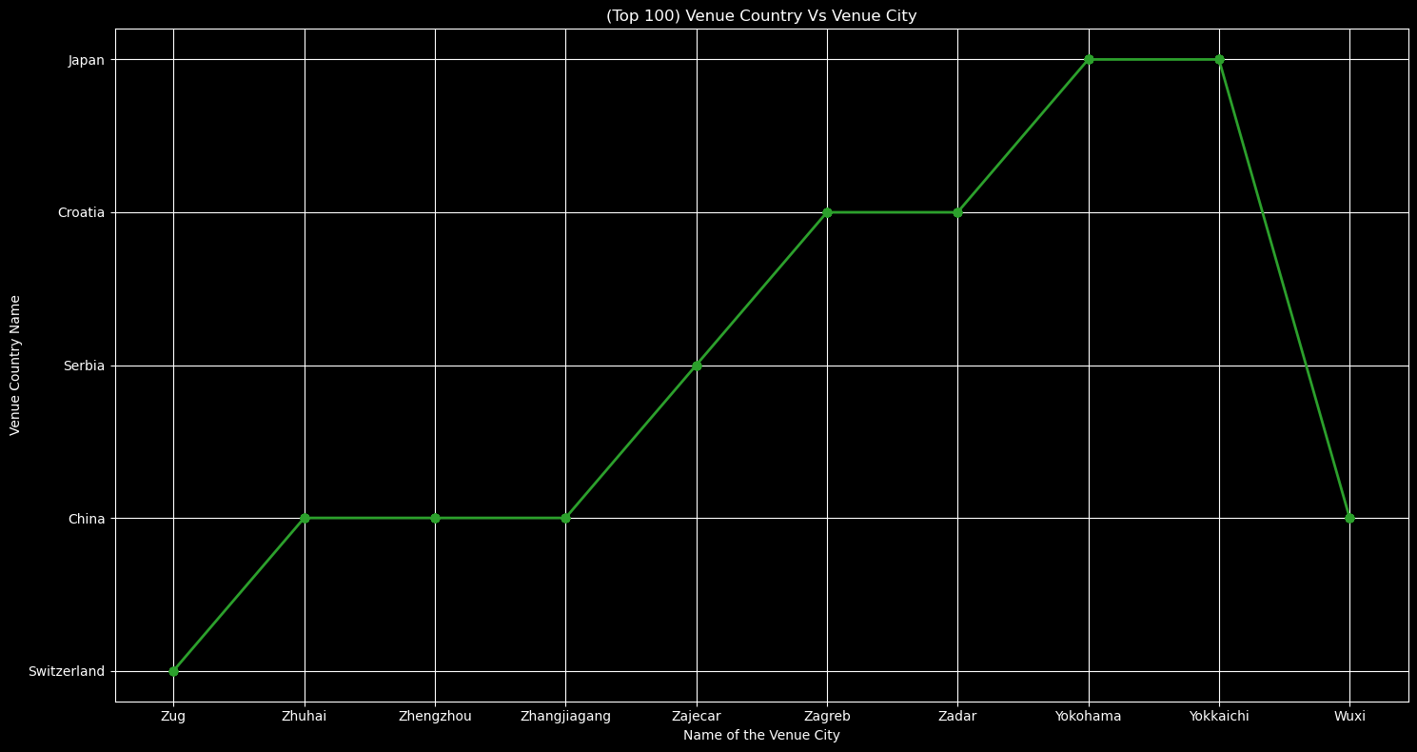

*# Chart - 13 visualization code*

plt**.**style**.**use('dark_background')

*# Remove any leading or trailing spaces from column names*

data3**.**columns **=** data3**.**columns**.**str**.**strip()

*# Sort by city_name and select the top 5*

top_d3 **=** data3[['city_name', 'country_name']]**.**sort_values(by**=**'city_name', ascending**=False**)**.**head(100)

*# Plot the results*

plt**.**plot(

plt**.**figure(figsize**=**(15, 8))

top_d3['city_name'], top_d3['country_name'], marker**=**"o",

linestyle**=**'-', linewidth**=**2

color**=**'tab:green',

)

plt**.**xlabel("Name of the Venue City") plt**.**ylabel("Venue Country Name")

plt**.**title("(Top 100) Venue Country Vs Venue City") plt**.**grid(**True**)

plt**.**tight_layout() plt**.**show()

1. Why did you pick the specific chart?

The above line chart gives clear trend analysis over a period of specific time.

1. What is/are the insight(s) found from the chart?

The following are the insights for the above line chart:-

* 1. The top cities providing venue are from japan which are Yokohama and yokkaichi.
  2. The second highest performing cities to provide venue are from croatia which are zagreb and zadar.
  3. The third highest performing city to provide venue is from serbia which is zajecar.

1. Will the gained insights help creating a positive business impact?

Are there any insights that lead to negative growth? Justify with specific reason.

The above insight shows that the top performing cities are from japan, serbia and croatia.

Chart - 14 - Correlation Heatmap

In [189…

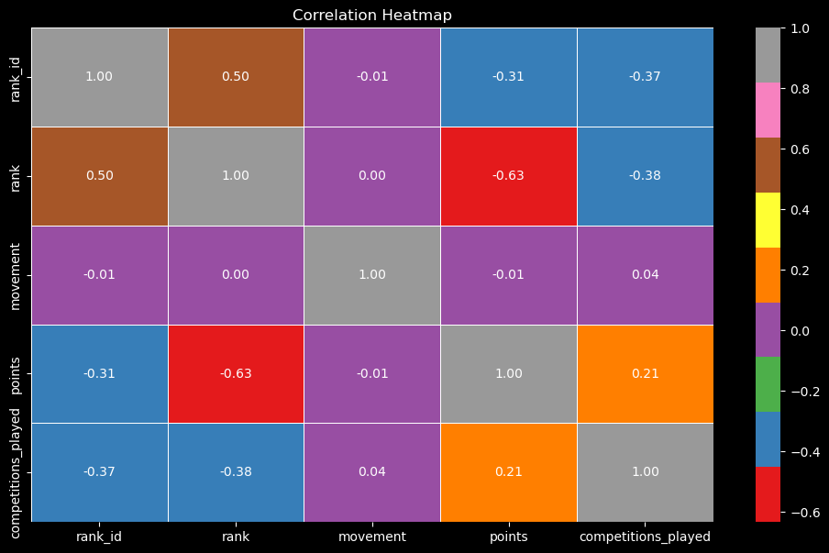

plt**.**style**.**use('dark_background')

heat **=** data2**.**select_dtypes(include**=**['int64', 'float64'])

heat_map **=** heat**.**corr()**.**fillna(0) plt**.**figure(figsize**=**(12, 7))

sns**.**heatmap(heat_map, annot**=True**, cmap**=**"Set1", fmt**=**".2f", linewidths**=**0.5) plt**.**show()

plt**.**title("Correlation Heatmap")

1. Why did you pick the specific chart?

The above heatmap is best to find correlation between different numerical variables.

1. What is/are the insight(s) found from the chart?

The following are the insights for the above heatmap:-

* 1. The highest correlation is between rank_id and rank with value of 0.5.
  2. Second highest correlation is between points and competitions_played with value of 0.21.
  3. The lowest correlation is between rank and points with value of -0.63.

Chart - 15 - Pair Plot

In [191…

*# Pair Plot visualization code*

plt.style.use('dark_background')

numerical = data2.select_dtypes(include=['int64', 'float64']) numerical = numerical.dropna(axis=1, thresh=len(numerical) * 0.8) sns.pairplot(numerical, diag_kind='kde', plot_kws={'alpha': 0.5}) plt.show()

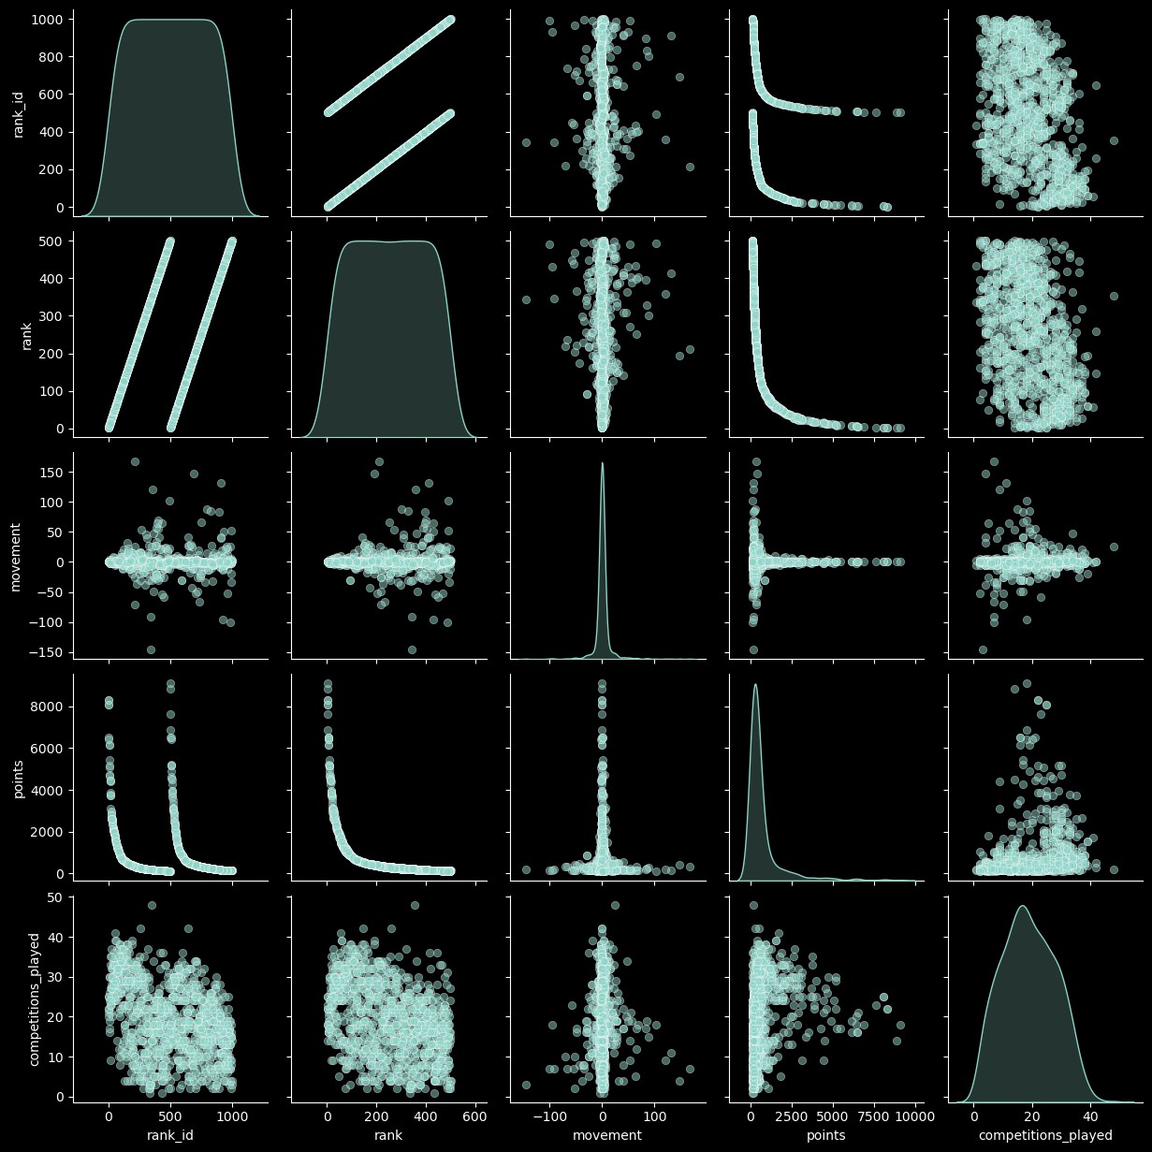

1. Why did you pick the specific chart?

The above pair plot is best to compare numerical variables with itself and with each other.

1. What is/are the insight(s) found from the chart?

The following are the insights for the above pair plot:-

* 1. points variable when compared with rank_id and rank it is showing a continuous decline over a peiod of time.
  2. rank when compared with rank_id shows an straight increasing line over a period of specific time.

PowerBI Analysis for the Three Merged Datasets

Category Competition Dataset Power BI Analysis

In [5]:

**from** PIL **import** Image

**import** IPython.display **as** display

image_path = "C:\\Users\\hp\\Desktop\\Exam Docs\\Labmentix Data analytics intern\\Week 17- Major Last P

*# Change this to your actual image path*

image = Image.open(image_path)

display.display(image)

*# Show image in Jupyter*

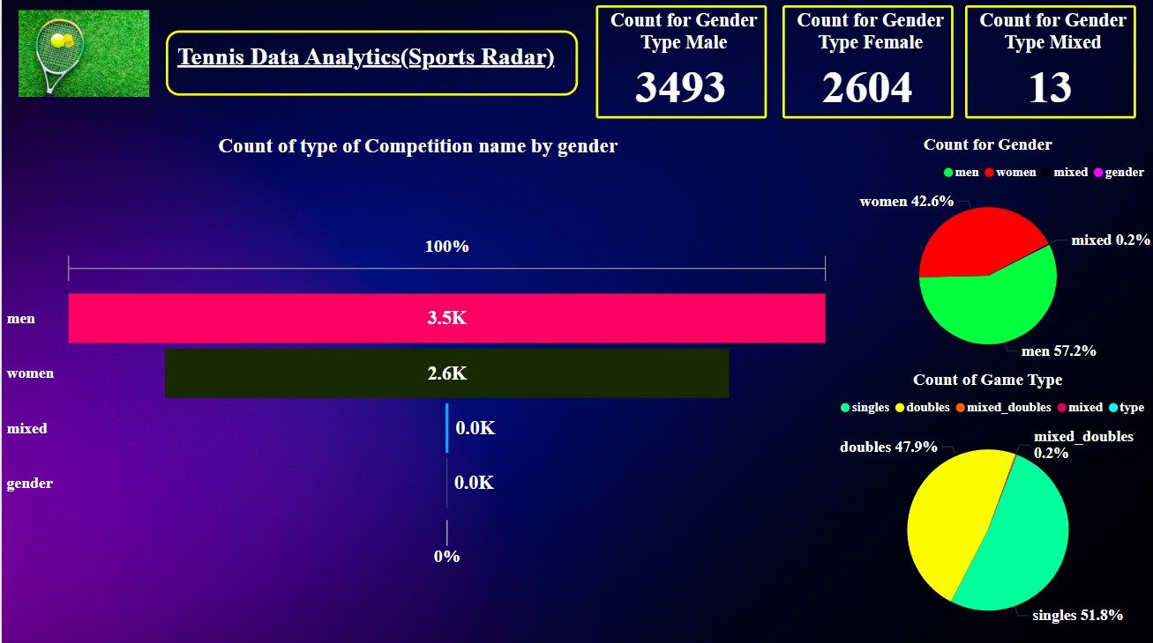

Competitor Ranking Dataset Power BI Analysis

In [9]:

**from** PIL **import** Image

**import** IPython.display **as** display

image_path = "C:\\Users\\hp\\Desktop\\Exam Docs\\Labmentix Data analytics intern\\Week 17- Major Last P

*# Change this to your actual image path*

image = Image.open(image_path)

display.display(image)

*# Show image in Jupyter*

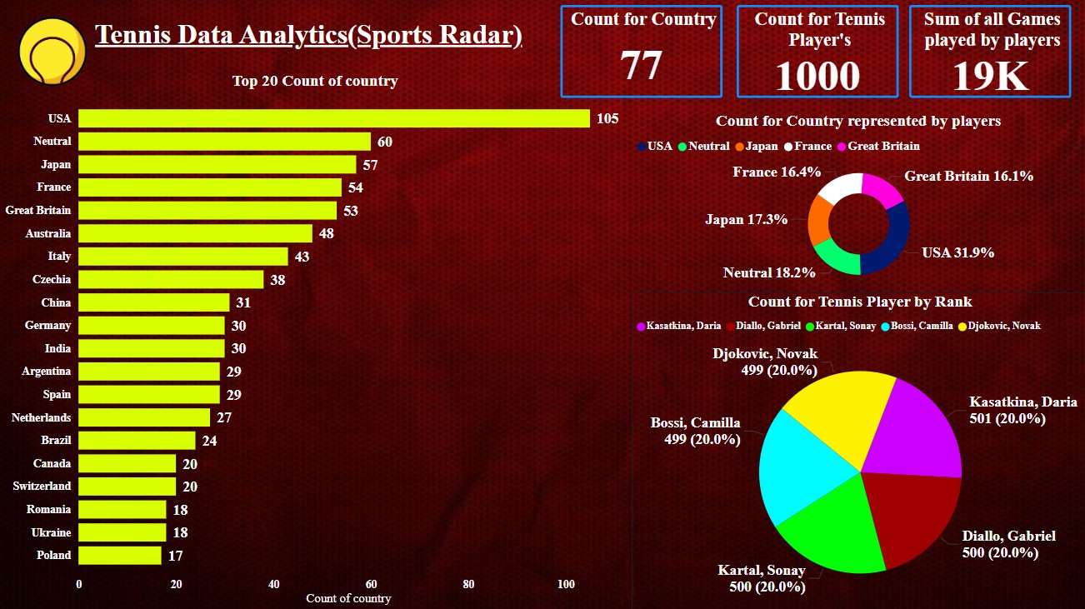

Complexes Venue Dataset Power BI Analysis

In [1]:

**from** PIL **import** Image

**import** IPython.display **as** display

image_path = "C:\\Users\\hp\\Desktop\\Exam Docs\\Labmentix Data analytics intern\\Week 17- Major Last P

*# Change this to your actual image path*

image = Image.open(image_path)

display.display(image)

*# Show image in Jupyter*

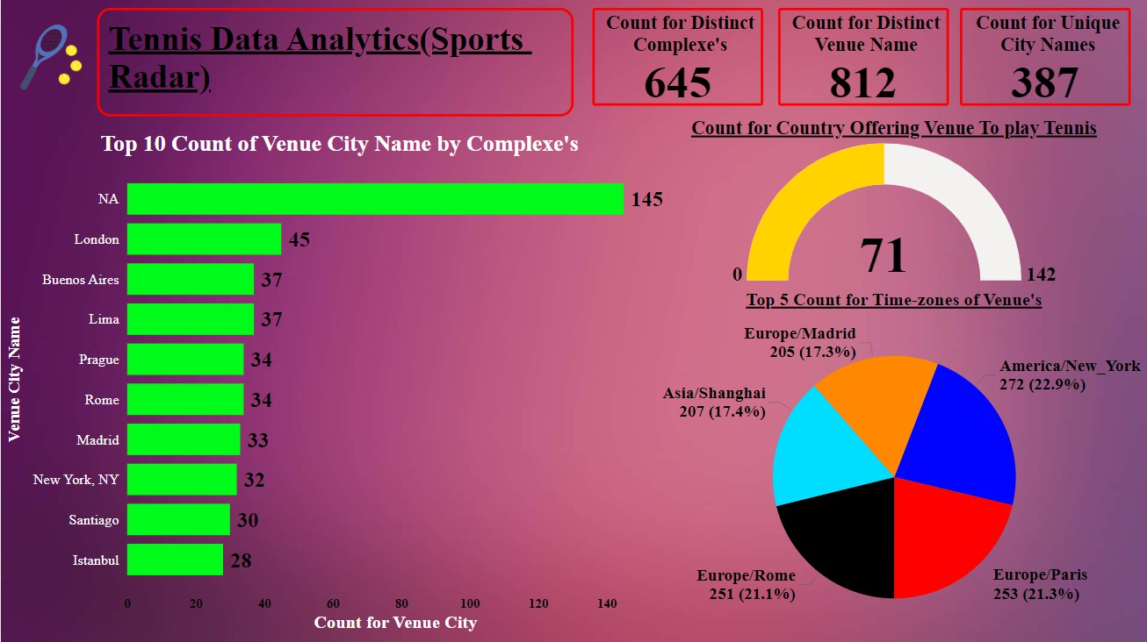

**5. Solution to Business Objective**

What do you suggest the client to achieve Business Objective ?

Explain Briefly.

The following are the suggestions to full fill the business objective for the Tennis Federation's:-

1. Men are participating more in single's tennis games than women and shows that global tennis federation can encourage women to participate in tennis games and contribute in this game as an individual.
2. In double's tennis games also the men are dominating so the tennis federation should organize campaigns and seminars to promote women participation in tennis double's game.
3. USA, France and Japan are great at producing tennis players in maximum nos from their countries.
4. USA, France and Italy are top countries to provide venue's at their place to play tennis games , this is because the major grand slam's tournament's like US open, French open and Wimbeldon generally happens in these countries making these countries a popular place for tennis enthusiast and tennis players.
5. London, Buenos Aires and Lima are top cities to provide venue's at their place to play tennis games , this is because the major grand slam's tournament's like US open, French open and Wimbeldon mostly happens in these cities making these countries a popular place for tennis enthusiast and tennis players, for example the center court at london is very famous for wimbeldon tournment.
6. Italy and South Africa can produce players from men and women both gender type, this will make an inclusion of gender equality among others and will promote positivity in the tennis games.
7. Men and women gender are giving equal importance to single's game as well as double's game type while the mixed gender is focusing more on mixed double's game type rather than the mixed single's game type.

The above are some suggestion/ points which can help tennis federation to improve tennis overall experience for both audience and players.

**Conclusion**

The following are the concluding points for the EDA analysis of Tennis Game Dataset extracted from the Sport Radar API Websource:-

1. There are total 6 datasets but we merged them into 3.
2. There are 8 columns have some missing values in them.
3. There are no duplicates for all three merged datasets.
4. Size of the Merged Dataset 1 - 6110 rows , 7 columns.
5. Size of the Merged Dataset 2 - 1000 rows, 10 columns.
6. Size of the Merged Dataset 3 - 3600 rows, 8 columns.
7. Men has highest count for single's tennis games which is 1810 and women's count for single's tennis games is 1353.
8. Men has highest count for double's tennis games which is 1680 and women's count for double's tennis games is 1250.
9. USA has maximum contribution, neutral is the second highest contributor to produce tennis playersn, Japan is third in producing best tennis players from their country, France is fourth in producing best tennis players from their country and Great Britain is fifth in producing best tennis players from their country.
10. The top country to provide venue is USA, Second highest to provide venue stage is Italy and third highest to provide venue stage is France.
11. The top city to provide venue is London, Second highest city to provide venue stage is Buenos Aires, third highest city to provide venue stage is Lima.
12. Countries like Italy and Slovenia are dominated by men tennis player's and South Africa country is mostly dominated by women tennis player's.
13. For men and women gender the distribution of single's and double's game type is equally distributed and for mixed gender, less than 20% distribution is for mixed game type and rest is distributed for the mixed_double's game type.
14. The highest distribution is for men tennis players which is 57.2%.
15. The second highest distribution is for women tennis players which is 42.6%.
16. The third and lowest distribution is for the mixed tennis players where both men and women play together which is 0.2%.
17. The highest correlation is between rank_id and rank with value of 0.5.
18. Second highest correlation is between points and competitions_played with value of 0.21.
19. The lowest correlation is between rank and points with value of -0.63.