API Rate Limitter (USING REDIS)

1) Why : To limit the no. Of access on API on minute basis, daily basis, weekly basis So that its latency should not break and we will serve the requests.
Suppose If there is a API which is Hitted by many users

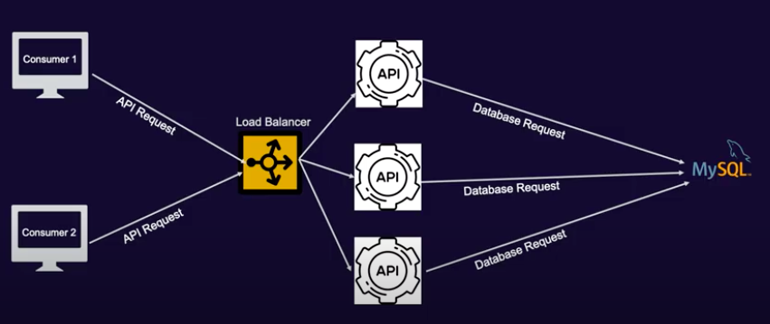

Ex:
100 users are hitting the API, In which each User hitting that api for 5 times in a minute and we are returning the data But if some bad user is hitting the data in 1000 times in 1 minute So our resources are busy bcoz its doing the lots of operations like hitting the DB and doing some processing and we will not be able to serve other user request. So in this case we will restrict each user to hit the api 5 times in a minute. In this case bad use will hit the api only 5 times after that he will get limit exceeded error.

In todays world API rate limiting is very common.

2) Options : IP Based and User Token Based (eg. JWT)
IP Based : In this we apply the restriction at API level. But its not that much good because there is a chance multiple users are connected with the same public IP and there are 100 users associated with one public IP. If one bad user among those 100 users exist then they can hit the api again again and other user we will not able to serve the data.
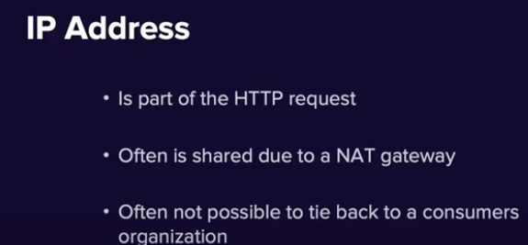

User Token Based : Its always good to use User Token based approach Because each user send the information into the header First we validate the user via some authentication logic and if its a valid user we will allow/not allow user to api
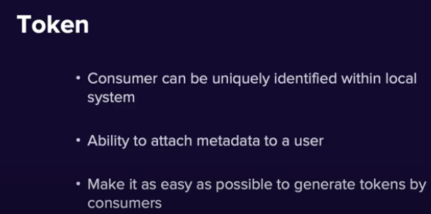

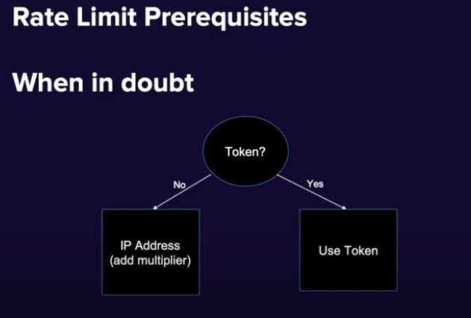

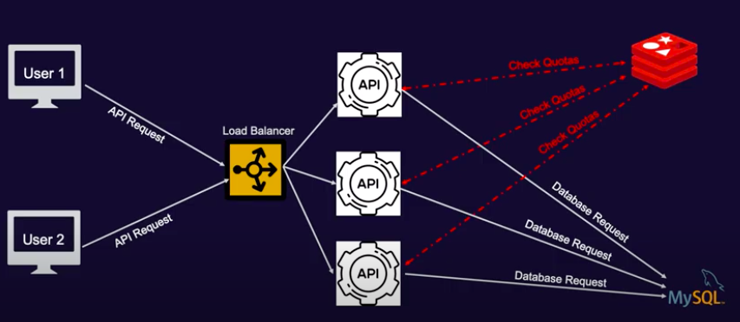

Solution:
For Rate limiting the Users at a API we configure the count (quota for each user for each api) We use Redis as its atomic and faster for each read and write.
So whenever the user is trying to hit the API we will see the user and for a api what is the count if its more then the MAX COUNT we will throw exception “Limit exceeded” else we will allow the user to that api and we will change the count to count + 1.
And for each minute/30 Sec we will remove the old entries from redis cache.

At Filter level we will see each URL and see its quota (count) and will allow/disallow

Below scheduler is deleted all the entries from cache in last 30 sec.

package com.java.notification.filter;
import com.java.notification.utils.RedisUtility;
import lombok.SneakyThrows;
import org.apache.catalina.connector.RequestFacade;
import org.springframework.beans.factory.annotation.Autowired;
import org.springframework.http.HttpRequest;
import org.springframework.stereotype.Component;
import javax.servlet.*;
import java.io.IOException;
@Component
public class CustomRateLimiter implements Filter {
@Autowired
RedisUtility redisUtility;
private int MAX_API_LIMIT_PER_MINUTE = 5;
@SneakyThrows
@Override
public void doFilter(ServletRequest servletRequest, ServletResponse servletResponse, FilterChain filterChain) throws IOException, ServletException {
String url = null;
if(servletRequest instanceof RequestFacade) {
url = ((RequestFacade)servletRequest).getServletPath();
} else if(servletRequest instanceof HttpRequest) {
url = ((HttpRequest)servletRequest).getURI().getPath();
}
System.out.println(url);
int apiCalledCount = redisUtility.getRedisData(url);
System.out.println(apiCalledCount);
if(apiCalledCount > MAX_API_LIMIT_PER_MINUTE) {
throw new Exception("limit exceeded");
}
// All the cache will be expiry in 30 sec Check code in Application.java.
// We have schedule a job which will delete the specific cache in every 30 secs.
redisUtility.putRedisData(url, apiCalledCount + 1);
filterChain.doFilter(servletRequest, servletResponse);
}
}

Below Code will use to set and get the data from cache
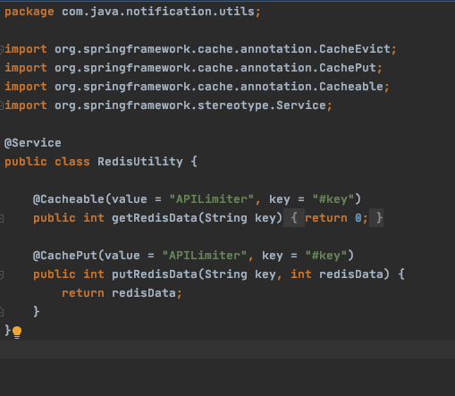

Rate Limiter Methods :

1) Bucketing :

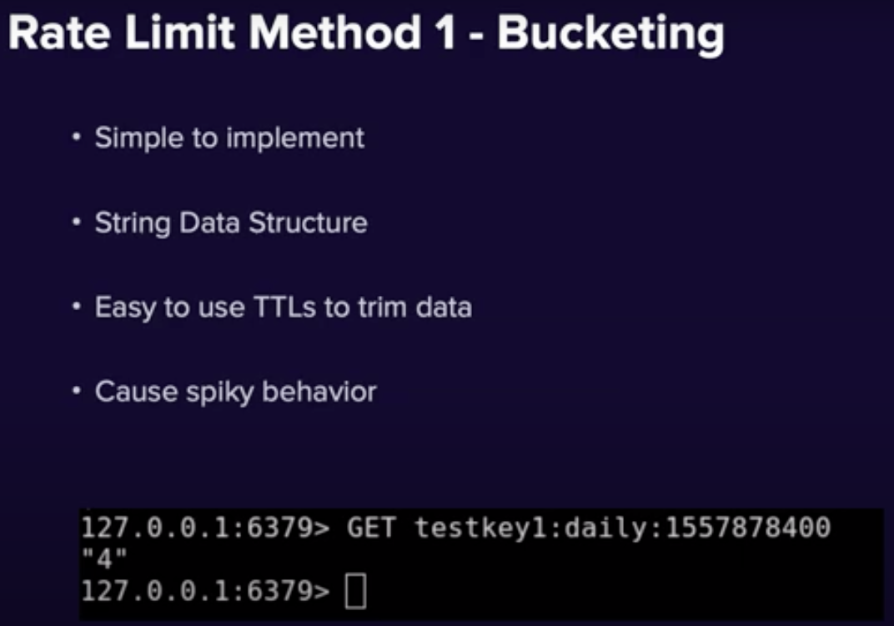
In Bucketing approach : If we assign a daily limit that 300 call per user for a API. And suppose
- For Mon day whole day (from 00 – 23:59) 300 call coming its ok
- For Tue Whole day (from 00 – 23:59) 300 calls coming its ok
- For Wed Suppose from 00:00 to 01:00 all the 300 calls are coming So its a spiky behavior So its not that much good approach.



2nd Sliding Window

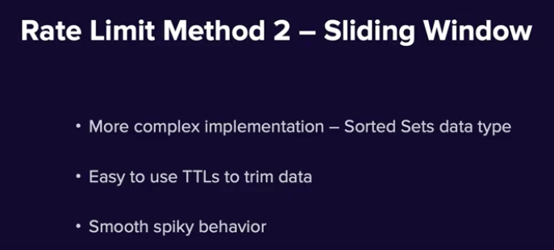

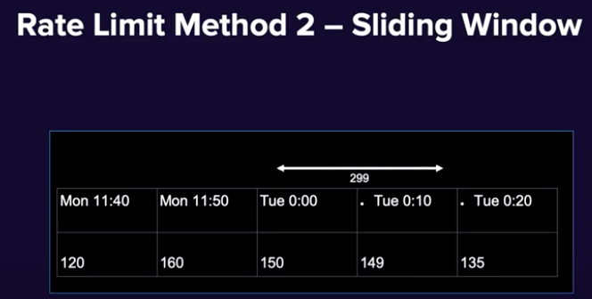

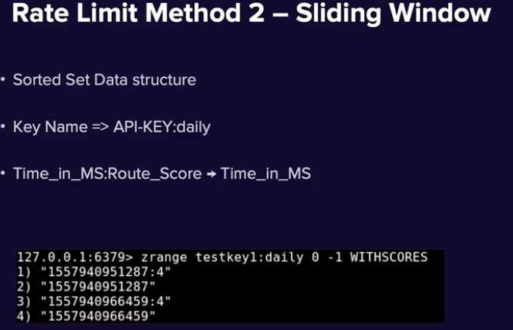

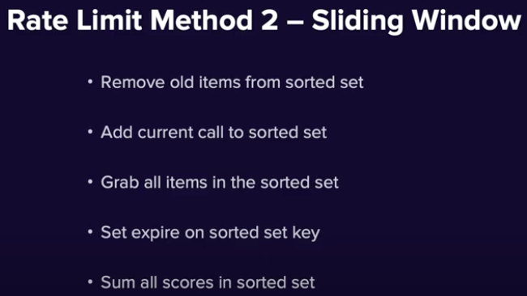

Few Good Notes :

