Google System Type Ahead Search :

We have to design the search which will work on

1. minimum 3 character
2. Grammer Mistakes we can ignore
3. Personalized Search : No need as of Now

1) Clarity :
a) No. of Character needed for seach ?
b) How many results return per search : 3
c) No adult data yes/no ?
d)

2) Estimate of Scale :
Amount of data
No. of queries per seconds ?

Note: Goggle per day rec. 2B+ queries in which 60% Old and 40% old

For each query = 50 character
2B query per day = 50*2B = 50*2 * 1000 * 1000 * 1000 Byte
= 100 * 1000 * 1000 KB
= 100 * 1000 MB
= 100 GB

For for a Years 365 Days --> They will store 365 TB data

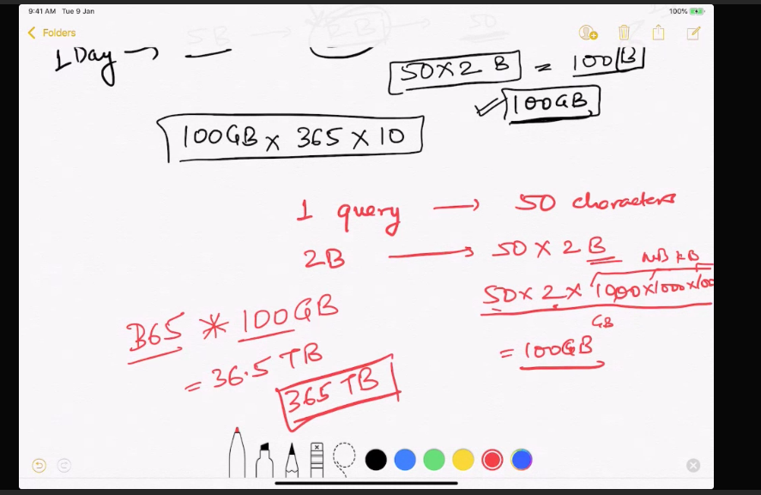
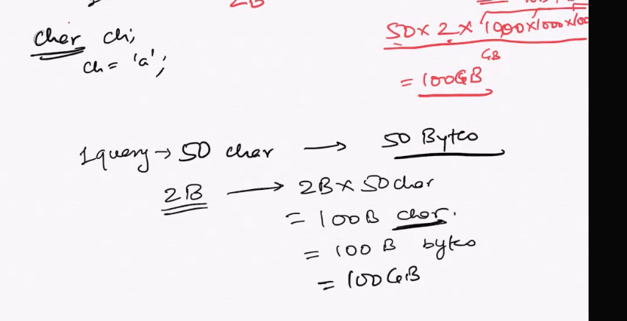

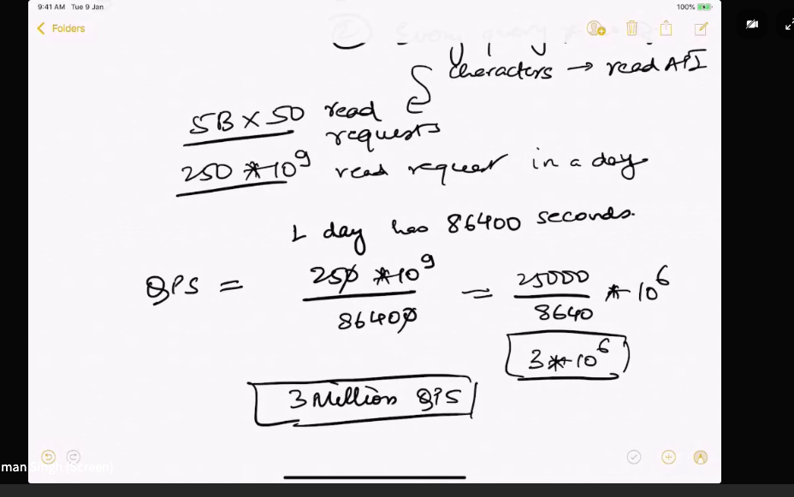

Multiple Saves will create issue

two ways :
1. Maintain the hashMap
Hashmap to store the frequent value with count lets take example 15000 this is the threshold If any search exceed this then it will remove from 15000 and save it.

2. sampling : save 1 out of 100 and increase the save By using this we are saving 100 writes. [Most Popular word will come in frequent search]

Few Terms need to learn

Sharding
Hot and cold ?

Vertical and Horizontal scaling ?

Consistent hashing ? It help in horizontal scaling -> Not the vertical scaling

MemCache ?

Time decay ?
CAP ?

