Spring Framework :-

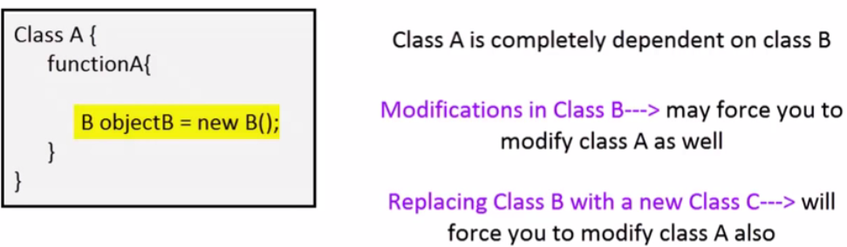
Problems :-

It is free and open source java frameworks. Its basically have two main features :-
AOP and dependency injection

Spring provide :-
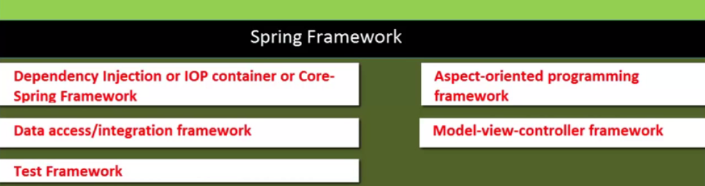

Reason of using Spring :-

a) Dependency Injection
b) It provide really good integration with other framework like struts2 or Hibernate.
c) Its gives you lots of flexiblity like it provide you AOPs , MVC etc.

Dependency Injection :-

In Spring framework, Dependency Injection (DI) design pattern is used to define the object dependencies between each other. It exits in two major types : Setter Injection. Constructor Injection

IOC :-

inversion of control (IoC) is a programming technique in which object coupling is bound at run time by an assembler(supplier) object and is typically not known at compile time using static analysis.

IoC and Dependency Injection :-

In traditional programming, the flow of the business logic is determined by objects that are statically assigned to one another.
With inversion of control, the flow depends on the object graph that is instantiated by the assembler (supplier) and is made possible by object interactions being defined through abstractions. The binding process is achieved through dependency injection, although some argue that the use of a service locator also provides inversion of control.

Inversion of control as a design guideline serves the following purposes:
- There is a decoupling of the execution of a certain task from implementation.
- Every module can focus on what it is designed for.
- Modules make no assumptions about what other systems do but rely on their contracts.
- Replacing modules has no side effect on other modules.

Setter Injection vs. Constructor Injection

1):- Partial dependency:
can be injected using setter injection but it is not possible by constructor. Suppose there are 3 properties in a class, having 3 arg constructor and setters methods. In such case, if you want to pass information for only one property, it is possible by setter method only.

2):- Overriding:
Setter injection overrides the constructor injection. If we use both constructor and setter injection, IOC container will use the setter injection.

3):- Changes:
We can easily change the value by setter injection. It doesn't create a new bean instance always like constructor. So setter injection is flexible than constructor injection

4):- Sequence :
If we are using Constructor injection then its mandatory to maintain the no. of the parameters and type of parameters. If we want to create object by using diff. Constructor then it will be messy because we will need diff. Constructor based on our requirement.

What is Bean Factory ?
- A BeanFactory is like a factory class that contains a collection of beans.
- The BeanFactory holds Bean Definitions of multiple beans within itself and then instantiates the bean whenever asked for by clients.
- BeanFactory is able to create associations between collaborating objects as they are instantiated. This removes the burden of configuration from bean itself and the beans client.
- BeanFactory also takes part in the life cycle of a bean, making calls to custom initialization and destruction methods.

What is Application Context?
- A bean factory is fine to simple applications, but to take advantage of the full power of the Spring framework, you may want to move up to Springs more advanced container, the application context.
- On the surface, an application context is same as a bean factory. Both load bean definitions, wire beans together, and dispense beans upon request.
- But it also provides:
- A means for resolving text messages, including support for internationalization.
- A generic way to load file resources.
- Events to beans that are registered as listeners.

What should be used preferably BeanFactory or ApplicationContext?
- A Bean Factory pretty much just instantiates and configures beans.
- An Application Context also does that, and it provides the supporting infrastructure to enable lots of enterprise-specific features such as transactions and AOP.
- In short, favor the use of an ApplicationContext.

What are the common implementations of the Application Context ?
The three commonly used implementation of ‘Application Context’ are
- ClassPathXmlApplicationContext :
It Loads context definition from an XML file located in the classpath, treating context definitions as classpath resources. The application context is loaded from the application’s classpath by using the code .
ApplicationContext context = new ClassPathXmlApplicationContext(“bean.xml”);

- FileSystemXmlApplicationContext :
It loads context definition from an XML file in the filesystem. The application context is loaded from the file system by using the code .
ApplicationContext context =new FileSystemXmlApplicationContext(“bean.xml”);

- XmlWebApplicationContext :
It loads context definition from an XML file contained within a web application.

AOP :-

AOP is aspect programming language which is used for separate business logic from other code or make the code relevant.
For example. If you have a function GetInterest() So you can separate it from logging and logic.

Because is logging is common thing So you can make it as Aspect and by using the aspect configuration you can use it with function even without writing the code in function. And if something change in aspect then you need not to change the method. Or even if you wish to apply this aspect on some other place or some other method then you need not to change the code, Just change the configurations.
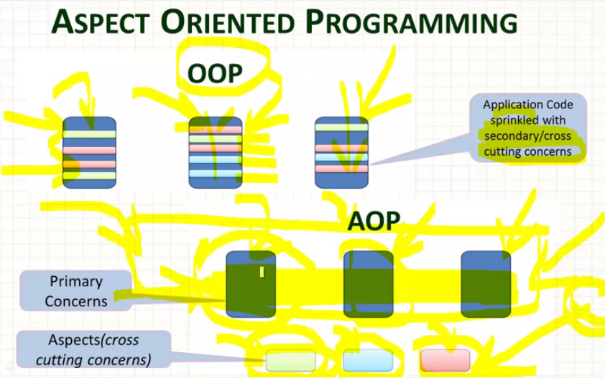

Problem Without Aspects :-
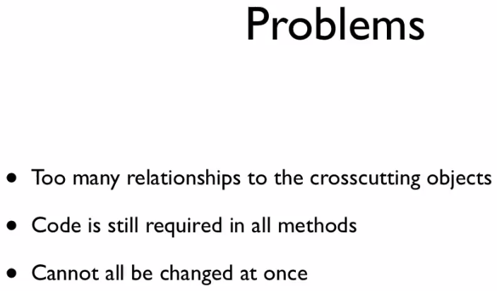
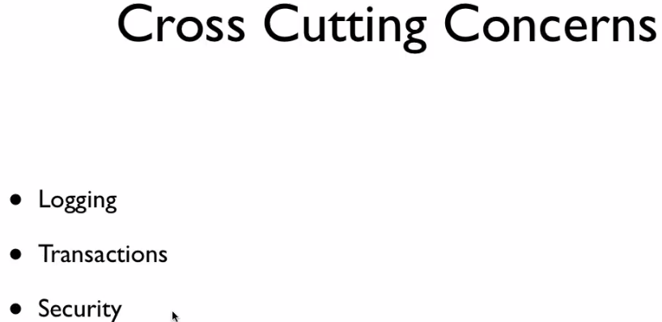

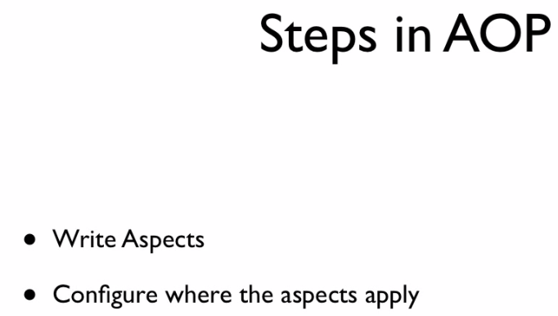
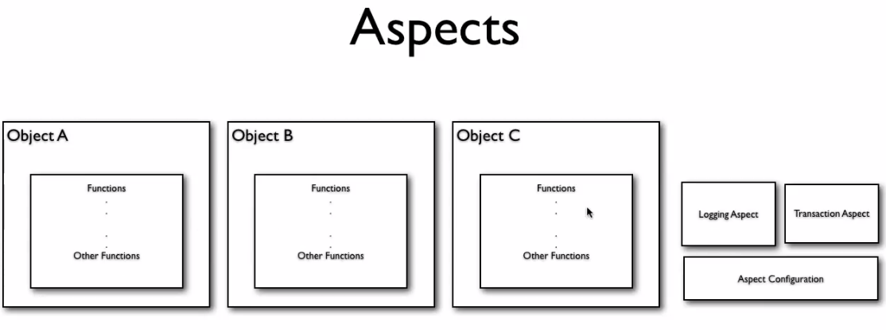
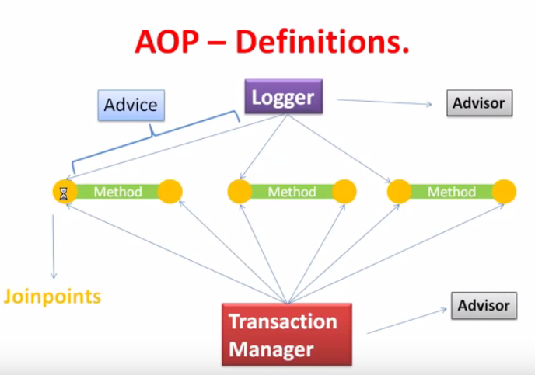

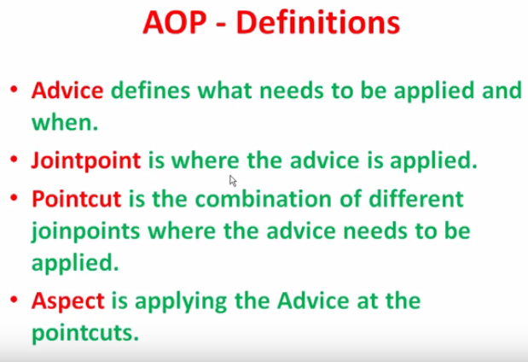

Advice :-
It is implementation of an aspect.
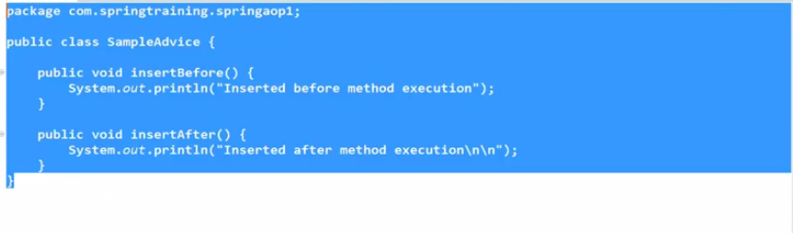
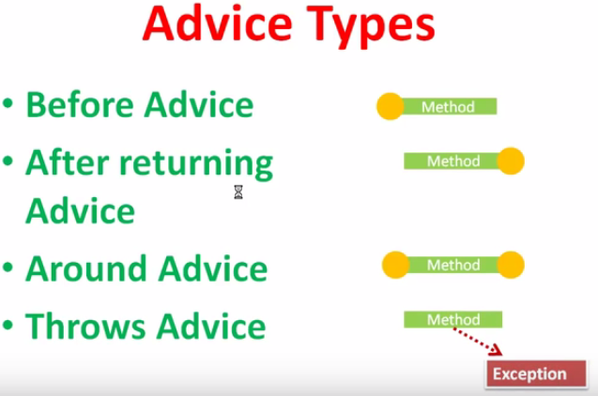

JointPoints :-
These are the points where the advice will be applied.
Ex:- you can apply advice before method or after method call.

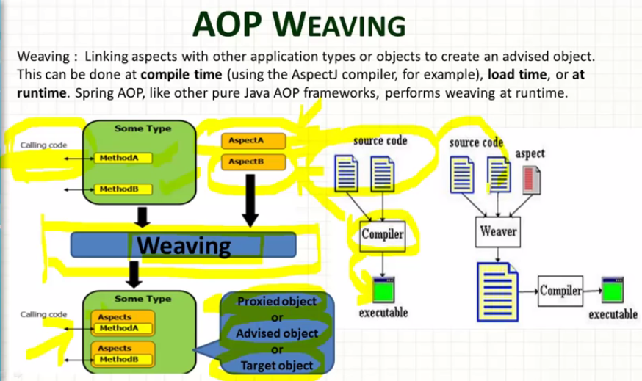

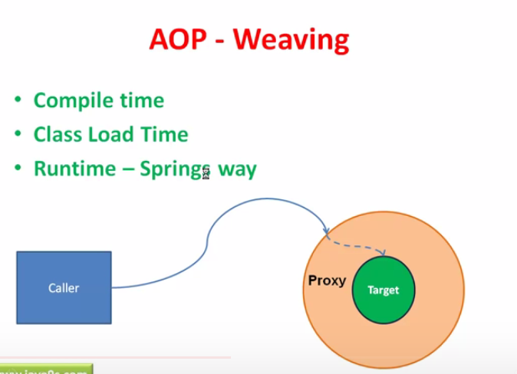

\

MVC

@Controller
Public class XYZ
{
@RequestMapping(“/welcome”)
public ModelAndView m1()
{
}

@RequestMapping(“hi”)
public ModelAndView m1()
{
}

}

URL will be :-
http:localhost:8080/XYZ/welcome
http:localhost:8080/XYZ/hi

@Controller
@RequestMapping(“/greet”)
Public class XYZ
{
@RequestMapping(“/welcome”)
public ModelAndView m1()
{
}

@RequestMapping(“hi”)
public ModelAndView m1()
{
}

}

URL will be :-
http:localhost:8080/XYZ/greet/welcome
http:localhost:8080/XYZ/greet/hi

---------------------------------------------------------------------
@Controller
@RequestMapping(“/greet”)
Public class XYZ
{
@RequestMapping(“/welcome/{countryName}/{userName}”)
public ModelAndView m1(@PathVariable(”countryName”) String cName, @PathVariable(”userName”) String uName)
{
}

or

@RequestMapping(“/hi/{countryName}/{userName}”)
public ModelAndView m2(@PathVariable Map<String, String> pathVariable)
{
String countryName = pathVariable.get(“countryName”);
String uName = pathVariable.get(“userName”);
}

}

URL will be :-
http:localhost:8080/XYZ/greet/welcome/India/Ak
http:localhost:8080/XYZ/greet/hi/US/AKG

BEAN SCOPE

Differen types of spring bean scopes

In the spring bean configurations, bean attribute called 'scope' defines what kind of object has to created and returned. There are 5 types of bean scopes available, they are:
1) singleton: Returns a single bean instance per Spring IoC container.
2) prototype: Returns a new bean instance each time when requested.
3) request: Returns a single instance for every HTTP request call.
4) session: Returns a single instance for every HTTP session.
5) global session: global session scope is equal as session scope on portlet-based web applications.

Session attribute used in Applications:-

If you want to use session attribute then we need to use the SessionAttribute(“name”) with the controller and we can set the value of SessionAttribute ”name” in any controller method.

<h2>Adding of a String into the session</h2>

<form action="remember.html" method="post">
<table>
<tbody><tr>
<td>To remember:</td>
<td><input name="thoughtParam" type="text"></td>
</tr>
<tr>
<td><input type="submit"></td>
<td></td>
</tr>
</tbody></table>
</form>
<a href="${pageContext.request.contextPath}/">Main page</a>

@Controller
@SessionAttributes("thought")
public class SingleFieldController {

@RequestMapping(value="/single-field")
public ModelAndView singleFieldPage() {
return new ModelAndView("single-field-page");
}

@RequestMapping(value="/remember")
public ModelAndView rememberThought(@RequestParam String thoughtParam) {
ModelAndView modelAndView = new ModelAndView();
modelAndView.addObject("thought", thoughtParam);
modelAndView.setViewName("single-field-page");
return modelAndView;
}

}

<h1>Home page</h1>
<p>This is Home page.</p>
<p>Don't forget: ${thought}</p>
<p>
<a href="person-form.html">Person page</a> <br>
<a href="single-field.html">Single field page</a>
</p>

Another example of Session-attribute:-

@Controller
@SessionAttributes(value = "countrybean", types = {Country.class})
public class HelloController {
@Autowired
private CountryController controller;

//this method will assign the session-attribute value
@ModelAttribute("countrybean")
public Country addAttributes() {
Country country = new Country();
country.setCountryName("India");
country.setCapital("Delhi");
return country;
}

@RequestMapping(value="countryinfo")
public String country(){
return "start";
}
}

@Controller
public class CountryController {
@RequestMapping(value="/updateForm")
public ModelAndView country(HttpSession session, @CookieValue("JSESSIONID") String cookie){
Country countryObj = (Country)session.getAttribute("countrybean");
System.out.println("Country Name:"+ countryObj.getCountryName());
System.out.println("Capital:"+ countryObj.getCapital());
return new ModelAndView("updateCountry","country", countryObj);
}
}

Q):- Multi Action Controller Class :-
If a controller class having more than one action method then it is called Multi Action Controller class.

Ex:-

@Controller
@RequestMapping(“/greet”)
Public class XYZ
{
@RequestMapping(“/welcome”)
public ModelAndView m1()
{
}

@RequestMapping(“hi”)
public ModelAndView m1()
{
}

}

Web Services :-

For making the communication using the web services we need to think about two things
- :- Medium (can be Lan, Internet or anything)
- :- Format of I/p and o/p msg.

We can access web services in two ways:-

1):- Directly access the WSDL file and use the web service. In this case service provider provide the WSDL file to client and client directly use the web service.
2):- By using the UDDI file stored on internet. UDDI store all the WSDL of all the web services provider. Client can hit the UDDI and then find WSDL and then can use the Web Services.

Need to knows:-
WSDL :- web service description language
UDDI :- Universal description discovery and integration :- Its a directory on internet where all the service need to register their web services with UDDI using their WSDL file.
Any client want to use web service then he hit uddi and would search for a particular web service

- Client search for a service in UDDI.
- UDDI return all the service Providers offering that service
- Client choose one service provider and get WSDL.
- With the help of WSDL client access the web service

Web Services are of two Type :-
1):- REST
2):- SOAP

1):- REST :- Client can access the resource directly from URI.
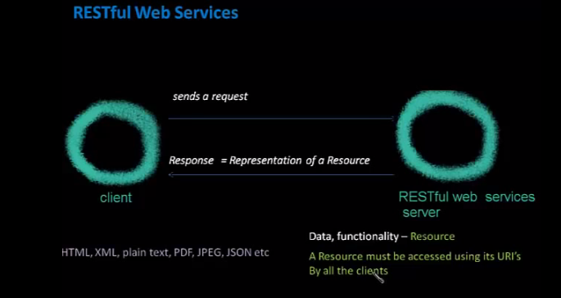

3 Main Feature
a):- In Restful web service client can directly call the web services using URI but in SOAP based web services client need to have WSDL file and its stub to access anything in web service.
b):- Self descriptive message → it means that response contains the information of format and in which format client read the response.
c):- Uniform Resource :- Restful services uses HTTP protocal. We can use other as well. But HTTP describe it greatly

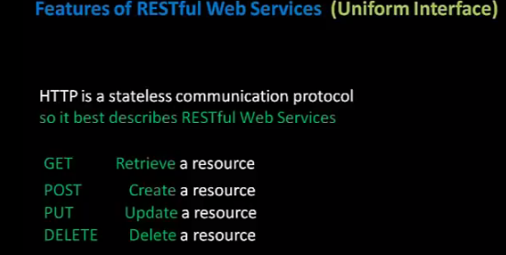

QueryParam vs PathParam

PathParam :- In this Parameter are passed using the URL after “/” as a parameter
Ex:- http://8092/StudentController/12/15
Here 12 is the class nane and 15 is the studentId

Function would be :-

package com.restfulService;

import javax.ws.rs.GET;
import javax.ws.rs.PUT;
import javax.ws.rs.Path;
import javax.ws.rs.PathParam;
import javax.ws.rs.Produces;
import javax.ws.rs.core.MediaType;

@Path("/student")
public class StudentService
{
@GET
@Path("{classInfo}/{studentInfo}")
public String GetUniversityHTMLName2(@PathParam("classInfo") String classNumber, @PathParam("studentInfo") String stuInfo)
{
return "Student Id :- " + stuInfo + "With class no. :- " + classNumber;
}
}

@QueryParam :-

If the parameter is mentioned in the format of Query String in the Http URL - Then those parameter are known as “Query Parameter”

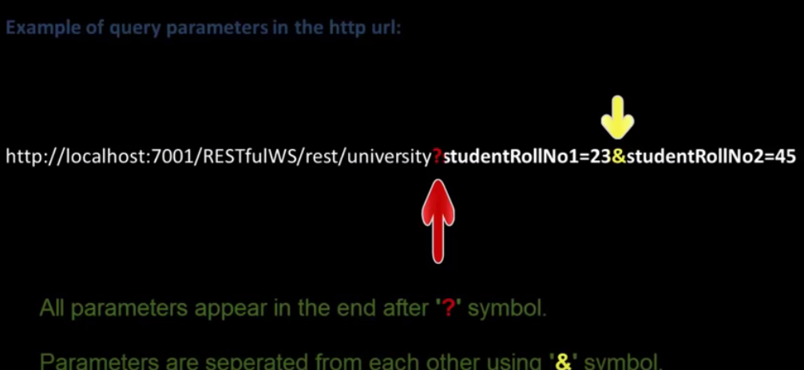

Function :-

@GET
@Path("/queryParamExample")
public String GetStudentInfoUsingQueryParam(@QueryParam("studentRollNo1") String studentRN1, @QueryParam("studentRollNo2") String studentRN2)
{
return "Query Param Example :---- >>>>> Student Id :- " + studentRN1 + "And Student Id : - " + studentRN2;
}

MatrixParam : - >

It is also used to defining the parameter anywhere in the URI.
Parameter are seprated by “;”.
There is no limit oif defining the parameter.
Parameter is apper anywhere in the URL

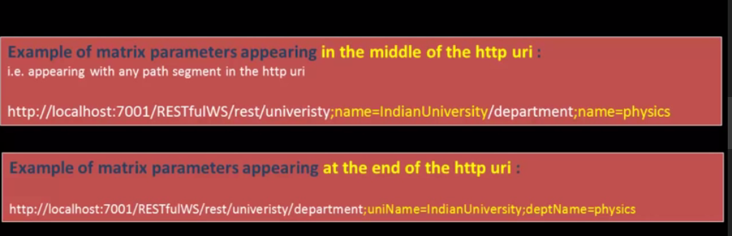

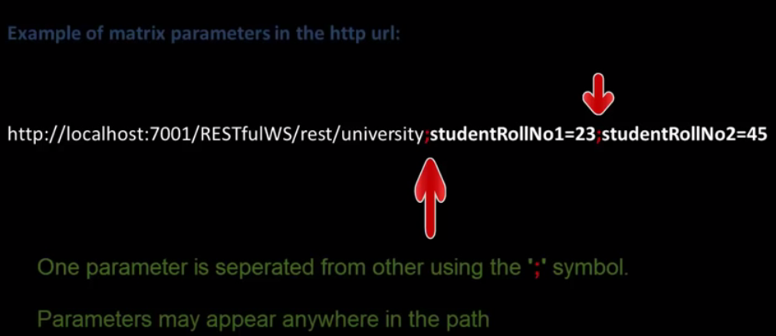

@GET
@Path("/matrixParamExample")
public String GetStudentInfoUsingMatrixParam(@MatrixParam("studentRollNo1") String studentRN1, @MatrixParam("studentRollNo2") String studentRN2)
{
return "Matrix Param Example :---- >>>>> Student Id :- " + studentRN1 + " and Student id : - " + studentRN2;
}

FormParam : - >

It is also used to fetch the form parameter.
Parameter are defined by the name when you define any field inside the form.
We are using the post for submitting the form because when we use POST it will send the parameter in to the body.
Note :- GET NOT USED :- If we use method as GET then it will send it into the URL.

Example:-Html File and a controller file
<form action="http://localhost:7001/UniversityRestfulWSDemo/rest/student/formParamExample" method="POST">
<input type="text" name="classId"/>
<input type="text" name="studentId"/>
<input type="submit" value="submit"/>
</form>

Controller File:-
@POST
@Path("/formParamExample")
public String GetStudentInfoUsingFormParam(@FormParam("classId") String classNumber, @FormParam("studentId") String stuInfo)
{
return "Form Param Example :---- >>>>> Student Id :- " + stuInfo + "With class no. :- " + classNumber;
}

Hibernate :-

Cache Machanism in Hibernate

Caching is facility provided by ORM frameworks which help users to get fast running web application, while help framework itself to reduce number of queries made to database in a single transaction. Hibernate also provide this caching functionality, in two layers.
- Fist level cache: This is enabled by default and works in session scope.
- Second level cache: This is apart from first level cache which is available to be used globally in session factory scope.

First Level Cache
- First-level cache always Associates with the Session object.
- Hibernate uses this cache by default. Here, it processes one transaction after another one, means wont process one transaction many times.
- Mainly it reduces the number of SQL queries it needs to generate within a given transaction. That is instead of updating after every modification done in the transaction, it updates the transaction only at the end of the transaction.
- First level cache is associated with “session” object and other session objects in application can not see it.
- The scope of cache objects is of session. Once session is closed, cached objects are gone forever.
- First level cache is enabled by default and you can not disable it.
- When we query an entity first time, it is retrieved from database and stored in first level cache associated with hibernate session.
- If we query same object again with same session object, it will be loaded from cache and no sql query will be executed.
- The loaded entity can be removed from session using evict() method. The next loading of this entity will again make a database call if it has been removed using evict() method.
- The whole session cache can be removed using clear() method. It will remove all the entities stored in cache.

Second level cache works
Second-level cache always associates with the Session Factory object.
While running the transactions, in between it loads the objects at the Session Factory level, so that those objects will be available to the entire application, not bound to single user. Since the objects are already loaded in the cache, whenever an object is returned by the query, at that time no need to go for a database transaction. In this way the second level cache works. Here we can use query level cache also. Later we will discuss about it.

- Whenever hibernate session try to load an entity, the very first place it look for cached copy of entity in first level cache (associated with particular hibernate session).
- If cached copy of entity is present in first level cache, it is returned as result of load method.
- If there is no cached entity in first level cache, then second level cache is looked up for cached entity.
- If second level cache has cached entity, it is returned as result of load method. But, before returning the entity, it is stored in first level cache also so that next invocation to load method for entity will return the entity from first level cache itself, and there will not be need to go to second level cache again.
- If entity is not found in first level cache and second level cache also, then database query is executed and entity is stored in both cache levels, before returning as response of load() method.
- Second level cache validate itself for modified entities, if modification has been done through hibernate session APIs.
- If some user or process make changes directly in database, the there is no way that second level cache update itself until “timeToLiveSeconds” duration has passed for that cache region. In this case, it is good idea to invalidate whole cache and let hibernate build its cache once again. You can use below code snippet to invalidate whole hibernate second level cache.

Concurrency strategies:
A concurrency strategy is a mediator which responsible for storing items of data in the cache and retrieving them from the cache. If you are going to enable a second-level cache, you will have to decide, for each persistent class and collection, which cache concurrency strategy to use.
- Transactional:
Use this strategy for read-mostly data where it is critical to prevent stale data in concurrent transactions , in the rare case of an update.

- Read-write:
Again use this strategy for read-mostly data where it is critical to prevent stale data in concurrent transactions,in the rare case of an update.

- Nonstrict-read-write:
This strategy makes no guarantee of consistency between the cache and the database. Use this strategy if data hardly ever changes and a small likelihood of stale data is not of critical concern.

- Read-only:
A concurrency strategy suitable for data which never changes. Use it for reference data only.

hbm2ddl.auto :-

a):- Create :- It recreate the data structure and data. i.e. It drop the table and then recreate the table again.

b):- Update :- It update the table schema and data. It does not delete previous created data. Sometimes behavior is bearded.

c):-create-drop :- It behave same as create if you are not explicitly close the sessionFactory object [sessionFactory.close()]. But if you close sessionFactory object explicitly then it will drop all the created schema. [Table deletion]

d):- validate :- It basically validate the table schema and compare the table schema with the schema created from annotation [or XML configuration] and
i):- if it find there is no difference In schema then it validate successfully and execute the query and
ii):- if it find there are some difference Then It will through some exception.

Some Annotation :-

Note :- By default Hibernate create Nullable column except the primary one.

@Id:- This is used for defining the primary keys

@Entity :- This is used to defined that these are the entity needs to be created in the table.

@Table :- Specify the mapping between database table and the entity class. It uses the table name attribute.

@Colomn :- It is used to specify the coloumn mapping with the attribute of class.

Nullable :- it is used to mark that this field can have null values

@Transiant :- If u want that this particular colomn would not be created while created the database table or while performing any insert update operation. Hibernate will colpletely Ignore that column.

@GeneratedValue :- It is used to generate the value automatically. If you are not declare any attribute for Generated then it will take “AUTO” as default.
@Generated value can be :- AUTO, SEQUENCE, IDENTITY, TABLE

@Version

@OrderBy

@Lob

Basic Operation in Hibernate :-
1):- save :--> session.save(employee1);

2):- get--> Here id is 1. If we provide id which is not exist then it will gives you null.
Employee emp = (Employee)session.get(Employee.class, 1);
System.out.println("Name :- " + emp.getEmployeeName());
3):- load :-

3):- update :-
Employee emp = (Employee)session.get(Employee.class, 1);
emp.setEmployeeName("Akshay gupta");
session.update(emp);

4):- delete
Employee emp1 = (Employee)session.get(Employee.class, 2);
session.delete(emp1);

Hibernate Session save
As the method name suggests, hibernate save() can be used to save entity to database. We can invoke this method outside a transaction, that’s why I don’t like this method to save data. If we use this without transaction and we have cascading between entities, then only the primary entity gets saved unless we flush the session.

Hibernate Persist
Hibernate persist is similar to save (with transaction) and it adds the entity object to the persistent context, so any further changes are tracked. If the object properties are changed before the transaction is committed or session is flushed, it will also be saved into database.
Second difference is that we can use persist() method only within the boundary of a transaction, so it’s safe and takes care of any cascaded objects.

Difference between Save and Persist() in Hibernate
Save()
- It return Serializable identifier of the object after saving.
- Saves the value to DB immediately and keeps track of the entity until the end of the session(I have tried to change the entity values outside of the transaction, it does not show any effect when session commits)
- Does not save the changes to the db outside of the transaction.
- Assigns the generated id to the entity you are persisting
- Session.save() for a detached object will create a new row in the table.
Like :- Serlizable_Object save();

Persist
Like :- void persist();
- Does not returns generated Id after saving. Its void return type.
- Saves the value to DB immediately and keeps track of the entity until the end of the session.(I have tried to change the entity values outside of the transaction, it does not show any effect when session commits)
- Does not save the changes to the db outside of the transaction.
- Assigns the generated id to the entity you are persisting
- session.persist() for a detached object will throw PersistentObjectException as it is not allowed.

Difference between load and get :-
1):-get always hit the database for returning real object.
Load not hit the database and it return the proxy or fake object
2):- Load will throw an exception if no object is available for the Id but get will return null if no object present in the database for that Id.

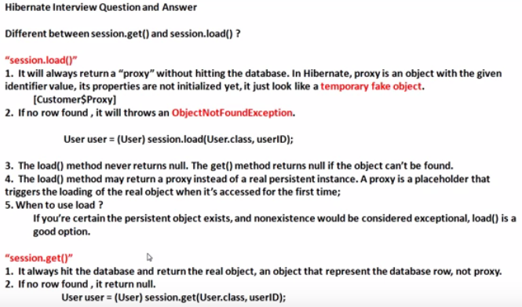

Hibernate Object (Transient, Persistent and Detached States)

package com.akshay.BasicOperation;
import org.hibernate.Session;
import org.hibernate.SessionFactory;
import org.hibernate.Transaction;
import org.hibernate.cfg.Configuration;

public class Main
{
public static void main(String args[])
{

//Start of Transient State
Employee employee = new Employee();
employee.setEmployeeName("Karan");

SessionFactory sessionFactory = new Configuration().configure().buildSessionFactory();
Session session = sessionFactory.openSession();
Transaction tran = session.beginTransaction();

employee.setEmployeeName("Name before change ");
//End of Transient state . Here Transient state is end Because employee is now going to attached with database after session.save(employee)
//Before session.save object is in Transient state after that it will move into Persistent State and automatically sync with database
session.save(employee);
//Start of Persistent State
employee.setEmployeeName("Name after change ");
tran.commit();
//End of Persistent State
session.close();
// Start of Detached State. After session is closed it will going into Detached state
employee.setEmployeeName("Name after close session");
//session.delete(employee); then it will be going into transient state.
// End of Detached state
}
}

Query Fire in the program :-

Hibernate: insert into Employee_Information (employeeName, id) values (?, ?)
Hibernate: update Employee_Information set employeeName=? where id=?

Output table :-
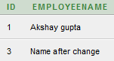

1) Transient :-
- Transient objects do not have association with the databases and session objects.
- They are simple objects and not persisted to the database.
- Once the last reference is lost, that means the object itself is lost. And of course, garbage collected.
- The commits and rollbacks will have no effects on these objects.
- They can become into persistent objects through the save method calls of Session object.
Note in Short :-
Object is in transient state before in connect with the session. When object in this state then object having no connectivity with database. When it connect with the session it will going into persistent state.
Special Case :- but if the object is deleted in persistent state then it will going into Transient State because it have no connectivity with database.

2) Persistent :-
When the object is connect with session then it comes in persistent state.
If any modification in performed with that object then it will automatically synced with the databse. I.e update query automatically fired without using “update” function.

3) Detached :-
- The detached object have corresponding entries in the database.
- These are persistent and not connected to the Session object.
- These objects have the synchronized data with the database when the session was closed. Since then, the change may be done in the database which makes this object stale.
- The detached object can be reattached after certain time to another object in order to become persistent again.
Note :- In short After closing the session object goes into detached state. But before closeing the connection if was synced with database i.e. it was in persitent state. In this state object is no more connected to the database. And if we make any change in the object it will not impact into database.

Q):- Can we reattached detached object or we can convert detached object into persistent state
Ans:- Yes we can convert detached object into persistent object. By open a new session and attached this object with that session.
So what is the need :-
Suppose After the session closed if we have some change in our object or in detached object, and want to sync these change with database. Then we made these type of changes

package com.akshay.BasicOperation;

import org.hibernate.Session;
import org.hibernate.SessionFactory;
import org.hibernate.Transaction;
import org.hibernate.cfg.Configuration;

public class Main
{
public static void main(String args[])
{
SessionFactory sessionFactory = new Configuration().configure().buildSessionFactory();
Session session = sessionFactory.openSession();
Transaction tran = session.beginTransaction();

//Start of persistent state
Employee emp = (Employee)session.get(Employee.class, 1);
System.out.println(emp.getEmployeeName());

emp.setEmployeeName("Akshay After Change in Persistent State");
//No need to write update statement because emp is in persistent state. Update Query will be fired

tran.commit();
//End of persistent State
session.close();

//Start of Detached State
emp.setEmployeeName("Akshay after close session");

//We are going to reattached the detached object or we are converting the detached object (emp) into persistent state
Session session1 = sessionFactory.openSession();
Transaction tran1 = session1.beginTransaction();
//Here the Detached object “emp” converted into persistent object
session1.update(emp);

emp.setEmployeeName("Akshay after close session but again create new session"); //update query will be fire
tran1.commit();
//End of persistent State
session1.close();
sessionFactory.close();

}
}

Hibernate: select employee0_.id as id1_1_0_, employee0_.employeeName as employee2_1_0_ from Employee_Information employee0_ where employee0_.id=?
Hibernate: update Employee_Information set employeeName=? where id=?
Hibernate: update Employee_Information set employeeName=? where id=?

java - What is lazy loading in Hibernate? - Stack Overflow

Lazy fetching decides whether to load child objects while loading the Parent Object. You need to do this setting respective hibernate mapping file of the parent class. Lazy = true (means not to load child) By default the lazy loading of the child objects is true

Hibernate Cascade, Hibernate Cascade Types, Cascade Attribute

Cascade Attribute In Hibernate. Example: if we apply insert(or update or delete) operation on parent class object, then child class objects will also be stored into the database

One to One mapping :-
It shows if the tables having only one records for same Id in tables then it shows as One to One mapping
Ex :- Student → StudentId, StudentName
StudentDetails → StudentId, StudentMobileNumber
In Student Table StudentId is primary key and in StudentDetails table StudentId is foreign key.
Here one to one mapping shows StudentDetails table having entry only and only if Student have the entry for that Id.

For this we Use @JOIN and @Cascade and other attribute

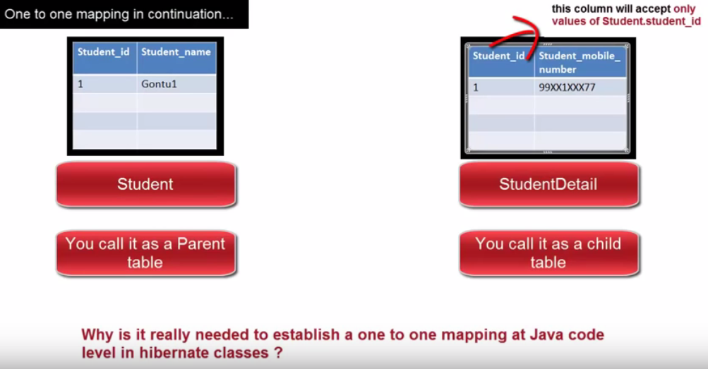

Note:-
Here in java code it seem like we are saving only the studentDetails data. But internally hibernate First Save parent table (Student) table data after that I will going to save its child Table (studentDetails) data and whatever Id is generated from Student Table it will use Id in StudentDetails table. So no need to bother about inserting the data in both table.

Two type of one to one mapping :-
1):- Unidirectional :-
ex :- When you save child object parent object automatically created.
2):- Bi-Directional :- When you save parent object and then child object automatically created.

For 1 to 1 Mapping :- code will be look like this :-

a) :- hibernate.cfg.xml
<?xml version="1.0" encoding="UTF-8"?>
<!DOCTYPE hibernate-configuration SYSTEM
"http://www.hibernate.org/dtd/hibernate-configuration-3.0.dtd">
<hibernate-configuration>
<session-factory>

<!-- Database Connection Information -->
<property name="connection.driver_class">oracle.jdbc.driver.OracleDriver</property>
<property name="connection.url">jdbc:oracle:thin:@localhost:1521:XE</property>
<property name="connection.username">system</property>
<property name="connection.password">oracle</property>

<!-- Echo all executed SQL to stdout -->
<property name="show_sql">true</property>

<!-- SQL dialect -->
<property name="dialect">org.hibernate.dialect.OracleDialect</property>

<!-- Disable the second-level cache. -->
<property name="cache.provider_class">org.hibernate.cache.NoCacheProvider</property>

<property name="connection.pool_size">1</property>

<!-- Drop and re-create the database schema on startup -->
<property name="hbm2ddl.auto">create</property>

<!-- For every entity you need to make entry here-->
<mapping class="com.akshay.hibernate.Student"/>
<mapping class="com.akshay.hibernate.StudentDetail"/>

</session-factory>
</hibernate-configuration>

2):- Main Class:-
package com.akshay.hibernate;

import java.util.Date;

import org.hibernate.Session;
import org.hibernate.SessionFactory;
import org.hibernate.Transaction;
import org.hibernate.cfg.Configuration;

public class Main {

public static void main(String[] args)
{
Student student = new Student();
student.setStudentName("Akshay2");

Student student1 = new Student();
student1.setStudentName("Akshay3");

StudentDetail studentDetail = new StudentDetail();
studentDetail.setStudentMobile("123456");
studentDetail.setDob(new Date());

studentDetail.setStudent(student);

StudentDetail studentDetail1 = new StudentDetail();
studentDetail1.setStudentMobile("22323");
studentDetail1.setDob(new Date());
studentDetail1.setStudent(student1);

SessionFactory sessionFactory = new Configuration().configure().buildSessionFactory();
Session session = sessionFactory.openSession();
Transaction tran = session.beginTransaction();

session.save(studentDetail);
session.save(studentDetail1);

tran.commit();
session.close();
sessionFactory.close();
}

}

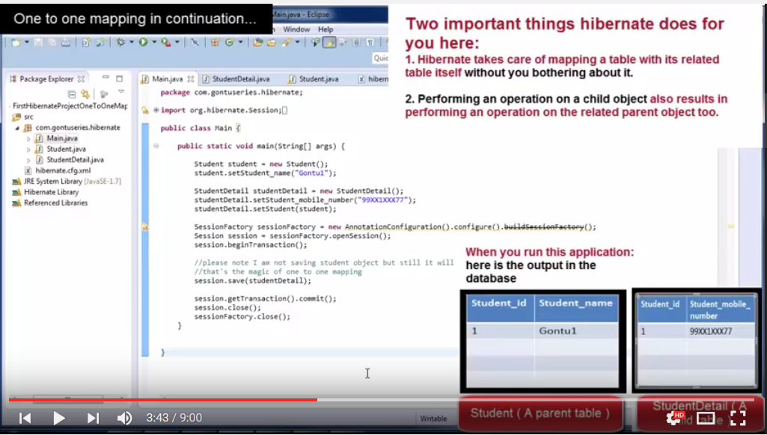
3):- StudentDetails.java
package com.akshay.hibernate;

import java.util.Date;

import javax.persistence.CascadeType;
import javax.persistence.Entity;
import javax.persistence.GeneratedValue;
import javax.persistence.Id;
import javax.persistence.JoinColumn;
import javax.persistence.OneToOne;
import javax.persistence.Temporal;
import javax.persistence.TemporalType;

import org.hibernate.annotations.Cascade;
import org.hibernate.annotations.GenericGenerator;
import org.hibernate.annotations.Parameter;

@Entity
public class StudentDetail {

@Id @GeneratedValue(generator="newGenerator")
@GenericGenerator(name="newGenerator" , strategy="foreign", parameters={@Parameter(value="student", name="property")}) // this line of code will stop for Hibernate to create diff. Id. By using this Hibernate create the same Id which is created for Student table
private int studentId;

private String studentMobile;

@Temporal(TemporalType.TIMESTAMP)
private Date dob;

public Date getDob() {
return dob;
}

public void setDob(Date dob) {
this.dob = dob;
}

@OneToOne(cascade = CascadeType.ALL) //If you want to perform all the operation into related table done automatically then we use ALL.
@JoinColumn(name="studentId") //It is the studentId of Student Class. Here we declare it as a Foreign key for StudentDetails class
private Student student;

public Student getstudent() {
return student;
}

public void setStudent(Student student) {
this.student = student;
}

public int getStudentId() {
return studentId;
}

public void setStudentId(int studentId) {
this.studentId = studentId;
}

public String getstudentMobile() {
return studentMobile;
}

public void setStudentMobile(String studentMobile) {
this.studentMobile = studentMobile;
}
}

4):- Student.java

package com.akshay.hibernate;

import javax.persistence.Column;
import javax.persistence.Entity;
import javax.persistence.GeneratedValue;
import javax.persistence.Id;
import javax.persistence.Table;
import javax.persistence.Transient;

@Entity
@Table(name="Student")
public class Student
{
@Id @GeneratedValue
private int studentId;

//@Transient
@Column(name="StudentName")
private String studentName;

//This line of code added for Bi-directional
@OneToOne(cascade = CascadeType.ALL)
@JoinColumn(name="studentId")
private StudentDetail studentDetail;

public StudentDetail getStudentDetail() {
return studentDetail;
}

public void setStudentDetail(StudentDetail studentDetail) {
this.studentDetail = studentDetail;
}

public int getStudentId() {
return studentId;
}

public void setStudentId(int studentId) {
this.studentId = studentId;
}

public String getStudentName() {
return studentName;
}

public void setStudentName(String studentName) {
this.studentName = studentName;
}
}

Student Table
StudentDetail Table


Many to One mapping :-
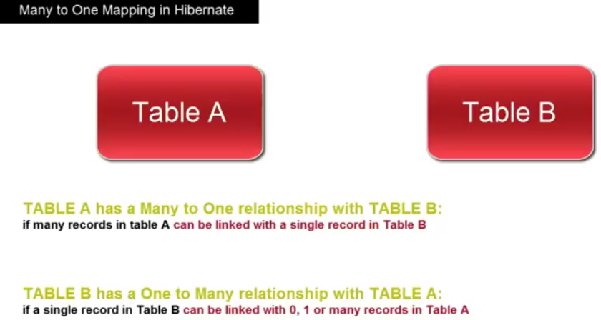
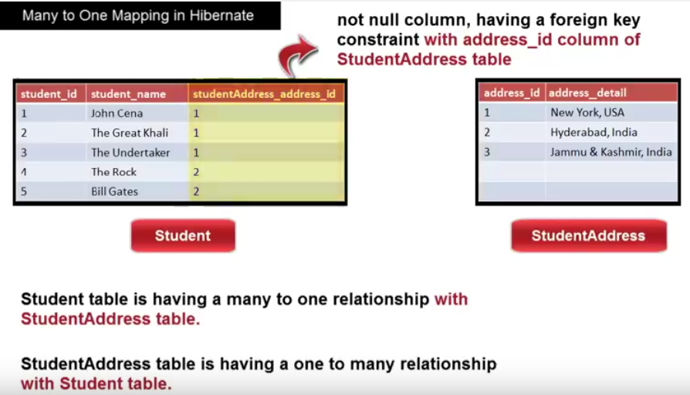
Ex :-

package com.akshay.MantToOneRelationShip;

import java.util.HashSet;
@Entity
public class EmployeeAddress
{
@Id @GeneratedValue
private int addressId;

private String addressName;

//@OneToMany(cascade = CascadeType.ALL) //If you are not using the mappedBy then Hibernate will create a new Table which contain mapping of EmployeeId and AddressId
@OneToMany(cascade = CascadeType.ALL, mappedBy="employeeAddress")//If you are using mappedBy then Hibernate will understand then which coloumn is used for mapping purpose and does not create any other table
private Set<Employee> employee = new HashSet<Employee>();

public Set<Employee> getEmployee() {
return employee;
}

public void setEmployee(Set<Employee> employee) {
this.employee = employee;
}

public int getAddressId() {
return addressId;
}

public void setAddressId(int addressId) {
this.addressId = addressId;
}

public String getAddressName() {
return addressName;
}

public void setAddressName(String addressName) {
this.addressName = addressName;
}
}

package com.akshay.MantToOneRelationShip;

import javax.persistence.CascadeType;
import javax.persistence.Entity;
import javax.persistence.GeneratedValue;
import javax.persistence.Id;
import javax.persistence.JoinColumn;
import javax.persistence.ManyToOne;
import javax.persistence.Transient;

@Entity
public class Employee
{
@Id @GeneratedValue
private int id;

private String employeeName;

@ManyToOne(cascade = CascadeType.ALL)
@JoinColumn(name="addressId") //if Join is not used then Hibernate create a extra coloumn with TableName_coloumnName [EmployeeAddre_AddressId], if used then it will create adressId
private EmployeeAddress employeeAddress;

public int getId() {
return id;
}

public void setId(int id) {
this.id = id;
}

public String getEmployeeName() {
return employeeName;
}

public void setEmployeeName(String employeeName) {
this.employeeName = employeeName;
}

public EmployeeAddress getEmployeeAddress() {
return employeeAddress;
}

public void setEmployeeAddress(EmployeeAddress employeeAddress) {
this.employeeAddress = employeeAddress;
}

}

package com.akshay.MantToOneRelationShip;

import org.hibernate.Session;
import org.hibernate.SessionFactory;
import org.hibernate.Transaction;
import org.hibernate.cfg.Configuration;

public class Main
{
public static void main(String args[])
{
EmployeeAddress address = new EmployeeAddress();
address.setAddressName("Hyderabad");

Employee employee = new Employee();
employee.setEmployeeName("Akshay");
employee.setEmployeeAddress(address);

Employee employee1 = new Employee();
employee1.setEmployeeName("Karan");
employee1.setEmployeeAddress(address);

SessionFactory sessionFactory = new Configuration().configure().buildSessionFactory();
Session session = sessionFactory.openSession();
Transaction tran = session.beginTransaction();

// session.save(employee);
// session.save(employee1);
// OR down line code

address.getEmployee().add(employee);
address.getEmployee().add(employee1);
// Here if you save address then its corresponding employee automatically created. It is bidirectional mapping

session.save(address);

tran.commit();
session.close();
sessionFactory.close();
}
}

Outputs:- Employee Table Address Table

Note :- Here if we are using the mappedBy in address class the two table will be created

@OneToMany(cascade = CascadeType.ALL, mappedBy="employeeAddress")
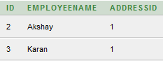

Note :- Here if we are not using mappedBy in address class then one more table [EMPLOYEEADDRESS_EMPLOYEE ] will be created
@OneToMany(cascade = CascadeType.ALL)
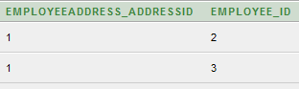

mappedBby :- If you use this then hibernate does not create another table for storing the mapping of two table. But if you are not using the mappedBy then hibernate will automatically create another table which will contain the information of both table key its a kind of mapping which provide bidirectional mapping.

Many to Many mapping :-
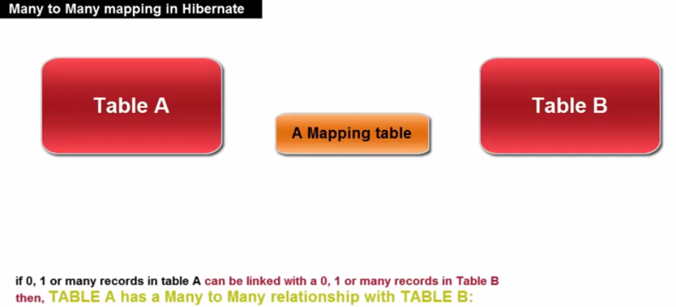

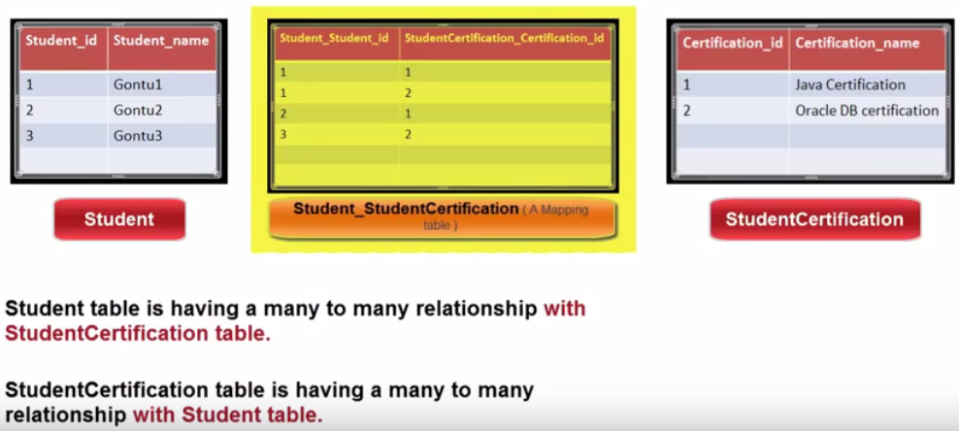
Example :-

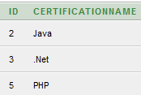
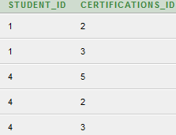

Certification STUDENT_DETAIL_CERTIFICATION STUDENT_DETAIL

Sample XML mapping of data :-

<?xml version="1.0" encoding="utf-8"?>

<!DOCTYPE hibernate-mapping PUBLIC
"-//Hibernate/Hibernate Mapping DTD//EN"
"http://www.hibernate.org/dtd/hibernate-mapping-3.0.dtd">

<hibernate-mapping>
<class name="Employee" table="EMPLOYEE">
<meta attribute="class-description">
This class contains the employee detail.
</meta>
<id name="id" type="int" column="id">
<generator class="native"/>
</id>
<property name="firstName" column="first_name" type="string"/>
<property name="lastName" column="last_name" type="string"/>
<property name="salary" column="salary" type="int"/>
</class>
</hibernate-mapping>

HQL Query in Hibernate :-

It is just like Sql queries for DB operations
Like:-
public class MainClass
{
public static void main(String args[])
{
SessionFactory sessionFactory = new Configuration().configure().buildSessionFactory();

Session session = sessionFactory.openSession();

session.beginTransaction();

String userId = “5”;
Query query = session.createQuery(“from UserDetails where UserId = ?”);
query.setInteger(0,Integer.parseInt(userId));
List<UserDetails> users = (List<UserDetails>)query.list();
session.getTransaction().commit();
session.close();
}
}

Named Query :-

It is used for managing the queries used in a particular place. So its easy to manage and consolidate the query. If the query change in future then we need to change it on a single place instead to everywhere where it is used.

Like:-
@Entity
@NamedQuery(name=”userDetailById”, query=”from UserDetails where userId= ?”)
public class UserDetail
{
- – – – - - - - -
- – - --- ----
}

public class MainClass
{
public static void main(String args[])
{
SessionFactory sessionFactory = new Configuration().configure().buildSessionFactory();

Session session = sessionFactory.openSession();

session.beginTransaction();

String userId = “5”;
Query query = session.getNamedQuery(“userDetailById”);
query.setInteger(0,Integer.parseInt(userId));
List<UserDetails> users = (List<UserDetails>)query.list();
session.getTransaction().commit();
session.close();
}
}

Criteria for where Clause in Hibernate :-
https://docs.jboss.org/hibernate/orm/3.3/reference/en/html/querycriteria.html

