Car Booking System

Source : https://www.youtube.com/watch?v=QjC0Oa3sc34&feature=youtu.be

Cheatsheet :
- every 3 sec location update
- Google S2 (square) Grid vs Uber H3 (Hexagon) Grid
- Driver, Rider, Notification, LocationSevice, DemandService, SupplyService

1. Requirements and Goals of the System

#
Let’s start with building a simpler version of Uber.
There are two types of users in our system:
  - Drivers
  - Customers.

- Drivers need to regularly notify the service about their current location and their availability to pick passengers.
- Passengers get to see all the nearby available drivers.
- Customer can request a ride; nearby drivers are notified that a customer is ready to be picked up.
- Once a driver and a customer accept a ride, they can constantly see each other’s current location until the trip finishes.
- Upon reaching the destination, the driver marks the journey complete to become available for the next ride.

API Design :

1. Rider to System

- registerUser
- updateUser
- updateLocation(currentLocation)
- searchCabs(currLocation, destination, carType)
- bookRide(userId, location, carType)
- cancelRide(userId)

2.Driver to System

- registerDriver
- updateDriver
- updateLocation(currentLocation)
- acceptRide(userId)
- cancelRide(userId)
- rejectRide(userId)
- completeRide(userId)

3. System to Rider
- showCabs(Map<CarType, Price> carWithPrice)
- bookingAccepted(DriverDetails, CarDetails)
- retryAgainNotification() // In case no case available, then Please retry after sometime
- rideCancelled()

4. System to Driver
- rideRequest(userId, location)
- rideCancelledNotification

Calculation of Data Storage Capacity :

As we are not saving any data for a booking like tracking of the ride But still we need to save few data to generate the invoice So we will save the tracking map image and rider and driver details

Considering we are in a large system where we have got per day booking = 10 Million
and for each booking we are saving data = 2 MB (Image of tracking Map + Car details + Driver details)

So for a day it will be = 2MB * 10 Millions = 20, 000, 000 MB ~= 20,000 GB ~= 20 TB

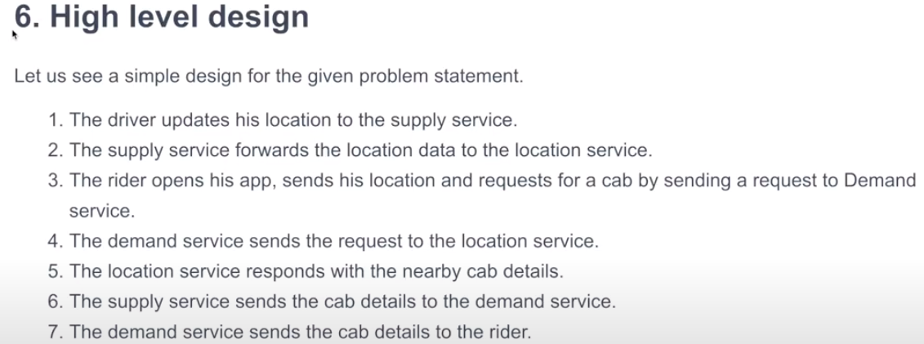
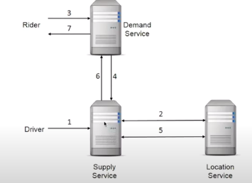
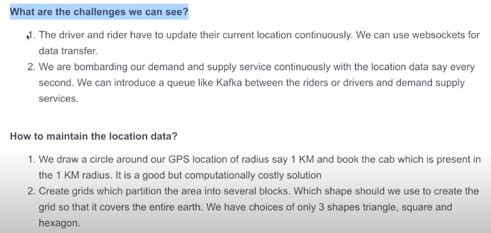

How Location Works :
We break the earth into multiple grids and Place the driver or rider into the Grid to check its near by drivers or riders

Note: There are few Important things :
1. Location needs to be updated in every 3 sec (Rider and driver both)
2. Google uses S2 library and it uses Square shape to break the map or location into pieces But UBER introduced new library (H3 library) which will break the map in Hexagon.

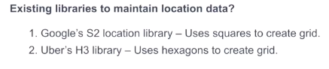

(Google S2 Library )Square : In this shape if we see the dashed distance vs line distance It clearly shows dashed are far although all are present at the same distance
Uber H3 Library (Hexagon Shape) : We can see all the nodes are at the same position
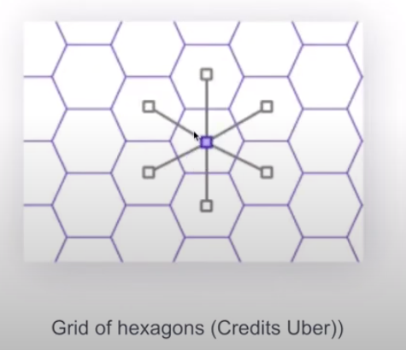
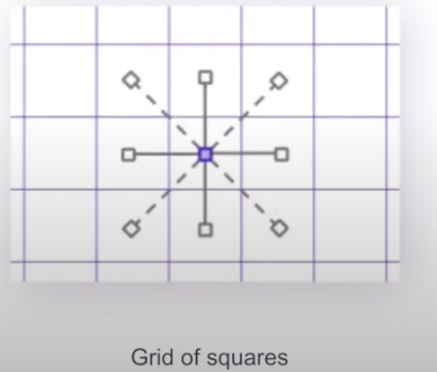

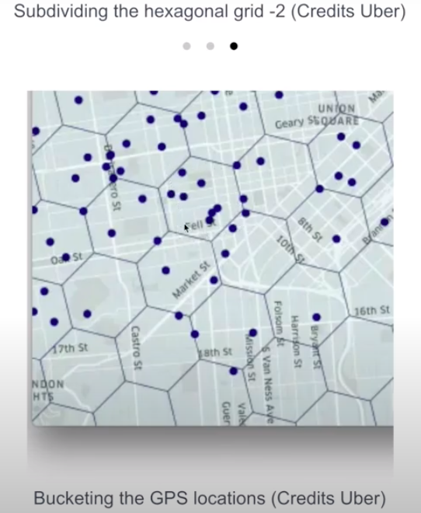
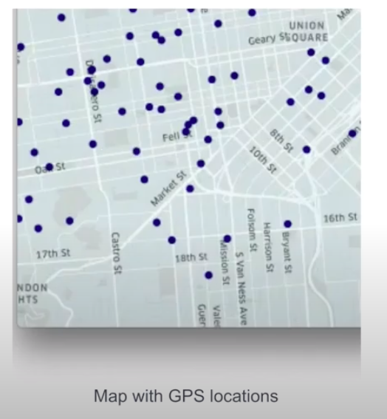

Uber System Design :
