Hibernate :-

Cache Machanism in Hibernate

Caching is facility provided by ORM frameworks which help users to get fast running web application, while help framework itself to reduce number of queries made to database in a single transaction. Hibernate also provide this caching functionality, in two layers.
- Fist level cache: This is enabled by default and works in session scope.
- Second level cache: This is apart from first level cache which is available to be used globally in session factory scope.

First Level Cache
- First-level cache always Associates with the Session object.
- Hibernate uses this cache by default. Here, it processes one transaction after another one, means wont process one transaction many times.
- Mainly it reduces the number of SQL queries it needs to generate within a given transaction. That is instead of updating after every modification done in the transaction, it updates the transaction only at the end of the transaction.
- First level cache is associated with “session” object and other session objects in application can not see it.
- The scope of cache objects is of session. Once session is closed, cached objects are gone forever.
- First level cache is enabled by default and you can not disable it.
- When we query an entity first time, it is retrieved from database and stored in first level cache associated with hibernate session.
- If we query same object again with same session object, it will be loaded from cache and no sql query will be executed.
- The loaded entity can be removed from session using evict() method. The next loading of this entity will again make a database call if it has been removed using evict() method.
- The whole session cache can be removed using clear() method. It will remove all the entities stored in cache.

Second level cache works
Second-level cache always associates with the Session Factory object.
While running the transactions, in between it loads the objects at the Session Factory level, so that those objects will be available to the entire application, not bound to single user. Since the objects are already loaded in the cache, whenever an object is returned by the query, at that time no need to go for a database transaction. In this way the second level cache works. Here we can use query level cache also. Later we will discuss about it.

- Whenever hibernate session try to load an entity, the very first place it look for cached copy of entity in first level cache (associated with particular hibernate session).
- If cached copy of entity is present in first level cache, it is returned as result of load method.
- If there is no cached entity in first level cache, then second level cache is looked up for cached entity.
- If second level cache has cached entity, it is returned as result of load method. But, before returning the entity, it is stored in first level cache also so that next invocation to load method for entity will return the entity from first level cache itself, and there will not be need to go to second level cache again.
- If entity is not found in first level cache and second level cache also, then database query is executed and entity is stored in both cache levels, before returning as response of load() method.
- Second level cache validate itself for modified entities, if modification has been done through hibernate session APIs.
- If some user or process make changes directly in database, the there is no way that second level cache update itself until “timeToLiveSeconds” duration has passed for that cache region. In this case, it is good idea to invalidate whole cache and let hibernate build its cache once again. You can use below code snippet to invalidate whole hibernate second level cache.

How to enable second level cache ?
<property key="hibernate.cache.use_second_level_cache">true</property>
<property name="hibernate.cache.region.factory_class">org.hibernate.cache.ehcache.EhCacheRegionFactory</property>

Also if you want to cache the entry then you should use @Cache annotation.
@Entity
@Cache(usage=CacheConcurrencyStrategy.READ_ONLY,
region="department")
public class DepartmentEntity implements Serializable
{
//code
}

When your session will expire ?
<cache
name="com.somecompany.someproject.domain.Country"
maxElementsInMemory="10000"
eternal="false"
timeToIdleSeconds="300"
timeToLiveSeconds="600"
overflowToDisk="true"
/>

TimeToIdealSeconds :->
timeToIdealSeconds=”seconds” means, if the object in the global cache is ideal, means not using by any other class or object then it will be waited for some time we specified and deleted from the global cache if time is exceeds more than timeToIdealSeconds value.
TimeToLiveSeconds :->
timeToLiveSeconds=”seconds” means, the other Session or class using this object or not, i mean may be it is using by other sessions or may not, what ever the situation might be, once it competed the time specified timeToLiveSeconds, then it will be removed from the global cache by hibernate.
eternal :->
if eternal=”true” then we should not write timeToIdealSeconds, timeToLiveSeconds, hibernate will take care about those values
So if you want to give values manually better use eternal=”false” always, so that we can assign values into timeToIdealSeconds, timeToLiveSeconds manually.

hbm2ddl.auto :-

a):- Create :- It recreate the data structure and data. i.e. It drop the table and then recreate the table again.

b):- Update :- It update the table schema and data. It does not delete previous created data. Sometimes behavior is bearded.

c):-create-drop :- It behave same as create if you are not explicitly close the sessionFactory object [sessionFactory.close()]. But if you close sessionFactory object explicitly then it will drop all the created schema. [Table deletion]

d):- validate :- It basically validate the table schema and compare the table schema with the schema created from annotation [or XML configuration] and
i):- if it find there is no difference In schema then it validate successfully and execute the query and
ii):- if it find there are some difference Then It will through some exception.

Some Annotation :-

Note :- By default Hibernate create Nullable column except the primary one.

@Id:- This is used for defining the primary keys

@Entity :- This is used to defined that these are the entity needs to be created in the table.

@Table :- Specify the mapping between database table and the entity class. It uses the table name attribute.

@Colomn :- It is used to specify the coloumn mapping with the attribute of class.

Nullable :- it is used to mark that this field can have null values

@Transiant :- If u want that this particular colomn would not be created while created the database table or while performing any insert update operation. Hibernate will colpletely Ignore that column.

@GeneratedValue :- It is used to generate the value automatically. If you are not declare any attribute for Generated then it will take “AUTO” as default.
@Generated value can be :- AUTO, SEQUENCE, IDENTITY, TABLE

@Version

@OrderBy

@Lob

Basic Operation in Hibernate :-
1):- save :--> session.save(employee1);

2):- get--> Here id is 1. If we provide id which is not exist then it will gives you null.
Employee emp = (Employee)session.get(Employee.class, 1);
System.out.println("Name :- " + emp.getEmployeeName());
3):- load :-

3):- update :-
Employee emp = (Employee)session.get(Employee.class, 1);
emp.setEmployeeName("Akshay gupta");
session.update(emp);

4):- delete
Employee emp1 = (Employee)session.get(Employee.class, 2);
session.delete(emp1);

Hibernate Session save
As the method name suggests, hibernate save() can be used to save entity to database. We can invoke this method outside a transaction, that’s why I don’t like this method to save data. If we use this without transaction and we have cascading between entities, then only the primary entity gets saved unless we flush the session.

Hibernate Persist
Hibernate persist is similar to save (with transaction) and it adds the entity object to the persistent context, so any further changes are tracked. If the object properties are changed before the transaction is committed or session is flushed, it will also be saved into database.
Second difference is that we can use persist() method only within the boundary of a transaction, so it’s safe and takes care of any cascaded objects.

Difference between Save and Persist() in Hibernate
Save()
- It return Serializable identifier of the object after saving.
- Saves the value to DB immediately and keeps track of the entity until the end of the session(I have tried to change the entity values outside of the transaction, it does not show any effect when session commits)
- Does not save the changes to the db outside of the transaction.
- Assigns the generated id to the entity you are persisting
- Session.save() for a detached object will create a new row in the table.
Like :- Serlizable_Object save();

Persist
Like :- void persist();
- Does not returns generated Id after saving. Its void return type.
- Saves the value to DB immediately and keeps track of the entity until the end of the session.(I have tried to change the entity values outside of the transaction, it does not show any effect when session commits)
- Does not save the changes to the db outside of the transaction.
- Assigns the generated id to the entity you are persisting
- session.persist() for a detached object will throw PersistentObjectException as it is not allowed.

Difference between load and get :-
1):-get always hit the database for returning real object.
Load not hit the database and it return the proxy or fake object
2):- Load will throw an exception if no object is available for the Id but get will return null if no object present in the database for that Id.

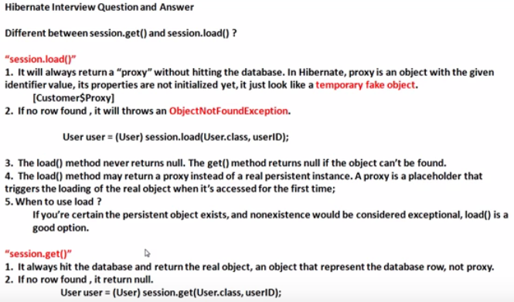

Hibernate Object (Transient, Persistent and Detached States)

package com.akshay.BasicOperation;
import org.hibernate.Session;
import org.hibernate.SessionFactory;
import org.hibernate.Transaction;
import org.hibernate.cfg.Configuration;

public class Main
{
public static void main(String args[])
{

//Start of Transient State
Employee employee = new Employee();
employee.setEmployeeName("Karan");

SessionFactory sessionFactory = new Configuration().configure().buildSessionFactory();
Session session = sessionFactory.openSession();
Transaction tran = session.beginTransaction();

employee.setEmployeeName("Name before change ");
//End of Transient state . Here Transient state is end Because employee is now going to attached with database after session.save(employee)
//Before session.save object is in Transient state after that it will move into Persistent State and automatically sync with database
session.save(employee);
//Start of Persistent State
employee.setEmployeeName("Name after change ");
tran.commit();
//End of Persistent State
session.close();
// Start of Detached State. After session is closed it will going into Detached state
employee.setEmployeeName("Name after close session");
//session.delete(employee); then it will be going into transient state.
// End of Detached state
}
}

Query Fire in the program :-

Hibernate: insert into Employee_Information (employeeName, id) values (?, ?)
Hibernate: update Employee_Information set employeeName=? where id=?

Output table :-
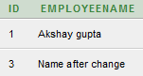

1) Transient :-
- Transient objects do not have association with the databases and session objects.
- They are simple objects and not persisted to the database.
- Once the last reference is lost, that means the object itself is lost. And of course, garbage collected.
- The commits and rollbacks will have no effects on these objects.
- They can become into persistent objects through the save method calls of Session object.
Note in Short :-
Object is in transient state before in connect with the session. When object in this state then object having no connectivity with database. When it connect with the session it will going into persistent state.
Special Case :- but if the object is deleted in persistent state then it will going into Transient State because it have no connectivity with database.

2) Persistent :-
When the object is connect with session then it comes in persistent state.
If any modification in performed with that object then it will automatically synced with the databse. I.e update query automatically fired without using “update” function.

3) Detached :-
- The detached object have corresponding entries in the database.
- These are persistent and not connected to the Session object.
- These objects have the synchronized data with the database when the session was closed. Since then, the change may be done in the database which makes this object stale.
- The detached object can be reattached after certain time to another object in order to become persistent again.
Note :- In short After closing the session object goes into detached state. But before closeing the connection if was synced with database i.e. it was in persitent state. In this state object is no more connected to the database. And if we make any change in the object it will not impact into database.

Q):- Can we reattached detached object or we can convert detached object into persistent state
Ans:- Yes we can convert detached object into persistent object. By open a new session and attached this object with that session.
So what is the need :-
Suppose After the session closed if we have some change in our object or in detached object, and want to sync these change with database. Then we made these type of changes

package com.akshay.BasicOperation;

import org.hibernate.Session;
import org.hibernate.SessionFactory;
import org.hibernate.Transaction;
import org.hibernate.cfg.Configuration;

public class Main
{
public static void main(String args[])
{
SessionFactory sessionFactory = new Configuration().configure().buildSessionFactory();
Session session = sessionFactory.openSession();
Transaction tran = session.beginTransaction();

//Start of persistent state
Employee emp = (Employee)session.get(Employee.class, 1);
System.out.println(emp.getEmployeeName());

emp.setEmployeeName("Akshay After Change in Persistent State");
//No need to write update statement because emp is in persistent state. Update Query will be fired

tran.commit();
//End of persistent State
session.close();

//Start of Detached State
emp.setEmployeeName("Akshay after close session");

//We are going to reattached the detached object or we are converting the detached object (emp) into persistent state
Session session1 = sessionFactory.openSession();
Transaction tran1 = session1.beginTransaction();
//Here the Detached object “emp” converted into persistent object
session1.update(emp);

emp.setEmployeeName("Akshay after close session but again create new session"); //update query will be fire
tran1.commit();
//End of persistent State
session1.close();
sessionFactory.close();

}
}

Hibernate: select employee0_.id as id1_1_0_, employee0_.employeeName as employee2_1_0_ from Employee_Information employee0_ where employee0_.id=?
Hibernate: update Employee_Information set employeeName=? where id=?
Hibernate: update Employee_Information set employeeName=? where id=?

java - What is lazy loading in Hibernate? - Stack Overflow

Lazy fetching decides whether to load child objects while loading the Parent Object. You need to do this setting respective hibernate mapping file of the parent class. Lazy = true (means not to load child) By default the lazy loading of the child objects is true

Hibernate Cascade, Hibernate Cascade Types, Cascade Attribute

Cascade Attribute In Hibernate. Example: if we apply insert(or update or delete) operation on parent class object, then child class objects will also be stored into the database

One to One mapping :-
It shows if the tables having only one records for same Id in tables then it shows as One to One mapping
Ex :- Student → StudentId, StudentName
StudentDetails → StudentId, StudentMobileNumber
In Student Table StudentId is primary key and in StudentDetails table StudentId is foreign key.
Here one to one mapping shows StudentDetails table having entry only and only if Student have the entry for that Id.

For this we Use @JOIN and @Cascade and other attribute

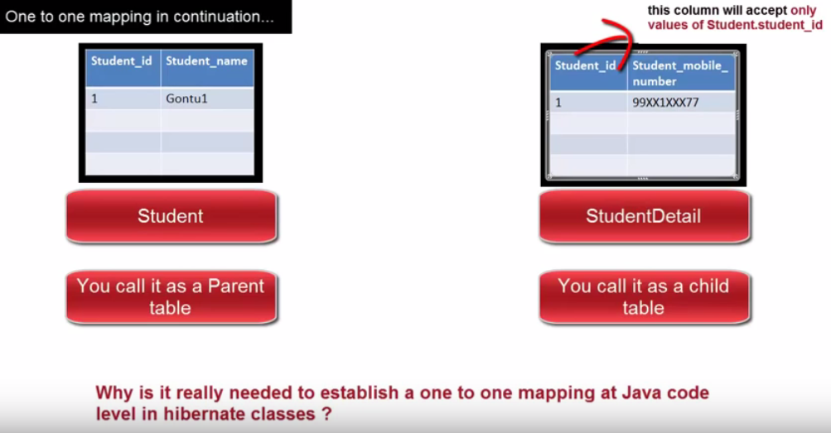

Note:-
Here in java code it seem like we are saving only the studentDetails data. But internally hibernate First Save parent table (Student) table data after that I will going to save its child Table (studentDetails) data and whatever Id is generated from Student Table it will use Id in StudentDetails table. So no need to bother about inserting the data in both table.

Two type of one to one mapping :-
1):- Unidirectional :-
ex :- When you save child object parent object automatically created.
2):- Bi-Directional :- When you save parent object and then child object automatically created.

For 1 to 1 Mapping :- code will be look like this :-

a) :- hibernate.cfg.xml
<?xml version="1.0" encoding="UTF-8"?>
<!DOCTYPE hibernate-configuration SYSTEM
"http://www.hibernate.org/dtd/hibernate-configuration-3.0.dtd">
<hibernate-configuration>
<session-factory>

<!-- Database Connection Information -->
<property name="connection.driver_class">oracle.jdbc.driver.OracleDriver</property>
<property name="connection.url">jdbc:oracle:thin:@localhost:1521:XE</property>
<property name="connection.username">system</property>
<property name="connection.password">oracle</property>

<!-- Echo all executed SQL to stdout -->
<property name="show_sql">true</property>

<!-- SQL dialect -->
<property name="dialect">org.hibernate.dialect.OracleDialect</property>

<!-- Disable the second-level cache. -->
<property name="cache.provider_class">org.hibernate.cache.NoCacheProvider</property>

<property name="connection.pool_size">1</property>

<!-- Drop and re-create the database schema on startup -->
<property name="hbm2ddl.auto">create</property>

<!-- For every entity you need to make entry here-->
<mapping class="com.akshay.hibernate.Student"/>
<mapping class="com.akshay.hibernate.StudentDetail"/>

</session-factory>
</hibernate-configuration>

2):- Main Class:-
package com.akshay.hibernate;

import java.util.Date;

import org.hibernate.Session;
import org.hibernate.SessionFactory;
import org.hibernate.Transaction;
import org.hibernate.cfg.Configuration;

public class Main {

public static void main(String[] args)
{
Student student = new Student();
student.setStudentName("Akshay2");

Student student1 = new Student();
student1.setStudentName("Akshay3");

StudentDetail studentDetail = new StudentDetail();
studentDetail.setStudentMobile("123456");
studentDetail.setDob(new Date());

studentDetail.setStudent(student);

StudentDetail studentDetail1 = new StudentDetail();
studentDetail1.setStudentMobile("22323");
studentDetail1.setDob(new Date());
studentDetail1.setStudent(student1);

SessionFactory sessionFactory = new Configuration().configure().buildSessionFactory();
Session session = sessionFactory.openSession();
Transaction tran = session.beginTransaction();

session.save(studentDetail);
session.save(studentDetail1);

tran.commit();
session.close();
sessionFactory.close();
}

}

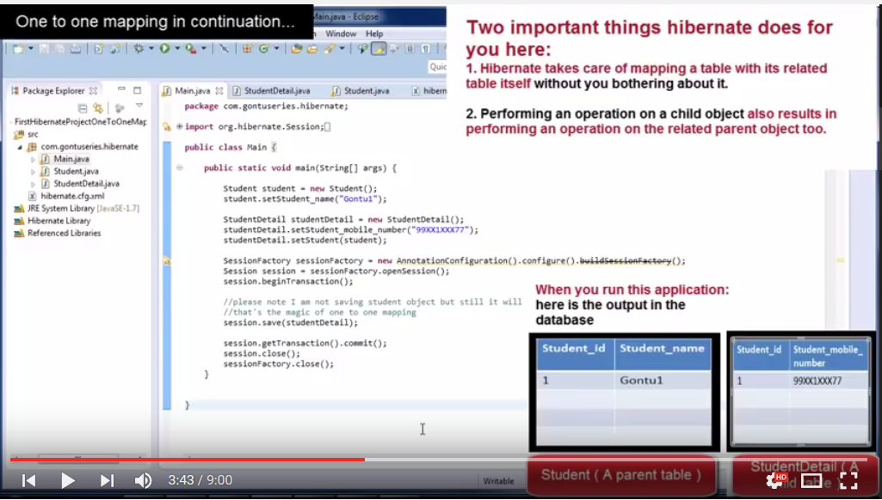
3):- StudentDetails.java
package com.akshay.hibernate;

import java.util.Date;

import javax.persistence.CascadeType;
import javax.persistence.Entity;
import javax.persistence.GeneratedValue;
import javax.persistence.Id;
import javax.persistence.JoinColumn;
import javax.persistence.OneToOne;
import javax.persistence.Temporal;
import javax.persistence.TemporalType;

import org.hibernate.annotations.Cascade;
import org.hibernate.annotations.GenericGenerator;
import org.hibernate.annotations.Parameter;

@Entity
public class StudentDetail {

@Id @GeneratedValue(generator="newGenerator")
@GenericGenerator(name="newGenerator" , strategy="foreign", parameters={@Parameter(value="student", name="property")}) // this line of code will stop for Hibernate to create diff. Id. By using this Hibernate create the same Id which is created for Student table
private int studentId;

private String studentMobile;

@Temporal(TemporalType.TIMESTAMP)
private Date dob;

public Date getDob() {
return dob;
}

public void setDob(Date dob) {
this.dob = dob;
}

@OneToOne(cascade = CascadeType.ALL) //If you want to perform all the operation into related table done automatically then we use ALL.
@JoinColumn(name="studentId") //It is the studentId of Student Class. Here we declare it as a Foreign key for StudentDetails class
private Student student;

public Student getstudent() {
return student;
}

public void setStudent(Student student) {
this.student = student;
}

public int getStudentId() {
return studentId;
}

public void setStudentId(int studentId) {
this.studentId = studentId;
}

public String getstudentMobile() {
return studentMobile;
}

public void setStudentMobile(String studentMobile) {
this.studentMobile = studentMobile;
}
}

4):- Student.java

package com.akshay.hibernate;

import javax.persistence.Column;
import javax.persistence.Entity;
import javax.persistence.GeneratedValue;
import javax.persistence.Id;
import javax.persistence.Table;
import javax.persistence.Transient;

@Entity
@Table(name="Student")
public class Student
{
@Id @GeneratedValue
private int studentId;

//@Transient
@Column(name="StudentName")
private String studentName;

//This line of code added for Bi-directional
@OneToOne(cascade = CascadeType.ALL)
@JoinColumn(name="studentId")
private StudentDetail studentDetail;

public StudentDetail getStudentDetail() {
return studentDetail;
}

public void setStudentDetail(StudentDetail studentDetail) {
this.studentDetail = studentDetail;
}

public int getStudentId() {
return studentId;
}

public void setStudentId(int studentId) {
this.studentId = studentId;
}

public String getStudentName() {
return studentName;
}

public void setStudentName(String studentName) {
this.studentName = studentName;
}
}

Student Table
StudentDetail Table


Many to One mapping :-
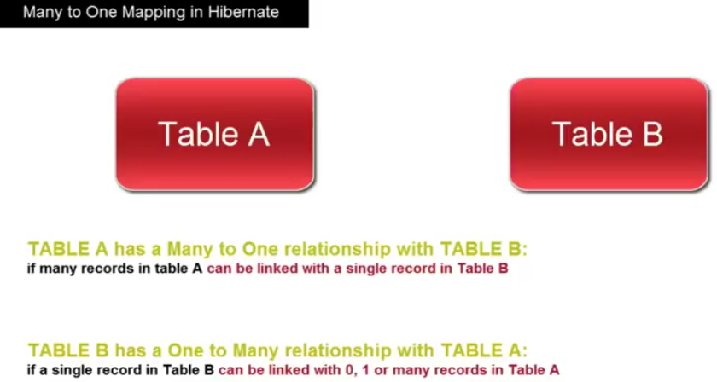
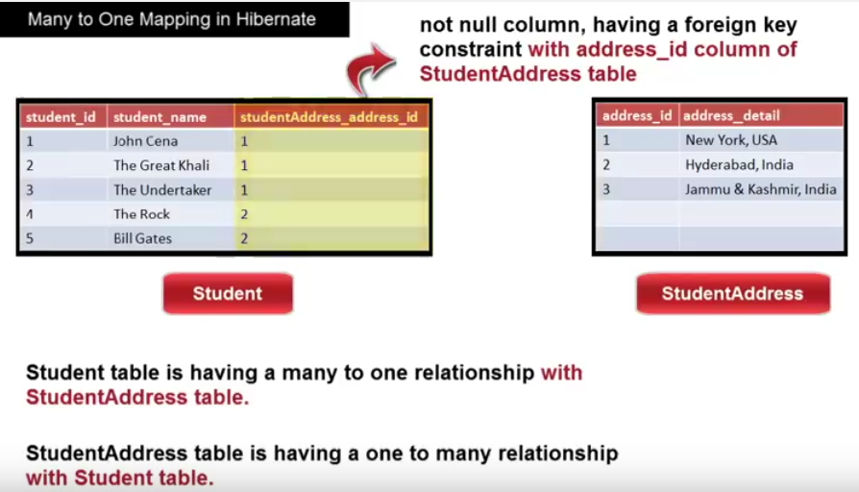
Ex :-

package com.akshay.MantToOneRelationShip;

import java.util.HashSet;
@Entity
public class EmployeeAddress
{
@Id @GeneratedValue
private int addressId;

private String addressName;

//@OneToMany(cascade = CascadeType.ALL) //If you are not using the mappedBy then Hibernate will create a new Table which contain mapping of EmployeeId and AddressId
@OneToMany(cascade = CascadeType.ALL, mappedBy="employeeAddress")//If you are using mappedBy then Hibernate will understand then which coloumn is used for mapping purpose and does not create any other table
private Set<Employee> employee = new HashSet<Employee>();

public Set<Employee> getEmployee() {
return employee;
}

public void setEmployee(Set<Employee> employee) {
this.employee = employee;
}

public int getAddressId() {
return addressId;
}

public void setAddressId(int addressId) {
this.addressId = addressId;
}

public String getAddressName() {
return addressName;
}

public void setAddressName(String addressName) {
this.addressName = addressName;
}
}

package com.akshay.MantToOneRelationShip;

import javax.persistence.CascadeType;
import javax.persistence.Entity;
import javax.persistence.GeneratedValue;
import javax.persistence.Id;
import javax.persistence.JoinColumn;
import javax.persistence.ManyToOne;
import javax.persistence.Transient;

@Entity
public class Employee
{
@Id @GeneratedValue
private int id;

private String employeeName;

@ManyToOne(cascade = CascadeType.ALL)
@JoinColumn(name="addressId") //if Join is not used then Hibernate create a extra coloumn with TableName_coloumnName [EmployeeAddre_AddressId], if used then it will create adressId
private EmployeeAddress employeeAddress;

public int getId() {
return id;
}

public void setId(int id) {
this.id = id;
}

public String getEmployeeName() {
return employeeName;
}

public void setEmployeeName(String employeeName) {
this.employeeName = employeeName;
}

public EmployeeAddress getEmployeeAddress() {
return employeeAddress;
}

public void setEmployeeAddress(EmployeeAddress employeeAddress) {
this.employeeAddress = employeeAddress;
}

}

package com.akshay.MantToOneRelationShip;

import org.hibernate.Session;
import org.hibernate.SessionFactory;
import org.hibernate.Transaction;
import org.hibernate.cfg.Configuration;

public class Main
{
public static void main(String args[])
{
EmployeeAddress address = new EmployeeAddress();
address.setAddressName("Hyderabad");

Employee employee = new Employee();
employee.setEmployeeName("Akshay");
employee.setEmployeeAddress(address);

Employee employee1 = new Employee();
employee1.setEmployeeName("Karan");
employee1.setEmployeeAddress(address);

SessionFactory sessionFactory = new Configuration().configure().buildSessionFactory();
Session session = sessionFactory.openSession();
Transaction tran = session.beginTransaction();

// session.save(employee);
// session.save(employee1);
// OR down line code

address.getEmployee().add(employee);
address.getEmployee().add(employee1);
// Here if you save address then its corresponding employee automatically created. It is bidirectional mapping

session.save(address);

tran.commit();
session.close();
sessionFactory.close();
}
}

Outputs:- Employee Table Address Table

Note :- Here if we are using the mappedBy in address class the two table will be created

@OneToMany(cascade = CascadeType.ALL, mappedBy="employeeAddress")
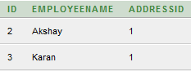

Note :- Here if we are not using mappedBy in address class then one more table [EMPLOYEEADDRESS_EMPLOYEE ] will be created
@OneToMany(cascade = CascadeType.ALL)
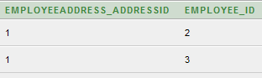

mappedBby :- If you use this then hibernate does not create another table for storing the mapping of two table. But if you are not using the mappedBy then hibernate will automatically create another table which will contain the information of both table key its a kind of mapping which provide bidirectional mapping.

Many to Many mapping :-
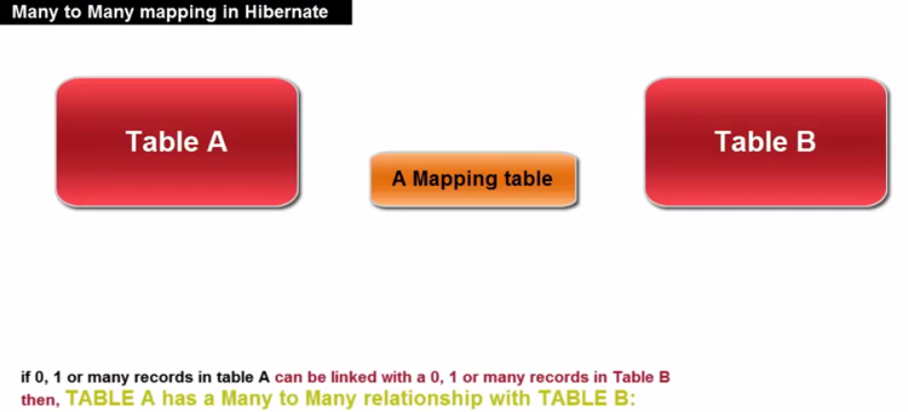

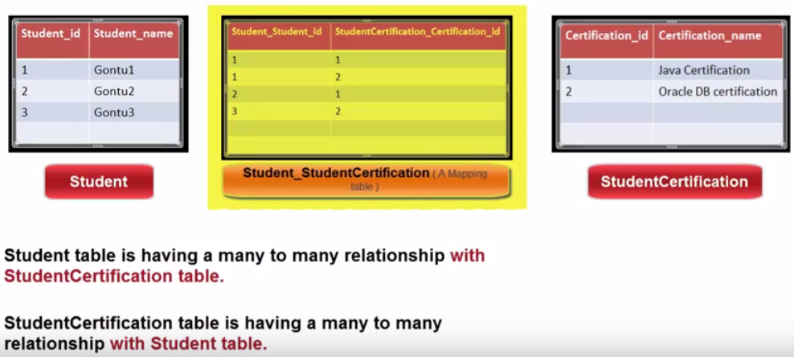
Example :-

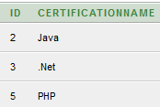
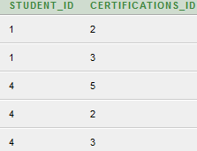

Certification STUDENT_DETAIL_CERTIFICATION STUDENT_DETAIL

Sample XML mapping of data :-

<?xml version="1.0" encoding="utf-8"?>

<!DOCTYPE hibernate-mapping PUBLIC
"-//Hibernate/Hibernate Mapping DTD//EN"
"http://www.hibernate.org/dtd/hibernate-mapping-3.0.dtd">

<hibernate-mapping>
<class name="Employee" table="EMPLOYEE">
<meta attribute="class-description">
This class contains the employee detail.
</meta>
<id name="id" type="int" column="id">
<generator class="native"/>
</id>
<property name="firstName" column="first_name" type="string"/>
<property name="lastName" column="last_name" type="string"/>
<property name="salary" column="salary" type="int"/>
</class>
</hibernate-mapping>

HQL Query in Hibernate :-

It is just like Sql queries for DB operations
Like:-
public class MainClass
{
public static void main(String args[])
{
SessionFactory sessionFactory = new Configuration().configure().buildSessionFactory();

Session session = sessionFactory.openSession();

session.beginTransaction();

String userId = “5”;
Query query = session.createQuery(“from UserDetails where UserId = ?”);
query.setInteger(0,Integer.parseInt(userId));
List<UserDetails> users = (List<UserDetails>)query.list();
session.getTransaction().commit();
session.close();
}
}

Named Query :-

It is used for managing the queries used in a particular place. So its easy to manage and consolidate the query. If the query change in future then we need to change it on a single place instead to everywhere where it is used.

Like:-
@Entity
@NamedQuery(name=”userDetailById”, query=”from UserDetails where userId= ?”)
public class UserDetail
{
- – – – - - - - -
- – - --- ----
}

public class MainClass
{
public static void main(String args[])
{
SessionFactory sessionFactory = new Configuration().configure().buildSessionFactory();

Session session = sessionFactory.openSession();

session.beginTransaction();

String userId = “5”;
Query query = session.getNamedQuery(“userDetailById”);
query.setInteger(0,Integer.parseInt(userId));
List<UserDetails> users = (List<UserDetails>)query.list();
session.getTransaction().commit();
session.close();
}
}

Criteria for where Clause in Hibernate :-
https://docs.jboss.org/hibernate/orm/3.3/reference/en/html/querycriteria.html

Hibernate - Criteria Queries
The Hibernate Session interface provides createCriteria() method, which can be used to create a Criteria object that returns instances of the persistence object's class when your application executes a criteria query.
Restrictions with Criteria :->
You can use add() method available for Criteria object to add restriction for a criteria query.
Following is the example to add a restriction to return the records with salary is equal to 2000 −

Criteria cr = session.createCriteria(Employee.class);
cr.add(Restrictions.eq("salary", 2000));

// To get records having salary more than 2000
cr.add(Restrictions.gt("salary", 2000));

// To get records having salary less than 2000
cr.add(Restrictions.lt("salary", 2000));

// To get records having fistName starting with zara
cr.add(Restrictions.like("firstName", "zara%"));

// Case sensitive form of the above restriction.
cr.add(Restrictions.ilike("firstName", "zara%"));

// To get records having salary in between 1000 and 2000
cr.add(Restrictions.between("salary", 1000, 2000));

// To check if the given property is null
cr.add(Restrictions.isNull("salary"));

// To check if the given property is not null
cr.add(Restrictions.isNotNull("salary"));

// To check if the given property is empty
cr.add(Restrictions.isEmpty("salary"));

// To check if the given property is not empty
cr.add(Restrictions.isNotEmpty("salary"));
List results = cr.list();
Projections & Aggregations
The Criteria API provides the org.hibernate.criterion.Projections class, which can be used to get average, maximum, or minimum of the property values. The Projections class is similar to the Restrictions class, in that it provides several static factory methods for obtaining Projection instances.
Criteria cr = session.createCriteria(Employee.class);

// To get total row count.
cr.setProjection(Projections.rowCount());

// To get average of a property.
cr.setProjection(Projections.avg("salary"));

// To get distinct count of a property.
cr.setProjection(Projections.countDistinct("firstName"));

// To get maximum of a property.
cr.setProjection(Projections.max("salary"));

// To get minimum of a property.
cr.setProjection(Projections.min("salary"));

// To get sum of a property.
cr.setProjection(Projections.sum("salary"));
// To get total salary
cr.setProjection(Projections.sum("salary"));

Transaction propagation
In Spring-managed transactions, be aware of the difference between physical and logical transactions, and how the propagation setting applies to this difference.
Main 3 propagation are as follow:
- Required
- Required_New
- Nested
- Never
- Not_Supported
- Supported
- Mandatory
@Transactional(propagation=Propagation.REQUIRED)

1) Required

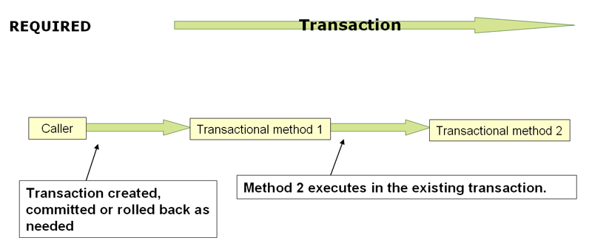

- If we print transaction for method 1 and 2 we will get same transaction
- When the propagation setting is PROPAGATION_REQUIRED, a logical transaction scope is created for each method upon which the setting is applied.
- Each such logical transaction scope can determine rollback-only status individually, with an outer transaction scope being logically independent from the inner transaction scope. Of course,
- in case of standard PROPAGATION_REQUIRED behavior, all these scopes will be mapped to the same physical transaction. So a rollback-only marker set in the inner transaction scope does affect the outer transaction's chance to actually commit (as you would expect it to).
However, in the case where an inner transaction scope sets the rollback-only marker, the outer transaction has not decided on the rollback itself, and so the rollback (silently triggered by the inner transaction scope) is unexpected. A corresponding UnexpectedRollbackException is thrown at that point. This is expected behavior so that the caller of a transaction can never be misled to assume that a commit was performed when it really was not. So if an inner transaction (of which the outer caller is not aware) silently marks a transaction as rollback-only, the outer caller still calls commit. The outer caller needs to receive an UnexpectedRollbackException to indicate clearly that a rollback was performed instead.

2) RequiresNew
Indicates that a new tx has to start every time the target method is called. If already a tx is going on, it will be suspended before starting a new one.

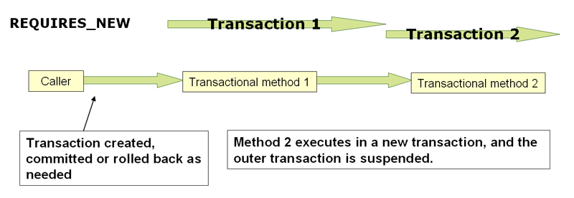
PROPAGATION_REQUIRES_NEW
PROPAGATION_REQUIRES_NEW, in contrast to PROPAGATION_REQUIRED, uses a completely independent transaction for each affected transaction scope. In that case, the underlying physical transactions are different and hence can commit or roll back independently, with an outer transaction not affected by an inner transaction's rollback status.

3) Nested :->
  - PROPAGATION_NESTED uses a single physical transaction with multiple savepoints that it can roll back to.
  - Such partial rollbacks allow an inner transaction scope to trigger a rollback for its scope, with the outer transaction being able to continue the physical transaction despite some operations having been rolled back.
  - This setting is typically mapped onto JDBC savepoints, so will only work with JDBC resource transactions.
4) MANDATORY
- The MANDATORY behavior states that an existing opened transaction must already exist. If not an exception will be thrown by the container.
org.springframework.transaction.IllegalTransactionStateException: No existing transaction found for transaction marked with propagation 'mandatory'
5) SUPPORTS
- Indicates that the target method can execute irrespective of a tx. If a tx is running, it will participate in the same tx. Else it will executed without a tx if no errors occur.
If exception occur it will rollback parent transaction as well if it occur.
6) NOT_SUPPORTED
- The NOT_SUPPORTED behavior will execute outside of the scope of any transaction.
- So it the exception occur it will not rollback any changes
7) NEVER
- The NEVER behavior states that an existing opened transaction must not already exist. If a transaction exists an exception will be thrown by the container.
org.springframework.transaction.IllegalTransactionStateException: Existing transaction found for transaction marked with propagation 'never'

Concurrency strategies

BEFORE USING THE CONCURRENCY STRATEGIES FIRST WE NEED TO ENABLE SECOND LEVEL CACHE.

- A concurrency strategy is a mediator which responsible for storing items of data in the cache and retrieving them from the cache.
- If you are going to enable a second-level cache, you will have to decide, for each persistent class and collection, which cache concurrency strategy to use.
- Read-only :
In read only strategy the entity is not allowed to be update because its cache marks it as immutable.

- Read-Write :
READ_WRITE CacheConcurrencyStartegy is an asynchronous write-through caching mechanism (since changes are being propagated only after the current database transaction is completed)
- Non strict-read-write :
NONSTRICT_READ_WRITE is a read-through caching strategy and updates end-up invalidating cache entries
- Transnational :
    - TRANSACTIONAL CacheConcurrencyStartegy is synchronized with the current XA transaction.
    - The TRANSACTIONAL CacheConcurrencyStrategy employes a READ_COMMITTED transaction isolation, preventing dirty reads while still allowing the lost updates phenomena.
    - Adding optimistic locking can eliminate the lost update anomaly since the database transaction will rollback on version mismatches.

1) Read-Only :-
- In read only strategy the entity is not allowed to be update because its cache marks it as immutable.
- Only first time it will hit the query to DB to get its value after that all calls get it from cache only. (No DB Calls).
- When an entity is persisted only the database contains a copy of this entity.
- It you are trying to update the entity then it will throw this exception.

java.lang.UnsupportedOperationException: Can't write to a readonly object

How we use READ_ONLY:-
@Cache(usage=CacheConcurrencyStrategy.READ_ONLY)

Diff. Behaviour with Get/Update/Delete Operation with readonly:

Persisting entities : Possible

update entities : No possible

delete entities : Possible

@Entity
@Table(name = "CONCURRENCY_STRATEGY_Employee")
@Cache(usage=CacheConcurrencyStrategy.READ_ONLY) //this will not work if you are not enable secind level cache
public class CONCURRENCY_STRATEGY_Employee {

@Id
@GeneratedValue
@Column(name = "ID", nullable = false)
private int id;

@Column(name = "USERNAME", nullable = false)
private String username;

@Column(name = "NAME", nullable = false)
private String name;

public int getId() {
return id;
}

public void setId(int id) {
this.id = id;
}

public String getUsername() {
return username;
}

public void setUsername(String username) {
this.username = username;
}

public String getName() {
return name;
}

public void setName(String name) {
this.name = name;
}
}
package com.akshay.concurrencyStrategy;
import org.springframework.context.support.AbstractApplicationContext;
import org.springframework.context.support.ClassPathXmlApplicationContext;
public class ConcurrencyStrategyDemo {
static AbstractApplicationContext ctx = null;
static EmployeeService employeeService = null;

public static void setup() {
ctx = new ClassPathXmlApplicationContext("applicationContext_CONCURRENCY_STRATEGY.xml");
employeeService = (EmployeeService) ctx.getBean("employeeService");
}

/**
* INSERT : WE CAN INSERT NEW ENTRY
* UPDATE : WE CAN't ALLOW UPDATE [NOT ALLOWED]
* DELETE : WE CAN DELETE ENTRY
*******/
public static void concurency_READONLY() {
CONCURRENCY_STRATEGY_Employee employee = new CONCURRENCY_STRATEGY_Employee();
employee.setName("ConcurrencyStretegy_READONLY");
employee.setUsername("ConcurrencyStretegy_READONLY_USERNAME");
employeeService.saveUser(employee);
try {
CONCURRENCY_STRATEGY_Employee emp = employeeService.getUser(employee.getId()); //Query fired 1st time
CONCURRENCY_STRATEGY_Employee emp1 = employeeService.getUser(employee.getId()); //No query fire. Read from Cache
CONCURRENCY_STRATEGY_Employee emp2 = employeeService.getUser(employee.getId()); //No query fire. Read from Cache
emp.setName("UPDATE" + emp.getName());
employeeService.updateUser(emp); //Exception : we can’t update
System.out.println("UPDATE done");
} catch (Exception e) {
System.out.println(e);
}
}
public static void main(String[] args) {
setup();
concurency_READONLY();
}
}

Output:-
Hibernate: insert into CONCURRENCY_STRATEGY_Employee (NAME, USERNAME) values (?, ?)
insert done
UPDATE Start
Hibernate: select concurrenc0_.ID as ID1_0_0_, concurrenc0_.NAME as NAME2_0_0_, concurrenc0_.USERNAME as USERNAME3_0_0_ from CONCURRENCY_STRATEGY_Employee concurrenc0_ where concurrenc0_.ID=?
Hibernate: update CONCURRENCY_STRATEGY_Employee set NAME=?, USERNAME=? where ID=?
java.lang.UnsupportedOperationException: Can't write to a readonly object

Output explanation:
- Here we can see 1st time when we insert its successfully insert and
- when we get first time its successfully return.
- But when we again try to get it for 2nd and 3rd time it doesn’t hit database. It return from cache.
- And when we try to update the employee then its throw exception:
- java.lang.UnsupportedOperationException: Can't write to a readonly object

If we remove @Cache from class->
@Entity
@Table(name = "CONCURRENCY_STRATEGY_Employee")
public class CONCURRENCY_STRATEGY_Employee {

Then run same program then :
Hibernate: insert into CONCURRENCY_STRATEGY_Employee (NAME, USERNAME) values (?, ?)
Hibernate: select concurrenc0_.ID as ID1_0_0_, concurrenc0_.NAME as NAME2_0_0_, concurrenc0_.USERNAME as USERNAME3_0_0_ from CONCURRENCY_STRATEGY_Employee concurrenc0_ where concurrenc0_.ID=?
Hibernate: select concurrenc0_.ID as ID1_0_0_, concurrenc0_.NAME as NAME2_0_0_, concurrenc0_.USERNAME as USERNAME3_0_0_ from CONCURRENCY_STRATEGY_Employee concurrenc0_ where concurrenc0_.ID=?
Hibernate: select concurrenc0_.ID as ID1_0_0_, concurrenc0_.NAME as NAME2_0_0_, concurrenc0_.USERNAME as USERNAME3_0_0_ from CONCURRENCY_STRATEGY_Employee concurrenc0_ where concurrenc0_.ID=?
Hibernate: update CONCURRENCY_STRATEGY_Employee set NAME=?, USERNAME=? where ID=?
UPDATE done
Output Explanation:-

If we are not using @cache with entity then this entity will not cached. And every time it will hit database for get. Here we can see no exception while we are updating the entity because we removed @cache and we are not using any Concurrency Strategy.

2) Non Strict Read-Write:-

- NON Strict READ Write is good for read mostly data.
- When we perform update it will invalidate the cache instead of update the cache.
- So whenever we perform get operation after update, it will not get it from cache as cache was invalidated so get it from DB and save it into cache.
- The cache invalidation is not synchronized with the current database transaction. Even if the associated Cache region entry gets invalidated twice (before and after transaction completion), there’s still a tiny time window when the cache and the database might drift apart.

@Entity
@Table(name = "CONCURRENCY_STRATEGY_Employee")
@Cache(usage=CacheConcurrencyStrategy.NONSTRICT_READ_WRITE)
public class CONCURRENCY_STRATEGY_Employee {
Same program:
/**
* INSERT : WE CAN INSERT NEW ENTRY
* UPDATE : WE CAN UPDATE [CACHE ENTRIES ARE INVALIDATED INSTEAD OF UPDATE]
* DELETE : WE CAN DELETE ENTRY
*******/
// Please check CONCURRENCY_STRATEGY_Employee.java and Set @cache to
// NON_STRICT_READ_wRITE if its not set
public static void concurency_NON_STRICT_READ_WRITE() {
CONCURRENCY_STRATEGY_Employee employee = new CONCURRENCY_STRATEGY_Employee();
employee.setName("ConcurrencyStretegy_READONLY");
employee.setUsername("ConcurrencyStretegy_READONLY_USERNAME");

employeeService.saveUser(employee); //1st time insert [value are not present incache]

CONCURRENCY_STRATEGY_Employee emp = employeeService.getUser(employee.getId()); //Hit DB to get value and save it into cache
CONCURRENCY_STRATEGY_Employee emp1 = employeeService.getUser(employee.getId()); //No query will be fired as value present in cache

emp1.setName("UPDATE" + emp.getName());
employeeService.updateUser(emp1); //update query will be fired and mark cache to be invalidated

CONCURRENCY_STRATEGY_Employee emp2 = employeeService.getUser(emp.getId()); //as cache was invalidated because of update query So it will hit the database and save it into cache
CONCURRENCY_STRATEGY_Employee emp3 = employeeService.getUser(emp.getId()); //No query will be fired as value present in cache
CONCURRENCY_STRATEGY_Employee emp4 = employeeService.getUser(emp.getId()); //No query will be fired as value present in cache
}
CONSOLE LOG:-
Hibernate: insert into CONCURRENCY_STRATEGY_Employee (NAME, USERNAME) values (?, ?)
Hibernate: select concurrenc0_.ID as ID1_0_0_, concurrenc0_.NAME as NAME2_0_0_, concurrenc0_.USERNAME as USERNAME3_0_0_ from CONCURRENCY_STRATEGY_Employee concurrenc0_ where concurrenc0_.ID=?
Hibernate: update CONCURRENCY_STRATEGY_Employee set NAME=?, USERNAME=? where ID=?
Hibernate: select concurrenc0_.ID as ID1_0_0_, concurrenc0_.NAME as NAME2_0_0_, concurrenc0_.USERNAME as USERNAME3_0_0_ from CONCURRENCY_STRATEGY_Employee concurrenc0_ where concurrenc0_.ID=?
EXPLANATION:-
- Insert will hit the query to database.
- 1st time Get also hit the db query to store it into Cache
- If we again hit get then it will return from Cache.
- If we update employee then update query will fired and cache will be marked as invalidated.
- If we again hit “get” then it will hit DB (as cache was invalidated) and save it into cache.
3) Read-Write:-

- It is same like NON_STRICT_READ_WRITE Strategy.
- But whenever we update anything it is not invalidating the cache instead of this it will update the cache.
- So if we want to get the data it will not hit the database it will just read from cache because cache was updated.

- It is an asynchronous write-through caching mechanism (since changes are being propagated only after the current database transaction is completed)
- To prevent data integrity issues (e.g. stale cache entries), it uses a locking mechanism that provides unit-of-work isolation guarantees.
- A write-through cache strategy is better choice for write-intensive applications, since cache entries can be updated rather than being discarded.
/**
* INSERT : WE CAN INSERT NEW ENTRY
* UPDATE : WE CAN UPDATE [CACHE ENTRIES ARE Updated after transaction commit]
* DELETE : WE CAN DELETE ENTRY
*******/
// Please check CONCURRENCY_STRATEGY_Employee.java and Set @cache to
// READ_wRITE if its not set
public static void concurency_READ_WRITE() {
CONCURRENCY_STRATEGY_Employee employee = new CONCURRENCY_STRATEGY_Employee();
employee.setName("ConcurrencyStretegy_READONLY");
employee.setUsername("ConcurrencyStretegy_READONLY_USERNAME");

employeeService.saveUser(employee); //1st time insert [value are not present in cache]

CONCURRENCY_STRATEGY_Employee emp = employeeService.getUser(employee.getId()); //Hit DB to get value and save it into cache
CONCURRENCY_STRATEGY_Employee emp1 = employeeService.getUser(employee.getId()); //No query will be fired as value present in cache

emp1.setName("UPDATE" + emp.getName());
employeeService.updateUser(emp1); //update query will be fired and cache will also updated

CONCURRENCY_STRATEGY_Employee emp2 = employeeService.getUser(emp.getId()); //No query will be fired as value present in cache and it was updated
CONCURRENCY_STRATEGY_Employee emp3 = employeeService.getUser(emp.getId()); //No query will be fired as value present in cache
CONCURRENCY_STRATEGY_Employee emp4 = employeeService.getUser(emp.getId()); //No query will be fired as value present in cache
}
CONSOLE LOG : →
Hibernate: insert into CONCURRENCY_STRATEGY_Employee (NAME, USERNAME) values (?, ?)
Hibernate: select concurrenc0_.ID as ID1_0_0_, concurrenc0_.NAME as NAME2_0_0_, concurrenc0_.USERNAME as USERNAME3_0_0_ from CONCURRENCY_STRATEGY_Employee concurrenc0_ where concurrenc0_.ID=?
Hibernate: update CONCURRENCY_STRATEGY_Employee set NAME=?, USERNAME=? where ID=?
EXPLANATION:-
- Insert will hit the query to database.
- 1st time Get also hit the db query to store it into Cache
- If we again hit get then it will return from Cache.
- If we update employee then update query will fired and cache will also update.
- If we again hit “get” then it get it from cache as it was updated.

4) Transactional:-
- Its Same as READ_WRITE but it is synchronization mechanism
- It employes a READ_COMMITTED transaction isolation, preventing dirty reads while still allowing the lost updates phenomena.
- Adding optimistic locking can eliminate the lost update anomaly since the database transaction will rollback on version mismatches.
- Once the database transaction fails, the current XA transaction is rolled back, causing the cache to discard all uncommitted changes.
- If the READ_WRITE concurrency strategy implies less overhead, the TRANSACTIONAL synchronization mechanism is appealing for higher write-read ratios (requiring fewer database hits compared to its READ_WRITE counterpart). The inherent performance penalty must be compared against the READ_WRITE extra database access when deciding which mode is more suitable for a given data access pattern.
/**
* INSERT : WE CAN INSERT NEW ENTRY
* UPDATE : WE CAN UPDATE [CACHE ENTRIES ARE Updated after transaction commit]
* DELETE : WE CAN DELETE ENTRY
* IT IS SYNCHRONOUS MECHANISM */
// Please check CONCURRENCY_STRATEGY_Employee.java and Set @cache to
// TRANSACTIONAL if its not set
public static void concurency_TRANSACTION() {
CONCURRENCY_STRATEGY_Employee employee = new CONCURRENCY_STRATEGY_Employee();
employee.setName("ConcurrencyStretegy_READONLY");
employee.setUsername("ConcurrencyStretegy_READONLY_USERNAME");

employeeService.saveUser(employee); //1st time insert [value are not present in cache]

CONCURRENCY_STRATEGY_Employee emp = employeeService.getUser(employee.getId()); //Hit DB to get value and save it into cache
CONCURRENCY_STRATEGY_Employee emp1 = employeeService.getUser(employee.getId()); //No query will be fired as value present in cache

emp1.setName("UPDATE" + emp.getName());
employeeService.updateUser(emp1); //update query will be fired and cache will also updated

CONCURRENCY_STRATEGY_Employee emp2 = employeeService.getUser(emp.getId()); //No query will be fired as value present in cache and it was updated
CONCURRENCY_STRATEGY_Employee emp3 = employeeService.getUser(emp.getId()); //No query will be fired as value present in cache
CONCURRENCY_STRATEGY_Employee emp4 = employeeService.getUser(emp.getId()); //No query will be fired as value present in cache
}

Hibernate: insert into CONCURRENCY_STRATEGY_Employee (NAME, USERNAME) values (?, ?)
Hibernate: select concurrenc0_.ID as ID1_0_0_, concurrenc0_.NAME as NAME2_0_0_, concurrenc0_.USERNAME as USERNAME3_0_0_ from CONCURRENCY_STRATEGY_Employee concurrenc0_ where concurrenc0_.ID=?
Hibernate: update CONCURRENCY_STRATEGY_Employee set NAME=?, USERNAME=? where ID=?

