Spring Framework :-

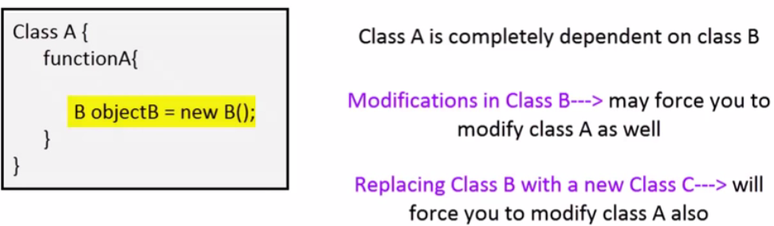
Problems :-

It is free and open source java frameworks. Its basically have two main features :-
AOP and dependency injection

Spring provide :-
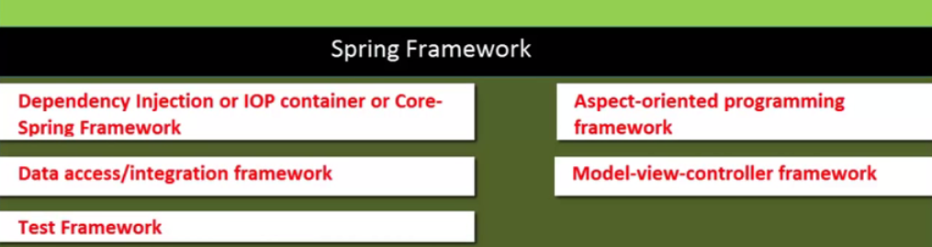

Reason of using Spring :-

a) Dependency Injection
b) It provide really good integration with other framework like struts2 or Hibernate.
c) Its gives you lots of flexiblity like it provide you AOPs , MVC etc.

Spring Bean:-

Any normal java class that is initialized by Spring IoC container is called Spring Bean. We use Spring ApplicationContext to get the Spring Bean instance.

Dependency Injection :-

- Dependency Injection design pattern allows us to remove the hard-coded dependencies
- It make our application loosely coupled, extendable and maintainable.
- We can implement dependency injection pattern to move the dependency resolution from compile-time to runtime.
- It can be achieved by using two type:
  - Setter Injection
  - Constructor Injection

IOC :-

- Inversion of control (IoC) is a programming technique in which object coupling is bound at run time by an assembler(supplier) object and is typically not known at compile time using static analysis.
- Spring IoC container is the program that injects dependencies into an object and make it ready for our use.
- Inversion of Control (IoC) is the mechanism to achieve loose-coupling between Objects dependencies.
- To achieve loose coupling and dynamic binding of the objects at runtime, the objects define their dependencies that are being injected by other assembler objects.

IoC and Dependency Injection :-

In traditional programming, the flow of the business logic is determined by objects that are statically assigned to one another.
With inversion of control, the flow depends on the object graph that is instantiated by the assembler (supplier) and is made possible by object interactions being defined through abstractions. The binding process is achieved through dependency injection, although some argue that the use of a service locator also provides inversion of control.

Inversion of control as a design guideline serves the following purposes:
- There is a decoupling of the execution of a certain task from implementation.
- Every module can focus on what it is designed for.
- Modules make no assumptions about what other systems do but rely on their contracts.
- Replacing modules has no side effect on other modules.

Setter Injection vs. Constructor Injection

1):- Partial dependency:
can be injected using setter injection but it is not possible by constructor. Suppose there are 3 properties in a class, having 3 arg constructor and setters methods. In such case, if you want to pass information for only one property, it is possible by setter method only.

2):- Overriding:
Setter injection overrides the constructor injection. If we use both constructor and setter injection, IOC container will use the setter injection.

3):- Changes:
We can easily change the value by setter injection. It doesn't create a new bean instance always like constructor. So setter injection is flexible than constructor injection

4):- Sequence :
If we are using Constructor injection then its mandatory to maintain the no. of the parameters and type of parameters. If we want to create object by using diff. Constructor then it will be messy because we will need diff. Constructor based on our requirement.

What is Bean Factory ?
- A BeanFactory is like a factory class that contains a collection of beans.
- The BeanFactory holds Bean Definitions of multiple beans within itself and then instantiates the bean whenever asked for by clients.
- BeanFactory is able to create associations between collaborating objects as they are instantiated. This removes the burden of configuration from bean itself and the beans client.
- BeanFactory also takes part in the life cycle of a bean, making calls to custom initialization and destruction methods.

What is Application Context?
- A bean factory is fine to simple applications, but to take advantage of the full power of the Spring framework, you may want to move up to Springs more advanced container, the application context.
- On the surface, an application context is same as a bean factory. Both load bean definitions, wire beans together, and dispense beans upon request.
- But it also provides:
- A means for resolving text messages, including support for internationalization.
- A generic way to load file resources.
- Events to beans that are registered as listeners.

What should be used preferably BeanFactory or ApplicationContext?
- A Bean Factory pretty much just instantiates and configures beans.
- An Application Context also does that, and it provides the supporting infrastructure to enable lots of enterprise-specific features such as transactions and AOP.
- In short, favor the use of an ApplicationContext.

What are the common implementations of the Application Context ?
The three commonly used implementation of ‘Application Context’ are
- ClassPathXmlApplicationContext :
It Loads context definition from an XML file located in the classpath, treating context definitions as classpath resources. The application context is loaded from the application’s classpath by using the code .
ApplicationContext context = new ClassPathXmlApplicationContext(“bean.xml”);

- FileSystemXmlApplicationContext :
It loads context definition from an XML file in the filesystem. The application context is loaded from the file system by using the code .
ApplicationContext context =new FileSystemXmlApplicationContext(“bean.xml”);

- XmlWebApplicationContext :
It loads context definition from an XML file contained within a web application.

Some important Configuration setting:-

1) context:component-scan element in the spring configuration file would eliminate the need for declaring all the beans in the XML files.
Below declaration in your spring configuration file:
<context:component-scan base-package="org.controller"/>

The above declaration in the spring application configuration file would scan the classes inside the specified package and create the beans instance.
The following are the annotations scanned by this element:
          - @Component
          - @Repository
          - @Service
          - @Controller
One advantage of this element is that it also resolves @Autowired and @Qualifier annotations. Therefore if you declare <context:component-scan>, is not necessary anymore declare <context:annotation-config> too.
2) mvc:annotation- config and mvc:annotation-driven is used for enabling the Spring MVC components with its default configurations.
If you don’t include mvc:annotation-driven then also your MVC application would work, if you have used the context:component-scan for creating the beans or defined the beans in your XML file.
But, mvc:annotation-driven does some extra job on configuring the special beans that would not have been configured if you are not using this element in your XML file.
This tag would register the HandlerMapping and HandlerAdapter required to dispatch requests to your @Controllers. In addition, it also applies some defaults based on what is present in your classpath.
Such defaults are:
- Using the Spring 3 Type ConversionService as a simpler and more robust alternative to JavaBeans PropertyEditors
- Support for formatting Number fields with @NumberFormat
- Support for formatting Date, Calendar, and Joda Time fields with @DateTimeFormat, if Joda Time is on the classpath
- Support for validating @Controller inputs with @Valid, if a JSR-303 Provider is on the classpath
- Support for reading and writing XML, if JAXB is on the classpath
- Support for reading and writing JSON, if Jackson is on the classpath

3) context:annotation-driven and context:annotation-config is used for activating annotations in beans already registered in the application context.
That means it will resolve @Autowired and @Qualifier annotations for the beans which are already created ) and stored in the spring container.
4) context:component-scan can also do the same job, but context:component-scanwill also scan the packages for registering the beans to application context.
5) context:annotation-config will not search for the beans registration, this will only activate the already registered beans in the context.

Some important Annotation:
@Bean:-
- @Bean is used to explicitly declare a single bean, rather than letting Spring do it automatically as above. It decouples the declaration of the bean from the class definition, and lets you create and configure beans exactly how you choose.
- @Bean annotation you control instance creation logic in method's body
- @Bean Is used with method body.
@Configuration
public class BeanConfiguration {
//Here object creation of EmpAddress is in two diff. Ways So we can decide how we want to create the object by calling getEmpAddress1 or getEmpAddress2
@Bean
public EmpAddress getEmpAddress1() {
return new EmpAddress();
}
@Bean
public EmpAddress getEmpAddress2() {
return new EmpAddress();
}
}

@Component (@Controller and @Service and @Repository) are used to auto-detect and auto-configure beans using classpath scanning.
There's an implicit one-to-one mapping between the annotated class and the bean (i.e. one bean per class). Control of wiring is quite limited with this approach, since it's purely declarative.

How to handle globalException in java?
We can use @ControllerAdvice (at class level) and ExceptionHandler at method level
/You can configure the same thing in Config file. So that you need not to write the long java code class.
@ControllerAdvice
public class GlobalExceptionHandlerClass
{
@ExceptionHandler(value=NullPointerException.class)
public String handleNullPointerException(Exception e)
{
System.out.println("Null Pointer exception occurs");
return "NullPointerException";
}

@ExceptionHandler(value=IOException.class)
public String handleIOException(Exception e)
{
System.out.println("IO exception occurs");
return "IOException";
}

@ResponseStatus(value = HttpStatus.INTERNAL_SERVER_ERROR)
@ExceptionHandler(value=Exception.class)
public String handleException(Exception e)
{
System.out.println("Exception occurs");
return "Exception";
}

}

AOP :-

AOP is aspect programming language which is used for separate business logic from other code or make the code relevant.
For example. If you have a function GetInterest() So you can separate it from logging and logic.

Because is logging is common thing So you can make it as Aspect and by using the aspect configuration you can use it with function even without writing the code in function. And if something change in aspect then you need not to change the method. Or even if you wish to apply this aspect on some other place or some other method then you need not to change the code, Just change the configurations.
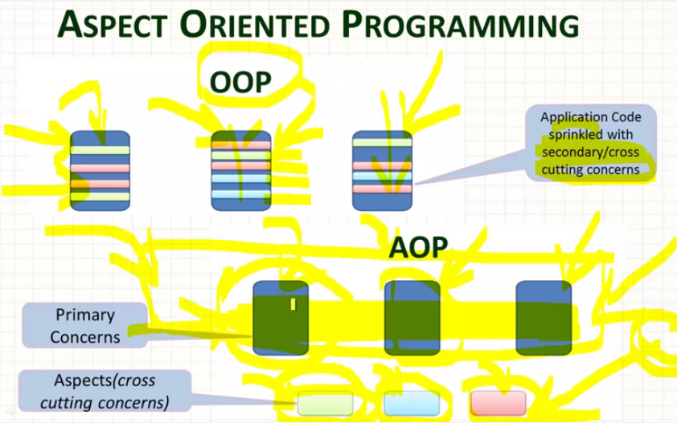

Problem Without Aspects :-
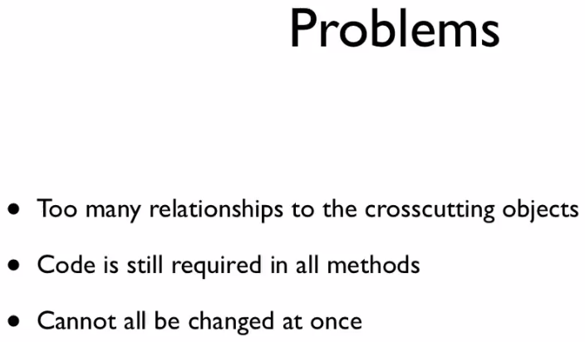
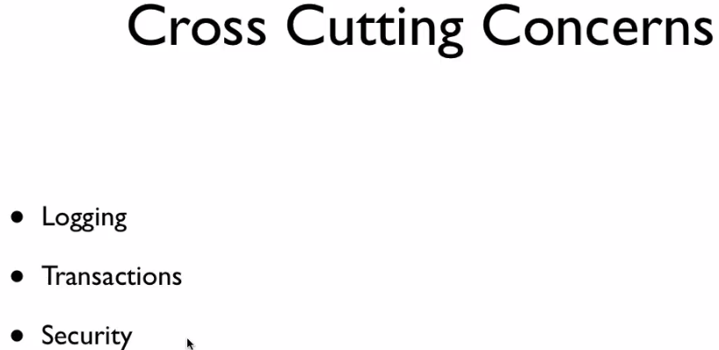

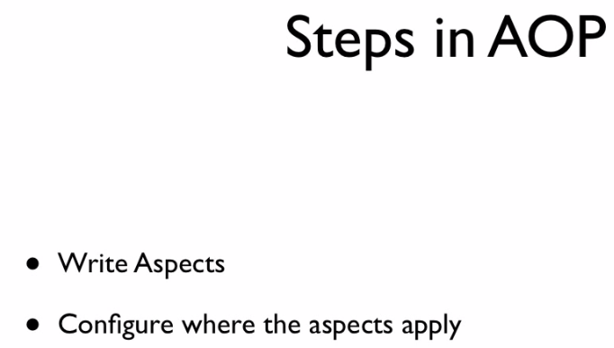
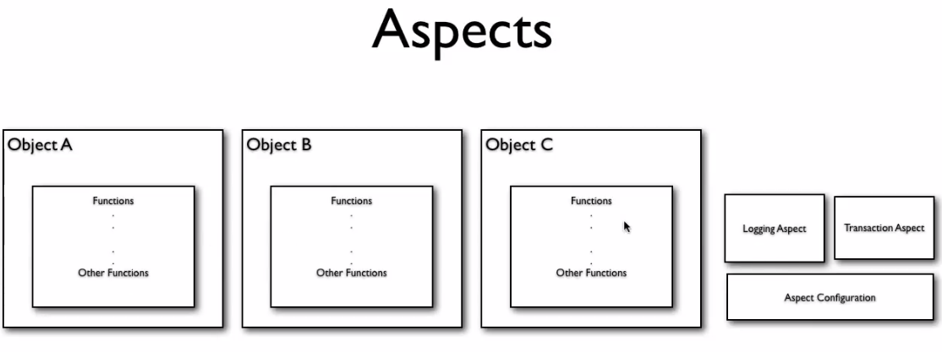
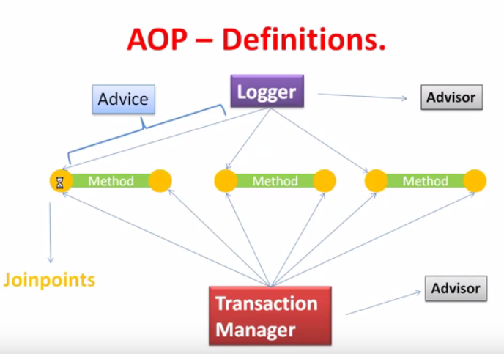

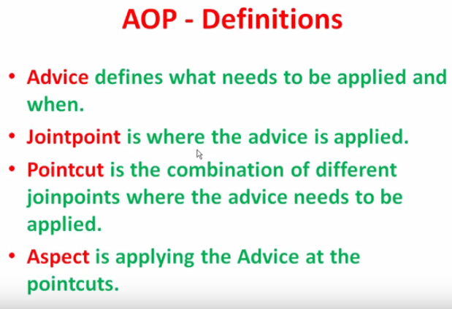

Advice :-
It is implementation of an aspect.
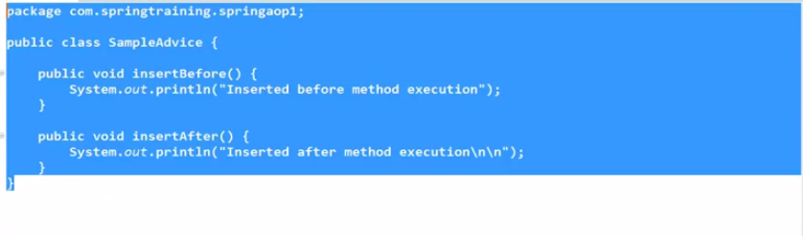
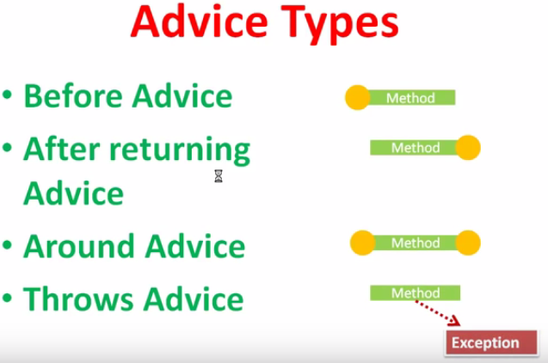

JointPoints :-
These are the points where the advice will be applied.
Ex:- you can apply advice before method or after method call.

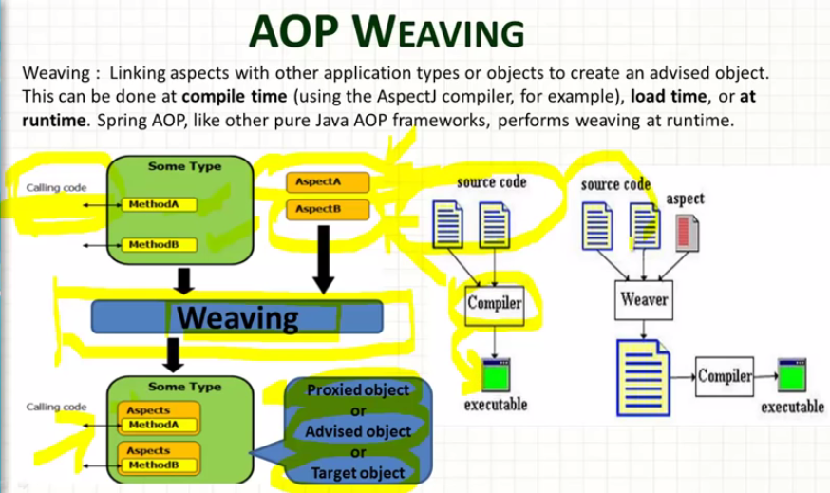

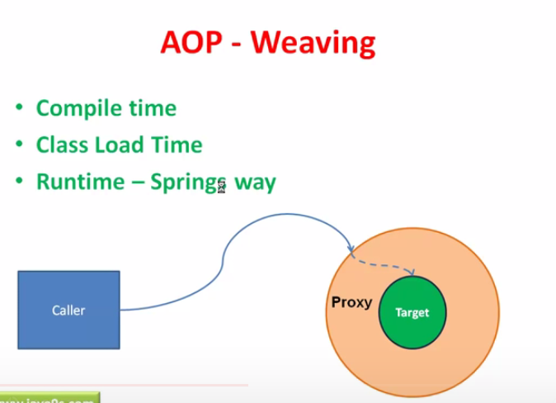

\

MVC

What are some of the important Spring annotations you have used?

- @Controller – for controller classes in Spring MVC project.
- @RequestMapping – for configuring URI mapping in controller handler methods. This is a very important annotation
- @ResponseBody – for sending Object as response, usually for sending XML or JSON data as response.
- @PathVariable – for mapping dynamic values from the URI to handler method arguments.
- @Autowired – for autowiring dependencies in spring beans.
- @Qualifier – with @Autowired annotation to avoid confusion when multiple instances of bean type is present.
- @Service – for service classes.
- @Scope – for configuring scope of the spring bean.
- @Configuration, @ComponentScan and @Bean – for java based configurations.
- AspectJ annotations for configuring aspects and advices, @Aspect, @Before, @After, @Around, @Pointcut etc.

@Controller
Public class XYZ
{
@RequestMapping(“/welcome”)
public ModelAndView m1()
{
}

@RequestMapping(“hi”)
public ModelAndView m1()
{
}

}

URL will be :-
http:localhost:8080/XYZ/welcome
http:localhost:8080/XYZ/hi

@Controller
@RequestMapping(“/greet”)
Public class XYZ
{
@RequestMapping(“/welcome”)
public ModelAndView m1()
{
}

@RequestMapping(“hi”)
public ModelAndView m1()
{
}

}

URL will be :-
http:localhost:8080/XYZ/greet/welcome
http:localhost:8080/XYZ/greet/hi

---------------------------------------------------------------------
@Controller
@RequestMapping(“/greet”)
Public class XYZ
{
@RequestMapping(“/welcome/{countryName}/{userName}”)
public ModelAndView m1(@PathVariable(”countryName”) String cName, @PathVariable(”userName”) String uName)
{
}

or

@RequestMapping(“/hi/{countryName}/{userName}”)
public ModelAndView m2(@PathVariable Map<String, String> pathVariable)
{
String countryName = pathVariable.get(“countryName”);
String uName = pathVariable.get(“userName”);
}

}

URL will be :-
http:localhost:8080/XYZ/greet/welcome/India/Ak
http:localhost:8080/XYZ/greet/hi/US/AKG

BEAN SCOPE

Differen types of spring bean scopes

In the spring bean configurations, bean attribute called 'scope' defines what kind of object has to created and returned. There are 5 types of bean scopes available, they are:
1) singleton: Returns a single bean instance per Spring IoC container.
2) prototype: Returns a new bean instance each time when requested.
3) request: Returns a single instance for every HTTP request call.
4) session: Returns a single instance for every HTTP session.
5) global session: global session scope is equal as session scope on portlet-based web applications.

Session attribute used in Applications:-

If you want to use session attribute then we need to use the SessionAttribute(“name”) with the controller and we can set the value of SessionAttribute ”name” in any controller method.

<h2>Adding of a String into the session</h2>

<form action="remember.html" method="post">
<table>
<tbody><tr>
<td>To remember:</td>
<td><input name="thoughtParam" type="text"></td>
</tr>
<tr>
<td><input type="submit"></td>
<td></td>
</tr>
</tbody></table>
</form>
<a href="${pageContext.request.contextPath}/">Main page</a>

@Controller
@SessionAttributes("thought")
public class SingleFieldController {

@RequestMapping(value="/single-field")
public ModelAndView singleFieldPage() {
return new ModelAndView("single-field-page");
}

@RequestMapping(value="/remember")
public ModelAndView rememberThought(@RequestParam String thoughtParam) {
ModelAndView modelAndView = new ModelAndView();
modelAndView.addObject("thought", thoughtParam);
modelAndView.setViewName("single-field-page");
return modelAndView;
}

}

<h1>Home page</h1>
<p>This is Home page.</p>
<p>Don't forget: ${thought}</p>
<p>
<a href="person-form.html">Person page</a> <br>
<a href="single-field.html">Single field page</a>
</p>

Another example of Session-attribute:-

@Controller
@SessionAttributes(value = "countrybean", types = {Country.class})
public class HelloController {
@Autowired
private CountryController controller;

//this method will assign the session-attribute value
@ModelAttribute("countrybean")
public Country addAttributes() {
Country country = new Country();
country.setCountryName("India");
country.setCapital("Delhi");
return country;
}

@RequestMapping(value="countryinfo")
public String country(){
return "start";
}
}

@Controller
public class CountryController {
@RequestMapping(value="/updateForm")
public ModelAndView country(HttpSession session, @CookieValue("JSESSIONID") String cookie){
Country countryObj = (Country)session.getAttribute("countrybean");
System.out.println("Country Name:"+ countryObj.getCountryName());
System.out.println("Capital:"+ countryObj.getCapital());
return new ModelAndView("updateCountry","country", countryObj);
}
}

Q):- Multi Action Controller Class :-
If a controller class having more than one action method then it is called Multi Action Controller class.

Ex:-

@Controller
@RequestMapping(“/greet”)
Public class XYZ
{
@RequestMapping(“/welcome”)
public ModelAndView m1()
{
}

@RequestMapping(“hi”)
public ModelAndView m1()
{
}

}

Spring Boot

- Spring Boot makes it easy to create stand-alone, production-grade Spring based Applications that you can “just run”.
- It is a tool by which you can create spring based application.
- We take an opinionated view of the Spring platform and third-party libraries, so that you can get started with minimum fuss.
- Most Spring Boot applications need very little Spring configuration.
- You can use Spring Boot to create Java applications that can be started by using java -jar or more traditional war deployments. We also provide a command line tool that runs “spring scripts”.
- Our primary goals are:
    - Provide a radically faster and widely accessible getting started experience for all Spring development.
    - Be opinionated out of the box but get out of the way quickly as requirements start to diverge from the defaults.
    - Provide a range of non-functional features that are common to large classes of projects (such as embedded servers, security, metrics, health checks, and externalized configuration).
    - Absolutely no code generation and no requirement for XML configuration.

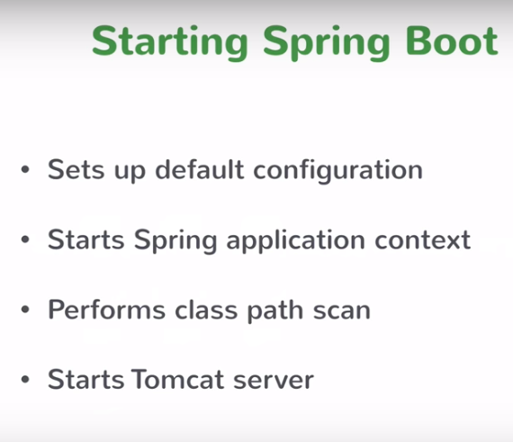

SPRING SECURITY :

Method 1
<http auto-config="true" >
<intercept-url pattern="/*" access="hasRole('ROLE_USER')"/>
<http-basic/>
</http>
<authentication-manager>
<authentication-provider>
<user-service >
<user name="A" password="A" authorities="ROLE_USER"/>
</user-service>
</authentication-provider>
</authentication-manager>

Method 2

<!--
<http auto-config="true" >
<intercept-url pattern="/login" access="permitAll" />
<intercept-url pattern="/logout" access="permitAll" />
<intercept-url pattern="/accessdenied" access="permitAll" />
<intercept-url pattern="/**" access="hasRole('ROLE_USER')" />
<form-login login-page="/login" default-target-url="/list" authentication-failure-url="/accessdenied" />
<logout logout-success-url="/logout" />
</http>

Method 3

<authentication-manager alias="authenticationManager">
<authentication-provider>
<user-service>
<user name="lokesh" password="password" authorities="ROLE_USER" />
</user-service>
</authentication-provider>
</authentication-manager>
→

SPRING MVC Conf.
<?xml version="1.0" encoding="UTF-8"?>
<beans xmlns="http://www.springframework.org/schema/beans"
xmlns:xsi="http://www.w3.org/2001/XMLSchema-instance"
xmlns:p="http://www.springframework.org/schema/p"
xmlns:context="http://www.springframework.org/schema/context"
xmlns:util="http://www.springframework.org/schema/util"
xmlns:tx="http://www.springframework.org/schema/tx"
xmlns:mvc="http://www.springframework.org/schema/mvc"
xmlns:aop="http://www.springframework.org/schema/aop"
xsi:schemaLocation="
http://www.springframework.org/schema/beans
http://www.springframework.org/schema/beans/spring-beans-3.0.xsd
http://www.springframework.org/schema/context
http://www.springframework.org/schema/context/spring-context-3.0.xsd
http://www.springframework.org/schema/util
http://www.springframework.org/schema/util/spring-util-3.0.xsd
http://www.springframework.org/schema/mvc
http://www.springframework.org/schema/mvc/spring-mvc-3.0.xsd
http://www.springframework.org/schema/tx
http://www.springframework.org/schema/tx/spring-tx.xsd
http://www.springframework.org/schema/aop
http://www.springframework.org/schema/aop/spring-aop-4.0.xsd" >

<context:component-scan base-package="com.akshay.controller" />
<bean id="viewResolver"
class="org.springframework.web.servlet.view.InternalResourceViewResolver">
<property name="prefix">
<value>/WEB-INF/</value>
</property>
<property name="suffix">
<value>.jsp</value>
</property>
</bean>
<mvc:annotation-driven />

<bean id="dataSource" class="org.apache.commons.dbcp.BasicDataSource">
<property name="driverClassName" value="com.mysql.jdbc.Driver" />
<property name="url" value="jdbc:mysql://snagpal.blackarrow-corp.com:3306/demoAKTest" />
<property name="username" value="root" />
<property name="password" value="" />
</bean>

<bean id="sessionFactory"
class="org.springframework.orm.hibernate4.LocalSessionFactoryBean">
<property name="dataSource" ref="dataSource" />
<property name="packagesToScan" value="com.akshay.entity" />
<property name="hibernateProperties">
<props>
<prop key="hibernate.dialect">org.hibernate.dialect.MySQL5Dialect</prop>
<prop key="hibernate.show_sql">true</prop>
<prop key="hibernate.hbm2ddl.auto">update</prop>
</props>
</property>
</bean>

<bean id="transactionManager"
class="org.springframework.orm.hibernate4.HibernateTransactionManager">
<property name="sessionFactory" ref="sessionFactory" />
</bean>
<tx:annotation-driven transaction-manager="transactionManager" />

<bean id="studentDao" class="com.akshay.dao.StudentDaoImpl"></bean>
<bean id="studentService" class="com.akshay.service.StudentService"></bean>

<bean id="validator"
class="org.springframework.validation.beanvalidation.LocalValidatorFactoryBean" />

<!-- Start Of Advice Configuration -->
<!--End Of Advice Configuration -->
<mvc:annotation-driven />

</beans>

