In the above image, classes B, C and D are inherited from the parent class A.  
There can be a situation where a single class is being inherited from multiple parent classes as below.

https://miro.medium.com/max/60/1*xUHcyW44Zi0gE2UaCTkCDA.png?q=20

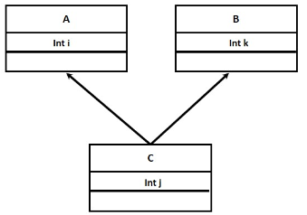

Multiple inheritance

C is derived from the classes A and B where C can access the properties and behaviours of parent classes A and B.

However, there is one issue with multiple inheritance. There is an ambiguity that arises when 2 classes inherit from one superclass, and another class inherits from the child classes that are under the previously created superclass.

https://miro.medium.com/max/50/1*KMbFLqTeuO_TXXq11Tdojg.png?q=20

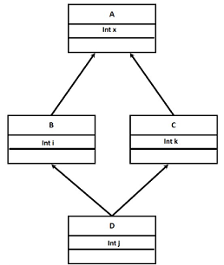

Deadly diamond of death

The ambiguity is, classes B and C inherits from class A, and class D inherits from the classes B and C. If there is a method in class A, both the B and C classes and overriding the method and D doesn’t override it.

Question !!! Which version of the method does D inherit???

This problem is called the **Deadly Diamond of Death.**

Multiple inheritance can be implemented as below.

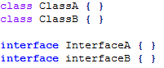

Class & interface definition

https://miro.medium.com/max/806/1*pEJncWiwd3t6nOjlzeJHKA.png

Line no 1: **Valid multiple inheritance** where MyClass is inherited from multiple interfaces.  
Line no 2: **Valid multiple inheritance** where MyClass is inherited from 1 class and 1 interface.

Line no 3: **Invalid multiple inheritance** where MyClass is inherited from multiple classes.