ScreenShots

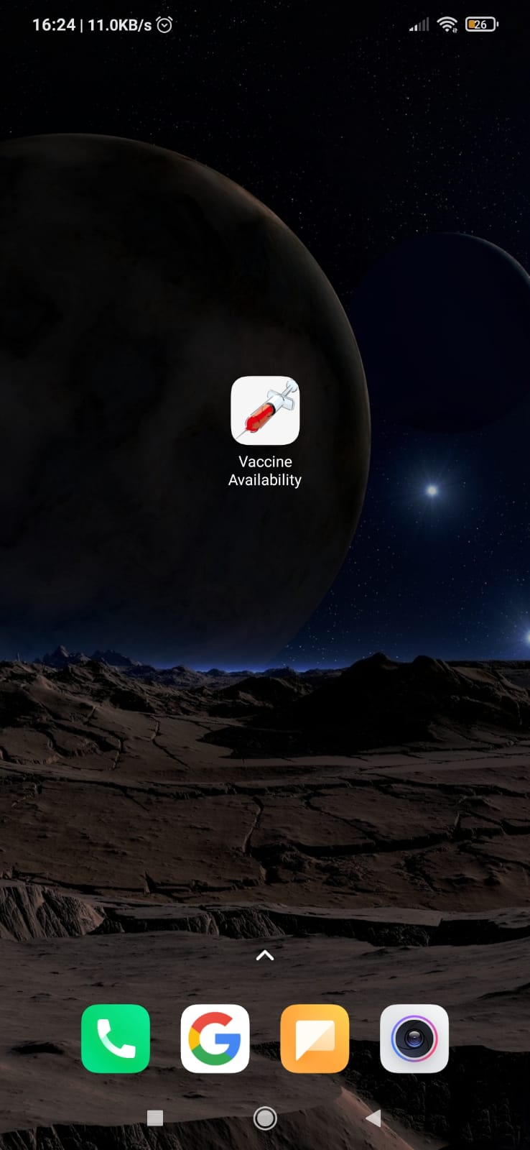In this app I have stored the email and password in the firebase.The main purpose of the app is to show the availability of vaccine as per the pincode given by user.This app uses API call to fetch the required result and show to the user.The remaining codes are given after screenshots.

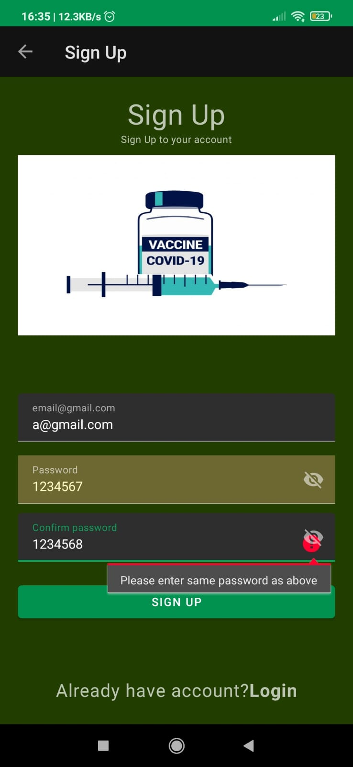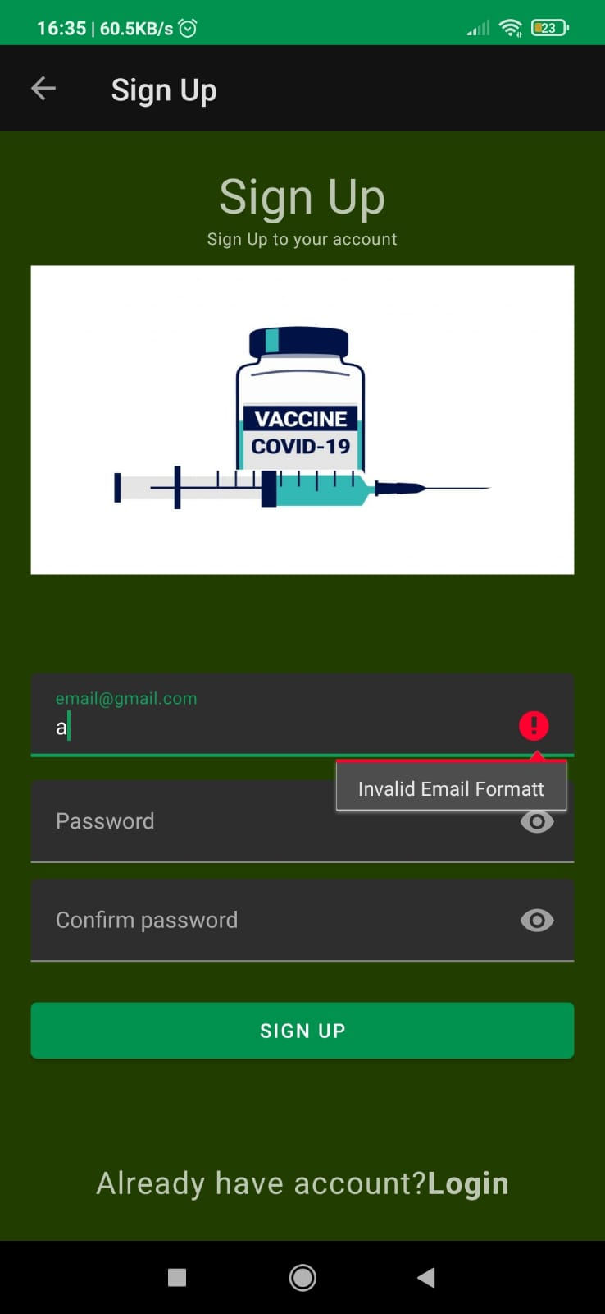

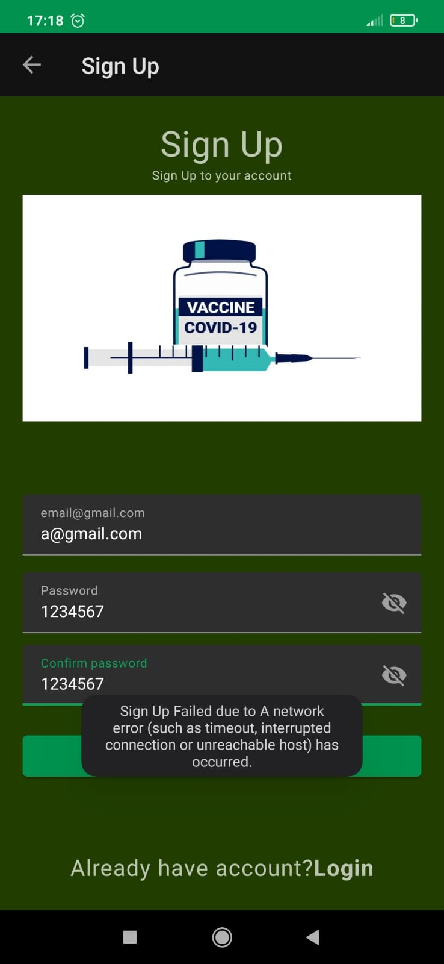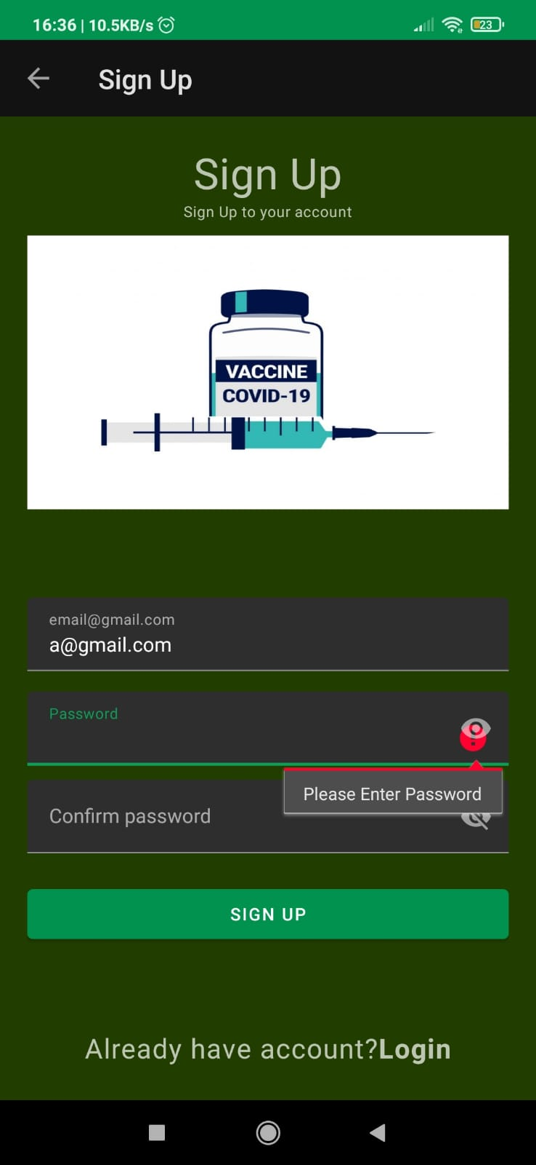

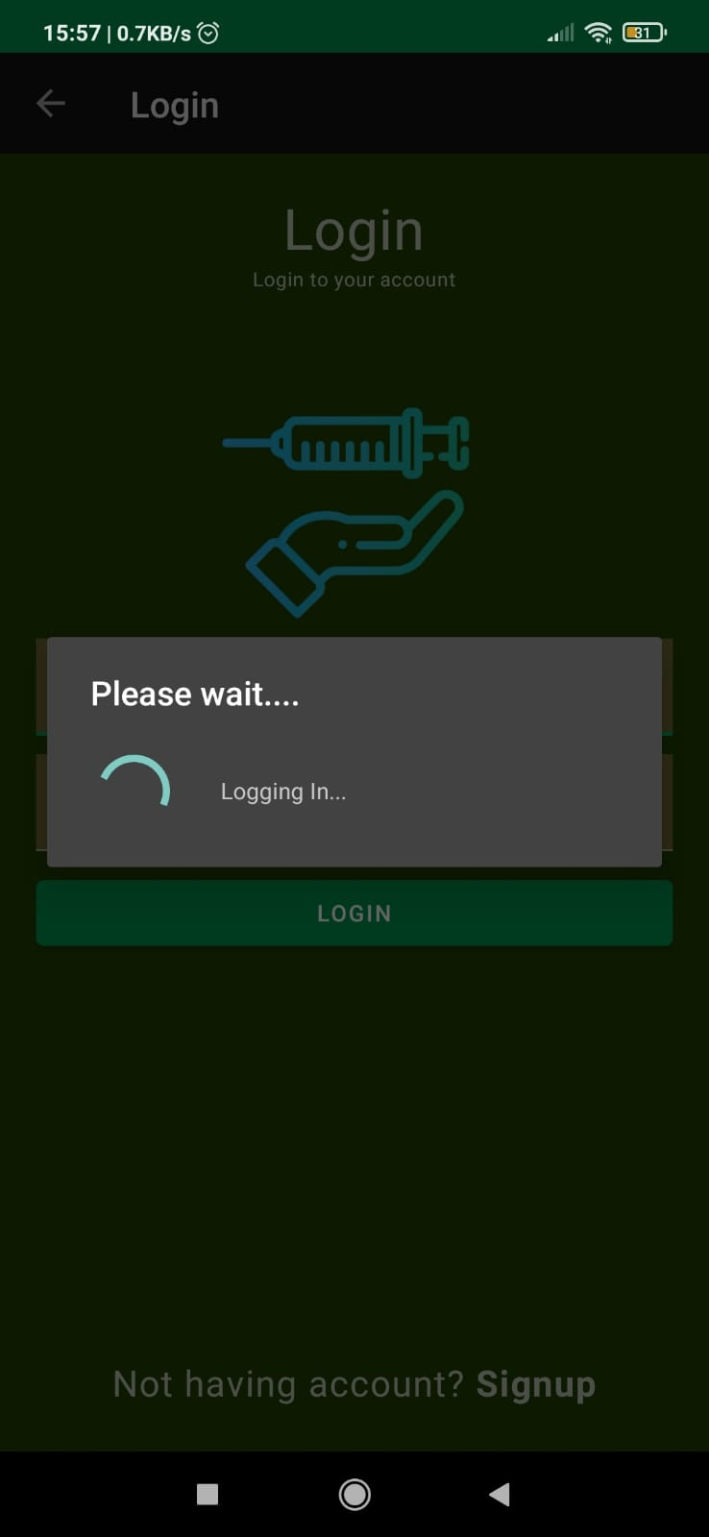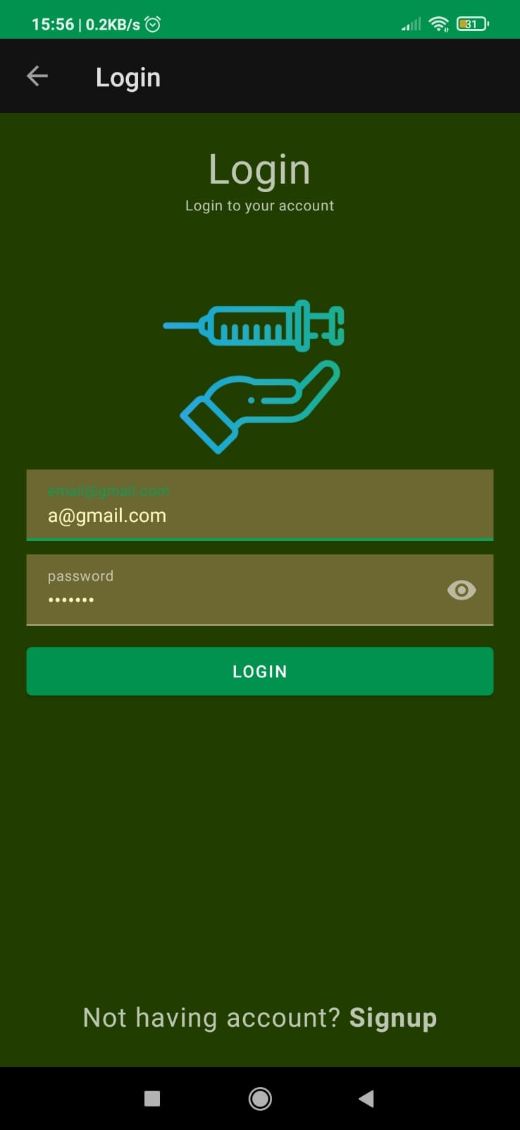

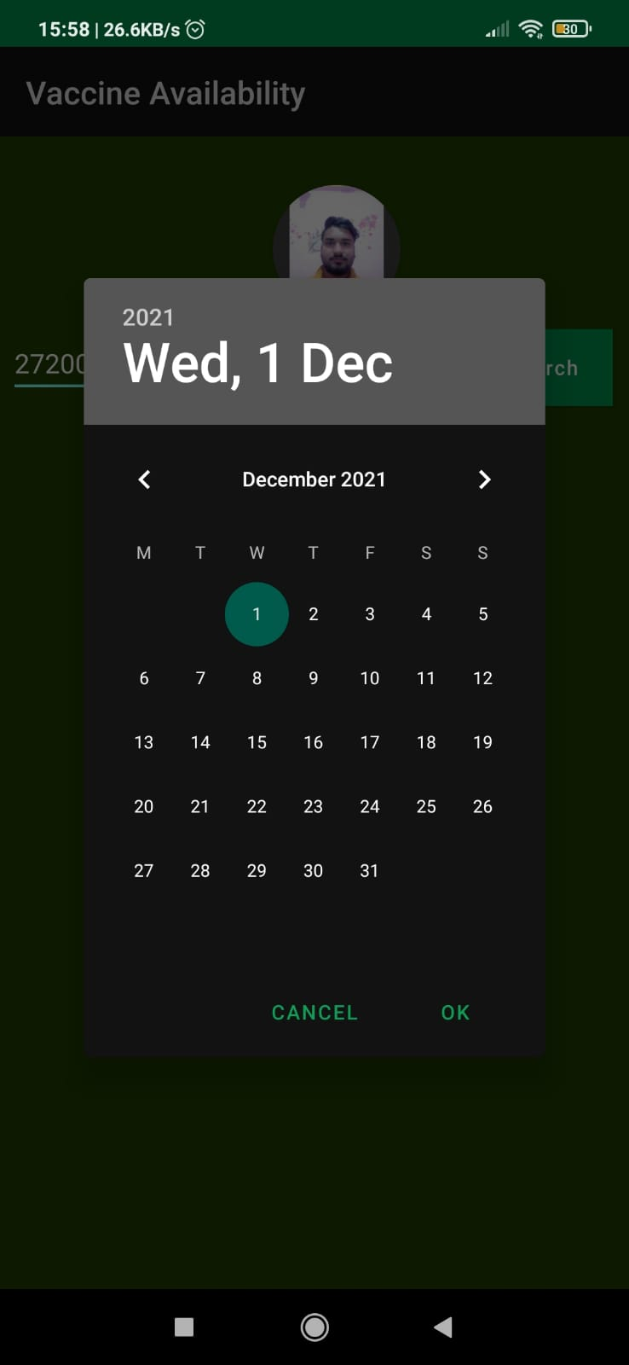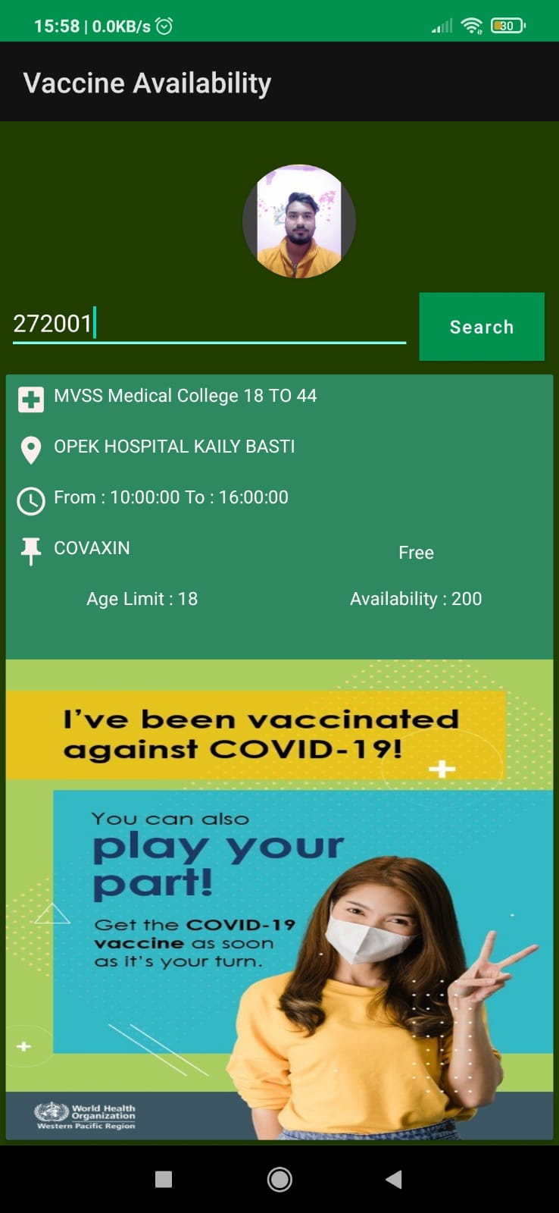

**activity_sign_up.xml**

*<?***xml version="1.0" encoding="utf-8"***?>*<**RelativeLayout xmlns:android="http://schemas.android.com/apk/res/android"  
 xmlns:app="http://schemas.android.com/apk/res-auto"  
 xmlns:tools="http://schemas.android.com/tools"  
 android:layout_width="match_parent"  
 android:layout_height="match_parent"  
 android:padding="20dp"  
 android:background="@color/col1"  
 tools:context=".Sign_Up"**>  
  
 <**LinearLayout  
 android:layout_width="wrap_content"  
 android:layout_height="wrap_content"  
 android:orientation="vertical"  
 android:id="@+id/ll"**>  
  
 <**TextView  
 android:id="@+id/titleLabelTv"  
 style="@style/TextAppearance.MaterialComponents.Headline4"  
 android:layout_width="wrap_content"  
 android:layout_height="wrap_content"  
  
 android:layout_gravity="center"  
 android:text="Sign Up"** />  
  
 <**TextView  
 android:layout_width="wrap_content"  
 android:layout_height="wrap_content"  
 android:layout_gravity="center"  
 android:layout_below="@+id/titleLabelTv"  
 android:text="Sign Up to your account"  
 style="@style/TextAppearance.MaterialComponents.Caption"**/>  
  
 <**ImageView  
 android:id="@+id/signimg"  
 android:layout_width="wrap_content"  
 android:layout_height="200dp"  
 android:layout_gravity="center"  
 android:layout_marginTop="10dp"  
 android:background="@drawable/sign_up"** />  
  
 </**LinearLayout**>  
  
 <**com.google.android.material.textfield.TextInputLayout  
 android:id="@+id/passwordTil1"  
 android:layout_above="@id/passwordTil"  
  
 android:layout_marginBottom="-385dp"  
  
 android:layout_width="match_parent"  
 android:layout_height="wrap_content"** >  
<**EditText  
 android:id="@+id/emailEt"  
 android:layout_width="match_parent"  
 android:layout_height="wrap_content"  
 android:inputType="text"  
 android:hint="email@gmail.com"**/>  
 </**com.google.android.material.textfield.TextInputLayout**>  
  
 <**com.google.android.material.textfield.TextInputLayout  
 android:id="@+id/passwordTil"  
 app:passwordToggleEnabled="true"  
 android:layout_width="match_parent"  
 android:layout_height="wrap_content"  
 android:layout_marginTop="400dp"**>  
  
 <**EditText  
 android:id="@+id/passwordEt"  
 android:layout_width="match_parent"  
 android:layout_height="wrap_content"  
 android:hint="Password"  
 android:inputType="textPassword"** />  
 </**com.google.android.material.textfield.TextInputLayout**>  
 <**com.google.android.material.textfield.TextInputLayout  
 android:id="@+id/passwordTil2"  
 android:layout_below="@id/passwordTil"  
 android:layout_marginTop="10dp"  
 android:layout_marginBottom="10dp"  
 app:passwordToggleEnabled="true"  
 android:layout_width="match_parent"  
 android:layout_height="wrap_content"  
 android:layout_centerInParent="true"**>  
  
 <**EditText  
 android:id="@+id/confirmEt"  
 android:layout_width="match_parent"  
 android:layout_height="wrap_content"  
 android:inputType="textPassword"  
 android:hint="Confirm password"**/>  
 </**com.google.android.material.textfield.TextInputLayout**>  
  
 <**Button  
 android:layout_width="match_parent"  
 android:layout_height="wrap_content"  
 android:id="@+id/signupBtn"  
 android:text="Sign Up"  
 android:layout_below="@+id/passwordTil2"  
 android:layout_marginTop="10dp"**/>  
  
 <**TextView  
 android:id="@+id/alreadyaccount"  
 style="@style/TextAppearance.MaterialComponents.Caption"  
 android:layout_width="wrap_content"  
 android:layout_height="wrap_content"  
 android:layout_alignParentBottom="true"  
 android:layout_centerHorizontal="true"  
 android:padding="5dp"  
 android:textSize="20dp"  
 android:text="@string/already_account"** />  
</**RelativeLayout**>

**activity_login.xml**

*<?***xml version="1.0" encoding="utf-8"***?>*<**RelativeLayout xmlns:android="http://schemas.android.com/apk/res/android"  
 xmlns:app="http://schemas.android.com/apk/res-auto"  
 xmlns:tools="http://schemas.android.com/tools"  
 android:layout_width="match_parent"  
 android:layout_height="match_parent"  
 android:padding="20dp"  
 android:background="@color/col1"  
 tools:context=".Login"**>  
  
 <**TextView  
 android:id="@+id/titleLabelTv"  
 android:layout_width="wrap_content"  
 android:layout_height="wrap_content"  
 android:layout_centerHorizontal="true"  
 android:text="Login"  
 style="@style/TextAppearance.MaterialComponents.Headline4"**/>  
  
 <**TextView  
 android:layout_width="wrap_content"  
 android:layout_height="wrap_content"  
 android:layout_centerHorizontal="true"  
 android:layout_below="@+id/titleLabelTv"  
 android:text="Login to your account"  
 style="@style/TextAppearance.MaterialComponents.Caption"**/>  
  
  
  
 <**ImageView  
 android:layout_width="200dp"  
 android:layout_height="200dp"  
 android:layout_centerHorizontal="true"  
 android:background="@drawable/login"  
 android:layout_marginTop="80dp"**/>  
  
  
 <**com.google.android.material.textfield.TextInputLayout  
 android:id="@+id/passwordTil1"  
 android:layout_above="@id/passwordTil"  
 android:layout_marginBottom="10dp"  
  
 android:layout_width="match_parent"  
 android:layout_height="wrap_content"  
 android:layout_centerInParent="true"**>  
  
 <**EditText  
 android:id="@+id/emailEt"  
 android:layout_width="match_parent"  
 android:layout_height="wrap_content"  
 android:inputType="text"  
 android:hint="email@gmail.com"**/>  
 </**com.google.android.material.textfield.TextInputLayout**>  
  
 <**com.google.android.material.textfield.TextInputLayout  
 android:id="@+id/passwordTil"  
 app:passwordToggleEnabled="true"  
 android:layout_width="match_parent"  
 android:layout_height="wrap_content"  
 android:layout_centerInParent="true"**>  
  
 <**EditText  
 android:id="@+id/passwordEt"  
 android:layout_width="match_parent"  
 android:layout_height="wrap_content"  
 android:inputType="textPassword"  
 android:hint="password"**/>  
 </**com.google.android.material.textfield.TextInputLayout**>  
  
 <**Button  
 android:layout_width="match_parent"  
 android:layout_height="wrap_content"  
 android:id="@+id/loginBtn"  
 android:text="Login"  
 android:layout_below="@+id/passwordTil"  
 android:layout_marginTop="10dp"**/>  
  
 <**TextView  
 android:id="@+id/noaccountTv"  
 android:layout_width="wrap_content"  
 android:layout_height="wrap_content"  
 android:text="@string/no_account"  
 android:layout_alignParentBottom="true"  
 android:padding="5dp"  
 android:textSize="20dp"  
 android:layout_centerHorizontal="true"  
 style="@style/TextAppearance.MaterialComponents.Caption"**/>  
</**RelativeLayout**>

**Activity_main.xml**

*<?***xml version="1.0" encoding="utf-8"***?>*<**RelativeLayout  
 xmlns:android="http://schemas.android.com/apk/res/android"  
 xmlns:tools="http://schemas.android.com/tools"  
 xmlns:app="http://schemas.android.com/apk/res-auto"  
 android:layout_width="match_parent"  
 android:layout_height="match_parent"  
 android:background="@color/col1"  
  
 tools:context=".MainActivity"**>  
  
  
  
 <**androidx.cardview.widget.CardView  
 android:layout_width="80dp"  
 android:layout_height="80dp"  
 android:layout_marginTop="30dp"  
 android:layout_gravity="center"  
 app:cardCornerRadius="100dp"  
 android:layout_marginLeft="170dp"  
 android:layout_weight="1"**>  
  
 <**ImageView  
 android:id="@+id/img"  
 android:layout_width="match_parent"  
 android:layout_height="match_parent"  
 android:src="@drawable/ic_launcher_foreground"  
 android:onClick="clickMe"**/>  
  
  
 </**androidx.cardview.widget.CardView**>  
  
  
  
  
 <**EditText  
  
 android:id="@+id/idEdtPinCode"  
 android:layout_width="match_parent"  
 android:layout_height="wrap_content"  
 android:layout_marginStart="5dp"  
 android:layout_marginTop="120dp"  
 android:layout_marginEnd="5dp"  
 android:layout_marginBottom="5dp"  
 android:layout_marginLeft="10dp"  
 android:layout_toStartOf="@id/idBtnSearch"  
 android:layout_toLeftOf="@id/idBtnSearch"  
 android:hint="Enter PinCode"  
 android:inputType="number"** />  
 <**Button  
 android:id="@+id/idBtnSearch"  
 android:layout_width="wrap_content"  
 android:layout_height="wrap_content"  
 android:layout_alignParentEnd="true"  
 android:layout_alignParentRight="true"  
 android:layout_marginTop="120dp"  
 android:layout_marginRight="10dp"  
 android:background="@color/purple_200"  
 android:text="Search"  
 android:textAllCaps="false"** />  
  
  
 *<!--progress bar for loading indicator-->* <**ProgressBar  
 android:id="@+id/idPBLoading"  
 android:layout_width="wrap_content"  
 android:layout_height="wrap_content"  
 android:layout_centerInParent="true"  
 android:visibility="gone"** />  
  
 <**androidx.recyclerview.widget.RecyclerView  
 android:id="@+id/centersRV"  
 android:layout_width="match_parent"  
 android:layout_height="match_parent"  
 android:layout_below="@id/idEdtPinCode"  
 android:layout_marginTop="5dp"  
 tools:listitem="@layout/center_rv_item"** />  
  
  
</**RelativeLayout**>

**center_rv_item.xml**

*<?***xml version="1.0" encoding="utf-8"***?>*<**androidx.cardview.widget.CardView  
 xmlns:android="http://schemas.android.com/apk/res/android"  
 android:layout_width="match_parent"  
 android:layout_height="match_parent"  
  
 android:layout_margin="4dp"**>  
  
 <**RelativeLayout  
 android:background="@color/col2"  
 android:layout_width="match_parent"  
 android:layout_height="wrap_content"**>  
  
 *<!--text view for displaying center name-->* <**TextView  
 android:id="@+id/idTVCenterName"  
 android:layout_width="match_parent"  
 android:layout_height="wrap_content"  
 android:layout_margin="3dp"  
 android:drawableLeft="@drawable/ic_baseline_local_hospital_24"  
 android:drawablePadding="4dp"  
 android:padding="3dp"  
 android:text="Center Name"  
 android:textColor="@color/black"** />  
  
 *<!--text view for displaying center address-->* <**TextView  
 android:id="@+id/idTVCenterAddress"  
 android:layout_width="match_parent"  
 android:layout_height="wrap_content"  
 android:layout_below="@id/idTVCenterName"  
 android:layout_margin="3dp"  
 android:drawableLeft="@drawable/ic_location"  
 android:drawablePadding="4dp"  
 android:padding="3dp"  
 android:text="Center Address"  
 android:textColor="@color/black"** />  
  
 *<!--text view for displaying center timings-->* <**TextView  
 android:id="@+id/idTVCenterTimings"  
 android:layout_width="match_parent"  
 android:layout_height="wrap_content"  
 android:layout_below="@id/idTVCenterAddress"  
 android:layout_margin="3dp"  
 android:drawableLeft="@drawable/ic_time"  
 android:drawablePadding="4dp"  
 android:padding="3dp"  
 android:text="Timings"  
 android:textColor="@color/black"** />  
  
 <**LinearLayout  
 android:id="@+id/idLL1"  
 android:layout_width="match_parent"  
 android:layout_height="wrap_content"  
 android:layout_below="@id/idTVCenterTimings"  
 android:orientation="horizontal"  
 android:weightSum="2"**>  
  
 *<!--text view for displaying vaccine name-->* <**TextView  
 android:id="@+id/idTVVaccineName"  
 android:layout_width="0dp"  
 android:layout_height="wrap_content"  
 android:layout_margin="3dp"  
 android:layout_weight="1"  
 android:drawableLeft="@drawable/ic_vacine"  
 android:drawablePadding="4dp"  
 android:padding="3dp"  
 android:text="Vaccine Name"  
 android:textColor="@color/black"** />  
  
 *<!--text view for displaying center fees type-->* <**TextView  
 android:id="@+id/idTVFeeType"  
 android:layout_width="0dp"  
 android:layout_height="wrap_content"  
 android:layout_gravity="center"  
 android:layout_margin="3dp"  
 android:layout_weight="1"  
 android:padding="3dp"  
 android:text="Fee Type"  
 android:textAlignment="center"  
 android:textColor="@color/black"** />  
 </**LinearLayout**>  
  
 <**LinearLayout  
 android:id="@+id/idLL2"  
 android:layout_width="match_parent"  
 android:layout_height="wrap_content"  
 android:layout_below="@id/idLL1"  
 android:orientation="horizontal"  
 android:weightSum="2"**>  
  
 *<!--text view for displaying age limit-->* <**TextView  
 android:id="@+id/idTVAgeLimit"  
 android:layout_width="0dp"  
 android:layout_height="wrap_content"  
 android:layout_gravity="center"  
 android:layout_margin="3dp"  
 android:layout_weight="1"  
 android:padding="3dp"  
 android:text="Age Limit"  
 android:textAlignment="center"  
 android:textColor="@color/black"** />  
  
 *<!--text view for displaying center availability-->* <**TextView  
 android:id="@+id/idTVAvaliablity"  
 android:layout_width="0dp"  
 android:layout_height="wrap_content"  
 android:layout_gravity="center"  
 android:layout_margin="3dp"  
 android:layout_weight="1"  
 android:padding="3dp"  
 android:text="Avaliablity"  
 android:textAlignment="center"  
 android:textColor="@color/black"** />  
  
 </**LinearLayout**>  
  
 <**ImageView  
 android:layout_width="wrap_content"  
 android:layout_height="wrap_content"  
 android:layout_marginTop="200dp"  
 android:background="@drawable/vaccine_back"** />  
 </**RelativeLayout**>  
  
</**androidx.cardview.widget.CardView**>

Sign_Up.kt

**package** com.example.covid_19vaccineavailabilityapp  
  
**import** android.app.ProgressDialog  
**import** android.content.Intent  
**import** android.os.Binder  
**import** androidx.appcompat.app.AppCompatActivity  
**import** android.os.Bundle  
**import** android.text.TextUtils  
**import** android.util.Patterns  
**import** android.widget.Button  
**import** android.widget.TextView  
**import** android.widget.Toast  
**import** androidx.appcompat.app.ActionBar  
**import** com.example.covid_19vaccineavailabilityapp.databinding.ActivitySignUpBinding  
**import** com.google.firebase.auth.FirebaseAuth  
  
**class** Sign_Up : AppCompatActivity() {  
 **private lateinit var binding**: ActivitySignUpBinding  
  
 **private lateinit var actionBar**: ActionBar  
  
 **private lateinit var progressDialog**:ProgressDialog  
  
 **private lateinit var firebaseAuth**: FirebaseAuth  
  
  
 **lateinit var btn**:TextView  
 **private var email**=**" "  
 private var password**=**""  
 private var confirmpassword**=**" "  
  
 override fun** onCreate(savedInstanceState: Bundle?) {  
 **super**.onCreate(savedInstanceState)  
 **binding**= ActivitySignUpBinding.inflate(*layoutInflater*)  
 setContentView(**binding**.*root*)  
  
 **btn**=findViewById(R.id.*alreadyaccount*)  
  
 **actionBar**=*supportActionBar*!!  
 **actionBar**.*title*=**"Sign Up"  
 actionBar**.setDisplayHomeAsUpEnabled(**true**)  
 **actionBar**.setDisplayShowHomeEnabled(**true**)  
  
  
  
 **progressDialog**= ProgressDialog(**this**)  
 **progressDialog**.setTitle(**"Please wait...."**)  
 **progressDialog**.setMessage(**"Creating Account..."**)  
 **progressDialog**.setCanceledOnTouchOutside(**false**)  
  
 **firebaseAuth**= FirebaseAuth.getInstance()  
  
  
 **btn**.setOnClickListener()**{** startActivity(Intent(**this**,Login::**class**.*java*))  
 finish()  
  
 **}  
 binding**.**signupBtn**.setOnClickListener()**{** validateData()  
 **}** }  
  
 **private fun** validateData() {  
 **email**=**binding**.**emailEt**.*text*.toString().*trim*()  
 **password**=**binding**.**passwordEt**.*text*.toString().*trim*()  
 **confirmpassword**=**binding**.**confirmEt**.*text*.toString().*trim*()  
  
  
  
 **if**(!Patterns.*EMAIL_ADDRESS*.matcher(**email**).matches()){  
 **binding**.**emailEt**.*error*=**"Invalid Email Formatt"** }  
 **else if**(TextUtils.isEmpty(**password**)){  
 **binding**.**passwordEt**.*error*=**"Please Enter Password"** }  
  
 **else if**( **password**.**length**<6){  
 **binding**.**passwordEt**.*error*=**"Password must be atleast 6 characters"** }  
 **else if**(TextUtils.isEmpty(**confirmpassword**)){  
 **binding**.**confirmEt**.*error*=**"Confirm Password cant be empty"** }  
 **else**{  
 **if**(**password**.*contentEquals*(**confirmpassword**)){  
 firebaseSignup()  
 }  
 **else**{  
 **binding**.**confirmEt**.*error*=**"Please enter same password as above"** }  
 }  
 }  
  
 **private fun** firebaseSignup() {  
 **progressDialog**.show()  
 **firebaseAuth**.createUserWithEmailAndPassword(**email**, **password**)  
 .addOnSuccessListener **{  
  
 progressDialog**.dismiss()  
 *// Toast.makeText(this,"Account Created with email $email",Toast.LENGTH_SHORT).show()* startActivity(Intent(**this**,Login::**class**.*java*))  
 finish()  
 **}** .addOnFailureListener()**{** e**->  
 progressDialog**.dismiss()  
  
 Toast.makeText(**this**,**"Sign Up Failed due to ${**e.**message}"**,Toast.*LENGTH_SHORT*).show()  
 **}** }  
  
 override **fun** onSupportNavigateUp(): Boolean {  
 **return super**.onSupportNavigateUp()  
 }  
}

Login.kt

**package** com.example.covid_19vaccineavailabilityapp  
  
**import** android.app.ProgressDialog  
**import** android.content.Intent  
**import** androidx.appcompat.app.AppCompatActivity  
**import** android.os.Bundle  
**import** android.text.TextUtils  
**import** android.util.Patterns  
**import** android.widget.ProgressBar  
**import** android.widget.Toast  
**import** androidx.appcompat.app.ActionBar  
**import** com.example.covid_19vaccineavailabilityapp.databinding.ActivityLoginBinding  
**import** com.google.firebase.auth.FirebaseAuth  
  
**class** Login : AppCompatActivity() {  
 **private lateinit var binding**: ActivityLoginBinding  
 **private lateinit var actionBar**: ActionBar  
 **private lateinit var progressDialog**:ProgressDialog  
 **private lateinit var firebaseAuth**: FirebaseAuth  
  
 **private var email**=**" "  
 private var password**=**" "  
 override fun** onCreate(savedInstanceState: Bundle?) {  
 **super**.onCreate(savedInstanceState)  
 **binding**= ActivityLoginBinding.inflate(*layoutInflater*)  
 setContentView(**binding**.*root*)  
  
 **actionBar**=*supportActionBar*!!  
 **actionBar**.*title*=**"Login"  
 actionBar**.setDisplayHomeAsUpEnabled(**true**)  
 **actionBar**.setDisplayShowHomeEnabled(**true**)  
  
  
 **progressDialog**= ProgressDialog(**this**)  
 **progressDialog**.setTitle(**"Please wait...."**)  
 **progressDialog**.setMessage(**"Logging In..."**)  
 **progressDialog**.setCanceledOnTouchOutside(**false**)  
  
  
 **firebaseAuth**= FirebaseAuth.getInstance()  
  
  
  
 **binding**.**noaccountTv**.setOnClickListener()**{** startActivity(Intent(**this**,Sign_Up::**class**.*java*))  
 finish()  
 **}  
  
  
 binding**.**loginBtn**.setOnClickListener()**{** validateData()  
 **}** }  
  
 **private fun** validateData() {  
 **email** = **binding**.**emailEt**.*text*.toString()  
 **password** = **binding**.**passwordEt**.*text*.toString()  
  
 **if** (!Patterns.*EMAIL_ADDRESS*.matcher(**email**).matches()) {  
 **binding**.**emailEt**.setError(**"Invalid Email Format"**)  
 }  
 **else if**(TextUtils.isEmpty(**password**)){  
 **binding**.**passwordEt**.*error*=**"Please Enter Password"** }  
 **else**{  
 firebaseLogin()  
 }  
 }  
  
 **private fun** firebaseLogin() {  
  
 **progressDialog**.show()  
 **firebaseAuth**.signInWithEmailAndPassword(**email**, **password**)  
 .addOnSuccessListener **{  
 progressDialog**.dismiss()  
 startActivity(Intent(**this**,MainActivity::**class**.*java*))  
 **}** .addOnFailureListener **{**e**->  
 progressDialog**.dismiss()  
 Toast.makeText(**this**,**"Login Failed due to ${**e.**message}"**,Toast.*LENGTH_SHORT*).show()  
  
 **}** }  
  
  
}

**MainActivity.kt**

**package** com.example.covid_19vaccineavailabilityapp  
  
**import** android.app.DatePickerDialog  
**import** android.app.DownloadManager  
**import** android.content.Intent  
**import** android.graphics.Bitmap  
**import** androidx.appcompat.app.AppCompatActivity  
**import** android.os.Bundle  
**import** android.provider.MediaStore  
**import** android.util.Log  
**import** android.view.View  
**import** android.widget.*  
**import** androidx.activity.result.ActivityResultLauncher  
**import** androidx.activity.result.contract.ActivityResultContracts  
**import** androidx.recyclerview.widget.LinearLayoutManager  
**import** androidx.recyclerview.widget.RecyclerView  
**import** com.android.volley.Request  
**import** com.android.volley.toolbox.JsonObjectRequest  
**import** com.android.volley.toolbox.Volley  
**import** org.json.JSONException  
**import** java.util.*  
**import** kotlin.collections.ArrayList  
  
**class** MainActivity : AppCompatActivity() {  
 **private lateinit var searchButton**:Button  
  
   
 **lateinit var pinCodeEdt**:EditText  
  
   
 **lateinit var centersRV**: RecyclerView  
  
   
 **lateinit var centerRVAdapter**: CenterRVAdapter  
  
   
 **lateinit var centerList**: List<CenterRvModal>  
  
  
 **lateinit var image**:ImageView  
  
 **lateinit var imageset**:ActivityResultLauncher<Intent>  
   
 **lateinit var loadingPB**: ProgressBar  
 **override fun** onCreate(savedInstanceState: Bundle?) {  
 **super**.onCreate(savedInstanceState)  
 setContentView(R.layout.*activity_main*)  
  
 **searchButton** = findViewById(R.id.*idBtnSearch*)  
 **pinCodeEdt** = findViewById(R.id.*idEdtPinCode*)  
 **centersRV** = findViewById(R.id.*centersRV*)  
 **loadingPB** = findViewById(R.id.*idPBLoading*)  
 **centerList** = ArrayList<CenterRvModal>()  
  
 **searchButton**.setOnClickListener **{  
  
   
 val** pinCode = **pinCodeEdt**.*text*.toString()  
  
   
 **if** (pinCode.**length** != 6) {  
  
   
 Toast.makeText(**this**@MainActivity, **"Please enter valid pin code"**, Toast.*LENGTH_SHORT*).show()  
 } **else** {  
  
   
 (**centerList as** ArrayList<CenterRvModal>).clear()  
  
   
 **val** c = Calendar.getInstance()  
  
   
 **val** year = c.get(Calendar.*YEAR*)  
 **val** month = c.get(Calendar.*MONTH*)  
 **val** day = c.get(Calendar.*DAY_OF_MONTH*)  
  
   
 **val** dpd = DatePickerDialog(  
 **this**,  
 DatePickerDialog.OnDateSetListener **{** view, year, monthOfYear, dayOfMonth **->  
   
 loadingPB**.setVisibility(View.*VISIBLE*)  
  
   
 **val** dateStr: String = **"""$**dayOfMonth **- ${**monthOfYear + 1**} - $**year**"""** getAppointments(pinCode, dateStr)  
 **}**,  
 year,  
 month,  
 day  
 )  
   
 dpd.show()  
 }  
 **}  
  
  
   
 image**=findViewById(R.id.*img*)  
  
 **imageset**=registerForActivityResult(ActivityResultContracts.StartActivityForResult())**{  
 if**(**it**.*resultCode*== *RESULT_OK*){  
 handleCamImg(**it**.*data*)  
 }  
 **}** }  
  
   
 **private fun** getAppointments(pinCode: String, date: String) {  
 **val** url = **"https://cdn-api.co-vin.in/api/v2/appointment/sessions/public/calendarByPin?pincode="** + pinCode + **"&date="** + date  
 **val** queue = Volley.newRequestQueue(**this**@MainActivity)  
  
   
 **val** request =  
   
 JsonObjectRequest(Request.Method.*GET*, url, **null**, **{** response **->** Log.e(**"TAG"**, **"SUCCESS RESPONSE IS $**response**"**)  
   
 **loadingPB**.setVisibility(View.*GONE*)  
   
 **try** {  
   
 **val** centerArray = response.getJSONArray(**"centers"**)  
  
   
 **if** (centerArray.length().equals(0)) {  
 Toast.makeText(**this**, **"No Center Found"**, Toast.*LENGTH_SHORT*).show()  
 }  
 **for** (i **in** 0 *until* centerArray.length()) {  
  
   
 **val** centerObj = centerArray.getJSONObject(i)  
  
   
   
 **val** centerName: String = centerObj.getString(**"name"**)  
 **val** centerAddress: String = centerObj.getString(**"address"**)  
 **val** centerFromTime: String = centerObj.getString(**"from"**)  
 **val** centerToTime: String = centerObj.getString(**"to"**)  
 **val** fee_type: String = centerObj.getString(**"fee_type"**)  
  
   
 **val** sessionObj = centerObj.getJSONArray(**"sessions"**).getJSONObject(0)  
 **val** ageLimit: Int = sessionObj.getInt(**"min_age_limit"**)  
 **val** vaccineName: String = sessionObj.getString(**"vaccine"**)  
 **val** avaliableCapacity: Int = sessionObj.getInt(**"available_capacity"**)  
  
   
   
   
 **val** center = CenterRvModal(  
 centerName,  
 centerAddress,  
 centerFromTime,  
 centerToTime,  
 fee_type,  
 ageLimit,  
 vaccineName,  
 avaliableCapacity  
 )  
   
 **centerList** = **centerList** + center  
 }  
  
   
 **centerRVAdapter** = CenterRVAdapter(**centerList**)  
  
   
 **centersRV**.*layoutManager* = LinearLayoutManager(**this**)  
  
   
 **centersRV**.*adapter* = **centerRVAdapter  
  
   
 centerRVAdapter**.notifyDataSetChanged()  
  
 } **catch** (e: JSONException) {  
   
 e.printStackTrace();  
 }  
 **}**,  
 **{** error **->** Log.e(**"TAG"**, **"RESPONSE IS $**error**"**)  
   
 Toast.makeText(**this**@MainActivity, **"Fail to get response"**, Toast.*LENGTH_SHORT*).show()  
 **}**)  
   
   
 queue.add(request)  
  
  
  
 }  
  
   
 **fun** clickMe(v:View){  
  
 **val** i= Intent(MediaStore.*ACTION_IMAGE_CAPTURE*)  
 **imageset**.launch(i)  
 }  
  
 **fun** handleCamImg(data:Intent?){  
 **val** bitmmap=data?.*extras*?.get(**"data"**) **as** Bitmap  
 **image**.setImageBitmap(bitmmap)  
  
 }  
  
  
 override **fun** onResume() {  
 **super**.onResume()  
 }  
}

**CenterRVAdapter.kt**

**package** com.example.covid_19vaccineavailabilityapp  
  
**import** android.app.DatePickerDialog  
**import** android.app.DownloadManager  
**import** android.content.Intent  
**import** android.graphics.Bitmap  
**import** androidx.appcompat.app.AppCompatActivity  
**import** android.os.Bundle  
**import** android.provider.MediaStore  
**import** android.util.Log  
**import** android.view.View  
**import** android.widget.*  
**import** androidx.activity.result.ActivityResultLauncher  
**import** androidx.activity.result.contract.ActivityResultContracts  
**import** androidx.recyclerview.widget.LinearLayoutManager  
**import** androidx.recyclerview.widget.RecyclerView  
**import** com.android.volley.Request  
**import** com.android.volley.toolbox.JsonObjectRequest  
**import** com.android.volley.toolbox.Volley  
**import** org.json.JSONException  
**import** java.util.*  
**import** kotlin.collections.ArrayList  
  
**class** MainActivity : AppCompatActivity() {  
 **private lateinit var searchButton**:Button  
  
   
 **lateinit var pinCodeEdt**:EditText  
  
   
 **lateinit var centersRV**: RecyclerView  
  
   
 **lateinit var centerRVAdapter**: CenterRVAdapter  
  
   
 **lateinit var centerList**: List<CenterRvModal>  
  
  
 **lateinit var image**:ImageView  
  
 **lateinit var imageset**:ActivityResultLauncher<Intent>  
   
 **lateinit var loadingPB**: ProgressBar  
 **override fun** onCreate(savedInstanceState: Bundle?) {  
 **super**.onCreate(savedInstanceState)  
 setContentView(R.layout.*activity_main*)  
  
 **searchButton** = findViewById(R.id.*idBtnSearch*)  
 **pinCodeEdt** = findViewById(R.id.*idEdtPinCode*)  
 **centersRV** = findViewById(R.id.*centersRV*)  
 **loadingPB** = findViewById(R.id.*idPBLoading*)  
 **centerList** = ArrayList<CenterRvModal>()  
  
 **searchButton**.setOnClickListener **{  
  
   
 val** pinCode = **pinCodeEdt**.*text*.toString()  
  
   
 **if** (pinCode.**length** != 6) {  
  
   
 Toast.makeText(**this**@MainActivity, **"Please enter valid pin code"**, Toast.*LENGTH_SHORT*).show()  
 } **else** {  
  
   
 (**centerList as** ArrayList<CenterRvModal>).clear()  
  
   
 **val** c = Calendar.getInstance()  
  
   
 **val** year = c.get(Calendar.*YEAR*)  
 **val** month = c.get(Calendar.*MONTH*)  
 **val** day = c.get(Calendar.*DAY_OF_MONTH*)  
  
   
 **val** dpd = DatePickerDialog(  
 **this**,  
 DatePickerDialog.OnDateSetListener **{** view, year, monthOfYear, dayOfMonth **->  
   
 loadingPB**.setVisibility(View.*VISIBLE*)  
  
   
 **val** dateStr: String = **"""$**dayOfMonth **- ${**monthOfYear + 1**} - $**year**"""** getAppointments(pinCode, dateStr)  
 **}**,  
 year,  
 month,  
 day  
 )  
   
 dpd.show()  
 }  
 **}  
  
  
   
 image**=findViewById(R.id.*img*)  
  
 **imageset**=registerForActivityResult(ActivityResultContracts.StartActivityForResult())**{  
 if**(**it**.*resultCode*== *RESULT_OK*){  
 handleCamImg(**it**.*data*)  
 }  
 **}** }  
  
   
 **private fun** getAppointments(pinCode: String, date: String) {  
 **val** url = **"https://cdn-api.co-vin.in/api/v2/appointment/sessions/public/calendarByPin?pincode="** + pinCode + **"&date="** + date  
 **val** queue = Volley.newRequestQueue(**this**@MainActivity)  
  
   
 **val** request =  
   
 JsonObjectRequest(Request.Method.*GET*, url, **null**, **{** response **->** Log.e(**"TAG"**, **"SUCCESS RESPONSE IS $**response**"**)  
   
 **loadingPB**.setVisibility(View.*GONE*)  
   
 **try** {  
   
 **val** centerArray = response.getJSONArray(**"centers"**)  
  
   
 **if** (centerArray.length().equals(0)) {  
 Toast.makeText(**this**, **"No Center Found"**, Toast.*LENGTH_SHORT*).show()  
 }  
 **for** (i **in** 0 *until* centerArray.length()) {  
  
   
 **val** centerObj = centerArray.getJSONObject(i)  
  
   
   
 **val** centerName: String = centerObj.getString(**"name"**)  
 **val** centerAddress: String = centerObj.getString(**"address"**)  
 **val** centerFromTime: String = centerObj.getString(**"from"**)  
 **val** centerToTime: String = centerObj.getString(**"to"**)  
 **val** fee_type: String = centerObj.getString(**"fee_type"**)  
  
   
 **val** sessionObj = centerObj.getJSONArray(**"sessions"**).getJSONObject(0)  
 **val** ageLimit: Int = sessionObj.getInt(**"min_age_limit"**)  
 **val** vaccineName: String = sessionObj.getString(**"vaccine"**)  
 **val** avaliableCapacity: Int = sessionObj.getInt(**"available_capacity"**)  
  
   
   
   
 **val** center = CenterRvModal(  
 centerName,  
 centerAddress,  
 centerFromTime,  
 centerToTime,  
 fee_type,  
 ageLimit,  
 vaccineName,  
 avaliableCapacity  
 )  
   
 **centerList** = **centerList** + center  
 }  
  
   
 **centerRVAdapter** = CenterRVAdapter(**centerList**)  
  
   
 **centersRV**.*layoutManager* = LinearLayoutManager(**this**)  
  
   
 **centersRV**.*adapter* = **centerRVAdapter  
  
   
 centerRVAdapter**.notifyDataSetChanged()  
  
 } **catch** (e: JSONException) {  
   
 e.printStackTrace();  
 }  
 **}**,  
 **{** error **->** Log.e(**"TAG"**, **"RESPONSE IS $**error**"**)  
   
 Toast.makeText(**this**@MainActivity, **"Fail to get response"**, Toast.*LENGTH_SHORT*).show()  
 **}**)  
   
   
 queue.add(request)  
  
  
  
 }  
  
  
 **fun** clickMe(v:View){  
  
 **val** i= Intent(MediaStore.*ACTION_IMAGE_CAPTURE*)  
 **imageset**.launch(i)  
 }  
  
 **fun** handleCamImg(data:Intent?){  
 **val** bitmmap=data?.*extras*?.get(**"data"**) **as** Bitmap  
 **image**.setImageBitmap(bitmmap)  
  
 }  
  
  
 override **fun** onResume() {  
 **super**.onResume()  
 }  
}

**CenterRvModal.kt**

**package** com.example.covid_19vaccineavailabilityapp  
  
  
  
**data class** CenterRvModal(  
  
   
 **val centerName**: String,  
  
 **val centerAddress**: String,  
  
 **val centerFromTime**: String,  
  
 **val centerToTime**: String,  
  
 **var fee_type**: String,  
  
   
 **var ageLimit**: Int,  
  
 **var vaccineName**: String,  
  
   
 **var availableCapacity**: Int  
)