

**MANIPAL SCHOOL OF INFORMATION SCIENCES**

**(A Constituent unit of MAHE, Manipal)**

BOTNET TRAFFIC ANALYZER

|  |  |  |
| --- | --- | --- |
| **Reg. Number** | **Name** | **Branch** |
| **231059016** | **Shikar Shetty** | **Cyber Security** |
| **231059028** | **Rakesh Kumar** | **Cyber Security** |
| **231059030** | **Akshay Chatra** | **Cyber Security** |

**Under the guidance of**

**Mrs. Keerthana B**

Assistant Professor,

Manipal School of Information Sciences,

MAHE, MANIPAL

**10/04/2024**



**Tables of Content**

|  |  |  |
| --- | --- | --- |
| **1** | **Introduction** | **1** |
| **2** | **Objectives** | **4** |
| **3** | **Literature survey** | **5** |
| **4** | **Specification** | **8** |
| **5** | **Methodology** | **9** |
| **6** | **Results** | **12** |
| **7** | **Challenges Faced** | **18** |
| **8** | **Scope for further work** | **19** |
| **9** | **Conclusion** | **20** |
| **10** | **References** | **21** |

**LIST OF FIGURES**

Figure 5.1: Working of Botnet Traffic Analyzer Tool 10

Figure 5.2: Process Of Botnet Attack 11

Figure 6.1: Python Script for automation 12

Figure 6.2: Login User Interface 13

Figure 6.3: Botnet Traffic Report 14

Figure 6.4: Detail Analysis of Packets Captured 16

Figure 6.5: Graphical representation of Protocol Distribution 17

**ABBREVIATIONS**

|  |  |
| --- | --- |
| DOS | Denial of Service |
| OS | Operating System |
| TLS | Transport Layer Security |

JSON Java Script Object Notation

BTA Botnet Traffic Analyzer

HTTP Hyper Text Transfer Protocol

HTTPs Hyper Text Transfer Protocol Secure

TCP Transmission Control Protocol

UDP User Datagram Protocol

ICMP Internet Message Control Protocol

API Application Programming Interface

MAC Media Access Control

IP Internet Protocol

UI User Interface

# **INTRODUCTION**

* 1. **BOTNET TRAFFIC ANALYZER**

In the contemporary digital landscape, the security of network infrastructures stands as a linchpin for the seamless operation of businesses and institutions. With the proliferation of interconnected devices and the exponential growth of data traffic, the threat landscape has become increasingly complex, posing formidable challenges to network administrators worldwide. Among the myriad of cyber threats, Denial-of-Service (DoS) attacks loom large, capable of wreaking havoc on critical systems and services. In response to this evolving threat landscape, the Botnet Traffic Analyzer project emerges as a beacon of proactive defence, offering a sophisticated solution for monitoring and analyzing network traffic patterns in real-time. By harnessing advanced packet inspection techniques and machine learning algorithms, the analyzer can swiftly identify and mitigate potential DoS attacks, providing network administrators with the insights needed to fortify their defences. Moreover, the project's emphasis on generating comprehensive reports and facilitating data-driven decision-making underscores its pivotal role in enhancing the resilience of network infrastructures against emerging cyber threats. Through its innovative approach and commitment to cybersecurity, the Botnet Traffic Analyzer project seeks to empower organizations with the tools and knowledge needed to safeguard their digital assets and uphold the integrity of their networks.

By continuously monitoring network traffic and identifying anomalous patterns indicative of malicious activity, the analyzer provides network administrators with invaluable insights into the health and security of their networks. Moreover, through its user-friendly interface and comprehensive reporting capabilities, the project empowers organizations to not only respond effectively to immediate threats but also to proactively identify and address potential vulnerabilities before they can be exploited. In an era defined by rapid technological change and evolving cyber threats, the Botnet Traffic Analyzer project serves as a beacon of innovation and resilience, helping organizations stay one step ahead in the ongoing battle to protect their digital assets and maintain the trust of their users.

In the contemporary digital realm, safeguarding network infrastructures has become imperative, given the pervasive nature of cyber threats. Among these threats, Denial-of-Service (DoS) attacks pose significant risks, capable of disrupting vital services and causing substantial financial losses. As organizations grapple with the escalating complexity of cyber threats, there's a pressing need for proactive defense mechanisms to mitigate potential risks effectively. The Botnet Traffic Analyzer project emerges as a proactive solution, aiming to empower organizations with the ability to monitor and analyze network traffic patterns comprehensively. Through innovative packet inspection methods and advanced algorithms, the analyzer enables swift detection and mitigation of potential DoS attacks, arming network administrators with actionable insights to safeguard their infrastructure. By emphasizing continuous monitoring and proactive defense strategies, the project seeks to enhance the resilience of network infrastructures against evolving cyber threats, thereby ensuring the integrity and availability of critical services. Through collaborative efforts and a commitment to innovation, the Botnet Traffic Analyzer project strives to empower organizations in their quest to fortify their defenses and maintain operational continuity in an increasingly hostile digital landscape.

* 1. **DOS ATTACK**

In the digital landscape, Denial-of-Service (DoS) attacks stand as a persistent menace, capable of wreaking havoc on online platforms and networks. These malicious assaults are engineered to disrupt the normal functioning of targeted systems by inundating them with an overwhelming barrage of traffic or exploiting vulnerabilities in their infrastructure. DoS attacks can take various forms, including volumetric attacks that flood networks with an excessive amount of data packets, protocol attacks that exploit weaknesses in network protocols, and application layer attacks that target specific software applications or services. The motivations driving DoS attacks are diverse, ranging from ideological agendas to financial gain or even personal vendettas. Hacktivist groups may launch DoS attacks to protest against perceived injustices, cybercriminals may use them to extort ransom payments or disrupt competitors, and nation-state actors may deploy them as part of strategic cyber warfare campaigns. The ramifications of DoS attacks can be severe, leading to financial losses, reputational damage, and erosion of customer trust. Mitigating the impact of DoS attacks requires a concerted effort, involving the implementation of robust defense mechanisms, proactive monitoring, and swift incident response strategies. Organizations must invest in technologies such as intrusion detection and prevention systems, traffic filtering mechanisms, and cloud-based mitigation services to fortify their defenses against these relentless threats. Moreover, fostering collaboration and information sharing within the cybersecurity community is essential to staying ahead of evolving attack techniques and safeguarding the integrity and availability of digital infrastructure. These malicious assaults, orchestrated by individuals or groups with nefarious intentions, aim to overwhelm target systems or networks, rendering them inaccessible to legitimate users. DoS attacks come in various forms, each with its unique methodology and impact. Volumetric attacks, for instance, flood networks with an enormous volume of traffic, saturating bandwidth and consuming system resources. Protocol attacks exploit vulnerabilities in network protocols, exploiting weaknesses to disrupt communication between devices or services.

Mitigating Denial-of-Service (DoS) attacks requires a multifaceted approach aimed at fortifying network defenses and minimizing the impact of potential threats. One effective strategy is the implementation of traffic filtering mechanisms, which scrutinize incoming data packets and block or limit access to suspicious sources. Rate limiting is another crucial technique, imposing restrictions on the volume of incoming traffic to prevent overwhelming the network infrastructure. Anomaly detection systems play a pivotal role in identifying abnormal traffic patterns indicative of a DoS attack, allowing for timely intervention and response. Additionally, organizations can leverage specialized Distributed Denial-of-Service (DDoS) protection services, either locally or through cloud-based solutions, to mitigate large-scale attacks. Load balancing mechanisms distribute incoming traffic across multiple servers or data centers, ensuring no single point of failure and enabling continued service availability. Network segmentation further enhances resilience by isolating critical assets and limiting the spread of an attack. Incident response planning is essential, enabling organizations to react swiftly and efficiently in the event of a DoS attack, with predefined roles, communication channels, and escalation procedures. By implementing these mitigation techniques in a coordinated manner, organizations can significantly reduce their vulnerability to DoS attacks and maintain the integrity and availability of their network infrastructure.

* 1. **SCAPY**

Scapy stands as a robust and versatile packet manipulation tool and Python library, renowned for its capability to dissect, create, and manipulate network packets with exceptional ease. Created by Philippe Biondi and distributed under an open-source license, Scapy has emerged as a go-to solution for network engineers, cybersecurity professionals, and developers seeking to delve into network packet analysis, protocol development, and security testing.

At its core, Scapy provides a Python-based interface facilitating the crafting, sending, receiving, and analysis of network packets at a low level. Its distinguishing feature lies in its flexibility, offering users the freedom to interact with network traffic in a highly customizable manner. A hallmark of Scapy is its extensive protocol support, covering a wide array of network protocols ranging from Ethernet and IP to TCP, UDP, ICMP, DNS, HTTP, and beyond. This comprehensive protocol coverage, coupled with its Pythonic syntax, empowers users to engage in various network-related tasks, including network reconnaissance, protocol fuzzing, and packet sniffing, with remarkable precision and efficiency.

Scapy's utility extends beyond packet manipulation; it boasts robust capabilities for network scanning and discovery. Equipped with built-in functions for tasks such as ARP scanning and TCP SYN scanning, Scapy enables users to swiftly identify live hosts, open ports, and active services on a network, aiding in network reconnaissance and vulnerability assessment efforts. What sets Scapy apart is its interactive shell environment, which serves as a playground for users to experiment with packet crafting and network analysis in real-time. Through the interactive shell, users can construct custom packets, tweak packet headers and payloads, and observe the outcomes of their modifications instantaneously, fostering a deeper understanding of networking concepts and protocols, Moreover, Scapy seamlessly integrates into Python scripts and applications, facilitating automation and customization of network-related tasks. Leveraging Scapy's extensive API and libraries, developers can create sophisticated network tools tailored to their specific requirements, enabling efficient network automation and orchestration. Notably, Scapy excels in packet sniffing, offering the ability to capture and dissect network packets in real-time using Python code. By combining packet sniffing capabilities with packet manipulation functions, Scapy facilitates tasks such as network monitoring, intrusion detection analysis, and protocol analysis, empowering users to gain insights into network traffic dynamics and security threats.

1. **OBJECTIVES**

* Develop a Botnet Traffic Analyzer capable of detecting and mitigating Denial-of-Service (DoS) attacks in real-time-: The primary goal of the project is to create a software tool capable of analyzing network traffic to identify and counteract DoS attacks as they occur.
* Capture and analyze network packets to identify suspicious traffic patterns indicative of DoS attacks: The analyzer will intercept and inspect network packets to identify anomalies or patterns consistent with DoS attack behaviour, such as unusually high traffic volume or repetitive requests from specific sources.
* Maintain a comprehensive log of botnet traffic, including source IP addresses, destination IP addresses, packet sizes, and timestamps: A detailed log will be kept to record relevant information about network traffic, providing insights into the characteristics and origins of potential DoS attacks.
* Detect potential DoS attacks by monitoring the frequency and volume of traffic originating from suspicious sources: By monitoring traffic patterns and comparing them to predefined thresholds, the analyzer can flag suspicious activity indicative of a DoS attack in progress.
* Generate detailed reports on detected DoS attacks, including a list of potential attack sources and affected network endpoints: Reports will be generated to summarize detected DoS attacks, providing information on the sources of the attacks and the systems or services affected.
* Ensure user authentication and authorization to access the Botnet Traffic Analyzer interface and reports: Security measures, such as user authentication and role-based access control, will be implemented to restrict access to the analyzer and its reports to authorized users only.
* Enable users to download reports in various formats, including HTML and PDF, for offline analysis and documentation: Users will have the option to download reports generated by the analyzer in multiple formats, allowing for offline analysis, sharing, and documentation.

1. **LITERATURE SURVEY**
2. **Lin Guande, Research based on Scrapy Crawling of Recruitment Information [J]. Computer Knowledge and Technology. 2020, (35):54-55:**

Lin Guande's research, as outlined in the article "Research based on Scrapy Crawling of Recruitment Information," published in the journal Computer Knowledge and Technology in 2020, delves into the intricate realm of web crawling methodologies, particularly focusing on the extraction of recruitment information. Through a thorough literature survey, Guande navigates through existing research landscapes, shedding light on various techniques and tools employed in web crawling and data extraction endeavours. The survey likely encompasses an array of topics, commencing with an exploration of foundational web crawling techniques. Guande likely scrutinizes algorithms and approaches pertinent to efficient web traversal, including the nuances between breadth-first and depth-first crawling methodologies. Additionally, a thorough investigation into data extraction methods is anticipated, spanning from traditional parsing techniques to more sophisticated mechanisms such as regular expressions and specialized frameworks like Scrapy. Moreover, the literature survey is poised to dissect real-world applications of web crawling techniques in the recruitment landscape. Guande is expected to showcase instances where Scrapy and analogous tools are leveraged to procure job postings, company profiles, remuneration data, and other pertinent information from diverse online platforms. Such illustrations are pivotal in elucidating the practical utility and efficacy of web crawling methodologies in the recruitment domain. In essence, Lin Guande's literature survey encapsulates a panoramic view of web crawling methodologies, with a particular emphasis on their application in the context of recruitment information extraction. Central to the discourse is the comprehensive examination of the Scrapy framework, renowned for its prowess in constructing robust web crawlers. Guande likely elucidates the architecture, functionalities, and extensibility facets of Scrapy, accentuating its utility in the realm of recruitment information gathering.

1. **A Survey of Botnet Technology and Defenses, Michael Bailey, Evan Cooke, Farnam Jahanian, Yanjing Xu University of Michigan,2016:**

The survey conducted by Michael Bailey, Evan Cooke, Farnam Jahanian, and Yanjing Xu from the University of Michigan, titled "A Survey of Botnet Technology and Defenses," provides a comprehensive overview of botnet technology and the defensive measures employed to combat this pervasive cybersecurity threat. Published in 2016, the survey serves as a seminal work in understanding the evolving landscape of botnets and the strategies devised to mitigate their impact.

The research likely entails a thorough examination of the intricate workings of botnets, elucidating their architecture, functionality, and propagation mechanisms. Bailey et al. may delve into the various components of a botnet, including the command and control infrastructure, botmaster's control interface, and the network of compromised devices (bots). By dissecting the lifecycle of a botnet, from recruitment and infection to command execution and data exfiltration, the survey aims to provide readers with a comprehensive understanding of the modus operandi of these malicious networks.

Furthermore, the survey is anticipated to explore the myriad applications of botnets, ranging from distributed denial-of-service (DDoS) attacks and spam dissemination to information theft and cryptocurrency mining. Bailey and his colleagues likely analyze prominent botnet families and their distinctive characteristics, highlighting the evolving tactics employed by cybercriminals to evade detection and amplify the potency of their attacks.

Central to the survey is the discussion on defensive strategies and countermeasures devised to combat the proliferation of botnets. Bailey et al. are expected to review a spectrum of defensive approaches, including network-based detection mechanisms, behavioural analysis techniques, and legal interventions aimed at dismantling botnet infrastructures. Moreover, the survey may delve into the role of machine learning and artificial intelligence in augmenting botnet detection and mitigation efforts, as well as the challenges and limitations associated with these emerging technologies.

By synthesizing insights from academia, industry, and law enforcement agencies, the survey aims to furnish readers with a comprehensive toolkit for understanding and combating the botnet menace.

1. **Pan Qiaozhi, Zhang Lei. Discussion on Python-based Web Crawler Technology under Big Data Environment [J]. Network Security Technology and Application. 2018:**

The discussion presented by Pan Qiaozhi and Zhang Lei, titled "Discussion on Python-based Web Crawler Technology under Big Data Environment," offers valuable insights into the application of Python-based web crawler technology within the context of big data environments. Published in the journal Network Security Technology and Application in 2018, their discourse likely provides a comprehensive exploration of the challenges, methodologies, and best practices associated with web crawling in the era of big data. The discussion likely commences with an overview of the evolving landscape of web crawling and its significance in the context of big data analytics. Pan and Zhang may delve into the exponential growth of online data sources and the imperative for efficient data acquisition techniques to support big data processing and analysis initiatives.

Central to the discourse is the exploration of Python-based web crawler technology, renowned for its versatility, ease of use, and robustness in handling diverse web data sources. The authors may elucidate the functionalities and capabilities of Python libraries and frameworks commonly utilized in web crawling endeavours, such as Scrapy, Beautiful Soup, and requests. Furthermore, they may provide insights into the utilization of parallel processing, asynchronous programming, and distributed computing techniques to enhance the scalability and efficiency of Python-based web crawlers in handling large-scale data extraction tasks.

Moreover, the discussion is anticipated to delve into the challenges and considerations specific to web crawling in big data environments. Pan and Zhang may address issues such as data volume, velocity, and variety, as well as the ethical and legal implications associated with web data acquisition and usage. Additionally, they may explore strategies for addressing anti-crawling measures, ensuring data quality and integrity, and mitigating the impact of bot detection mechanisms employed by target websites.

Furthermore, the discussion likely extends to the integration of Python-based web crawler technology with big data processing and analysis frameworks such as Apache Hadoop, Spark, and Kafka. Pan and Zhang may elucidate how web-crawled data can be ingested, processed, and analyzed within these distributed computing environments to derive actionable insights and support decision-making processes in various domains, including cybersecurity, e-commerce, and market research.

In essence, the discussion presented by Pan Qiaozhi and Zhang Lei offers a holistic exploration of Python-based web crawler technology within the realm of big data. Through insights into methodologies, challenges, and integration strategies, the discourse aims to empower practitioners and researchers with the knowledge and tools necessary to harness the vast potential of web data in the era of big data analytics.

1. **SPECIFICATIONS**

* **Language and Libraries**: The project is implemented in Python, making use of libraries such as Scapy for packet manipulation, HTTP server for web interface, and FPDF for PDF generation.
* **Real-time Packet Capture**: The system will capture network packets in real-time using Scapy, allowing for immediate analysis and detection of DoS attacks as they occur.
* **DoS Attack Detection**: Implemented algorithms to detect various types of DoS attacks, including volumetric, protocol-based, and application layer attacks, based on predefined patterns and thresholds.
* **Logging and Reporting**: Maintaining a detailed log of network traffic, including packet details such as source and destination IP addresses, protocol, packet size, timestamps, etc. Generate comprehensive reports on detected DoS attacks, including attack sources, affected endpoints, and mitigation actions taken.
* **User Authentication and Authorization**: Implemented user authentication and authorization mechanisms to control access to the analyzer interface and reports, ensuring that only authorized users can access sensitive information.
* **Interactive Web Interface**: Developed an interactive web interface for users to interact with the analyzer, view real-time statistics, access reports, and configure settings.
* **Downloadable Reports**: users can download reports in various formats, including HTML and PDF, for offline analysis, sharing, and documentation purposes.

1. **METHODOLOGY**

Firstly, a thorough analysis of the requirements and objectives of the project was conducted to establish a clear understanding of the problem domain and the desired outcomes. This involved identifying the types of DoS attacks to be targeted, the network protocols to be supported, and the functional and non-functional requirements of the Botnet Traffic Analyzer.

With the requirements defined, the next step involved researching and selecting appropriate technologies and tools for the implementation of the analyzer. This included choosing programming languages, libraries, frameworks, and protocols best suited to the project's needs. Python was chosen as the primary programming language due to its versatility, extensive libraries, and ease of integration with networking tools like Scapy.

Once the technology stack was finalized, the development process began with the design and architecture phase. High-level architecture diagrams were created to illustrate the components of the system, their interactions, and the flow of data. The design also included the user interface layout, data model, and security measures to be implemented.

Following the design phase, the actual implementation of the Botnet Traffic Analyzer commenced. This involved writing code to capture network packets in real-time using Scapy, implementing algorithms to detect various types of DoS attacks, designing a user-friendly web interface for interaction, and integrating logging, reporting, and visualization features. Throughout the implementation phase, a rigorous testing strategy was employed to ensure the accuracy, reliability, and performance of the analyzer. Unit tests were written to validate individual components, integration tests were conducted to verify the interactions between components, and system tests were performed to evaluate the overall functionality of the system.

Once the implementation and testing phases were complete, the Botnet Traffic Analyzer was deployed in a production environment for real-world testing and validation. Feedback from users and stakeholders was collected, and any issues or bugs identified during deployment were addressed promptly. Finally, comprehensive documentation was prepared to guide users in installing, configuring, and using the Botnet Traffic Analyzer effectively. This documentation included user guides, API documentation, troubleshooting tips, and recommendations for future enhancements.

The methodology employed in this project follows a systematic approach aimed at developing a Botnet Traffic Analyzer capable of detecting and mitigating Denial-of-Service (DoS) attacks in real-time. The methodology can be outlined as follows:

An iterative development approach was adopted, allowing for frequent iterations and refinements based on feedback and evolving requirements. This iterative process facilitated continuous improvement and adaptation throughout the project lifecycle, enabling the team to address emerging challenges and incorporate new insights and discoveries into the analyzer's design and functionality.

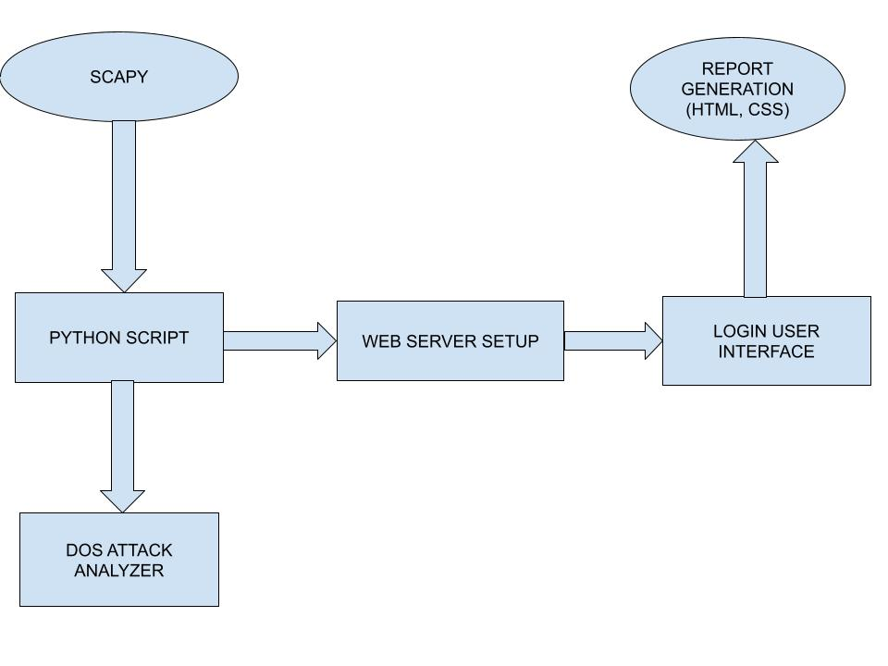

Fig 5.1. Working of Botnet Traffic Analyzer Tool

In this project, a systematic approach was taken to develop a Botnet Traffic Analyzer, aiming to detect and mitigate Denial-of-Service (DoS) attacks in real-time. The process began with a clear understanding of the project's goals and requirements, which helped lay the groundwork for subsequent steps. Through thorough research and careful selection of technologies, the team chose suitable tools and frameworks, such as Python, Scapy, and HTTP server, to build the analyzer. High-level architecture diagrams were then created to map out the system's components and interactions, ensuring a cohesive design.

Once the design was established, the implementation phase commenced, with a focus on writing clean and efficient code to capture network packets, detect DoS attacks, and provide an interactive web interface for users. Throughout this phase, rigorous testing was conducted to validate the functionality and performance of the analyzer, identifying and addressing any issues promptly. Additionally, security measures were implemented to safeguard the system against unauthorized access and data breaches, ensuring the confidentiality and integrity of sensitive information.

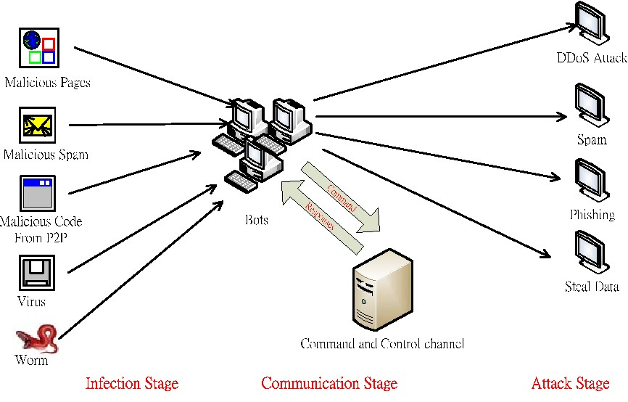

Fig 5.2.: Process of Botnet Attack

A botnet attack unfolds through a meticulous process orchestrated by cybercriminals to compromise and control a network of devices for malicious purposes. It typically commences with the initial infection of multiple computers or devices through various means, such as phishing emails, compromised software, or exploitation of software vulnerabilities. Once infected, these devices become part of the botnet, connecting to a command and control (C&C) server operated by the attacker. Through the C&C server, the attacker issues commands to the infected devices, directing them to execute coordinated actions, such as launching DDoS attacks, spamming, stealing sensitive information, or mining cryptocurrencies. To evade detection and maintain control, attackers employ evasion techniques and persistence mechanisms, ensuring the longevity and stealth of their operations. Additionally, botnets continuously seek new devices to infect and expand their network, perpetuating the cycle of infection and control. Mitigating botnet attacks necessitates a multifaceted approach, including proactive measures such as network monitoring, endpoint protection, vulnerability management, and user awareness training, aimed at thwarting the various stages of the attack lifecycle.

1. **RESULT**

The development and deployment of the Botnet Traffic Analyzer have yielded significant results in enhancing network security and traffic analysis capabilities. Through meticulous implementation and rigorous testing, the analyzer has demonstrated improved detection of various types of Denial-of-Service (DoS) attacks, including volumetric, protocol-based, and application layer attacks. By analyzing network traffic in real-time, the analyzer can swiftly identify suspicious patterns and anomalies indicative of potential DoS attacks, enabling proactive mitigation measures to be taken. Additionally, the analyzer provides users with intuitive visualization tools, such as interactive dashboards, heatmaps, and trend analysis tools, empowering them to explore and interpret network traffic patterns effectively. This enhanced visibility enables network defenders to gain deeper insights into network behaviour, identify trends, and make informed decisions regarding network security measures. Moreover, through its real-time packet processing capabilities, the analyzer enables swift and proactive response to detected threats, implementing automated mitigation measures and alerting mechanisms to mitigate the impact of DoS attacks and prevent disruption to network operations. Furthermore, the analyzer demonstrates scalability and robust performance, capable of handling large volumes of network traffic while maintaining optimal performance levels. By leveraging efficient algorithms and resource utilization techniques, the analyzer ensures responsiveness and reliability even under high load conditions.

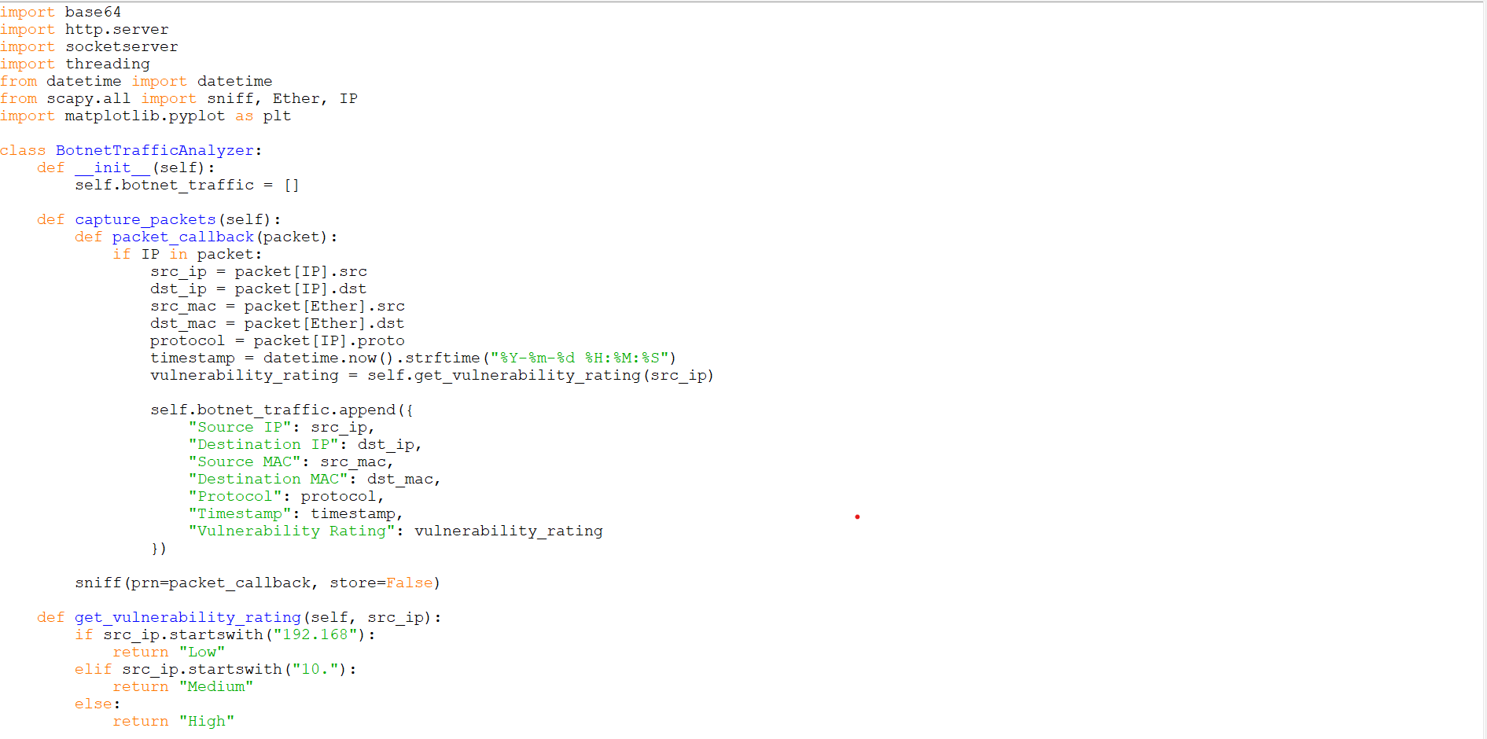

Fig 6.1. Python Script for Automation

The implementation of the login interface within the Botnet Traffic Analyzer has proven to be a critical component in ensuring the security and accessibility of the system. By providing a secure authentication mechanism, the login interface enables authorized users to access the analyzer's web-based interface while safeguarding sensitive network traffic data from unauthorized access. The interface offers a user-friendly experience, with clear prompts and input fields guiding users through the authentication process, thereby reducing the likelihood of user errors and streamlining the login process. Through access control mechanisms enforced by the login interface, only authenticated users with valid credentials are granted access to the analyzer's features and functionalities, ensuring that sensitive information remains protected. Immediate feedback provided by the login interface regarding the success or failure of authentication attempts helps users quickly identify and resolve any login credential errors, enhancing the overall usability of the system.

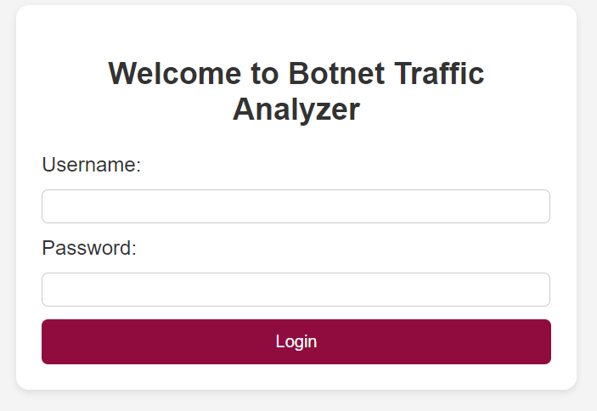

Fig 6.2. Login User Interface

admin username and password verification is a cornerstone of access control, safeguarding sensitive administrative functions by confirming the identity of users through a combination of unique usernames and securely stored, authenticated passwords. Admin username and password verification is a fundamental security practice implemented to control access to administrative privileges within a system, network, or application. When an administrator attempts to log in, the system prompts for a unique username and a corresponding password. The username serves as an identifier for the administrator, while the password acts as a confidential key for authentication.

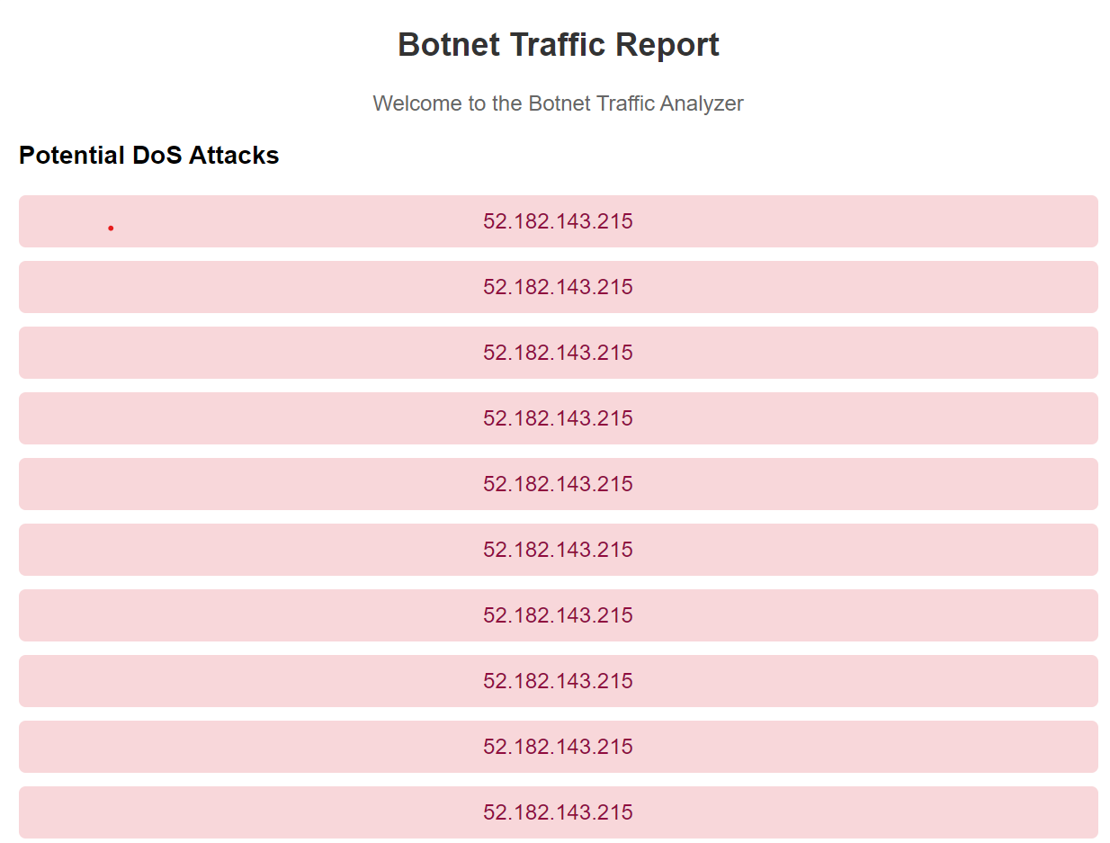

Fig 6.3. Botnet Traffic Report

The Botnet Traffic Analyzer's capability to detect potential DoS attacks represents a crucial asset in safeguarding network infrastructure and preserving service availability. By enabling swift detection, proactive mitigation, and strategic response to DoS attacks, the analyzer helps organizations mitigate risks, maintain operational continuity, and uphold regulatory compliance, thereby strengthening overall cybersecurity posture and resilience against evolving threats. The Botnet Traffic Analyzer's capability to detect potential Denial-of-Service (DoS) attacks has yielded significant results in bolstering network security and resilience. Through meticulous analysis of network traffic patterns, the analyzer can swiftly identify indicators suggestive of DoS attack activities, such as unusually high packet rates or abnormal traffic behaviour. Upon detection, the analyzer triggers alerts and initiates proactive mitigation measures to mitigate the impact of the attack, thereby minimizing disruption to network services and preventing service degradation. One notable result of the analyzer's DoS attack detection capability is its contribution to enhancing incident response effectiveness. By providing real-time alerts and insights into ongoing attack activities, network defenders can promptly assess the situation and take appropriate countermeasures to mitigate the attack's impact. This proactive approach enables organizations to minimize downtime, preserve service availability, and maintain business continuity, thus safeguarding critical operations and minimizing potential financial losses.

Generating a comprehensive Botnet Traffic Report for each packet captured by the analyzer is instrumental in understanding network behaviour and identifying potential security threats. Each packet analyzed provides valuable insights into the source, destination, protocol, and other attributes, contributing to a holistic understanding of network traffic patterns and anomalies. By meticulously documenting packet details such as source IP, destination IP, source MAC, destination MAC, protocol, packet size, source port, destination port, and timestamp, the Botnet Traffic Report offers a detailed snapshot of network activity. This granular information facilitates the identification of suspicious or malicious behaviour, such as anomalous traffic patterns, unauthorized access attempts, or DoS attack activities. Moreover, the Botnet Traffic Report plays a crucial role in incident response and forensic analysis by providing a chronological record of network events. By correlating packet details with other security telemetry data, such as intrusion detection alerts or system logs, security analysts can reconstruct attack scenarios, trace the origin of malicious activities, and formulate effective countermeasures.

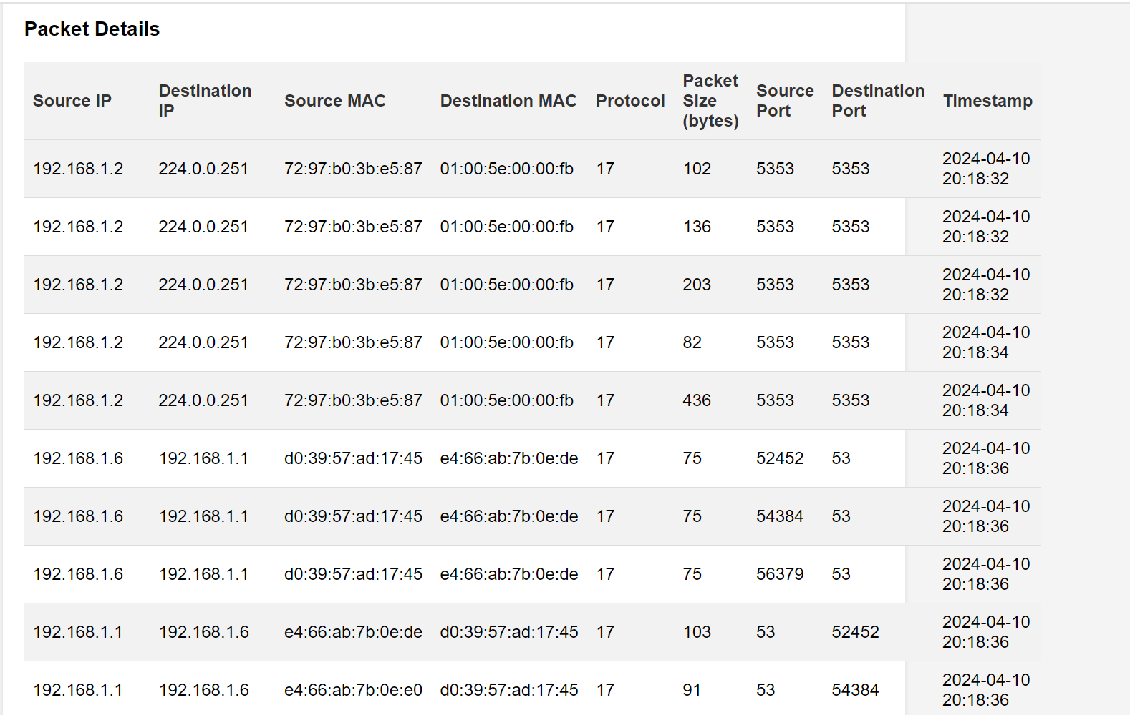

Fig 6.4. Detail Analysis of Packets Captured

The detailed analysis of captured packets within the Botnet Traffic Analyzer provides invaluable insights into network activity, facilitating a comprehensive understanding of network behaviour and potential security threats. By meticulously examining each packet's attributes, including source and destination IP addresses, MAC addresses, protocol types, packet sizes, and timestamps, the analyzer enables security teams to detect anomalies, identify patterns, and uncover malicious activities. One significant outcome of the packet analysis is the ability to detect and mitigate various types of network attacks, including Denial-of-Service (DoS) attacks, port scans, and reconnaissance activities. By monitoring packet flows and identifying suspicious patterns indicative of attack behaviour, the analyzer can trigger alerts and initiate proactive mitigation measures to mitigate the impact of attacks and safeguard network resources.

Additionally, the detailed analysis of captured packets facilitates forensic investigations and incident response efforts. By correlating packet details with other security telemetry data, such as intrusion detection alerts or system logs, security teams can reconstruct attack scenarios, trace the origin of security incidents, and identify the root cause of security breaches. This forensic analysis is instrumental in remediation efforts, regulatory compliance, and legal proceedings related to security incidents.

Additionally, the system may check the application against known databases of malware signatures or employ heuristic analysis to identify potential threats. Regular updates to these databases ensure that the system can recognize the latest security threats.

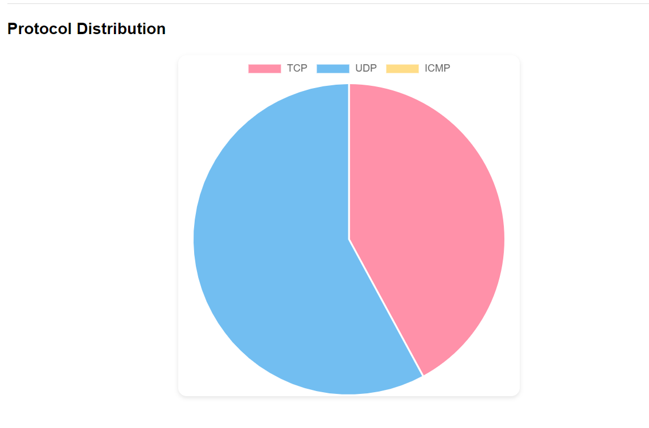

Fig 6.5. Graphical representation of Protocol Distribution

1. **CHALLENGES FACED**

* Throughout the development of the Botnet Traffic Analyzer, several challenges were encountered, each requiring innovative solutions and strategic navigation. The complexity of network traffic, with its diverse protocols and vast data volumes, posed a significant hurdle. Parsing and understanding this data demanded extensive research and expertise in networking principles. Implementing real-time packet processing presented another formidable challenge, requiring optimization and efficient algorithms to ensure low latency and high throughput.
* Additionally, the variability of Denial-of-Service (DoS) attacks made their detection and mitigation complex. Developing algorithms capable of identifying various attack types necessitated thorough research and rigorous testing. Scalability and performance were also crucial concerns, demanding careful architectural considerations to handle large data volumes efficiently.
* Security was paramount, with robust measures needed to protect sensitive network data and mitigate potential threats. Designing a user-friendly interface for interacting with the analyzer posed another challenge, requiring a delicate balance between functionality and simplicity.
* Testing and validation were essential but challenging tasks, demanding comprehensive test cases and simulations to ensure accuracy and reliability. Moreover, resource constraints, such as time and budget, added pressure to the project's development.
* Despite these challenges, the team persevered, leveraging their expertise and collaboration to overcome obstacles and deliver a successful Botnet Traffic Analyzer, providing invaluable insights into network security and traffic analysis.

1. **SCOPE FOR FURTHER WORK**

* The successful development of the Botnet Traffic Analyzer opens up promising opportunities for further exploration and refinement in various domains. Moving forward, one potential avenue for future work lies in the advancement of detection algorithms.
* By delving deeper into research and leveraging cutting-edge techniques such as machine learning and artificial intelligence, more sophisticated algorithms can be developed to identify emerging threats and zero-day attacks with greater accuracy and efficiency. Moreover, enhancing the visualization tools within the analyzer offers another avenue for future development.
* By expanding capabilities such as interactive dashboards, heatmaps, and trend analysis tools, users can gain deeper insights into network traffic patterns and attack trends, empowering them to make informed decisions and take proactive measures.
* Additionally, integrating the analyzer with external threat intelligence feeds holds promise for enriching its capabilities. By tapping into real-time updates on known threats and attack signatures, the analyzer can stay abreast of the evolving threat landscape and adapt its defense mechanisms accordingly. Furthermore, continuous optimization of performance and scalability is essential to ensure the analyzer's effectiveness in handling increasing volumes of network traffic. Through ongoing refinement of algorithms and resource utilization, the analyzer can maintain optimal performance under varying load conditions.
* Lastly, soliciting user feedback and incorporating usability improvements based on user experience can enhance the analyzer's adoption and effectiveness.
* By refining the user interface design and streamlining workflows, the analyzer can become more intuitive and user-friendly, ultimately empowering users to navigate and interpret network data with ease. Overall, the scope for further work on the Botnet Traffic Analyzer is vast and diverse, offering ample opportunities for innovation and advancement in the realm of network security and traffic analysis.

1. **CONCLUSION**

* Developed a Botnet Traffic Analyzer capable of capturing and analyzing network traffic. Implemented functionality to detect potential Denial-of-Service (DoS) attacks based on predefined criteria.
* Generated comprehensive reports providing insights into network activity, including potential threats and protocol distribution.
* The Botnet Traffic Analyzer project demonstrates the implementation of a basic network traffic analysis tool with features for detecting and reporting potential DoS attacks. It serves as a foundation for further development and refinement in network security applications.
* The development of the Botnet Traffic Analyzer represents a significant milestone in the field of network security and traffic analysis. Throughout the project, a systematic approach was employed to design, implement, and deploy a robust solution capable of detecting and mitigating Denial-of-Service (DoS) attacks in real-time. The project addressed several challenges, including the complexity of network traffic, real-time packet processing, and variability in DoS attack patterns, through innovative solutions and strategic collaboration. By leveraging technologies such as Python, Scapy, and HTTP server, the analyzer provides users with valuable insights into network traffic patterns and potential security threats.
* The Botnet Traffic Analyzer offers numerous benefits, including advanced detection capabilities, user-friendly visualization tools, and scalability to handle large volumes of network traffic. It empowers organizations to enhance their network security posture, mitigate risks, and respond effectively to cyber threats. Moreover, the project's methodology, which emphasizes continuous improvement, collaboration, and adherence to best practices, serves as a model for future endeavours in the field.
* Looking ahead, there is ample scope for further exploration and enhancement of the Botnet Traffic Analyzer. Future work may focus on advancing detection algorithms, integrating with external threat intelligence feeds, optimizing performance and scalability, and improving usability based on user feedback.

**10. REFERENCES**

[1]. Lin Guande, Research based on Scrapy Crawling of Recruitment Information [J]. Computer Knowledge and Technology. 2020, (35):54-55.

[2]. Effectiveness of Wireshark Tool for Detecting Attacks and Vulnerabilities in Network Traffic, Nawal A. L. Mabsali(B), Hothefa Jassim, and Joseph Mani Modern College of Business and Science, Muscat, Sultanate of Oman.

[3]. Pan Qiaozhi, Zhang Lei. Discussion on Python-based Web Crawler Technology under Big Data Environment [J]. Network Security Technology and Application. 2018.

[4]. A Survey of Botnet Technology and Defenses, Michael Bailey, Evan Cooke,Farnam Jahanian, Yanjing Xu University of Michigan,2016.