1. Visit following webpage-

<https://www.paypal.com/in/webapps/mpp/account-selection?pros=2>

choose “For Business”

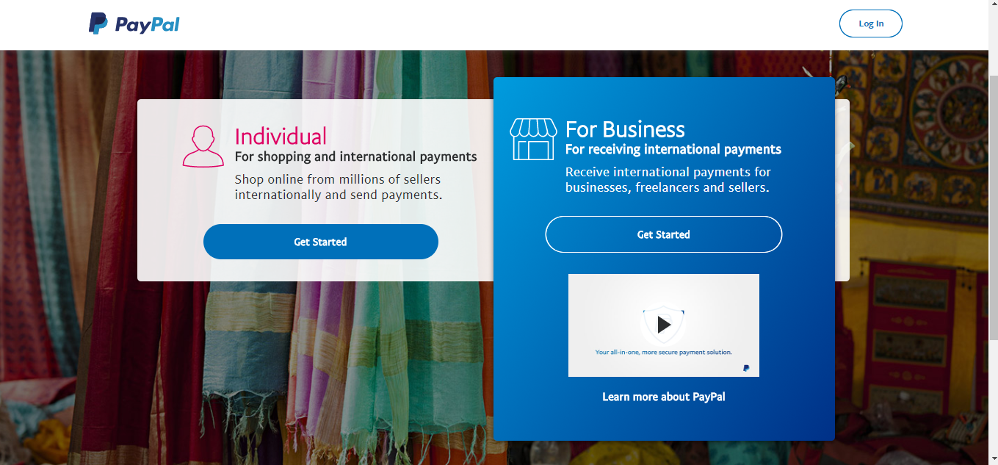

1. Go through the signup procedure

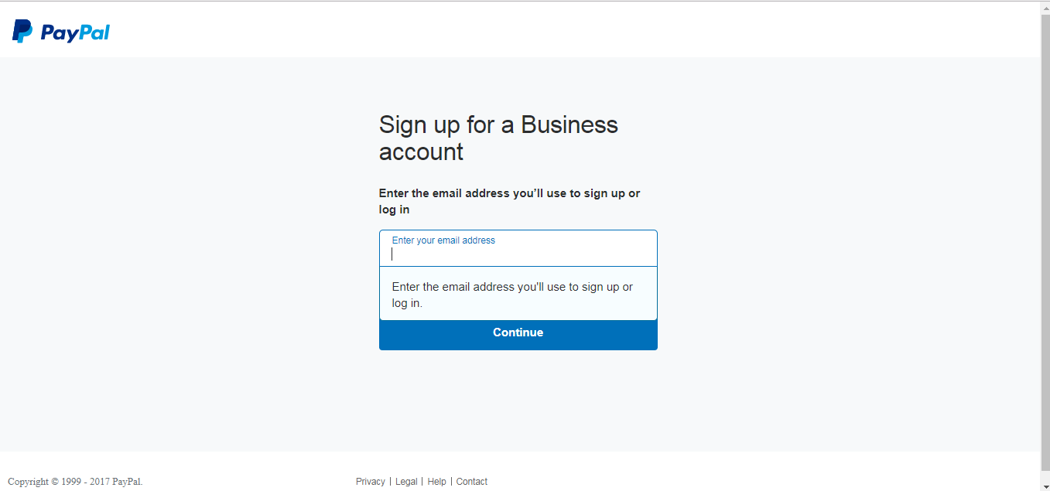

1. After completion of signup, you need to verify your email id and then login with your email and password.

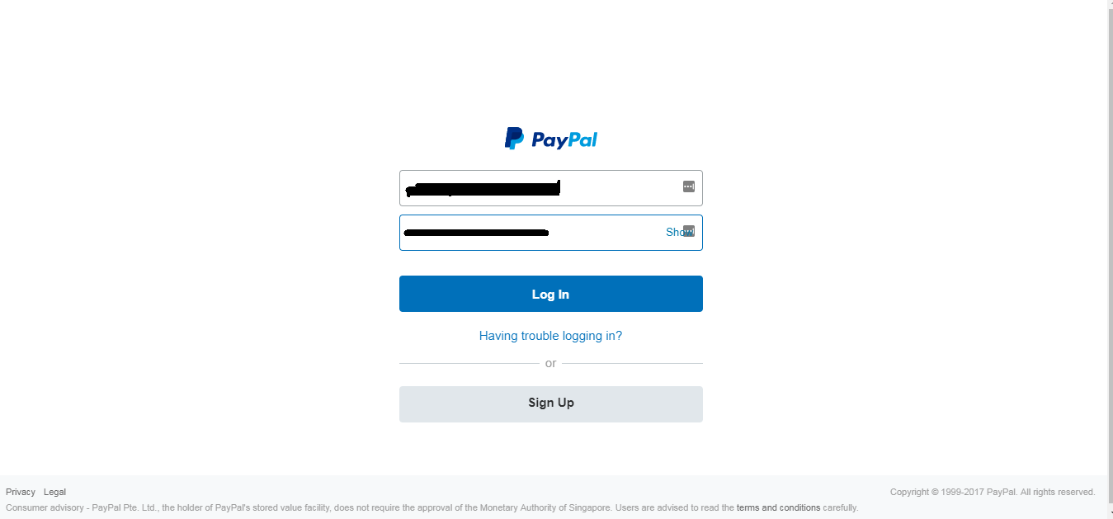

1. After logging in, go to following url-

<https://developer.paypal.com/developer/accounts/>

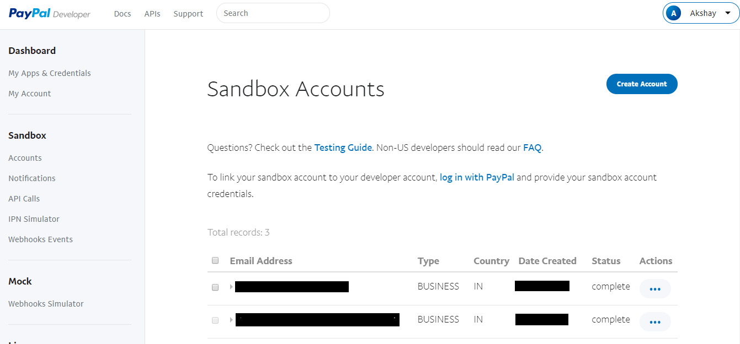

1. Click on create account and verify your email and password.
2. After creating a sandbox account go to “My Apps & Credentials” tab on upper left corner.

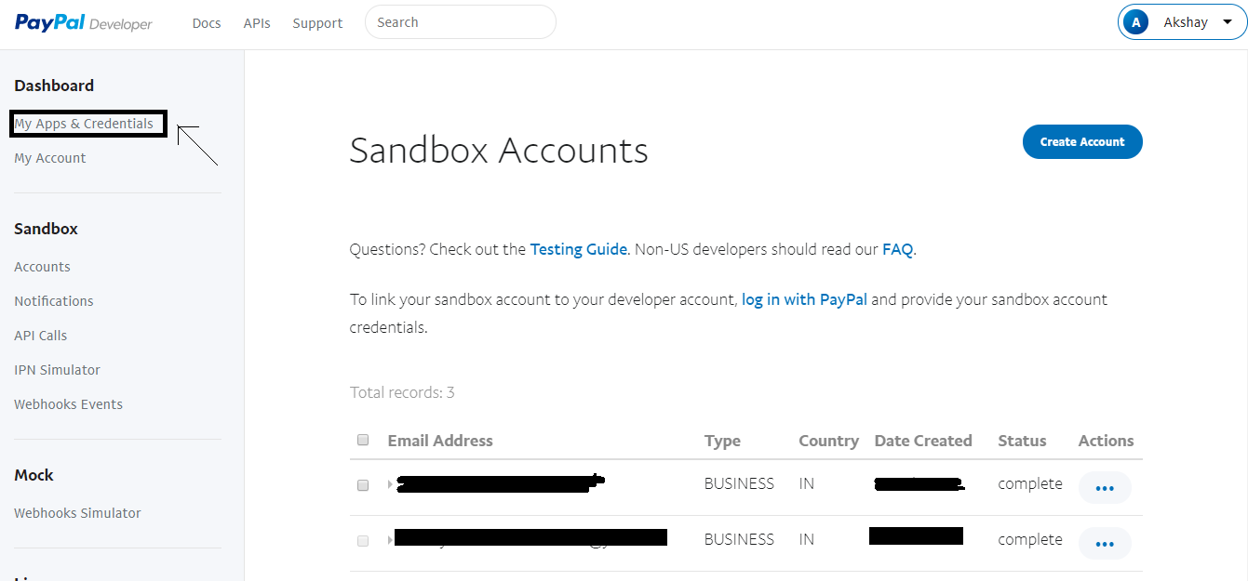

1. In “My Apps & Credentials” section travel to “REST API apps”

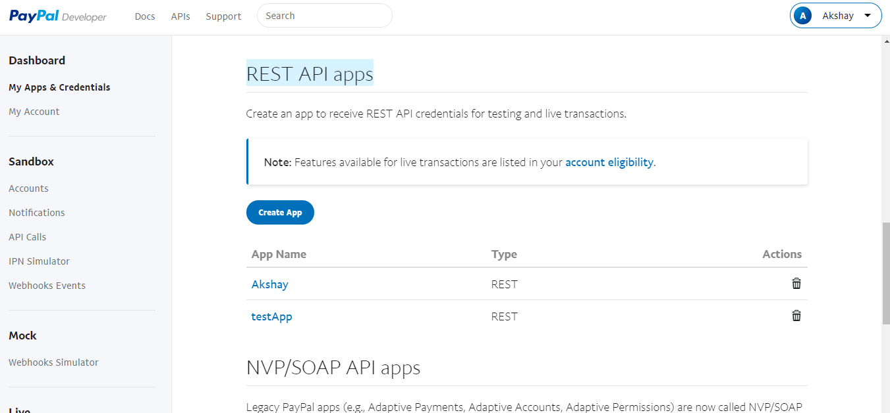

1. Click on create app it will ask you for app name, and sandbox account.

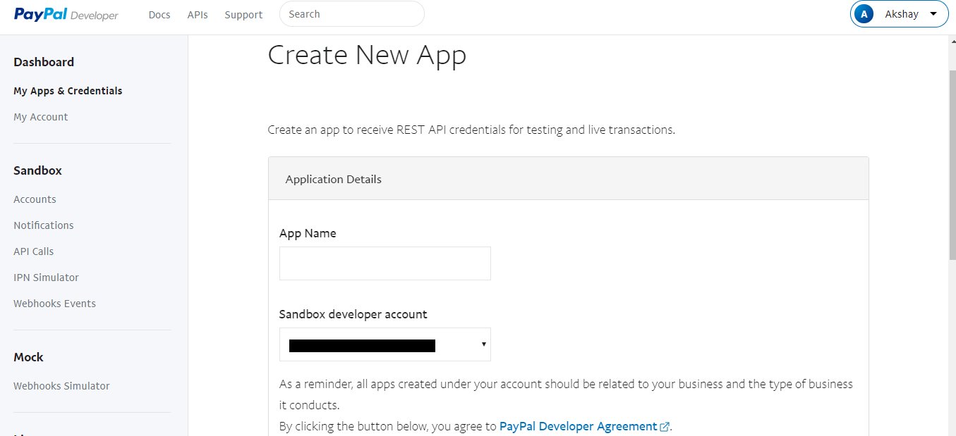

1. It will give you sandbox account email and the client id and secret key-

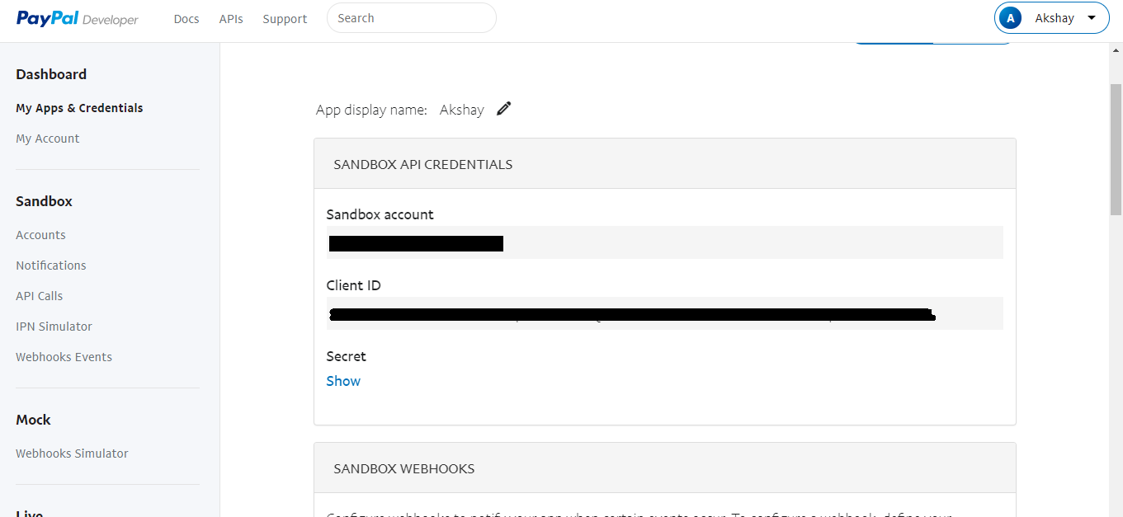

1. That’s all we need to get started with setting payment gateway using paypal.