1. Help :

Here if we can **Help** as a dropdown and add the values (online application process for new connection, List of documents) to it. It would look good

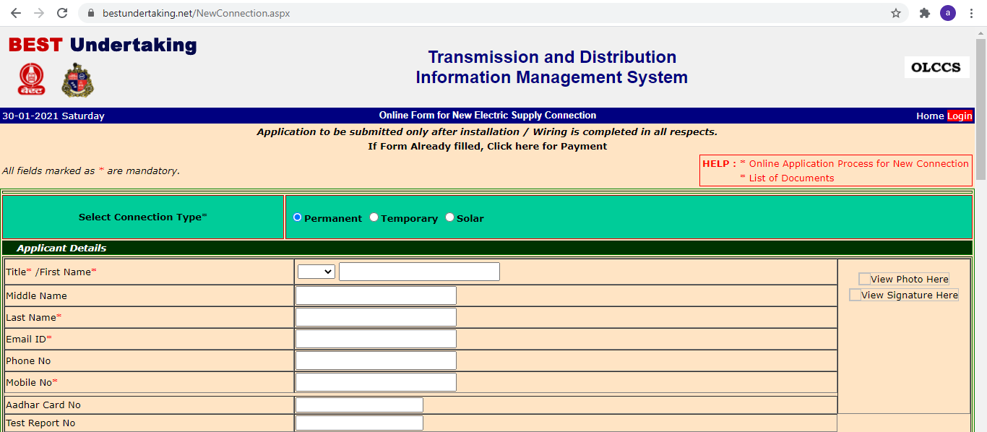

1. View photo Here :

If the View photo here is a link where we can click and directly upload there photo here. Then it should show the photo of user it would be good



1. View Signature Here :

If the View Signature here is a link where we can click and directly upload there Signature here. Then it should show the Signature of user it would be good



1. Pin Code/Select Area/Select road name:

It would be better to have Pin Code/Select Area/Select road name field as a text box rather than a dropdown.

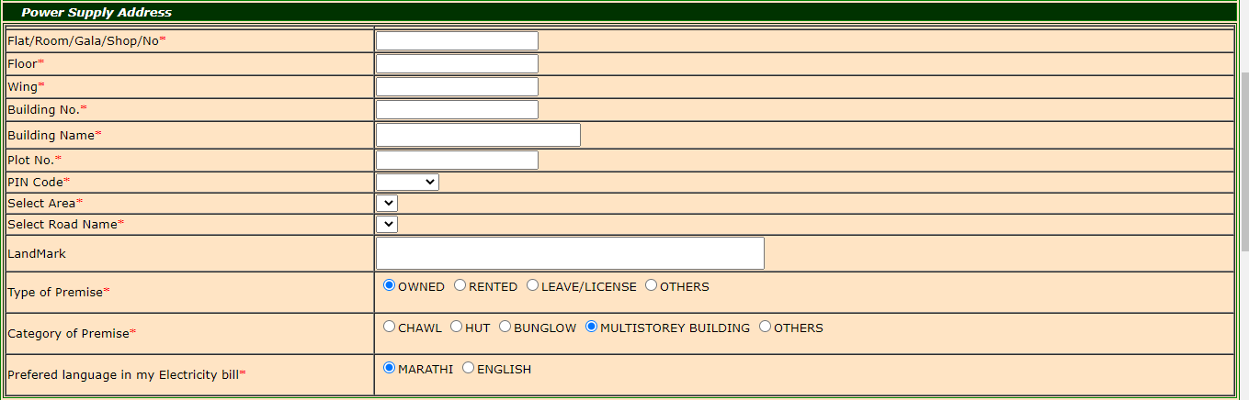

1. Preferred language in my Electricity bill:

It would be better to have language field as a dropdown rather than radio button



1. Documents

Here it would be better to have anyone and have both functionalities choosing file and uploading in it.

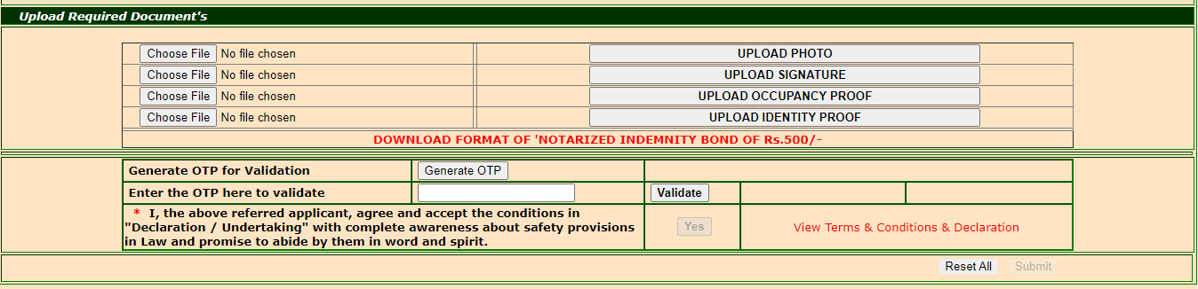

1. Title of the webpage is not in center.

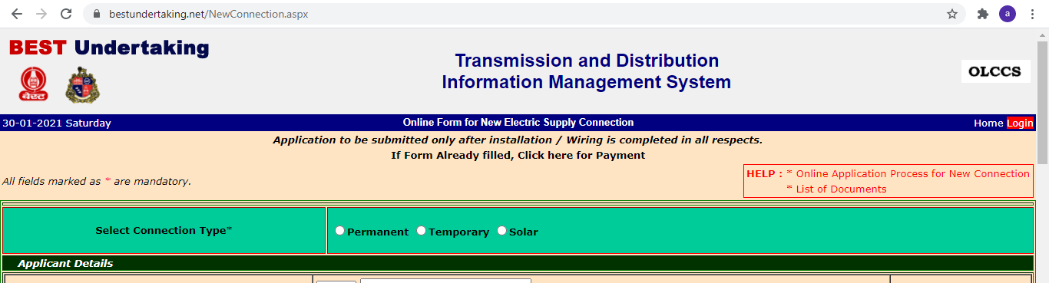

1. Better to have a dropdown rather than radio button



1. It would be better to have the below sections in different pages rather than having in one page ***Applicant Details***

***Power Supply Address***

***Connection Details***

***Upload Required Document's***

Bugs:

1. When we give an alphanumeric value in total load filed it redirects to some other error page

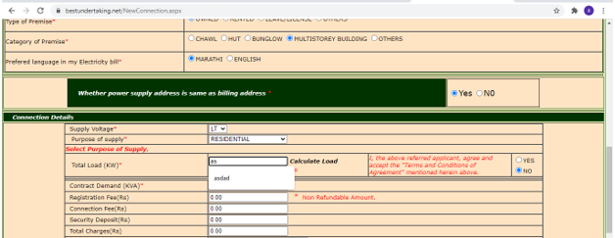

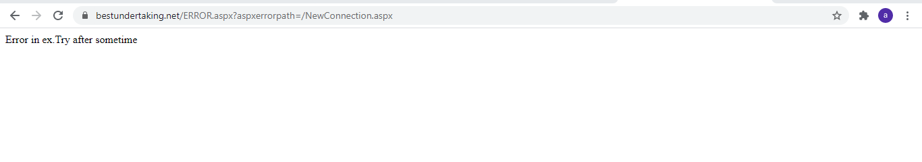

1. When we click on Reset all the fields are not getting blank

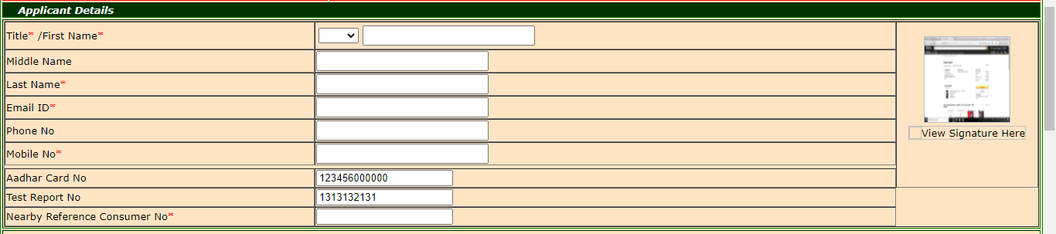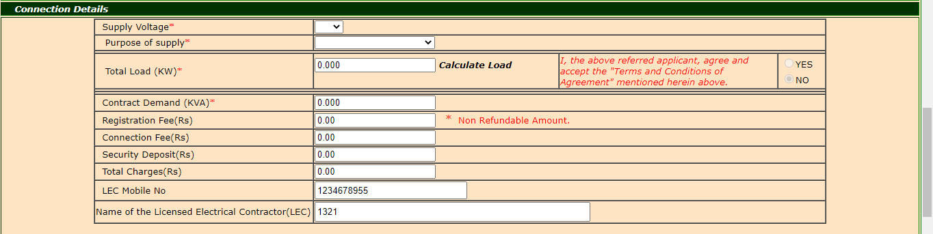

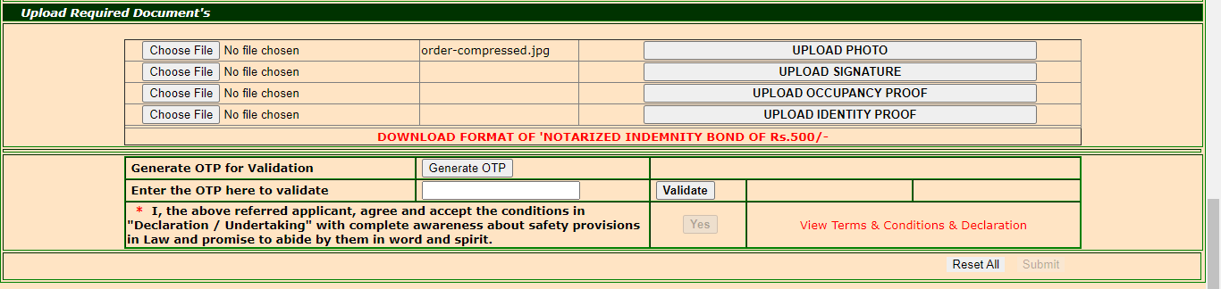

1. Even if don’t enter OTP and click on validate button the Yes button is getting enabled

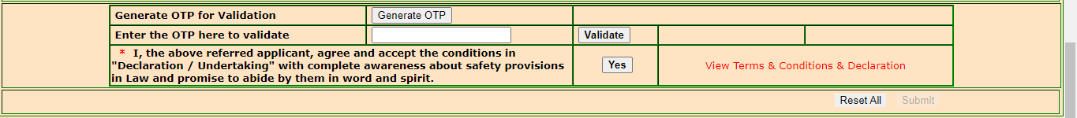

1. The validate OTP field should be mandatory field



1. When we click submit by keeping all the fields blank, For the first filed we are getting Required twice

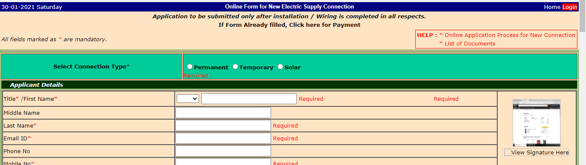

1. It’s taking lot of time to load

