BIRLA INSTITUTE OF TECHNOLOGY & SCIENCE, PILANI
Work Integrated Learning Programmes Division
AIML ZG535 — Machine Learning on Edge
LogiEdge: Intelligent Edge AI Platform for Cold-Chain Logistics
Phase 1 Report: System Planning & Architectural Design

Group 27
Linda Kuriakose | 2024AC05557
Akshay Ashok Deshpande | 2024AD05483
Kamalesh Kumar Gadhwal | 2024AC05919
A Jaya Suriya | 2024AD05006

Abstract
Cold-chain logistics plays a vital role in transporting temperature-sensitive products such as vaccines, pharmaceuticals, dairy products, and fresh food. Even minor deviations in environmental conditions can reduce product quality and lead to substantial financial losses. Traditional monitoring systems generally rely on cloud-based processing, which introduces delays in detecting abnormal conditions due to network latency, bandwidth limits, or temporary connectivity loss.
This project introduces LogiEdge, a lightweight Edge AI system designed to monitor cold-chain transport conditions locally on-device for FreightBridge Logistics' 85-truck pharmaceutical pilot fleet. The system simulates multi-sensor telemetry, processes incoming streams in real time using a 5-sample moving-average filter and a 30-second/10-second sliding window, and prepares a 7-value feature vector for machine learning-based anomaly classification. The proposed architecture prioritises local edge inference to ensure real-time response times while maintaining minimal computational overhead and remaining functional through cellular connectivity gaps of up to 90 minutes on the target route.
Phase 1 focuses on the planning and design aspects of the solution: it establishes functional requirements and hardware/network constraints with quantified figures, proposes an edge-based processing architecture, and justifies the hardware and communication technologies selected for implementation using the Constraint Triangle framework and a Roofline/Arithmetic Intensity analysis.

1. Introduction
The demand for safe, verifiable transportation of temperature-sensitive goods has made cold-chain monitoring an essential domain within modern supply chain management. Goods such as vaccines, biological samples, and fresh produce require continuous adherence to strictly regulated environmental thresholds. Any unmonitored rise in temperature, severe mechanical shock from road vibration, or prolonged door openings can compromise shipment safety before reaching the destination.
While IoT deployment has enabled continuous sensor data collection, conventional solutions remain heavily reliant on cloud platforms for anomaly detection and analytics. This centralised paradigm presents critical vulnerabilities during transit:
- Latency & Congestion: continuous raw telemetry streaming over cellular networks (4G/LTE) incurs significant bandwidth cost and latency.
- Connectivity Outages: FreightBridge's Nashik–Aurangabad route loses cellular coverage for 35–90 minutes at seven documented locations; vehicles in these dead zones cannot receive real-time cloud-generated alerts, increasing spoilage risk.
- Contractual privacy requirements: pharmaceutical clients require assurance that raw cargo-condition data is not exposed to third-party cloud processors.
Edge AI mitigates these limitations by executing machine learning inference directly on the truck-mounted device, so that anomaly detection does not depend on an active network link. LogiEdge implements this approach end-to-end: sensor simulation, MQTT-based local messaging, windowed feature extraction, on-device TFLite inference, PSI-based drift monitoring, and an Ansible-managed Docker deployment pipeline.

2. Edge AI Constraint Analysis (Quantified)

2.1 Latency Constraint
FreightBridge requires fault detection and alerting within 90 seconds of onset. LogiEdge's window step is 10 seconds (30-second window, 10-second step), so a fault signature is visible to the classifier within one step interval — well inside the 90-second budget. Measured on-device inference latency (Section 4, Phase 2 results) is sub-millisecond, so the window cadence, not model compute, is the limiting factor. Cloud inference cannot meet this SLA on this route: round-trip latency of 150–400 ms is irrelevant once the truck enters a 35–90 minute coverage gap — there is no link at all for the SLA to be measured against.

2.2 Bandwidth Constraint
Stream | Rate | Bytes/sample | Bytes/day (raw)
Temperature | 1 Hz | 4 B (float32) | 345,600 B (~0.34 MB)
Vibration (3-axis, raw) | 500 Hz | 12 B | 518,400,000 B (~494.4 MB)
Door events | ~20/day | ~50 B | ~1 KB

Raw uncompressed streaming totals ~494.7 MB/truck/day. At ₹0.10/MB this is ₹49.47/truck/day, or ₹4,205/day (~₹1.26 lakh/month) across the 85-truck pilot. LogiEdge instead keeps raw telemetry on the truck's local MQTT broker and ships only classification results (~150 B JSON) once per 10-second window — about 1.3 MB/truck/day, a 99.7% reduction, consistent with the project's ~98% target.

2.3 Connectivity Constraint
A cloud-only system goes completely blind for the duration of each 35–90 minute coverage gap on the route: no telemetry reaches the backend and no alert can be raised. At a 1°C/minute spoilage rate, a single blackout can compromise an entire shipment. LogiEdge's edge node keeps classifying locally regardless of link state, logs alerts to local storage, and backfills to the operations centre once connectivity returns.

2.4 Privacy Constraint
Pharmaceutical clients require assurance that cargo-condition data is not exposed to unauthorised third parties. Because raw telemetry never leaves the vehicle — only a class label and confidence score cross the cellular link — there is no cloud data store of raw sensor streams to be breached or mishandled by a third-party processor.

3. Hardware Selection — Constraint Triangle Analysis
Three candidate platforms were evaluated against Cost, Power, and Compute/Latency capability, plus a fourth non-negotiable constraint: the project's mandated software stack (Docker, local Mosquitto broker, Ansible-managed deployment).
Option | Hardware | Price (India) | TDP
1 | Raspberry Pi 5 (8GB) + AI HAT+ (13 TOPS) | ~₹15,000/truck | 7.5 W
2 | Jetson Orin Nano Super Dev Kit (67 TOPS) | ~₹45,000/truck | 15 W (moderate load)
3 | STM32H7 MCU + sensor ICs | ~₹3,500/truck | 0.4 W

Fleet cost at scale (85-truck pilot → 265-truck full fleet):
Option | Pilot (85 trucks) | Full fleet (265 trucks)
Pi 5 + AI HAT+ | ₹12,75,000 | ₹39,75,000
Jetson Orin Nano | ₹38,25,000 | ₹1,19,25,000
STM32H7 MCU | ₹2,97,500 | ₹9,27,500

Compute/latency is not the deciding factor: the trained model (32→16→3 MLP) runs in sub-millisecond time on plain CPU, so all three options clear the 90-second SLA trivially and hardware AI-accelerator TOPS ratings (13/67) are irrelevant to this workload. Power is satisfied by all three. Cost at fleet scale dominates: the Jetson costs 3x the Pi 5 option and 13x the MCU option for zero latency benefit, and is rejected outright.
The deciding constraint is the mandated software platform. Docker, a local Mosquitto broker, and Ansible-managed deployment all require a full Linux userspace and Python runtime. The STM32H7 is a bare microcontroller and cannot host this stack without an added Linux gateway device, which erases its cost/power advantage. Raspberry Pi 5 + AI HAT+ is therefore selected: it clears the latency SLA by orders of magnitude, sits comfortably inside the 10 W power budget, remains affordable at fleet scale relative to a single ₹28 lakh spoilage incident, and natively supports every mandated software deliverable.

3.1 Arithmetic Intensity and Roofline Classification
Given: model performs 45 MFLOPs/inference, accesses 18 MB of data per inference. Raspberry Pi 5 CPU: 16 GFLOP/s peak compute (NEON SIMD), 12 GB/s peak LPDDR4X bandwidth.
- Arithmetic Intensity = FLOPs / Bytes = 45×10⁶ / 18×10⁶ = 2.5 FLOPs/byte
- Ridge point = Peak Compute / Peak Bandwidth = 16 GFLOP/s / 12 GB/s = 1.33 FLOPs/byte
Since AI (2.5) > Ridge point (1.33), the model sits to the right of the ridge point on the roofline: it is compute-bound, not memory-bandwidth-bound. This means memory-layout/caching optimisations offer limited benefit; the effective levers are ones that reduce FLOPs (structured pruning) or raise effective throughput per FLOP (INT8 quantisation on NEON SIMD) — which is exactly the M2/M3 optimisation path implemented in Phase 2.

4. Sensor Specification
Sensor | Purpose | Sampling Rate | Normal Parameters
Temperature | Refrigerated storage temperature | 1 Hz | N(4.0°C, 0.3) — setpoint 4°C
Vibration | Compressor/mechanical anomaly | 0.5 Hz | N(0.45g, 0.05) RMS
Door | Open/close event detection | Discrete event | 'OPEN' or 'CLOSE' with timestamp

5. Proposed System Architecture
The architecture below reflects the as-built LogiEdge pipeline. Two points are worth calling out explicitly, since they are easy to get wrong in a first-pass design: the MQTT consumer and the inference service are independent subscribers to the same raw telemetry topic (not a sequential chain), and the training-time preprocessing path is entirely separate from the live inference path, though both call the same feature-extraction function so training and serving never diverge.
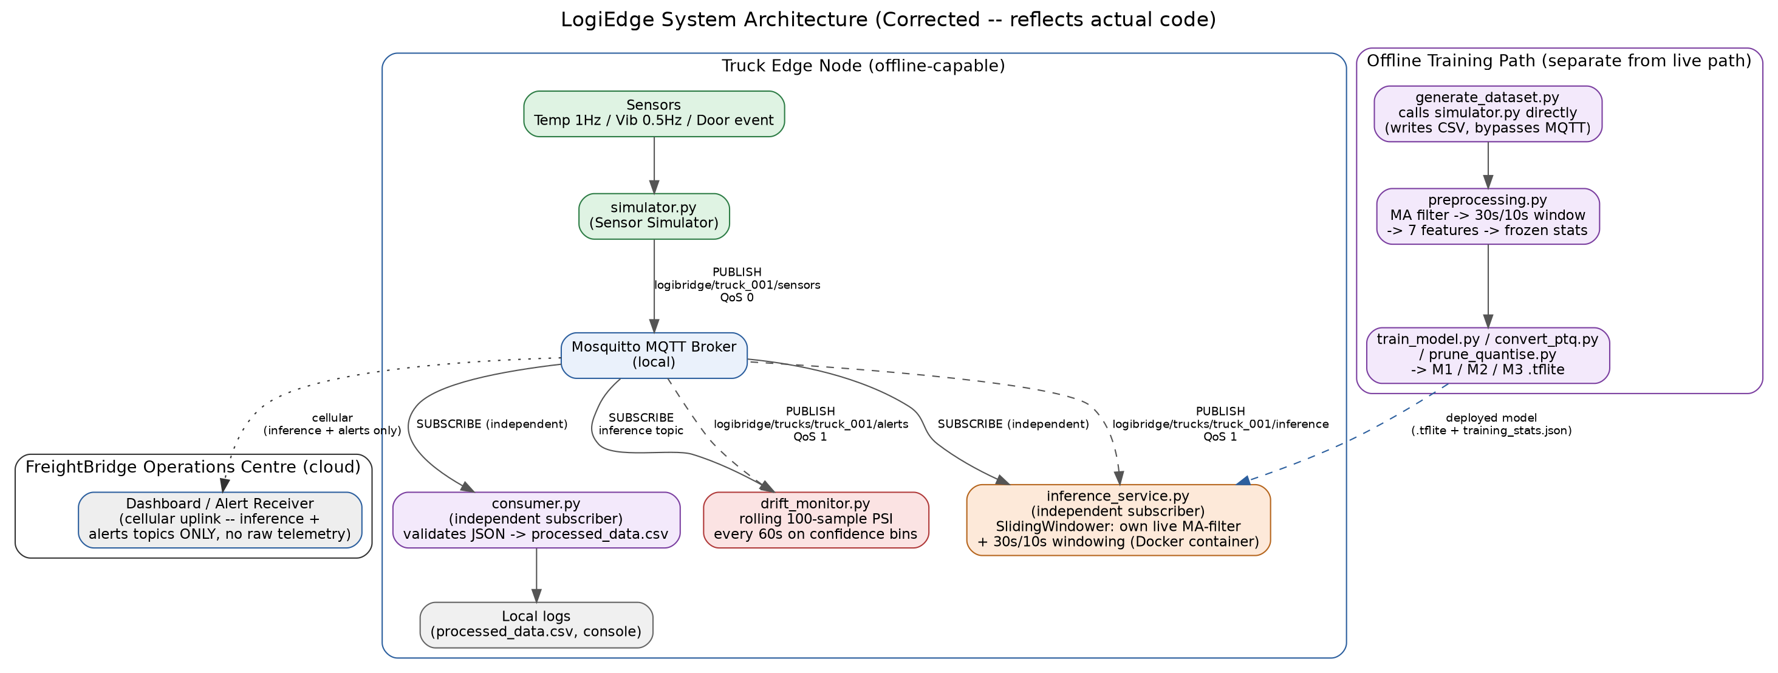
Figure 1: LogiEdge system architecture — truck edge node, offline training path, and cloud operations centre.
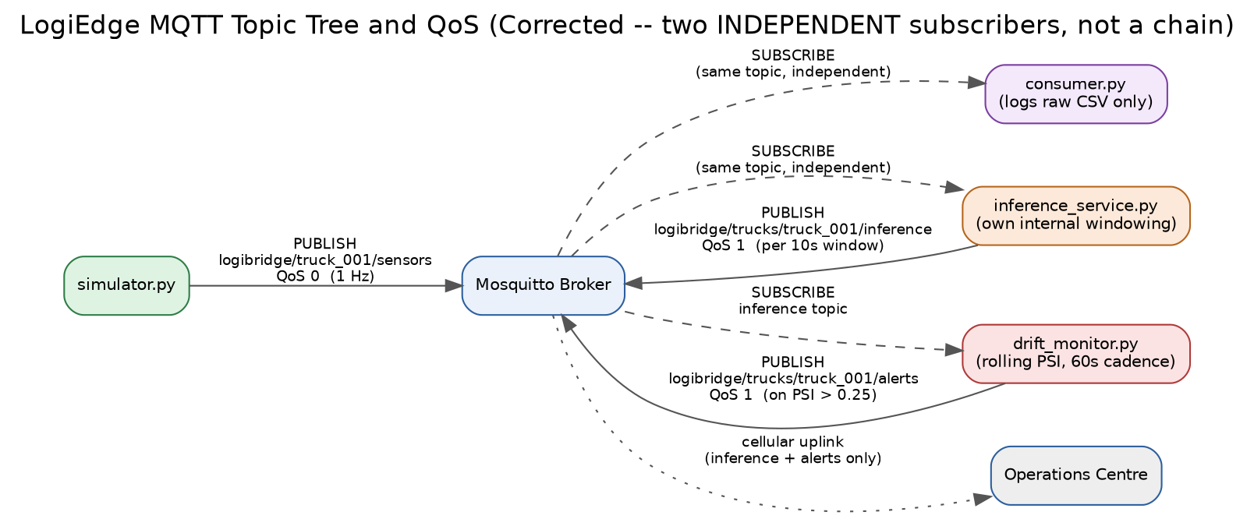
Figure 2: MQTT topic tree, QoS levels, and independent-subscriber pattern.

5.1 Component Summary
- Sensor Simulator: publishes temperature/vibration/door telemetry to logibridge/truck_001/sensors at QoS 0.
- Mosquitto Broker: local, on-truck message hub — no raw telemetry ever reaches the cellular link.
- MQTT Consumer: independent subscriber, validates JSON schema, logs to processed_data.csv.
- Preprocessing Pipeline: 5-sample moving average → 30s/10s sliding window → 7-value feature vector, normalised against a frozen Normal-class baseline.
- TFLite Inference Service: independent subscriber; Docker-packaged; runs its own live windowing (identical math to offline preprocessing) and publishes predictions at QoS 1.
- PSI Drift Monitor: rolling 100-sample window on output confidence bins, checked every 60s, publishes alerts at QoS 1.
- Deployment: Docker container + Ansible playbook (7 tasks, idempotent) for fleet rollout.

6. Data Fusion Strategy
LogiEdge implements feature-level fusion: temperature and vibration features are extracted independently within each 30-second window, then concatenated into a single joint feature vector (temp_mean, temp_std, temp_slope, vib_rms, vib_peak, vib_kurtosis, plus door_open_ratio) before being passed to the classifier. This is preferred over data-level fusion (concatenating raw temperature and vibration samples before any feature extraction), which would force the model to learn its own noise-robust statistics from scratch on a very small training set (~300 windows) — infeasible with a 2-hidden-layer MLP. It is also preferred over decision-level fusion (separate per-sensor classifiers combined by voting), which would triple the number of models to maintain on a resource-constrained device for no accuracy benefit, since temperature and vibration anomalies are frequently correlated (e.g., a stuck compressor raises both vibration and temperature together) and a joint feature vector lets the model learn that correlation directly.

7. Conclusion
Phase 1 establishes a quantified case for edge inference over cloud processing on every relevant axis — latency, bandwidth, connectivity, and privacy — and selects the Raspberry Pi 5 + AI HAT+ as the target hardware through an explicit Constraint Triangle and Roofline analysis rather than a qualitative preference. The proposed architecture, sensor specification, and feature-level fusion strategy defined here are carried forward unchanged into the Phase 2 implementation.

