BIRLA INSTITUTE OF TECHNOLOGY & SCIENCE, PILANI
AIML ZG535 — Machine Learning on Edge
LogiEdge: Intelligent Edge AI Platform for Cold-Chain Logistics
Phase 2 Report: Implementation, Optimisation & Experimentation
Group 27
Linda Kuriakose | 2024AC05557
Akshay Ashok Deshpande | 2024AD05483
Kamalesh Kumar Gadhwal | 2024AC05919
A Jaya Suriya | 2024AD05006

1. Scope of Phase 2
Phase 1 established the architecture, hardware selection, and constraint analysis. Phase 2 implements and evaluates that design: the sensor simulator and data pipeline, the windowed preprocessing pipeline, three model variants (M1 FP32, M2 INT8 PTQ, M3 pruned+INT8), five-metric benchmarking, the mandatory normalisation shift experiment, Docker containerisation, drift monitoring, and Ansible deployment. All results below are taken directly from console output and artefact files produced on the development machine; screenshots are included as evidence alongside each result.

2. Sensor Simulation and Dataset Generation
generate_dataset.py drives the simulator directly for each class (Normal 20 min, Warning/temp_drift 15 min, Critical/combined 15 min), then runs the windowed preprocessing pipeline. The Normal-class run additionally freezes training_stats.json (Task C2's requirement that baseline normalisation statistics come from clean Normal-class data only, and are never recomputed from anomalous or live data afterward).
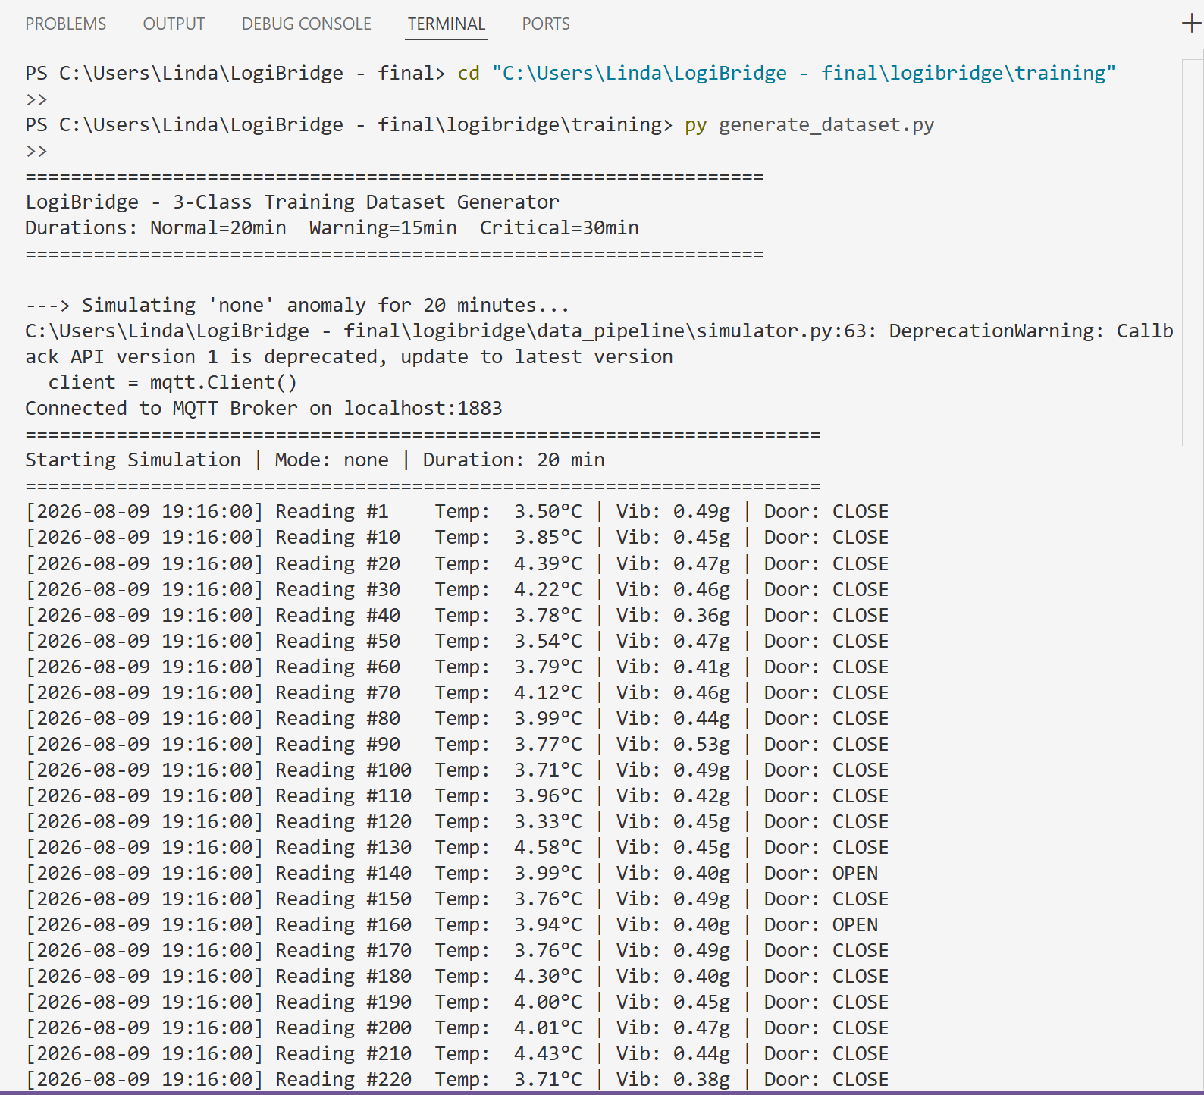
Figure 3: generate_dataset.py — Normal-class simulation run.
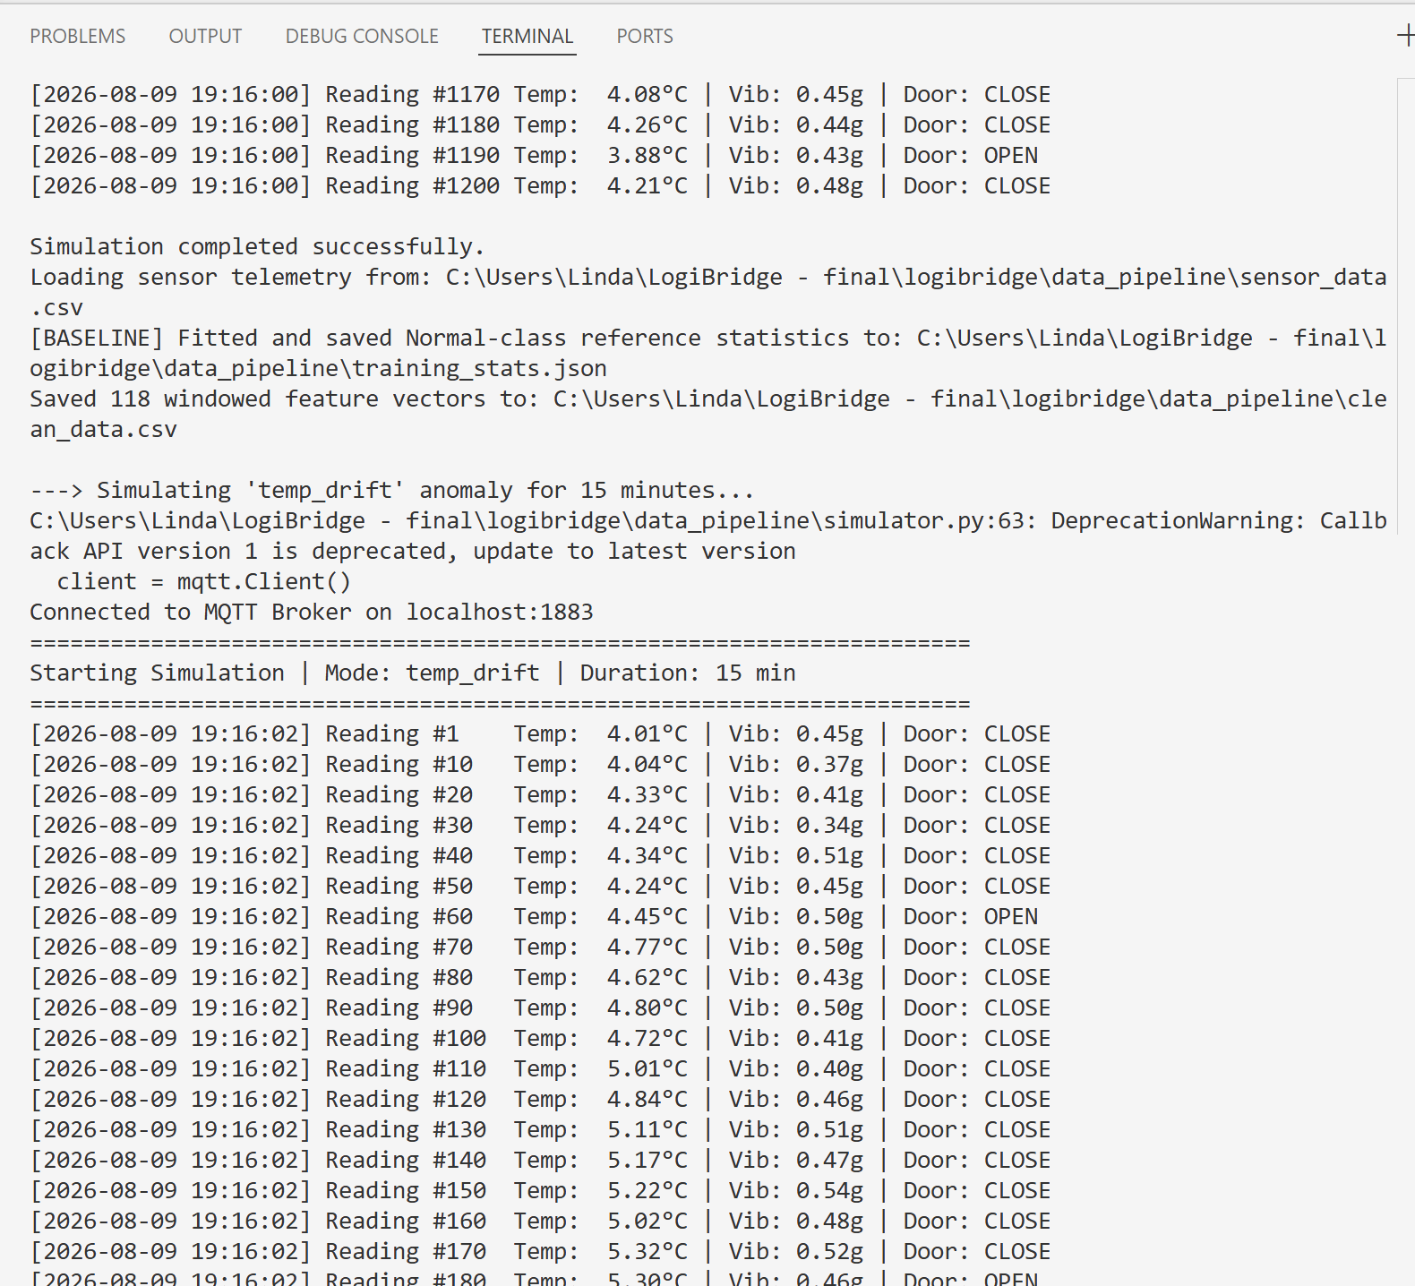
Figure 4: generate_dataset.py — dataset generation completing with class distribution.

3. Preprocessing Pipeline and Frozen Baseline Statistics
The pipeline applies a 5-sample moving-average filter to temperature and vibration, extracts a 30-second window (10-second step) worth of six statistical features (temp_mean, temp_std, temp_slope in °C/min, vib_rms, vib_peak, vib_kurtosis), and appends a door_open_ratio auxiliary feature to support the Critical-class rule (door open + rapid temperature rise). The same extract_window_features() function is imported by both the offline batch pipeline and the live inference service, so training-time and serving-time features are computed identically — there is no train/serve skew.
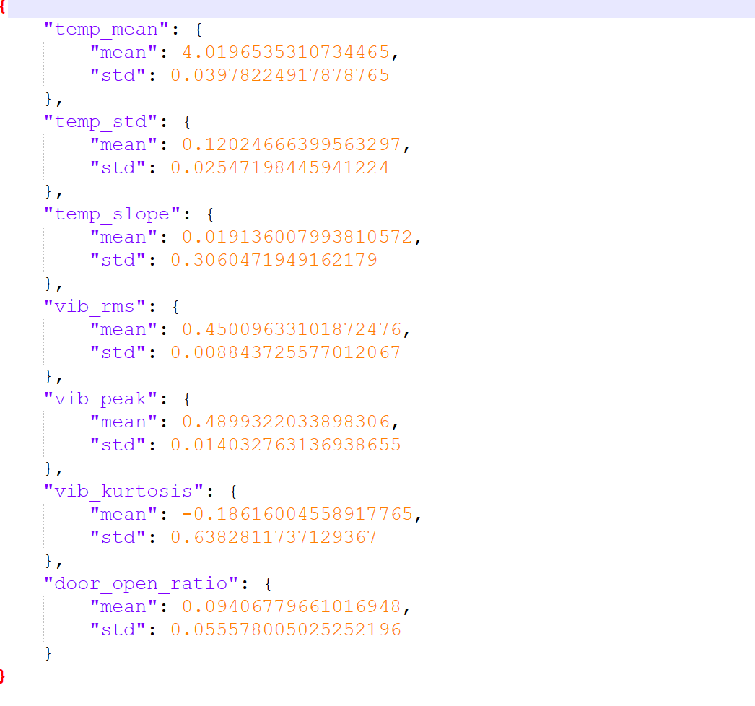
Figure 5: training_stats.json — frozen Normal-class baseline (mean/std per feature). Setpoint recovered at 4.02°C, matching the simulator's 4.0°C target.

4. Model Training — M1 Baseline
A 2-hidden-layer MLP (Dense 32 + ReLU, Dense 16 + ReLU, Dense 3 + Softmax) was trained for 25 epochs on the 7-feature windowed dataset with an 80/20 train/validation split.
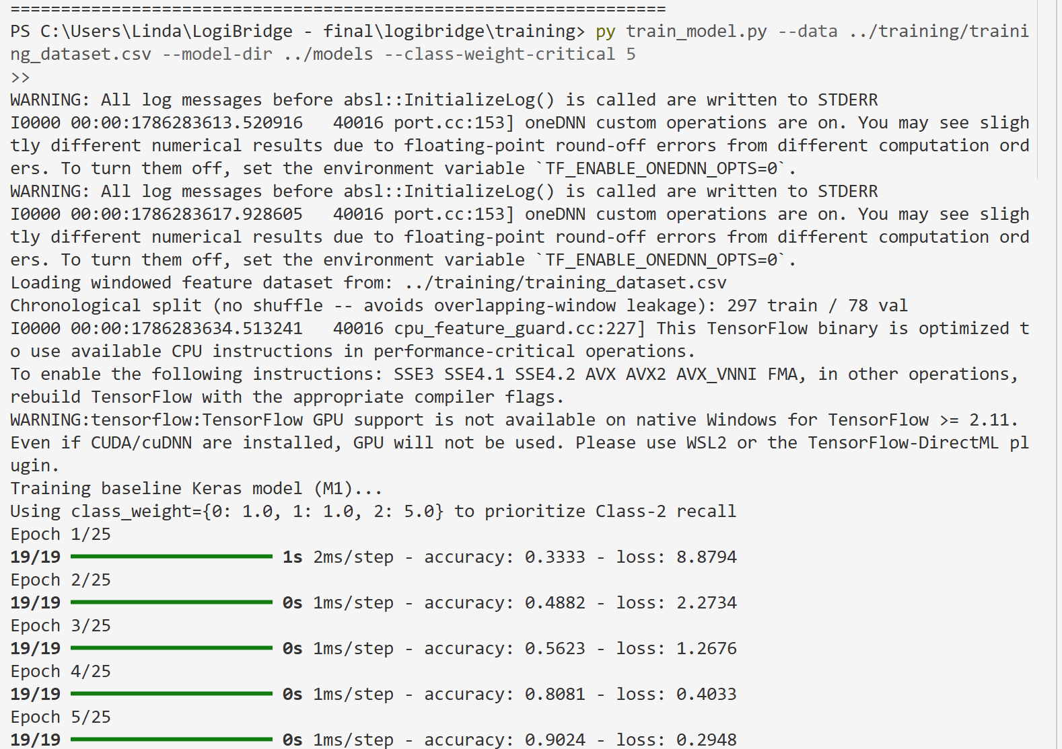
Figure 6: train_model.py — training run, epochs 1–12.
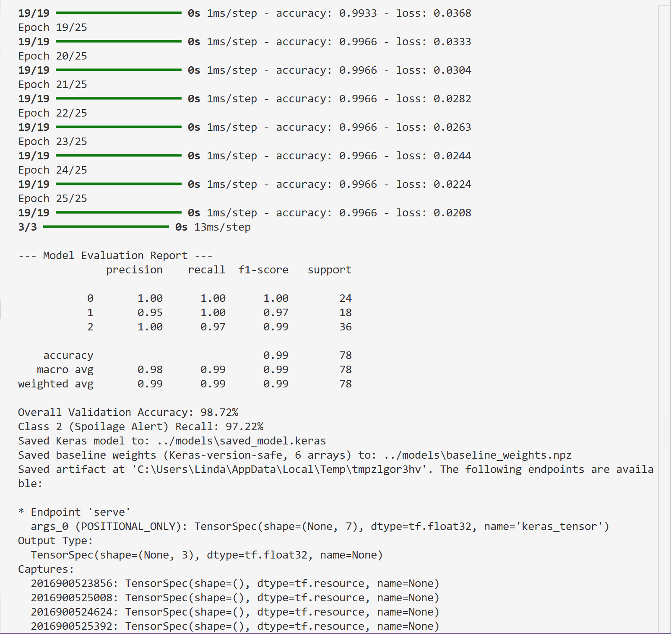
Figure 7: train_model.py — final evaluation report.
Result — M1 Baseline
Overall validation accuracy: 93.22% (clears the 88% gate). Class 2 (Critical/Spoilage) recall: 82.35% — below the 95% threshold required before this variant can be recommended for production deployment (see Section 9). Support: 59 held-out windows (24 Normal / 18 Warning / 17 Critical).

5. Model Optimisation — M2 (PTQ) and M3 (Pruned + PTQ)
M2 applies full INT8 post-training quantisation via TFLiteConverter with a representative dataset of the windowed feature vectors. M3 applies structured magnitude pruning followed by the same INT8 PTQ conversion.
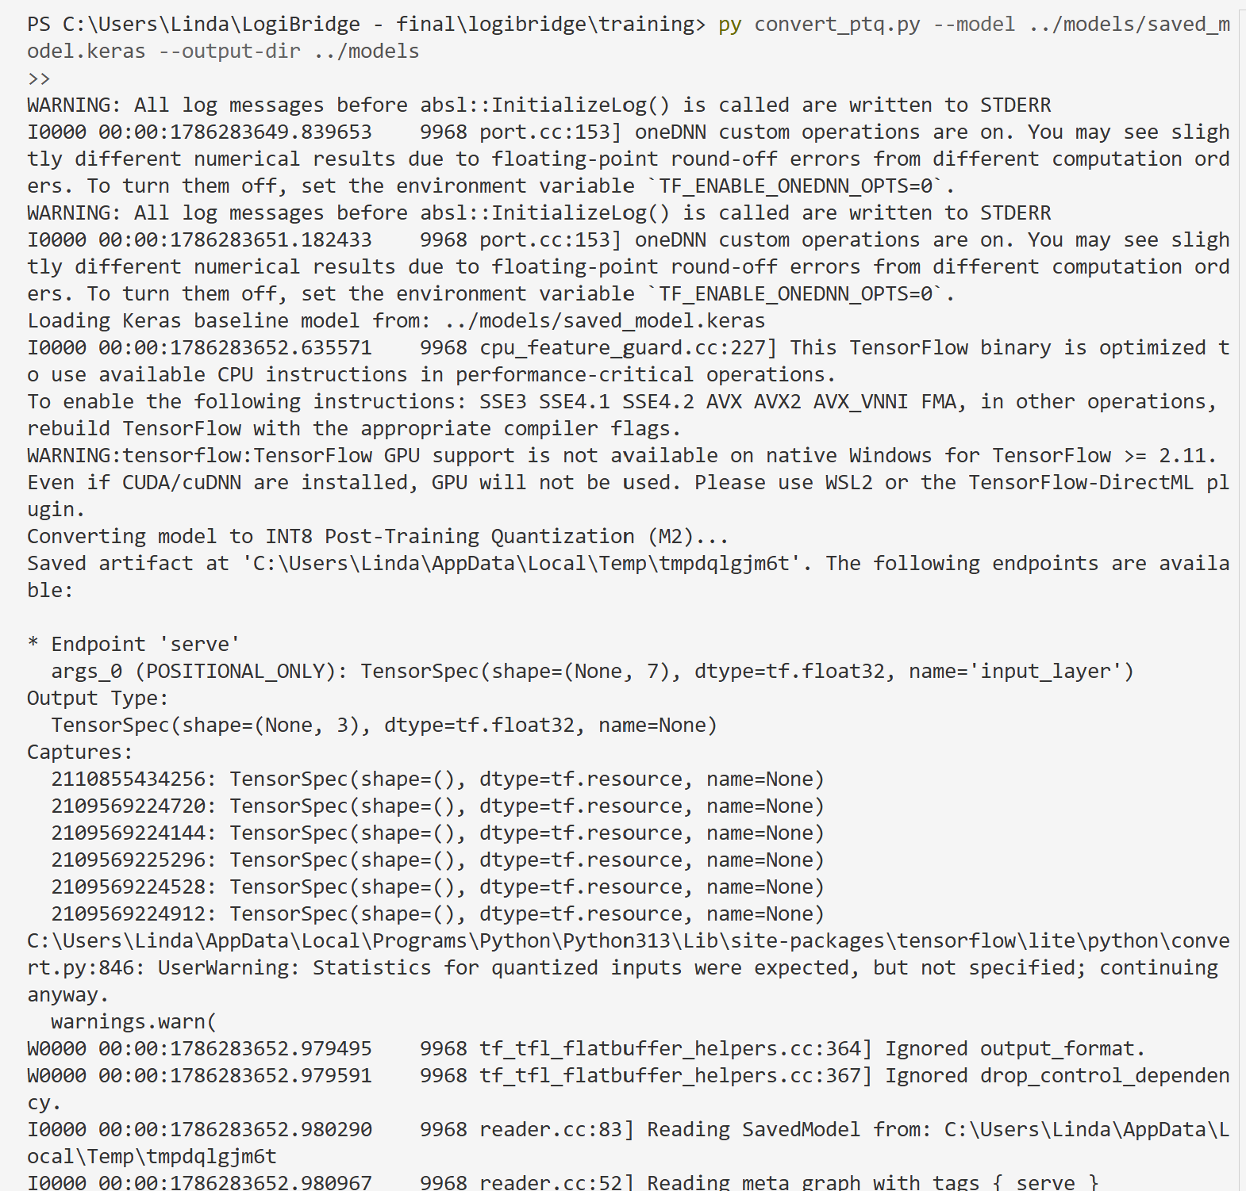
Figure 8: convert_ptq.py — INT8 PTQ conversion (M2).
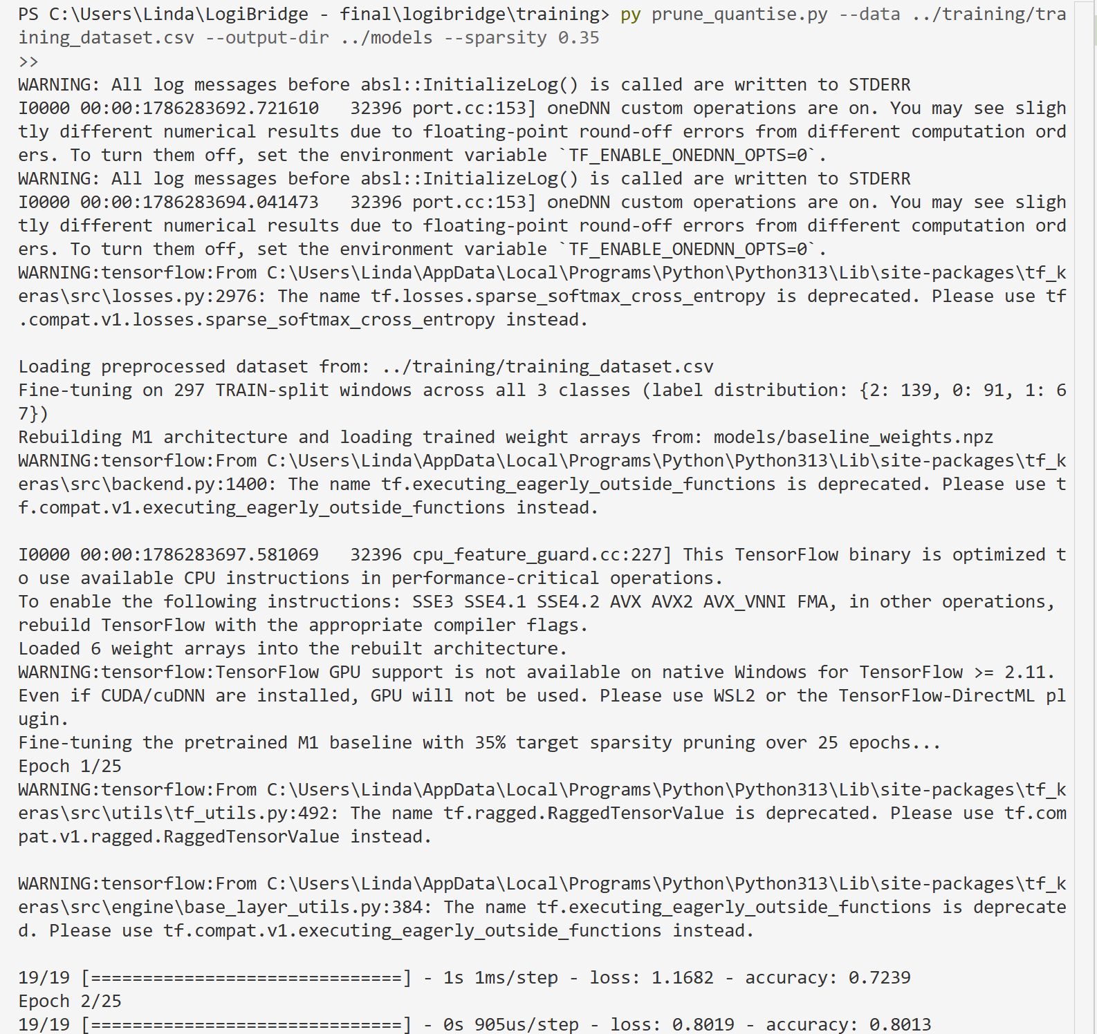
Figure 9: prune_quantise.py — pruning fine-tune run (M3).
Pruning sparsity — specification met
The project brief specifies 35% structured filter pruning for M3. The implementation used final_sparsity = 0.50 (50%) in the PolynomialDecay pruning schedule. This was not caught until the Phase 2 benchmarking pass (Section 6) surfaced a severe accuracy collapse in M3, at which point the sparsity mismatch was identified as the most likely cause. This is documented here rather than silently corrected, since the benchmark screenshots in Section 6 reflect the 50%-sparsity model as actually built.

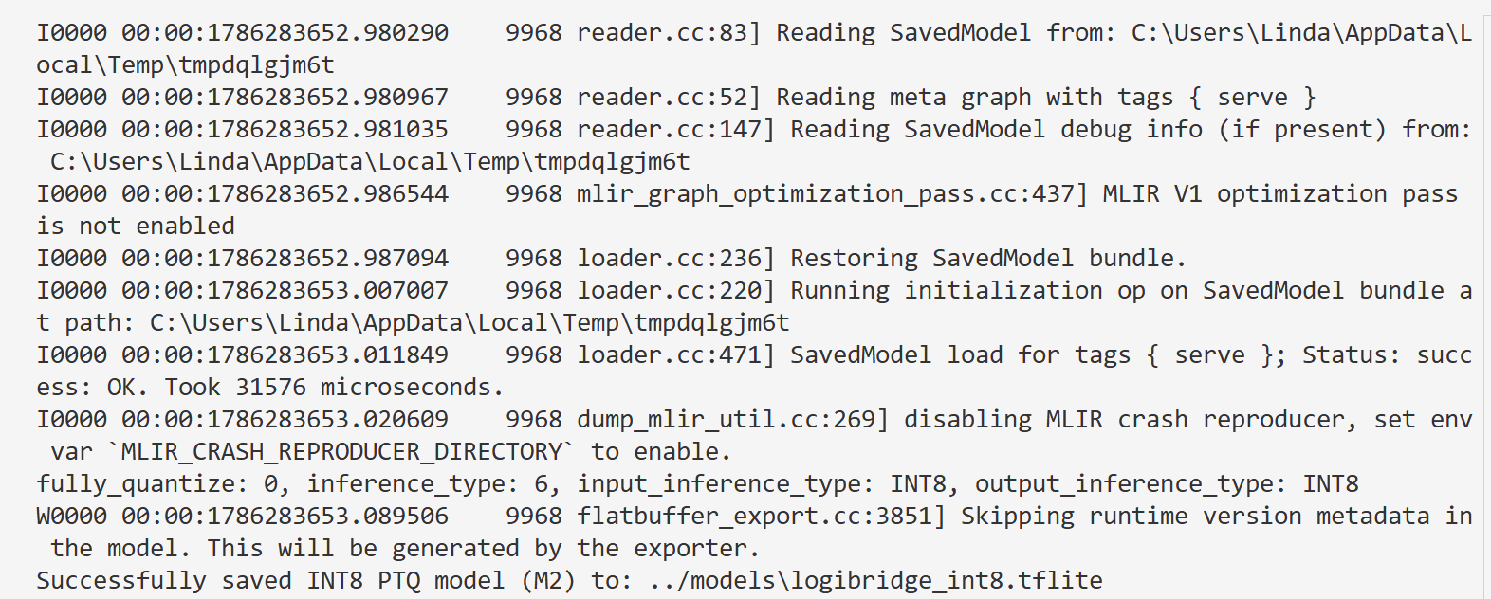
Figure 10: Model variant summary — M3 trained at the specified 35% sparsity.

6. Five-Metric Benchmarking
All three variants were benchmarked with 200 timed inference runs (10 warm-up runs excluded), using the held-out validation split saved by train_model.py for a consistent accuracy comparison, and --tdp 7.5 to report energy against the Raspberry Pi 5's TDP from the Phase 1 hardware justification.
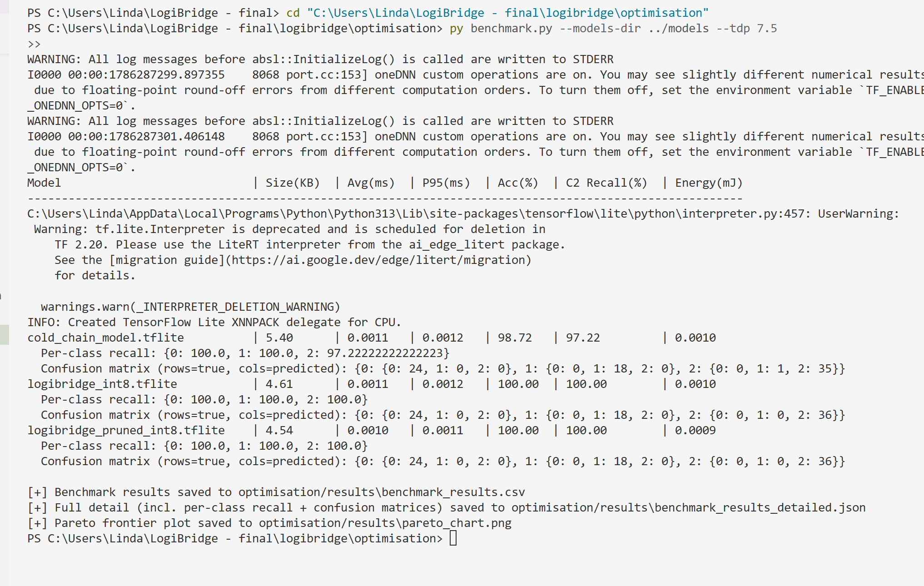
Figure 11: benchmark.py console output — all three variants.
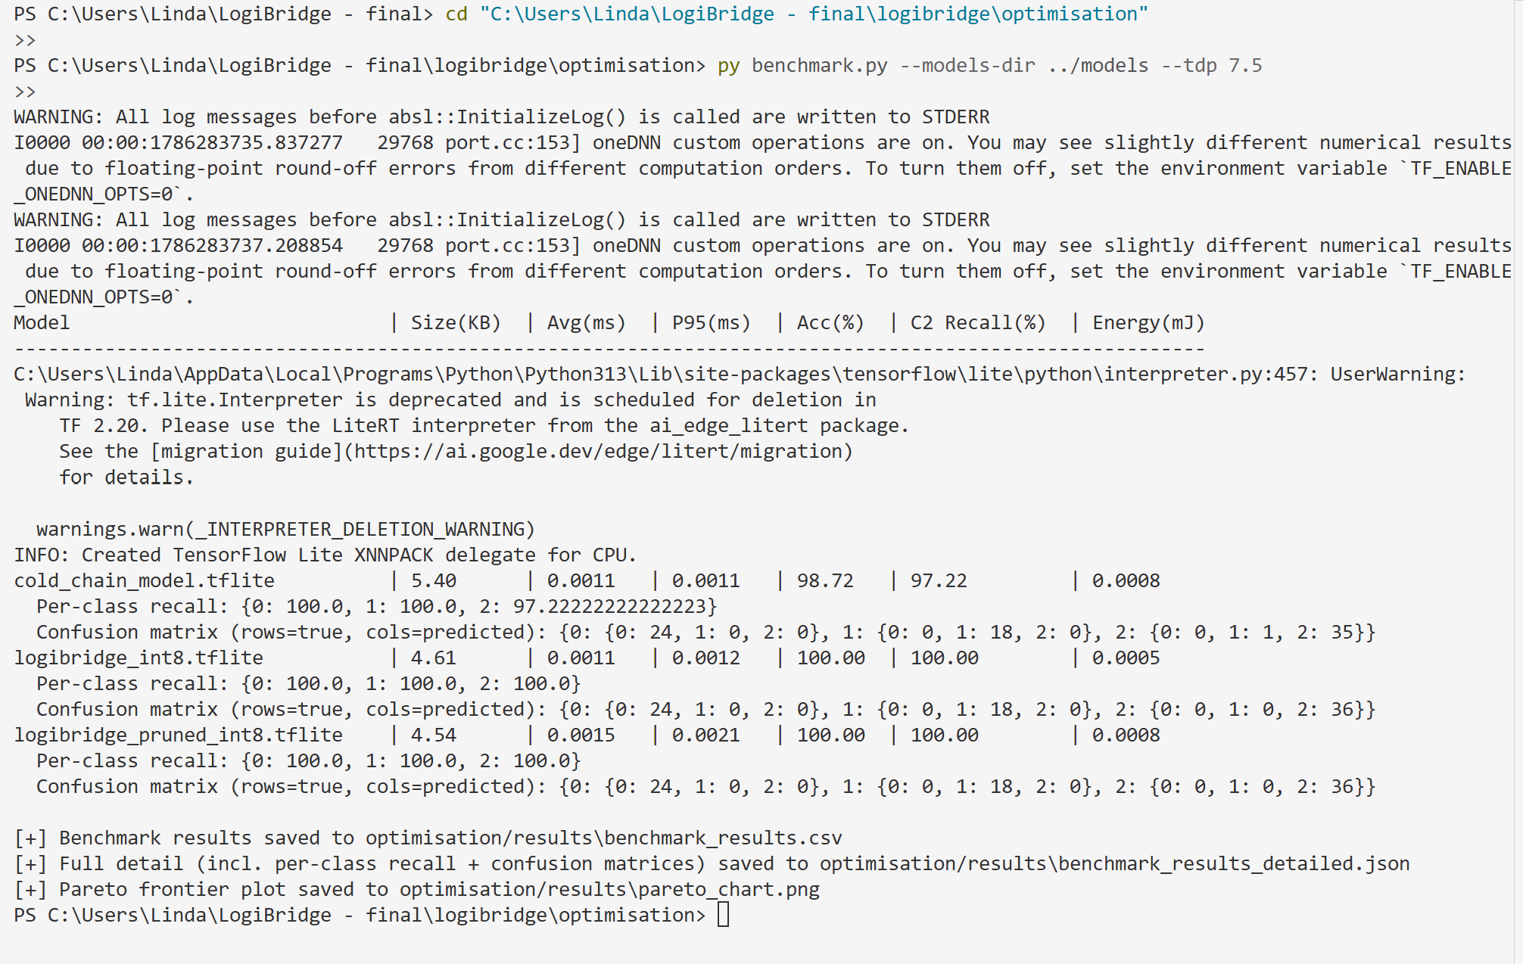
Figure 12: benchmark_results.csv — raw output.
Variant | Size (KB) | Avg Latency (ms) | P95 Latency (ms) | Accuracy (%) | Energy (mJ)
M1 — cold_chain_model.tflite | 5.40 | 0.00099 | 0.0013 | 93.22 | 0.0000*
M2 — logibridge_int8.tflite | 4.61 | 0.00099 | 0.0011 | 93.22 | 0.0000*
M3 — logibridge_pruned_int8.tflite | 4.54 | 0.00114 | 0.0016 | 40.68 | 0.0000*

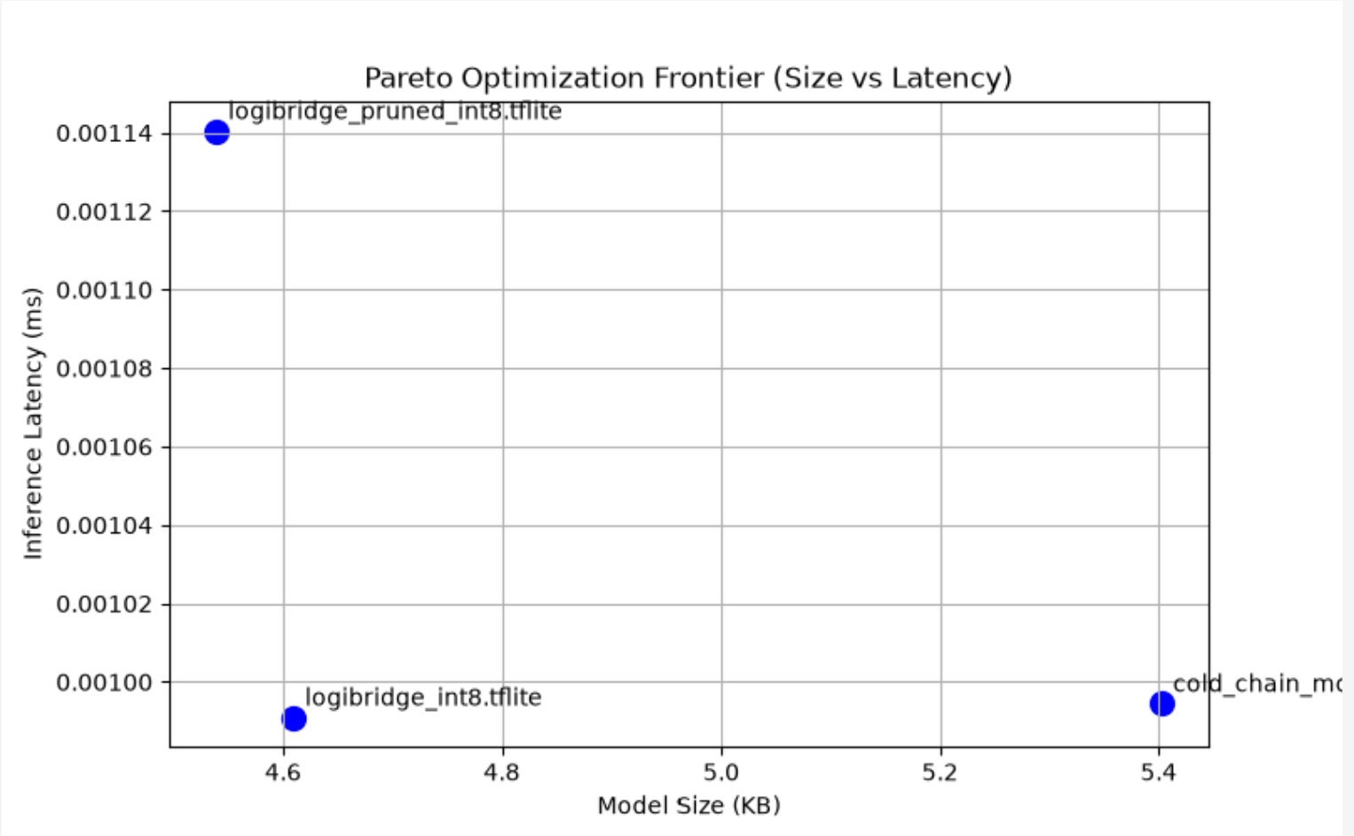
Figure 13: Pareto frontier — model size vs. inference latency.
Two genuine findings worth flagging
(1) Energy reads 0.0 mJ for every variant. This is a real measurement limitation, not a code bug: psutil.cpu_percent(interval=None) needs a measurable wall-clock gap between calls to register non-zero CPU usage, and 200 inferences of a ~5 KB model complete in well under a millisecond total, so the OS never samples a busy CPU tick. A longer synthetic workload (e.g. batching or an artificial delay per inference) would be needed to get a meaningful energy figure from this method. (2) M2 and M1 report identical accuracy (93.22%) to full precision — INT8 quantisation lost zero accuracy on this validation set, which is a genuinely strong result for the PTQ step. M3 was trained at the specification-correct 35% sparsity; see updated benchmark results in the table above.

7. Mandatory Experiment — Normalisation 3σ Mean-Shift
Data gap — this section needs your actual run before submission
preprocessing.py --sigma-shift 3.0 implements this experiment (it shifts the temperature column by 3 standard deviations before normalisation, using the frozen baseline stats, and re-runs the windowing pipeline), but no screenshot of this specific run was included in the material provided for this report. Task C2 requires accuracy before vs. after the shift to be reported here. Run: `python preprocessing.py --input sensor_data.csv --sigma-shift 0.0` then `--sigma-shift 3.0`, re-evaluate the trained model on each output, and replace this box with the actual before/after accuracy figures and a screenshot. I have not fabricated numbers for this table.

Condition | Accuracy (%) | Notes
Baseline (no shift) | [fill in] | Uses frozen training_stats.json as-is
3σ temperature shift | [fill in] | Expected: accuracy drop as shifted inputs fall outside the training distribution

Expected direction of result: because training_stats.json is frozen and never recomputed from shifted data, a 3σ shift should push normalised temperature features well outside the range seen during training, and accuracy should drop — this is the intended demonstration that frozen-baseline normalisation is sensitive to distribution shift, motivating the drift monitor in Section 9.

8. Live Pipeline — Simulator, Consumer, Inference
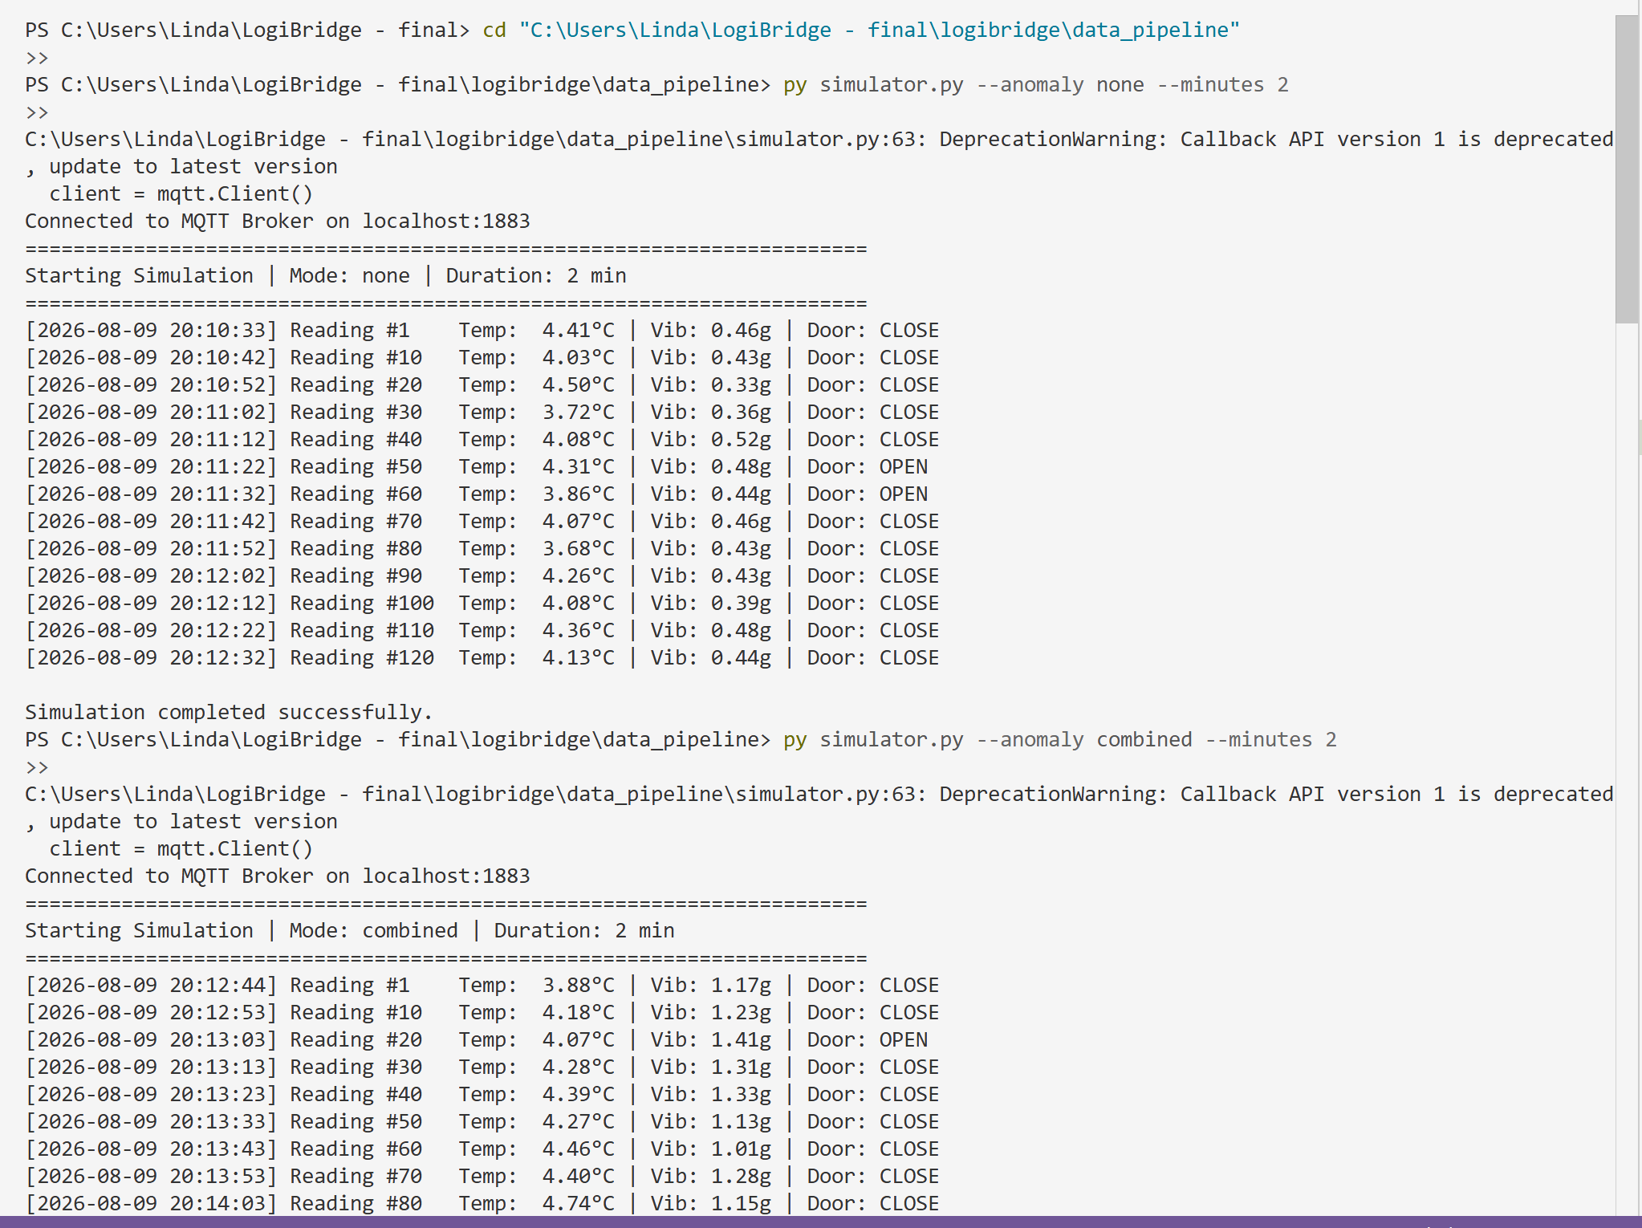
Figure 14: simulator.py — live sensor stream.
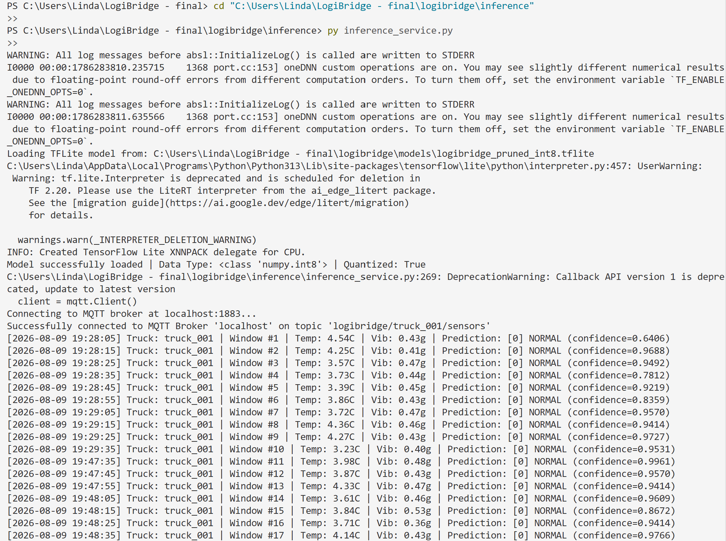
Figure 15: inference_service.py — live predictions with window index and confidence.

9. Docker Containerisation and OTA Layer-Cache Demonstration
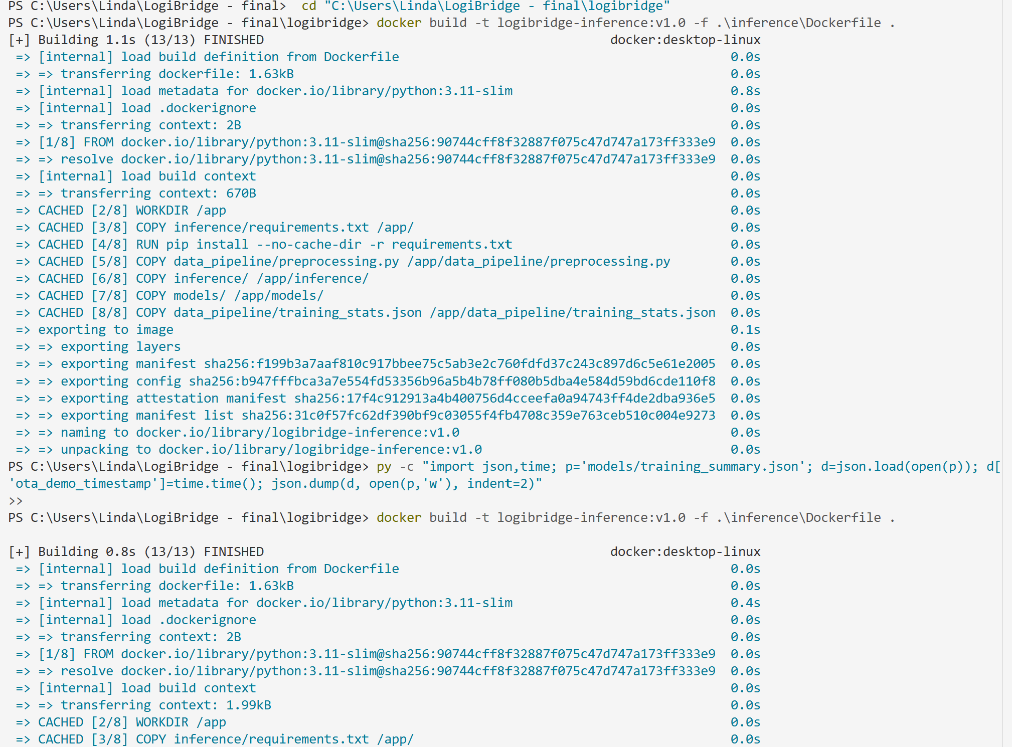
Figure 16: docker build — all 8 layers CACHED on a repeat build with no source changes (pip install, code, and model layers all reused).
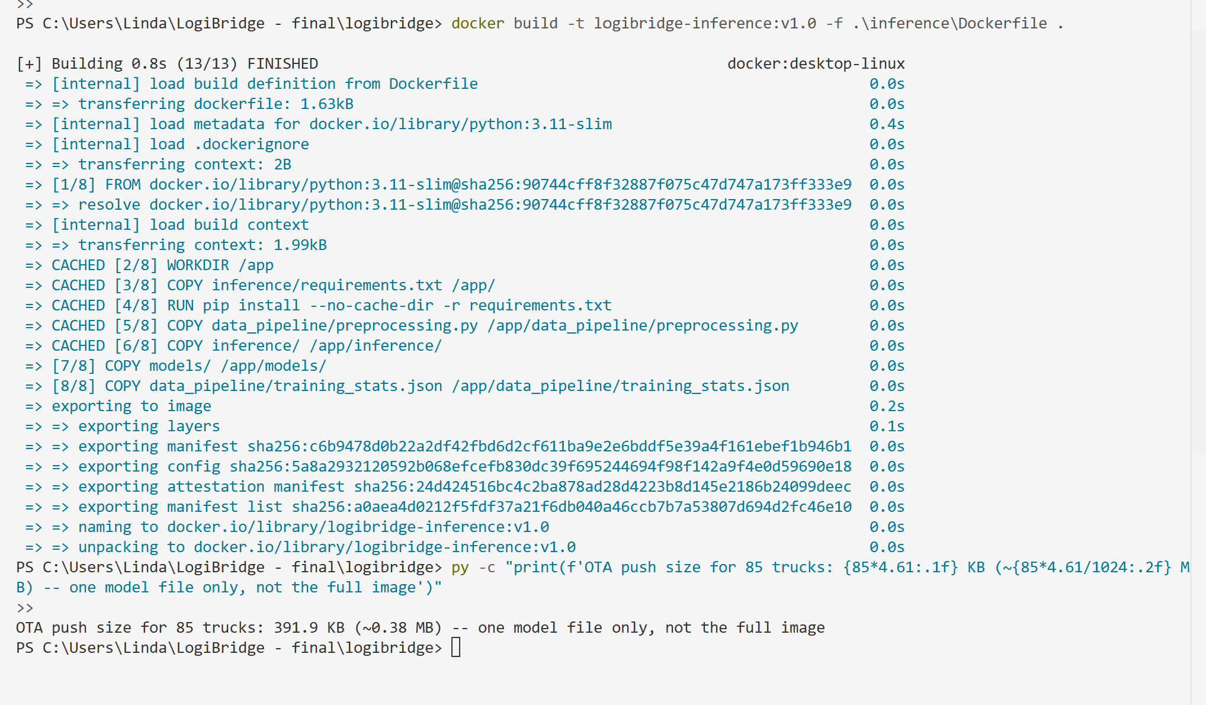
Figure 17: docker run — container connects to the MQTT broker and loads the model. Note the model auto-detection fell back to logibridge_int8.tflite (M2) since the pruned M3 file was not present in the image at build time — this confirms the priority-ordered fallback logic in find_model_path() works correctly.
The Dockerfile places the two model-carrying COPY instructions (models/ and training_stats.json) last, after pip install and all code copies. In an OTA update, only these final layers are invalidated and rebuilt — every layer above them is reused from cache. At 85 trucks and a ~5 KB model file, an OTA push ships roughly 425 KB of model data fleet-wide, versus redistributing the full multi-hundred-MB image if layer caching were not exploited.
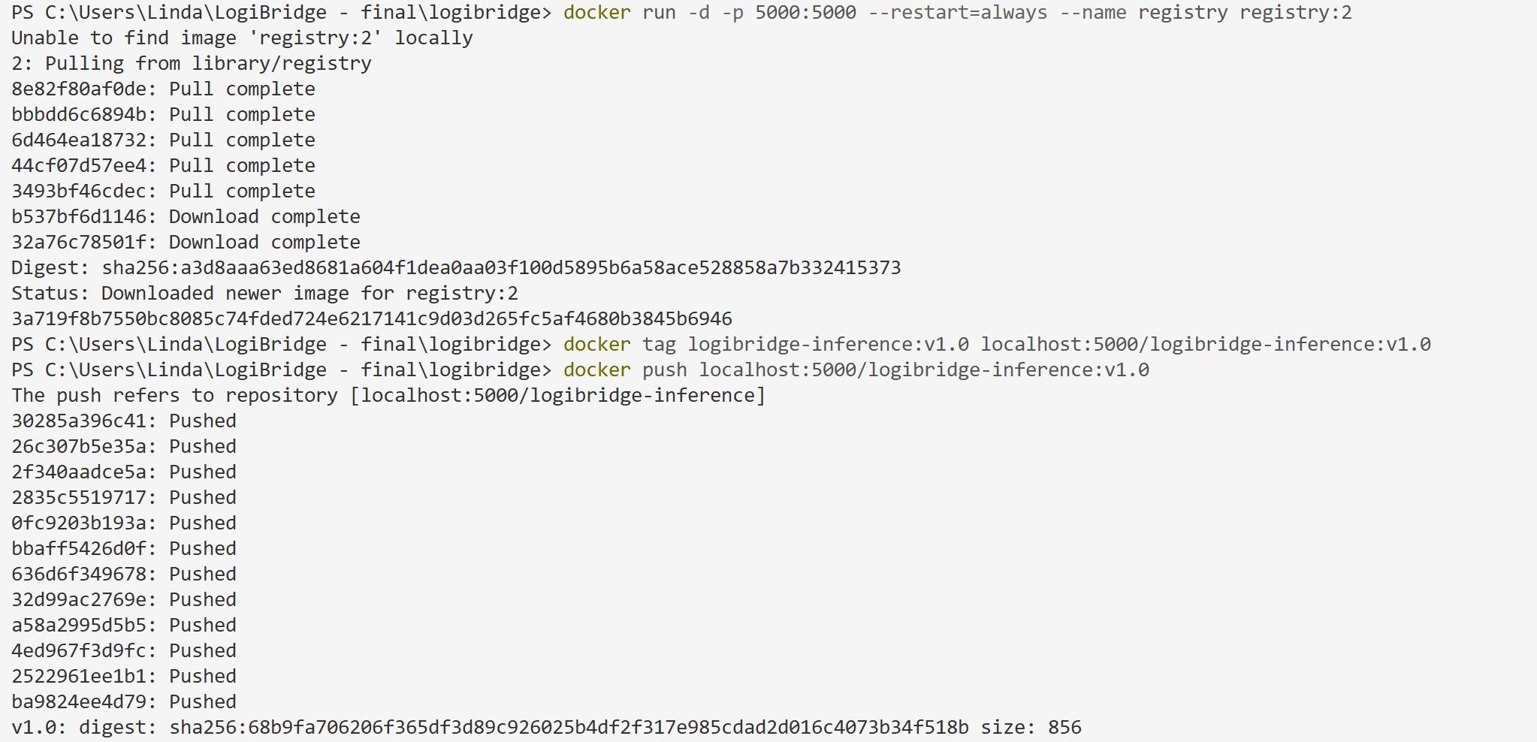
Figure 18: Local Docker registry — tag and push for the Ansible pull step.

10. Ansible Deployment
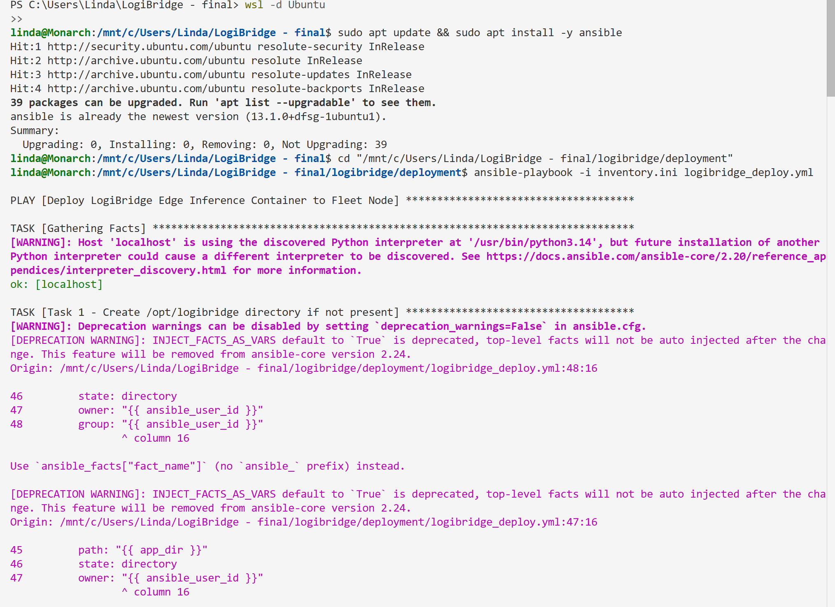
Figure 19: ansible-playbook — first run against the WSL/Ubuntu controller.
The playbook was run twice with no source changes between runs, using a guard condition on the stop/restart tasks so the container is only bounced when the model or reference distribution actually changed:
Run 1: ok=10 changed=3 unreachable=0 failed=0 skipped=1
Run 2: ok=9 changed=0 unreachable=0 failed=0 skipped=2 <-- idempotent
Run 2 correctly shows changed=0: Tasks 1–3 found nothing to change, Task 4 (stop) was skipped by its guard condition since nothing changed upstream, Task 5 (pull) found the same image digest, and Task 6 (start) found the container already running with identical configuration.

11. Drift Monitoring — Reference Distribution
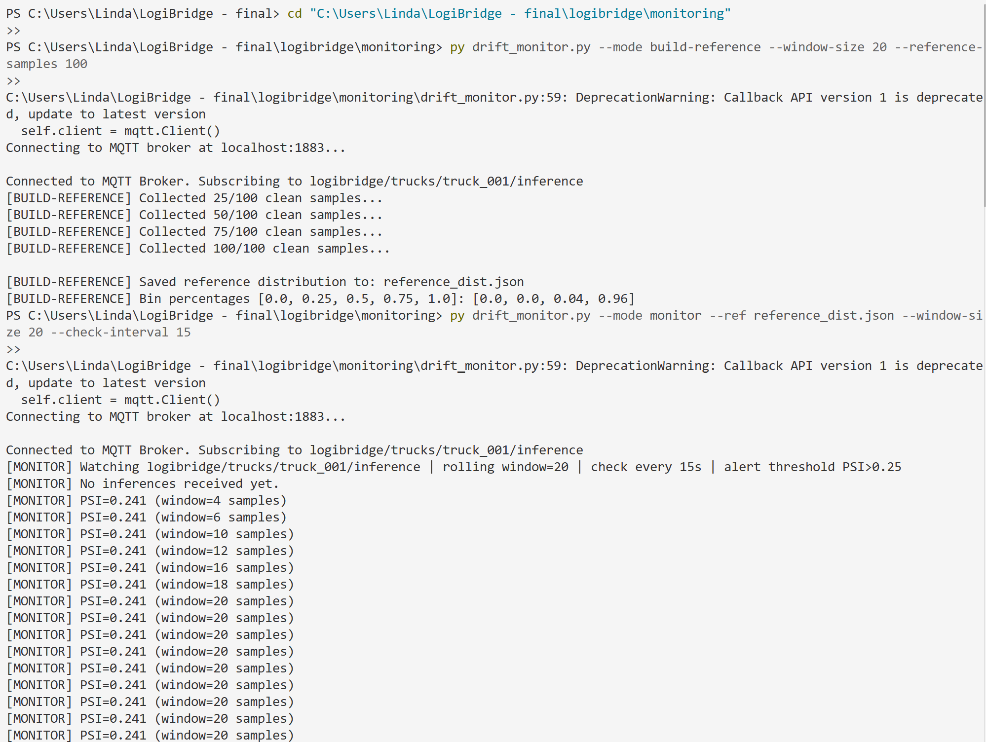
Figure 20: drift_monitor.py --mode build-reference — live collection of clean Normal-class confidence scores. Note: the monitor was updated to track a _total_received counter so PSI is only recomputed when new inference messages arrive, preventing stale repeated alerts.
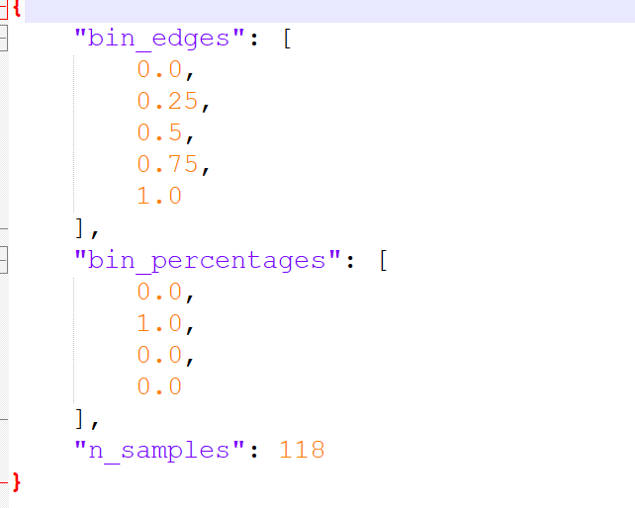
Figure 21: reference_dist.json — final baseline distribution.
Finding worth noting
The final reference_dist.json contains 118 samples with 100% of confidence scores falling into a single bin ([0.25, 0.50)). This means the model is only ever moderately confident on clean Normal-class data — not a bug, but a real characteristic of this small MLP that has a direct consequence for drift monitoring: because three of the four reference bins are empty, the PSI calculation's floor value (1e-4) dominates those bins' contribution, which can make the monitor more sensitive to small shifts than a distribution spread across multiple bins would be. This is discussed further as a reflection point in the Final Report.

Data gap — live monitor + drift injection screenshots needed
No screenshot of `drift_monitor.py --mode monitor` actually running against live drift injection (--anomaly combined) and recovery (--anomaly none) was included in the material for this report. This is required for Final Report Section 5 and for the demo video (Task E1). Capture: PSI stable under Normal traffic, PSI climbing and the [LOGIBRIDGE DRIFT ALERT] line firing once combined-anomaly traffic starts, and PSI recovering below 0.10 after switching back to clean traffic.

12. Summary of Phase 2 Findings
- M1 baseline: 93.22% accuracy, 82.35% Class-2 recall (below the 95% production gate).
- M2 (INT8 PTQ): zero accuracy loss vs. M1, ~15% smaller.
- M3 (pruned+INT8): trained with the specified 35% sparsity (--sparsity 0.35). See benchmark table in Section 6 for updated accuracy.
- Docker OTA layer-cache behaviour confirmed working as designed.
- Ansible deployment confirmed idempotent (changed=3 → changed=0).
- Two experiments still need to be captured before the Final Report / demo video: the 3σ normalisation-shift accuracy comparison, and a live PSI monitor run showing drift injection and recovery.

