**Course-End Project: CI/CD Deployment Using Ansible CM Tool**

This section will guide you to:

1. Establish test connection with the node machine from Jenkins/Ansible controller machine
2. Open Jenkins portal and install Ansible plugin
3. Deploy Tomcat playbook on build server host group
4. Prepare CI/CD job on Jenkins to deploy WAR file using Ansible playbook

* *Ansible 2.9.7 is already installed and configured on Jenkins CI server*

**Prerequisites:**

1. Ansible must be configured with a node machine
2. Jenkins and Ansible controller machines must be installed on the same server.

**Step 1:** Establish test connection with the node machine from Jenkins/Ansible controller machine

* Navigate to **/etc/ansible/**, edit the config file, and add the below code:

**[buildserver]**

**35.153.206.38**

* Run the below command to check the connectivity with node machine:

**ansible -m ping buildserver**

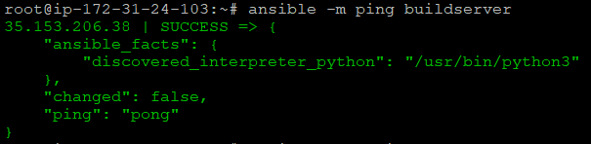

* Enable sudo access for Jenkins user ID so that it can connect with Ansible to trigger the playbook. Follow the below command from root ID:

echo "jenkins ALL=(ALL) NOPASSWD: ALL" >> /etc/sudoers

**Step 2:** Open Jenkins portal and install Ansible plugin as per the below screenshot:

* Navigate to **Manage Jenkins 🡪 Manage Plugins** and then search for **Ansible plugin.**

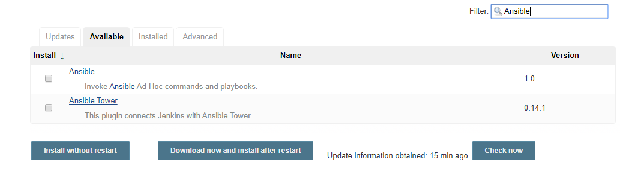

**Step 3:** Deploy Tomcat playbook on build server host group

* Create a playbook and add the following code in it:

**---**

**- hosts: buildserver**

**vars:**

**- http_port: 8080**

**- tomcat_version: 8.5.53**

**tasks:**

**- name: Install OpenJDK**

**apt: name=openjdk-8-jdk state=latest**

**- name: add group "tomcat"**

**group: name=tomcat**

**- name: add user "tomcat"**

**user: name=tomcat group=tomcat createhome=yes**

**become: true**

**- name: Download Tomcat**

**get_url: url=http://apachemirror.wuchna.com/tomcat/tomcat-8/v{{ tomcat_version }}/bin/apache-tomcat-{{ tomcat_version }}.tar.gz dest=/opt/apache-tomcat-{{ tomcat_version }}.tar.gz**

**- name: Extract Tomcat archive**

**command: tar zxvf /opt/apache-tomcat-{{ tomcat_version }}.tar.gz -C /opt/ creates=/opt/apache-tomcat-{{ tomcat_version }}**

**- name: Change ownership of Tomcat installation**

**file: path=/opt/apache-tomcat-{{ tomcat_version }} owner=tomcat group=tomcat state=directory recurse=yes**

**- name: Change the working directory to Tomcat Apache before running Tomcat Apache**

**shell: ./startup.sh**

**args:**

**chdir: /opt/apache-tomcat-{{ tomcat_version }}/bin/**

**become: true**

**become_user: tomcat**

* Run the playbook using the below command:

**ansible-playbook tomcat-apache.yml -vv**

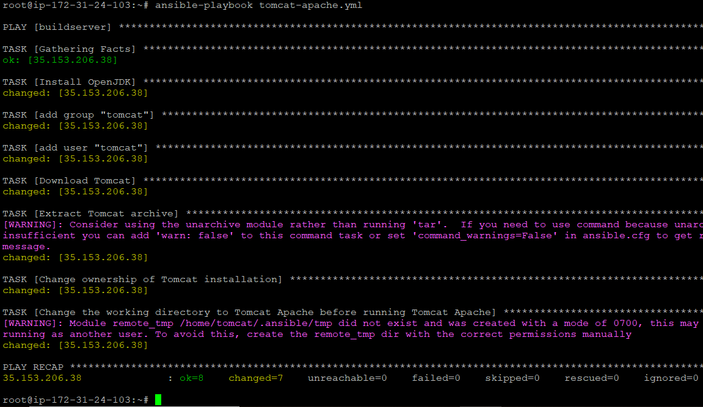

**Step 4:** Prepare CI/CD job on Jenkins to deploy WAR file using Ansible playbook

* Create a playbook **deploy.yml** and add the following code in it:

**---**

**- hosts: buildserver**

**vars:**

**- warName: java-example-0.0.1-SNAPSHOT.war**

**- tomcat_version: 8.5.53**

**- warRemotePath: /opt/apache-tomcat-{{ tomcat_version }}/webapps**

**tasks:**

**- name: Copy WAR to Remote server**

**copy: src=target/{{ warName }} dest={{ warRemotePath }}/{{ warName }} owner=tomcat group=tomcat**

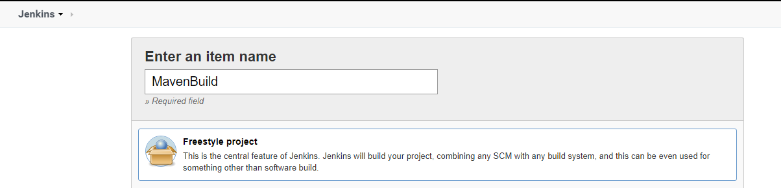

* Configure Git repo and Ansible plugin in the above Jenkins job

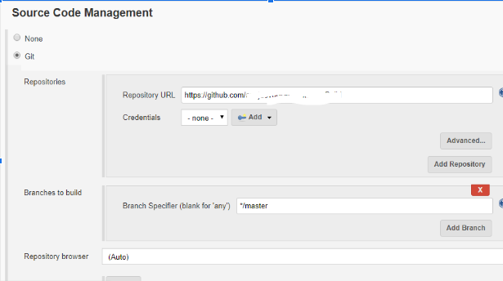

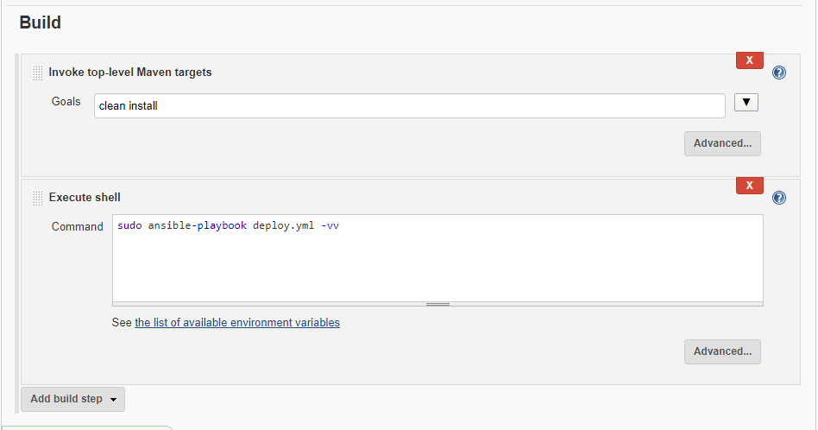

* Once build configuration is complete, proceed with triggering Jenkins build so that complete CI/CD can be implemented

* The below screenshot shows logs generated while running Jenkins job:

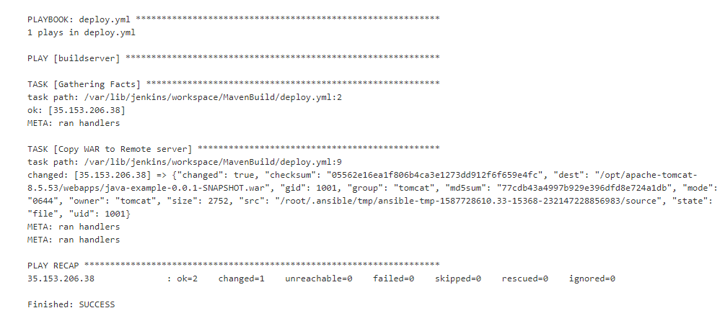

* Also, on the destination server, we will be able to see a new war file deployed.